The Regional Integration through Transit Initiative
Tele-Commuter Resources, Inc.
October, 1999

INTRODUCTION
The Regional Integration through Transit initiative (RIT) has been developed to support the Tele-Commuter Resources (TCR) Distributed City Model. This model envisions the continued evolution of the Internet and its “anywhere, anytime, anything” mantra. While the current approach to telecom deployment reinforces the organizational tenets of the Industrial age, the Distributed City Model (DCM) anticipates the next stage of development that will build upon the concept of tele-commuting. TCR defines this term not as a telework strategy but rather as a community strategy which provides parity of access through tele-medicine, distance learning, telework etc.

As the implications of the global economy become more apparent, regions with technologic and community leadership will understand the competitive advantages of the DCM and begin realigning investment strategies to support this reflection of the emerging Knowledge Economy. These strategies will allow individuals to live in those communities that best respond to their desired quality of life and allow all communities within the region to fully participate in the regional economy... With 43% of urban residents (1996 Metropolitan Council study) wanting to live in a rural small town, a dramatic population redistribution is possible with major implications for the types and locations of investment requirements. It is a fundamental hypothesis that this re-distribution of population will result in reduced cost to the public sector, a more competitive private sector and a more self-reliant community sector.

THE DISTRIBUTED CITY MODEL
For a region to compete globally it must create an environment of efficiency and effectiveness. TCR believes that reducing the high cost of urban growth and continuing to provide rural subsidies because of limited rural opportunities is an unsustainable policy. New strategies must be developed that equalize opportunity while reducing costs for all three sectors of the economy.

The integration implicit in a deployment of the DCM must occur at several levels:
- policy- local, regional and state agencies and institutions must collaborate to deliver capacity into communities throughout the region. Collectively they can serve as the catalyst that demonstrates cooperative approaches that invest in content delivery to build a broader local market for telecom services
- technology- Instead of building multiple lines into a community, the focus must shift into managing access to distribute that service within it. Current practice of delivering T-1s to specific locations within a community. Split the market so that only those who can afford individual connectivity are served; in many cases precluding many potential customers from entering the regional or global market. Rather than a focus on individual connections we must shift to supporting a systemic community network..
- transportation- Intra-regional travel costs must be reduced, speed must be increased and flexibility must be expanded. A new form of transit must be deployed that eliminates the “windshield t7meThe auto wastes too much time, air schedules are too limited and rail is too expensive and/or too inflexible
This White Paper examines the transportation linkages within this concept.

THE REQUIREMENTS
Through the provision of ubiquitous bandwidth the region can provide the necessary support services to all communities. This creates the potential for residential choice but it does not address the human side of the equation- people do want to get together. IF the region truly wants to equalize economic opportunities for all communities then it must provide a system which eliminates the ”windshield factors”, ie, need to drive the vehicle, relatively slow speeds, potential impacts due to weather. Any solution must be affordable, fast and extremely flexible for both origin and destinations.

Unlike cars, planes and trains, a system that meets the above requirements must be able to go non-stop from point A to point B. This requires off-line boarding and de-boarding.

SERVICE LEVELS
It is the goal of MNDot to serve 90% of the state's population transportation by providing intercity bus and air service according to their 1997 and ---- plans respectively. Despite this goal, service has been reduced further.
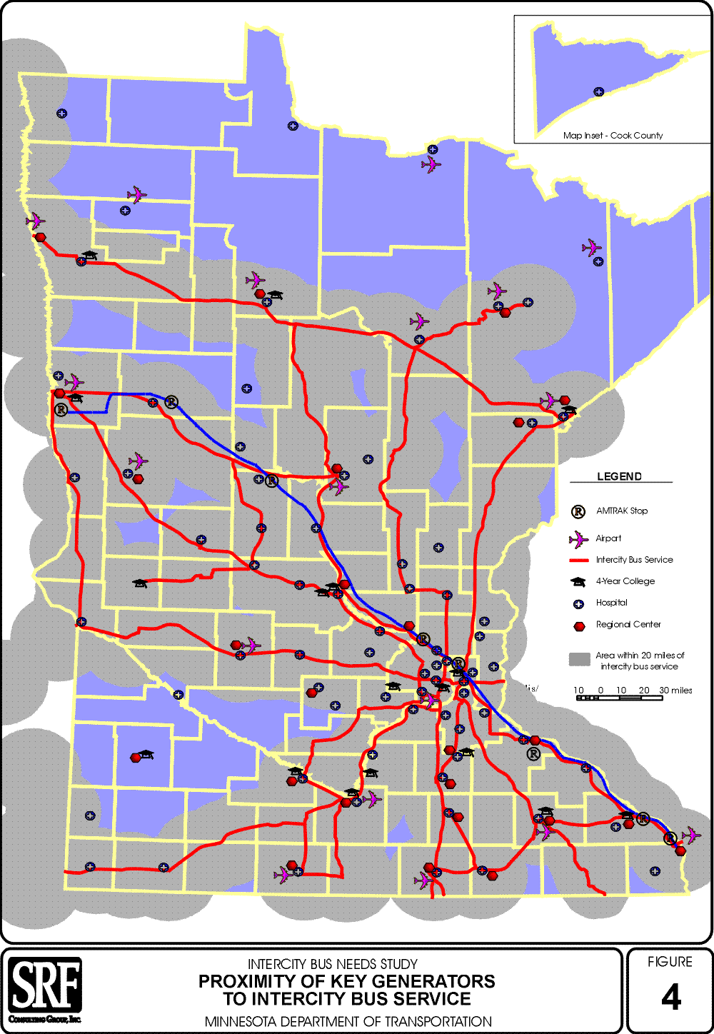
InterCity bus service generally operates six days a week with one round trip per day. Air Service operates in only eight out-state Minnesota communities with service levels of 2-7 flights per day, 7 days a week. Of these eight communities, # are being served under the Essential Service
schedule flexibility
cost

THE SYSTEM DEFINED

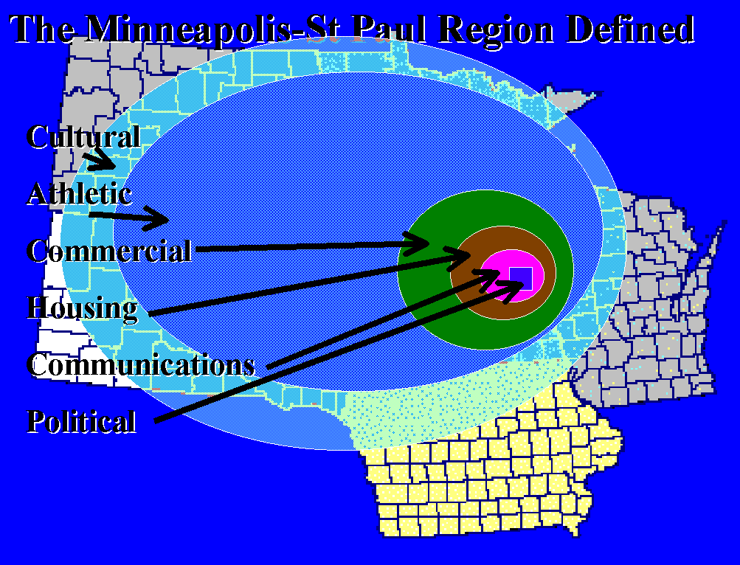

THE COMPONENTS
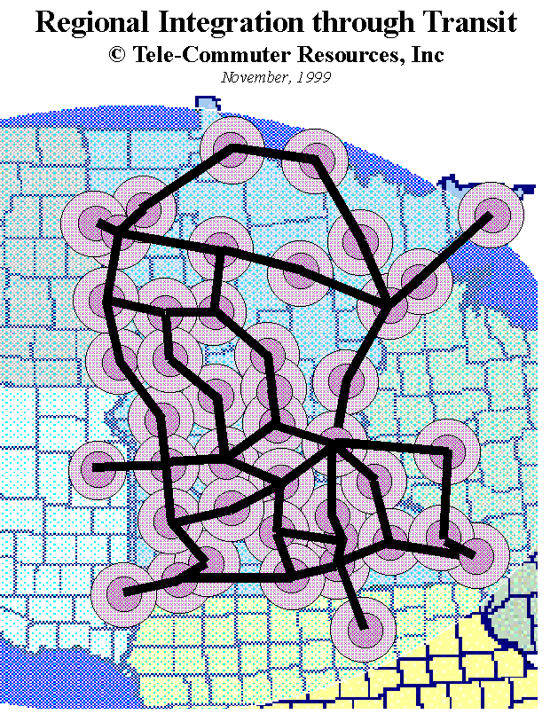
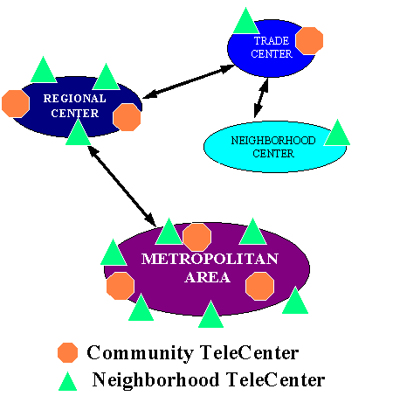

taxi 2000
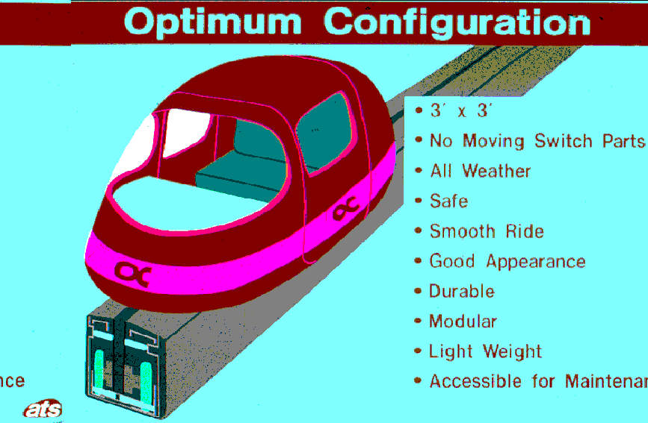

cybertran
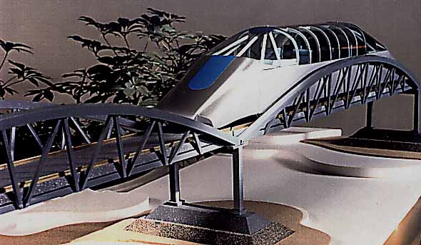

THE FEASIBILITY
- single system vs current costs
- insert map with systems
- potential ridership
- cost comparison table

Table
Transportation Analysis- Current State Investments
Mode Riders Cost/Ride Cost/Mile Rider Contribution
Air Travel
Automobile
Bikeways
Bus Transit
Telecommuting

Table
RIT Infrastructure
Cost/Station
Mode Cost/Mile Urban Rural Cost/Car Riders
Taxi2000
CyberTran

Table
Ridership Operations
# of Riders Captured
Mode Total Travelers 1% 3% 5% 10%
Taxi2000
CyberTran

Table
Revenue Scenario’s
Revenue
Ridership .10 .20 .30
Taxi2000
1%
3%
5%
10%
CyberTran
1%
3%
5%
10%

THE SUMMARY
"Goal: 90% of the state's population should be within one hour's driving time of an airport with scheduled air service."
In 1988 it was 87%
Recommended adding Fergus Falls and Willmar but instead we have lost Chisholm, Marshall, Mankato and Worthington---

Minnesota State Aviation System Plan; Recommended Airport Development 1990-2010
(p 3 volume B) $846 million ($564 federal)
Minnesota State Aviation System Plan; Executive Summary 1990-2010
P1 VOLUME A) 4206 aircraft; 140 publicly owned strips 49,000 jobs, $.3 billion impact
Rural growth- 63% turboprop; 54% jets
- operations [take-off OR landing]- 424,783 local; 628,128 itinerant
1.3% annual growth through 2020 for passenger enplanements
Minnesota State Aviation System Plan; Plan Overview 1990-2010

Table 5,15 1987 326,659 passengers Duluth & Rochester alone 239,909 73%
2000 432,200 328,000 76%
2020 494,300 377,000 76%
current air service 1987 passengers flights/day Days/Week Cost Minutes
Bemidji 24,631 7 7
Brainard 14,994 5 7
Duluth 118,434 # 7
Fairmont 1,436 2 5
Grand Rapids 3,537 4 7
Chisholm 17,358 - -
International Falls 15,888 5 7
Marshall 993 - -
Mankato 771 - -
Rochester 121,473 # 7
Thief River Falls 6,409 3 6
Worthington 735 - -

Former air service
Yr Closed Passengers
Alexandria -
Baudette -
Detroit Lakes -
Ely -
Eveleth -
New Ulm -
Park Rapids -
Warroad -
Willmar -
Winona -

Of 22 cities with air service in 19 , only 12 remained in 1990 . In the past 9 years, 33% of those cities have also lost service and Duluth and Rochester account for about 75% of all Greater Minnesota trips.

Air Service and the Minnesota Economy- CTS- for MAC
Multiplier 2.7443 based on air transport employment for new employment
1993 Rank 1989 Rank Factor Type
1 2 Local Public Schools Quality of Life
2 3 Work Attitudes of Workers Labor
3 1 Labor Availability Labor
4 5 Crime Rate Quality of Life
5 6 Electricity Costs & Supply Site/utilities
6 7 Quality of Area for Raising Children Quality of Life
7 4 Trainability of Work Force Labor
8 8 Local Tax Rates Business Services
9 9 Skill Level Labor
10 13 Local Business Climate Business Services
Source: Center of Interdisciplinary Transportation Studies of the Univ of N Carolina, Charolotte

45% of large firms substitute telecom for air travel, 31 % for mid size and 33% w <100 emp
Source: Stephenson and Bender 1996
Minnesota Inter-city Bus Needs Study, MNDot, 1997

To a large extent this study was prompted by the passage of the ISTEA, which includes authorization for funding of inter-city bus services in rural areas as part of the Section 5311(f) program of capital and operating assistance administered by the Federal Transit Administration. This same legislation mandates a number of changes in the way transportation investment are made, beginning with changes to make state and local planning more multi-modal (serving multiple modes) and more intermodal (facilitating connections between modes). This shift in the overall planning focus has helped to spotlight the need for an inter-city bus service plan as this mode has not been represented in much of the plann8ing that has been undertaken for either highway transportation or for urban and rural transit.
Minnesota Inter-city Bus Needs Study, MNDot, 1997

Twice as energy efficient as Amtrak
Three times automobiles and public transit
Four times commercial aviation

Passenger load factor was 56% (26 riders on a 47 passenger vehicle)

Route system 4400 miles in 1981; 2500 miles in 1995 (-43%)

The profile of an inter-city bus rider is somewhat more oriented toward lower income, lower auto availability and more elderly and young adults than the general population.

Revenue for inter-city bus = $ .10/mile
Coverage- 1 round trip/day- 6 days/week

$1,000,000 a year in subsides to gap-fill 8 routes

Variables for the Regional Integration through Transit Model

Passenger Capture Rates- What percent of the passenger mileage do you think would be converted to the Taxi2000 and CyberTran systems given their capabilities for each of the following road types:
Interstate-
Principal Arterial
Minor Arterial
Major Collector
Minor Collector
Local

What do you think would be the average one way trip length for:
CyberTran _____
Taxi2000 _____

With a 3 and 12 person capacity for the Taxi2000 and CyberTran systems respectively, what do you think would be the average number of riders in:
CyberTran _____
Taxi2000 _____

With the ability to deliver freight in specially designed CyberTran vehicles, what percent of passenger trips do you think the freight industry might become? ____

A 1996 Met Council report indicates that 43% of urban dwellers would prefer to live in a "rural small town". What percent of these do you think would relocate given the TeleCenter Network and the Guideway system? _____%
What do you think the average wage would be for those that decided to relocate? $_________

If these systems were actually deployed what effect do you think this would have on rural residential property valuations? _____%

If it costs $ .262 to DRIVE your car, what would you be willing to pay to RIDE:
CyberTran/Mile: $________
Taxi2000/Mile $________

