1. Crofts TS†, Sontha P, King AO, Wang B, Biddy B, Zanolli N, Gaumnitz J, Dantas G† (2019) Discovery and characterization of a nitroreductase capable of conferring bacterial resistance to chloramphenicol. **Cell Chemical Biology**, 26 (4): 559-70.

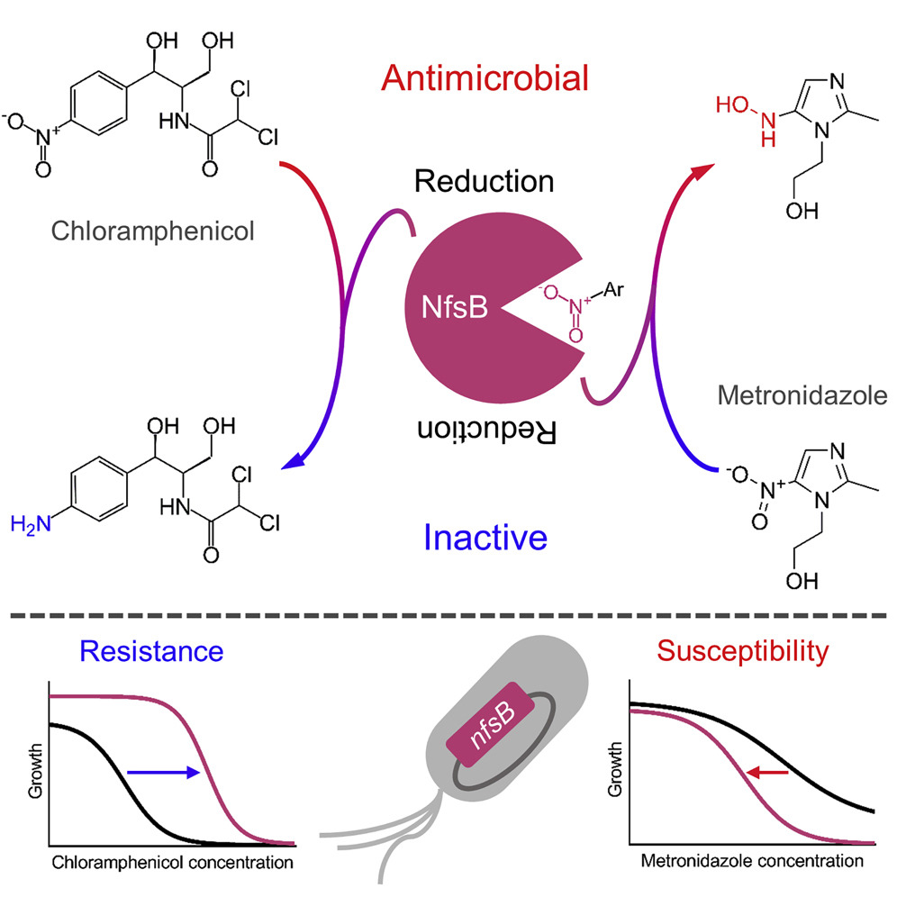

1. Crofts TS, Wang B, Spivak A, Gianoulis TA, Forsberg KJ, Gibson MK, Johnsky LA, Broomall SM, Rosenzweig CN, Skowronski EW, Gibbons HS, Sommer MOA, Dantas G (2018) Shared strategies for β-lactam catabolism in the soil microbiome. **Nature Chemical Biology**, 14 (6). 556-64.

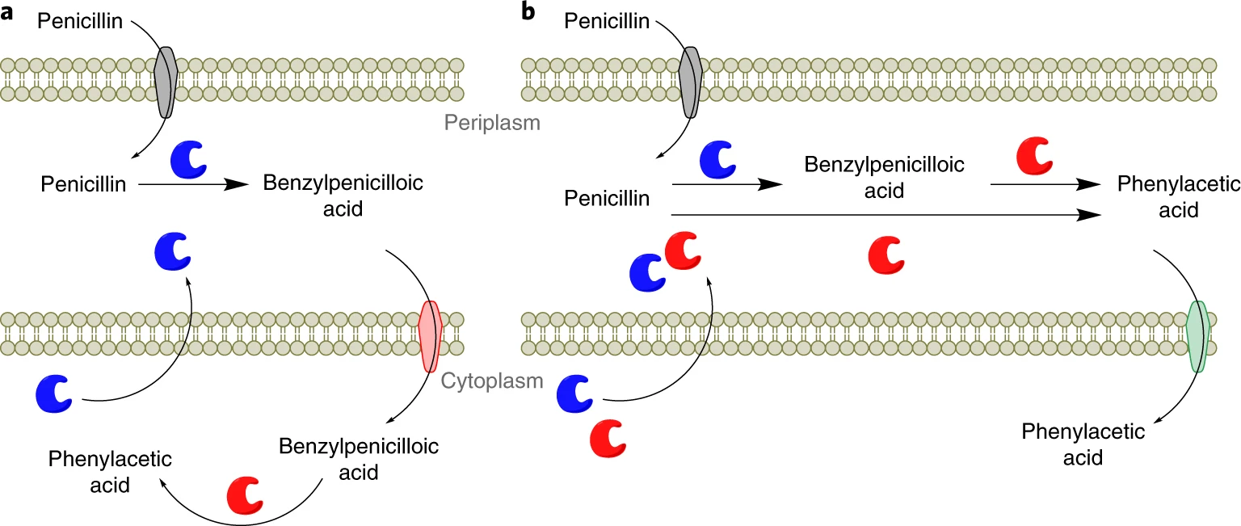

1. Keen EC*, Crofts TS*, Dantas G (2018) Checkpoint checkmate: Microbiota modulation of cancer immunotherapy. **Clinical Chemistry**, 64 (9). 1280-3.
2. Crofts TS, Wang B, Spivak A, Gianoulis TA, Forsberg KJ, Gibson MK, Johnsky LA, Broomall SM, Rosenzweig CN, Skowronski EW, Gibbons HS, Sommer MOA, Dantas G (2017) Draft genome sequences of three β-lactam-catabolizing soil Proteobacteria. **Genome Announcements**, 5 (32). 8-10.
3. Crofts TS*, Gasparrini AJ*, Dantas G (2017) Next-generation approaches to understand and combat the antibiotic resistome. **Nature Reviews Microbiology**, 15 (7), 422-34.

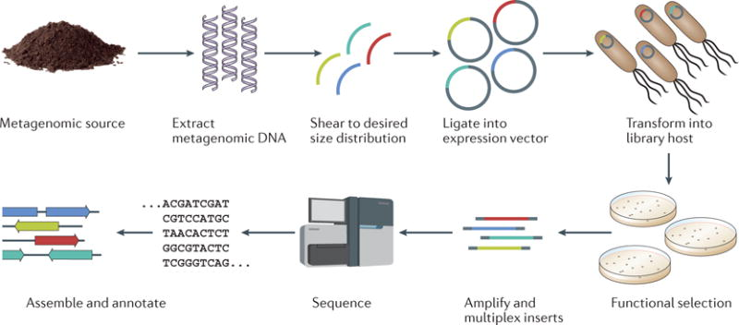

1. Gasparrini AJ*, Crofts TS*, Gibson MK, Tarr PI, Warner BB, Dantas G (2016) Antibiotic perturbation of the preterm infant gut microbiome and resistome. **Gut Microbes**, 7 (5), 443-9.

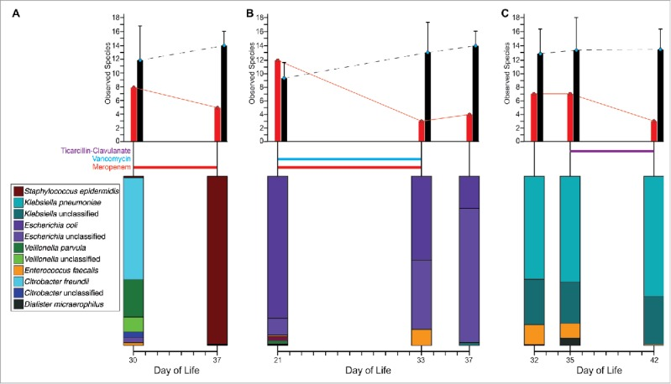

1. Gibson MK*, Crofts TS*, Dantas G (2015) Antibiotics and the developing infant gut microbiota and resistome. **Current Opinion in Microbiology**, 27, 51-6.
2. Crofts TS*, Hazra AB*, Tran JLA, Sokolovskaya O, Osadchiy V, Ad O, Pelton J, Bauer S, Taga ME (2014) Regiospecific formation of cobamide isomers is directed by CobT. **Biochemistry**, 53 (49), 7805-15.

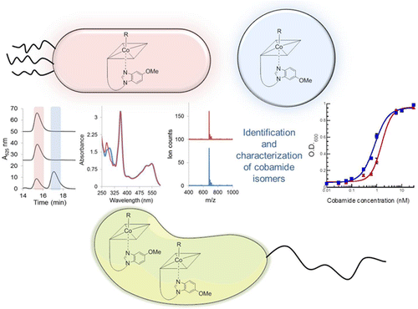

1. Crofts TS, Men Y, Alvarez-Cohen L, Taga ME (2014) A bioassay for the detection of benzimidazoles reveals their presence in a range of environmental samples. **Frontiers in Microbiology**. 5:592.

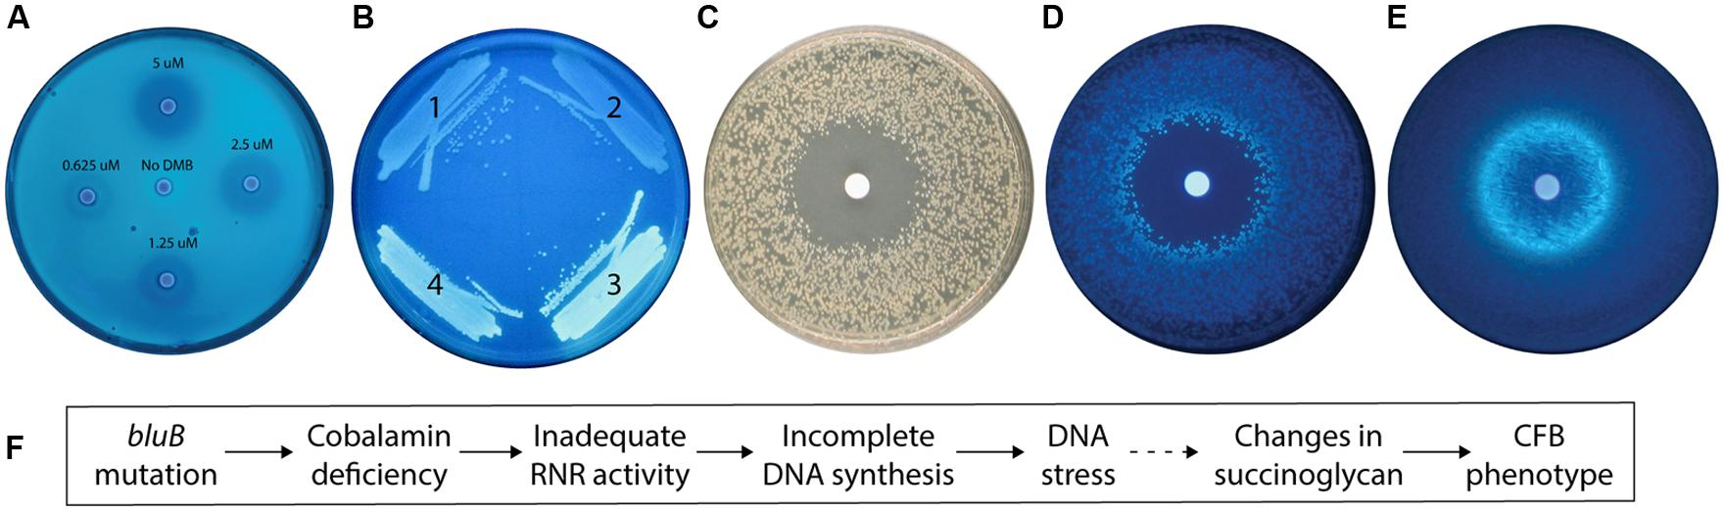

1. Men Y, Seth EC, Yi S, Crofts TS, Allen RH, Taga ME, Alvarez-Cohen L (2014) Identification of specific corrinoids reveals corrinoid modifications in dechlorinating microbial communities. **Environmental Microbiology**, 17 (12), 4873-84.
2. Crofts TS, Seth EC, Hazra AB, Taga ME (2013) Cobamide structure depends on both lower ligand availability and CobT substrate specificity. **Chemistry and Biology**, 20 (10), 1265-74.

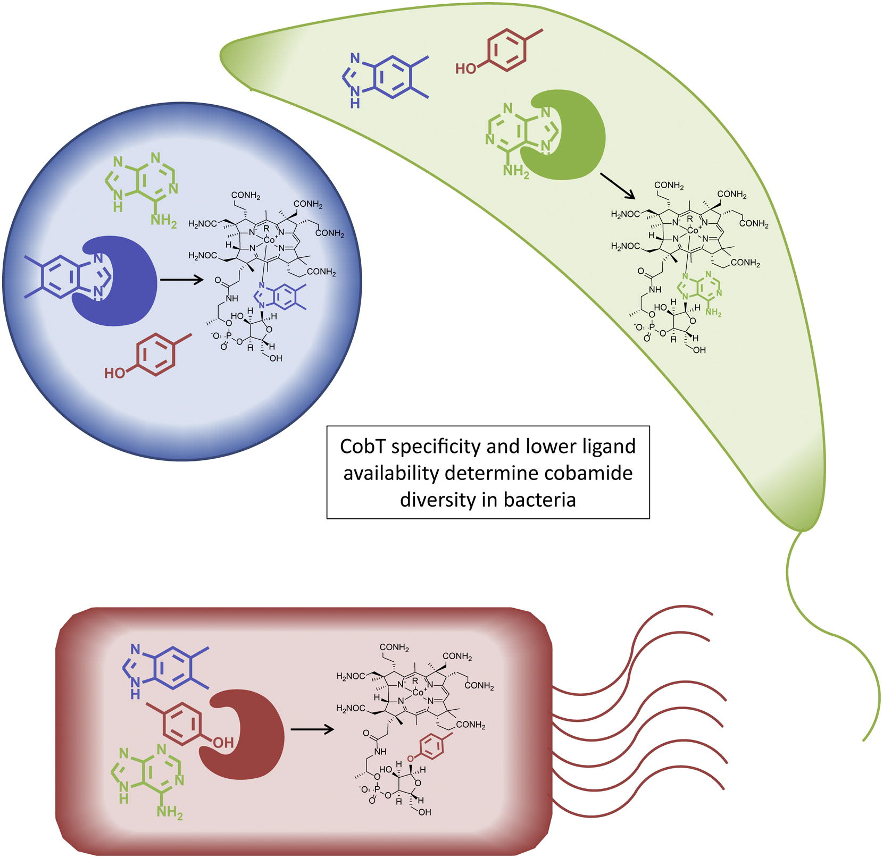

1. Hazra AB, Tran JLA, Crofts TS, Taga ME (2013) Analysis of substrate specificity in CobT homologs reveals widespread preference for 5,6-dimethylbenzimidazole, the lower axial ligand of vitamin B12. **Chemistry and Biology**, 20 (10), 1275-85.

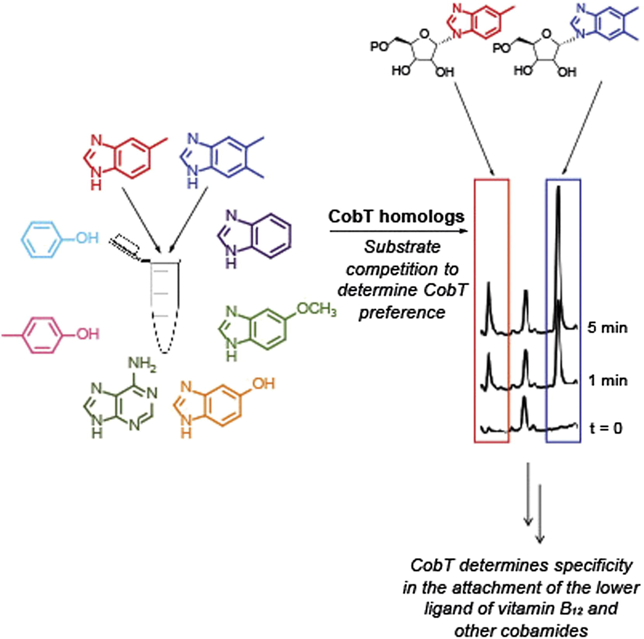

1. Bowerman NA, Crofts TS, Chlewicki L, Do P, Baker BM, Garcia KC, Kranz DM (2009). Engineering the binding properties of the T cell receptor:peptide:MHC ternary complex that governs T cell activity. **Molecular Immunology**, 46 (15), 3000-8.

*Authors contributed equally to these works

†Shared corresponding author position