|  |  |  |
| --- | --- | --- |
| **Advanced Graphics Programming** | | **Major Lab 09** |
| **The Pythagorean Fractal** | **80, 90, 100 and 110 Point Versions** | |
| **Assignment Purpose:**  The purpose of this program is to demonstrate knowledge using recursion with graphics. | | |

Write a program, which displays the Pythagorean Fractal. This fractal was explained in the last section of Chapter 9. There are different variations of this fractal – each worth a different amount of points. You will note the provided file does not provide much more than a skeleton. You need to create whatever methods or attributes that you deem necessary in order to create the fractal.

|  |  |
| --- | --- |
| **FractalLab Student Version** | **Do not copy this file, which is provided.** |
| **// FractalLabst.java**  **// The Pythagorean Fractal**  **// This is the student, starting version of the Fractal Lab.**  **import java.awt.*;**  **import java.applet.*;**  **public class FractalLabst extends Applet**  **{**  **public void paint(Graphics g)**  **{**  **}**  **}** | |

**80 Point Version – Black & White 45-45-90 Pythagorean Fractal**

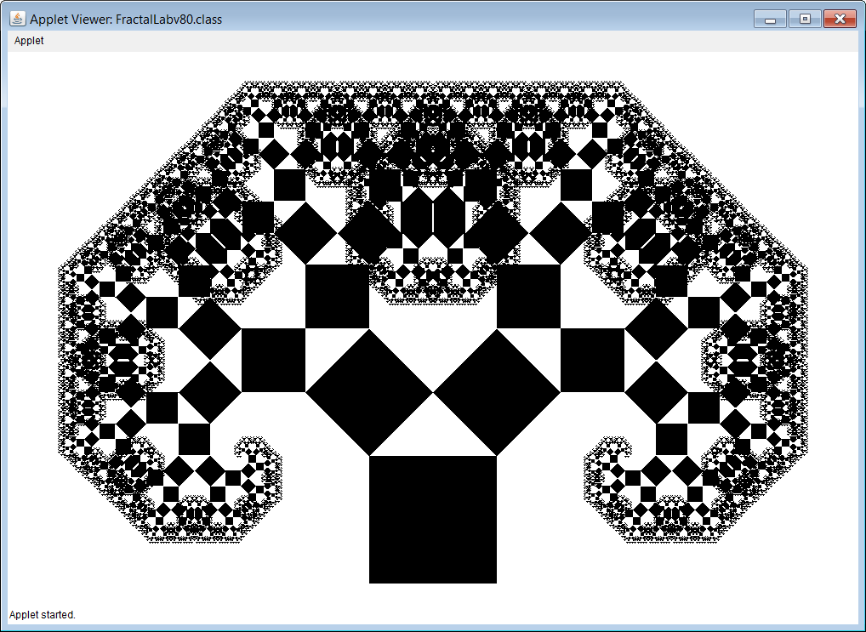

**90 Point Version – Color 45-45-90 Pythagorean Fractal**

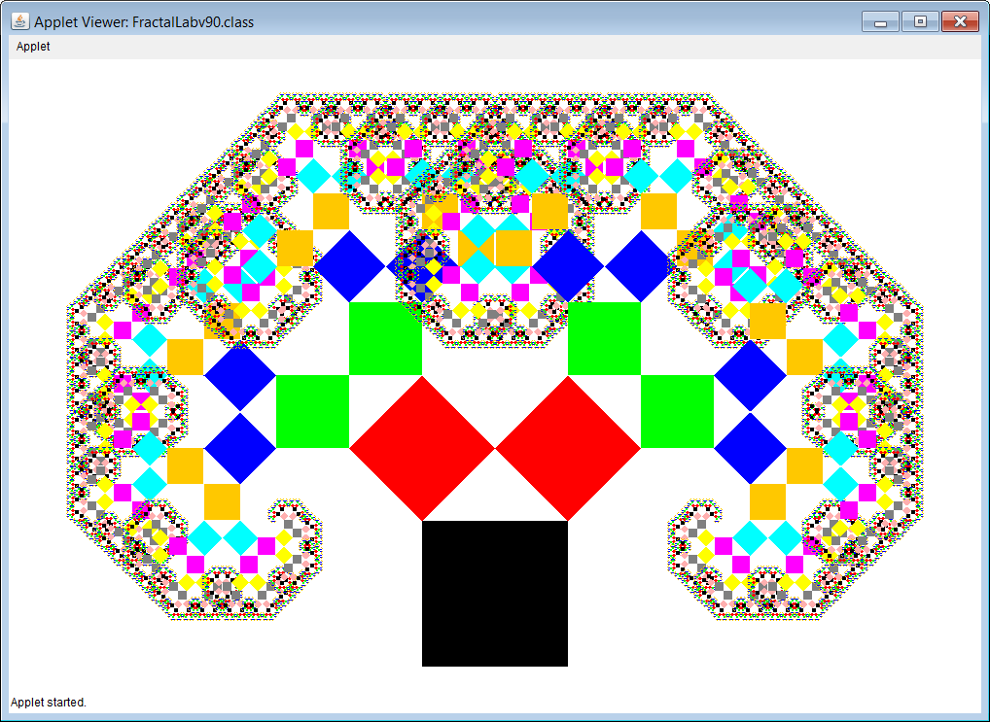

**100 Point Version – Standard 30-60-90 Pythagorean Fractal**

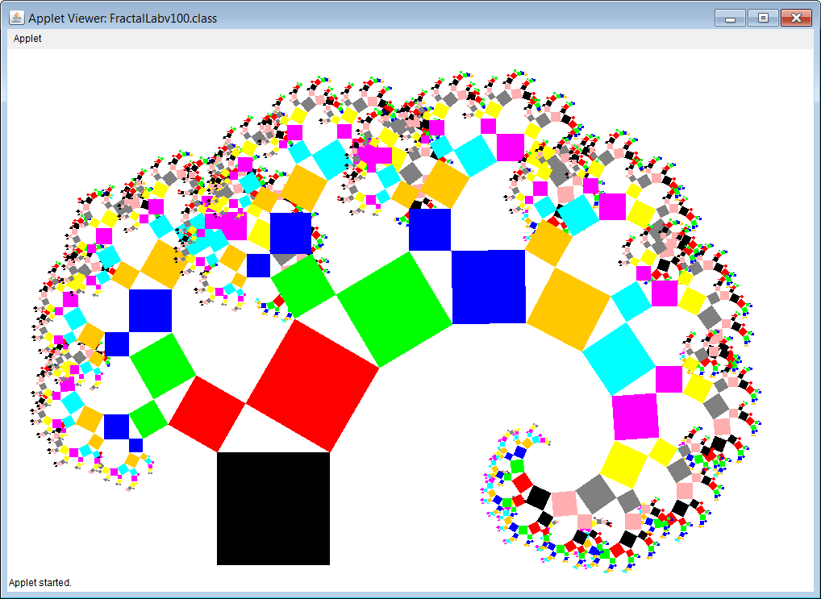

**110 Point Version – Pythagorean Christmas Tree Fractal**

