MINE

Using CPU

\nUsing model: physics_pyro

Device: cpu

\n============================================================

====== TRAINING MODE ======

============================================================\n

Loading pre-processed training data...

Engineering features...

Created 40 features in total.

--- Training PHYSICS_PYRO model ---

Model created successfully

=== Trying AutoNormalizingFlow ===

Guide parameters: 12

✅ AutoNormalizingFlow SUCCESS! Test loss: 2501784997144.0259

 Setup complete using: AutoNormalizingFlow

Training for 1000 epochs...

Epoch 0, Loss: 37210520125646.02

Epoch 100, Loss: 36593131076238.01

Epoch 200, Loss: 26788641686860.66

Epoch 300, Loss: 23546132068086.88

Epoch 400, Loss: 19597461116395.59

Epoch 500, Loss: 17730452735154.99

Epoch 600, Loss: 15239042203961.33

Epoch 700, Loss: 14056964907728.06

Epoch 800, Loss: 14085151477708.80

Epoch 900, Loss: 12691932987629.01

Generating validation predictions...

Training complete. Final loss: 12132028967536.77

\nPHYSICS_PYRO Validation Score: 0.0000

Pyro models saved to: /kaggle/working/ariel-data-2025-27

DIAGNOSTICS AS PER CHAT 1:

Mean absolute error: 0.05445435465401565

Mean normalized error: 0.040871988836159175

Max normalized error: 0.30299770781590335

Min normalized error: 8.392721622157349e-07

END DIAGNOSTICS AS PER CHAT 1

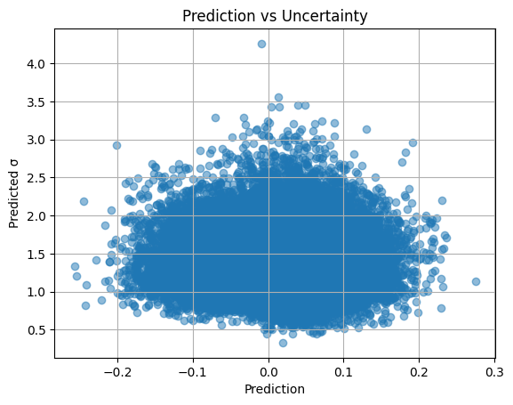

PYRO Validation Score: 0.0000

DIAGNOSTICS AS PER CHAT 2:

Mean pred: 0.006045403890311718

Std pred: 0.06656938046216965

Any NaN? False

y_val mean/std: 0.014978743488125727 0.011348901591756461

Pred mean/std: 0.006045403890311718 0.06656938046216965

Sigma mean: 1.4233638048171997

[[-0.02757454 0.098853 -0.09920603 ... -0.03868464 0.03652468

0.02113963]

[-0.0050741 0.08195488 -0.04010978 ... 0.00775601 0.02526713

0.07126313]

[ 0.00983677 0.12242467 -0.12557974 ... -0.00951196 0.0019161

0.09765451]

[ 0.06871227 0.08680807 -0.06139482 ... 0.01289052 -0.02366347

0.18440181]

[ 0.02006172 0.08494344 -0.04376814 ... -0.04433586 0.02955908

0.1576577 ]]

[[0.00580957 0.0056696 0.00566773 ... 0.00556971 0.00557163 0.00555928]

[0.02132329 0.02150939 0.02150258 ... 0.02125517 0.02125705 0.02125592]

[0.00518672 0.00515674 0.00515666 ... 0.00516809 0.00516835 0.00516852]

[0.00639365 0.00638071 0.0063805 ... 0.00638365 0.00638342 0.00638337]

[0.01639064 0.0163704 0.01637054 ... 0.01633427 0.01633436 0.01633411]]

END DIAGNOSTICS AS PER CHAT 2

\nRetraining on full dataset...

--- Training PHYSICS_PYRO model ---

Model created successfully

=== Trying AutoNormalizingFlow ===

Guide parameters: 12

✅ AutoNormalizingFlow SUCCESS! Test loss: 2300711681398.8735

 Setup complete using: AutoNormalizingFlow

Training for 1000 epochs...

Epoch 0, Loss: 34781267375072.60

Epoch 100, Loss: 33745093712426.49

Epoch 200, Loss: 28114756734998.76

Epoch 300, Loss: 22584103493701.11

Epoch 400, Loss: 18166763237900.95

Epoch 500, Loss: 19996616246242.59

Epoch 600, Loss: 16599508869457.97

Epoch 700, Loss: 16383556945651.57

Epoch 800, Loss: 13879795215829.95

Epoch 900, Loss: 15168894670829.66

Generating validation predictions...

Training complete. Final loss: 12160305644590.28

Pyro models saved to: /kaggle/working/ariel-data-2025-27

\nTraining complete!

YOURS

Using CPU

\nUsing model: physics_pyro

Device: cpu

\n============================================================

====== TRAINING MODE ======

============================================================\n

Loading pre-processed training data...

Engineering features...

Created 40 features in total.

--- Training PHYSICS_PYRO model with FLOW guide ---

Model created successfully

=== Trying FLOW ===

Flow config: depth=1, hidden_dims=[1024, 1024]

Guide parameters: 6

✅ FLOW SUCCESS! Test loss: 2925490610744.4438

 Setup complete using: FLOW

 Using Normalizing Flow - expect slower but more expressive training

Training for 1500 epochs...

Epoch 0, Loss: 21160298551792.09

Epoch 50, Loss: 18253543237759.60

Epoch 100, Loss: 18882151975586.47

Epoch 150, Loss: 18928758961770.70

Epoch 200, Loss: 18528542587331.54

Epoch 250, Loss: 19537998514706.77

Epoch 300, Loss: 12723609305841.52

Epoch 350, Loss: 17164711315454.07

Epoch 400, Loss: 11830956541395.51

Epoch 450, Loss: 15355807582456.51

Epoch 500, Loss: 15046493471559.91

Epoch 550, Loss: 13822744374321.84

Epoch 600, Loss: 14001115744325.20

Epoch 650, Loss: 12202276266515.63

Epoch 700, Loss: 11639447722267.64

Epoch 750, Loss: 11890948865850.94

Epoch 800, Loss: 12078821014710.66

Epoch 850, Loss: 11072081126710.18

Epoch 900, Loss: 11505100984987.39

Epoch 950, Loss: 10896446732663.67

Epoch 1000, Loss: 10176146176237.91

Epoch 1050, Loss: 9835487025408.18

Epoch 1100, Loss: 9467319276372.01

Epoch 1150, Loss: 9739960656884.97

Epoch 1200, Loss: 9439608659149.49

Epoch 1250, Loss: 8410234190740.40

Epoch 1300, Loss: 9097129249390.73

Epoch 1350, Loss: 9825332580371.08

Epoch 1400, Loss: 8851622751337.29

Epoch 1450, Loss: 9153801612640.59

Generating validation predictions...

Using 400 samples for predictions...

Processing validation in chunks for memory efficiency...

Computing flow-specific uncertainty metrics...

Training complete. Final loss: 7920403429716.17

Guide type used: FLOW

\nPHYSICS_PYRO Validation Score: 0.0000

Pyro models saved to: /kaggle/working/ariel-data-2025-27

DIAGNOSTICS AS PER CHAT 1:

Mean absolute error: 0.061846183318315734

Mean normalized error: 0.033666302139940874

Max normalized error: 0.21624434714956547

Min normalized error: 1.8888210264988713e-06

END DIAGNOSTICS AS PER CHAT 1

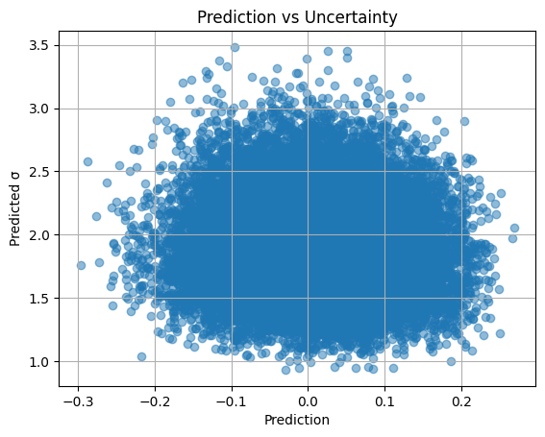

PYRO Validation Score: 0.0000

DIAGNOSTICS AS PER CHAT 2:

Mean pred: 0.007584832608699799

Std pred: 0.07681337743997574

Any NaN? False

y_val mean/std: 0.014978743488125727 0.011348901591756461

Pred mean/std: 0.007584832608699799 0.07681337743997574

Sigma mean: 1.8957765102386475

[[-0.05570088 0.12709886 -0.07539137 ... -0.01017794 -0.01048193

-0.07821721]

[-0.05673364 0.02638932 -0.09766624 ... 0.02348617 0.01908786

0.11747307]

[-0.05726661 0.02737197 -0.09126429 ... 0.01568543 -0.06219359

-0.08554865]

[-0.09671362 0.05380657 -0.04735439 ... 0.04825614 -0.00017548

-0.02430624]

[-0.04891948 0.05011496 -0.01881584 ... 0.04034371 -0.00640338

-0.01463257]]

[[0.00580957 0.0056696 0.00566773 ... 0.00556971 0.00557163 0.00555928]

[0.02132329 0.02150939 0.02150258 ... 0.02125517 0.02125705 0.02125592]

[0.00518672 0.00515674 0.00515666 ... 0.00516809 0.00516835 0.00516852]

[0.00639365 0.00638071 0.0063805 ... 0.00638365 0.00638342 0.00638337]

[0.01639064 0.0163704 0.01637054 ... 0.01633427 0.01633436 0.01633411]]

END DIAGNOSTICS AS PER CHAT 2

\nRetraining on full dataset...

--- Training PHYSICS_PYRO model with FLOW guide ---

Model created successfully

=== Trying FLOW ===

Flow config: depth=1, hidden_dims=[1024, 1024]

Guide parameters: 6

✅ FLOW SUCCESS! Test loss: 2021088879407.2788

 Setup complete using: FLOW

 Using Normalizing Flow - expect slower but more expressive training

Training for 1500 epochs...

Epoch 0, Loss: 22853337953836.45

Epoch 50, Loss: 22446782094488.21

Epoch 100, Loss: 23930129228117.53

Epoch 150, Loss: 19688603597870.04

Epoch 200, Loss: 19184122892076.57

Epoch 250, Loss: 20620816794300.95

Epoch 300, Loss: 20122466371693.58

Epoch 350, Loss: 18784806325459.96

Epoch 400, Loss: 14797245737682.74

Epoch 450, Loss: 17826143616833.20

Epoch 500, Loss: 11899550124263.59

Epoch 550, Loss: 12072628260146.45

Epoch 600, Loss: 12534515175477.36

Epoch 650, Loss: 14149375605030.96

Epoch 700, Loss: 12711336597598.37

Epoch 750, Loss: 14602733016843.22

Epoch 800, Loss: 14273613175136.48

Epoch 850, Loss: 11547328256980.28

Epoch 900, Loss: 12326110054272.72

Epoch 950, Loss: 13410162187924.36

Epoch 1000, Loss: 11950161821856.70

Epoch 1050, Loss: 11134331767135.40

Epoch 1100, Loss: 10841124834113.72

Epoch 1150, Loss: 8546928400210.06

Epoch 1200, Loss: 10948856981327.96

Epoch 1250, Loss: 10445530643610.07

Epoch 1300, Loss: 11817468620484.21

Epoch 1350, Loss: 9456628032216.08

Epoch 1400, Loss: 9945065355937.04

Epoch 1450, Loss: 8912450665399.95

Generating validation predictions...

Using 400 samples for predictions...

Computing flow-specific uncertainty metrics...

Training complete. Final loss: 9550989529040.60

Guide type used: FLOW

Pyro models saved to: /kaggle/working/ariel-data-2025-27

\nTraining complete!