**Here is your test task:**

1. API

    a. Write positive and negative test cases for the API endpoints:

        i. POST - endpoint, that creates a new and unique user in the database:

            1. URL: <https://gorest.co.in/public-api/users>

            2. Method: POST

            3. Headers:

                a. "Accept" = "application/json"

                b. “Content-Type” = "application/json"

            4. Body (example JSON):

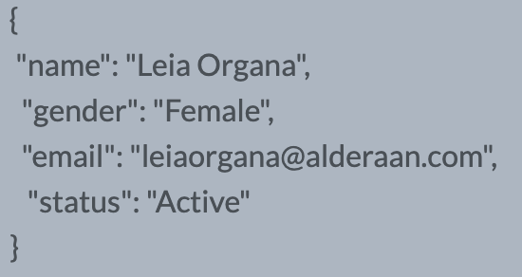

            5. Endpoint requires Authentication, by Bearer Token (‘TEST_TOKEN’) that can be generated on <https://gorest.co.in/access-token> after а successful login to the site.

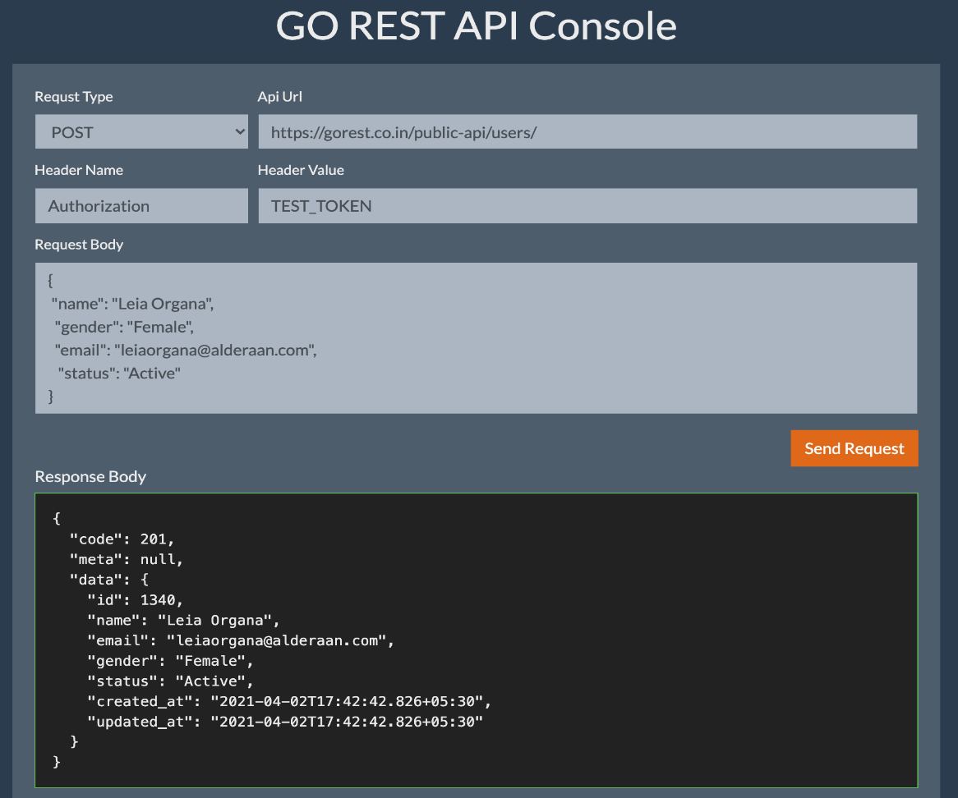

        ii. GET - endpoint, that returns the user by the id:

            1. URL: [https://gorest.co.in/public-ap...](https://gorest.co.in/public-api/users/){USER_ID}

            2. Method: GET

            3. In the URL the USER_ID must be sent after ...users/

