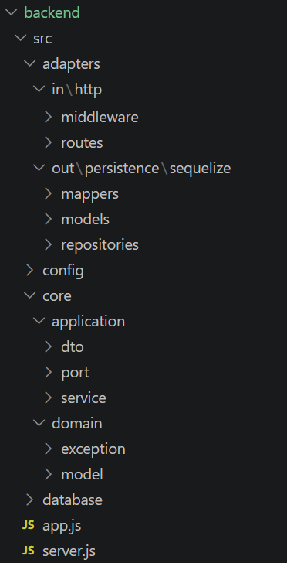
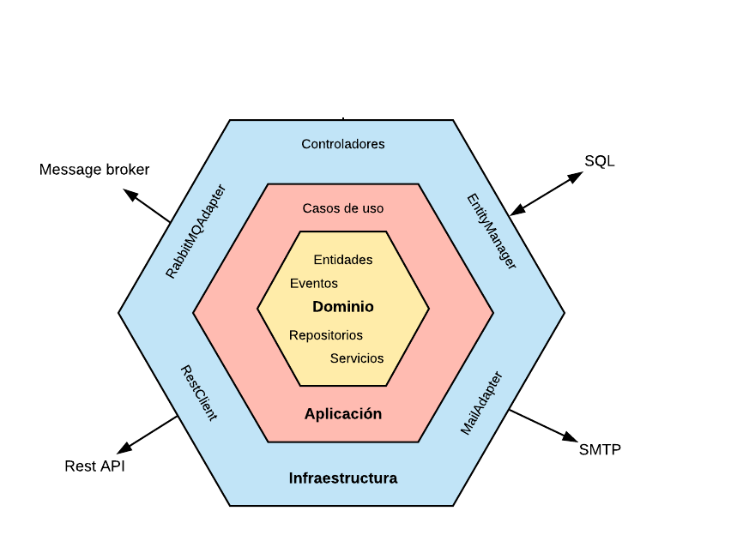

Only one independently of frameworks/tecnologies
core/application
core/domain
A diferent one for each framework/tecnologiy
adapters

model
port/out/
repository
core/application

service
port/in/
usecase
adapters/out/persistence/sequelize
adapters
core/domain

adapters/in/http

