
University of Engineering and Technology,
Lahore
Department of Computer Science
Project Report
Team Members
Name | Roll Number | Email
Duaa Zehra | 2025-CS-134 | tcs179669@gmail.com
Alishba Rafi | 2025-CS-162 | -

Session: Fall’25 Morning | Section: C | Semester: 1st

Course: CSC101 - Discrete Mathematics | Teacher: Mr. Waqas Ali
January 4th, 2026

Table of Contents

Contents
Table of Contents 2
Project Report 3
1. BASIC CRYPTOGRAPHIC-SUITE 3
2. CHOSEN TRACK 3
4. Summary 3
5. Technology Stack & Libraries Utilized 3
6. List of Features 4
7. Mathematical Foundations 4
Relevant Concepts 4
8. Examination of Key Functions/Methods 5
Function 1: gcd(int a, int b) 5
Function 2: extendedGCD(int a, int b, int &x, int &y) 6
Function 3: modPow(int base, int exp, int mod) 6
8
9. Limitations 9
10. User Interface 9
Interface Overview 9
Screen Documentation 9
Sample Test Cases 9
10. Future Improvements 11
11. Conclusion 11
13. References & Learning Sources 11

Project Report
Submission Deadline: January 6, 2026

BASIC CRYPTOGRAPHIC-SUITE

CHOSEN TRACK
- Track 5: Number Theory Applications

Summary
This project implements a Basic Cryptographic Suite that demonstrates how fundamental concepts from number theory and discrete mathematics are applied in classical and modern cryptography. The problem addressed by this project is understanding how mathematical theory—particularly modular arithmetic, greatest common divisors, and prime-based computations — forms secure communication systems.
The project includes implementations of Caesar Cipher, Affine Cipher, and RSA Cryptosystem, allowing users to encrypt and decrypt text through a menu-driven command-line interface. Each algorithm was implemented from first principles rather than relying on external cryptographic libraries, ensuring a strong emphasis on mathematical correctness and learning.
The methodology involved identifying the mathematical foundations behind each cipher, translating those principles into efficient algorithms, and validating correctness through input validation and modular arithmetic techniques. Functions such as Euclid’s Algorithm, Extended Euclidean Algorithm, and fast modular exponentiation were implemented to support encryption and decryption processes.
Key achievements include:
- A fully functional CLI-based cryptographic toolkit
- Correct handling of modular inverses and coprime constraints
- RSA encryption with block-based message encoding
- Robust input validation to prevent invalid operations
This project is significant in the context of discrete mathematics because it demonstrates how abstract mathematical concepts directly enable real-world security mechanisms. By bridging theory and implementation, the project reinforces the practical importance of number theory in computer science and cybersecurity.

Technology Stack & Libraries Utilized
- Programming Languages: C++
Chosen for its high performance and strong support for low-level arithmetic operations essential in cryptography.
- Libraries:

<iostream> – Used for input/output operations.
<string> – Used for text handling and manipulation.
These standard libraries were selected due to their reliability, portability, and availability without external dependencies.
- Development Environment:
IDE: Visual Studio Code
Compiler: GCC / MinGW (C++17 standard)
Version Control: Git (GitHub)

List of Features
- Caesar Cipher Encryption
Shifts letters forward by a fixed key value.
[Core Feature]
- Caesar Cipher Decryption
Reverses Caesar encryption using the same key.
[Core Feature]
- Affine Cipher Encryption
Encrypts text using the function $C=(aP+b)mod 26$.
[Core Feature]
- Affine Cipher Decryption
Uses modular inverse of $a$to recover plaintext.
[Core Feature]
- RSA Encryption
Encrypts blocks of plaintext using public-key cryptography.
[Core
- RSA Decryption
Uses private key generation via Extended Euclidean Algorithm.
[Core Feature]
- Input Validation System
Prevents invalid menu selections and non-numeric input.
[Core Feature]

Mathematical Foundations

Relevant Concepts
- Modular Arithmetic
- Greatest Common Divisor (GCD)
- Coprime Integers
- Prime Numbers
- Modular Inverse
- Exponentiation by Squaring

Formal Definitions
- GCD:
$gcd⁡(a,b)$is the largest integer dividing both $a$and $b$.

- Modular Inverse:
An integer $a^{-1}$such that
$$a⋅a^{-1}≡1 (\text{mod }m)$$
- RSA Encryption:
$$C=M^{e}mod n$$
- RSA Decryption:
$$M=C^{d}mod n$$
Proofs & Correctness
- Correctness of GCD:
Euclid’s Algorithm terminates because the remainder strictly decreases.

- Correctness of RSA:
Based on Euler’s Theorem:
$$M^{ϕ(n)}≡1mod n$$
- Time Complexity:
  - GCD: $O(log⁡n)$
  - Modular Exponentiation: $O(log⁡e)$
Illustrative Example
Affine Encryption Example:
- Plaintext: A → 0
- $a=5,b=8$
- $C=(5⋅0+8)mod 26=I$

Examination of Key Functions/Methods

Function 1: gcd(int a, int b)
Purpose: Checks coprimality for Affine and RSA keys
Complexity: $O(log⁡n)$
int gcd(int a, int b) {
while (b != 0) {
int t = b;
b = a % b;
a = t;
}
return a;
}

Function 2: extendedGCD(int a, int b, int &x, int &y)
Purpose: Computes modular inverse
Importance: Essential for RSA and Affine decryption
Complexity: $O(log⁡n)$

Function 3: modPow(int base, int exp, int mod)
Purpose: Efficient modular exponentiation
Optimization: Exponentiation by squaring
Complexity: $O(log⁡exp)$
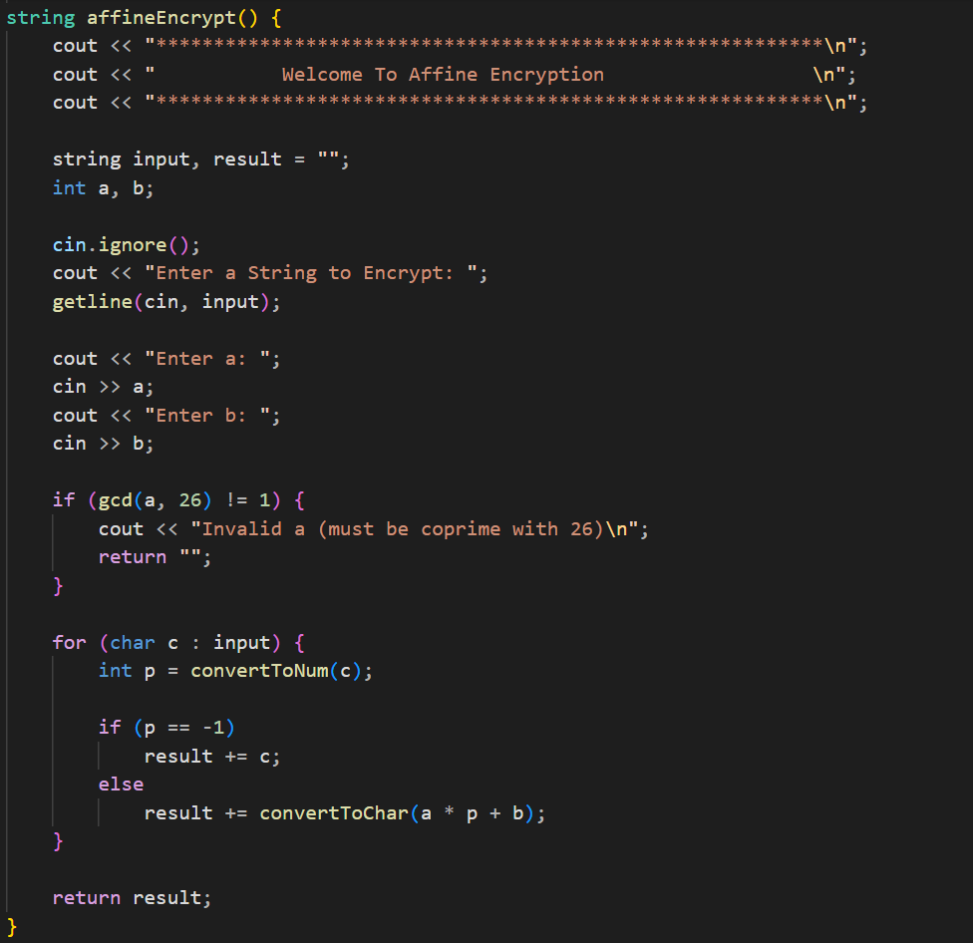
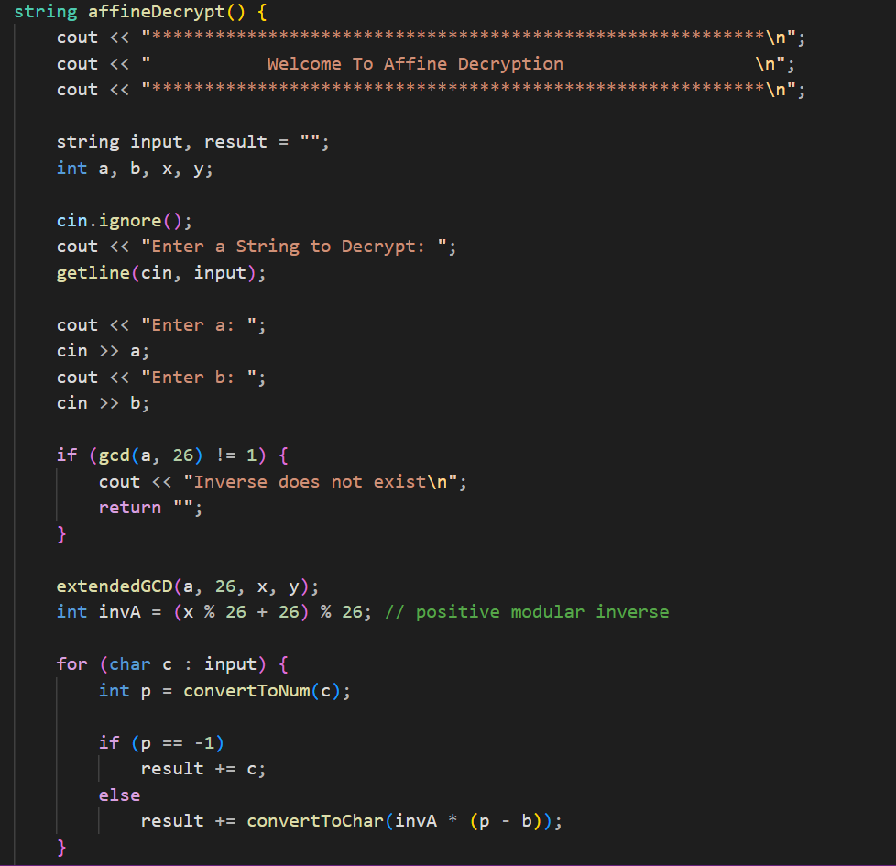
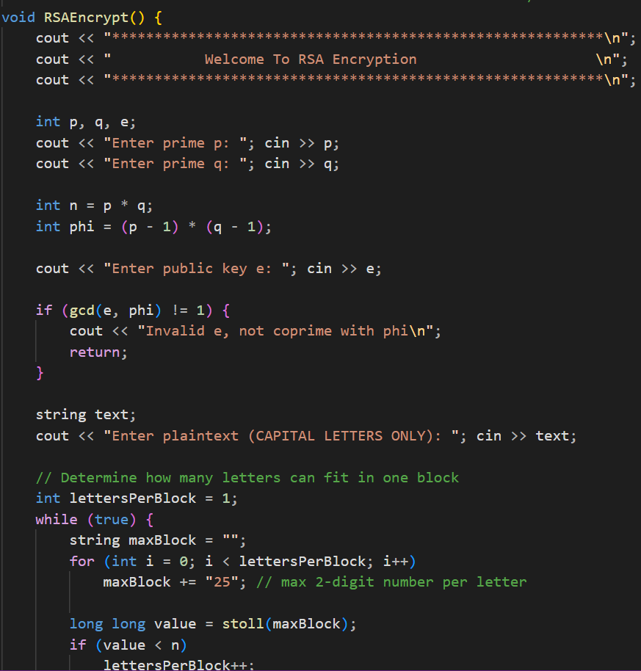

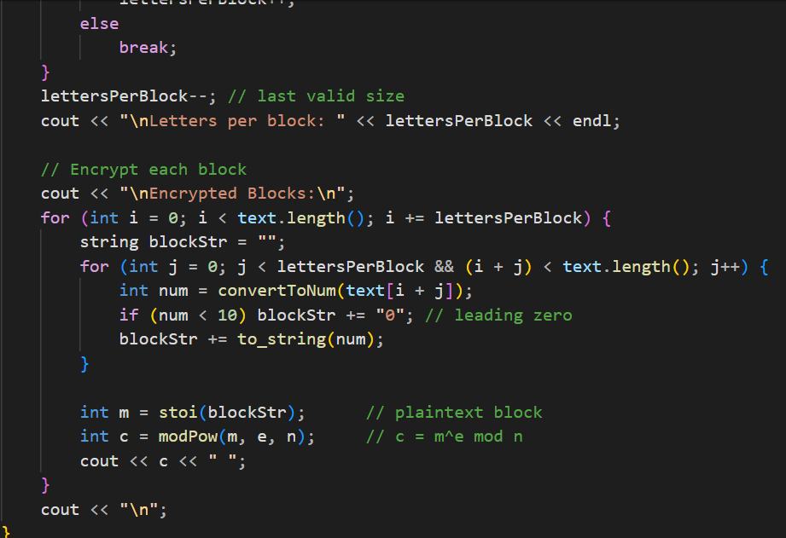

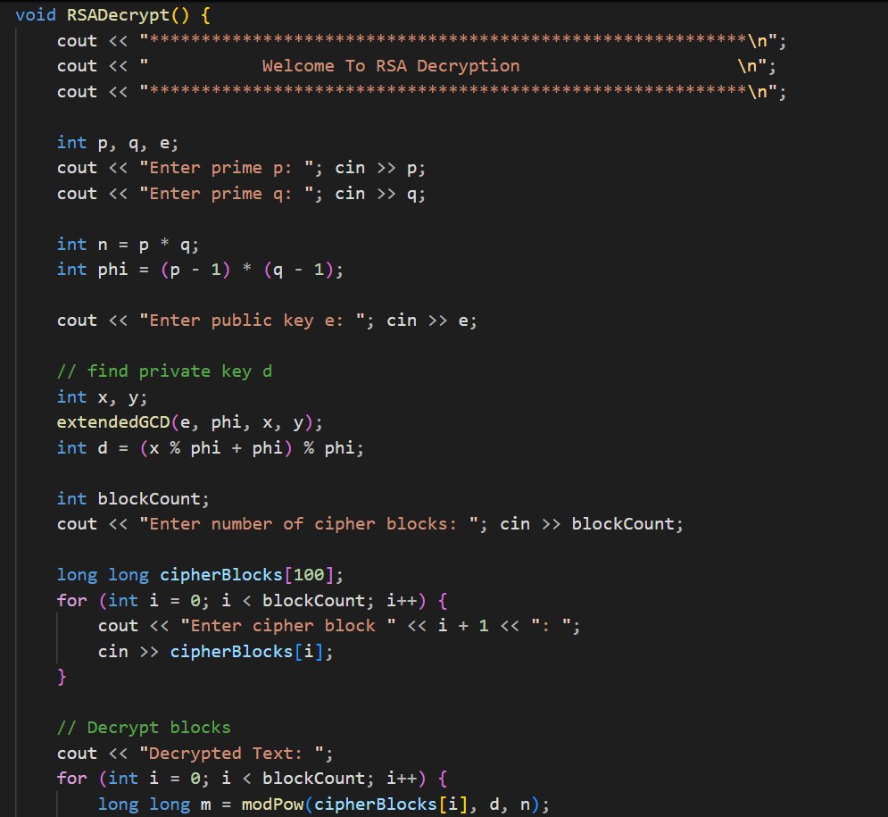
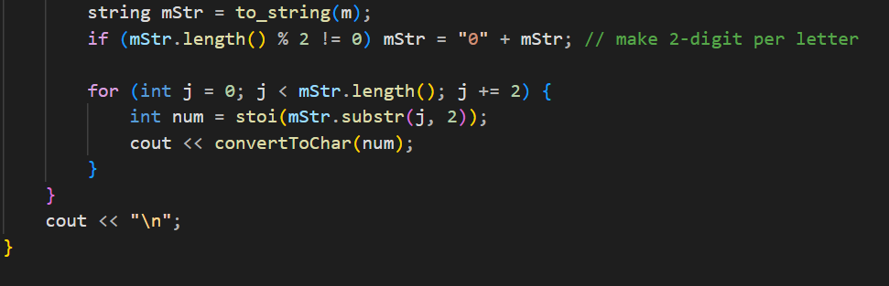

Limitations
- Scope: Not suitable for real-world secure communication
- RSA Constraints: Small primes only
- Performance: No big integer support
- Input Assumptions: RSA plaintext assumes uppercase letters
- Security: No padding or hashing

10. User Interface

Interface Overview
The project uses a menu-driven command-line interface focused on simplicity and clarity.

Screen Documentation
Main Menu
- Options 1–9 for cipher selection
- Numeric input only
Cipher Screens
- Text input
- Key input
- Encrypted/Decrypted output displayed immediately

Sample Test Cases
Test Case 1: Caesar Encrypt
- Input: HELLO, K = 3
- Output: KHOOR
- Status: Pass
Test Case 2: Affine Decrypt
- Input: IHHWVCSWFRCP, a=5, b=8
- Output: AFFINECIPHER
- Status: Pass
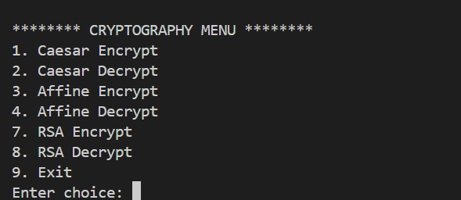
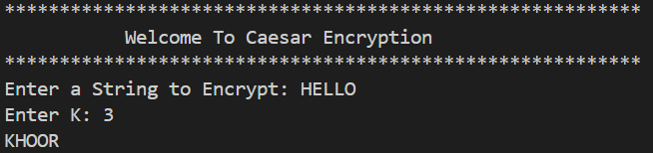
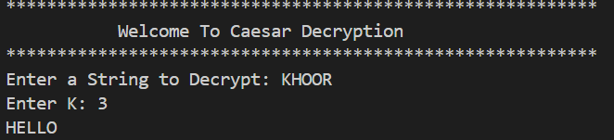
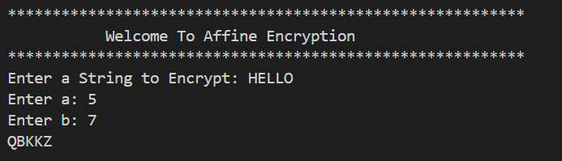
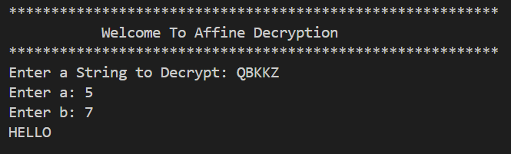

Future Improvements
- Add AES or DES implementations
- Support lowercase RSA plaintext
- Use big integer libraries
- Add file-based encryption
- Improve UI with GUI
- Integrate hashing algorithms

Conclusion
This project successfully demonstrates the practical application of number theory in cryptography. By implementing classical and modern encryption algorithms from scratch, the project strengthened understanding of modular arithmetic, coprimality, and algorithmic efficiency. Challenges such as modular inverses and RSA block handling were overcome through mathematical reasoning and careful implementation. Overall, this project highlights the strong relationship between discrete mathematics theory and secure computing systems

13. References & Learning Sources
- GitHub:
- Video Demo:
- Textbooks: Course textbook and any additional books consulted (e.g., Rosen, Discrete Mathematics and Its Applications, 8th ed.)
- C++ Reference Documentation (cppreference.com)
- GeeksforGeeks – RSA Algorithm
- AI Assistance: ChatGPT used for explanation refinement and report structuring

