**Practical No.3**

**1. Predict Canada’s per capita income in 2020. There is an exercise folder here on github at the same level as this notebook, download that and you will find the canada_per_capita_income.csv file. Using this build a regression model and predict the per capita income of canadian citizens in year 2020**

**Implementation:**

**Program and Outputs:**

#Linear Regression Using Python

import numpy as np

from matplotlib import pyplot as plt

import pandas as pd

from sklearn import linear_model

url='https://raw.githubusercontent.com/codebasics/py/master/ML/1_linear_reg/Exercise/canada_per_capita_income.csv'

lr2=pd.read_csv(url)

lr2.head()

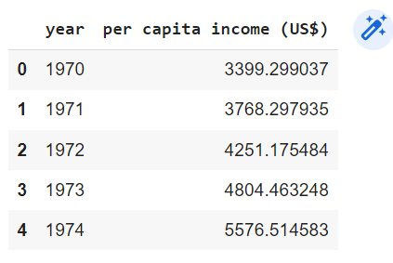

lr2 = lr2.rename(columns={'per capita income (US$)': 'Income'})

plt.scatter(lr2.year,lr2.Income,color='g',marker='+')

plt.show()

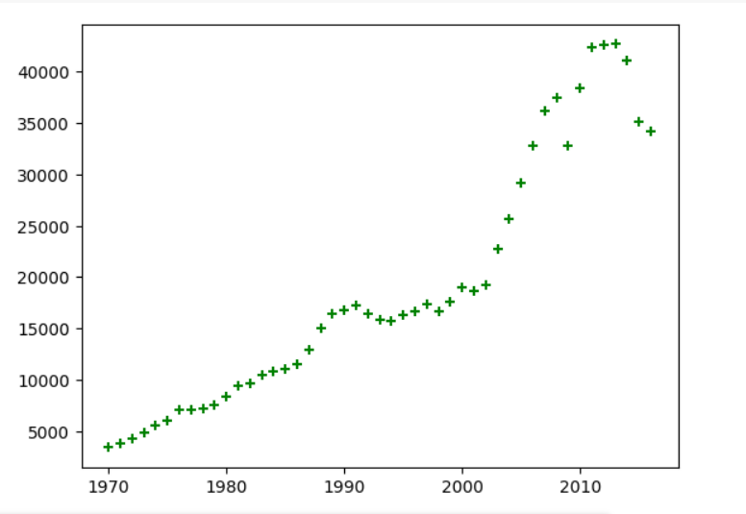

lr3=lr2.drop('Income',axis=1)

lr3.head()

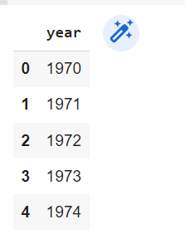

rg1=linear_model.LinearRegression()

rg1.fit(lr3,lr2.Income)

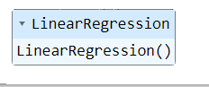

rg1.predict([[2020]])



rg1.coef_



rg1.intercept_



#y=mx+b

828.46507522*2020+(-1632210.7578554575)



**2. Download employee retention dataset from here:**

**https://www.kaggle.com/giripujar/hr-analytics.**

**Now do some exploratory data analysis to figure out which variables have direct and clear impact on employee retention (i.e. whether they leave the company or continue to work)**

**Plot bar charts showing impact of employee salaries on retention**

**Plot bar charts showing correlation between department and employee retention**

**Now build logistic regression model using variables that were narrowed down in**

**step 1**

**Measure the accuracy of the model**

**Implementation:**

**Program And Output:**

#logitsic regression- Binary classification import pandas as pd

import numpy as np

from matplotlib import pyplot as plt

import pandas as pd

from sklearn import linear_model

url='http://raw.githubusercontent.com/WamanParulekar/AIML/main/lic.csv'

lic = pd.read_csv(url)

lic

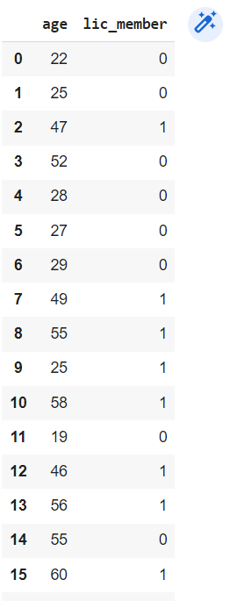

plt.scatter(lic.age,lic.lic_member,marker="*",color='r')

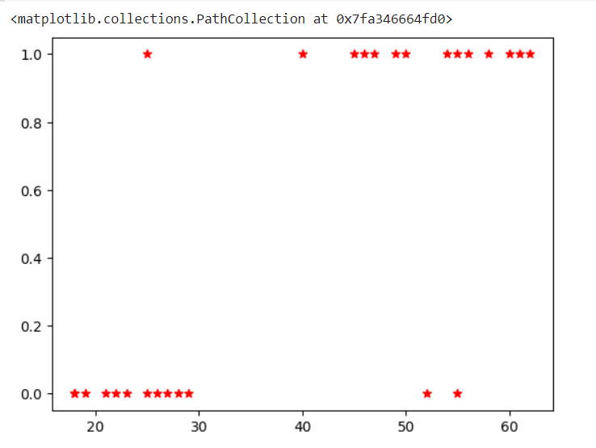

from sklearn.model_selection import train_test_split

x_train, x_test, y_train, y_test = train_test_split(lic[['age']],lic.lic_member, train_size=0.8)

len(x_test)



len(y_test)



from sklearn.linear_model import LogisticRegression

lr = LogisticRegression()

lr.fit(x_train , y_train)

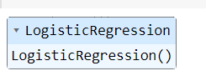

lr.predict(x_test)



lic

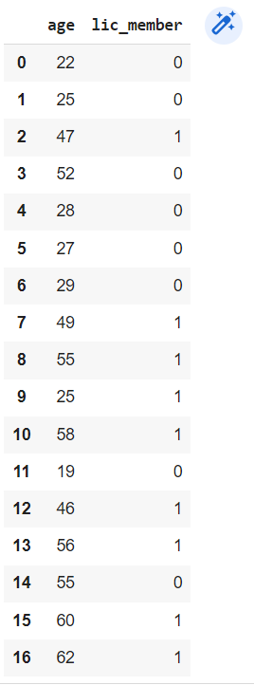

lr.score(x_test,y_test)



lr.predict([[30]])



**3. Using K nearest neighbors classification predict type of flower**

**given ‘sepal_length’, ‘sepal_width’,’petal_length’, ‘petal_width’ = 4.8,3.0,1.5,0.3**

**Implementation:**

**Program:**

#KNN classification

import pandas as pd

import numpy as np

from sklearn import linear_model

import matplotlib.pyplot as plt

url = 'http://archive.ics.uci.edu/ml/machine-learning-databases/iris/iris.data'

iris = pd.read_csv(url, names=['sepal_length', 'sepal_width', 'petal_length', 'petal_width', 'class'])

iris.head()

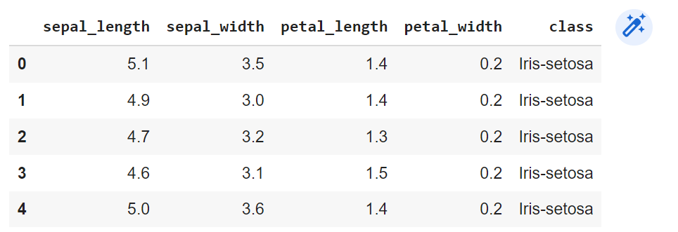

iris1 = iris[:50]

iris2 = iris[50:100]

iris3 = iris[100:]

plt.scatter(iris1.sepal_length,iris1.sepal_width,marker="*",color='r')

plt.scatter(iris2.sepal_length,iris2.sepal_width,marker="*",color='b')

plt.scatter(iris3.sepal_length,iris3.sepal_width,marker="*",color='g')

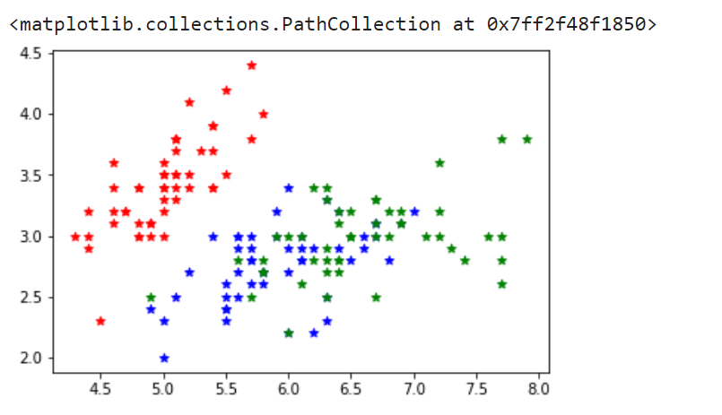

from sklearn.model_selection import train_test_split

X = iris.drop('class',axis=1)

y = iris[['class']]

X_train,X_test,y_train,y_test = train_test_split(X,y,train_size=0.8)

from sklearn.neighbors import KNeighborsClassifier

knn = KNeighborsClassifier()

knn.fit(X_train,y_train)



knn.predict([[4.8,3.0,1.5,0.3]])

