**FINOLEX ACADEMY OF MANAGEMENT AND TECHNOLOGY, RATNAGIRI**

**DEPARTMENT OF MCA**

**PRACTICAL NO. 01**

**Basic of C#**

**Que.1.Design a window application to demonstrate basic and advanced controls. Create Registration form with following fields first name, middle name, surname, photo, dob, address, mobile no, username, password, gender, hobbies, city. Use appropriate controls to take inputs. And show the entered data on another form.**

**Ans:**

* **Code –**

**RegistrationForm.cs[Design]**

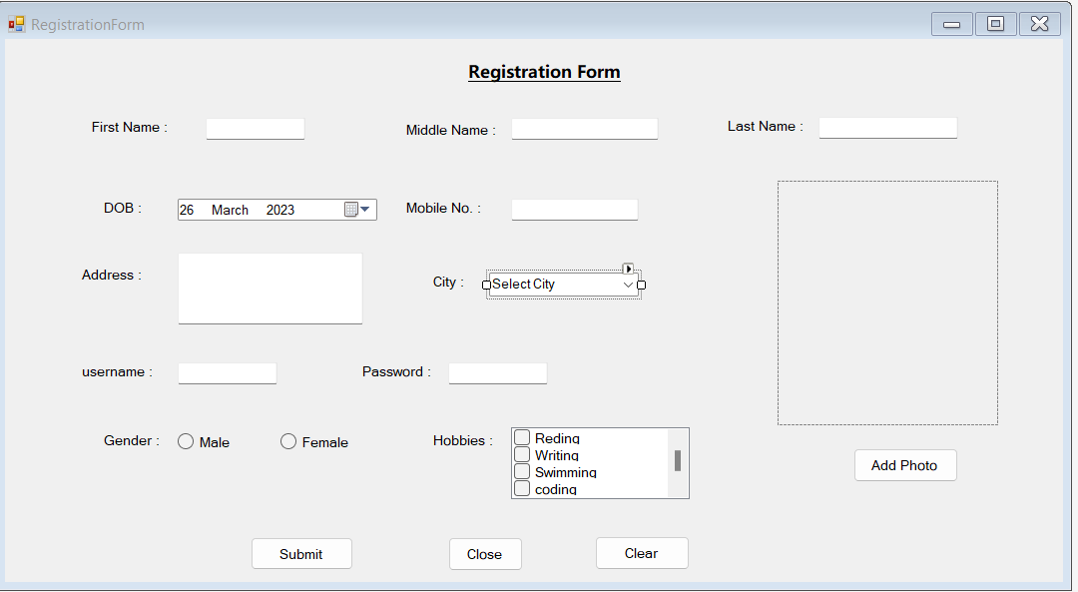

**RegistrationForm.cs**

using System;

using System.Collections.Generic;

using System.ComponentModel;

using System.Data;

using System.Drawing;

using System.Linq;

using System.Text;

using System.Threading.Tasks;

using System.Windows.Forms;

namespace PracticalNo01

{

public partial class RegistrationFrom : Form

{

public RegistrationFrom()

{

InitializeComponent();

}

string imageLocation;

private void btnsubmit_Click(object sender, EventArgs e)

{

Details d = new Details();

d.firstName = txtfirst.Text;

d.middleName = txtmiddle.Text;

d.lastName = txtlast.Text;

DateTime dt = this.dobpicker.Value.Date;

dobpicker.Format = DateTimePickerFormat.Custom;

dobpicker.CustomFormat = "dd/MM/yyyy";

dobpicker.ShowUpDown = true;

d.dob = dobpicker.Value.ToString("dd/MM/yyyy");

d.mob = txtmobile.Text;

d.address = txtaddress.Text;

d.username = txtuser.Text;

d.passowrd = txtpass.Text;

if (radiomale.Checked == true)

{

d.gender = radiomale.Text;

}

else

{

d.gender = radiofemale.Text;

}

d.path = imageLocation;

int i;

string s;

s = "Hobbies: ";

for (i = 0; i <= (checkhobby.Items.Count - 1); i++)

{

if (checkhobby.GetItemChecked(i))

{

s = s + checkhobby.Items[i].ToString() + ",";

}

}

d.hobbies = s;

d.city = citylist.SelectedItem.ToString();

d.ShowDialog();

}

public void setPhoto()

{

imageLocation = "";

try

{

OpenFileDialog dialog = new OpenFileDialog();

dialog.Filter = "jpg files(*.jpg)|*.jpg| PNG files(.*.png)|*.png| All files(*.*)|*.*";

if (dialog.ShowDialog() == System.Windows.Forms.DialogResult.OK)

{

imageLocation = dialog.FileName;

image1.ImageLocation = imageLocation;

}

}

catch (Exception)

{

MessageBox.Show("An Error Occured", "Error", MessageBoxButtons.OK, MessageBoxIcon.Error);

}

}

private void btnaddimg_Click(object sender, EventArgs e)

{

setPhoto();

}

private void btnclose_Click(object sender, EventArgs e)

{

this.Close();

}

private void btnclear_Click(object sender, EventArgs e)

{

txtfirst.Clear();

txtmiddle.Clear();

txtlast.Clear();

txtaddress.Clear();

txtmobile.Clear();

txtuser.Clear();

txtpass.Clear();

}

}

}

**Details.cs[Design]**

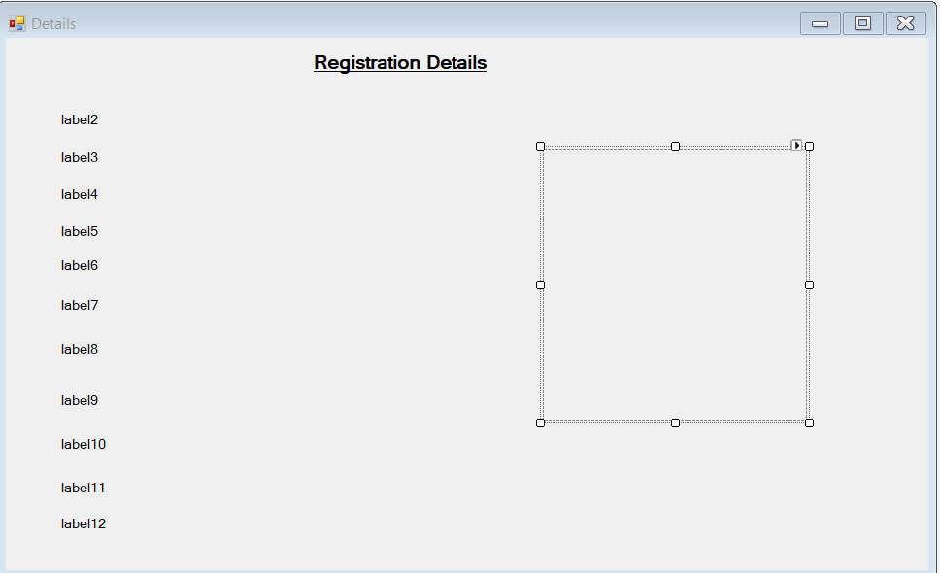

**Details.cs**

using System;

using System.Collections.Generic;

using System.ComponentModel;

using System.Data;

using System.Drawing;

using System.Linq;

using System.Text;

using System.Threading.Tasks;

using System.Windows.Forms;

namespace PracticalNo01

{

public partial class Details : Form

{

public string firstName { get; set; }

public string middleName { get; set; }

public string lastName { get; set; }

public string dob { get; set; }

public string mob { get; set; }

public string address { get; set; }

public string username { get; set; }

public string passowrd { get; set; }

public string gender { get; set; }

public bool Checked { get; set; }

public string path { get; set; }

public string hobbies { get; set; }

public string city { get; set; }

public Details()

{

InitializeComponent();

}

private void Details_Load(object sender, EventArgs e)

{

lblfirst.Text = "First Name: " + firstName;

lblmiddle.Text = "Middle Name: " + middleName;

lbllast.Text = "Last Name: " + lastName;

lbldob.Text = "Date Of Birth: " + dob;

lblmob.Text = "Mobile Number: " + mob;

lbladdress.Text = "Address: " + address;

lblusername.Text = "Username: " + username;

lblpass.Text = "Password: " + passowrd;

lblgender.Text = "Gender: " + gender;

picbox.ImageLocation = path;

lblhobby.Text = hobbies;

lblcity.Text = "City: " + city;

}

}

}

**Program.cs**

using System;

using System.Collections.Generic;

using System.Linq;

using System.Threading.Tasks;

using System.Windows.Forms;

namespace PracticalNo01

{

static class Program

{

/// <summary>

/// The main entry point for the application.

/// </summary>

[STAThread]

static void Main()

{

Application.EnableVisualStyles();

Application.SetCompatibleTextRenderingDefault(false);

Application.Run(new RegistrationFrom());

}

}

}

* **OUTPUT :**

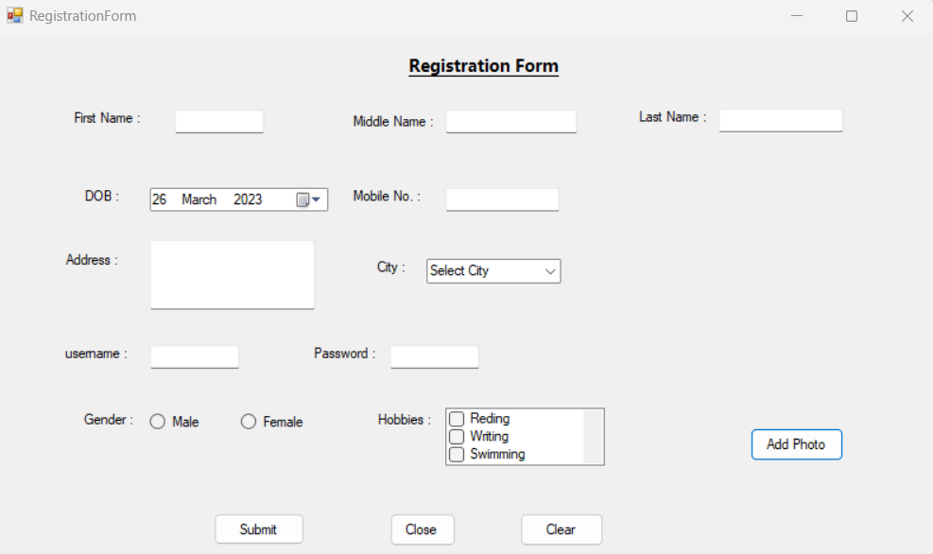

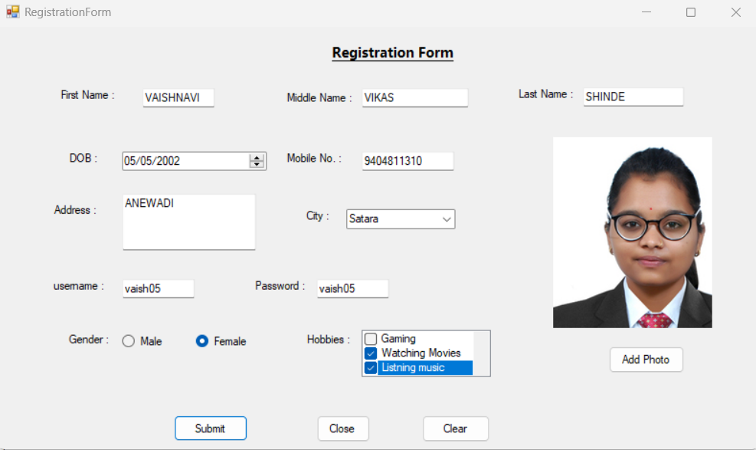

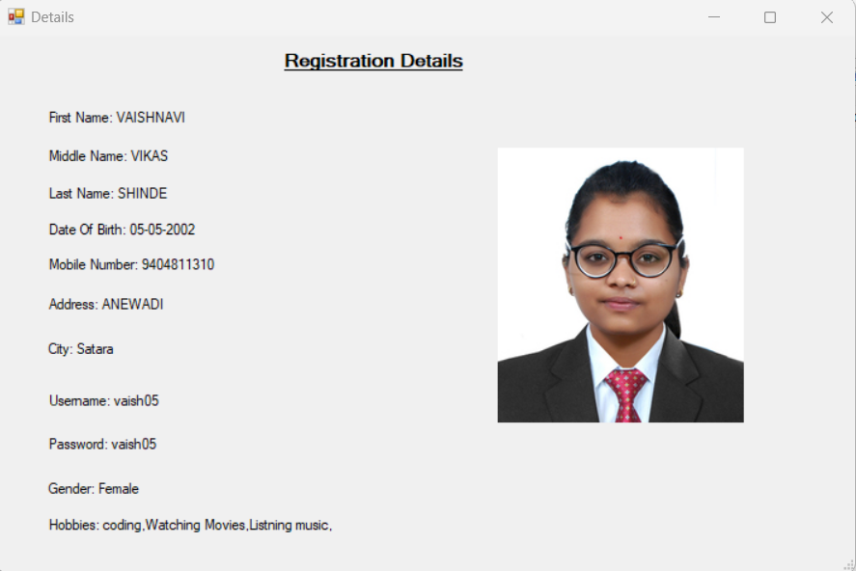

**Que.2.Design a window application in c# using objects and classes to find whether an entered year is leap year or not.**

**Ans:**

* **Code:**

**FrmLeapYear.cs[Design]**

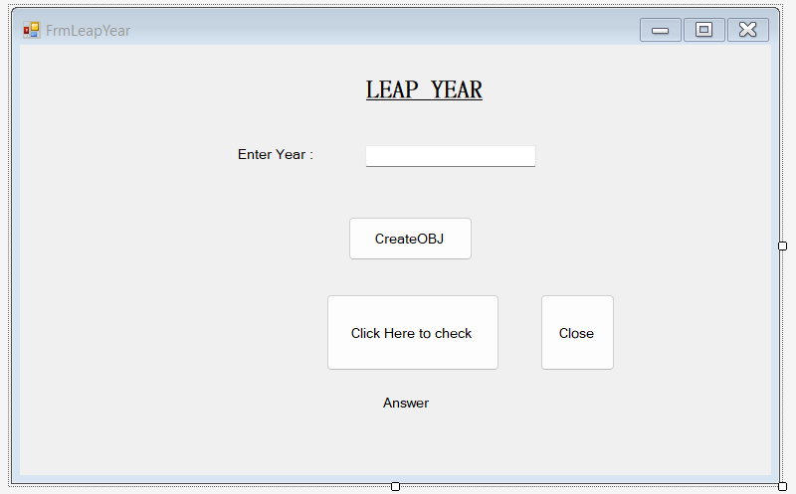

**FrmLeapYear.cs**

using System;

using System.Collections.Generic;

using System.ComponentModel;

using System.Data;

using System.Drawing;

using System.Linq;

using System.Text;

using System.Threading.Tasks;

using System.Windows.Forms;

namespace PracticalNo01

{

public partial class FrmLeapYear : Form

{

Leapyear l1 = null;

public FrmLeapYear()

{

InitializeComponent();

}

private void FrmLeapYear_Load(object sender, EventArgs e)

{

}

private void btnCreateObj_Click(object sender, EventArgs e)

{

int year = Convert.ToInt32(txtYear.Text);

l1 = new Leapyear(year);

MessageBox.Show("Object created successfully");

}

private void btnCheck_Click(object sender, EventArgs e)

{

lblAnswer.Text = " The Entered Year is " + l1.Year().ToString();

}

class Leapyear

{

int year;

public Leapyear()

{ }

public Leapyear(int y)

{

year = y;

}

~Leapyear()

{ }

public int Year()

{

int lyear = year;

if (((year % 4 == 0) && (year % 100 != 0)) || (year % 400 == 0))

{

MessageBox.Show("It is a leap year");

}

else

{

MessageBox.Show("It is not a leap year");

}

return lyear;

}

}

private void btnClose_Click(object sender, EventArgs e)

{

this.Close();

}

}

}

* **Program.cs**

using System;

using System.Collections.Generic;

using System.Linq;

using System.Threading.Tasks;

using System.Windows.Forms;

namespace PracticalNo01

{

static class Program

{

/// <summary>

/// The main entry point for the application.

/// </summary>

[STAThread]

static void Main()

{

Application.EnableVisualStyles();

Application.SetCompatibleTextRenderingDefault(false);

Application.Run(new FrmLeapYear());

}

}

}

* **OUTPUT :**

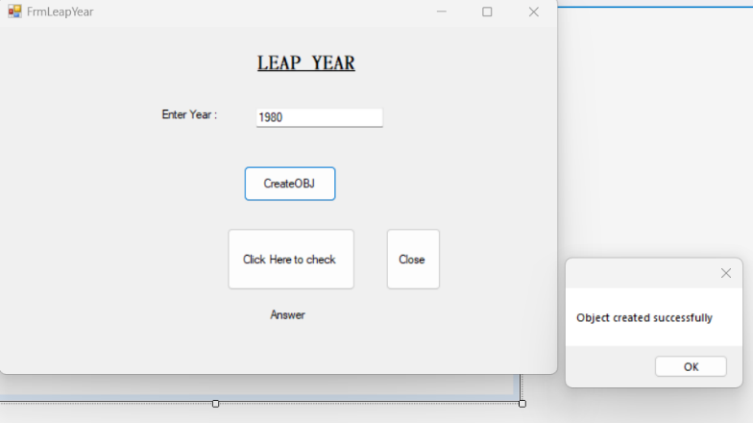

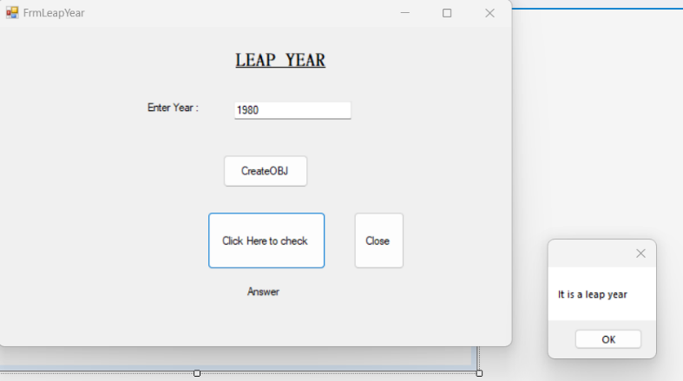

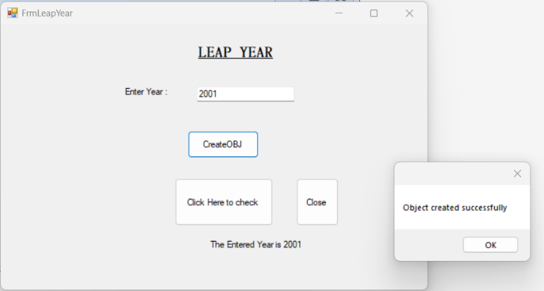

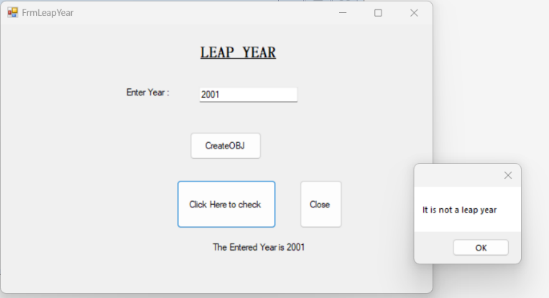

**Que.3.Design a Window application in c# using objects and classes for wind conversion from knots to mph, kph.**

**Ans:**

* **Code-**

**FrmWindConversion.cs[Design]**

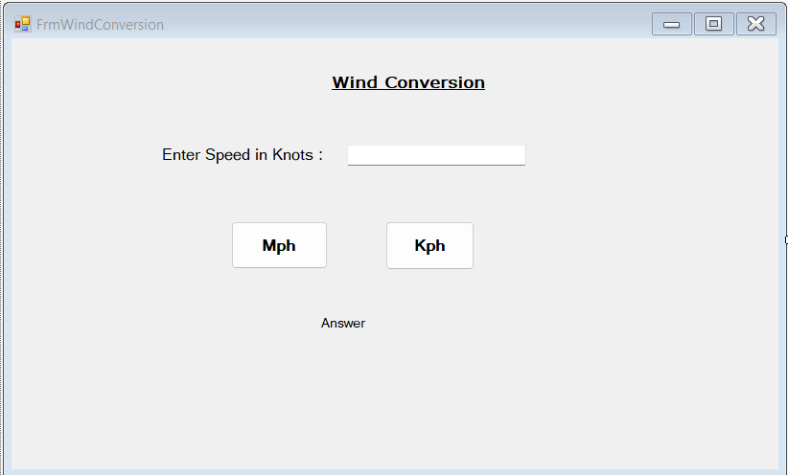

**FrmWindConversion.cs**

using System;

using System.Collections.Generic;

using System.ComponentModel;

using System.Data;

using System.Drawing;

using System.Linq;

using System.Text;

using System.Threading.Tasks;

using System.Windows.Forms;

namespace PracticalNo01

{

public partial class FrmWindConversion : Form

{

SpeedConvert convert = null;

public FrmWindConversion()

{

InitializeComponent();

}

private void btnMph_Click(object sender, EventArgs e)

{

double knots = Convert.ToInt32(txtKnots.Text);

convert = new SpeedConvert(knots);

lblMsg.Text = "Speed In Miles Per Hour: " +convert.convertMph(knots).ToString();

}

private void btnKph_Click(object sender, EventArgs e)

{

double knots = Convert.ToInt32(txtKnots.Text);

lblMsg.Text = "Speed In Kilometer Per Hour: " +convert.convertKph(knots).ToString();

}

}

class SpeedConvert

{

private double knots;

public SpeedConvert()

{

knots = 0;

}

public SpeedConvert(double k)

{

knots = k;

}

public double convertMph(double k)

{

return k* 1.1508;

}

public double convertKph(double k)

{

return k * 1.852;

}

}

}

**Program.cs**

using System;

using System.Collections.Generic;

using System.Linq;

using System.Threading.Tasks;

using System.Windows.Forms;

namespace PracticalNo01

{

static class Program

{

/// <summary>

/// The main entry point for the application.

/// </summary>

[STAThread]

static void Main()

{

Application.EnableVisualStyles();

Application.SetCompatibleTextRenderingDefault(false);

Application.Run(new FrmWindConversion());

}

}

}

* **OUTPUT :**

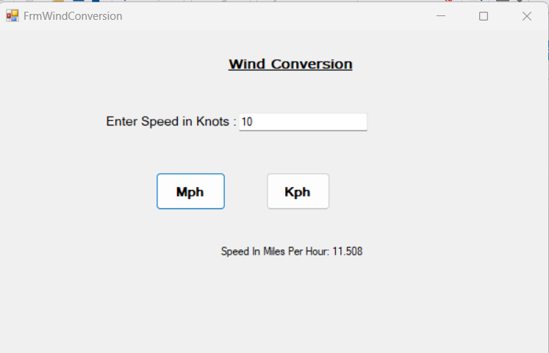

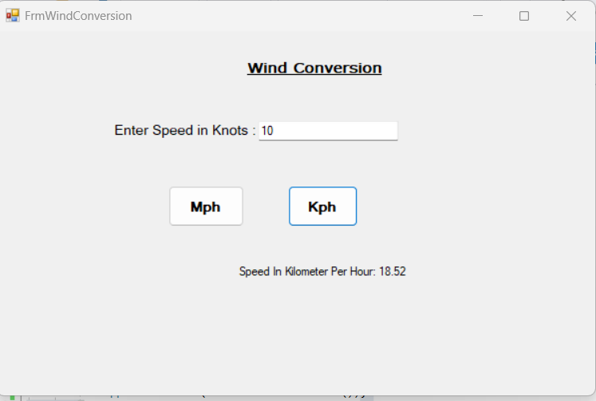

**Que.4.Design a Window application to demonstrate multiple inheritance.**

**Ans:**

* **Code:**

**FrmMultipleInheritance.cs[Design]**

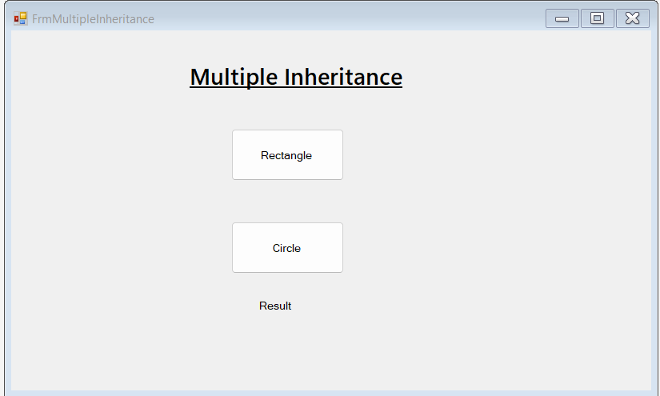

**FrmMultipleInheritance.cs**

using System;

using System.Collections.Generic;

using System.ComponentModel;

using System.Data;

using System.Drawing;

using System.Linq;

using System.Text;

using System.Threading.Tasks;

using System.Windows.Forms;

namespace PracticalNo01

{

public partial class FrmMultipleInheritance : Form

{

public FrmMultipleInheritance()

{

InitializeComponent();

}

private void FrmMultipleInheritance_Load(object sender, EventArgs e)

{

}

private void btnRectangle1_Click(object sender, EventArgs e)

{

double length = 10;

double width = 5;

Rectangle1 rectangle = new Rectangle1(length, width);

lblResult.Text = $"Rectangle Area: {rectangle.GetArea()}\nRectangle Perimeter: {rectangle.GetPerimeter()}";

}

private void btnCircle1_Click(object sender, EventArgs e)

{

double radius = 5;

Circle circle = new Circle(radius);

lblResult.Text = $"Circle Area: {circle.GetArea()}\nCircle Circumference: {circle.GetPerimeter()}";

}

private void lblResult_Click(object sender, EventArgs e)

{

}

}

public interface IShape

{

double GetArea();

double GetPerimeter();

}

public class Rectangle1 : Form, IShape

{

private double length;

private double width;

public Rectangle1(double length, double width)

{

this.length = length;

this.width = width;

}

public double GetArea()

{

return length * width;

}

public double GetPerimeter()

{

return 2 * (length + width);

}

}

public class Circle : Button, IShape

{

private double radius;

public Circle(double radius)

{

this.radius = radius;

}

public double GetArea()

{

return 3.14 * radius * radius;

}

public double GetPerimeter()

{

return 2 * 3.14 * radius;

}

public class Rectangle1 : Form, IShape

{

private double length;

private double width;

public Rectangle1(double length, double width)

{

this.length = length;

this.width = width;

}

public double GetArea()

{

return length * width;

}

public double GetPerimeter()

{

return 2 * (length + width);

}

}

public class Circle1 : Button, IShape

{

private double radius;

public Circle1(double radius)

{

this.radius = radius;

}

public double GetArea()

{

return 3.14* radius*radius;

}

public double GetPerimeter()

{

return 2 * 3.14 * radius;

}

}

}

}

**Program.cs**

using System;

using System.Collections.Generic;

using System.Linq;

using System.Threading.Tasks;

using System.Windows.Forms;

namespace PracticalNo01

{

static class Program

{

/// <summary>

/// The main entry point for the application.

/// </summary>

[STAThread]

static void Main()

{

Application.EnableVisualStyles();

Application.SetCompatibleTextRenderingDefault(false);

Application.Run(new FrmMultipleInheritance());

} }}

* **OUTPUT :**

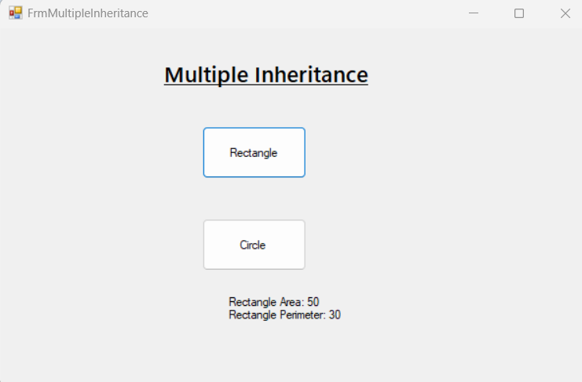

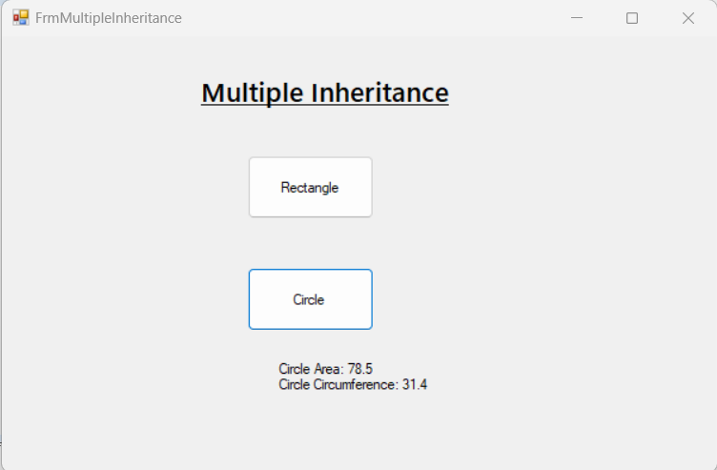

**Que.5.Design a Window application to demonstrate abstract class.**

**Ans:**

* **Code :**

**FrmAbstractClass.cs[Design]**

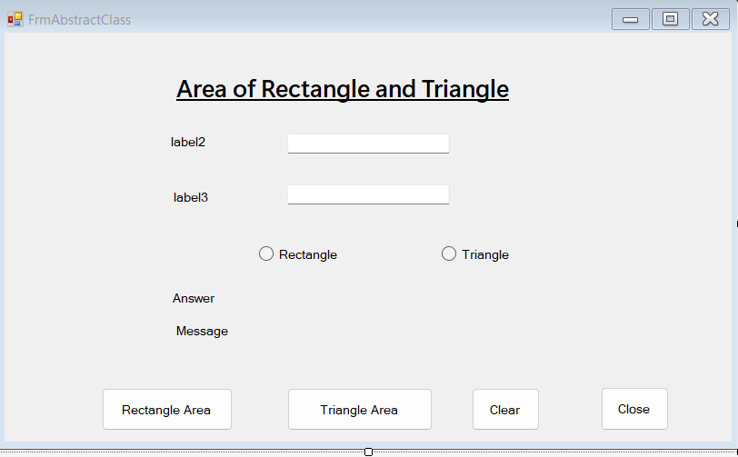

**FrmAbstractClass.cs**

using System;

using System.Collections.Generic;

using System.ComponentModel;

using System.Data;

using System.Drawing;

using System.Linq;

using System.Text;

using System.Threading.Tasks;

using System.Windows.Forms;

namespace PracticalNo01

{

public partial class FrmAbstractClass : Form

{

Rectangle r1 = null;

Triangle t1 = null;

public FrmAbstractClass()

{

InitializeComponent();

}

private void FrmAbstractClass_Load(object sender, EventArgs e)

{

label2.Text = "";

label3.Text = "";

lblAnswer.Text = "";

lblMessage.Text = "";

btnAreaRectangle.Enabled = false;

btnAreaTriangle.Enabled = false;

}

private void rbRectangle_CheckedChanged(object sender, EventArgs e)

{

label2.Text = " Enter length : ";

label3.Text = " Enter width : ";

btnAreaRectangle.Enabled = true;

btnAreaTriangle.Enabled = false;

}

private void rbTriangle_CheckedChanged(object sender, EventArgs e)

{

label2.Text = " Enter base: ";

label3.Text = " Enter height : ";

btnAreaRectangle.Enabled = false;

btnAreaTriangle.Enabled = true;

}

private void btnClear_Click(object sender, EventArgs e)

{

textBox1.Text = " ";

textBox2.Text = " ";

}

private void btnClose_Click(object sender, EventArgs e)

{

this.Close();

}

private void btnAreaRectangle_Click(object sender, EventArgs e)

{

int l = Convert.ToInt32(textBox1.Text);

int w = Convert.ToInt32(textBox2.Text);

r1 = new Rectangle(l, w);

lblAnswer.Text = "Area of Rectangle = " + r1.area().ToString();

lblMessage.Text = r1.show();

}

private void btnAreaTriangle_Click(object sender, EventArgs e)

{

int b = Convert.ToInt32(textBox1.Text);

int h = Convert.ToInt32(textBox2.Text);

t1 = new Triangle(b, h);

lblAnswer.Text = "Area of Triangle = " + t1.area().ToString();

lblMessage.Text = t1.show();

}

}

abstract class Shape

{

public virtual double area()

{

return 0;

}

public abstract string show();

}

class Rectangle : Shape

{

private int length;

private int width;

public Rectangle(int l =0,int w=0)

{

length = l;

width = w;

}

public override double area() //return area of rectangle

{

return (width*length);

}

public override string show()

{

return("Inside Rectangle Class!!");

}

}

class Triangle :Shape

{

private int Base;

private int height;

public Triangle(int b=0,int h=0)

{

Base = b;

height = h;

}

public override double area()

{

return (0.5*Base*height);

}

public override string show()

{

return("Inside Triangle Class!!");

}

}

}

* **Program.cs**

using System;

using System.Collections.Generic;

using System.Linq;

using System.Threading.Tasks;

using System.Windows.Forms;

namespace PracticalNo01

{

static class Program

{

/// <summary>

/// The main entry point for the application.

/// </summary>

[STAThread]

static void Main()

{

Application.EnableVisualStyles();

Application.SetCompatibleTextRenderingDefault(false);

Application.Run(new FrmAbstractClass());

}

}

}

* **OUTPUT :**

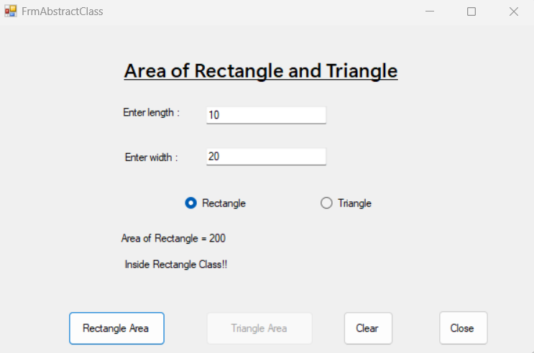

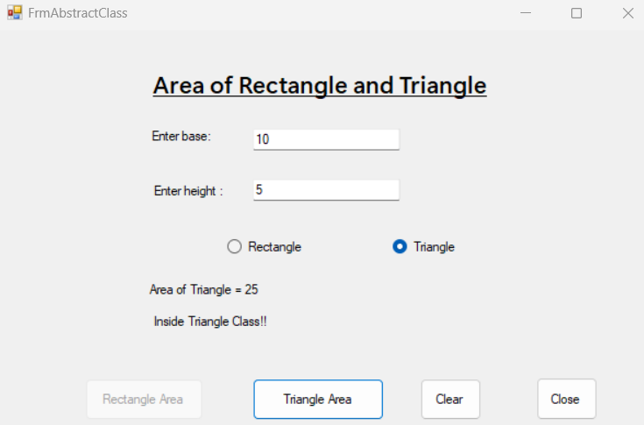

**Que.6.Design a Window application to demonstrate Indexer.**

**Ans:**

* **Code –**

**FrmIndexer.cs[Design]**

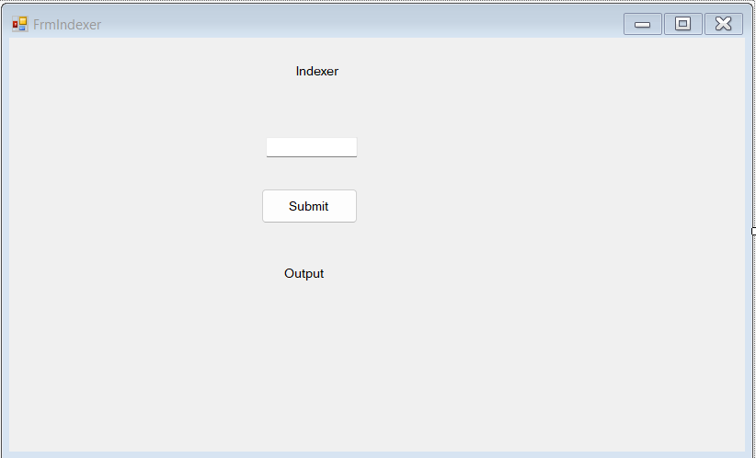

**FrmIndexer.cs**

using System;

using System.Collections.Generic;

using System.ComponentModel;

using System.Data;

using System.Drawing;

using System.Linq;

using System.Text;

using System.Threading.Tasks;

using System.Windows.Forms;

namespace PracticalNo01

{

public partial class FrmIndexer : Form

{

public FrmIndexer()

{

InitializeComponent();

}

private void FrmIndexer_Load(object sender, EventArgs e)

{

}

private void btnSubmit_Click(object sender, EventArgs e)

{

StringCollection stringCollection = new StringCollection();

stringCollection[0] = "Banana";

stringCollection[1] = "Papaya";

stringCollection[2] = "Dates";

stringCollection[3] = "Orange";

stringCollection[4] = "Apple";

string output = " ";

for(int i=0;i<stringCollection.Count;i++){

output += stringCollection[i] + "\n";

}

lblOutput.Text = output;

}

}

public class StringCollection

{

private string[] strings = new string[10];

public string this[int index]

{

get

{

return strings[index];

}

set

{

strings[index] = value;

}

}

public int Count

{

get

{

return strings.Length;

}

}

}

}

* **Program.cs**

using System;

using System.Collections.Generic;

using System.Linq;

using System.Threading.Tasks;

using System.Windows.Forms;

namespace PracticalNo01

{

static class Program

{

/// <summary>

/// The main entry point for the application.

/// </summary>

[STAThread]

static void Main()

{

Application.EnableVisualStyles();

Application.SetCompatibleTextRenderingDefault(false);

Application.Run(new FrmIndexer());

}

}

}

* **OUTPUT -**

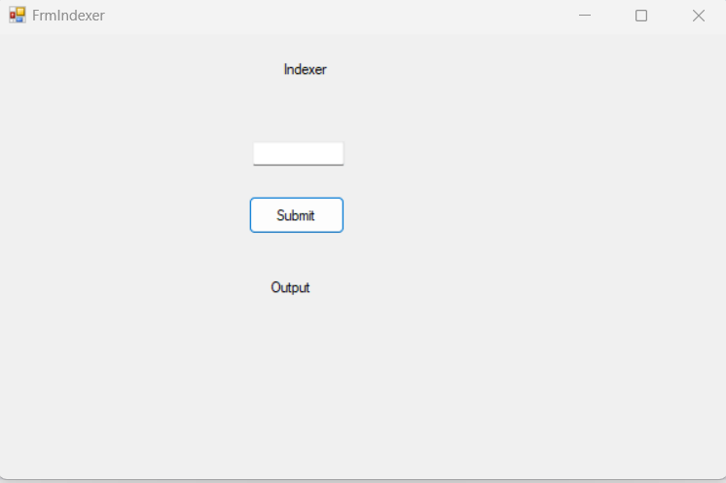

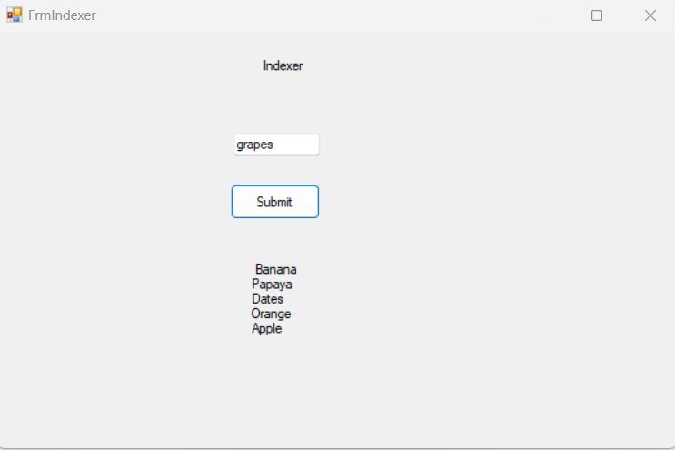

**Que.7.Design a Window application to demonstrate string manipulations.**

**Ans:**

* **Code –**

**FrmStringManipulation.cs[Design]**

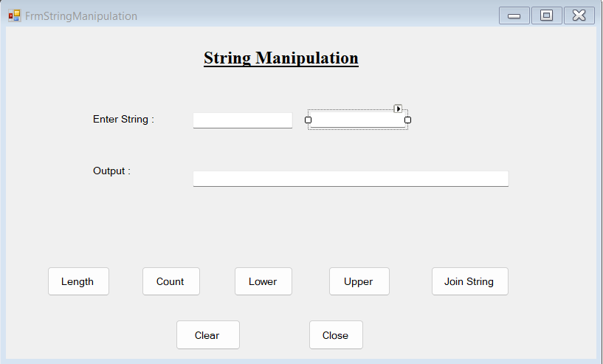

**FrmStringManipulation.cs**

using System;

using System.Collections.Generic;

using System.ComponentModel;

using System.Data;

using System.Drawing;

using System.Linq;

using System.Text;

using System.Threading.Tasks;

using System.Windows.Forms;

namespace PracticalNo01

{

public partial class FrmStringManipulation : Form

{

public FrmStringManipulation()

{

InitializeComponent();

}

private void btnLength_Click(object sender, EventArgs e)

{

string txt1 = txtString1.Text;

string txt2 = txtString2.Text;

int l,l2;

l = txt1.Length;

l2 = txt2.Length;

l = txt1.Replace(" ", "").Length;

l2 = txt2.Replace(" ", "").Length;

txtOutput.Text = "Textbox1 Length="+l.ToString() +", Textbox2 Length= "+l2.ToString();

}

private void btnCount_Click(object sender, EventArgs e)

{

string words = txtString1.Text.Trim();

string words1 = txtString2.Text.Trim();

MessageBox.Show("Number of words: " + CountWords(words)+" ,"+ CountWords1(words1));

}

private int CountWords(string words)

{

String[] allwords = words.Split(' ');

return allwords.Length;

}

private int CountWords1(string words1)

{

String[] allwords1 = words1.Split(' ');

return allwords1.Length;

}

private void btnLower_Click(object sender, EventArgs e)

{

string txt1 = txtString1.Text;

string txt2 = txtString2.Text;

txtOutput.Text = txt1.ToLower()+ " "+txt2.ToLower();

}

private void btnUpper_Click(object sender, EventArgs e)

{

string txt1 = txtString1.Text;

string txt2= txtString2.Text;

txtOutput.Text = txt1.ToUpper()+" "+txt2.ToUpper();

}

private void btnJoinString_Click(object sender, EventArgs e)

{

string msg = "Heyy !!";

string txt1 = txtString1.Text;

string txt2 = txtString2.Text;

txtOutput.Text = msg + " " + txt1 + " " + txt2;

}

private void btnClear_Click(object sender, EventArgs e)

{

txtString1.Clear();

txtString2.Clear();

txtOutput.Clear();

}

private void btnClose_Click(object sender, EventArgs e)

{

this.Close();

}

}

}

* **Program.cs**

using System;

using System.Collections.Generic;

using System.Linq;

using System.Threading.Tasks;

using System.Windows.Forms;

namespace PracticalNo01

{

static class Program

{

/// <summary>

/// The main entry point for the application.

/// </summary>

[STAThread]

static void Main()

{

Application.EnableVisualStyles();

Application.SetCompatibleTextRenderingDefault(false);

Application.Run(new FrmStringManipulation());

}

}

}

* **OUTPUT -**

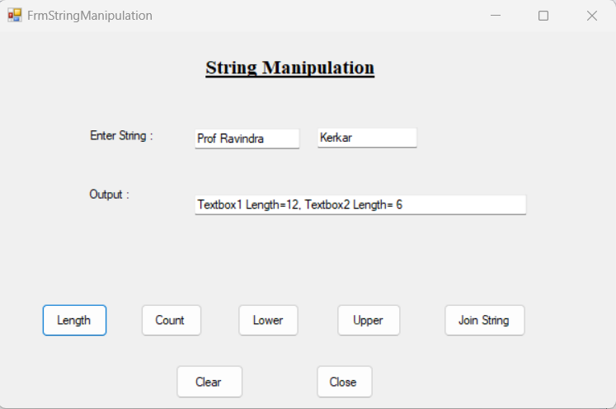

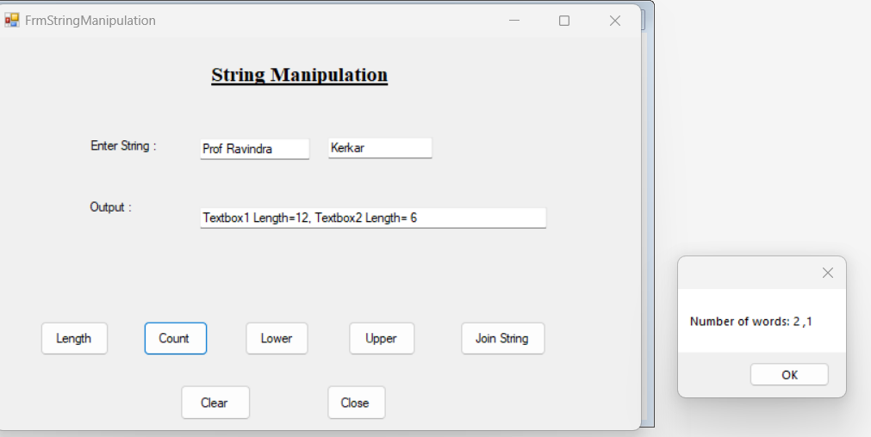

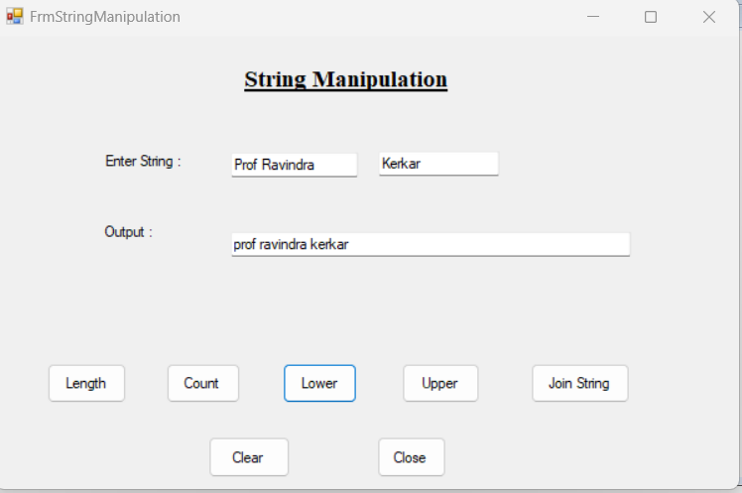

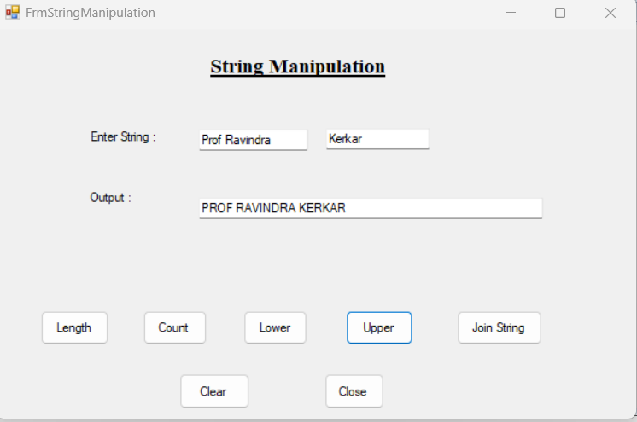

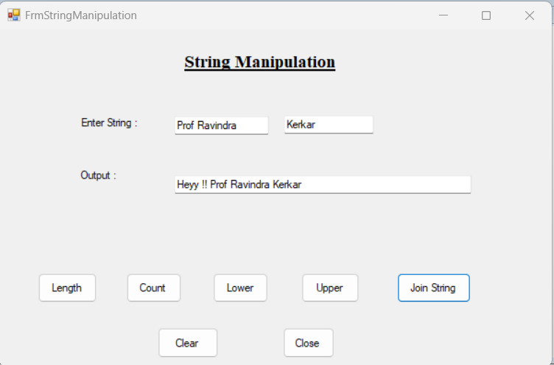

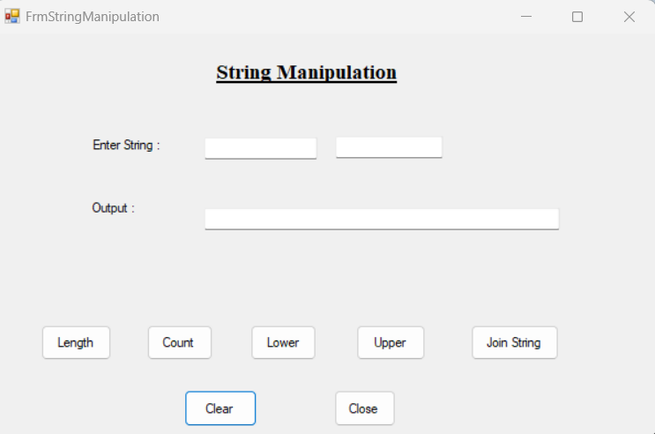

**Que.8.Design a window application to show following:**

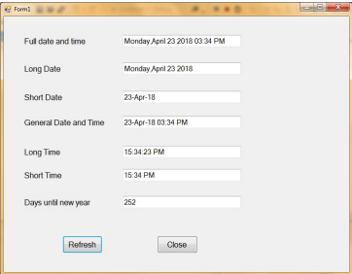

**Ans:**

* **Code –**

**FrmQue8.cs[Design]**

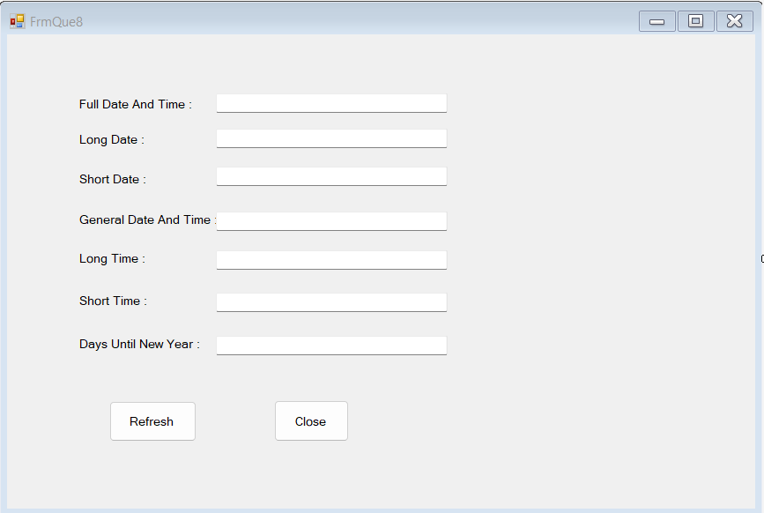

**FrmQue8.cs**

using System;

using System.Collections.Generic;

using System.ComponentModel;

using System.Data;

using System.Drawing;

using System.Linq;

using System.Text;

using System.Threading.Tasks;

using System.Windows.Forms;

namespace PracticalNo01

{

public partial class FrmQue8 : Form

{

DateTime d = new DateTime();

public FrmQue8()

{

InitializeComponent();

}

private void FrmQue8_Load(object sender, EventArgs e)

{

}

private void btnrefresh_Click(object sender, EventArgs e)

{

d = DateTime.Now;

txtfullname.Text = d.ToString("dddd, MMMM dd yyyy HH:mm:ss tt");

txtlongdate.Text = d.ToLongDateString();

txtshortdate.Text = d.ToString("dd-MMM-yy");

txtgeneral.Text = d.ToString(" dd-MMM-yy HH:mm tt");

txtlongtime.Text = d.ToLongTimeString();

txtshorttime.Text = d.ToShortTimeString();

int noOfDays = DateTime.IsLeapYear(DateTime.Now.Year) ? 366 : 365;

txtdays.Text = (noOfDays - DateTime.Now.DayOfYear).ToString();

txtfullname.Enabled = true;

txtlongdate.Enabled = false;

txtshortdate.Enabled = false;

txtgeneral.Enabled = false;

txtlongtime.Enabled = false;

txtshorttime.Enabled = false;

txtdays.Enabled = false;

}

private void btnclose_Click(object sender, EventArgs e)

{

this.Close();

}

}

}

* **Program.cs**

using System;

using System.Collections.Generic;

using System.Linq;

using System.Threading.Tasks;

using System.Windows.Forms;

namespace PracticalNo01

{

static class Program

{

/// <summary>

/// The main entry point for the application.

/// </summary>

[STAThread]

static void Main()

{

Application.EnableVisualStyles();

Application.SetCompatibleTextRenderingDefault(false);

Application.Run(new FrmQue8());

}

}

}

* **OUTPUT -**

