**FINOLEX ACADEMY OF MANAGEMENT AND TECHNOLOGY, RATNAGIRI**

**DEPARTMENT OF MCA**

**PRACTICAL NO. 02**

**Introduction to ASP.NET**

**Que.1.Design asp.net web form to demonstrate various events in asp.net page life cycle.**

**Ans:**

* **CODE –**

**Page_Life_Cycle.aspx**

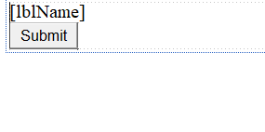

<%@ Page Language="C#" AutoEventWireup="true" CodeFile="Page_Life_Cycle.aspx.cs" Inherits="Page_Life_Cycle" %>

<!DOCTYPE html>

<html xmlns="http://www.w3.org/1999/xhtml">

<head runat="server">

<title></title>

</head>

<body>

<form id="form1" runat="server">

<div>

<asp:Label ID="lblName" runat="server" ></asp:Label>

<br/>

<asp:Button ID="btnSubmit" runat="server" Text="Submit"

OnClick="btnSubmit_Click" />

</div>

</form>

</body>

</html>

**Page_Life_Cycle.aspx.cs**

using System;

using System.Collections.Generic;

using System.Linq;

using System.Web;

using System.Web.UI;

using System.Web.UI.WebControls;

public partial class Page_Life_Cycle : System.Web.UI.Page

{

protected void Page_PreInit(object sender, EventArgs e)

{

lblName.Text = lblName.Text + "<br/>" + "PreInit";

}

protected void Page_Init(object sender, EventArgs e)

{

lblName.Text = lblName.Text + "<br/>" + "Init";

}

protected void Page_InitComplete(object sender, EventArgs e)

{

lblName.Text = lblName.Text + "<br/>" + "InitComplete";

}

protected override void OnPreLoad(EventArgs e)

{

lblName.Text = lblName.Text + "<br/>" + "PreLoad";

}

protected void Page_Load(object sender, EventArgs e)

{

lblName.Text = lblName.Text + "<br/>" + "Load";

}

protected void Page_LoadComplete(object sender, EventArgs e)

{

lblName.Text = lblName.Text + "<br/>" + "LoadComplete";

}

protected override void OnPreRender(EventArgs e)

{

System.Threading.Thread.Sleep(3000);

lblName.Text = lblName.Text + "<br/>" + "PreRender";

}

protected override void OnSaveStateComplete(EventArgs e)

{

lblName.Text = lblName.Text + "<br/>" + "SaveStateComplete";

}

protected void Page_UnLoad(object sender, EventArgs e)

{

lblName.Text = lblName.Text + "<br/>" + "UnLoad";

}

protected void btnSubmit_Click(object sender, EventArgs e)

{

lblName.Text = lblName.Text + "<br/>" + "btnSubmit_Click";

}

}

* **OUTPUT :**

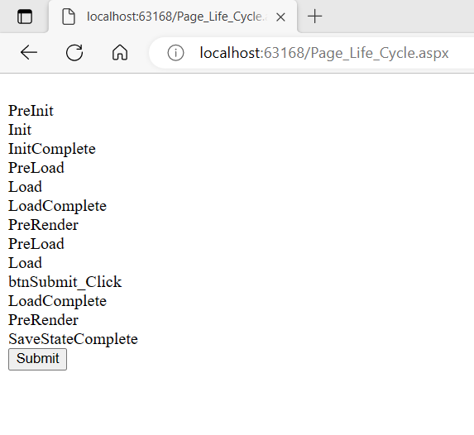

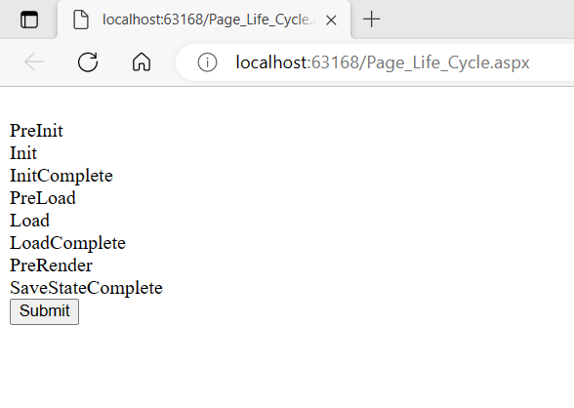

**Que.2. Design asp.net web form to demonstrate postback posting, cross- page posting and auto postback.**

**Ans:**

* **CODE –**

1. **Post Back Posting**

**PostingDemo.aspx**

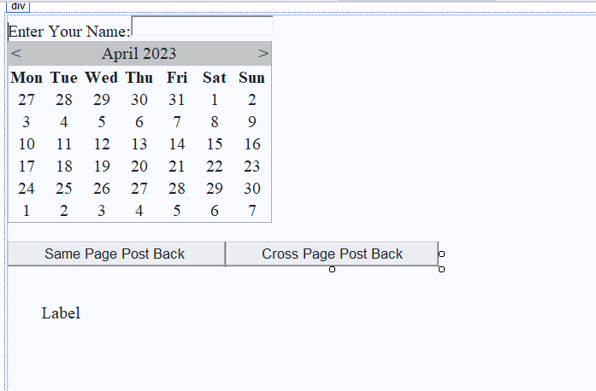

<%@ Page Language="C#" AutoEventWireup="true" CodeBehind="PostingDemo.aspx.cs" Inherits="PracticalNo._2.PostinfDemo" %>

<!DOCTYPE html>

<html xmlns="http://www.w3.org/1999/xhtml">

<head runat="server">

<title></title>

</head>

<body>

<form id="form1" runat="server">

<div style="height: 461px">

<asp:Label ID="lblName" runat="server" Text="Enter Your Name:"></asp:Label>

<asp:TextBox ID="TextBox1" runat="server"></asp:TextBox>

<br />

<asp:Calendar ID="Calendar1" runat="server"></asp:Calendar>

<br />

<asp:Button ID="btnPostBack_Posting" runat="server" OnClick="btnPostBack_Posting_Click" Text="Same Page Post Back " />

<asp:Button ID="btnCrossPage_Posting" runat="server" OnClick="btnCrossPage_Posting_Click" PostBackUrl="~/PostingDemo2.aspx" Text="Cross Page Post Back" />

<br />

<br />

<br />

&nbsp;&nbsp;&nbsp;&nbsp;&nbsp;&nbsp;&nbsp;

<asp:Label ID="lblMsg" runat="server" Text="Label"></asp:Label>

</div>

</form>

</body>

</html>

**PostingDemo.aspx.cs**

using System;

using System.Collections.Generic;

using System.Linq;

using System.Web;

using System.Web.UI;

using System.Web.UI.WebControls;

namespace PracticalNo._2

{

public partial class PostinfDemo : System.Web.UI.Page

{

protected void Page_Load(object sender, EventArgs e)

{

}

protected void btnPostBack_Posting_Click(object sender, EventArgs e)

{

lblMsg.Text = " Hi " + TextBox1.Text + ",Here is output of the Same Page post back Button: " + Calendar1.SelectedDate.ToString("dd/MM/yyyy");

}

protected void btnCrossPage_Posting_Click(object sender, EventArgs e)

{

}

}

}

1. **Cross Page Posting**

**PostingDemo2.aspx**

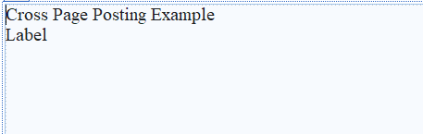

<%@ Page Language="C#" AutoEventWireup="true" CodeBehind="PostingDemo2.aspx.cs" Inherits="PracticalNo._2.PostingDemo2" %>

<!DOCTYPE html>

<html xmlns="http://www.w3.org/1999/xhtml">

<head runat="server">

<title></title>

</head>

<body>

<form id="form1" runat="server">

<div style="height: 232px">

<asp:Label ID="Label1" runat="server" Text="Cross Page Posting Example"></asp:Label>

<br />

<asp:Label ID="Label2" runat="server" Text="Label"></asp:Label>

</div>

</form>

</body>

</html>

**PostingDemo2.aspx.cs**

using System;

using System.Collections.Generic;

using System.Globalization;

using System.Linq;

using System.Web;

using System.Web.UI;

using System.Web.UI.WebControls;

namespace PracticalNo._2

{

public partial class PostingDemo2 : System.Web.UI.Page

{

protected void Page_Load(object sender, EventArgs e)

{

if(Page.PreviousPage !=null && PreviousPage.IsCrossPagePostBack)

{

System.Web.UI.WebControls.Calendar Cal1 = new System.Web.UI.WebControls.Calendar();

TextBox textBox1 = new TextBox();

Cal1 = (System.Web.UI.WebControls.Calendar)(PreviousPage.FindControl("Calendar1"));

textBox1 = (TextBox)(PreviousPage.FindControl("textBox1"));

Label2.Text = " <br/>Hii " + textBox1.Text + "Here is output of the Cross Page post back Button:" + Cal1.SelectedDate.ToString("dd/MM/yyyy");

}

}

}

}

1. **Auto Post Back Posting**

**AutoPostBack.aspx**

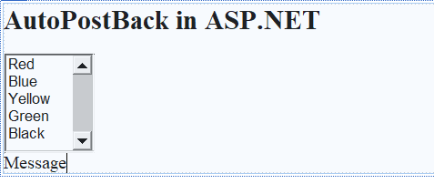

<%@ Page Language="C#" AutoEventWireup="true" CodeBehind="AutoPostBack.aspx.cs" Inherits="PracticalNo._2.AutoPostBack" %>

<!DOCTYPE html>

<html xmlns="http://www.w3.org/1999/xhtml">

<head runat="server">

<title>Auto Post Back</title>

</head>

<body>

<form id="form1" runat="server">

<div>

<h2>AutoPostBack in ASP.NET</h2>

<asp:ListBox ID="ListBox1" runat="server" OnSelectedIndexChanged="ListBox1_SelectedIndexChanged" AutoPostBack="True" Height="110px" Width="100px">

<asp:ListItem>Red</asp:ListItem>

<asp:ListItem>Blue</asp:ListItem>

<asp:ListItem>Yellow</asp:ListItem>

<asp:ListItem>Green</asp:ListItem>

<asp:ListItem>Black</asp:ListItem>

</asp:ListBox>

<br />

<asp:Label ID="Label1" runat="server" Text="Message"></asp:Label>

</div>

</form>

</body>

</html>

**AutoPostBack.aspx.cs**

using System;

using System.Collections.Generic;

using System.Linq;

using System.Web;

using System.Web.UI;

using System.Web.UI.WebControls;

namespace PracticalNo._2

{

public partial class AutoPostBack : System.Web.UI.Page

{

protected void Page_Load(object sender, EventArgs e)

{

}

protected void ListBox1_SelectedIndexChanged(object sender, EventArgs e)

{

if (ListBox1.SelectedItem != null)

{

Label1.Text = "You selected " + ListBox1.SelectedItem.ToString();

}

else

Label1.Text = " Select any color from listbox";

}

}

}

* **OUTPUT :**

1. **Post Back Posting**

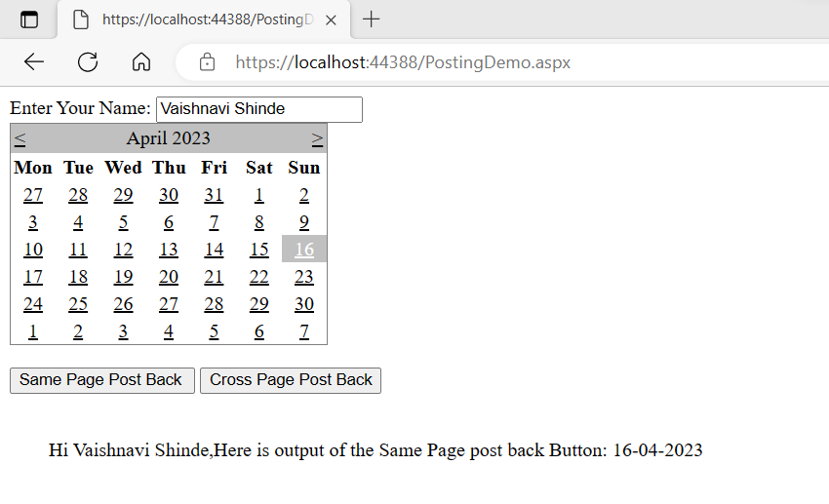

1. **Cross Page Posting**

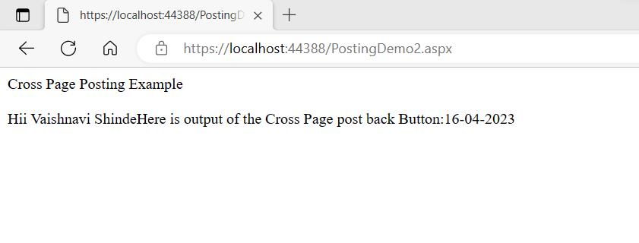

1. **Auto Post Back Posting**

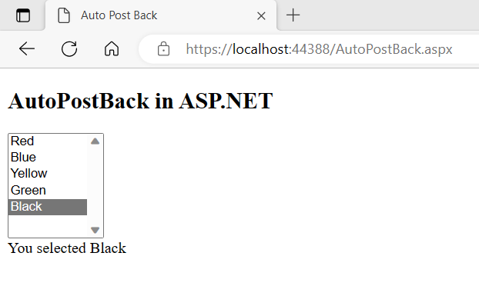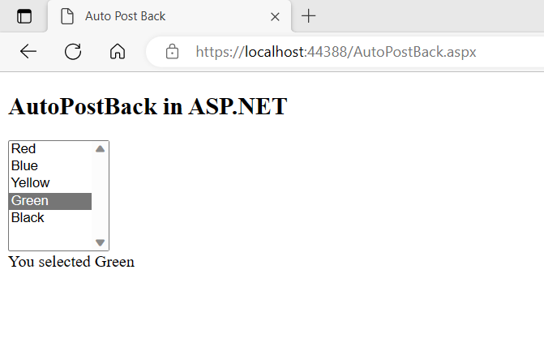

**Que.3. Design asp.net web form to demonstrate FileUpload, Calendar and AdRotator controls.**

**Ans:**

* **CODE –**

**FileUploadPro.aspx**

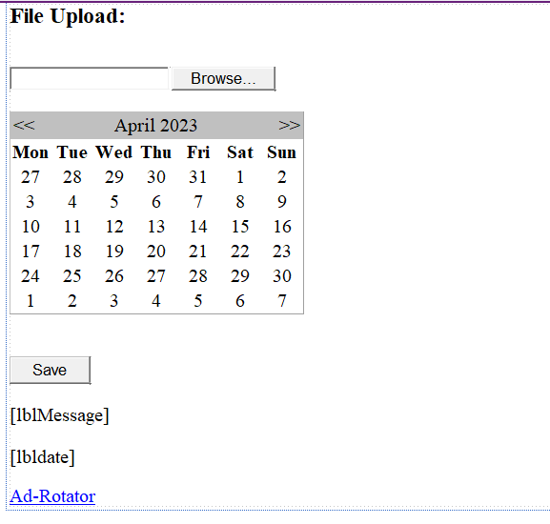

<%@ Page Language="C#" AutoEventWireup="true" CodeFile="FileUploadPro.aspx.cs" Inherits="FileUploadPro" %>

<!DOCTYPE html>

<html xmlns="http://www.w3.org/1999/xhtml">

<head runat="server">

<title></title>

</head>

<body>

<form id="form1" runat="server">

<div>

<h3> File Upload:</h3>

<br />

<asp:FileUpload ID="FileUpload1" runat="server" />

<br /> <br />

<asp:Calendar ID="Calendar1" runat="server" NextMonthText="&amp;gt;&amp;gt;" PrevMonthText="&amp;lt;&amp;lt;"></asp:Calendar>

<br /><br />

<asp:Button ID="btnSave" runat="server" Text="Save" style="width:85px" OnClick="btnSave_Click" />

<br /><br />

<asp:Label ID="lblMessage" runat="server" />

<br /><br />

<asp:Label ID="lbldate" runat="server" />

</div>

<p>

<asp:LinkButton ID="LinkButton1" runat="server" PostBackUrl="~/AdRotatorExample.aspx">Ad-Rotator</asp:LinkButton>

</p>

</form>

</body>

</html>

**FileUploadPro.aspx.cs**

using System;

using System.Collections.Generic;

using System.Linq;

using System.IO;

using System.Web;

using System.Text;

using System.Web.UI;

using System.Web.UI.WebControls;

public partial class FileUploadPro : System.Web.UI.Page

{

protected void btnSave_Click(object sender, EventArgs e)

{

StringBuilder sb = new StringBuilder();

if (FileUpload1.HasFile)

{

try

{

sb.AppendFormat(" Uploading file: {0}", FileUpload1.FileName);

//saving the file

string filename = Path.GetFileName(FileUpload1.FileName);

FileUpload1.SaveAs(Server.MapPath("~/") + filename);

//Showing the file information

sb.AppendFormat("<br/> Save As: {0} ",

FileUpload1.PostedFile.FileName);

sb.AppendFormat("<br/> File type: {0}",

FileUpload1.PostedFile.ContentType);

sb.AppendFormat("<br/> File length: {0}",

FileUpload1.PostedFile.ContentLength);

}

catch (Exception ex)

{

sb.Append("<br/> Error <br/>");

sb.AppendFormat("Unable to save file <br/> {0}", ex.Message);

}

}

lblMessage.Text = sb.ToString();

lbldate.Text = "Selected Date: " + Calendar1.SelectedDate.ToString("dd / MM / yyyy");

}

}

**AdRotatorExample.aspx**

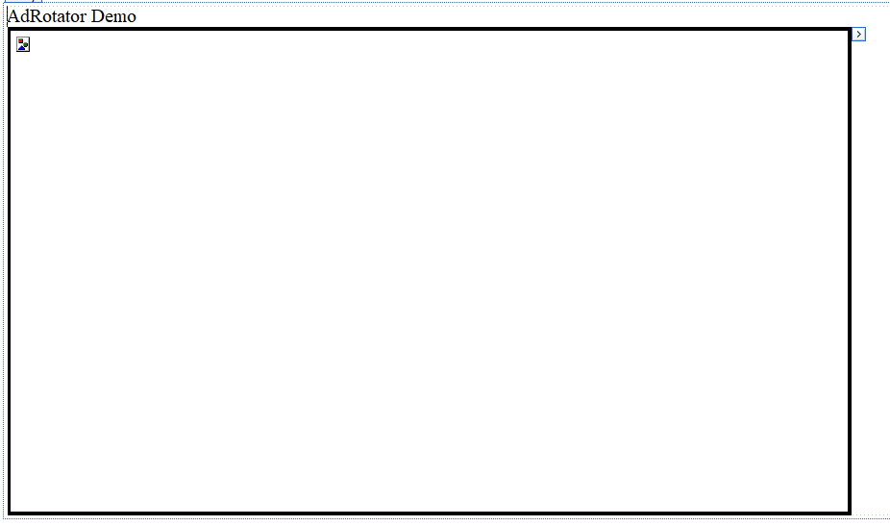

<%@ Page Language="C#" AutoEventWireup="true" CodeFile="AdRotatorExample.aspx.cs" Inherits="AdRotatorExample" %>

<!DOCTYPE html>

<html xmlns="http://www.w3.org/1999/xhtml">

<head runat="server">

<title></title>

</head>

<body>

<form id="form1" runat="server">

<div>

AdRotator Demo<br />

</div>

<asp:AdRotator ID="AdRotator1" runat="server" BorderStyle="Solid" Height="500px" Width="80%" AdvertisementFile="~/ads.xml" />

</form>

</body>

</html>

**ads.xml**

<?xml version="1.0" encoding="utf-8" ?>

<Advertisements>

<Ad>

<ImageUrl>Images/A.jpg</ImageUrl>

<NavigateUrl>https://www.amazon.in</NavigateUrl>

<AlternateText>

Amazon India online Shopping Site.

</AlternateText>

<Impressions>5</Impressions>

<Keyword>shopping</Keyword>

</Ad>

<Ad>

<ImageUrl>Images/B.jpg</ImageUrl>

<NavigateUrl>https://www.flipkart.com</NavigateUrl>

<AlternateText>

Flipkart online Shopping Site.

</AlternateText>

<Impressions>5</Impressions>

<Keyword>shopping</Keyword>

</Ad>

<Ad>

<ImageUrl>Images/C.jpg</ImageUrl>

<NavigateUrl>https://www.snapdeal.com</NavigateUrl>

<AlternateText>

Snapdeal online Shopping Site.

</AlternateText>

<Impressions>5</Impressions>

<Keyword>shopping</Keyword>

</Ad>

</Advertisements>

* **OUTPUT :**

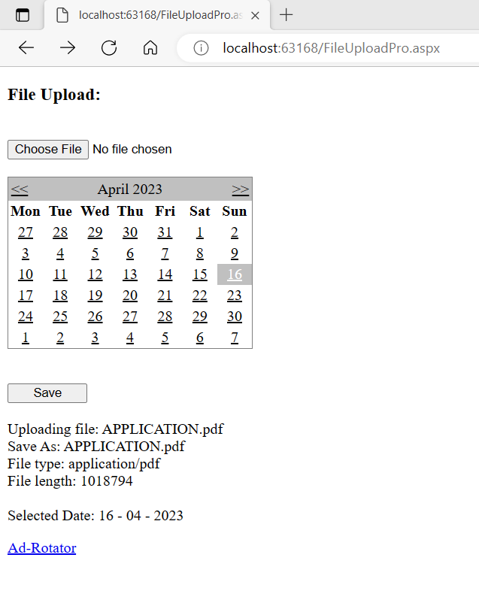

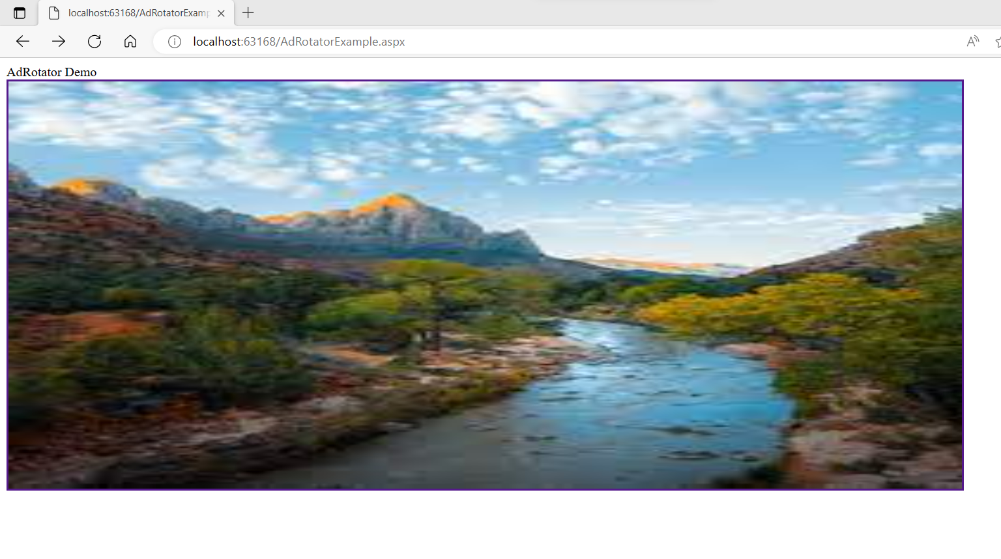

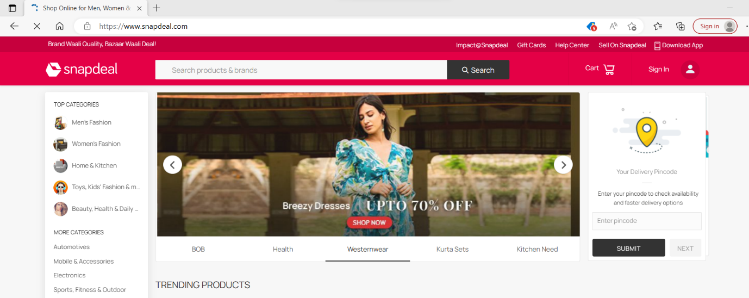

**Que.4. Design asp.net web form to demonstrate Validation controls in asp.net. After successful submission of  data, show same data on another page.**

**Ans:**

* **CODE –**

1. **Validation Control Form**

**WebForm1.aspx**

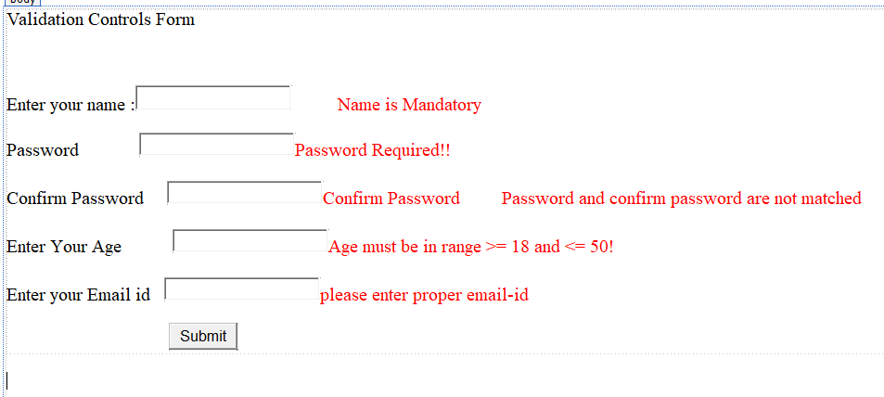

<%@ Page Language="C#" AutoEventWireup="true" CodeBehind="WebForm1.aspx.cs" Inherits="Validation.WebForm1" %>

<!DOCTYPE html>

<html xmlns="http://www.w3.org/1999/xhtml">

<head runat="server">

<title></title>

</head>

<body style="height: 498px">

<form id="form1" runat="server">

<div>

Validation Controls Form</div>

<p>

&nbsp;</p>

<p>

<asp:Label ID="Label1" runat="server" Text="Enter your name :"></asp:Label>

<asp:TextBox ID="TxtName" runat="server" Height="21px"></asp:TextBox>

&nbsp;&nbsp;&nbsp;&nbsp;&nbsp;&nbsp;&nbsp;&nbsp;&nbsp;

<asp:RequiredFieldValidator ID="RequiredFieldValidator1" runat="server" ControlToValidate="TxtName" Display="Dynamic" ErrorMessage="Name is Mandatory" ForeColor="Red">Name is Mandatory</asp:RequiredFieldValidator>

</p>

<asp:Label ID="Label2" runat="server" Text="Password"></asp:Label>

&nbsp;&nbsp;&nbsp;&nbsp;&nbsp;&nbsp;&nbsp;&nbsp;&nbsp;&nbsp;&nbsp;&nbsp;

<asp:TextBox ID="TxtPass" runat="server"></asp:TextBox>

<asp:Localize ID="Localize1" runat="server"></asp:Localize>

<asp:RequiredFieldValidator ID="RequiredFieldValidator2" runat="server" ControlToValidate="TxtPass" Display="Dynamic" ErrorMessage="Password Required!!" ForeColor="Red">Password Required!!</asp:RequiredFieldValidator>

<br />

<br />

<asp:Label ID="Label3" runat="server" Text="Confirm Password"></asp:Label>

&nbsp;&nbsp;&nbsp;&nbsp;

<asp:TextBox ID="TxtCOnPass" runat="server"></asp:TextBox>

<asp:RequiredFieldValidator ID="RequiredFieldValidator3" runat="server" ControlToValidate="TxtCOnPass" Display="Dynamic" ErrorMessage="Confirm Password" ForeColor="Red">Confirm Password</asp:RequiredFieldValidator>

&nbsp;&nbsp;&nbsp;&nbsp;&nbsp;&nbsp;&nbsp;&nbsp;

<asp:CompareValidator ID="CompareValidator1" runat="server" ControlToCompare="TxtPass" ControlToValidate="TxtCOnPass" Display="Dynamic" ErrorMessage="Password and confirm password are not matched" ForeColor="Red">Password and confirm password are not matched</asp:CompareValidator>

<br />

<br />

<asp:Label ID="Label4" runat="server" Text="Enter Your Age "></asp:Label>

&nbsp;&nbsp;&nbsp;&nbsp;&nbsp;&nbsp;&nbsp;&nbsp;&nbsp;

<asp:TextBox ID="TxtAge" runat="server"></asp:TextBox>

<asp:RangeValidator ID="RangeValidator1" runat="server" ControlToValidate="TxtAge" Display="Dynamic" ErrorMessage="Age must be in range &gt;= 18 and &lt;= 50!" ForeColor="Red" MaximumValue="50" MinimumValue="18" Type="Integer">Age must be in range &gt;= 18 and &lt;= 50!</asp:RangeValidator>

<br />

<br />

<asp:Label ID="Label5" runat="server" Text="Enter your Email id "></asp:Label>

&nbsp;

<asp:TextBox ID="TxtMail" runat="server"></asp:TextBox>

<asp:RegularExpressionValidator ID="RegularExpressionValidator2" runat="server" ControlToValidate="TxtMail" Display="Dynamic" ErrorMessage="Please Enter proper email id" ForeColor="Red" ValidationExpression="\w+([-+.']\w+)*@\w+([-.]\w+)*\.\w+([-.]\w+)*">please enter proper email-id</asp:RegularExpressionValidator>

<br />

<p>

&nbsp;&nbsp;&nbsp;&nbsp;&nbsp;&nbsp;&nbsp;&nbsp;&nbsp;&nbsp;&nbsp;&nbsp;&nbsp;&nbsp;&nbsp;&nbsp;&nbsp;&nbsp;&nbsp;&nbsp;&nbsp;&nbsp;&nbsp;&nbsp;&nbsp;&nbsp;&nbsp;&nbsp;&nbsp;&nbsp;&nbsp;&nbsp;&nbsp;&nbsp;&nbsp;

<asp:Button ID="Submit" runat="server" Text="Submit" OnClick="Submit_Click" />

</p>

</form>

</body>

</html>

**WebForm1.aspx.cs**

using System;

using System.Collections.Generic;

using System.Linq;

using System.Web;

using System.Web.UI;

using System.Web.UI.WebControls;

namespace Validation

{

public partial class WebForm1 : System.Web.UI.Page

{

protected void Page_Load(object sender, EventArgs e)

{

this.UnobtrusiveValidationMode = System.Web.UI.UnobtrusiveValidationMode.None;

}

protected void Submit_Click(object sender, EventArgs e)

{

Server.Transfer("WebForm2.aspx");

}

}

}

1. **Validation Control Demo**

**WebForm2.aspx**

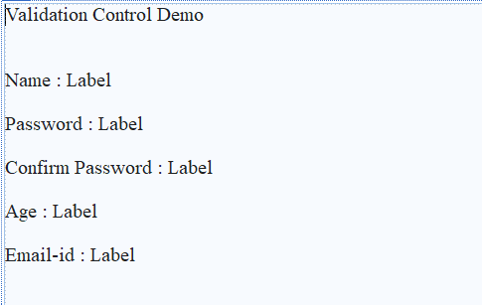

<%@ Page Language="C#" AutoEventWireup="true" CodeBehind="WebForm2.aspx.cs" Inherits="Validation.WebForm2" %>

<!DOCTYPE html>

<html xmlns="http://www.w3.org/1999/xhtml">

<head runat="server">

<title></title>

</head>

<body>

<form id="form1" runat="server">

<div style="height: 568px">

Validation Control Demo<br />

<br />

<br />

<asp:Label runat="server" Text="Name : "></asp:Label>

<asp:Label ID="lblName" runat="server" Text="Label"></asp:Label>

<br />

<br />

<asp:Label ID="Label8" runat="server" Text="Password : "></asp:Label>

<asp:Label ID="lblPass" runat="server" Text="Label"></asp:Label>

<br />

<br />

<asp:Label ID="Label10" runat="server">Confirm Password : </asp:Label>

<asp:Label ID="lblConPass" runat="server" Text="Label"></asp:Label>

<br />

<br />

<asp:Label ID="Label12" runat="server" Text="Age : "></asp:Label>

<asp:Label ID="lblAge" runat="server" Text="Label"></asp:Label>

<br />

<br />

<asp:Label ID="Label13" runat="server" Text="Email-id : "></asp:Label>

<asp:Label ID="lblMail" runat="server" Text="Label"></asp:Label>

</div>

</form>

</body>

</html>

**WebForm2.aspx.cs**

using System;

using System.Collections.Generic;

using System.Linq;

using System.Web;

using System.Web.UI;

using System.Web.UI.WebControls;

namespace Validation

{

public partial class WebForm2 : System.Web.UI.Page

{

protected void Page_Load(object sender, EventArgs e)

{

Page lastPage = (Page)Context.Handler;

lblName.Text = ((TextBox)lastPage.FindControl("TxtName")).Text;

lblPass.Text = ((TextBox)lastPage.FindControl("TxtPass")).Text;

lblConPass.Text = ((TextBox)lastPage.FindControl("TxtCOnPass")).Text;

lblAge.Text = ((TextBox)lastPage.FindControl("TxtAge")).Text;

lblMail.Text = ((TextBox)lastPage.FindControl("TxtMail")).Text;

}

}

}

* 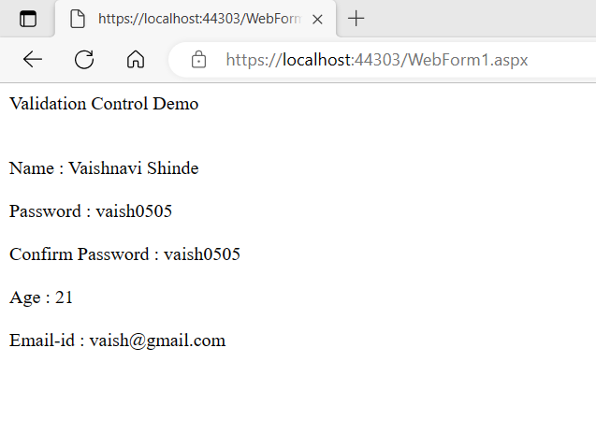**OUTPUT :**

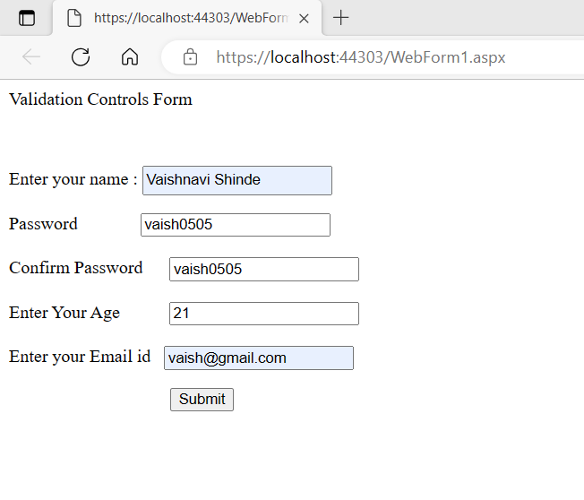

**Que.5.Design asp.net web application to demonstrate Master Page and Content Pages in asp.net.**

**Ans:**

* **CODE –**

**Site1.Master**

<%@ Master Language="C#" AutoEventWireup="true" CodeBehind="Site1.master.cs" Inherits="PracticalNo._2.Site1" %>

<!DOCTYPE html>

<html>

<head runat="server">

<title>Master Page Demonstartion</title>

<link href="css/StyleSheet1.css" rel="stylesheet" />

<asp:ContentPlaceHolder ID="head" runat="server">

</asp:ContentPlaceHolder>

</head>

<body>

<form id="form1" runat="server">

<div id="header">

<h1>Master Page Demonstration</h1>

</div>

<div id="nav">

<ul>

<li><a href="home.aspx">Home</a></li>

<li><a href="#">About</a></li>

<li><a href="#">Article</a></li>

<li><a href="#">Contact</a></li>

</ul>

</div>

<div id="right">

<h1>News</h1>

<a href="#">

<p>Creating a asp.net website</p>

</a>

<a href="#">

<p>Learn MVC</p>

</a>

<a href="#">

<p>Learn Web Services</p></a>

</div>

<div id="con">

<asp:ContentPlaceHolder ID="ContentPlaceHolder1" runat="server">

</asp:ContentPlaceHolder>

</div>

<div id="footer">

copyright @asp.net

</div>

</form>

</body>

</html>

**StyleSheet1.css**

#header {

color: #b91a1a;

text-align: center;

font-size: 20px;

}

#nav {

background-color: #ff0000;

color:#ff0000;

text-align: center;

padding: 5px;

}

ul {

list-style-type: none;

}

li a {

color: #F1FAEE;

font-size: 30px;

column-width: 5px;

}

li {

display: inline;

padding-left: 2px;

column-width: 20px;

}

a {

text-decoration: none;

margin-left: 20px;

}

li a:hover {

background-color: #F3FFBD;

padding: 1%;

color: #FF1654;

}

#news {

text-align: right;

padding-right: 2em;

width: 25%;

padding-bottom: 79%;

background-color: #C7EFCF;

}

#footer {

background-color: #C7EFCF;

padding-bottom: 5%;

text-align: center;

font-size: 20px;

}

#con {

border: double;

border-color: burlywood;

}

**home.aspx**

<%@ Page Title="" Language="C#" MasterPageFile="~/Site1.Master" AutoEventWireup="true" CodeBehind="home.aspx.cs" Inherits="PracticalNo._2.home" %>

<asp:Content ID="Content1" ContentPlaceHolderID="head" runat="server">

</asp:Content>

<asp:Content ID="Content2" ContentPlaceHolderID="ContentPlaceHolder1" runat="server">

<h1>Home page</h1>

<b>Master Pages and Content Pages in: [1]</b>

<br />

<ul>

<li>Master pages allow you to create a consistent look and behavior for all the pages (or group of pages) in your web application.</li>

<li>A master page provides a template for other pages, with shared layout and function</li>

<li>The master page defines placeholders for the content, which can be overridden by</li>

<li>The content pages contain the content you want to display.</li>

<li>When users request the content page, ASP.NET merges the pages to produc output</li>

<li>The @Master directive defines it as a master page. </li>

<li>The master page contains a placeholder tag asp:ContentPlaceHolder for individual</li>

<li>The id attribute identifies the placeholder, allowing many placeholders in the sar</li>

<li>The @Page directive defines it as a standard content page.

</li>

<li>The content page contains a content tag asp:Content with a reference to the master</li>

</ul>

</asp:Content>

* **OUTPUT :**

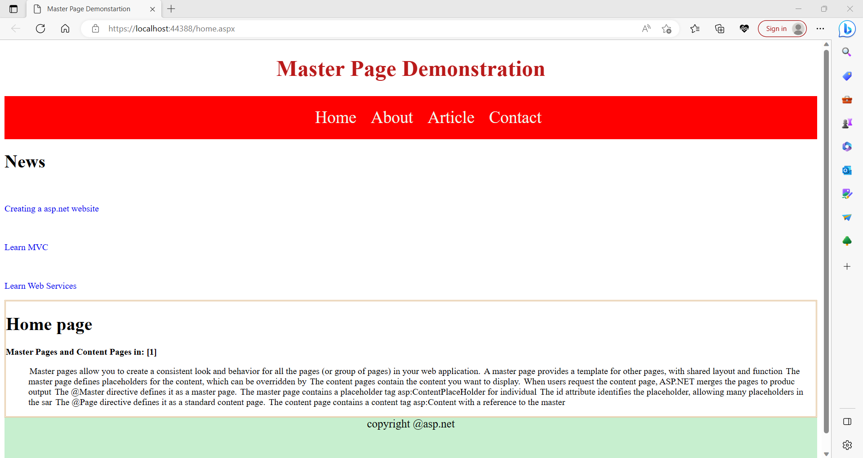

**Que.6. Design asp.net web form to demonstrate JQuery (use CDN JQuery library).**

**Ans:**

* **CODE –**

**JQueryDemo.aspx**

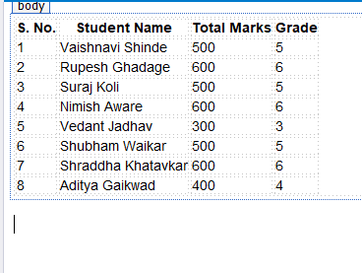

<%@ Page Language="C#" AutoEventWireup="true" CodeFile="JQueryDemo.aspx.cs" Inherits="JQueryDemo" %>

<!DOCTYPE html>

<html xmlns="http://www.w3.org/1999/xhtml">

<head runat="server">

<title></title>

<style type="text/css">

body{font-family:Arial; font-size:14px;}

</style>

<script type="text/javascript" src="http://ajax.googleapis.com/ajax/libs/jquery/1.3.2/jquery.min.js"></script>

<script type="text/javascript" >

$(document).ready(function () {

$("#tblStudents").css("font-style", "Arial");

$("#tblStudents tr:even").not('thead tr').css("background-color", "#ccc");

<%-- even row formatting --%>

$("#tblStudents tr:odd").css("background-color", "#f5f5f5"); <%-- odd row formatting --%>

$("#tblStudents th").css({ "padding": "5px 10px", "color": "#fff" }); <%--table heading font formatting --%>

$("#tblStudents td").css("padding", "5px 10px");

$("#tblStudents tr th").css("background-color", "gray"); <%-- table heading row formatting --%>

});

</script>

</head>

<body>

<form id="form1" runat="server">

<div>

<table id="tblStudents" runat="server">

<thead>

<tr>

<th>S. No. </th>

<th> Student Name</th>

<th>Total Marks</th>

<th>Grade</th>

</tr>

</thead>

<tr>

<td> 1 </td>

<td> Vaishnavi Shinde</td>

<td>500</td>

<td>5</td>

</tr>

<tr>

<td>2</td>

<td>Rupesh Ghadage</td>

<td> 600</td>

<td>6 </td>

</tr>

<tr>

<td>3</td>

<td>Suraj Koli </td>

<td>500</td>

<td>5</td>

</tr>

<tr>

<td>4 </td>

<td>Nimish Aware </td>

<td>600</td>

<td>6</td>

</tr>

<tr>

<td>5</td>

<td>Vedant Jadhav </td>

<td>300</td>

<td>3</td>

</tr>

<tr>

<td>6</td>

<td>Shubham Waikar</td>

<td>500</td>

<td>5</td>

</tr>

<tr>

<td>7</td>

<td>Shraddha Khatavkar</td>

<td>600</td>

<td>6</td>

</tr>

<tr>

<td>8</td>

<td>Aditya Gaikwad</td>

<td>400</td>

<td> 4</td>

</tr>

</table>

</div>

</form>

</body>

</html>

* **OUTPUT :**

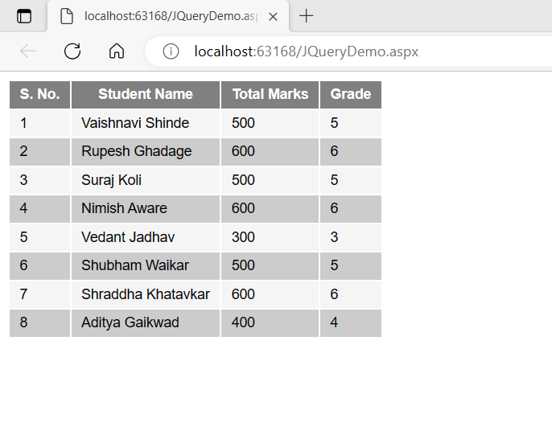

**Que.7.Design asp.net web form to demonstrate JQuery (download and use local JQuery library).**

**Ans:**

* **CODE –**

**JQueryLocal.aspx**

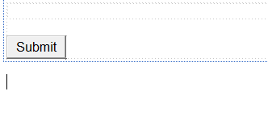

<%@ Page Language="C#" AutoEventWireup="true" CodeFile="JQueryLocal.aspx.cs" Inherits="JQueryLocal" %>

<!DOCTYPE html>

<script type="text/javascript" src="/Scripts/jquery-3.6.0.min.js"></script>

<script type="text/javascript" >

$(document).ready(function ()

{

$("#btnSubmit").click(function ()

{ alert("Alert using jQuery"); });

});

</script>

<html xmlns="http://www.w3.org/1999/xhtml">

<head runat="server">

<title></title>

</head>

<body>

<form id="form1" runat="server">

<div>

</div>

<p>

<asp:Button ID="btnSubmit" runat="server" Text="Submit" />

</p>

</form>

</body>

</html>

* **OUTPUT :**

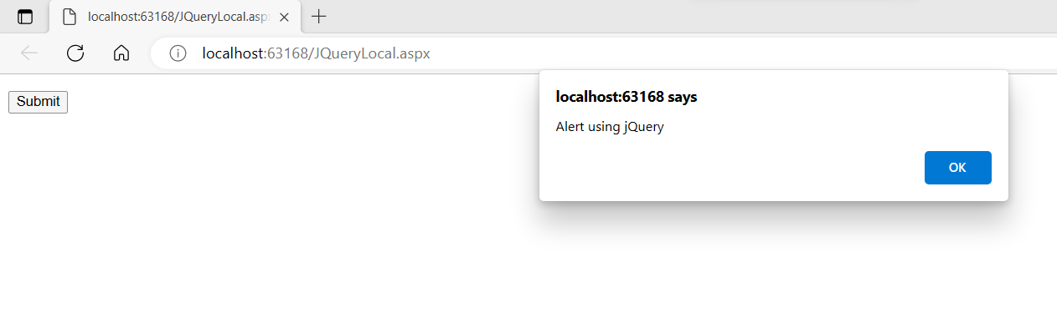

**Que.8. Design asp.net web form to demonstrate AngularJS (use CDN).**

**Ans:**

* **CODE –**

**AngularJsCDN.aspx**

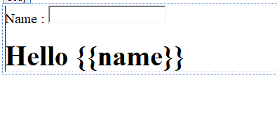

<%@ Page Language="C#" AutoEventWireup="true" CodeFile="AngularJsCDN.aspx.cs" Inherits="AngularJsCDN" %>

<!DOCTYPE html>

<html xmlns="http://www.w3.org/1999/xhtml">

<head runat="server">

<title>AngularJS Demo</title>

</head>

<script src="https://ajax.googleapis.com/ajax/libs/angularjs/1.6.9/angular.min.js"></script>

<body>

<form id="form1" runat="server">

<div ng-app="">

<p>Name : <input type="text" ng-model="name"></p>

<h1>Hello **{{**name**}}**</h1>

</div>

</form>

</body>

</html>

* **OUTPUT :**

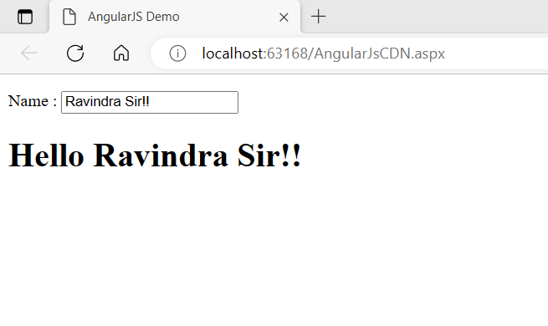

**Que.9. Design asp.net web form to demonstrate AngularJS (download and use local library).**

**Ans:**

* **CODE –**

**AngularJSLocal.aspx**

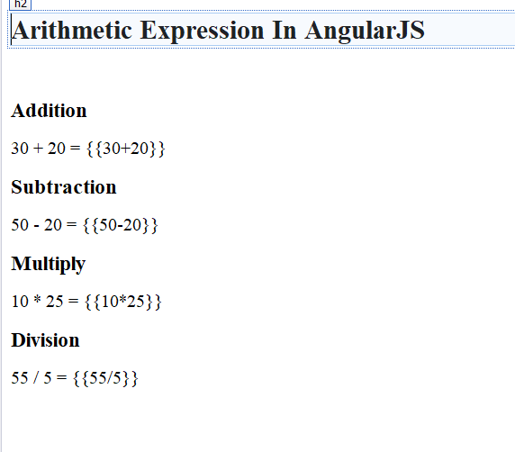

<%@ Page Language="C#" AutoEventWireup="true" CodeFile="AngularJsLocal.aspx.cs" Inherits="AngularJsLocal" %>

<!DOCTYPE html>

<html xmlns="http://www.w3.org/1999/xhtml">

<head runat="server">

<title>Angular Js Demo</title>

<script src="Scripts/angular.min.js"></script>

</head>

<body ng-app="">

<h2>Arithmetic Expression In AngularJS</h2>

<br />

<h3>Addition</h3>

30 + 20 = **{{**30+20**}}**

<br />

<h3>Subtraction</h3>

50 - 20 = **{{**50-20**}}**

<br />

<h3>Multiply</h3>

10 * 25 = **{{**10*25**}}**

<br />

<h3>Division</h3>

55 / 5 = **{{**55/5**}}**

</body>

</html>

* **OUTPUT :**

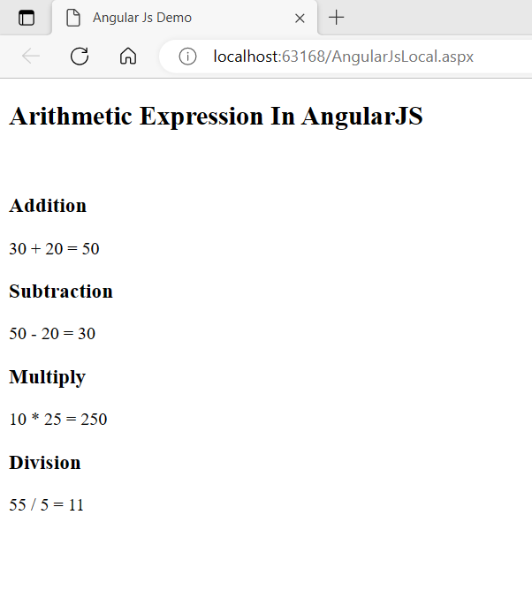

**Que.10. Design asp.net web form to demonstrate NodeJS.**

**Ans:**

* **CODE –**

**index.pug**

extends layout

block content

h1= title

p Welcome to #{title}

script.

var f1 = function() { document.getElementById('myImage').src='#{data.item1}' }

script.

var f2 = function() { document.getElementById('myImage').src='#{data.item2}' }

script.

var f3 = function() { document.getElementById('myImage').src='#{data.item3}' }

button(onclick='f1()') One!

button(onclick='f2()') Two!

button(onclick='f3()') Three!

p

a: img(id='myImage' height='300' width='300' src='')

**index.js**

'use strict';

var express = require('express');

var router = express.Router();

/* GET home page. */

var getData = function () {

var data = {

'item1': 'https://images.unsplash.com/photo-1563422156298-c778a278f9a5',

'item2': 'https://images.unsplash.com/photo-1620173834206-c029bf322dba',

'item3': 'https://images.unsplash.com/photo-1602491673980-73aa38de027a'

}

return data;

}

router.get('/', function (req, res) {

res.render('index', { title: 'Flowers Gallery',"data":getData() });

});

module.exports = router;

**users.js**

'use strict';

var express = require('express');

var router = express.Router();

/* GET users listing. */

router.get('/', function (req, res) {

res.send('respond with a resource');

});

module.exports = router;

* 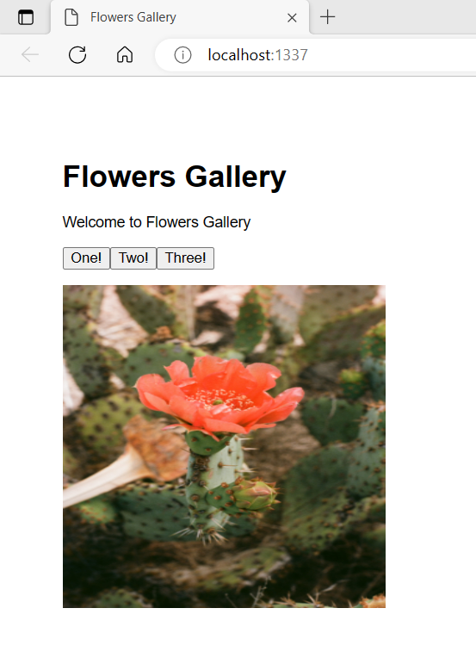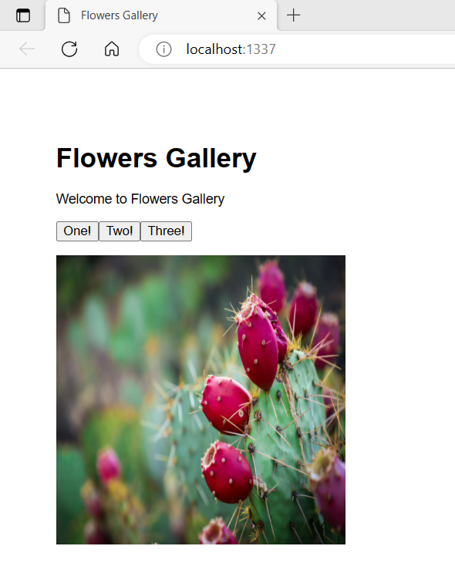**OUTPUT :**

