**FINOLEX ACADEMY OF MANAGEMENT AND TECHNOLOGY, RATNAGIRI**

**DEPARTMENT OF MCA**

**PRACTICAL NO. 06**

**ASP.NET MVC**

1. **Create an MVC application to demonstrate ViewBag Object.**

**Ans :**

* **Code :**

**HomeController.cs**

using System;

using System.Collections.Generic;

using System.Linq;

using System.Web;

using System.Web.Mvc;

namespace MyFirstMVCApp.Controllers

{

public class HomeController : Controller

{

// GET: Home

public ViewResult Index()

{

int hour = DateTime.Now.Hour;

ViewBag.Greeting = hour < 12 ? "Good Morning!!" : "Good Afternoon!!";

return View();

}}}

**Index.cshtml**

@{

Layout = null;

}

<!DOCTYPE html>

<html>

<head>

<meta name="viewport" content="width=device-width" />

<title>Index</title>

</head>

<body>

<div>

@ViewBag.Greeting (from the view)

</div>

</body>

</html>

* **Output :**

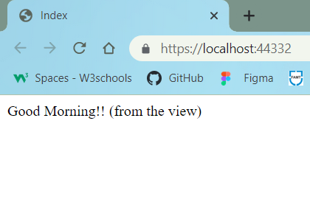

1. **Create an MVC application to accept Customer details and display the same using views. Use automatically implemented properties, strongly typed HTML Input helpers methods.**

**Ans :**

* **Code :**

**HomeController.cs**

using CustomerApplication.Models;

using System;

using System.Collections.Generic;

using System.Linq;

using System.Web;

using System.Web.Mvc;

namespace CustomerApplication.Controllers

{

public class HomeController : Controller

{

// GET: Home

public ActionResult Index()

{

return View();

}

[HttpGet]

public ViewResult CustomerInput()

{

return View();

}

[HttpPost]

public ViewResult CustomerInput(Customer c1)

{

if (ModelState.IsValid)

{

return View("CustomerDisplay", c1);

}

else

{ //There is validation error

return View();

}

}

}

}

**Indesx.cshtml**

@{

Layout = null;

}

<!DOCTYPE html>

<html>

<head>

<meta name="viewport" content="width=device-width" />

<link href="~/Content/bootstrap.css" rel="stylesheet" />

<link href="~/Content/bootstrap-theme.css" rel="stylesheet" />

<title>Customer Information System</title>

<style>

.btn a {

color: white;

text-decoration: none

}

body {

background-color: #F1F1F1;

}

</style>

</head>

<body>

<div class="text-center">

<p> Customer information system allows to store retrive customer details </p>

<div class="btn btn-success">

@Html.ActionLink("Add Customer Details", "CustomerInput")

</div>

</body>

</html>

**CustomerInput.cshtml**

@model CustomerApplication.Models.Customer

@{

Layout = null;

}

<!DOCTYPE html>

<html>

<head>

<link href="~/Content/bootstrap.css" rel="stylesheet" />

<link href="~/Content/bootstrap-theme.css" rel="stylesheet" />

<meta name="viewport" content="width=device-width" />

<link rel="stylesheet" type="text/css" href="~/Content/StyleSheet1.css" />

<title>CustomerInput</title>

</head>

<body>

<div class="panel panel-success">

<div class="panel-heading text-center">

<h4>

Customer Information

System

</h4>

</div>

<div class="panel-body">

@using (Html.BeginForm())

{

@Html.ValidationSummary()

<div class="form-group">

<label>Customer ID :</label>@Html.TextBoxFor(x => x.CustID, new{ @class = "form-control" })

</div>

<div class="form-group">

<label>Customer Name :</label>@Html.TextBoxFor(x =>x.CustName, new { @class = "form-control" })

</div><div class="form-group">

<label>Customer Address:</label>@Html.TextBoxFor(x =>x.CustAdd, new { @class = "form-control" })

</div>

<div class="text-center">

<input class="btn btn-success" type="submit" value="Submit Customer Data" />

</div> }

</div>

</div>

</body>

</html>

**CustomerDisplay.cshtml**

@model CustomerApplication.Models.Customer

@{

Layout = null;

}

<!DOCTYPE html>

<html>

<head>

<link href="~/Content/bootstrap.css" rel="stylesheet" />

<link href="~/Content/bootstrap-theme.css" rel="stylesheet" />

<meta name="viewport" content="width=device-width" />

<title>CustomerDisplay</title>

<style>

body {

background-color: #F1F1F1;

}

</style>

</head>

<body>

<div class="text-center">

<h1>Customer Information System</h1>

<p>Customer ID : @Model.CustID</p>

<p>Customer Name : @Model.CustName</p>

<p>Customer Address : @Model.CustAdd</p>

</div>

</body>

</html>

**Customer.cs**

using System;

using System.Collections.Generic;

using System.ComponentModel.DataAnnotations;

using System.Linq;

using System.Web;

namespace CustomerApplication.Models

{

public class Customer

{

[Required(ErrorMessage = "Please enter Customer ID!")]

public int CustID { get; set; }

[Required(ErrorMessage = "Please enter Customer Name!")]

public string CustName { get; set; }

[Required(ErrorMessage = "Please enter Customer Address!")]

public string CustAdd { get; set; }

}

}

**StyleSheet1.css**

body {

.field-validation-error

{

color: #f00;

}

.field-validation-valid {

display: none;

}

.input-validation-error {

border: 1px solid #f00;

background-color: #fee;

}

.validation-summary-errors {

font-weight: bold;

color: #f00;

}

.validation-summary-valid {

display:  none;

}

* **Output :**

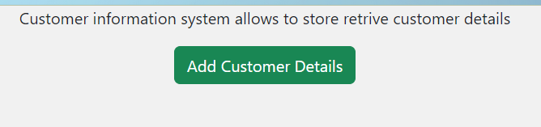

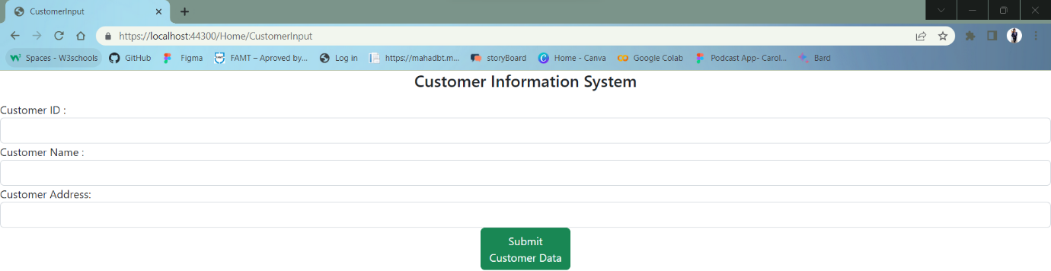

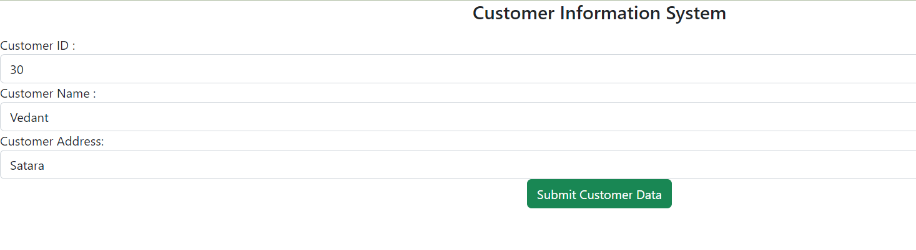

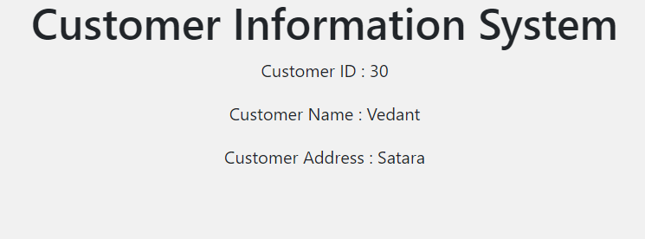

1. **Create an MVC application to demonstrate extension methods and use layout.**

**Ans :**

* **Code :**

**HomeController.cs**

using ProductMVCApplication.Models;

using System;

using System.Collections.Generic;

using System.Linq;

using System.Text;

using System.Web;

using System.Web.Mvc;

namespace ProductMVCApplication.Controllers

{

public class HomeController : Controller

{

// GET: Home

public ViewResult AutoProperty()

{

Product p1 = new Product();

p1.Name = "Kayak";

string pName = p1.Name;

return View("AutoProperty", (object)String.Format("Product name: {0}", pName));

}

public ViewResult CreateProduct()

{

Product p1 = new Product();

p1.ProductID = 100;

p1.Name = "Kayak";

p1.Price = 1500;

return View("AutoProperty", (object)String.Format("Price: {0}", p1.Price));

}

public ViewResult CreateCollection()

{

string[] stringArray = { "apple", "orange", "plum" };

List<int> intList = new List<int> { 10, 20, 30, 40 };

Dictionary<string, int> myDict = new Dictionary<string, int>

{ { "apple", 10 }, { "orange", 20 }, { "plum", 30 } };

return View("Result", (object)stringArray[1]);

}

public ViewResult UseExtension()

{

ShoppingCart cart = new ShoppingCart

{

Products = new List<Product>

{

new Product {Name = "Kayak", Price = 275M},

new Product {Name = "Lifejacket", Price = 48.95M},

new Product {Name = "Soccer ball", Price = 19.50M},

new Product {Name = "Corner flag", Price = 34.95M}

}

};

decimal cartTotal = cart.TotalPrices();

return View("Result", (object)String.Format("Total: {0:c}", cartTotal));

}

public ViewResult CreateAnonArray()

{

var oddsAndEnds = new[]

{

new { Name = "MVC", Category = "Pattern" },

new { Name = "Hat", Category = "Clothing" },

new { Name = "Apple", Category = "Fruit" }

};

StringBuilder result = new StringBuilder();

foreach (var item in oddsAndEnds)

{

result.Append(item.Name).Append(" ");

}

return View("Result", (object)result.ToString());

}

Product myProduct = new Product

{

ProductID = 1,

Name = "Kayak",

Description = "A boat for one person",

Category = "Watersports",

Price = 275M

};

public ActionResult Index()

{

return View(myProduct);

}

}

}

**Product.cs**

using System;

using System.Collections.Generic;

using System.Linq;

using System.Web;

namespace ProductMVCApplication.Models

{

public class Product

{

public int ProductID { get; set; }

public string Name { get; set; }

public string Description { get; set; }

public decimal Price { get; set; }

public string Category { set; get; }

}

}

**ShoppingCart.cs**

using System;

using System.Collections.Generic;

using System.Linq;

using System.Web;

namespace ProductMVCApplication.Models

{

public class ShoppingCart

{

public List<Product> Products { get; set; }

}

}

**MyExtensionMethods.cs**

using System;

using System.Collections.Generic;

using System.Linq;

using System.Web;

namespace ProductMVCApplication.Models

{

public static class MyExtensionMethods

{

public static decimal TotalPrices(this ShoppingCart cartParam)

{

decimal total = 0;

foreach (Product prod in cartParam.Products)

{ total += prod.Price; }

return total;

}

}

}

**AutoProperty.cshtml**

@model String

@{

Layout = null;

}

<!DOCTYPE html>

<html>

<head>

<meta name="viewport" content="width=device-width" />

<title>AutoProperty</title>

</head>

<body>

<div>

@Model

</div>

</body>

</html>

**Index.cshtml**

@model ProductMVCApplication.Models.Product

@{

ViewBag.Title = "Product Name";

Layout = "~/Views/_BasicLayout.cshtml";

}

<!DOCTYPE html>

<html>

<head>

<meta name="viewport" content="width=device-width" />

<title>Index</title>

</head>

<body>

<div>

Product Name = @Model.Name<br />

Product Price=@Model.Price

</div>

</body>

</html>

**Result.cshtml**

@model String

@{

Layout = null;

}

<!DOCTYPE html>

<html>

<head>

<meta name="viewport" content="width=device-width" />

<title>Result</title>

</head>

<body>

<div>

@Model

</div>

</body>

</html>

**_BasicLayout.cshtml**

<!DOCTYPE html>

<html>

<head>

<meta name="viewport" content="width=device-width" />

<title>@ViewBag.Title</title>

</head>

<body>

<h1>Product Information</h1>

<div style="padding: 20px; border: solid medium black; font-size: 20pt">

@RenderBody()

</div>

<h2>Visit <a href="https://www.snapdeal.com/">Snapdeal</a></h2>

</body>

</html>

**RouteConfig.cs**

using System;

using System.Collections.Generic;

using System.Linq;

using System.Web;

using System.Web.Mvc;

using System.Web.Routing;

namespace ProductMVCApplication

{

public class RouteConfig

{

public static void RegisterRoutes(RouteCollection routes)

{

routes.IgnoreRoute("{resource}.axd/{*pathInfo}");

routes.MapRoute(

name: "Default",

url: "{controller}/{action}/{id}",

defaults: new { controller = "Home", action = "Index", id = UrlParameter.Optional }

);

}

}

}

* **Output :**



