**Practical No. 10**

**Title: Create a SPA (Single Page Application)**

**Aim: To Create a SPA (Single Page Application)**

**Implementation:**

**Program:**

**Register.html**

<html>

    <body>

        <script src="https://ajax.googleapis.com/ajax/libs/angularjs/1.8.2/angular.min.js"></script>

        <style>

            .center {

  margin: auto;

  width: 50%;

  border: 3px solid rgb(10, 10, 10);

  padding: 10px;

}

           body {

  background-image: url("image1.jpg");

}

        </style>

    </body>

    <body>

<center><h1><b></b>REGISTER</h1></b></center>

    <form action="formsubmit" method="POST">

        <center>

        <input type="text" placeholder="Enter name" name="name1" id="name1" style="width: 250px; height: 30px;" /><br>

        <br>

        <input type="email" placeholder="Enter mail id" name="email" id="email" style="width: 250px; height: 30px;" /><br>

        <br>

        <input type="text" placeholder="Enter branch" name="branch" id="branch"style="width: 250px; height: 30px;" /><br>

        <br>

        <input type="text" placeholder="Enter div" name="div" id="div" style="width: 250px; height: 30px;" /><br>

        <br>

        <input type="text" placeholder="Enter city" name="city" id="city"style="width: 250px; height: 30px;" /><br>

        <br>

        <input type="submit" style="width: 200px; color: rgb(74, 134, 194); height: 30px "/><br>

        <br>

        <input type="button" value="Delete" style="width: 200px; color: rgb(44, 102, 201); height: 30px"/><br>

        <br><br>

    </center>

    </form>

</body>

    </html>

**Index.js**

const express = require ('express');

var mysql = require('mysql');

var app = express();

var bodyparser = require ('body-parser');

app.use(bodyparser.json());

app.use(bodyparser.urlencoded({extended:true}));

app.get('/regsiter1',(req,res)=>{

    res.sendFile(__dirname+ '/regsiter1.html')

});

var con = mysql.createConnection({

    host: 'localhost',

    user: 'root',

    password:'',

    database:'student'

});

app.post('/formsubmit', (req,res)=>{

name1  =req.body.name1;

email   =req.body.email;

branch =req.body.branch;

sdiv    = req.body.div;

city   = req.body.city;

con.connect (function(error){

    if(error)throw error;

    console.log('connected');

    con.query(" INSERT INTO studentrecords(name1,email,branch,div,city)VALUES('"+name1+"','"+email+"','"+branch+"','"+div+"','"+city+"')",

    function(error,result){

        if (error)throw error;

        console.log('record inserted');

    })

})

});

app.listen(8098);

**Output:**

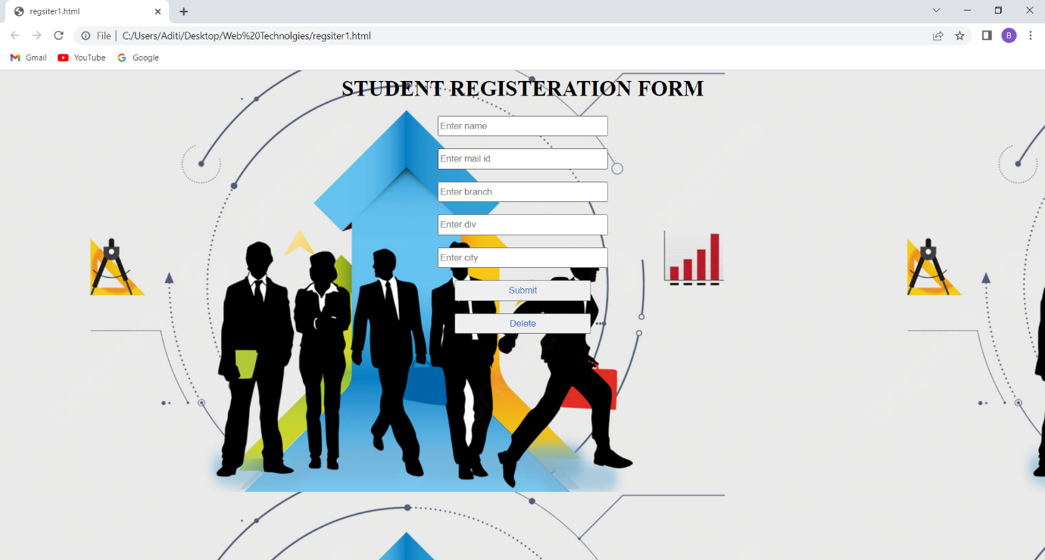

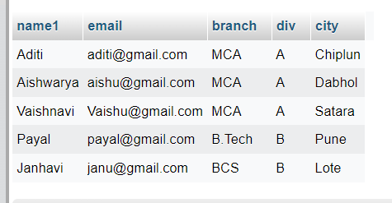

**Practical No. 11**

**Title: Create a SPA (Single Page Application) To Do List**

**Aim: To Create a SPA (Single Page Application)**

**Implementation:**

**Program:**

<!DOCTYPE html>

<html>

<link href="https://cdn.jsdelivr.net/npm/bootstrap@5.0.2/dist/css/bootstrap.min.css" rel="stylesheet" integrity="sha384-EVSTQN3/azprG1Anm3QDgpJLIm9Nao0Yz1ztcQTwFspd3yD65VohhpuuCOmLASjC" crossorigin="anonymous">

<script src="https://cdn.jsdelivr.net/npm/bootstrap@5.0.2/dist/js/bootstrap.bundle.min.js" integrity="sha384-MrcW6ZMFYlzcLA8Nl+NtUVF0sA7MsXsP1UyJoMp4YLEuNSfAP+JcXn/tWtIaxVXM" crossorigin="anonymous"></script>

<script src="https://cdn.jsdelivr.net/npm/@popperjs/core@2.9.2/dist/umd/popper.min.js" integrity="sha384-IQsoLXl5PILFhosVNubq5LC7Qb9DXgDA9i+tQ8Zj3iwWAwPtgFTxbJ8NT4GN1R8p" crossorigin="anonymous"></script>

<script src="https://cdn.jsdelivr.net/npm/bootstrap@5.0.2/dist/js/bootstrap.min.js" integrity="sha384-cVKIPhGWiC2Al4u+LWgxfKTRIcfu0JTxR+EQDz/bgldoEyl4H0zUF0QKbrJ0EcQF" crossorigin="anonymous"></script>

<script src="https://ajax.googleapis.com/ajax/libs/angularjs/1.6.9/angular.min.js">

</script>

<body ng-app="todoapp" ng-controller="todoctrl">

<div class="container alert alert-primary">

<h2>MCA Todo List SPA</h2>

<form ng-submit="todoAdd()">

<input class="form-control" type="text" ng-model="todoInput" size="20" placeholder="Add New">

<input class="btn btn-primary" type="submit" value="Add New">

</form>

</div>

<br>

<div class="container mt-4 p-5 bg-primary text-white rounded">

<h2>MCA Todo List Items</h2>

<div ng-repeat="x in todoList">

<h4><input class="form-check-input" type="checkbox" ng-model="x.done"> <span ng-bind="x.todoText"></span></h4>

</div>

<p><button class="btn btn-warning" ng-click="remove()">Remove marked</button></p>

</div>

<script>

var app = angular.module('todoapp', []);

app.controller('todoctrl', function($scope) {

$scope.todoList = [];

$scope.todoAdd = function() {

$scope.todoList.push({todoText:$scope.todoInput, done:false});

$scope.todoInput = "";

};

$scope.remove = function() {

var oldList = $scope.todoList;

$scope.todoList = [];

angular.forEach(oldList, function(x) {

if (!x.done) $scope.todoList.push(x);

});

};

});

</script>

</body>

</html

**Output:**

