# FINOLEX ACADEMY OF MANAGEMENT AND TECHNOLOGY, RATNAGIRI DEPARTMENT OF MCA

**PRACTICAL NO .02**

# Q1. Create tables Employee and Department as per the given schema and insert data into them.dept(deptno number(2,0),dname varchar2(14),loc varchar2(13),constraint pk_dept primary key (deptno)); emp(empno number(4,0),ename varchar2(10), job varchar2(9), mgr number(4,0),hiredate date,sal number(7,2),comm number(7,2),deptno number(2,0), constraint pk_emp primary key (empno),constraint fk_deptno foreign key (deptno) references dept (deptno));

**Execute the following queries.**

# Create a table employee with attribute empid, name, deptid,deptname, salary and joining date.

**Write the queries -**

# To return the first salary reported in each department.

1. **To show us how the average salary has changed over the years**

# To display the salary of each employee, along with the lowest and highest within their department

1. **To divide the whole result set into five buckets based on salary**

# To display for each employee in Department 30 in the employees table, the hire date of the employee hired just after

=>create table dept( deptno number(2,0), dname varchar2(14), loc varchar2(13),

constraint pk_dept primary key (deptno)

);

create table emp( empno number(4,0), ename varchar2(10), job varchar2(9), mgr number(4,0), hiredate date,

sal number(7,2), comm number(7,2), deptno number(2,0),

constraint pk_emp primary key (empno),

constraint fk_deptno foreign key (deptno) references dept (deptno)

);

insert into dept

values(10, 'ACCOUNTING', 'NEW YORK');

insert into dept

values(20, 'RESEARCH', 'DALLAS');

insert into dept

values(30, 'SALES', 'CHICAGO');

insert into dept

values(40, 'OPERATIONS', 'BOSTON');

insert into emp values(

7839, 'KING', 'PRESIDENT', null,

to_date('17-11-1981','dd-mm-yyyy'), 5000, null, 10

);

insert into emp values(

7698, 'BLAKE', 'MANAGER', 7839,

to_date('1-5-1981','dd-mm-yyyy'), 2850, null, 30

);

insert into emp values(

7782, 'CLARK', 'MANAGER', 7839,

to_date('9-6-1981','dd-mm-yyyy'), 2450, null, 10

);

insert into emp values(

7566, 'JONES', 'MANAGER', 7839,

to_date('2-4-1981','dd-mm-yyyy'), 2975, null, 20

);

insert into emp values(

7788, 'SCOTT', 'ANALYST', 7566,

to_date('13-JUL-87','dd-mm-rr') - 85,

3000, null, 20

);

insert into emp values(

7902, 'FORD', 'ANALYST', 7566,

to_date('3-12-1981','dd-mm-yyyy'), 3000, null, 20

);

insert into emp values(

7369, 'SMITH', 'CLERK', 7902,

to_date('17-12-1980','dd-mm-yyyy'), 800, null, 20

);

insert into emp values(

7499, 'ALLEN', 'SALESMAN', 7698,

to_date('20-2-1981','dd-mm-yyyy'), 1600, 300, 30

);

insert into emp values(

7521, 'WARD', 'SALESMAN', 7698,

to_date('22-2-1981','dd-mm-yyyy'), 1250, 500, 30

);

insert into emp values(

7654, 'MARTIN', 'SALESMAN', 7698,

to_date('28-9-1981','dd-mm-yyyy'), 1250, 1400, 30

);

insert into emp values(

7844, 'TURNER', 'SALESMAN', 7698,

to_date('8-9-1981','dd-mm-yyyy'), 1500, 0, 30

);

insert into emp values(

7876, 'ADAMS', 'CLERK', 7788,

to_date('13-JUL-87', 'dd-mm-rr') - 51, 1100, null, 20

);

insert into emp values(

7900, 'JAMES', 'CLERK', 7698,

to_date('3-12-1981','dd-mm-yyyy'), 950, null, 30

);

insert into emp values(

7934, 'MILLER', 'CLERK', 7782,

to_date('23-1-1982','dd-mm-yyyy'), 1300, null, 10

);

# To return the first salary reported in each department.

select empno,sal, sum (sal) over() as avg_dept_sal from emp;

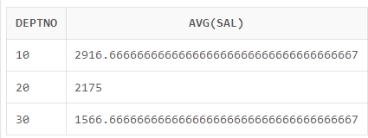

# To show us how the average salary has changed over the years

select avg(sal) from emp;

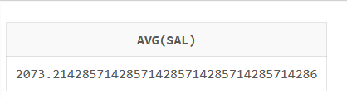

# To display the salary of each employee, along with the lowest and highest within their Department

SELECT MIN(sal) AS min_sal, MAX(sal) AS max_sal

FROM emp;

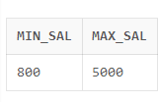

# To divide the whole result set into five buckets based on salary

SELECT empno, ename,deptno,sal,

NTILE(5) OVER (ORDER BY sal) AS bucket_no FROM emp;

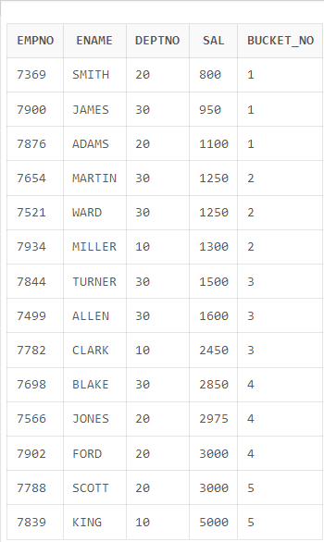

# To display for each employee in Department 30 in the employees table, the hire date of the employee hired just after

SELECT ename, hiredate,

LEAD(hiredate, 1) OVER (ORDER BY hiredate) AS "Next Hired" FROM emp WHERE deptno = 30 ORDER BY hiredate;

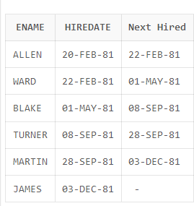

# 2. Create the table Sales and insert records as given. Write analytical queries –

1. **To find total profit for each country.**

SELECT Country, SUM(Profit) AS Total_Profit FROM Sale

GROUP BY Country;

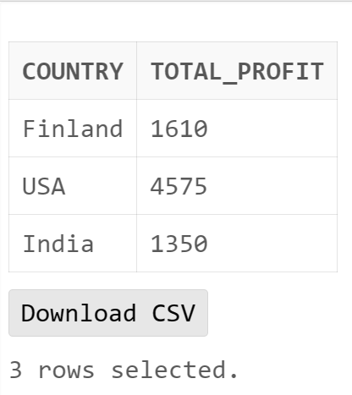

1. **Display Country with maximum profit.** SELECT Country, MAX(Profit) AS Total_Profit FROM Sale

GROUP BY Country;

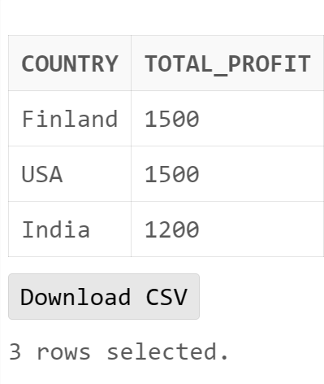

# Display products with maximum and minimum profit in each country.

SELECT Country, Product, MAX(Profit) AS Max_Profit, MIN(Profit) AS Min_Profit FROM Sale

GROUP BY Country, Product;

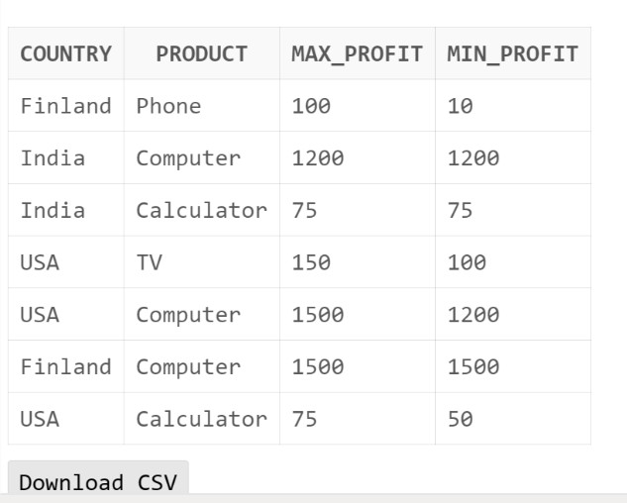

# Display average sale of each product in each country.

SELECT Country, Product, AVG(Profit) as avg_profit FROM Sale

GROUP BY Country, Product;

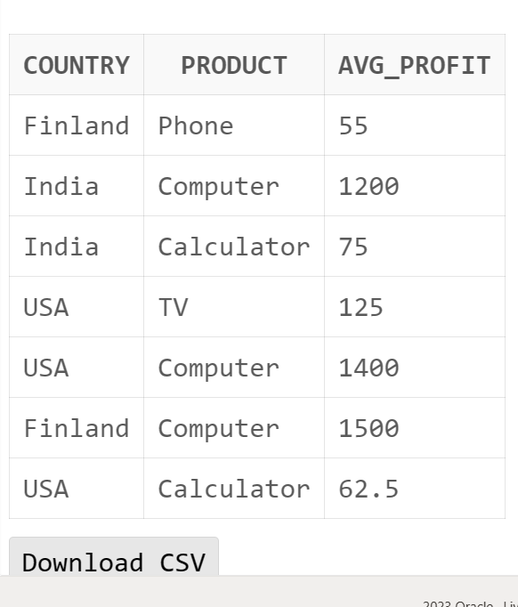

# Find total profit product wise.

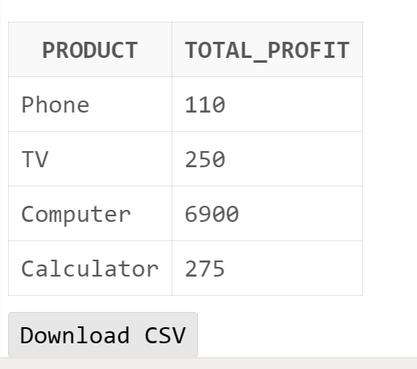

**3. The research is about to create the star schema for the sales system. The research consists**

# of all the information related to the sale’s record like items, location and the time etc.

**Create a**

# schema (database) with fact and dimension tables. Perform the OLAP operations on your schema.

* **Suppose we want to record in a warehouse information about every Item sale, e.g.:**

# Product number,

* **location from where the product was sold,**

# date of the sale, and

* **Units sold.**

# The fact table is thus:

**Sales(item_key, loc_key, time_key, units)**

# The dimension tables include information about the Items, Location, and time “dimensions”:

**Loc(loc_key, city,state,country) items(item_key,item_name, item_category, color,price) Time(time_key,sdate,week,month,quarter,syear),**

# Display data for quarter 1.

1. **Display total sales of pen or jeans from “mumbai&quot; or “chennai” for quarter 1 or 2.**

# Find the total units sales in each state.

1. **Find the total units sales in each city**

CREATE TABLE loc(loc_key INT NOT NULL PRIMARY KEY,city varchar(30),state varchar(30),country varchar(30));

CREATE TABLE items(item_key INT NOT NULL PRIMARY KEY,item_name varchar(30),item_category varchar(30),color varchar(30),price INT);

CREATE TABLE Stime (time_key DATE NOT NULL PRIMARY KEY, sdate date,week varchar(30),smonth varchar(30),quarter varchar(30),syear int);

CREATE TABLE salesfact(loc_key INT, item_key int,time_key date,units_sold int,

FOREIGN KEY(loc_key) REFERENCES loc(loc_key), FOREIGN KEY(item_key) REFERENCES items(item_key), FOREIGN KEY(time_key) REFERENCES Stime(time_key)); INSERT INTO loc VALUES(1,'Southlake','Texas','US'); INSERT INTO loc VALUES(2,'Houston','Texas','US');

INSERT INTO loc VALUES(3,'Chennai','Maharashtra','India');

INSERT INTO loc VALUES(4,'Mumbai','Maharashtra','US'); INSERT INTO loc VALUES(5,'Algoma','Ontario','Canada'); INSERT INTO loc VALUES(6,'Bemont','Ontario','Canada'); INSERT INTO loc VALUES(7,'Devon','Alberta','Canada'); INSERT INTO loc VALUES(8,'Fairview','Alberta','Canada'); INSERT INTO loc VALUES(9,'Ratnagiri','Maharashtra','India'); INSERT INTO loc VALUES(10,'Nashik','Maharashtra','India'); INSERT INTO loc VALUES(11,'Cochin','Kerala','India'); INSERT INTO loc VALUES(12,'Adur','Kerala','India');

INSERT INTO loc VALUES(13,'Brisbane','Queensland','Australia'); INSERT INTO loc VALUES(14,'Sydney','NewSouthWales','Australia');

insert into items values(1101,'Parker','Pen','black',1000); insert into items values(1102,'Parker','Pen','blue',1500);

insert into items values(1103,'CanonEOS1500','Camera','black',45000); insert into items values(1104,'Powershot','Camera','black',35000);

insert into items values(1105,'BoatRockerz255','Headphone','black',4000); insert into items values(1106,'PTron','Headphone','blue',5000);

insert into items values(1107,'Basshead225','Headphone','red',2000); insert into items values(1108,'JBLC100S1','Headphone','black',7000);

insert into items values(1109,'realme Buds2','Headphone','black',5500); insert into items values(1110,'Sony SA D40','HomeAudio','black',5000);

insert into items values(1111,'Infinity JBL','HomeAudio','black',10000); insert into items values(1112,'Philips Audio','HomeAudio','black',9000); insert into items values(1113,'Rugged','Jeans','black',1500);

insert into items values(1114,'OneLap India GPS','GPS','black',4500); insert into items values(1115,'Drivool','GPS','black',3000);

insert into items values(1116,'OneLap GO','GPS','black',4000); insert into items values(1117,'SmartKey Finder','GPS','black',4500);

insert into items values(1118,'OneLap Micro','GPS','black',2000);

insert into items values(1119,'Samsung Galaxy 21','Tablet','black',15000); insert into items values(1120,'Lenovo Tab 10','Tablet','black',11000);

insert into items values(1121,'Apple iPad','Tablet','black',8500); insert into items values(1122,'YogaSmart','Tablet','black',18000); insert into items values(1123,'Panasonic','Tablet','black',10000);

Insert into Stime(time_key,sdate,week,smonth,quarter,syear) select

TIME_ID,TIME_ID,CALENDAR_WEEK_NUMBER,CALENDAR_MONTH_NUMBER,CALENDAR_Q UARTER_NUMBER,CALENDAR_YEAR from SH.TIMES;

insert into salesfact values(2,1101,'02-Jan-98',10); insert into salesfact values(3,1102,'03-Jan-98',20); insert into salesfact values(4,1103,'04-Jan-98',20); insert into salesfact values(5,1104,'05-Jan-98',30); insert into salesfact values(6,1105,'06-Jan-98',30); insert into salesfact values(7,1106,'07-Jan-98',40); insert into salesfact values(7,1111,'11-Dec-98',20); insert into salesfact values(8,1112,'12-Dec-98',20); insert into salesfact values(9,1113,'13-Dec-98',20); insert into salesfact values(10,1114,'14-Dec-98',20); insert into salesfact values(8,1107,'08-Jan-98',15); insert into salesfact values(9,1108,'09-Jan-98',16); insert into salesfact values(10,1102,'10-Jan-98',17); insert into salesfact values(1,1103,'11-Jan-98',18); insert into salesfact values(1,1104,'12-Jan-98',11); insert into salesfact values(2,1105,'13-Jan-98',15); insert into salesfact values(2,1106,'14-Jan-98',19); insert into salesfact values(3,1107,'15-Jan-98',20); insert into salesfact values(4,1108,'16-Jan-98',5); insert into salesfact values(1,1101,'11-Feb-98',10); insert into salesfact values(1,1101,'12-Feb-98',20); insert into salesfact values(1,1101,'13-Feb-98',30); insert into salesfact values(10,1102,'14-Feb-98',40); insert into salesfact values(10,1102,'15-Feb-98',40); insert into salesfact values(2,1103,'16-Feb-98',10); insert into salesfact values(2,1103,'17-Feb-98',10); insert into salesfact values(3,1104,'18-Feb-98',15); insert into salesfact values(3,1104,'19-Feb-98',12); insert into salesfact values(4,1105,'20-Feb-98',13); insert into salesfact values(5,1105,'21-Feb-98',15); insert into salesfact values(6,1106,'22-Feb-98',14);

insert into salesfact values(7,1111,'23-Feb-98',18); insert into salesfact values(8,1112,'24-Feb-98',12); insert into salesfact values(9,1113,'25-Feb-98',11); insert into salesfact values(10,1114,'26-Feb-98',10); insert into salesfact values(10,1115,'01-Mar-98',20); insert into salesfact values(1,1115,'02-Mar-98',11); insert into salesfact values(2,1116,'03-Mar-98',20); insert into salesfact values(3,1116,'04-Mar-98',30); insert into salesfact values(4,1117,'05-Mar-98',10); insert into salesfact values(5,1117,'06-Mar-98',20); insert into salesfact values(6,1118,'07-Mar-98',20); insert into salesfact values(7,1118,'08-Mar-98',20); insert into salesfact values(8,1119,'09-Mar-98',20); insert into salesfact values(9,1119,'10-Mar-98',20); insert into salesfact values(10,1120,'11-Mar-98',20); insert into salesfact values(2,1121,'12-Mar-98',20); insert into salesfact values(3,1121,'13-Mar-98',20); insert into salesfact values(4,1101,'14-Mar-98',20); insert into salesfact values(5,1102,'15-Mar-98',20); insert into salesfact values(1,1103,'16-Mar-98',20); insert into salesfact values(2,1104,'17-Apr-98',20); insert into salesfact values(3,1105,'18-Apr-98',20); insert into salesfact values(4,1106,'19-Apr-98',20); insert into salesfact values(5,1107,'20-Apr-98',20); insert into salesfact values(6,1108,'21-Apr-98',20); insert into salesfact values(7,1109,'22-Apr-98',20); insert into salesfact values(8,1110,'23-Apr-98',20); insert into salesfact values(9,1104,'24-Apr-98',20); insert into salesfact values(10,1105,'25-Apr-98',20); insert into salesfact values(1,1112,'26-Apr-98',20); insert into salesfact values(2,1113,'27-Apr-98',20); insert into salesfact values(2,1114,'28-Apr-98',20); insert into salesfact values(3,1123,'29-Apr-98',20); insert into salesfact values(4,1122,'30-Apr-98',20); insert into salesfact values(1,1101,'01-May-98',20); insert into salesfact values(2,1102,'02-May-98',20); insert into salesfact values(2,1102,'03-May-98',20); insert into salesfact values(3,1103,'04-May-98',20); insert into salesfact values(4,1103,'05-May-98',20); insert into salesfact values(5,1104,'06-May-98',20); insert into salesfact values(6,1104,'07-May-98',20); insert into salesfact values(7,1105,'08-May-98',20); insert into salesfact values(8,1105,'09-May-98',20); insert into salesfact values(9,1106,'10-May-98',20); insert into salesfact values(10,1106,'11-May-98',20); insert into salesfact values(9,1107,'12-May-98',20); insert into salesfact values(8,1107,'13-May-98',20);

insert into salesfact values(7,1108,'14-May-98',20); insert into salesfact values(6,1108,'15-May-98',20); insert into salesfact values(5,1109,'16-May-98',20); insert into salesfact values(1,1109,'17-Jun-98',20); insert into salesfact values(2,1110,'18-Jun-98',20); insert into salesfact values(3,1111,'19-Jun-98',20); insert into salesfact values(5,1112,'20-Jun-98',20); insert into salesfact values(4,1113,'21-Jun-98',20); insert into salesfact values(6,1114,'22-Jun-98',20); insert into salesfact values(7,1115,'23-Jun-98',20); insert into salesfact values(8,1116,'24-Jun-98',20); insert into salesfact values(9,1117,'25-Jun-98',20); insert into salesfact values(10,1101,'26-Jun-98',20); insert into salesfact values(10,1102,'27-Jun-98',20); insert into salesfact values(6,1103,'28-Jun-98',20); insert into salesfact values(7,1104,'29-Jun-98',20); insert into salesfact values(8,1105,'30-Jun-98',20); insert into salesfact values(1,1106,'07-Jul-98',20); insert into salesfact values(2,1107,'08-Jul-98',20); insert into salesfact values(3,1101,'09-Jul-98',20); insert into salesfact values(4,1102,'10-Jul-98',20); insert into salesfact values(5,1103,'11-Jul-98',20); insert into salesfact values(6,1104,'12-Jul-98',20); insert into salesfact values(7,1105,'13-Jul-98',20); insert into salesfact values(8,1106,'14-Jul-98',20); insert into salesfact values(9,1107,'15-Jul-98',20); insert into salesfact values(10,1117,'16-Jul-98',20); insert into salesfact values(1,1118,'17-Jul-98',20); insert into salesfact values(2,1119,'18-Jul-98',20); insert into salesfact values(3,1120,'01-Aug-98',20); insert into salesfact values(4,1121,'02-Aug-98',20); insert into salesfact values(5,1101,'03-Aug-98',20); insert into salesfact values(6,1102,'04-Aug-98',20); insert into salesfact values(7,1103,'05-Aug-98',20); insert into salesfact values(8,1104,'06-Aug-98',20); insert into salesfact values(9,1105,'07-Aug-98',20); insert into salesfact values(10,1106,'08-Aug-98',20); insert into salesfact values(1,1107,'09-Aug-98',20); insert into salesfact values(2,1108,'10-Aug-98',20); insert into salesfact values(3,1109,'11-Aug-98',20); insert into salesfact values(10,1110,'12-Aug-98',20); insert into salesfact values(4,1111,'13-Aug-98',20); insert into salesfact values(5,1112,'14-Aug-98',20); insert into salesfact values(6,1113,'15-Aug-98',20); insert into salesfact values(7,1114,'16-Aug-98',20); insert into salesfact values(1,1115,'01-Sep-98',20); insert into salesfact values(2,1116,'02-Sep-98',20);

insert into salesfact values(3,1117,'03-Sep-98',20); insert into salesfact values(4,1118,'04-Sep-98',20); insert into salesfact values(5,1119,'05-Sep-98',20); insert into salesfact values(6,1120,'06-Sep-98',20); insert into salesfact values(7,1121,'07-Sep-98',20); insert into salesfact values(8,1122,'08-Sep-98',20); insert into salesfact values(9,1101,'09-Sep-98',20); insert into salesfact values(10,1102,'10-Sep-98',20); insert into salesfact values(1,1103,'11-Sep-98',20); insert into salesfact values(2,1104,'12-Sep-98',20); insert into salesfact values(2,1105,'13-Sep-98',20); insert into salesfact values(3,1106,'14-Sep-98',20); insert into salesfact values(4,1107,'15-Oct-98',20); insert into salesfact values(5,1108,'16-Oct-98',20); insert into salesfact values(6,1109,'17-Oct-98',20); insert into salesfact values(7,1110,'18-Oct-98',20); insert into salesfact values(8,1111,'19-Oct-98',20); insert into salesfact values(9,1101,'20-Oct-98',20); insert into salesfact values(10,1102,'21-Oct-98',20); insert into salesfact values(1,1103,'22-Oct-98',20); insert into salesfact values(2,1104,'23-Oct-98',20); insert into salesfact values(3,1105,'24-Oct-98',20); insert into salesfact values(4,1101,'15-Nov-98',20); insert into salesfact values(5,1102,'16-Nov-98',20); insert into salesfact values(6,1103,'17-Nov-98',20); insert into salesfact values(7,1104,'18-Nov-98',20); insert into salesfact values(8,1105,'19-Nov-98',20); insert into salesfact values(9,1106,'20-Nov-98',20); insert into salesfact values(10,1107,'21-Nov-98',20); insert into salesfact values(1,1114,'22-Nov-98',20); insert into salesfact values(2,1115,'23-Nov-98',20); insert into salesfact values(3,1116,'24-Nov-98',20); insert into salesfact values(4,1117,'25-Nov-98',20); insert into salesfact values(5,1118,'26-Nov-98',20); insert into salesfact values(6,1101,'01-Dec-98',20); insert into salesfact values(7,1102,'02-Dec-98',20); insert into salesfact values(8,1103,'03-Dec-98',20); insert into salesfact values(9,1104,'04-Dec-98',20); insert into salesfact values(1,1105,'05-Dec-98',20); insert into salesfact values(2,1106,'06-Dec-98',20); insert into salesfact values(3,1107,'07-Dec-98',20); insert into salesfact values(4,1108,'08-Dec-98',20); insert into salesfact values(5,1109,'09-Dec-98',20); insert into salesfact values(6,1110,'10-Dec-98',20); insert into salesfact values(1,1101,'01-Jan-98',10); insert into salesfact values(1,1101,'01-Jan-99',10); insert into salesfact values(2,1101,'02-Jan-99',10);

insert into salesfact values(3,1102,'03-Jan-99',20); insert into salesfact values(4,1103,'04-Jan-99',20); insert into salesfact values(5,1104,'05-Jan-99',30); insert into salesfact values(6,1105,'06-Jan-99',30); insert into salesfact values(7,1106,'07-Jan-99',40); insert into salesfact values(8,1107,'08-Jan-99',15); insert into salesfact values(9,1108,'09-Jan-99',16); insert into salesfact values(10,1102,'10-Jan-99',17); insert into salesfact values(1,1103,'11-Jan-99',18); insert into salesfact values(1,1104,'12-Jan-99',11); insert into salesfact values(2,1105,'13-Jan-99',15); insert into salesfact values(2,1106,'14-Jan-99',19); insert into salesfact values(3,1107,'15-Jan-99',20); insert into salesfact values(4,1108,'16-Jan-99',5); insert into salesfact values(1,1101,'11-Feb-99',10); insert into salesfact values(1,1101,'12-Feb-99',20); insert into salesfact values(1,1101,'13-Feb-99',30); insert into salesfact values(10,1102,'14-Feb-99',40); insert into salesfact values(10,1102,'15-Feb-99',40); insert into salesfact values(2,1103,'16-Feb-99',10); insert into salesfact values(2,1103,'17-Feb-99',10); insert into salesfact values(3,1104,'18-Feb-99',15); insert into salesfact values(3,1104,'19-Feb-99',12); insert into salesfact values(4,1105,'20-Feb-99',13); insert into salesfact values(5,1105,'21-Feb-99',15); insert into salesfact values(6,1106,'22-Feb-99',14); insert into salesfact values(7,1111,'23-Feb-99',18); insert into salesfact values(8,1112,'24-Feb-99',12); insert into salesfact values(9,1113,'25-Feb-99',11); insert into salesfact values(10,1114,'26-Feb-99',10); insert into salesfact values(10,1115,'01-Mar-99',20); insert into salesfact values(1,1115,'02-Mar-99',11); insert into salesfact values(2,1116,'03-Mar-99',20); insert into salesfact values(3,1116,'04-Mar-99',30); insert into salesfact values(4,1117,'05-Mar-99',10); insert into salesfact values(5,1117,'06-Mar-99',20); insert into salesfact values(6,1118,'07-Mar-99',20); insert into salesfact values(7,1118,'08-Mar-99',20); insert into salesfact values(8,1119,'09-Mar-99',20); insert into salesfact values(9,1119,'10-Mar-99',20); insert into salesfact values(10,1120,'11-Mar-99',20); insert into salesfact values(2,1121,'12-Mar-99',20); insert into salesfact values(3,1121,'13-Mar-99',20); insert into salesfact values(4,1101,'14-Mar-99',20); insert into salesfact values(5,1102,'15-Mar-99',20); insert into salesfact values(1,1103,'16-Mar-99',20); insert into salesfact values(2,1104,'17-Apr-99',20);

insert into salesfact values(3,1105,'18-Apr-99',20); insert into salesfact values(4,1106,'19-Apr-99',20); insert into salesfact values(5,1107,'20-Apr-99',20); insert into salesfact values(6,1108,'21-Apr-99',20); insert into salesfact values(7,1109,'22-Apr-99',20); insert into salesfact values(8,1110,'23-Apr-99',20); insert into salesfact values(9,1104,'24-Apr-99',20); insert into salesfact values(10,1105,'25-Apr-99',20); insert into salesfact values(1,1112,'26-Apr-99',20); insert into salesfact values(2,1113,'27-Apr-99',20); insert into salesfact values(2,1114,'28-Apr-99',20); insert into salesfact values(3,1123,'29-Apr-99',20); insert into salesfact values(4,1122,'30-Apr-99',20); insert into salesfact values(1,1101,'01-May-99',20); insert into salesfact values(2,1102,'02-May-99',20); insert into salesfact values(2,1102,'03-May-99',20); insert into salesfact values(3,1103,'04-May-99',20); insert into salesfact values(4,1103,'05-May-99',20); insert into salesfact values(5,1104,'06-May-99',20); insert into salesfact values(6,1104,'07-May-99',20); insert into salesfact values(7,1105,'08-May-99',20); insert into salesfact values(8,1105,'09-May-99',20); insert into salesfact values(9,1106,'10-May-99',20); insert into salesfact values(10,1106,'11-May-99',20); insert into salesfact values(9,1107,'12-May-99',20); insert into salesfact values(8,1107,'13-May-99',20); insert into salesfact values(7,1108,'14-May-99',20); insert into salesfact values(6,1108,'15-May-99',20); insert into salesfact values(5,1109,'16-May-99',20); insert into salesfact values(1,1109,'17-Jun-99',20); insert into salesfact values(2,1110,'18-Jun-99',20); insert into salesfact values(3,1111,'19-Jun-99',20); insert into salesfact values(5,1112,'20-Jun-99',20); insert into salesfact values(4,1113,'21-Jun-99',20); insert into salesfact values(6,1114,'22-Jun-99',20); insert into salesfact values(7,1115,'23-Jun-99',20); insert into salesfact values(8,1116,'24-Jun-99',20); insert into salesfact values(9,1117,'25-Jun-99',20); insert into salesfact values(10,1101,'26-Jun-99',20); insert into salesfact values(10,1102,'27-Jun-99',20); insert into salesfact values(6,1103,'28-Jun-99',20); insert into salesfact values(7,1104,'29-Jun-99',20); insert into salesfact values(8,1105,'30-Jun-99',20); insert into salesfact values(1,1106,'07-Jul-99',20); insert into salesfact values(2,1107,'08-Jul-99',20); insert into salesfact values(3,1101,'09-Jul-99',20); insert into salesfact values(4,1102,'10-Jul-99',20);

insert into salesfact values(5,1103,'11-Jul-99',20); insert into salesfact values(6,1104,'12-Jul-99',20); insert into salesfact values(7,1105,'13-Jul-99',20); insert into salesfact values(8,1106,'14-Jul-99',20); insert into salesfact values(9,1107,'15-Jul-99',20); insert into salesfact values(10,1117,'16-Jul-99',20); insert into salesfact values(1,1118,'17-Jul-99',20); insert into salesfact values(2,1119,'18-Jul-99',20); insert into salesfact values(3,1120,'01-Aug-99',20); insert into salesfact values(4,1121,'02-Aug-99',20); insert into salesfact values(5,1101,'03-Aug-99',20); insert into salesfact values(6,1102,'04-Aug-99',20); insert into salesfact values(7,1103,'05-Aug-99',20); insert into salesfact values(8,1104,'06-Aug-99',20); insert into salesfact values(9,1105,'07-Aug-99',20); insert into salesfact values(10,1106,'08-Aug-99',20); insert into salesfact values(1,1107,'09-Aug-99',20); insert into salesfact values(2,1108,'10-Aug-99',20); insert into salesfact values(3,1109,'11-Aug-99',20); insert into salesfact values(10,1110,'12-Aug-99',20); insert into salesfact values(4,1111,'13-Aug-99',20); insert into salesfact values(5,1112,'14-Aug-99',20); insert into salesfact values(6,1113,'15-Aug-99',20); insert into salesfact values(7,1114,'16-Aug-99',20); insert into salesfact values(1,1115,'01-Sep-99',20); insert into salesfact values(2,1116,'02-Sep-99',20); insert into salesfact values(3,1117,'03-Sep-99',20); insert into salesfact values(4,1118,'04-Sep-99',20); insert into salesfact values(5,1119,'05-Sep-99',20); insert into salesfact values(6,1120,'06-Sep-99',20); insert into salesfact values(7,1121,'07-Sep-99',20); insert into salesfact values(8,1122,'08-Sep-99',20); insert into salesfact values(9,1101,'09-Sep-99',20); insert into salesfact values(10,1102,'10-Sep-99',20); insert into salesfact values(1,1103,'11-Sep-99',20); insert into salesfact values(2,1104,'12-Sep-99',20); insert into salesfact values(2,1105,'13-Sep-99',20); insert into salesfact values(3,1106,'14-Sep-99',20); insert into salesfact values(4,1107,'15-Oct-99',20); insert into salesfact values(5,1108,'16-Oct-99',20); insert into salesfact values(6,1109,'17-Oct-99',20); insert into salesfact values(7,1110,'18-Oct-99',20); insert into salesfact values(8,1111,'19-Oct-99',20); insert into salesfact values(9,1101,'20-Oct-99',20); insert into salesfact values(10,1102,'21-Oct-99',20); insert into salesfact values(1,1103,'22-Oct-99',20); insert into salesfact values(2,1104,'23-Oct-99',20);

insert into salesfact values(3,1105,'24-Oct-99',20); insert into salesfact values(4,1101,'15-Nov-99',20); insert into salesfact values(5,1102,'16-Nov-99',20); insert into salesfact values(6,1103,'17-Nov-99',20); insert into salesfact values(7,1104,'18-Nov-99',20); insert into salesfact values(8,1105,'19-Nov-99',20); insert into salesfact values(9,1106,'20-Nov-99',20); insert into salesfact values(10,1107,'21-Nov-99',20); insert into salesfact values(1,1114,'22-Nov-99',20); insert into salesfact values(2,1115,'23-Nov-99',20); insert into salesfact values(3,1116,'24-Nov-99',20); insert into salesfact values(4,1117,'25-Nov-99',20); insert into salesfact values(5,1118,'26-Nov-99',20); insert into salesfact values(6,1101,'01-Dec-99',20); insert into salesfact values(7,1102,'02-Dec-99',20); insert into salesfact values(8,1103,'03-Dec-99',20); insert into salesfact values(9,1104,'04-Dec-99',20); insert into salesfact values(1,1105,'05-Dec-99',20); insert into salesfact values(2,1106,'06-Dec-99',20); insert into salesfact values(3,1107,'07-Dec-99',20); insert into salesfact values(4,1108,'08-Dec-99',20); insert into salesfact values(5,1109,'09-Dec-99',20); insert into salesfact values(6,1110,'10-Dec-99',20); insert into salesfact values(7,1111,'11-Dec-99',20); insert into salesfact values(8,1112,'12-Dec-99',20); insert into salesfact values(9,1113,'13-Dec-99',20); insert into salesfact values(10,1114,'14-Dec-99',20); insert into salesfact values(3,1101,'02-Apr-98',10); insert into salesfact values(3,1102,'03-Apr-98',20); insert into salesfact values(4,1101,'04-May-98',20); insert into salesfact values(3,1113,'05-Jan-98',30); insert into salesfact values(3,1113,'05-Apr-98',30); insert into salesfact values(4,1113,'03-Jan-98',15);

1. **Display data for quarter 1.**

**-->**

select i.item_name,l.city,t.quarter,s.units_sold from salesfact s left join items i on s.item_key=i.item_key

left join loc l on s.loc_key=l.loc_key

left join Stime t on s.time_key=t.time_key where t.quarter=1;

**Output**

|  |  |  |  |
| --- | --- | --- | --- |
| **ITEM_NAME** | **CITY** | **QUARTER** | **UNITS_SOLD** |
| Parker | Southlake | 1 | 10 |
| Parker | Houston | 1 | 10 |
| Parker | Chennai | 1 | 20 |
| CanonEOS1500 | Mumbai | 1 | 20 |
| Powershot | Algoma | 1 | 30 |
| BoatRockerz255 | Bemont | 1 | 30 |
| PTron | Devon | 1 | 40 |
| Basshead225 | Fairview | 1 | 15 |
| JBLC100S1 | Ratnagiri | 1 | 16 |
| Parker | Nashik | 1 | 17 |
| CanonEOS1500 | Southlake | 1 | 18 |
| Powershot | Southlake | 1 | 11 |
| BoatRockerz255 | Houston | 1 | 15 |
| PTron | Houston | 1 | 19 |
| Basshead225 | Chennai | 1 | 20 |
| JBLC100S1 | Mumbai | 1 | 5 |
| Parker | Southlake | 1 | 10 |
| Parker | Southlake | 1 | 20 |
| Parker | Southlake | 1 | 30 |
| Parker | Nashik | 1 | 40 |
| Parker | Nashik | 1 | 40 |
| CanonEOS1500 | Houston | 1 | 10 |
| CanonEOS1500 | Houston | 1 | 10 |
| Powershot | Chennai | 1 | 15 |
| Powershot | Chennai | 1 | 12 |
| BoatRockerz255 | Mumbai | 1 | 13 |
| BoatRockerz255 | Algoma | 1 | 15 |
| PTron | Bemont | 1 | 14 |
| Infinity JBL | Devon | 1 | 18 |
| Philips Audio | Fairview | 1 | 12 |
| Rugged | Ratnagiri | 1 | 11 |
| OneLap India GPS | Nashik | 1 | 10 |
| Drivool | Nashik | 1 | 20 |
| Drivool | Southlake | 1 | 11 |
| OneLap GO | Houston | 1 | 20 |
| OneLap GO | Chennai | 1 | 30 |
| SmartKey Finder | Mumbai | 1 | 10 |
| SmartKey Finder | Algoma | 1 | 20 |
| OneLap Micro | Bemont | 1 | 20 |
| OneLap Micro | Devon | 1 | 20 |
| Samsung Galaxy 21 | Fairview | 1 | 20 |
| Samsung Galaxy 21 | Ratnagiri | 1 | 20 |
| Lenovo Tab 10 | Nashik | 1 | 20 |
| Apple iPad | Houston | 1 | 20 |
| Apple iPad | Chennai | 1 | 20 |

|  |  |  |  |
| --- | --- | --- | --- |
| Parker | Mumbai | 1 | 20 |
| Parker | Algoma | 1 | 20 |
| CanonEOS1500 | Southlake | 1 | 20 |
| Parker | Southlake | 1 | 10 |
| Parker | Houston | 1 | 10 |
|  |  |  |  |

1. **Display total sales of pen or jeans from “mumbai&quot; or “chennai” for**

**quarter 1 or 2.**

**-->**

select i.item_category,l.city,t.quarter,sum(s.units_sold) from salesfact s left join items i on s.item_key=i.item_key

left join loc l on s.loc_key=l.loc_key

left join Stime t on s.time_key=t.time_key

where (i.item_category in ('Pen','Jeans') and l.city in('Chennai','Mumbai') and t.quarter in (1,2))

group by(i.item_category,l.city,t.quarter) order by t.quarter;

**Output**

|  |  |  |  |
| --- | --- | --- | --- |
| **ITEM_CATEGORY** | **CITY** | **QUARTER** | **SUM(S.UNITS_SOLD)** |
| Jeans | Chennai | 1 | 30 |
| Pen | Chennai | 1 | 40 |
| Jeans | Mumbai | 1 | 15 |
| Pen | Mumbai | 1 | 40 |
| Jeans | Chennai | 2 | 30 |
| Pen | Chennai | 2 | 30 |
| Jeans | Mumbai | 2 | 40 |
| Pen | Mumbai | 2 | 20 |

1. **Find the total units sales in each state.**

**-->**

select i.item_name,l.state,sum(s.units_sold) as state_sales from salesfact s

left join items i on s.item_key=i.item_key left join loc l on s.loc_key=l.loc_key

left join Stime t on s.time_key=t.time_key group by (i.item_name,l.state);

**Output**

|  |  |  |
| --- | --- | --- |
| **ITEM_NAME** | **STATE** | **STATE_SALES** |
| CanonEOS1500 | Ontario | 120 |
| Parker | Alberta | 40 |
| CanonEOS1500 | Alberta | 80 |
| JBLC100S1 | Maharashtra | 82 |
| Parker | Maharashtra | 684 |
| BoatRockerz255 | Maharashtra | 186 |
| Samsung Galaxy 21 | Texas | 40 |
| JBLC100S1 | Texas | 40 |
| OneLap India GPS | Texas | 80 |
| Parker | Texas | 280 |
| PTron | Alberta | 120 |
| CanonEOS1500 | Texas | 196 |
| SmartKey Finder | Ontario | 40 |
| OneLap Micro | Alberta | 40 |
| JBLC100S1 | Ontario | 120 |
| Sony SA D40 | Alberta | 80 |
| Philips Audio | Texas | 40 |
| JBLC100S1 | Alberta | 40 |
| Parker | Ontario | 200 |
| Drivool | Texas | 102 |
| Sony SA D40 | Ontario | 40 |
| Lenovo Tab 10 | Maharashtra | 80 |
| realme Buds2 | Alberta | 40 |
| OneLap India GPS | Alberta | 40 |
| OneLap India GPS | Maharashtra | 60 |
| Basshead225 | Alberta | 70 |
| PTron | Ontario | 28 |
| Apple iPad | Texas | 40 |
| Rugged | Texas | 40 |
| Panasonic | Maharashtra | 40 |
| Philips Audio | Ontario | 80 |
| OneLap GO | Alberta | 40 |
| realme Buds2 | Maharashtra | 40 |
| Samsung Galaxy 21 | Ontario | 40 |
| SmartKey Finder | Maharashtra | 180 |
| OneLap Micro | Ontario | 80 |
| Powershot | Maharashtra | 134 |
| Rugged | Maharashtra | 177 |
| CanonEOS1500 | Maharashtra | 120 |

|  |  |  |
| --- | --- | --- |
| Infinity JBL | Maharashtra | 80 |
| Drivool | Alberta | 40 |
| Basshead225 | Texas | 80 |
| OneLap Micro | Texas | 40 |
| BoatRockerz255 | Texas | 110 |
| PTron | Texas | 118 |
| Infinity JBL | Alberta | 116 |
| Powershot | Texas | 142 |
| realme Buds2 | Texas | 40 |
| Sony SA D40 | Texas | 40 |
| Sony SA D40 | Maharashtra | 40 |

1. **Find the total units sales in each city**

**-->**

select i.item_name,l.city,sum(s.units_sold) as city_sales from salesfact s

left join items i on s.item_key=i.item_key left join loc l on s.loc_key=l.loc_key

left join Stime t on s.time_key=t.time_key group by (i.item_name,l.city);

Output

|  |  |  |
| --- | --- | --- |
| **ITEM_NAME** | **CITY** | **CITY_SALES** |
| CanonEOS1500 | Fairview | 40 |
| BoatRockerz255 | Southlake | 40 |
| JBLC100S1 | Mumbai | 50 |
| Rugged | Chennai | 60 |
| Drivool | Southlake | 62 |
| JBLC100S1 | Bemont | 80 |
| Rugged | Houston | 40 |
| realme Buds2 | Southlake | 40 |
| Sony SA D40 | Houston | 40 |
| CanonEOS1500 | Algoma | 40 |
| Parker | Algoma | 120 |
| Powershot | Devon | 80 |
| BoatRockerz255 | Fairview | 120 |
| PTron | Ratnagiri | 80 |
| Sony SA D40 | Bemont | 40 |
| Philips Audio | Fairview | 64 |
| Rugged | Ratnagiri | 62 |
| PTron | Devon | 80 |

|  |  |  |
| --- | --- | --- |
| Basshead225 | Fairview | 70 |
| Powershot | Southlake | 22 |
| Powershot | Chennai | 54 |
| OneLap Micro | Devon | 40 |
| Samsung Galaxy 21 | Fairview | 40 |
| JBLC100S1 | Devon | 40 |
| OneLap GO | Fairview | 40 |
| Apple iPad | Mumbai | 40 |
| BoatRockerz255 | Ratnagiri | 40 |
| SmartKey Finder | Chennai | 40 |
| Parker | Ratnagiri | 80 |
| Parker | Bemont | 80 |
| Basshead225 | Chennai | 80 |
| realme Buds2 | Algoma | 80 |
| BoatRockerz255 | Bemont | 60 |
| JBLC100S1 | Ratnagiri | 32 |
| Parker | Nashik | 354 |
| BoatRockerz255 | Mumbai | 26 |
| Philips Audio | Southlake | 40 |
| CanonEOS1500 | Chennai | 40 |
| PTron | Fairview | 40 |
| Powershot | Fairview | 40 |
| Sony SA D40 | Nashik | 40 |
| PTron | Chennai | 40 |
| Basshead225 | Nashik | 40 |
| Parker | Devon | 40 |
| PTron | Houston | 78 |
| Parker | Southlake | 180 |
| Samsung Galaxy 21 | Ratnagiri | 40 |
| BoatRockerz255 | Chennai | 80 |
| PTron | Mumbai | 40 |
| OneLap Micro | Southlake | 40 |