Path in undirected graph is a sequence of vertices joined by edges. Nodes can repeat but NOT edges. A walk is a path in which either nodes or edges can repeat. A path is a simple path if all nodes are distinct. A cycle is a path in which the first and final vertices are the same but no edges repeat. Simple cycle: all vertices are distinct.

Subgraph S is a graph with all vertices and edges in it being also in G. A spanning subgraph of G is a subgraph that contains all vertices but not all edges. Connected graph is one where everything is connected to some part of G. A component of a graph is a set of vertices that do no connect with another part of graph. A connected component of G is a maximally connected subgraph of G. A tree is an undirected graph such that T is connected in one piece and T has no cycles. A DAG is a directed acyclic graph. A spanning tree of a connected graph is a spanning subgraph that is a tree with all vertices. A spanning tree is not unique unless the graph is a tree.

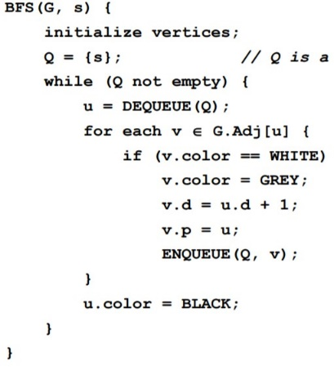Adjacency list is preferred for sparse graphs, E is much less than V^2, assume this representation. Adjacency matrix is preferred for dense graphs.

BFS, breadth first search, starts a root S and discovers new vertices in order of increasing number of edges from S, running time is O(V+E)

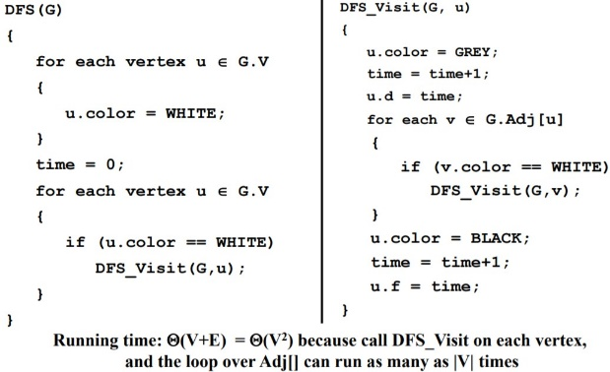DFS, depth first search

Topological Sort, DAG

Shortest Path,BFS if edges

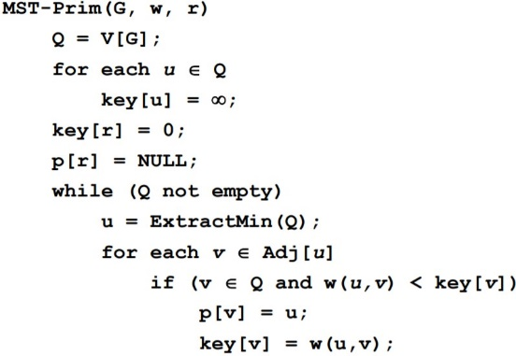

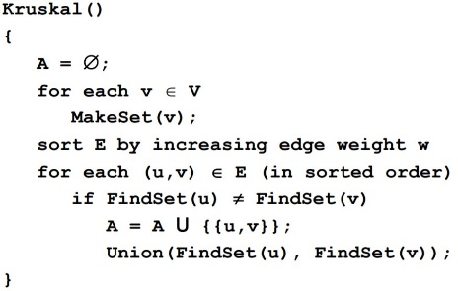

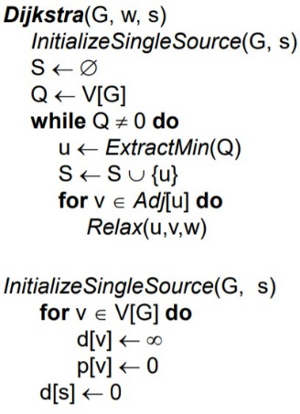

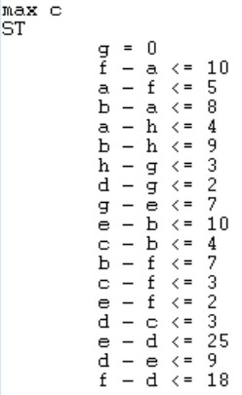on directed

a -> f = 10

f -> a = 5 GIN = 0,1,2,3,4…

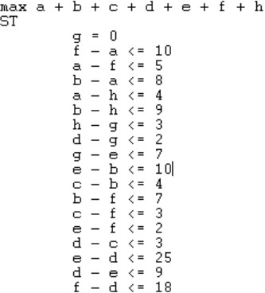 INT = 0 or 1

