OpenSprinkler User Interface (UI) Application Upgrade Description

Sources
https://opensprinkler.com/
https://github.com/OpenSprinkler/OpenSprinkler-Firmware
https://github.com/OpenSprinkler/OpenSprinkler-Firmware/releases

and on OpenSprinkler Hw version 2.3, released Aug 3. 2015
https://github.com/rayshobby/opensprinkler/blob/master/OpenSprinkler%20Controller/hardware/v2.3/AC/os23ac_sch.png
The corresponding UserManual 217 and AP 217: https://openthings.freshdesk.com/support/solutions/5000022938

The smartphone or web-browser based User Interface (UI) source code link:
https://github.com/OpenSprinkler/OpenSprinkler-App
The application can be downloaded from App Store or Play Store.
The app needs a Firmware Server connection to work.
If you need the connection to a Firmware Server send request to tcsaba101@gmail.com.

The data exchange between the Firmware Server and the UI Client is based on the API 2.1.7, see here: https://openthings.freshdesk.com/support/solutions/5000022938
We have added some new features to the API ver217 to fulfill the requirements of added
sensors handling, etc. To handle the changed functionality needs the re-development of the UI.
The changed API: API_SG_v02.xls
See the http request and service examples in the Appendix_1.
The “Get Localization” language support has to be maintained in the upgraded version too.

The main changes in the Controller Hardware and Firmware:
Sensors have been added: Current sensor, Flow Sensor, 2 pcs of Soil sensors inputs.
The existing Rain Sensor/ProramSwitch function still in operation on the same input connector.
Alarm messages generated based on the sensor data if it will be out of the predefined range compared to the calibrated reference value.
Detailed events logging on the SD card.
The Firmware is POST-ing http data packets to the cloud server, to store the logged data, create Alarm messages, store dynamic Ip address, etc for the UI.

The working Basics
The working principle: the Controller Firmware is the Server and the UI running on mobile device or in a browser is the Client. The Client is reaching the Server using port forwarding service.
The Client (UI) is sending http GET requests to the Firmware Server (see some examples in Appendix_2)
-to send settings of the system (See API Get commands)
-to change the settings (See API Set commands)
The Firmware Server is sending back the http answer header, plus
-added json data of the settings required (see API Get sections)
-acknowledgement of the Set Command handling (see API Section 1.)

The Targets of UI Development
Graphical visualization of changes what the received json data is representing,
Manage to record and save of the user inputs.
Send the completed data packages according to the API rules to the Firmware Server.
Resend in the case of non-acknowledgment.
Registering on the Cloud Server Controllers and Users.

Next Steps (will be described later)
The Firmware and the UI both will be Client of the Cloud Server. The data exchange will be implemented through the Cloud Server. This will eliminate the need for port forwarding service and dynamic IP address handling.
Changes and Content of new UI menus (the Orange shaded items is discussed in details in the document)
New or Modified Items of the UI menus | The system screen and new layout plan
Left Menu  Contractor password  Firmware upgrade  Station Setup  Soil Sensor Attach to Station  Status Window  Flow, Current display during Station Run  Last Run, last day water consumption  Alarm, System status display  Sensors Status display (like on the LCD) | 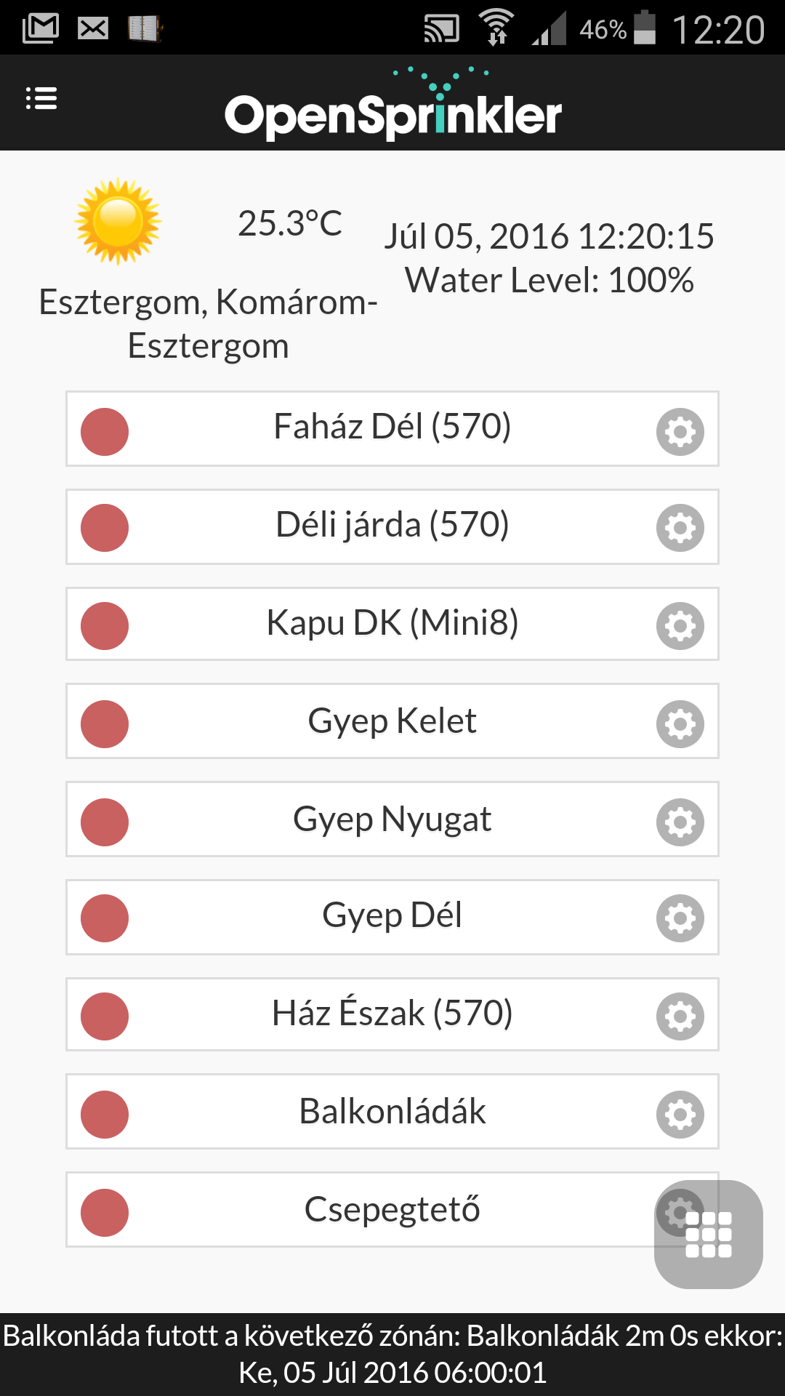  Left menu icon  Messages (if there is a red bell icon)  Information menu (General Setup)  Status window  Station  Station setup  Weather  Date and time
Information Menu  View Logs  Station Run Logs  Flow logs  Soil Sensors logs  Rain Sensor logs  Current logs  Alarm, Status messages logs  Edit Program  Soil Attach | 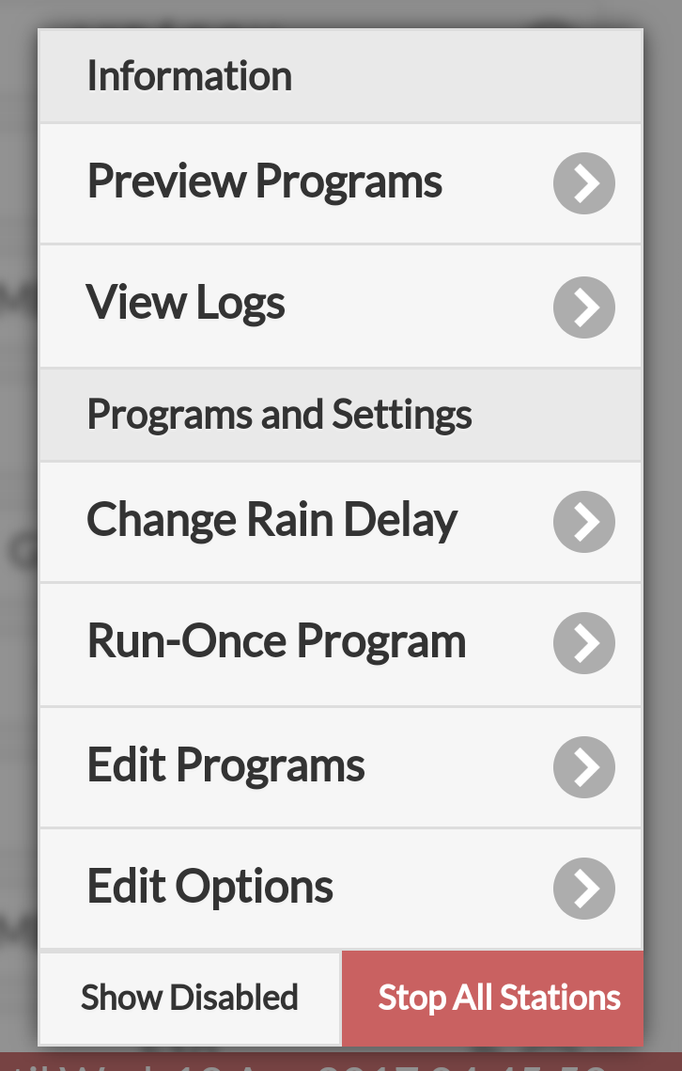 | The Information menu is the same
Sensors Setup  Rain Sensor / Program Switch  Flow Sensor  Soil Sensors  Current Sensor  LCD  Language  Alerts setup  Alerts Sources  Cloud Server Setup  Client Mode Setup  Urls  Refresh Timing  User Account  Registration  Messaging Rules  Change Password | 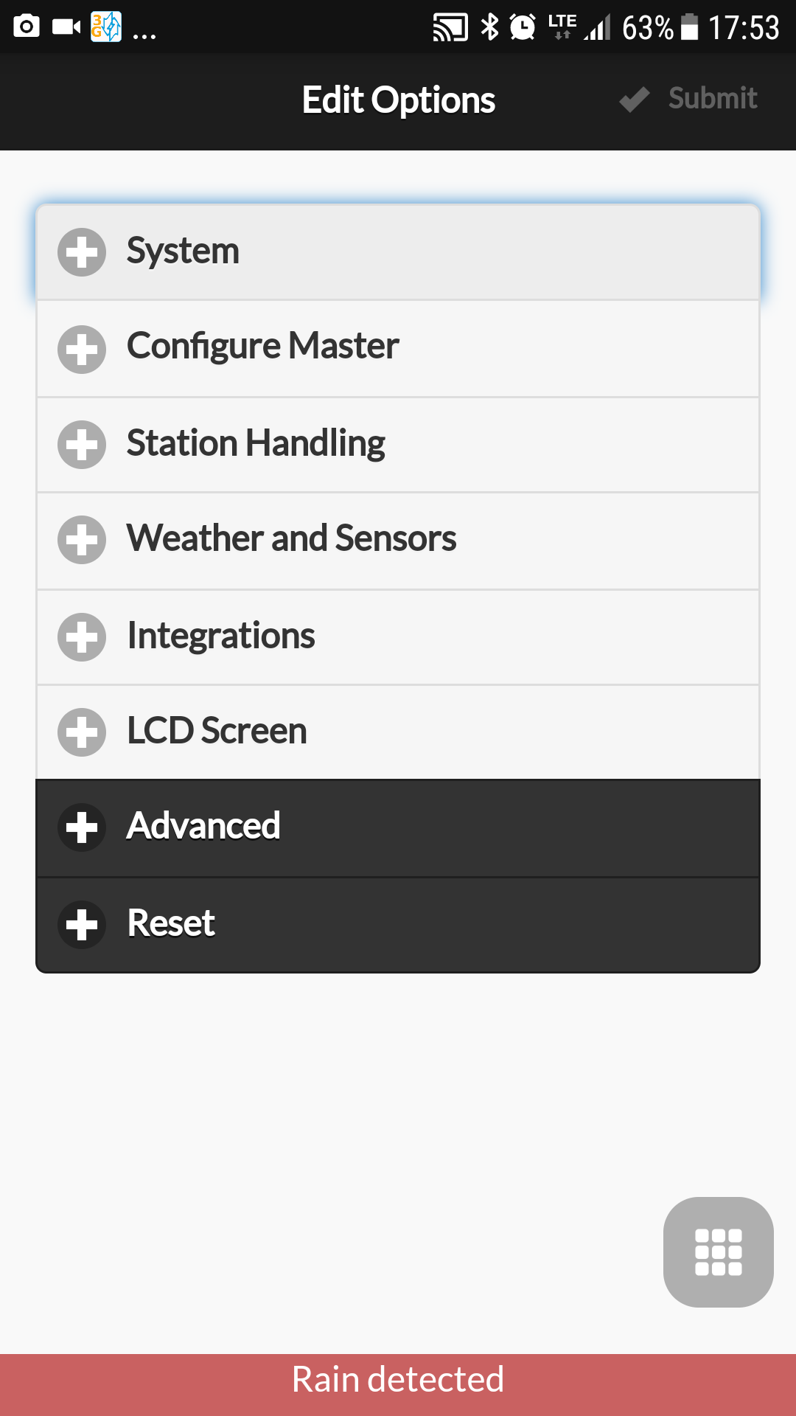 | System
 |  | Configure Master
 |  | Station Handling
 |  | Weather Setup
 |  | Sensors Setup
 |  | Integrations
 |  | LCD Screen
 |  | Advanced
 |  | Alerts Setup
 |  | Cloud Server
 |  | Reset

Station: Soil Sensor Attach
The Get Station (/js) command reply contains the attached Soil Sensors data:

{"stations":{"masop":[255,255],"ignore_rain":[0,0],"masop2":[0,0],"stn_dis":[0,0],"stn_seq":[255,255],"stn_as1":[85,170],"stn_as2":[170,85],"stn_spe":[0,0],"snames":["S01","S02","S03","S04","S05","S06","S07","S08","S09","S10","S11","S12","S13","S14","S15","S16"],"maxlen":24}}

The above json data field set is regarding to a 2 boards = 16 stations controller. The Soil sensor Station attach “stn_asx” dataset contains as many items (bytes) in the brackets, as the number of boards. Very similar to the logic of masop, masop2, ignore_rain, etc.
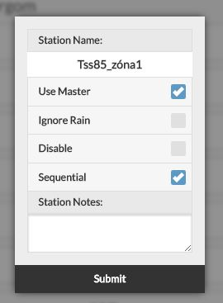
soil_sensor_1: "stn_as1":[85,170] = b01010101, b10101010
soil_sensor_2: “stn_as2":[170,85] = b10101010, b01010101

If the corresponding bit is high, the station handling is attached to the corresponding soil sensor status. When the soil sensor status is „disable” then the irrigation will be disabled on that station. This is very similar to the working principle of Rain Switch: if raining the irrigation should shut down.
√
Insert Here
Use Soil Sensor_1
√
Use Soil Sensor_2
√
Exclude Alarming

The Set station (/cs) command sending the station setups to the server.
The soil sensors setup give additional attributes to the command (in bold):

GET/cs?pw=a6d82bced638de3def1e9bbb4983225c&s0=S01&m0=255&m1=255&q0=255&q1=255&p0=0&p1=0&i0=0&i1=0&d0=0&d1=0&a0=0&b0=1&a1=1&b1=0&_=1491891461362 HTTP/1.1
a0=0 means Station_1 is not attached to Soil_1
b0=1 means Station_1 is attached to Soil_2
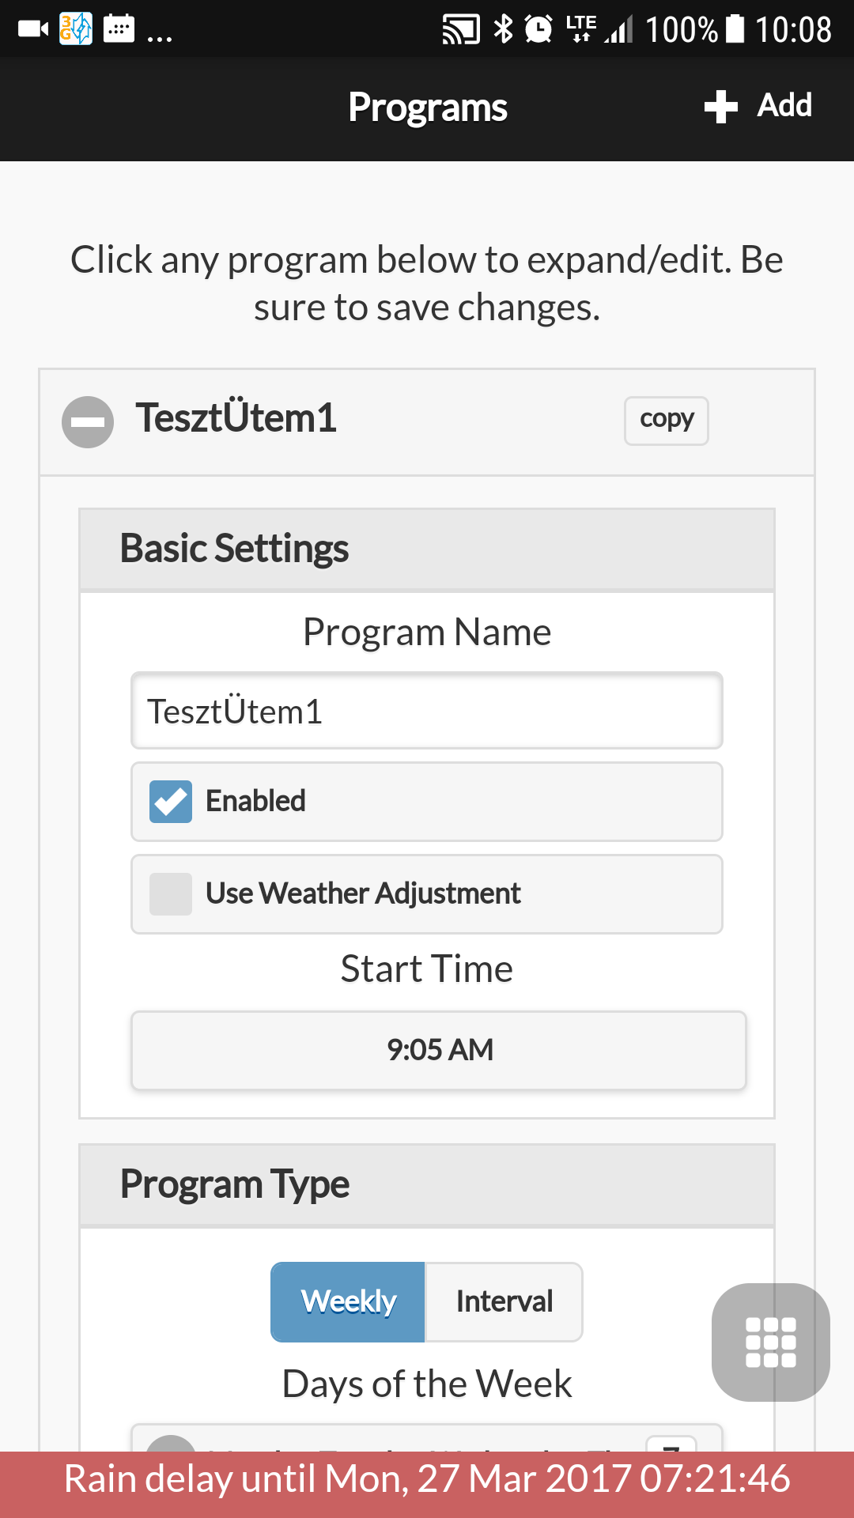
Edit Program: Soil Sensor Attach

The Get Program Data (jp) command json reply:

{"nprogs":1,"nboards":2,"mnp":23,"mnst":4,"pnsize":20,"pd":[[3,3,85,0,[360,3,180,0],[180,300,360,420,480,0,0,0,0,0,0,0,0,0,0,0],"Program 1"]]}

The arrowed value:
3 = b00000011 : last two bits shows the attached Soil Sensor attribute
b00000001 = Soil_1 is attached to the Program
b00000010 = Soil_2 is attached to the Program
When the sensor is attached and in „disable” state, the Program will be cleared at start time.

In the GUI this data interpreted as follows:
Insert Here
√
√
Soil1 Attached
Soil2 Attached

The Set Program Data (/cp) should contain the byte of the upgraded data:

GET/cp?pw=a6d82bced638de3def1e9bbb4983225c&pid=0&v=[3,3,85,0,[360,3,180,0],[180,300,360,420,480,0,0,0,0,0,0,0,0,0,0,0]]&name=Program%201&_=1491891460555 HTTP/1.1

Sensors Setup

This is a NEW separate menu point with all Sensor setup attributes.
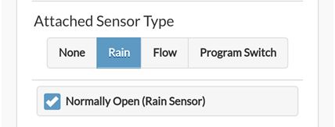
The Rain/Flow sensor setup has to been removed from the OLD „Weather and Sensors” menu.
The Sensors Setup layout is designed on the same graphical blocks like the Rain/Flow setup arrangement.

The Sensor Setup layout plan is according to the attached picture.
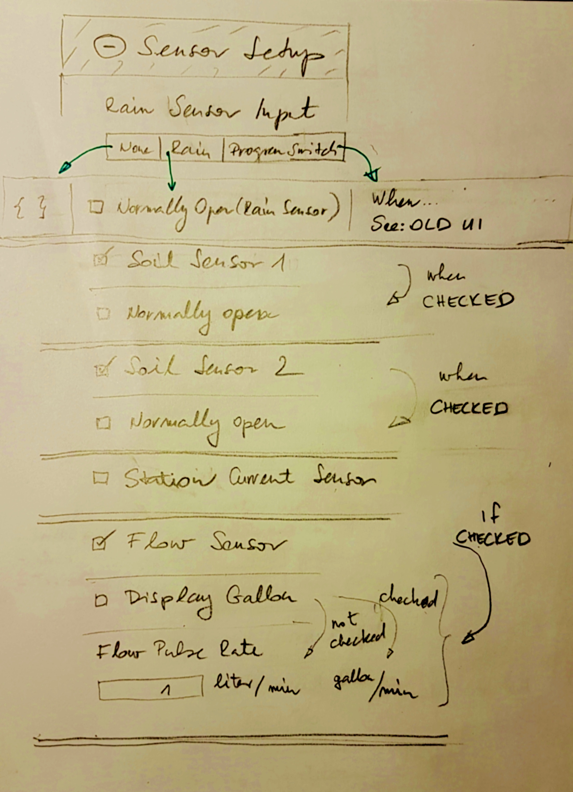
The Sensors Setup data is in the OPTIONS data set.
The appropriate commands: Get Options (/jo) response from the Firmware:

{"options":{"fwv":217,"tz":56,"ntp":1,"dhcp":1,"ip1":192,"ip2":168,"ip3":254,"ip4":99,"gw1":192,"gw2":168,"gw3":254,"gw4":1,"hp0":80,"hp1":0,"hwv":23,"ext":1,"sdt":0,"mas":0,"mton":0,"mtof":0,"urs":1,"rso":0,"wl":100,"den":1,"ipas":0,"dim":50,"uwt":0,"ntp1":50,"ntp2":97,"ntp3":210,"ntp4":169,"lg":1,"mas2":0,"mton2":0,"mtof2":0,"fwm":0,"fpr0":100,"fpr1":0,"re":0,"dns1":192,"dns2":168,"dns3":254,"dns4":1,"sar":0,"ife":0,"ufs":1,"ufl":0,"ufa":0,"ufr":20,"ufg":25,"ufm":10,"us1":1,"ud1":0,"us2":1,"ud2":0,"csi":1,"csa":1,"ucr":25,"sca":0,"scc":0,"hws":20,"fws":4,"cma":0,"cfd":60,"cff":10,"urt":0,"fms":1,"lns":0,"lng":0,"reset":0,"dexp":0,"mexp":3,"hwt":172}

and Set Options (/co)
GET/co?pw=a6d82bced638de3def1e9bbb4983225c&tyy=2017&tmm=3&tdd=15&thh=18&tmi=6&ttt=1492279608&o1=56&loc=Budapest&o36=1&o18=7&o19=0&o20=0&o37=8&o38=0&o39=0&o15=1&o17=0&wtkey=&o31=0&o23=100&o41=100&o42=0&ifkey=K9M8FIlpkXuH8qmL_7cX6&o49=0&o29=50&o12=80&o13=0&o32=50&o33=97&o34=210&o35=169&o4=192&o5=168&o6=254&o7=99&o8=192&o9=168&o10=254&o11=1&o44=192&o45=168&o46=254&o47=1&o3=1&o2=1&o21=1&_=1492279583434 HTTP/1.1

The Sensor Setup Layout fields explanation and data field contents
.
Item Name, | If selection | Get Data field (/jo) | Text | Select Objects | Set Data field (/co?) | Bin
Rain Sensor | - | "urs": x | Rain Sensor Input | Radio Buttons:  None, Rain, Program Sw. | o21=x
Rain Sensor | None | urs = 0 | {} | - | o21=0
Rain Sensor | Rain | urs = 1  "rso":0 or 1 | Normal Open (Rain Sensor) | Checkbox  checked = 1,  unchecked = 0 | o21=1, and  o22=0 or 1 | no  yes
Rain Sensor | Program Switch | urs = 2 | Text like in the OLD UI | - | o21=2
Rain Sensor Input
Soil_sensor_1 | . | “us1”:x | Soil Sensor 1 | Checkbox  checked = 1,  unchecked = 0 | o56=1  o56=0 | yes
Soil_sensor_1 | If checked | “ud1”:x | Normal Open | Checkbox  checked = 1,  unchecked = 0 | o57=1  o57=0 | yes
Soil_sensor_2 | . | “us2”:x | Soil Sensor 2 | Checkbox  checked = 1,  unchecked = 0 | o58=1  o58=0 | yes
Soil_sensor_2 | If checked | “ud2”:x | Normally Open | Checkbox  checked = 1,  unchecked = 0 | o59=1  o59=0 | yes

Soil Sensor 2
√

Current Sensor | - | “csi”:1 | Station Current Sensor | Checkbox  checked = 1,  unchecked = 0 | o60=1  o60=0 | y
Flow Sensor | - | "ufs":1 | Flow sensor | Checkbox  checked = 1,  unchecked = 0 | o50=1  o50=0 | y
Flow Sensor | if checked “Flow Sensor” | "ufl":0 | Display Unit Gallon | Checkbox  checked = 1, (gallon)  unchecked = 0 (liter) | o51=1  o51=0 | y
Flow Sensor | if checked “Flow Sensor” | "fpr0":100,  "fpr1":0," | gallon/min(o51=1)  liter/min (o51=0) | Input field:  0 – 655.35 | o41=100,  o42=0 | no
Flow Sensor
Display Gallon Unit
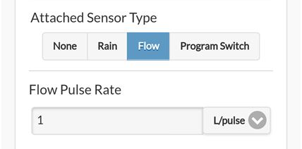
√

Alert Setup
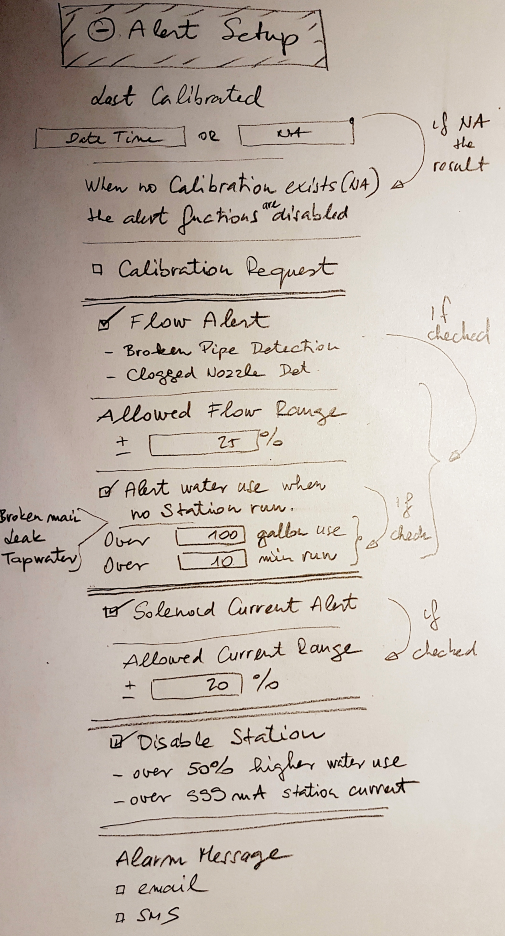
The layout is very similar to the Sensor Setup,.
The input data is the Get Options (/jo) json packet,

The „Last Calibrated” epoch time is obtained from Get Variables (/jc) packet.
The field name: „calt”.
The output data goes to Set Options (/co) fields.

The „Bin” column in all Sensor and Alert tables means “Binary” value.
The Binary values are cleared to zero by the Firmware if no value assigned in the /co command.
Those fields have to be included in the /co request if the value is not 0.

The Alert Setup Layout fields explanation and data field contents

Item Name, | If selection | Get Data field (/jo) | Text | Select Objects | Set Data field  (/co) | Bin
Calibration | - |  | Last Calibrated | - | -
Calibration | - | /jc? "calt": x | - | <Epoch Time> / „NA” | -
Calibration | content = “NA” | - | See on layout picture | - | - | -
Calibration | - | - | Calibration Request | Checkbox checked  unchecked | o63=1  o63=0 | y
Flow Alert | - | „ufa”:0,1,2, | Flow Alert  -Broken Pipe Detection  -Clogged Nozzle Detect | Checkbox checked  unchecked | o52=1  o52=0
Flow Alert | Flow Alert checked | „ufr”:25 | Allowed Flow Range | Input box:  +/- 0-50 (%) | o53=25
Flow Alert | Flow Alert checked | „ufa”:2, | Alert water use when no Station run  -Broken mainline  -Leakage  -Tap water use | Checkbox checked  unchecked | o52=3  o52=1
 | Alert water use checked | „ufg”:100  „ufm”:10 | Over  Over | Input boxes:  (0-255) gallons  (0-255) minutes | o54=100  o55=10
Current | - | „csa”:1 | Solenoid Current Alert | Checkbox checked  unchecked | o61=1  o61=0 | y
Current | Solenoid Alert checked | „ucr”:20 | Allowed Current Range | Input box:  +/- 0-50 (%) | o62=20
Fatal Error | - | „fad”:1 | Disable Station  -over 50% water use  -over 999mA Station current | Checkbox checked  unchecked | o65=1  o65=0 | y
Messaging | - | TBD: to be defined | Alarm Message | Checkboxes | TBD
Appendix_1

API http examples

Get All command (API Section 21)
#1
GET /ja?pw=a6d82bced638de3def1e9bbb4983225c&_=1492278751901 HTTP/1.1
Host: 192.168.254.99
Connection: keep-alive
Accept: application/json, text/javascript, */*; q=0.01
X-Requested-With: XMLHttpRequest
User-Agent: Mozilla/5.0 (Windows NT 6.1; WOW64) AppleWebKit/537.36 (KHTML, like Gecko) Chrome/56.0.2924.87 Safari/537.36
Referer: http://192.168.254.99/
Accept-Encoding: gzip, deflate, sdch
Accept-Language: hu,en-US;q=0.8,en;q=0.6,de;q=0.4

The response is one unit, but sliced to 5 pieces by the Firmware Server.
#2
HTTP/1.1 200 OK
Content-Type: application/json
Connection: close
Access-Control-Allow-Origin: *
Cache-Control: max-age=0, no-cache, no-store, must-revalidate
{"settings":{"devt":1492286301,"nbrd":2,"en":1,"rd":0,"rs":0,"rdst":0,"loc":"Budapest","wtkey":"","sunrise":356,"sunset":1173,"eip":1370893991,"lwc":1492285893,"lswc":1492285893,"lrun":[0,0,0,0],"curr":11,"flcrt":0,"flwrt":30,"sbits":[0,0,0],"ps":[[0,0,0],[0,0,0],[0,0,0],[0,0,0],[0,0,0],[0,0,0],[0,0,0],[0,0,0],[0,0,0],[0,0,0],[0,0,0],[0,0,0],[0,0,0],[0,0,0],[0,0,0],[0,0,0]],"wto":{},"ifkey":"K9M8FIlpkXuH8qmL_7cX6"}
#3
,"programs":{"nprogs":0,"nboards":2,"mnp":25,"mnst":4,"pnsize":20,"pd":[]}
#4
,"options":{"fwv":217,"tz":56,"ntp":1,"dhcp":1,"ip1":192,"ip2":168,"ip3":254,"ip4":99,"gw1":192,"gw2":168,"gw3":254,"gw4":1,"hp0":80,"hp1":0,"hwv":23,"ext":1,"sdt":0,"mas":0,"mton":0,"mtof":0,"urs":1,"rso":0,"wl":100,"den":1,"ipas":0,"dim":50,"uwt":0,"ntp1":50,"ntp2":97,"ntp3":210,"ntp4":169,"lg":1,"mas2":0,"mton2":0,"mtof2":0,"fwm":0,"fpr0":100,"fpr1":0,"re":0,"dns1":192,"dns2":168,"dns3":254,"dns4":1,"sar":0,"ife":0,"ufs":1,"ufl":0,"ufa":0,"ufr":20,"ufg":25,"ufm":10,"us1":1,"ud1":0,"us2":1,"ud2":0,"csi":1,"csa":1,"ucr":25,"sca":0,"scc":0,"hws":20,"fws":4,"cma":0,"cfd":60,"cff":10,"urt":0,"fms":1,"lns":0,"lng":0,"reset":0,"dexp":0,"mexp":3,"hwt":172}
#5
,"status":{"sn":[0,0,0,0,0,0,0,0,0,0,0,0,0,0,0,0],"nstations":16}
#6
,"stations":{"masop":[255,255],"ignore_rain":[0,0],"masop2":[0,0],"stn_dis":[0,0],"stn_seq":[255,255],"stn_as1":[85,170],"stn_as2":[170,85],"stn_spe":[0,0],"snames":["S01","S02","S03","S04","S05","S06","S07","S08","S09","S10","S11","S12","S13","S14","S15","S16"],"maxlen":24}}
______________________________

Set Station command (API section 9)
GET /cs?pw=a6d82bced638de3def1e9bbb4983225c&s0=S01&m0=255&m1=255&q0=255&q1=255&p0=0&p1=0&i0=0&i1=0&d0=0&d1=0&_=1491891461362 HTTP/1.1
Host: 192.168.254.99
Connection: keep-alive
Accept: text/plain, */*; q=0.01
X-Requested-With: XMLHttpRequest
User-Agent: Mozilla/5.0 (Windows NT 6.1; WOW64) AppleWebKit/537.36 (KHTML, like Gecko) Chrome/56.0.2924.87 Safari/537.36
Referer: http://192.168.254.99/
Accept-Encoding: gzip, deflate, sdch
Accept-Language: hu,en-US;q=0.8,en;q=0.6,de;q=0.4

HTTP/1.1 200 OK
Content-Type: application/json
Connection: close
Access-Control-Allow-Origin: *
Cache-Control: max-age=0, no-cache, no-store, must-revalidate

{"result":1}

_________________________________________
Set Program command (API section 14)
GET /cp?pw=a6d82bced638de3def1e9bbb4983225c&pid=0&v=[3,85,0,[360,3,180,0],[180,300,360,420,480,0,0,0,0,0,0,0,0,0,0,0]]&name=Program%201&_=1491891460555 HTTP/1.1
Host: 192.168.254.99
Connection: keep-alive
Accept: text/plain, */*; q=0.01
X-Requested-With: XMLHttpRequest
User-Agent: Mozilla/5.0 (Windows NT 6.1; WOW64) AppleWebKit/537.36 (KHTML, like Gecko) Chrome/56.0.2924.87 Safari/537.36
Referer: http://192.168.254.99/
Accept-Encoding: gzip, deflate, sdch
Accept-Language: hu,en-US;q=0.8,en;q=0.6,de;q=0.4

HTTP/1.1 200 OK
Content-Type: application/json
Connection: close
Access-Control-Allow-Origin: *
Cache-Control: max-age=0, no-cache, no-store, must-revalidate

{"result":1}

_________________________________________
Get Program Data command (API section 13)
GET /jp?pw=a6d82bced638de3def1e9bbb4983225c&_=1491891460556 HTTP/1.1
Host: 192.168.254.99
Connection: keep-alive
Accept: application/json, text/javascript, */*; q=0.01
X-Requested-With: XMLHttpRequest
User-Agent: Mozilla/5.0 (Windows NT 6.1; WOW64) AppleWebKit/537.36 (KHTML, like Gecko) Chrome/56.0.2924.87 Safari/537.36
Referer: http://192.168.254.99/
Accept-Encoding: gzip, deflate, sdch
Accept-Language: hu,en-US;q=0.8,en;q=0.6,de;q=0.4

HTTP/1.1 200 OK
Content-Type: application/json
Connection: close
Access-Control-Allow-Origin: *
Cache-Control: max-age=0, no-cache, no-store, must-revalidate

{"nprogs":1,"nboards":2,"mnp":23,"mnst":4,"pnsize":20,"pd":[[3,145,85,0,[360,3,180,0],[180,300,360,420,480,0,0,0,0,0,0,0,0,0,0,0],"Program 1"]]}
_________________________________________

Set Options command (API section 13)

GET /co?pw=a6d82bced638de3def1e9bbb4983225c&tyy=2017&tmm=3&tdd=15&thh=18&tmi=6&ttt=1492279608&o1=56&loc=Budapest&o36=1&o18=7&o19=0&o20=0&o37=8&o38=0&o39=0&o15=1&o17=0&wtkey=&o31=0&o23=100&o41=100&o42=0&ifkey=K9M8FIlpkXuH8qmL_7cX6&o49=0&o29=50&o12=80&o13=0&o32=50&o33=97&o34=210&o35=169&o4=192&o5=168&o6=254&o7=99&o8=192&o9=168&o10=254&o11=1&o44=192&o45=168&o46=254&o47=1&o3=1&o2=1&o21=1&_=1492279583434 HTTP/1.1
Host: 192.168.254.99
Connection: keep-alive
Accept: text/plain, */*; q=0.01
X-Requested-With: XMLHttpRequest
User-Agent: Mozilla/5.0 (Windows NT 6.1; WOW64) AppleWebKit/537.36 (KHTML, like Gecko) Chrome/56.0.2924.87 Safari/537.36
Referer: http://192.168.254.99/
Accept-Encoding: gzip, deflate, sdch
Accept-Language: hu,en-US;q=0.8,en;q=0.6,de;q=0.4

HTTP/1.1 200 OK
Content-Type: application/json
Connection: close
Access-Control-Allow-Origin: *
Cache-Control: max-age=0, no-cache, no-store, must-revalidate

{"result":1}

_________________________________________
Manual Station Run command (API section 11)

GET /cm?sid=6&en=1&t=120&pw=a6d82bced638de3def1e9bbb4983225c&_=1492404299025 HTTP/1.1
Host: 192.168.254.99
Connection: keep-alive
Accept: application/json, text/javascript, */*; q=0.01
X-Requested-With: XMLHttpRequest
User-Agent: Mozilla/5.0 (Windows NT 6.1; WOW64) AppleWebKit/537.36 (KHTML, like Gecko) Chrome/56.0.2924.87 Safari/537.36
Referer: http://192.168.254.99/
Accept-Encoding: gzip, deflate, sdch
Accept-Language: hu,en-US;q=0.8,en;q=0.6,de;q=0.4

HTTP/1.1 200 OK
Content-Type: application/json
Connection: close
Access-Control-Allow-Origin: *
Cache-Control: max-age=0, no-cache, no-store, must-revalidate

{"result":1}
_________________________________________
Get Log Data (API section 18)

GET /jl?pw=a6d82bced638de3def1e9bbb4983225c&type=wl&start=1491602400&end=1492293540&_=1492279583425 HTTP/1.1
Host: 192.168.254.99
Connection: keep-alive
Accept: application/json, text/javascript, */*; q=0.01
X-Requested-With: XMLHttpRequest
User-Agent: Mozilla/5.0 (Windows NT 6.1; WOW64) AppleWebKit/537.36 (KHTML, like Gecko) Chrome/56.0.2924.87 Safari/537.36
Referer: http://192.168.254.99/
Accept-Encoding: gzip, deflate, sdch
Accept-Language: hu,en-US;q=0.8,en;q=0.6,de;q=0.4

HTTP/1.1 200 OK
Content-Type: application/json
Connection: close
Access-Control-Allow-Origin: *
Cache-Control: max-age=0, no-cache, no-store, must-revalidate

[[0,"wl",100,1491763668]
,[0,"wl",100,1491763669]
,[0,"wl",100,1491763720]
,[0,"wl",100,1491763835]
,[0,"wl",100,1491764497]
,[0,"wl",100,1491764559]
,[0,"wl",100,1491768161]
,[0,"wl",100,1491770414]
,[0,"wl",100,1491770519]
,[0,"wl",100,1491770922]
,[0,"wl",100,1491771192]
,[0,"wl",100,1491771207]
,[0,"wl",100,1491771540]
}

