|  |
| --- |
| SYSTEM ARCHITECTURE & DESIGN RESTAURANT POS APP |
| RESTAURANT POS APP – V 1.0 |
|  |
| This document describes the basic system design and specifications for RESTAURANT POS APP. |
|  |
| **Author – Arindam Das** |

SYSTEM ARCHITECTURE & DESIGN RESTAURANT POS APP

**RESTAURANT POS APP – V 1.0**

# **Key Features**

• • •

* Fully Automated web app
* Hosted in Cloud and can be accessed from anywhere in any compatible device like laptop, tablet or desktop PC.
* Effective management for restaurant owner for his restaurant data, sales reports and cash management
* Admin & Cashier Role Management
* Admin can manage his whole restaurant
* Cashier can handle the cash management module & can generate invoices for each Sale.
* Admin can manage the inventory section (here it is restaurant food items under each category)
* Sales report are generated with an option of date range filter which can be exported in Excel format & can be stored in local device for the restaurant owner.
* Sales volume analytics can be determined with the reporting module.

Restaurant POS Application is a web based app which helps the restaurant owners to manage their restaurant products, cash management, order invoice generation and sales report generation & thus effectively manages their point of sale activities in effective and secured way.

Restaurant POS Application is developed in MVC design pattern with a strong framework of Laravel. It can be hosted in cloud server and can be accessed remotely from anywhere in the world.

There are three types of users in this application.

1. System Admin – Manages the whole POS application.

2. Restaurant/Store Admin – Admin for the particular business setup. He can see all the 3 modules – Data management, Cash and Reports.

3. Cashier – Can see and handle the cash management module with sale invoice generation.

Introduction:

Restaurant POS APP is a web based solution for managing Sales activity of any type of restaurant.

It reduces the human errors of generation of sales invoice or cash management and can handle large number of orders. Thus effectively reduces the human staffing cost for a restaurant owner. It manages the sales and cash segment effectively and instantly generate the sales receipt for the restaurant.

This POS APP also helps to generate the sales report with particular date range and thus helps in analytics for the restaurant owner to analyze the sales volume and also it helps in tax filing activities.

Restaurant POS APP is developed in MVC design pattern with effective data security with a role based access. Only System Admin/Restaurant Admin can access all the modules including the Sales Reports Section. User with cashier role is allowed to access only Cash Management Module.

Proper User creation with specific role is handled by the System Admin.

SYSTEM ANALYSIS

## **EXISTING SYSTEM:**

Existing order and sale receipt generation process is a manual system or a desktop application where restaurant owner needs to manage all the sales data manually for each customer while taking their orders and manually generating /writing the sale invoice/receipt. Then he needs to consolidate the data manually in an excel sheet after completion of cash section each day manually. This process is lengthy and might generate errors at any time. Also it takes more time & human effort.

## **Disadvantages of other existing system:**

* A lot of sale receipts and invoice hardcopies need to be maintained.
* Any time data can be lost. Also the process requires more human effort and erroneous.
* Needs to maintain records at two segments, one at sale invoice and another on excel sheet.
* Not accessible remotely or reports cannot generated instantly thus it makes difficult to analyze the sale volume.
* Difficulties in tax filing as records need to be consolidated manually.

## **PROPOSED SYSTEM:**

This restaurant POS Application is a web based application which will replace the existing manual/other system for managing sale & sale activities with a single point of sales solution. It will manage the restaurant inventory as per their category, user management and other data management with cash management module to handle day to day sales activities along with generation of sale receipt and reporting module to generate sales reports which can be exported and saved in the local device for future analytics and management.

## **OBJECTIVE/GOAL OF THE SYSTEM:**

The objective of the system is to provide better information management for the restaurant Point Of Sale activities with systematic data management, instant generation of sale receipt and better historical sale data management. Thus it helps to store the data exported in excel format in owners computer for future analytical and business goal purpose.

SYSTEM SPECIFICATIONS

## **HARDWARE REQUIREMENT:**

* Processor - Pentium-V and higher series/ AMD Processor with CPU@2.16 GHz(Min Clock Speed)
* RAM – Min 2GB (Preferable – 4GB)
* Cache Memory – 512 MB/1GB
* Hard Disk – 250 GB(minimum)
* Microsoft Compatible Key Board and Mouse
* Any standard tab device with good memory and Android OS with Google Chrome Browser app installed can also be used

## **SOFTWARE REQUIREMENT:**

* Operating System: Windows 7 and Higher
* Web – Technology – PHP
* Front End – HTML, CSS, JavaScript, JQuery and AJAX
* Back End – MySQL Database
* Frame Work – Laravel – V 6.0
* Design Pattern – MVC
* Web Server – Apache Server
* MS-Office 7 and higher version needs to be installed in the operating computer terminal for data export purpose.
* Browsers – Google Chrome, Mozilla Firefox

## **HOSTING:**

* Any standard web-hosting/cloud hosting provider with SSL.

**Standard UIs and flow of the RESTAURANT POS APP:**

Logo and client information are customizable.

**Login UI – Admin login**

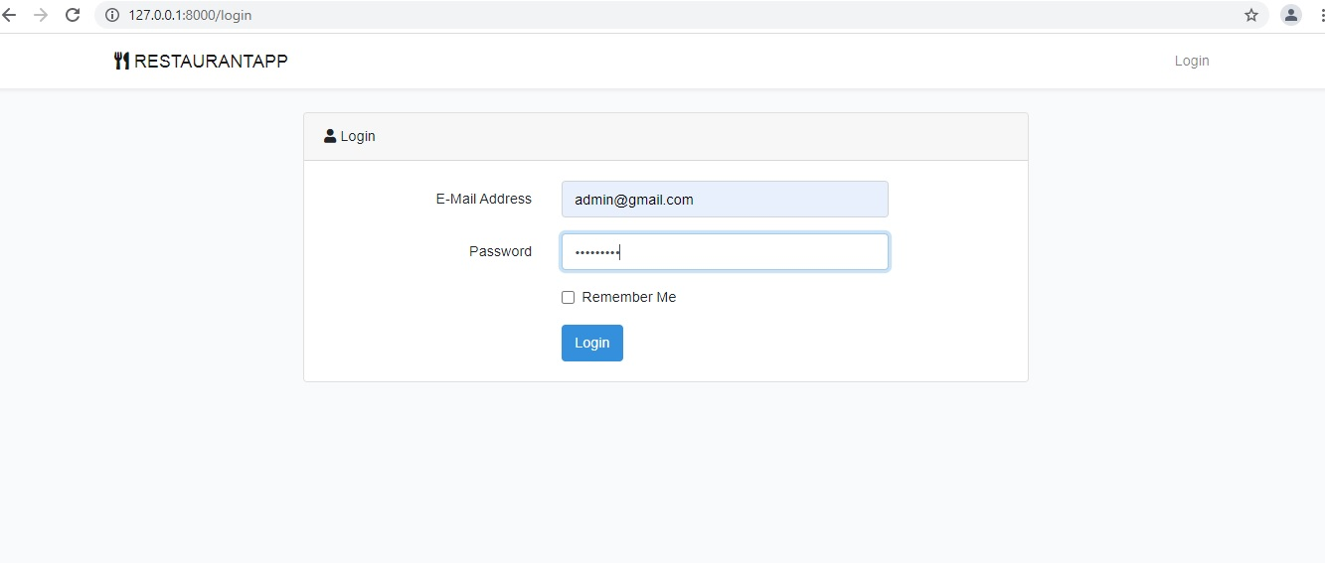

**Main Dashboard:**

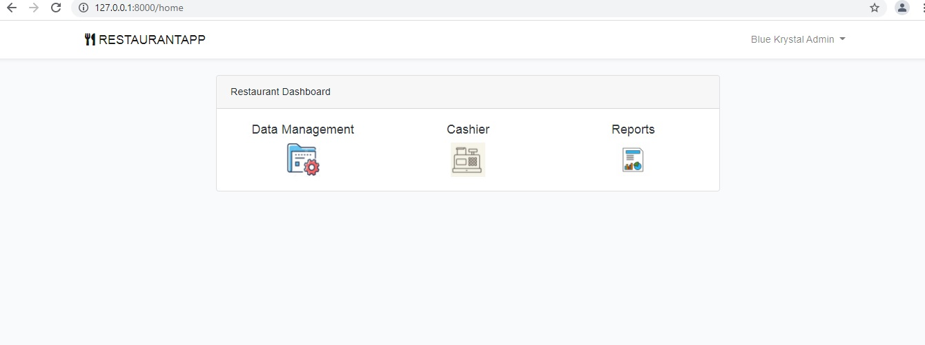

**Data Management Module -> Menu Management section**

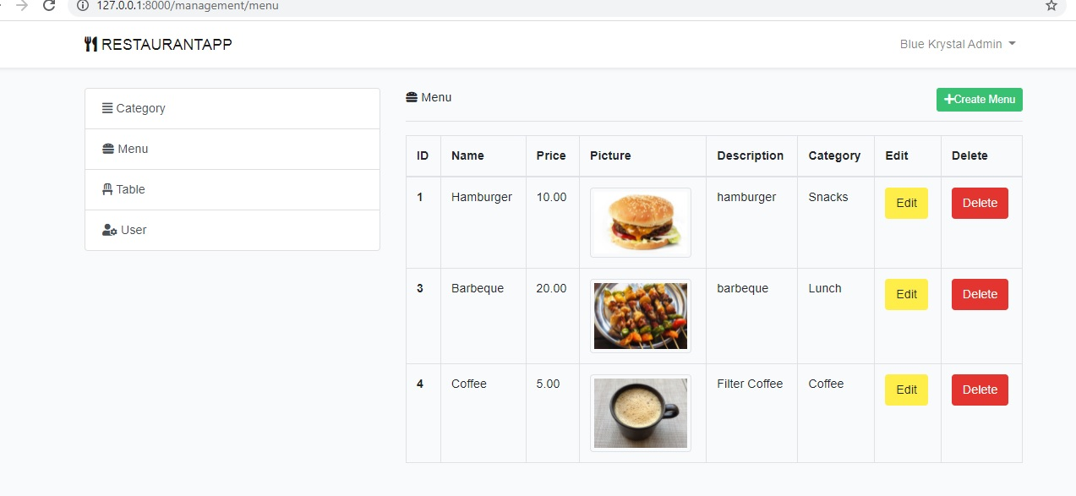

**New Menu Creation Form:**

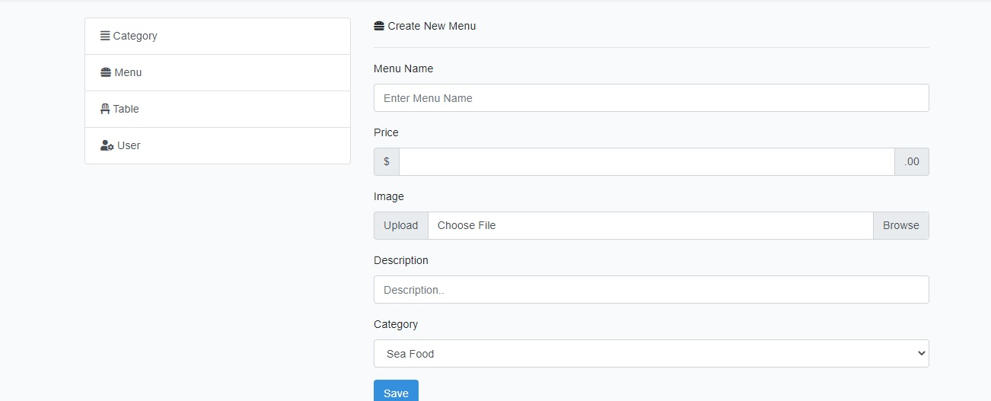

**Data Management -> Table Management sub section:**

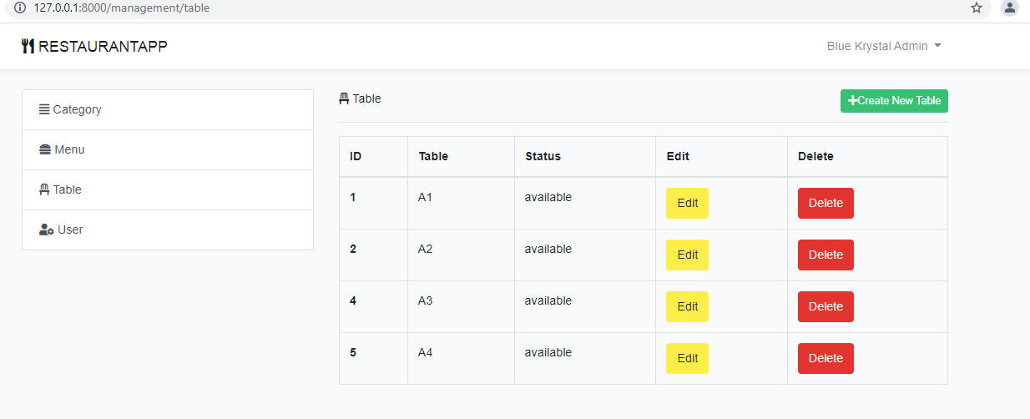

**Cashier Module:**

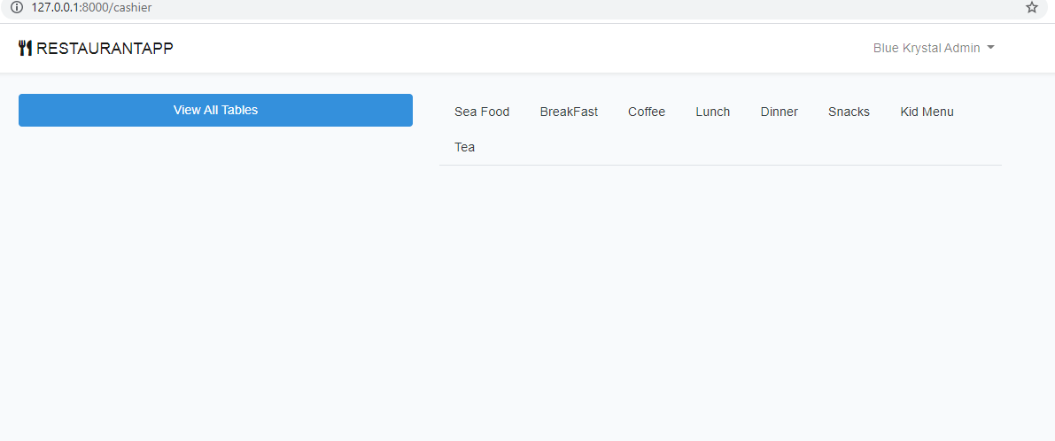

**Cashier Module -> Manage Sale -> Add item details for a table/counter for sale invoice:**

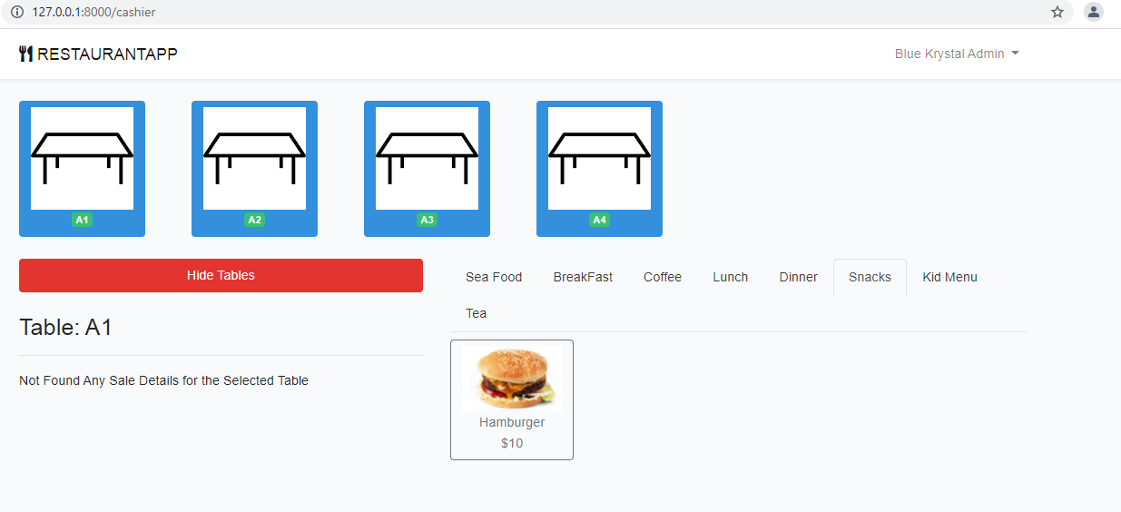

**Add Hamburger & Coffee to generate a sale receipt:**

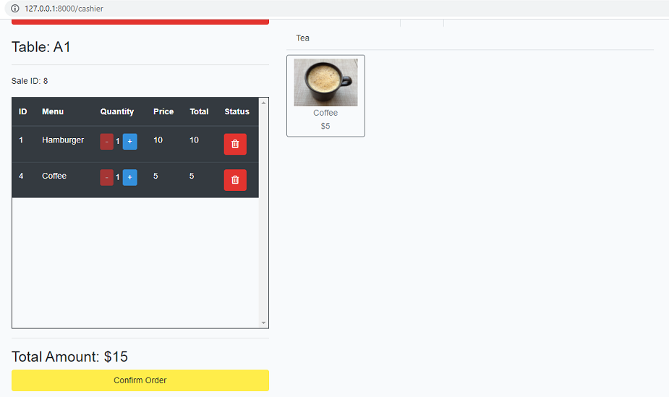

**Order Confirmation & calculate change:**

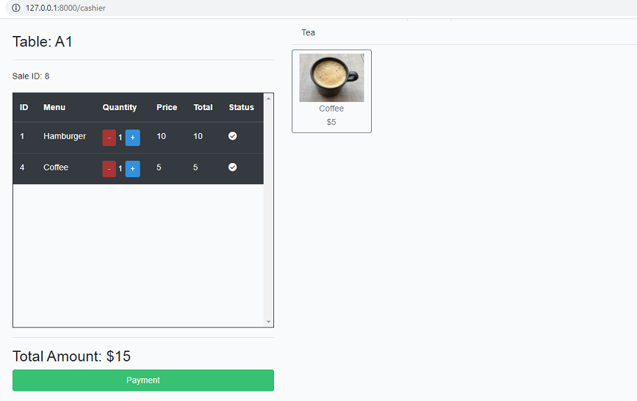

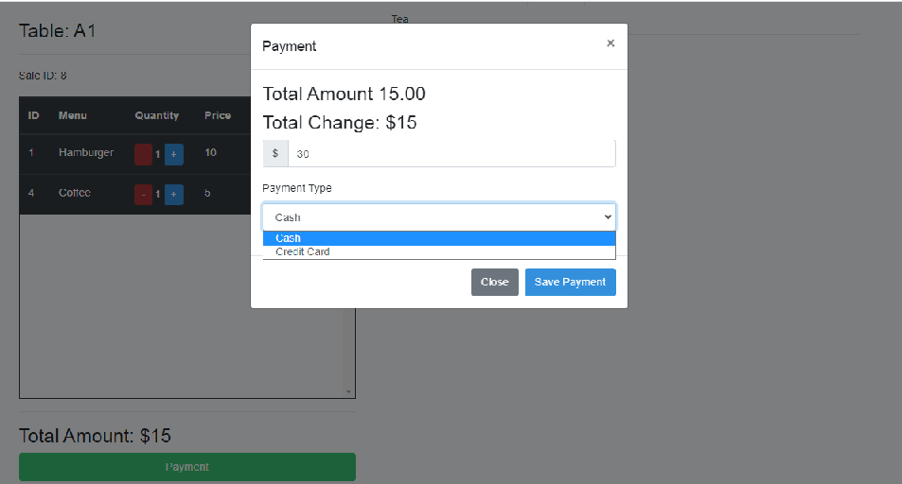

**Sale Receipt Generation:**

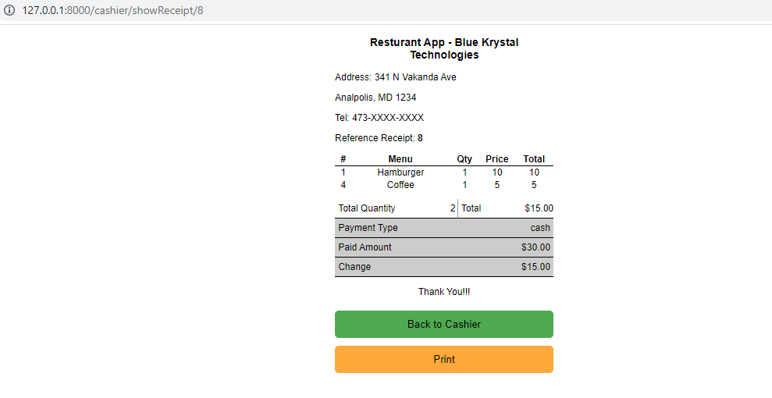

**Sale Receipt in PDF Format:**

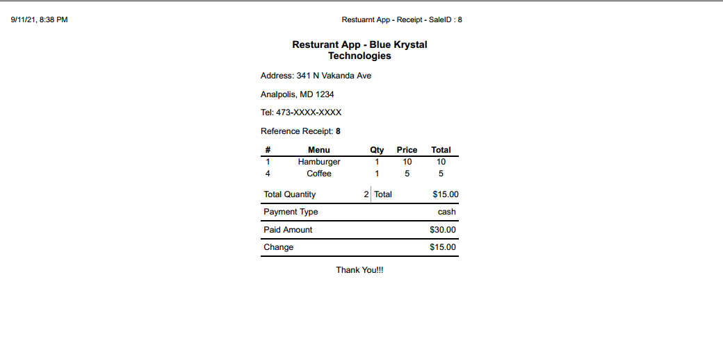

**Sales Report Generation Module:**

**Select the date range to filter the records:**

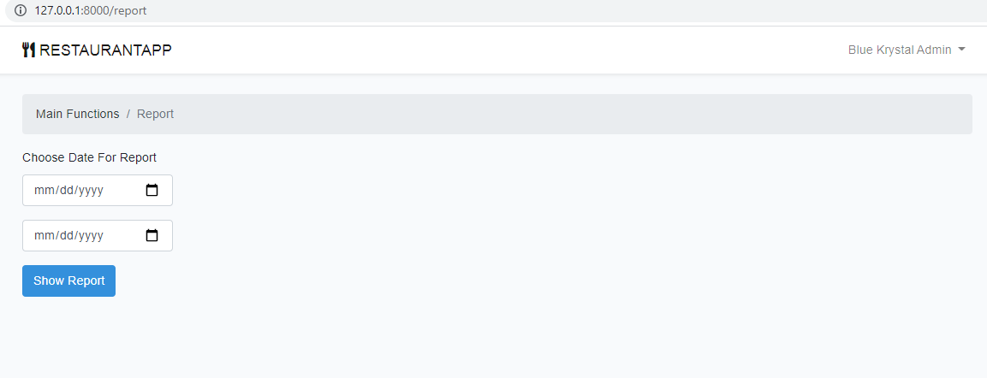

*Select the date in the date calendar in mm/dd/yyyy format*

**Sales Report: (Date Format used in web app is – MM/DD/YYYY)**

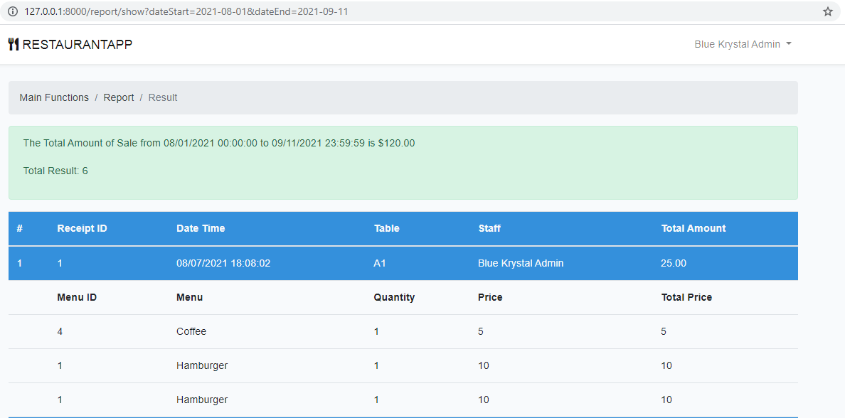

**Sales Report with Pagination Options:**

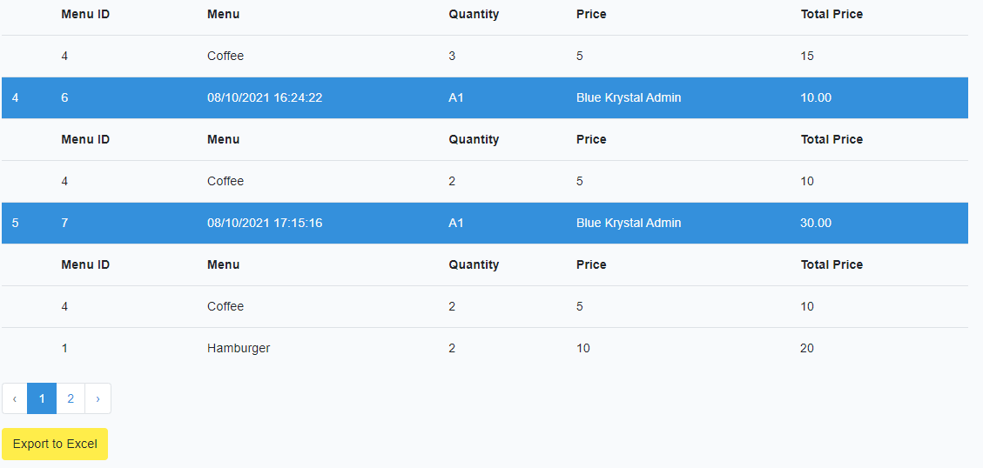

**Export to excel format: Date Format in excel sheet is – YYYY-MM-DD(Sale summary in Col F)**

