|  |
| --- |
| SYSTEM ARCHITECTURE & DESIGN RESTAURANT REAL TIME ORDER BOOKING |
| **RESTAURANT REALTIME ORDER BOOKING APP – V 1.0** |
|  |
| This document describes the basic system design and specifications for RESTAURANT REALTIME ORDER BOOKING Application |
|  |
| **Author – Arindam Das** |

SYSTEM ARCHITECTURE & DESIGN RESTAURANT REAL TIME ORDER BOOKING

# **Key Features**

• • •

* Fully Automated web app
* Hosted in Cloud and can be accessed from anywhere in any compatible device like laptop, tablet or desktop PC.
* Effective management for restaurant owner for his restaurant data, online order booking and table booking purpose
* Any restaurant owner can take unlimited online orders in real time from customers without any commission fees paid
* Helps to grow increase the online sales for the restaurant owners with unlimited virtual existence
* Restaurant owners can take current and advance order booking with order ahead option for both food and dine in bookings
* Restaurant owners will get the real time order booking notifications coming in their registered mobile app and can accept the orders.
* Customers get real time order confirmation and email notifications.
* Order and sales data can be tracked easily for restaurant owners

**RESTAURANT REALTIME ORDER BOOKING APP – V 1.0**

Restaurant Real Time Order Booking App is a web based application to manage online order bookings for any restaurant with real time order booking, book ahead options, real time order confirmation and generating order invoices for the customers in their email and listing of all order details for the restaurant owner in his authenticated mobile phone app. From the Admin panel dashboard, the restaurant admin can see all the order details with the option to see the sales data day and month wise. Also the system sends emails for the restaurant owner/admin with total sales data (summary of all sales for each day) and increase or decrease in volume. This way it helps in data analytics for the restaurant admin. The system also sends warning notifications and emails to system admin’s mobile if it is offline for a certain period. Emails are sent from the system in each 20 minutes of offline/inactivity for the restaurant admin.

Introduction:

Restaurant REAL TIME ORDER BOOKING APP can be used for managing online orders and sales data for any type of restaurant.

It reduces the human errors of generation of sales invoice or cash management and can handle large number of orders. Thus effectively reduces the human staffing cost for a restaurant owner.

This application helps to generate unlimited orders without commission for the restaurant owner.

Real time order booking notifications for the restaurant owner and order confirmation for customers are generated by this application. It also sends the restaurant online or offline status for the restaurant owner to his mobile. Also it sends the notification for the restaurant owner whether the restaurant is in opening hours or closing hour status.

Even if the restaurant is in closed hours the customer can see the menu and can order ahead with his chosen items from the menu. Those orders are accepted and delivered in his preferred time slot.

This application gives the restaurant an online visibility with a responsive web based design which can be opened from any smartphone, tablets, laptops or computers. Thus it generates more ordering traffic for the restaurant. With proper sales analytics and reports the owner can monitor his business growth.

SYSTEM ANALYSIS

## **EXISTING SYSTEM:**

Existing order and sale receipt generation process is a manual system or a desktop application where restaurant owner needs to manage all the sales data manually for each customer while taking their orders and manually generating /writing the sale invoice/receipt. Then he needs to consolidate the data manually in an excel sheet after completion of cash section each day manually. This process is lengthy and might generate errors at any time. Also it takes more time & human effort. Also there is a limitation of customer base with only specific area can be covered with manual sales promotion. Order booking is done via phone call and it is difficult to manage orders in high inbound customer call time. Also there is no proper visibility of the restaurant’s menus and amenities to the customers.

## **Disadvantages of other existing system:**

* A lot of sale receipts and invoice hardcopies need to be maintained.
* Any time data can be lost. Also the process requires more human effort and erroneous.
* Real time order booking and confirmation notifications cannot be generated
* Difficult to handle all inbound customer calls in pick hours. Also there is possibility that customers can get line engaged and the orders can be overlooked if sent in other media like WhatsApp if the restaurant admin in busy in other activities.
* Needs to maintain records at two segments, one at sale invoice and another on excel sheet.
* Not accessible remotely or reports cannot generated instantly thus it makes difficult to analyze the sale volume.
* Difficulties in tax filing as records need to be consolidated manually.

## **PROPOSED SYSTEM:**

This restaurant real time order booking application helps the restaurant owners to get unlimited online orders for food or advance dine-in orders with table booking facility without any commission paid to other agencies. Also this Gloria Food Order Booking App helps them to notify the customers about the order confirmation in real time and also the details of order with receipt is sent to customer’s email.

For the sale data analytics, the restaurant owner/system admin can login into their respective Gloria food ordering system admin panel where they can see the sales for each month and day wise sales with increase/decrease of sales volume from the previous day. This helps him to manage his business in a better way. Also if the owner’s mobile phone is offline the app sends notification and also some alert notification if in that time any customer was trying to place some order online.

## **OBJECTIVE/GOAL OF THE SYSTEM:**

The objective of the system is to provide better information management for the restaurant owners to manage their online food and dine-in (table booking) orders. This system generates online real time order booking notifications to the restaurant admin mobile app with real time order confirmation for the customers for their online bookings. Customers can also book advance order with preferred time slot as provided by the restaurant as per their T&C. Confirmation and notifications emails also sent to the customer’s emails. It helps to manage systematic data management for online sale for the restaurant and generates online receipts for each orders and sales reports and analytics for sale growth.

SYSTEM SPECIFICATIONS

## **HARDWARE REQUIREMENT:**

* Processor - Pentium-V and higher series/ AMD Processor with CPU@2.16 GHz(Min Clock Speed)
* RAM – Min 2GB (Preferable – 4GB)
* Cache Memory – 512 MB/1GB
* Hard Disk – 250 GB(minimum)
* Microsoft Compatible Key Board and Mouse
* Any standard tab device with good memory and Android OS with Google Chrome Browser app installed can also be used
* Any standard mobile phone with Android OS installed. Google play store to install restaurant order booking app.

## **SOFTWARE REQUIREMENT:**

* Operating System: Windows 7 and Higher
* Web – Technology – PHP 7.4
* Front End – HTML, CSS, JavaScript, JQuery and AJAX
* Back End – MySQL Database
* CMS platform – Wordpress 5.4
* Web Server – Apache Server
* MS-Office 7 and higher version needs to be installed in the operating computer terminal for data export purpose.
* Browsers – Google Chrome, Mozilla Firefox

## **HOSTING:**

* Any standard web-hosting/cloud hosting provider with SSL.

**Standard UIs and flow of the RESTAURANT REAL TIME ORDER BOOKING APP:**

Logo and client information are customizable.

**Home Page UI/Landing Page UI**

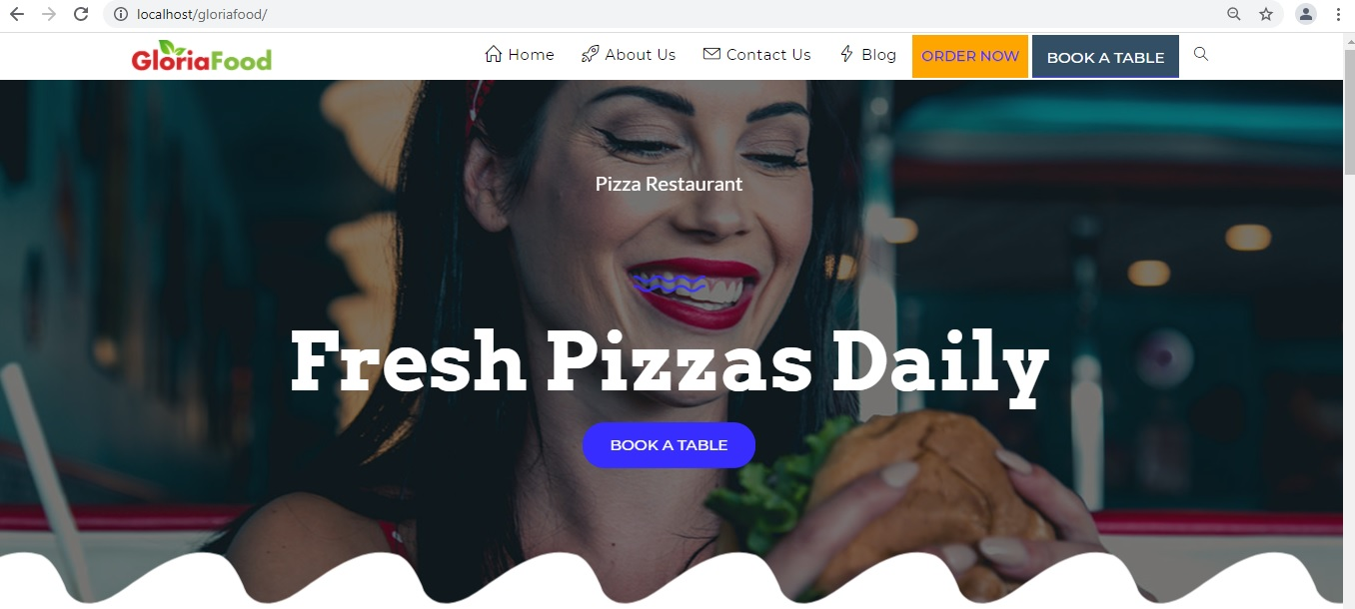

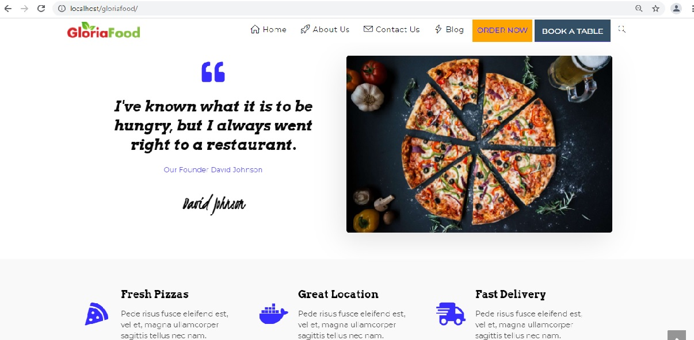

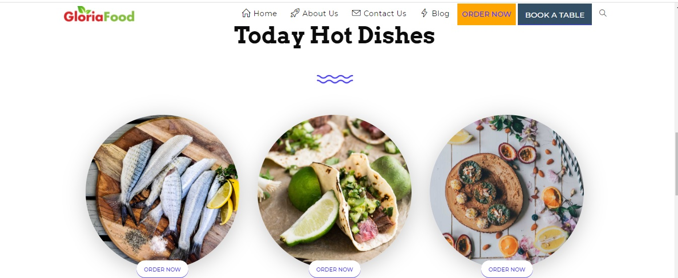

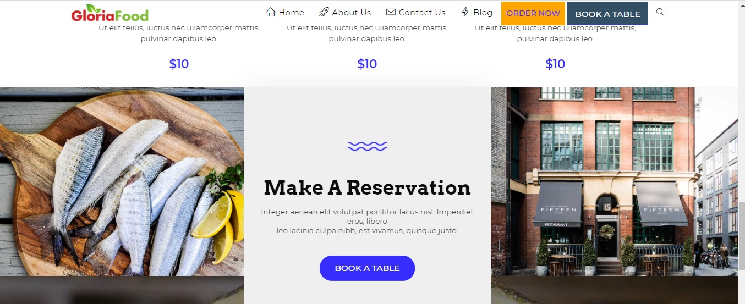

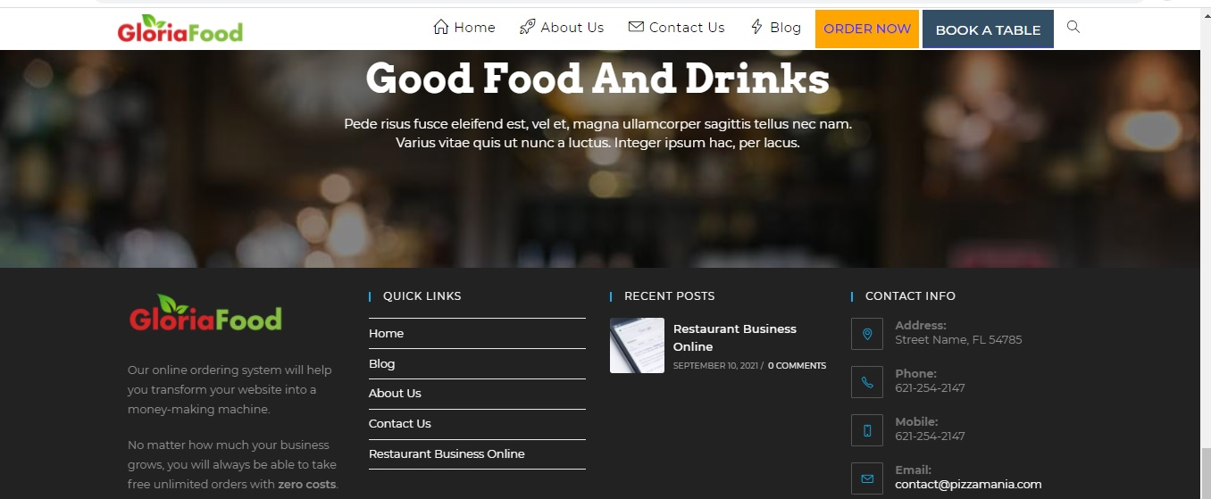

**About Us Page UI**





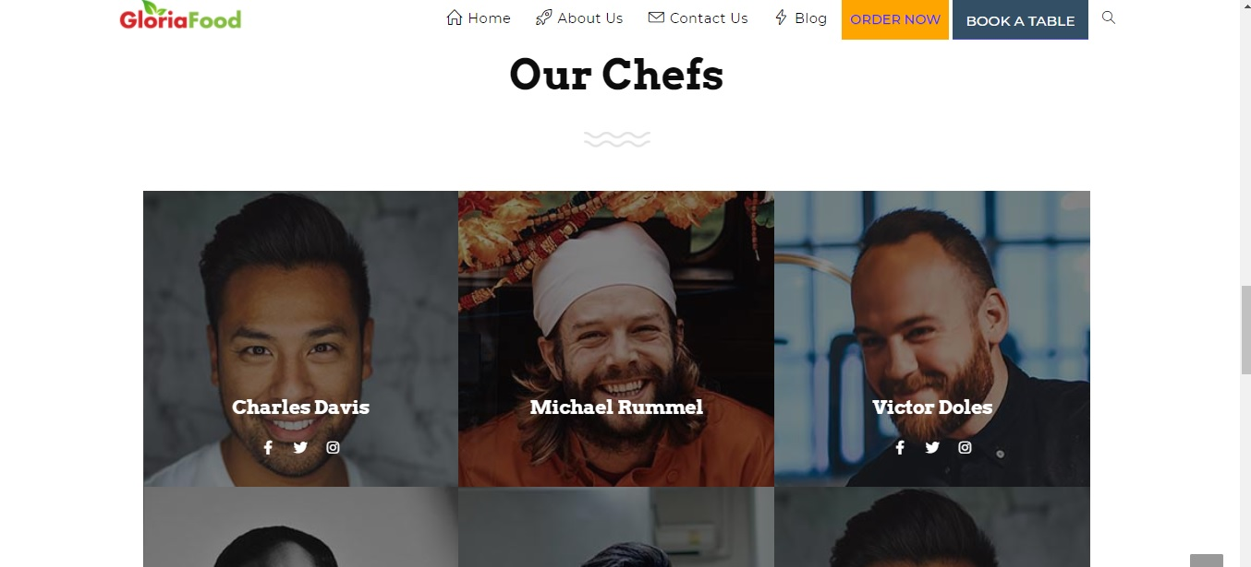

**Contact Us Page UI:**

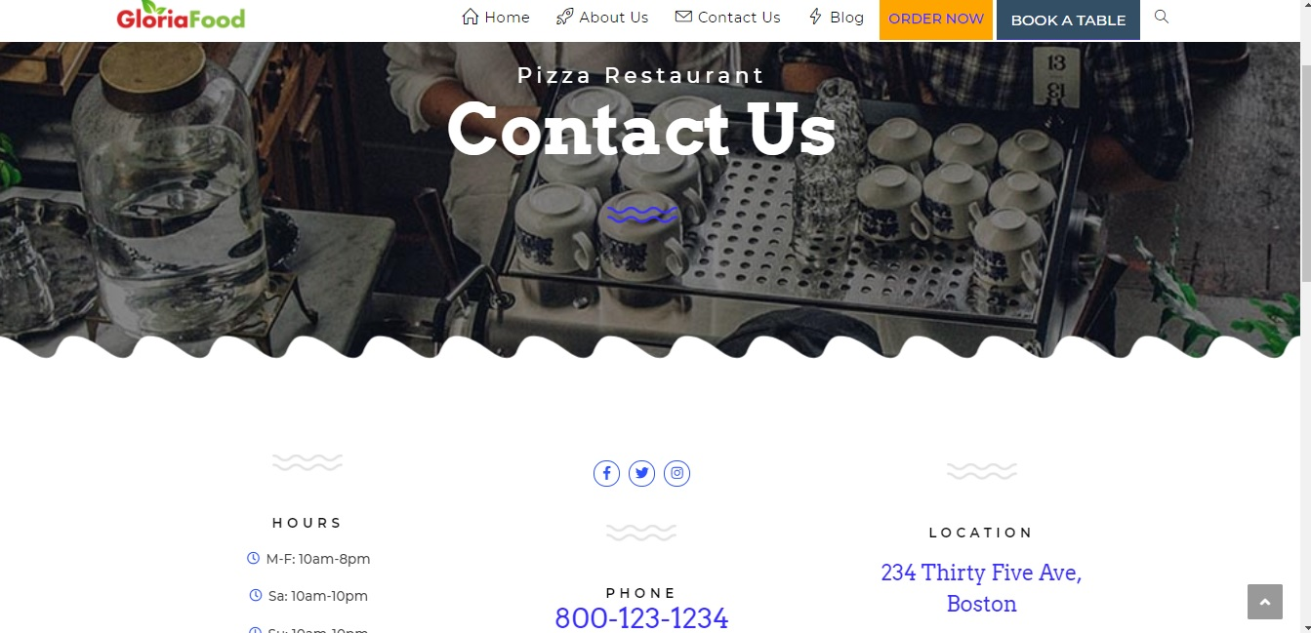

**Blog Page UI:**



**Order Booking Menu:**

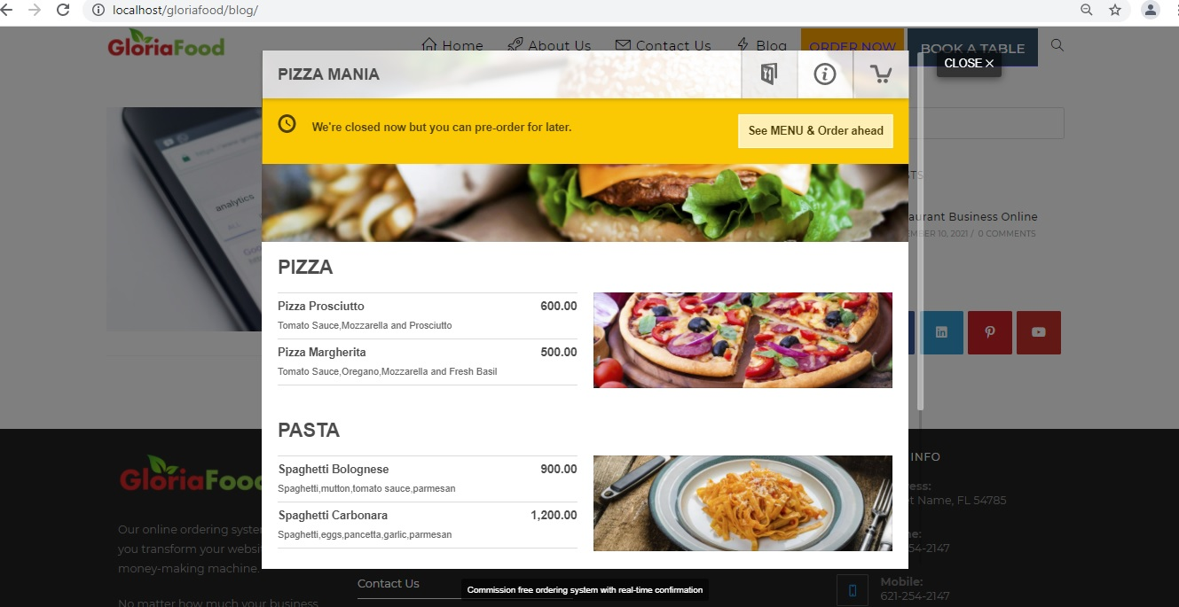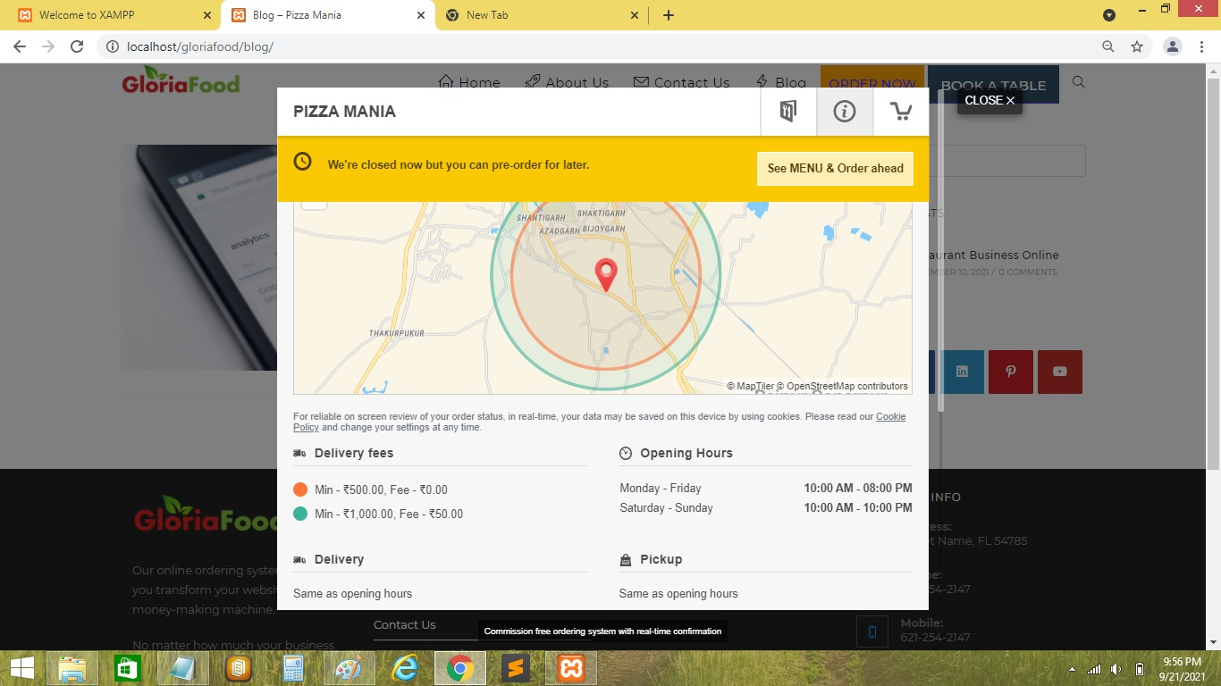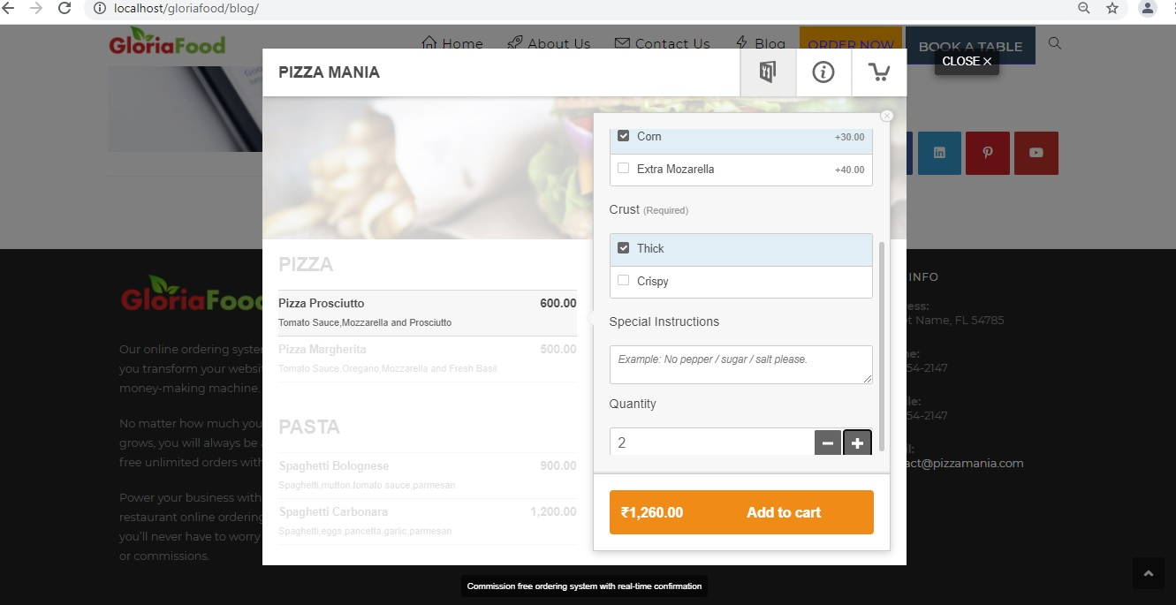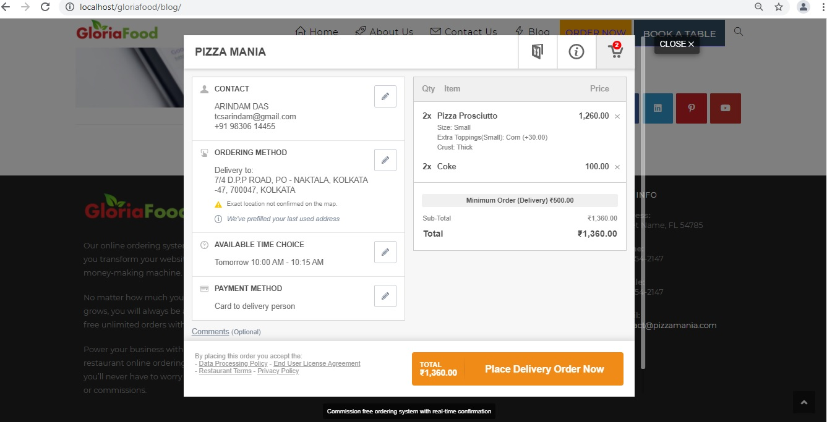

**Table Reservation Menu:**

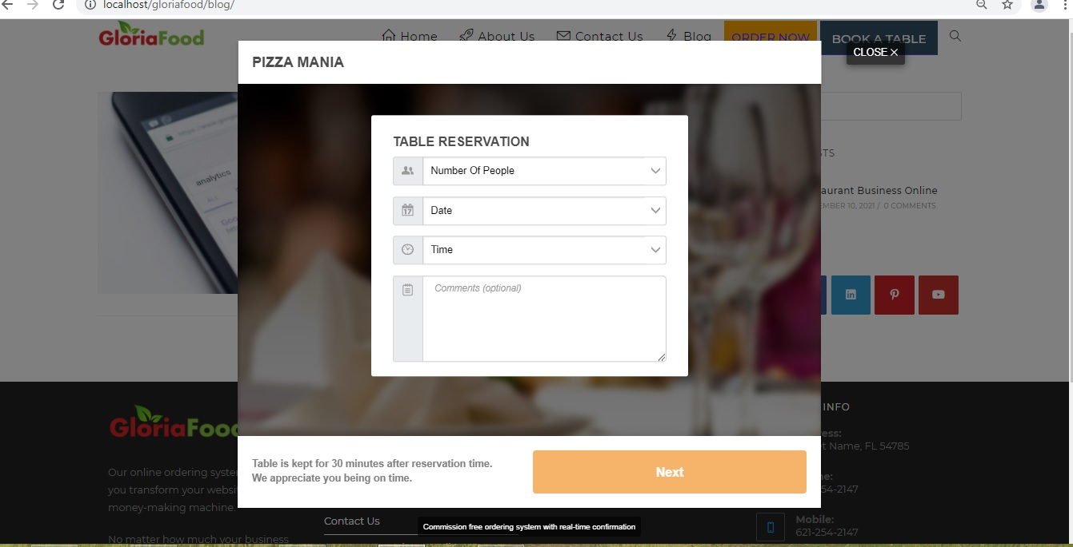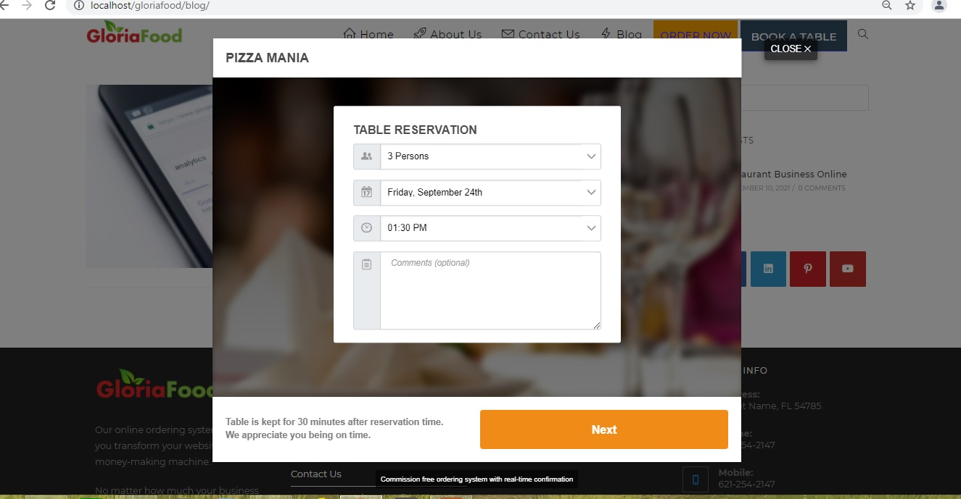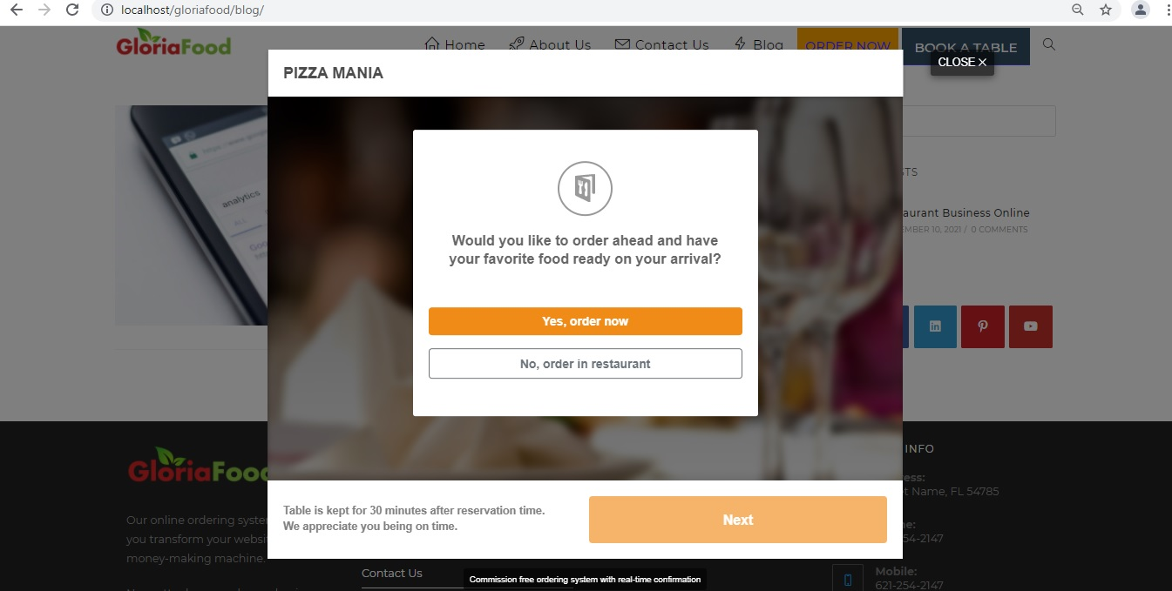

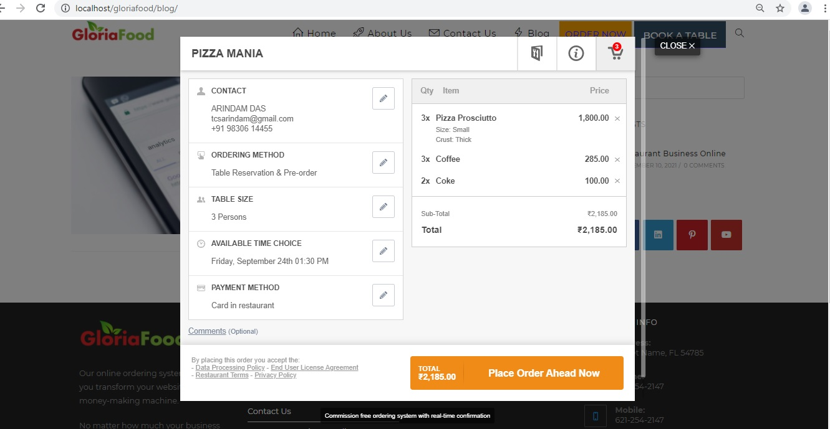

**Orders in ANDROID Restaurant APP:**

