Introduction to Product Engineering
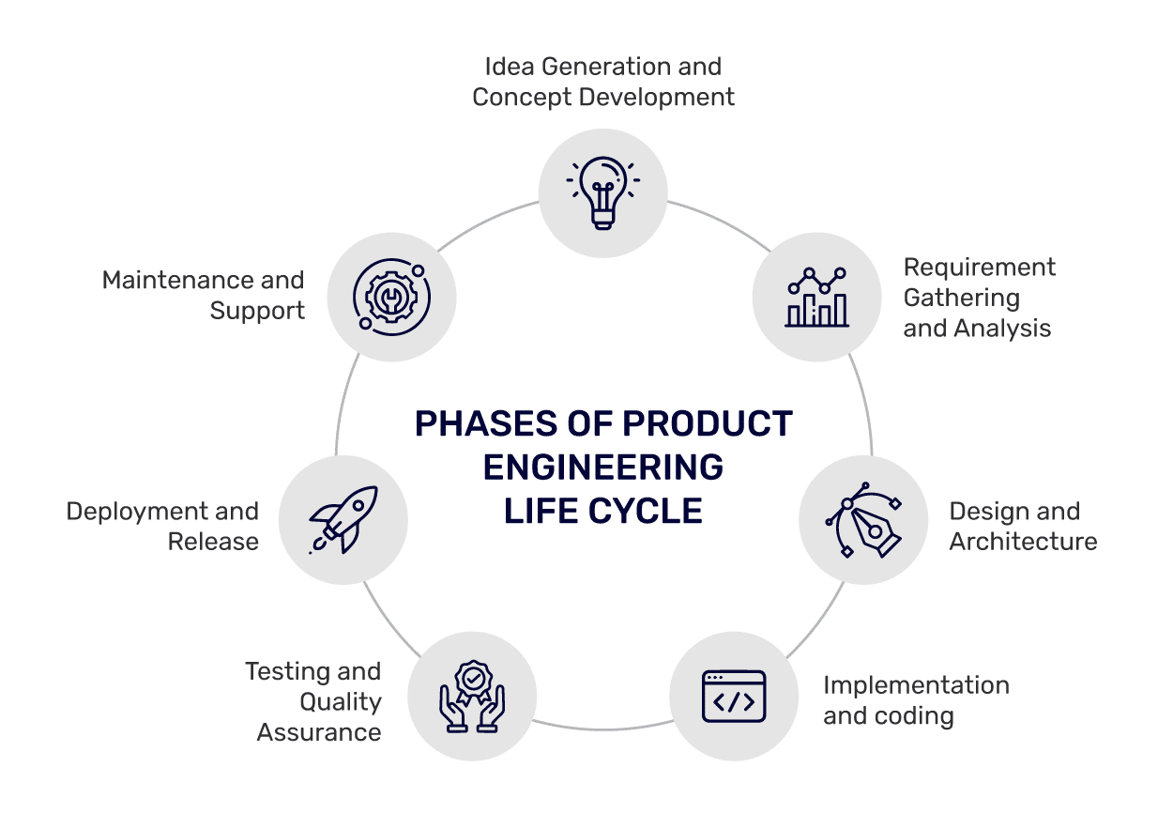
Design: DB design, API design, wireframes, git repos
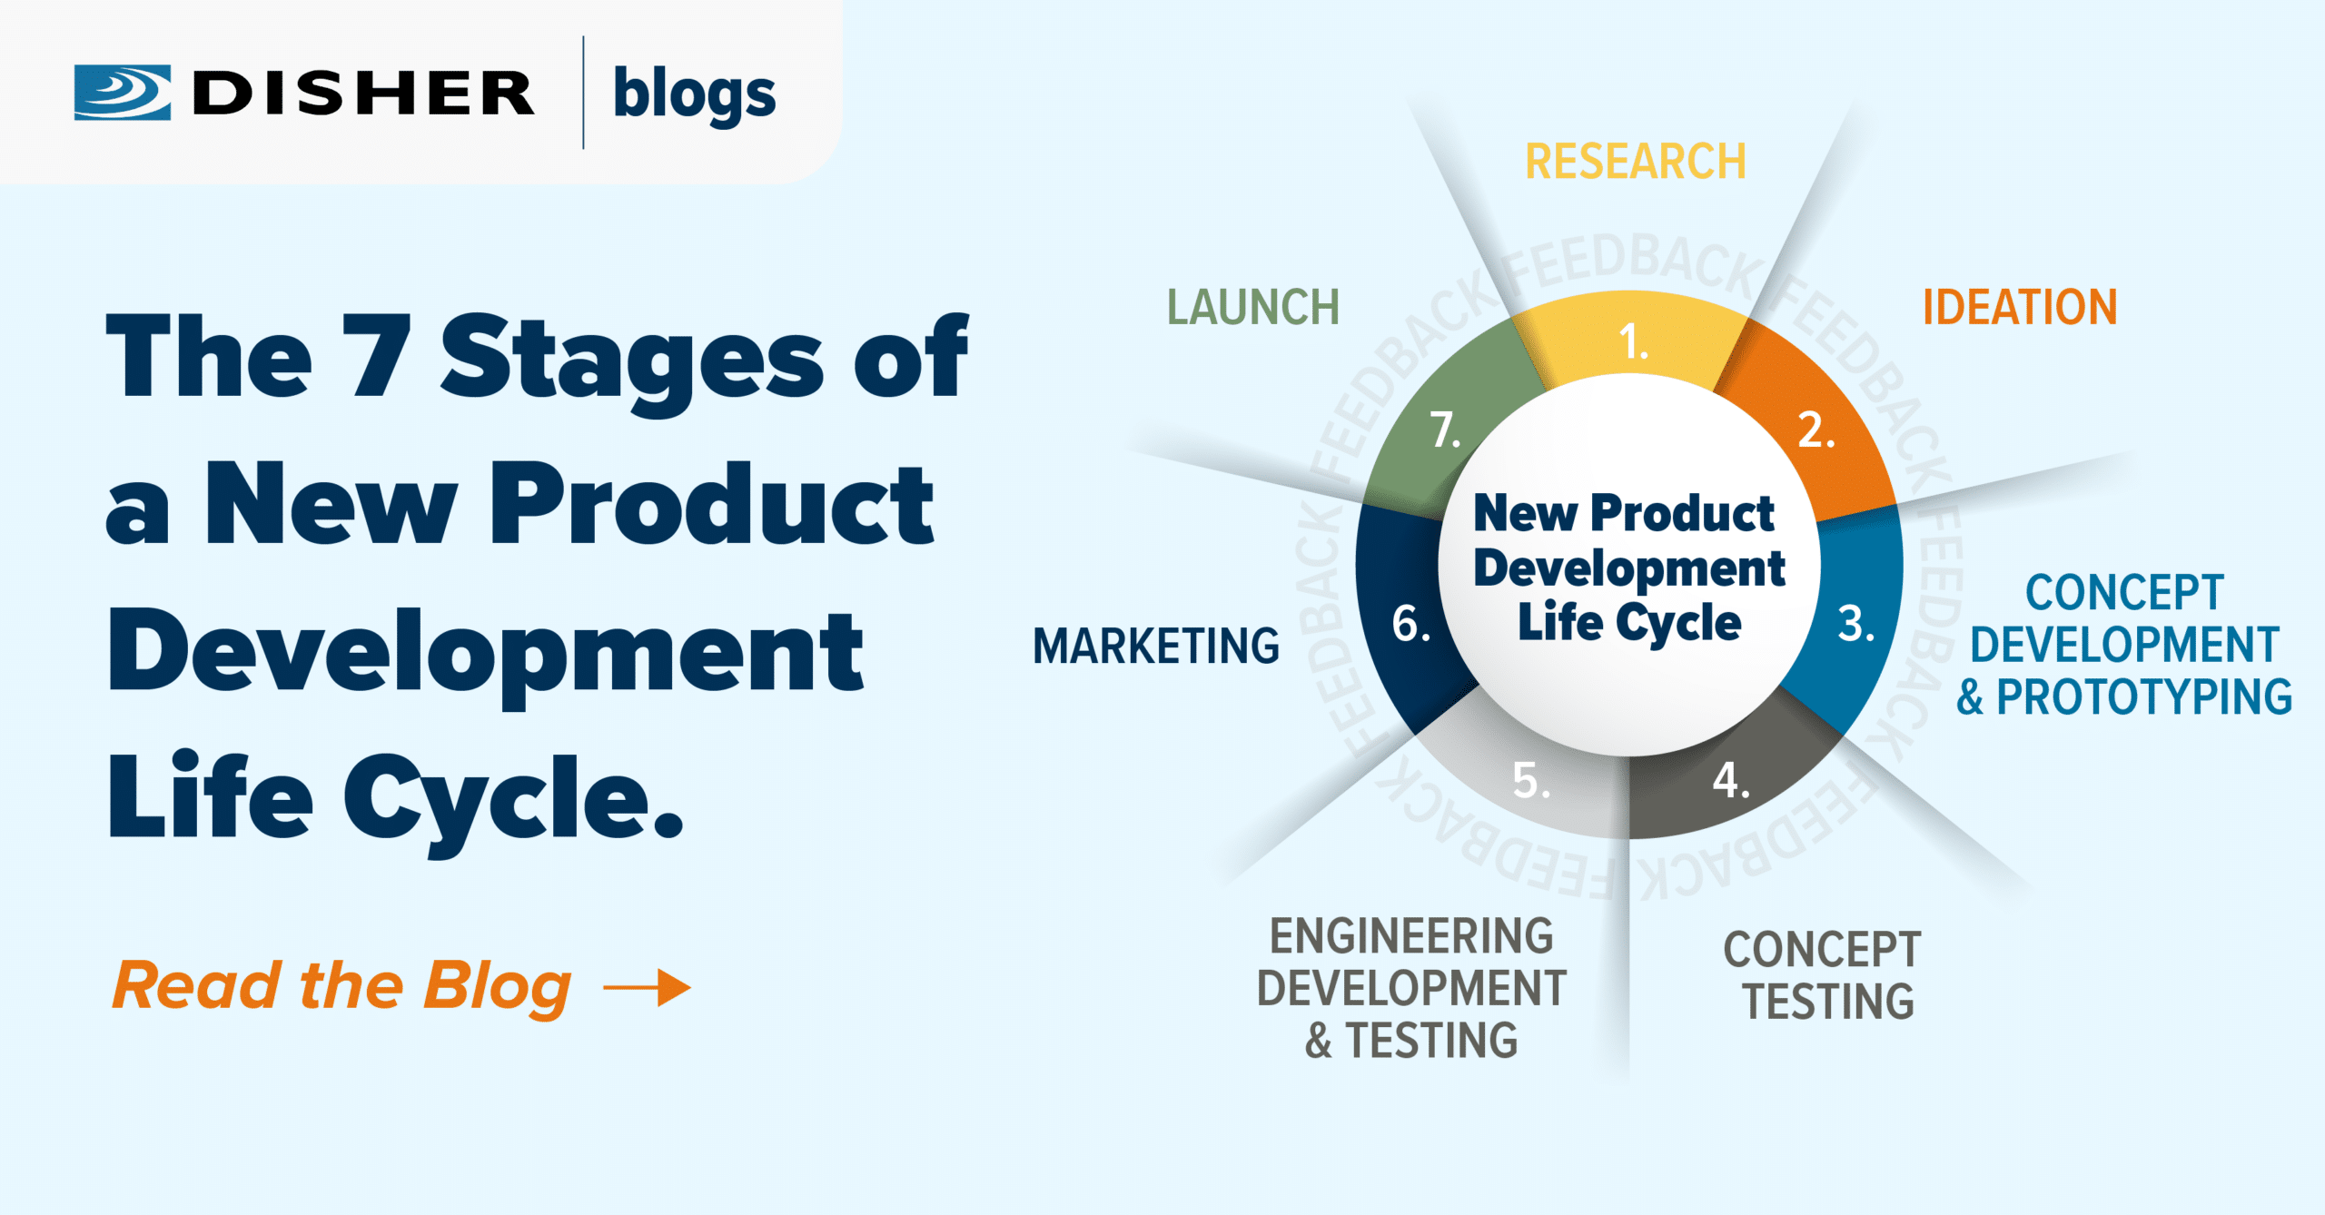
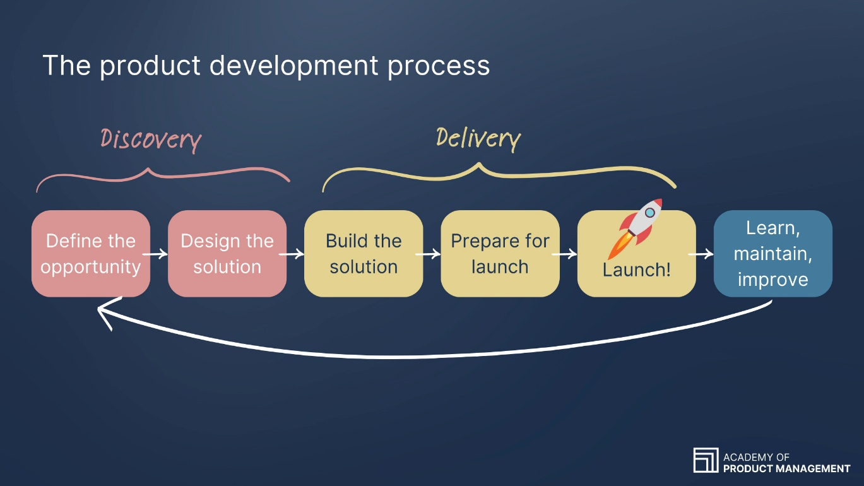

What is Product Engineering?
Product Engineering is the discipline of designing, building, scaling, and evolving software products that deliver real user value and business outcomes over time.
Unlike traditional project-based development, product engineering focuses on:
- Long-term ownership
- Continuous improvement
- User-centric decision-making
- Scalability, reliability, and quality
Key difference
- Project mindset: Deliver scope (requirement)→ finish → move on
- Product mindset: Deliver value (requirements + improvement)→ learn → iterate → improve

Understanding Users, Business Goals & Value Creation
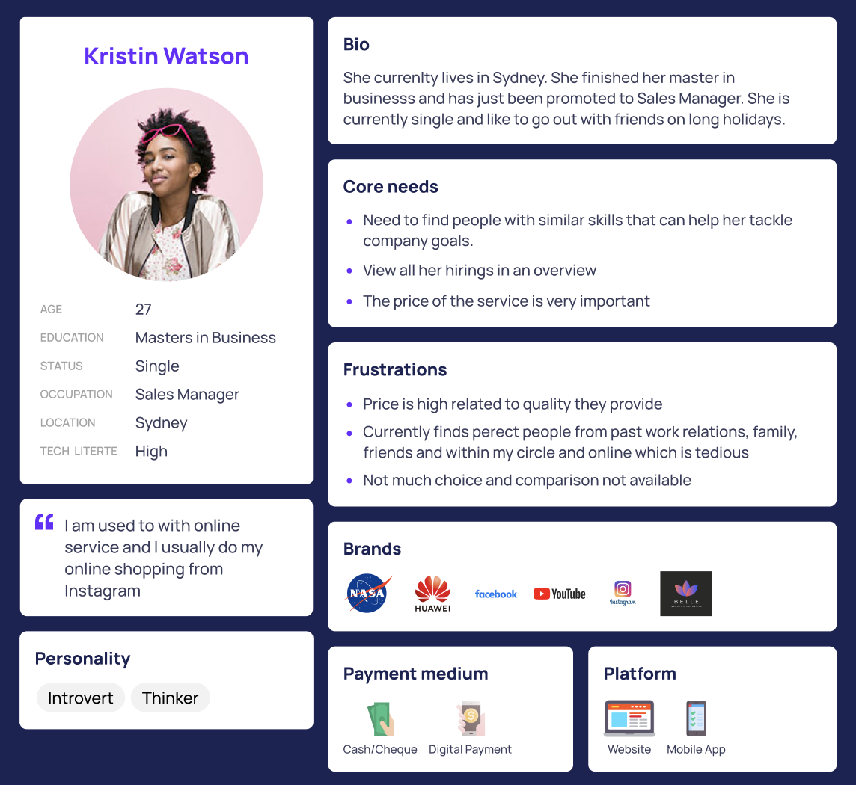

1. Understanding Users
Product engineers must deeply understand:
- Who the users are
- What problems they face
- How they currently solve those problems
- Pain points and unmet needs
Common tools:
- User personas
- User journeys
- Empathy maps
- Usage analytics

2. Understanding Business Goals
Every product decision should connect to a business objective:
- Revenue growth
- Cost reduction
- Market expansion
- User retention
- Operational efficiency

3. Value Creation
Value is created at the intersection of:
- User needs
- Business goals
- Technical feasibility
A feature is valuable only if it:
- Solves a real user problem
- Supports business outcomes
- Can be maintained and scaled efficiently

Problem-Solving vs. Feature-Building

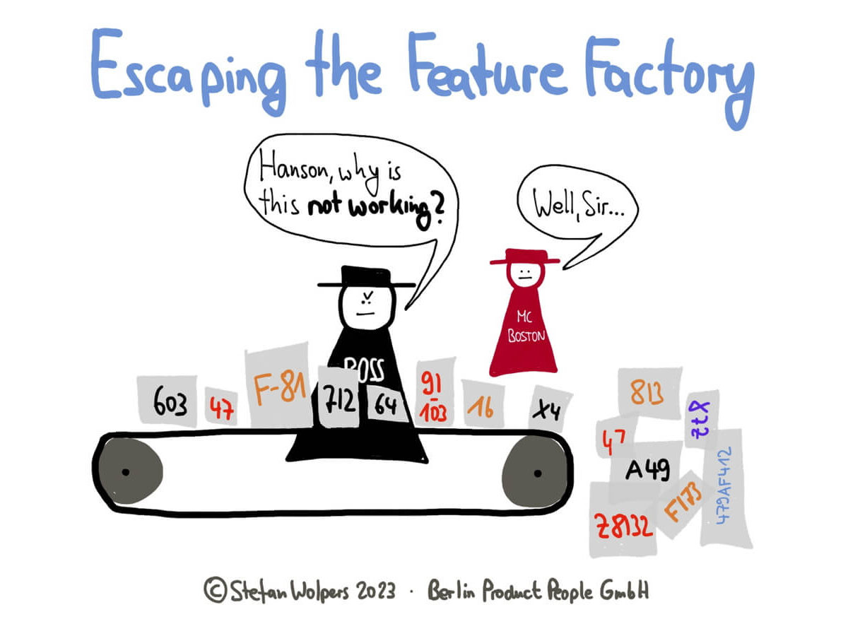

Feature-Building Mindset (Anti-Pattern)
- “Build what is written in the ticket”
- Success = feature shipped
- Limited questioning of requirements
- Leads to bloated products and wasted effort

Problem-Solving Mindset (Product Engineering)
- Start with why, not what
- Success = problem reduced or eliminated
- Engineers actively challenge assumptions
- Multiple solution options are explored
Example
- ❌ Feature: “Add a new filter to the dashboard”
- ✅ Problem: “Users can’t find critical data quickly”
A product engineer asks:
- What outcome are we trying to achieve?
- Can we solve this more simply?
- What are the trade-offs?

Designing Products for Scale, Reliability & Maintainability
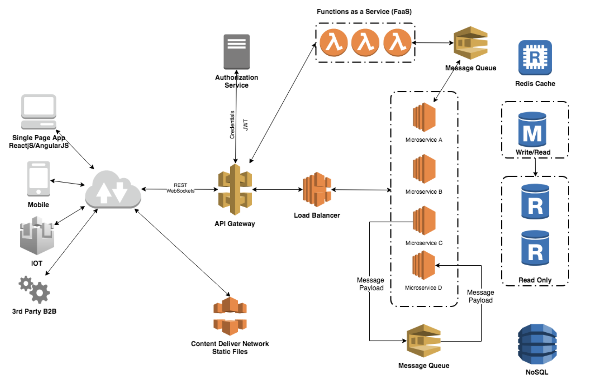
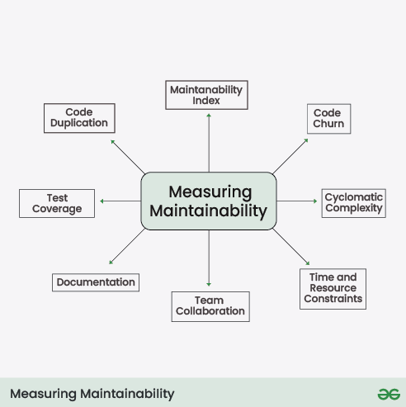
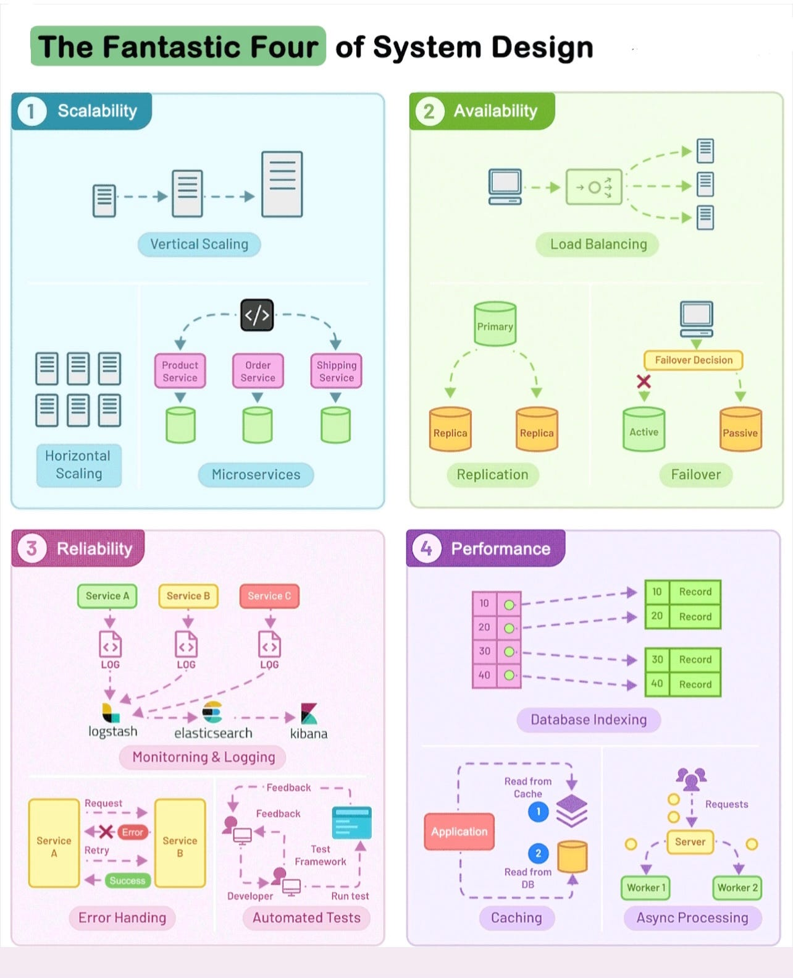

1. Designing for Scale
Scale refers to handling:
- More users
- More data
- More traffic
- More teams
Key practices:
- Modular architectures
- Horizontal scalability
- Stateless services
- Caching strategies
- Asynchronous processing

2. Designing for Reliability
Reliability ensures the system behaves predictably:
- Fault tolerance
- Graceful degradation
- Monitoring and alerting
- Automated recovery

3. Designing for Maintainability
Maintainability determines long-term success:
- Clean code
- Clear ownership
- Consistent patterns
- Automated tests
- Documentation
Rule of thumb
If it’s hard to change, it will eventually break the product.

Quality & Security as Core Product Principles
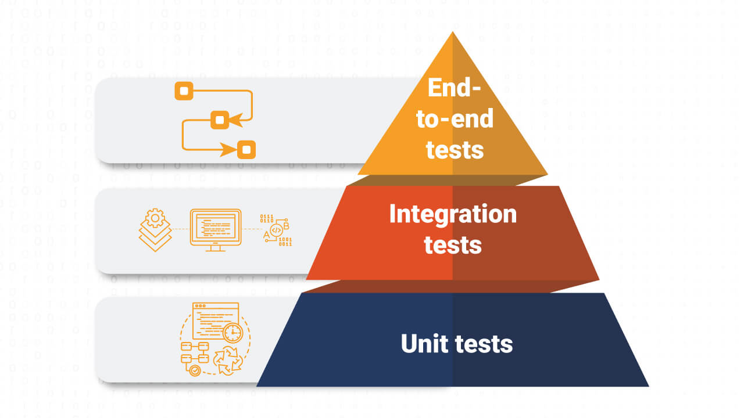
  - It breaks if code is modified in unexpected ways
  - Code coverage
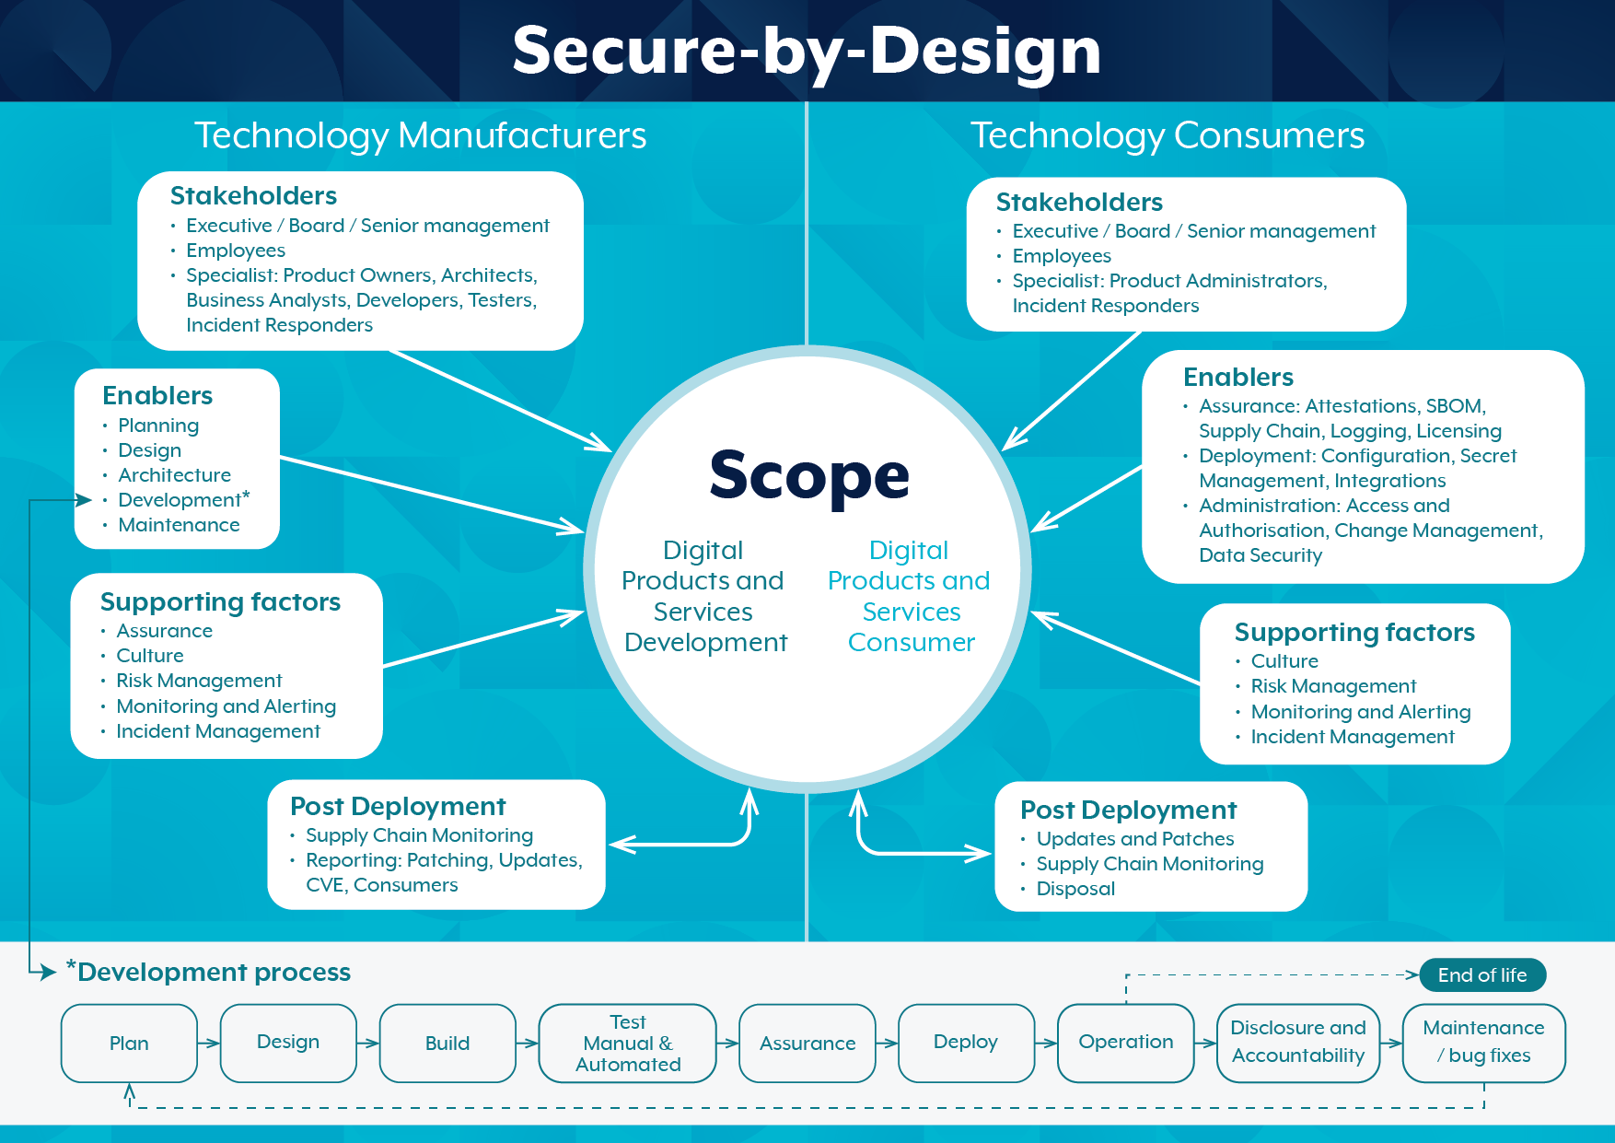
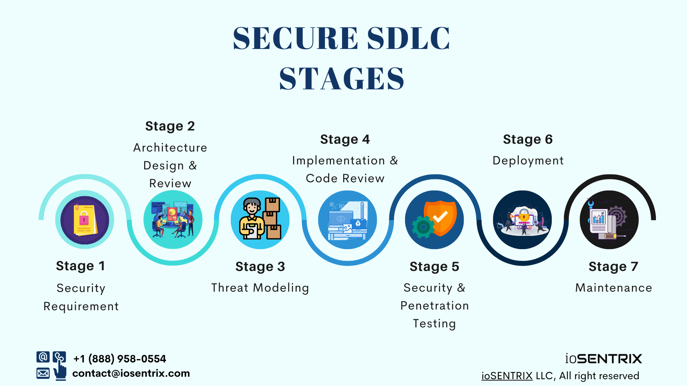

Quality is Not Optional
Quality is not a “testing phase” — it is a product property.
Includes:
- Functional correctness
- Performance
- Usability
- Reliability
- Accessibility
Quality practices:
- Automated testing (unit, integration, e2e)
- Code reviews
- CI pipelines
- Observability

Security by Design
Security must be embedded from day one:
- Least privilege access
- Secure authentication & authorization
- Input validation
- Secure data storage
- Regular vulnerability assessments
Product impact of poor security
- Loss of user trust
- Legal and compliance risks
- Business damage

Collaboration with Product Managers, Designers & Stakeholders
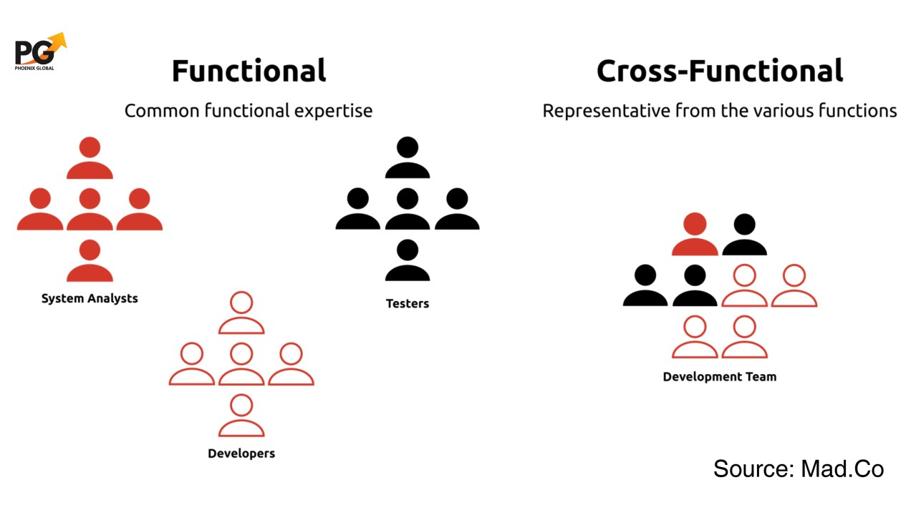
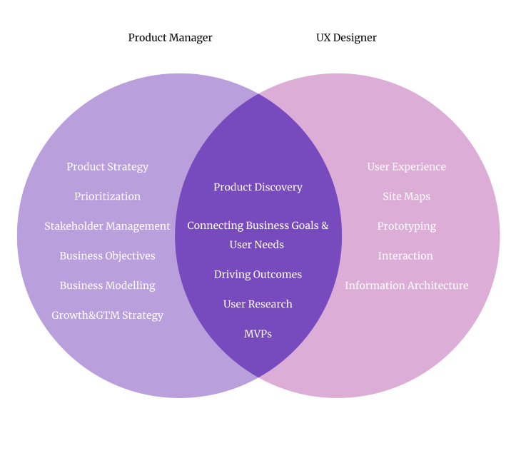
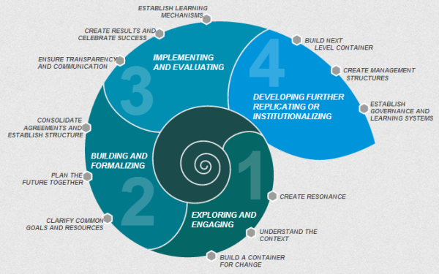

Product Engineering is a Team Sport

Product Managers
- Define what and why
- Own vision, roadmap, priorities
- Engineers collaborate on feasibility and trade-offs

Designers
- Define user experience
- Engineers collaborate on usability, accessibility, and implementation constraints

Stakeholders
- Business leaders, customers, operations
- Engineers provide technical clarity and realistic timelines
Strong product teams
- Communicate early and often
- Share ownership of outcomes
- Avoid siloed decision-making

Continuous Feedback, Iteration & Product Evolution
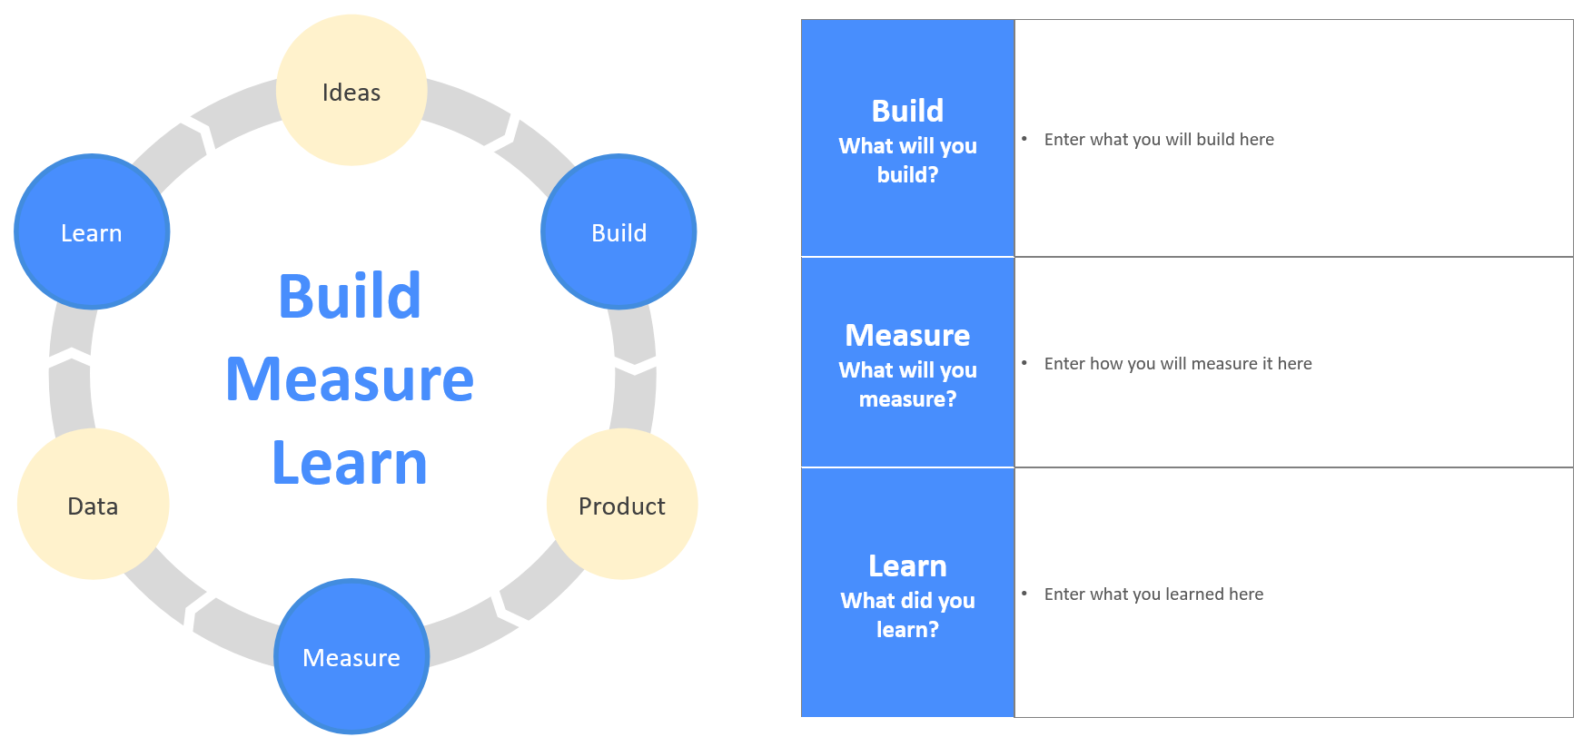
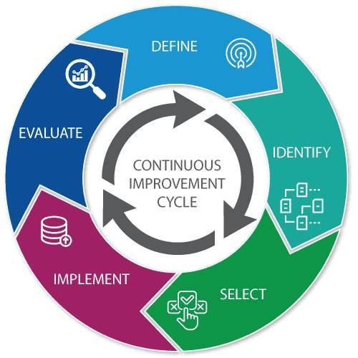
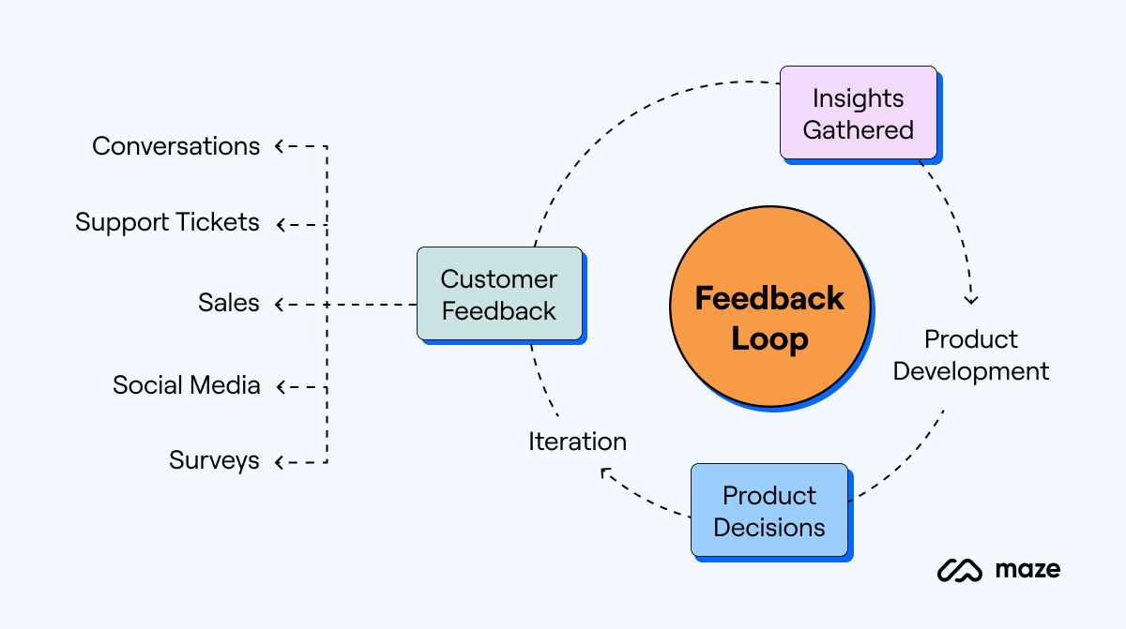

Feedback Loops
Product engineering relies on fast feedback:
- User analytics
- User feedback
- A/B testing
- Production metrics

Iterative Development
- Build small
- Release frequently
- Learn continuously
- Improve incrementally

Product Evolution
Products are never “done”:
- User needs change
- Technology evolves
- Markets shift
Engineering decisions should support future adaptability, not just immediate delivery.

Agile Methodology

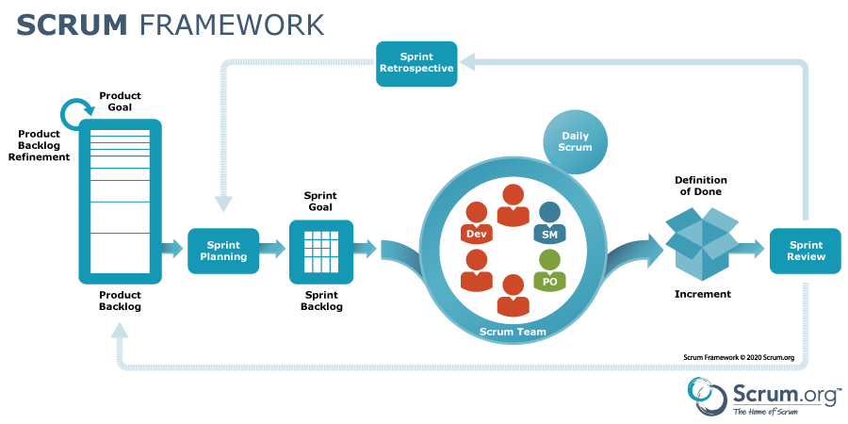
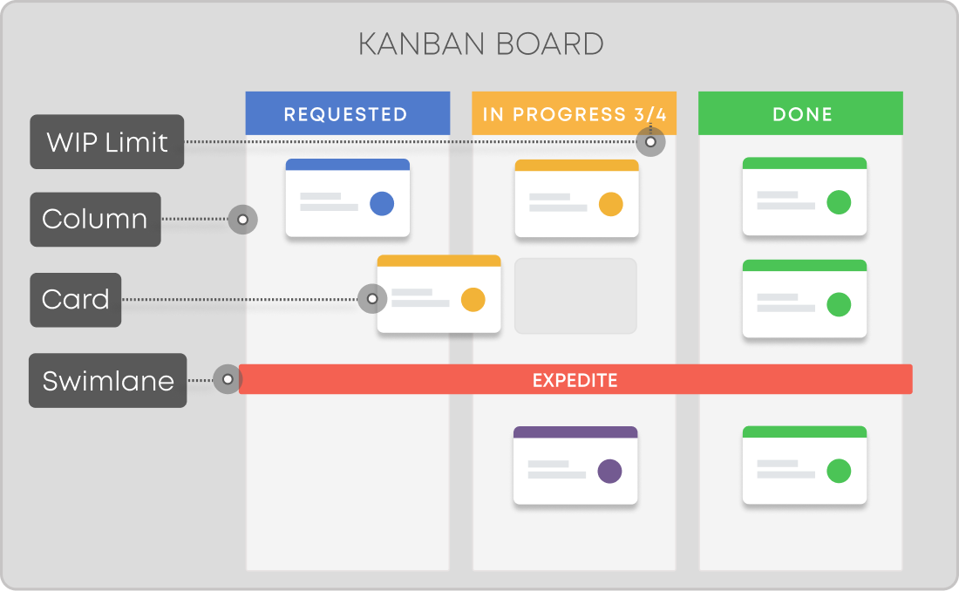

Agile Principles
Agile emphasizes:
- Individuals and interactions
- Working software
- Customer collaboration
- Responding to change
Core ideas:
- Short feedback cycles
- Incremental delivery
- Continuous improvement
- Empowered teams

Agile Frameworks

Scrum
- Time-boxed iterations called sprints
- Defined roles: Product Owner, Scrum Master, Development Team
- Predictable cadence

Kanban
- Continuous flow
- Visual work management
- Limit work in progress (WIP)
- Flexible prioritization

Scrum Ceremonies
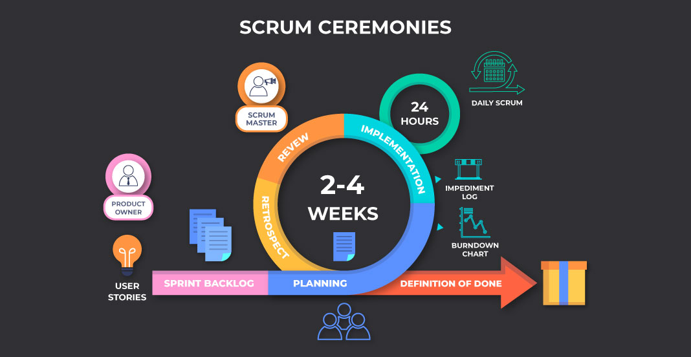

Sprint Planning
- Define sprint goal
- Select backlog items
- Estimate effort

Daily Stand-ups
- What was done?
- What’s next?
- Any blockers?

Sprint Review
- Demonstrate working software
- Collect stakeholder feedback

Sprint Retrospective
- What went well?
- What didn’t?
- What can be improved?

Key Takeaways
- Product engineering focuses on value, not just features
- Engineers are problem solvers, not ticket executors
- Scalability, reliability, quality, and security are first-class concerns
- Collaboration drives better outcomes
- Agile enables continuous learning and evolution

