Java Tutorial (Medium Level): Exception Handling, Logging, and File I/O
This tutorial covers three essential backend Java concepts used in real applications such as Spring Boot services, APIs, and enterprise systems.
Topics covered:
- Exception Handling
- Logging
- File Input/Output (File I/O)

1. Exception Handling in Java
An exception is an event that occurs during program execution that disrupts the normal flow of instructions.
Examples:
- Dividing by zero
- File not found
- Database connection failure
- Null pointer access

Exception Flow
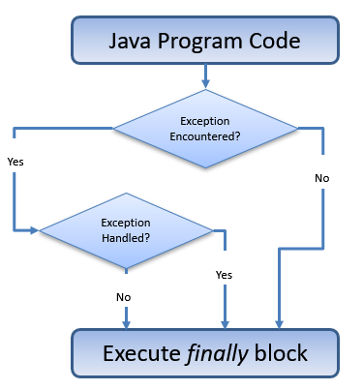
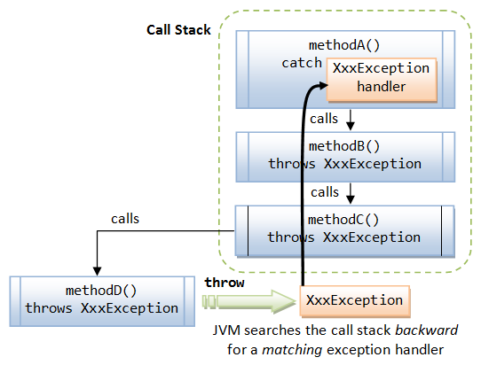

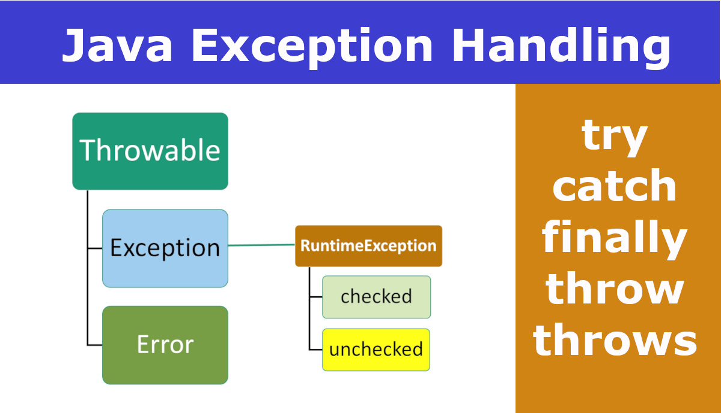

Basic Syntax
try {
// code that may cause exception
}
catch(ExceptionType e) {
// exception handling code
}
finally {
// always executed
}

Example: Divide by Zero
public class ExceptionExample {

public static void main(String[] args) {

try {
int result = 10 / 0;
System.out.println(result);
}

catch(ArithmeticException e) {
System.out.println("Cannot divide by zero");
}

finally {
System.out.println("Program finished");
}
}
}
Output
Cannot divide by zero
Program finished

Types of Exceptions
Java exceptions fall into two categories.
Type | Description
Checked Exceptions | Checked at compile time
Unchecked Exceptions | Occur at runtime

Checked Exceptions
Examples:
- IOException
- SQLException
- FileNotFoundException
Example:
import java.io.*;

public class CheckedExample {

public static void main(String[] args) {

try {
FileReader file = new FileReader("data.txt");
}

catch(FileNotFoundException e) {
System.out.println("File not found");
}
}
}

Unchecked Exceptions
Examples:
- NullPointerException
- ArithmeticException
- ArrayIndexOutOfBoundsException
Example:
String str = null;

System.out.println(str.length());
This throws NullPointerException.

Exception Hierarchy
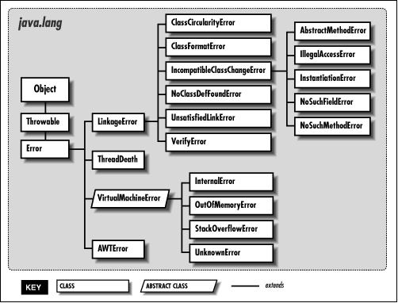
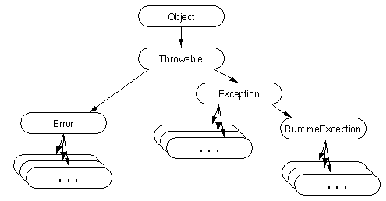
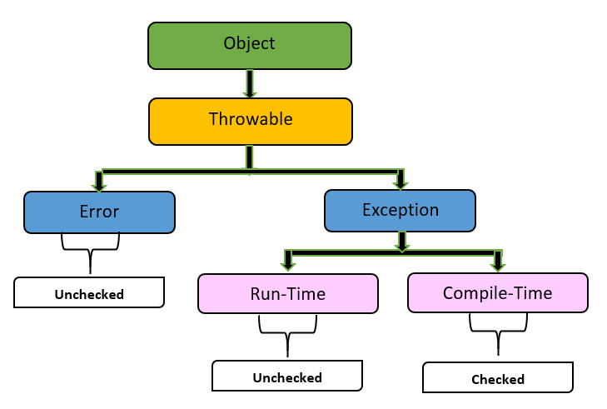
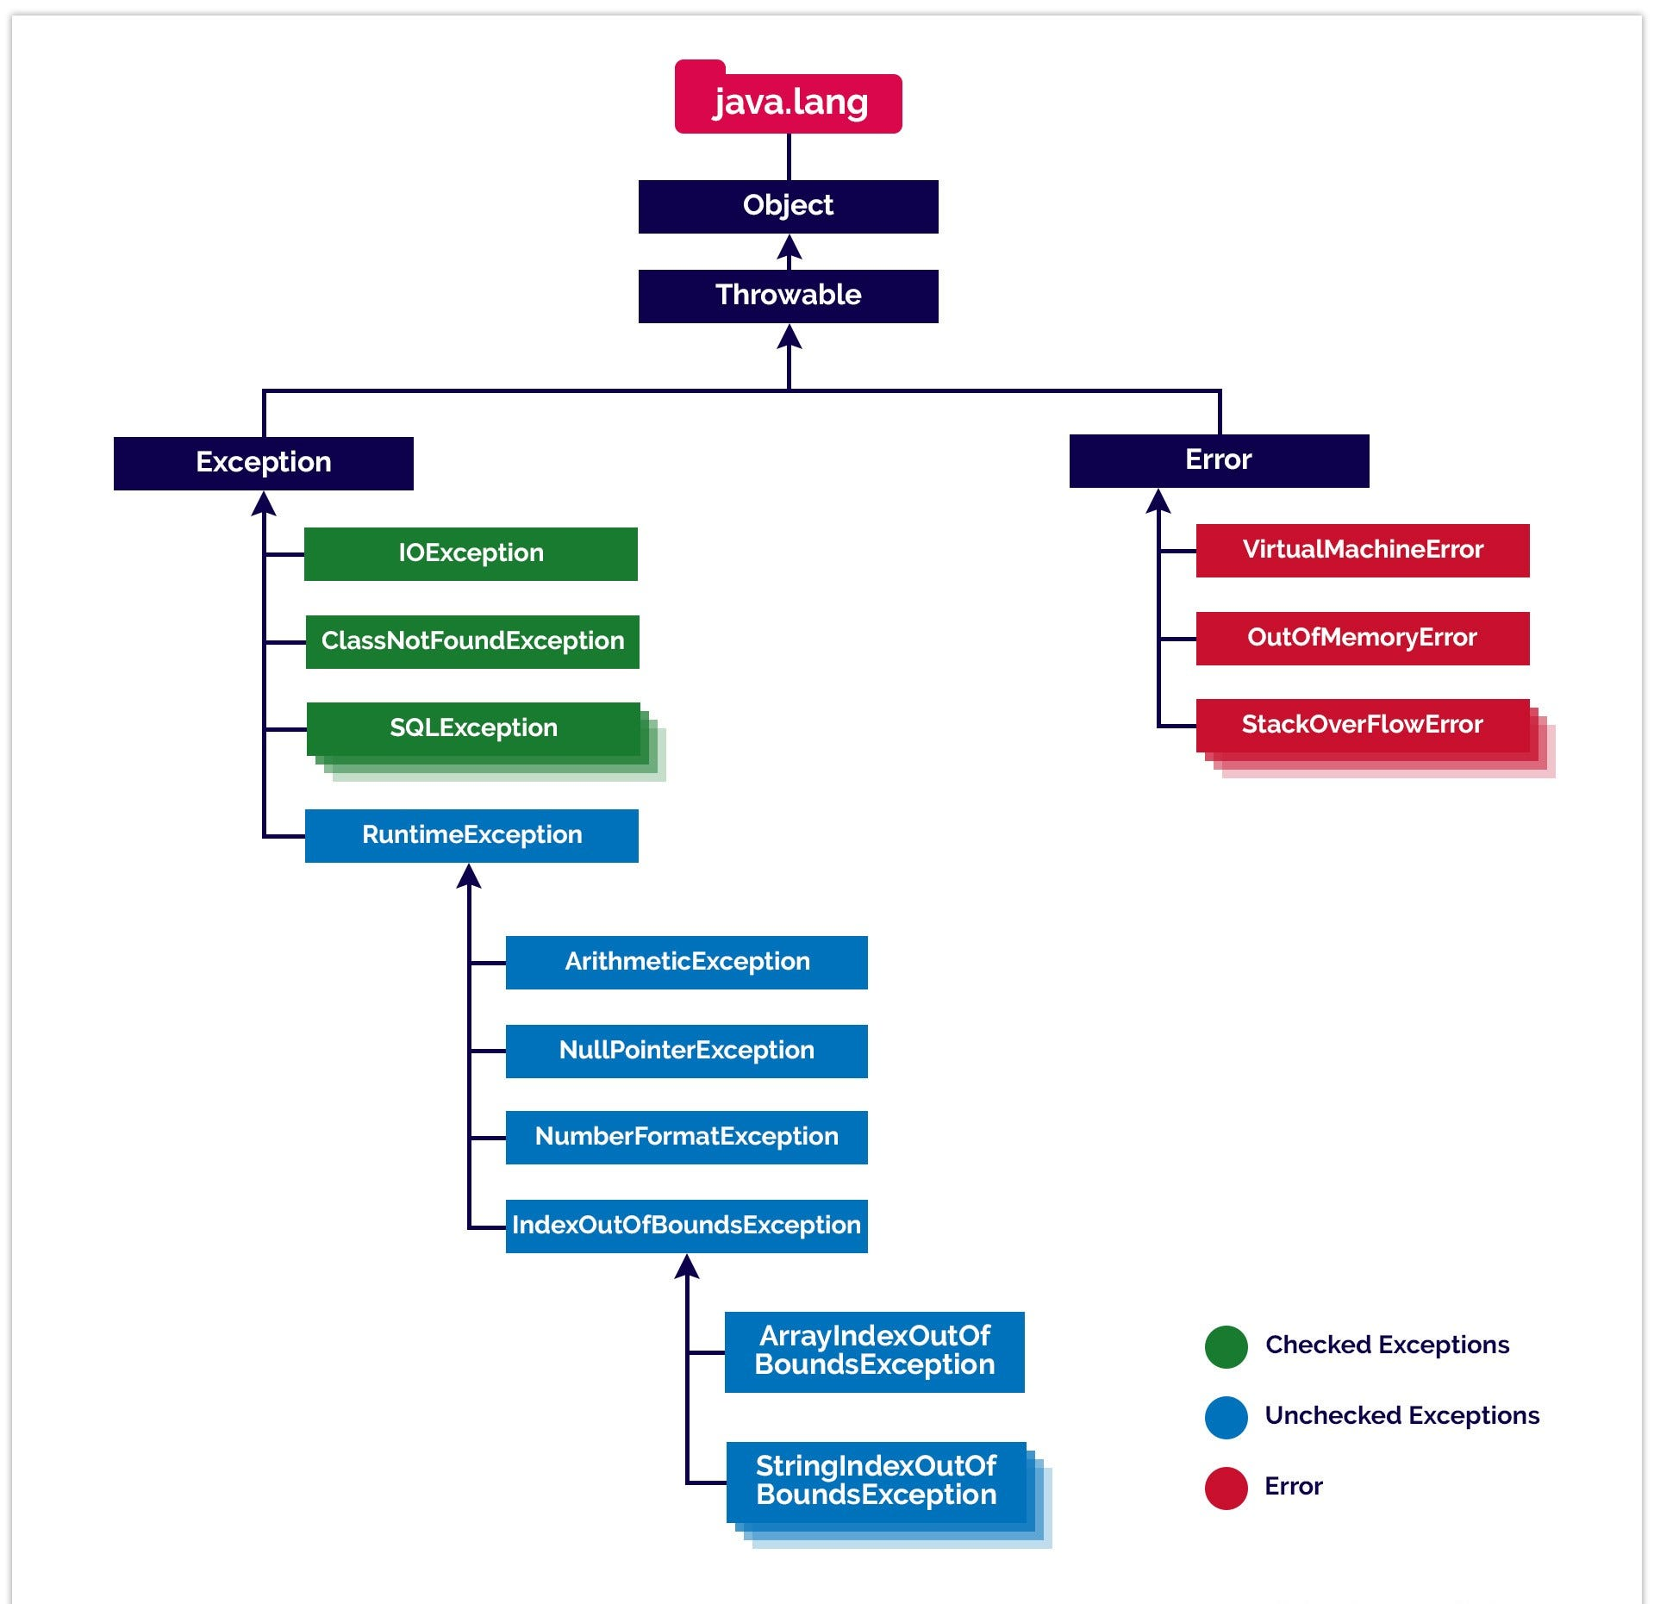

Hierarchy:
Throwable
├── Error
└── Exception
├── IOException
└── RuntimeException

Throw vs Throws

throw
Used to explicitly throw an exception.
if(age < 18) {
throw new IllegalArgumentException("Age must be 18+");
}

throws
Used to declare exceptions.
public void readFile() throws IOException {
FileReader file = new FileReader("data.txt");
}

Custom Exception
class InvalidAgeException extends Exception {

public InvalidAgeException(String message) {
super(message);
}
}
Usage:
if(age < 18) {
throw new InvalidAgeException("Not eligible");
}

2. Logging in Java
Logging is used to record application events.
Examples:
- Errors
- Warnings
- Debug information
- User actions
Logging helps with:
- Debugging
- Monitoring
- Production troubleshooting

Logging Architecture
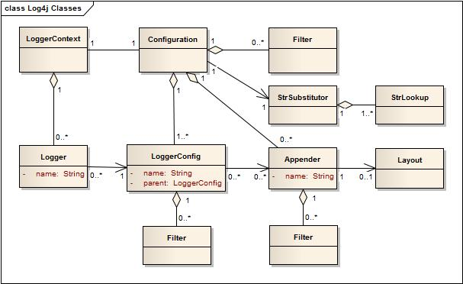
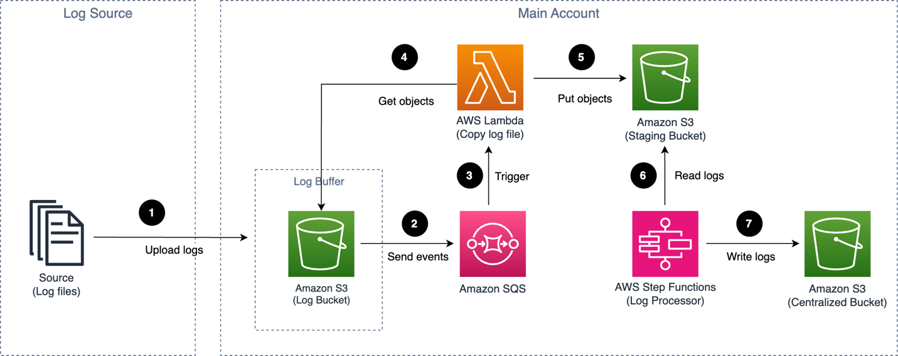
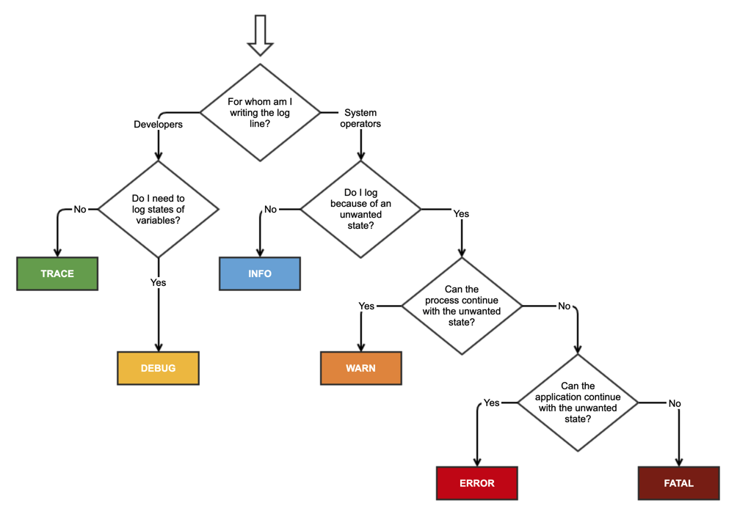
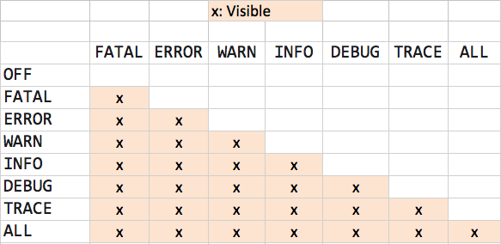

Logging Levels
Level | Purpose
SEVERE | Critical failure
WARNING | Potential issue
INFO | General information
DEBUG | Detailed debug info
TRACE | Very detailed logs

Using Java Logger
Java provides java.util.logging.
Example:
import java.util.logging.*;

public class LoggingExample {

private static final Logger logger =
Logger.getLogger(LoggingExample.class.getName());

public static void main(String[] args) {

logger.info("Application started");

logger.warning("Low memory warning");

logger.severe("System failure");
}
}
Output example:
INFO: Application started
WARNING: Low memory warning
SEVERE: System failure

Logging Best Practices
✔ Use logging instead of System.out.println()
✔ Log meaningful messages
✔ Use appropriate log levels
✔ Avoid logging sensitive information
Example:
logger.info("User login successful: " + username);

3. File I/O in Java
File I/O allows programs to read and write files.
Used for:
- Configuration files
- Logs
- Data processing
- Report generation

File I/O Architecture
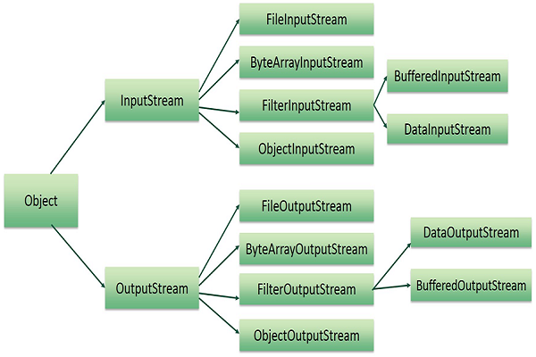
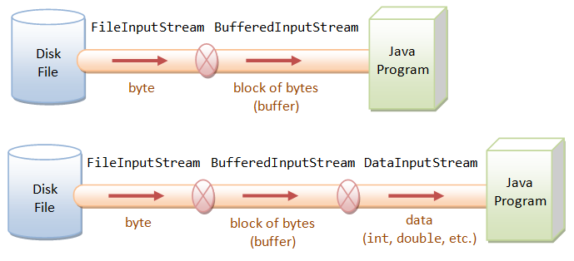

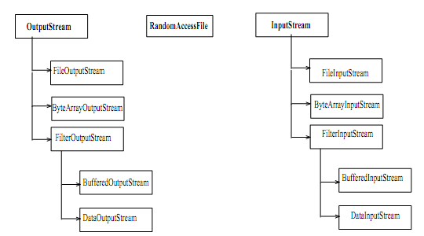

Reading Files

Using FileReader
import java.io.*;

public class FileReadExample {

public static void main(String[] args) throws IOException {

FileReader reader = new FileReader("data.txt");

int character;

while((character = reader.read()) != -1) {
System.out.print((char) character);
}

reader.close();
}
}

Writing Files

Using FileWriter
import java.io.*;

public class FileWriteExample {

public static void main(String[] args) throws IOException {

FileWriter writer = new FileWriter("output.txt");

writer.write("Hello Java File IO");

writer.close();
}
}

Buffered Reading
Buffered streams improve performance.
Example:
import java.io.*;

public class BufferedExample {

public static void main(String[] args) throws Exception {

BufferedReader reader =
new BufferedReader(new FileReader("data.txt"));

String line;

while((line = reader.readLine()) != null) {
System.out.println(line);
}

reader.close();
}
}

Try-With-Resources
Automatically closes resources.
Example:
import java.io.*;

public class TryResourceExample {

public static void main(String[] args) {

try(BufferedReader reader =
new BufferedReader(new FileReader("data.txt"))) {

System.out.println(reader.readLine());
}

catch(IOException e) {
e.printStackTrace();
}
}
}

Example: Logging + File I/O + Exception Handling
import java.io.*;
import java.util.logging.*;

public class FileLoggerExample {

private static final Logger logger =
Logger.getLogger(FileLoggerExample.class.getName());

public static void main(String[] args) {

try(BufferedReader reader =
new BufferedReader(new FileReader("data.txt"))) {

String line;

while((line = reader.readLine()) != null) {
logger.info(line);
}

}

catch(IOException e) {
logger.severe("File reading error: " + e.getMessage());
}
}
}

Interview Questions

Exception Handling
- Difference between checked vs unchecked exceptions
- Difference between throw and throws
- What is finally block
- What is try-with-resources

Logging
- Why logging is better than System.out.println()
- What are logging levels?
- What logging frameworks exist? (Log4j, SLF4J)

File I/O
- Difference between FileReader vs BufferedReader
- Difference between InputStream vs Reader
- What is NIO vs IO

