Java Lambda Expressions — Complete Tutorial with Code Examples
Lambda expressions were introduced in Java 8 to enable functional programming style in Java. They allow you to write concise implementations of functional interfaces.
Lambda expressions are heavily used with:
- Streams
- Collections
- Event handling
- Parallel processing

1. What is a Lambda Expression?
A lambda expression is a short block of code that takes parameters and returns a value.
Syntax:
(parameters) -> expression
or
(parameters) -> { statements }
Example:
(a, b) -> a + b

Lambda Expression Structure
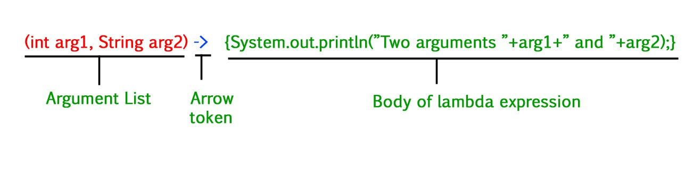
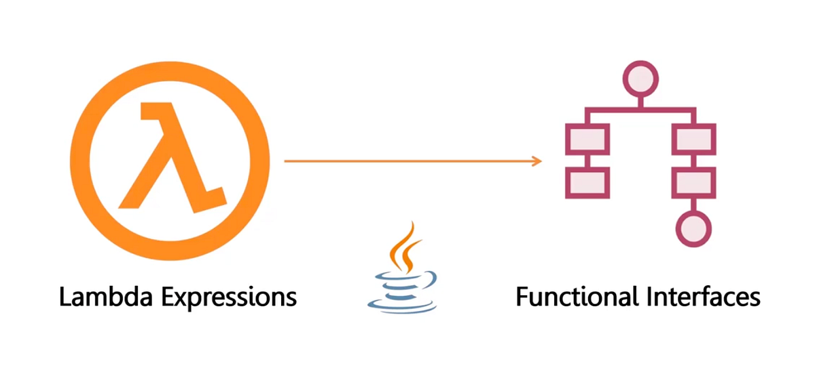
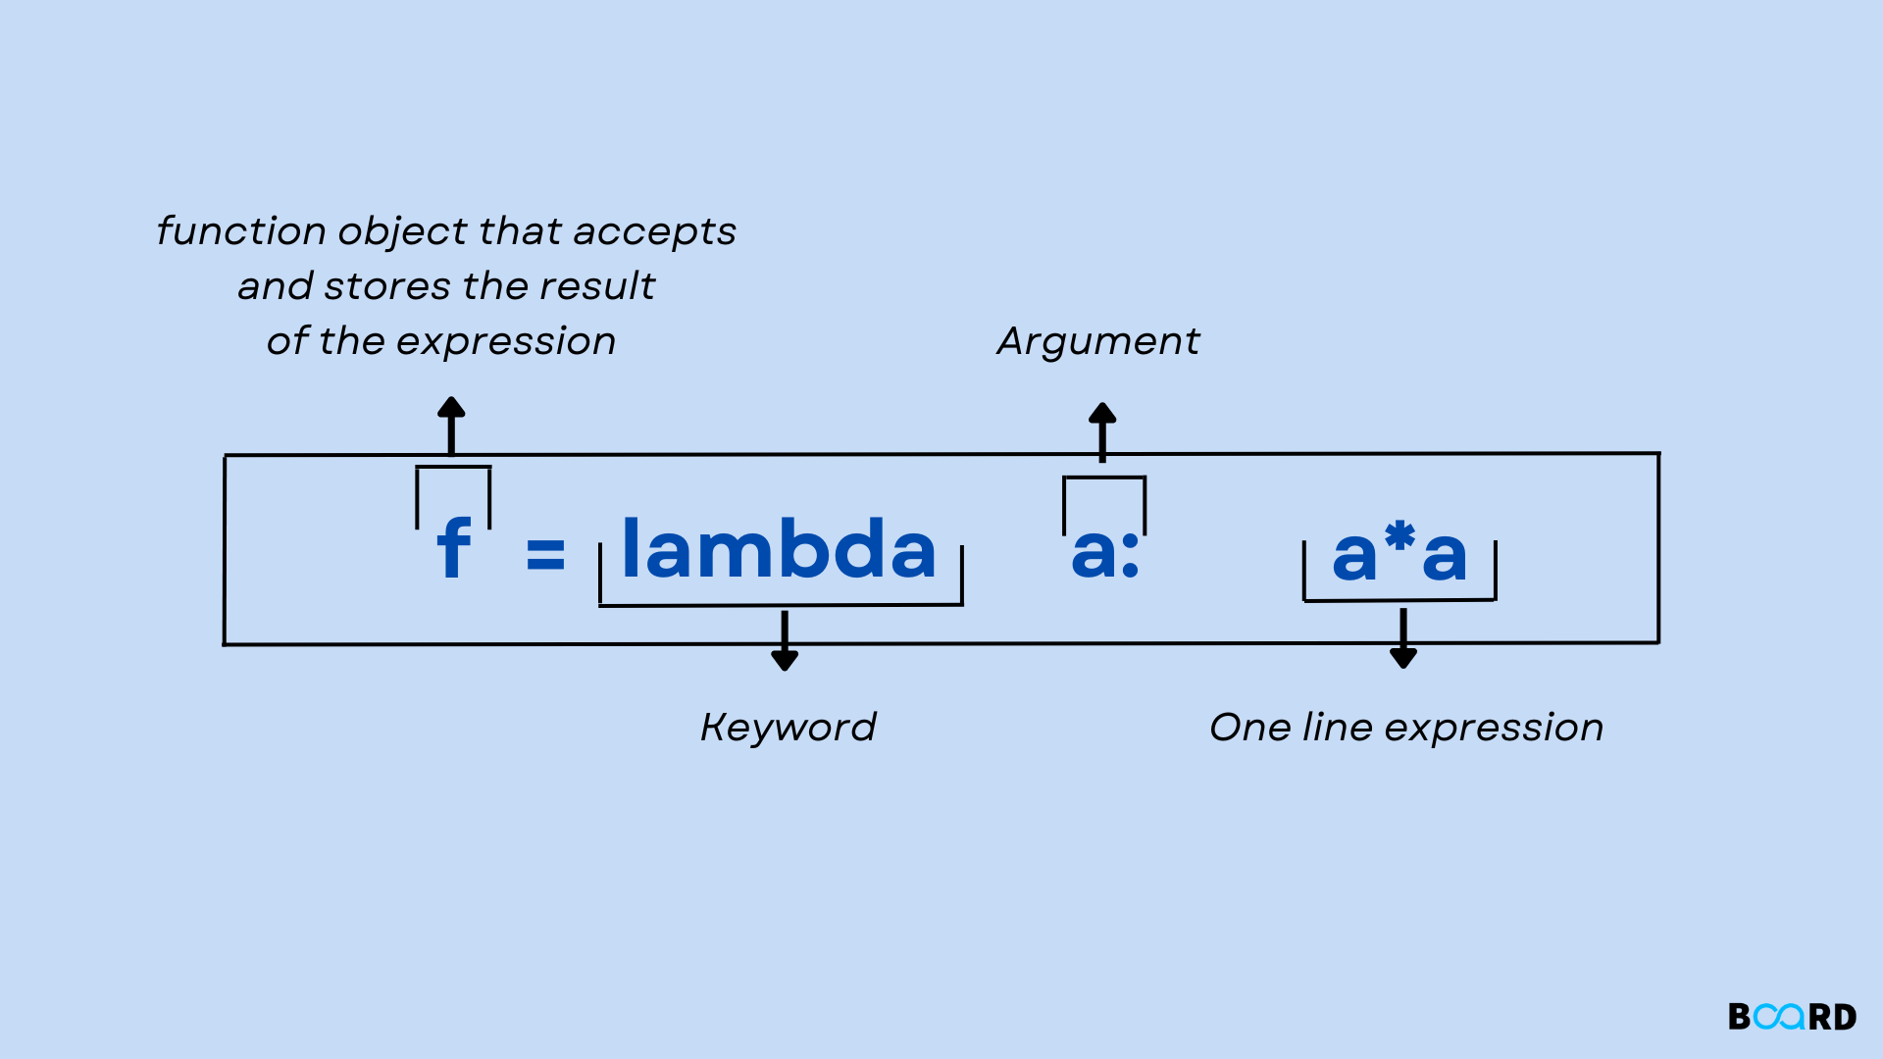

Parts:
(parameters) -> { body }
Example:
(int a, int b) -> a + b

2. Functional Interfaces
Lambda expressions work with functional interfaces.
A functional interface has only one abstract method.
Examples:
- Runnable
- Comparator
- Callable
- Predicate
- Consumer
- Supplier
Example:
@FunctionalInterface
interface MathOperation {
int operate(int a, int b);
}

Functional Interface Diagram
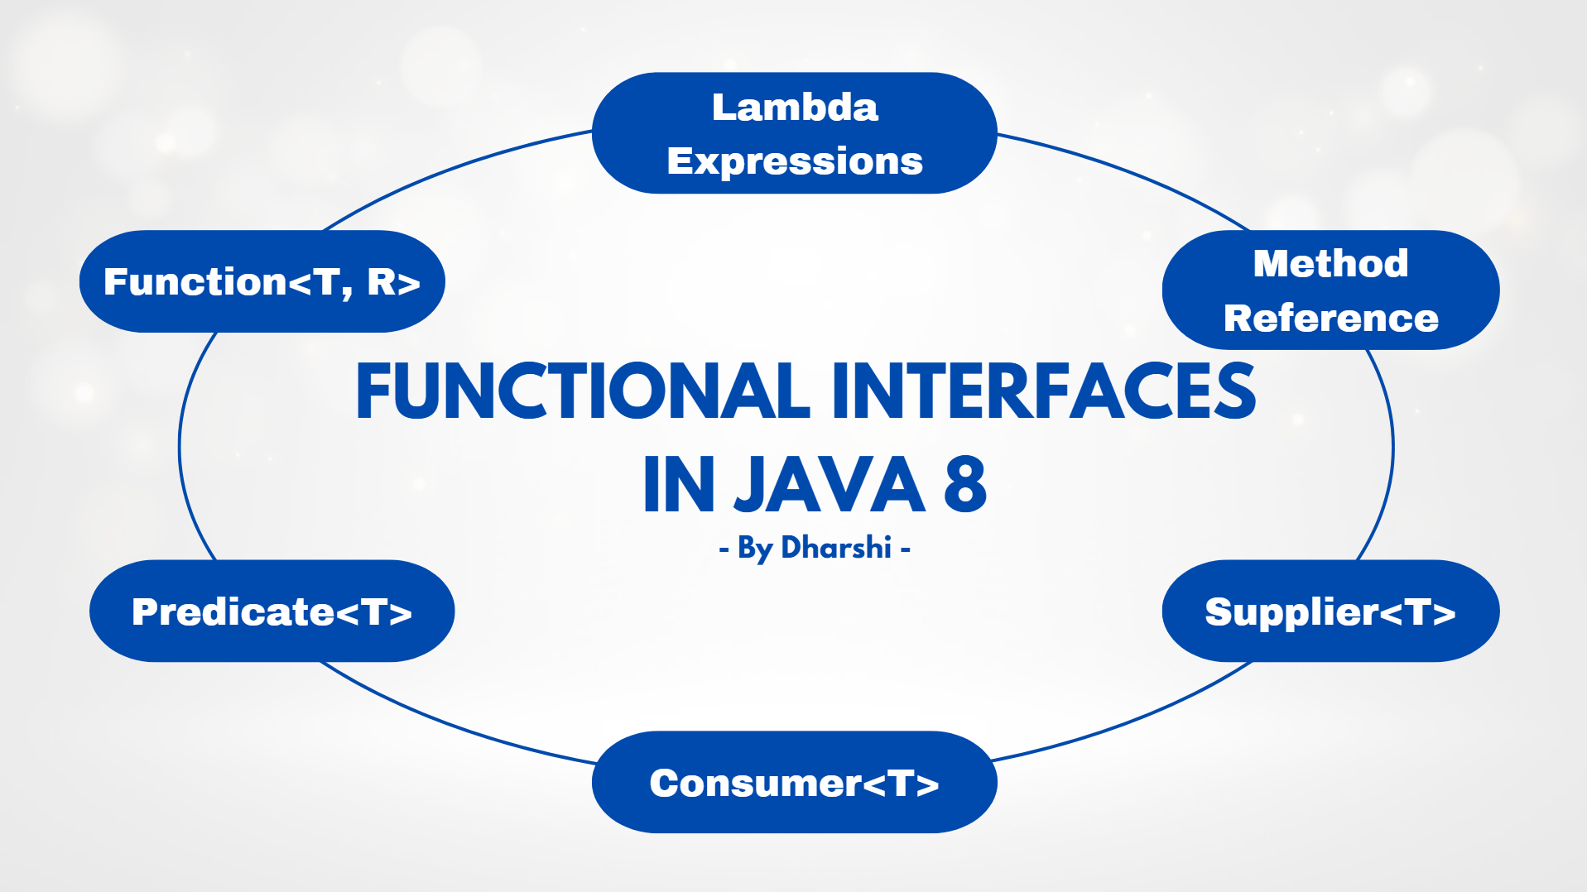
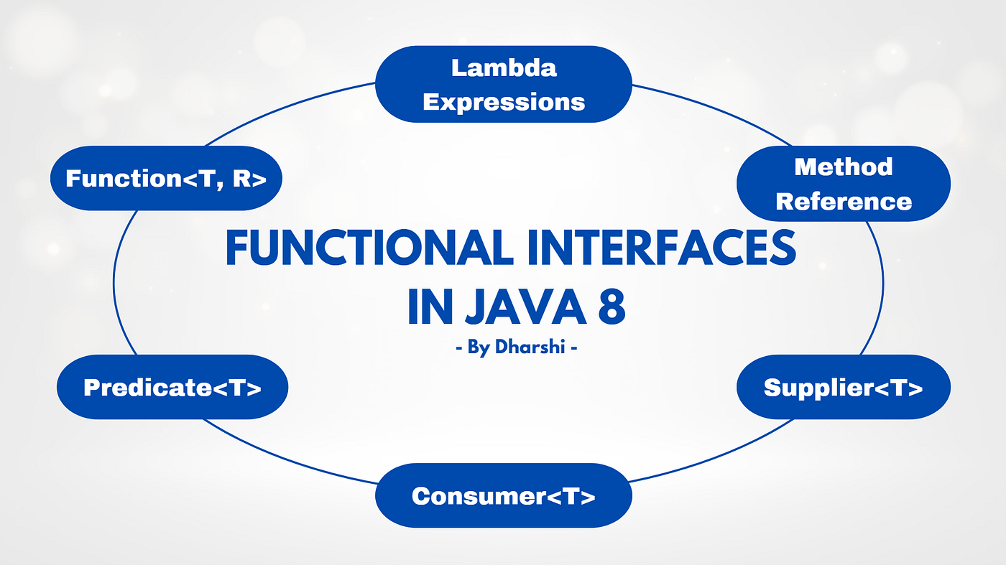
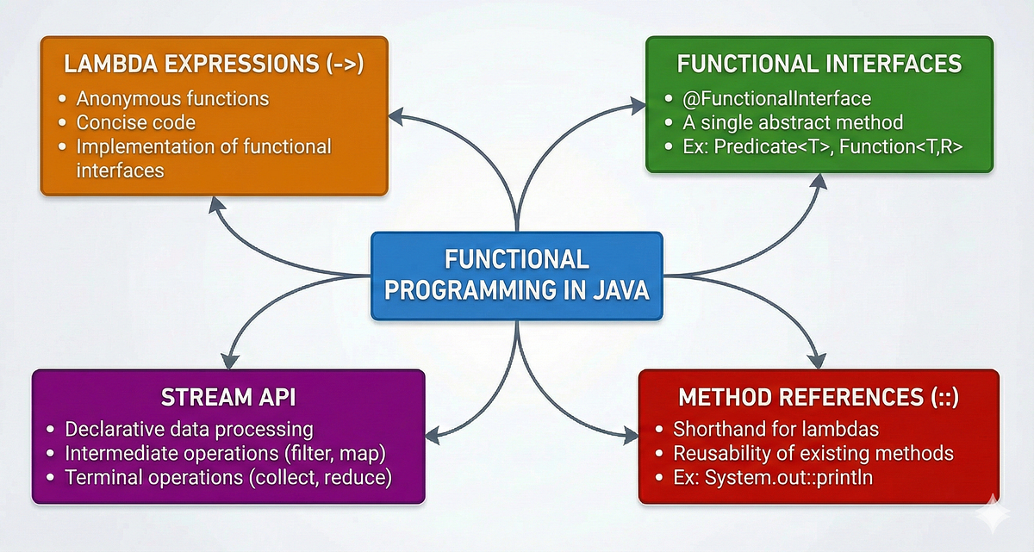
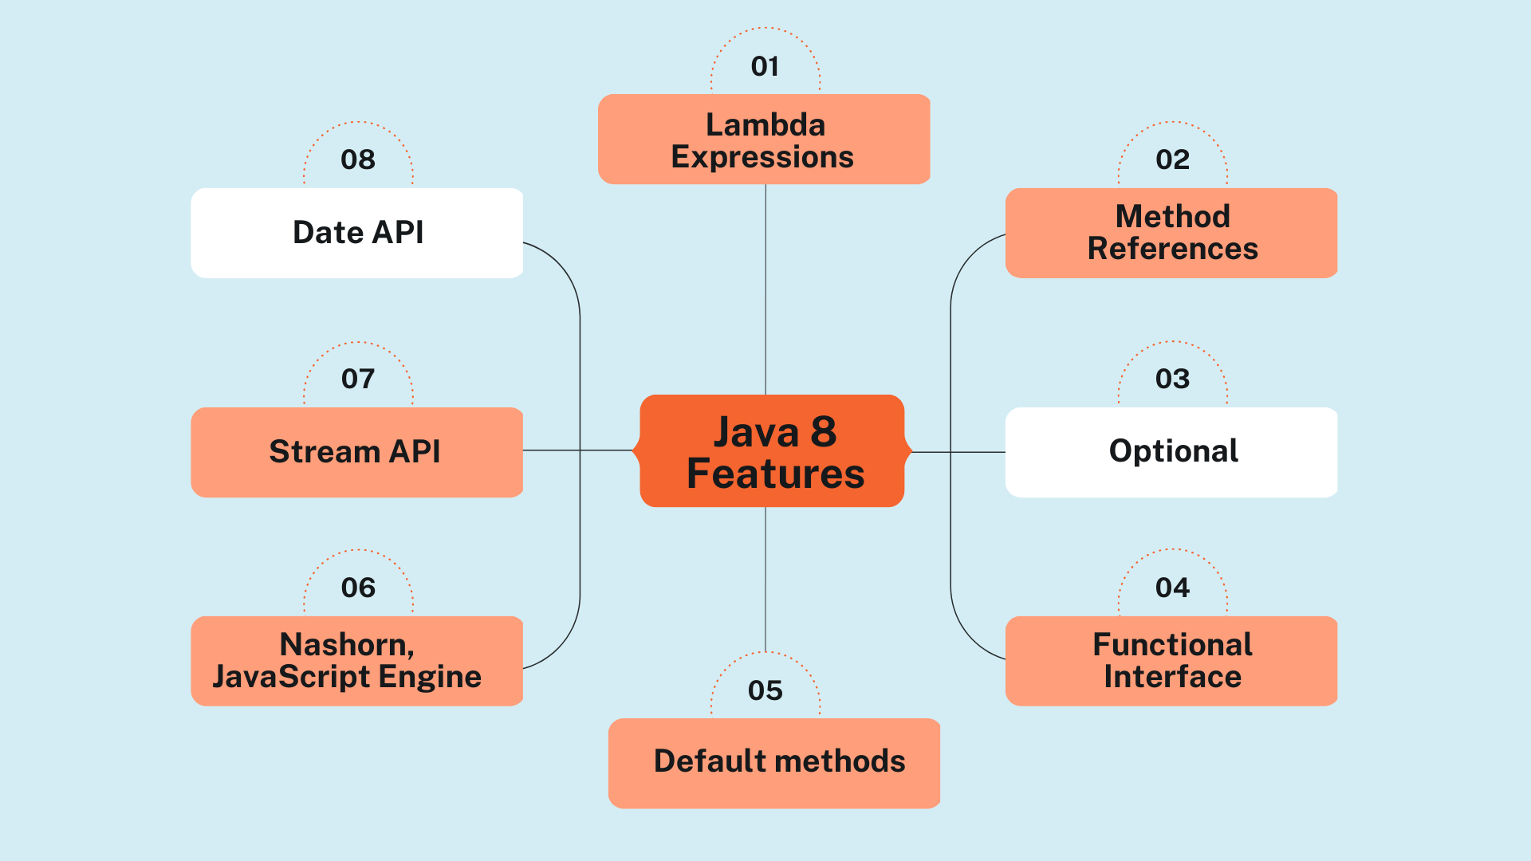

3. Lambda vs Anonymous Class
Before Java 8:
Runnable r = new Runnable() {
public void run() {
System.out.println("Running thread");
}
};
Using Lambda:
Runnable r = () -> System.out.println("Running thread");

4. Lambda Expression Examples

Example 1 — Simple Lambda
interface Greeting {

void sayHello();
}

public class LambdaExample {

public static void main(String[] args) {

Greeting greet = () -> System.out.println("Hello World");

greet.sayHello();
}
}
Output
Hello World

Example 2 — Lambda with Parameters
interface Add {

int sum(int a, int b);
}

public class LambdaExample {

public static void main(String[] args) {

Add add = (a, b) -> a + b;

System.out.println(add.sum(5, 3));
}
}
Output
8

Example 3 — Lambda with Multiple Statements
interface Calculator {

int multiply(int a, int b);
}

public class LambdaExample {

public static void main(String[] args) {

Calculator calc = (a, b) -> {

int result = a * b;

return result;
};

System.out.println(calc.multiply(4,5));
}
}
Output
20

5. Lambda with Collections
Lambda expressions are commonly used with collections.
Example:
import java.util.*;

public class Example {

public static void main(String[] args) {

List<String> names =
Arrays.asList("Java","Python","Go");

names.forEach(name -> System.out.println(name));
}
}
Output
Java
Python
Go

6. Lambda with Comparator
Sorting using lambda.
Before Java 8:
Collections.sort(list, new Comparator<Integer>() {
public int compare(Integer a, Integer b) {
return a - b;
}
});
Using Lambda:
list.sort((a,b) -> a - b);
Example:
import java.util.*;

public class SortExample {

public static void main(String[] args) {

List<Integer> numbers =
Arrays.asList(5,3,9,1);

numbers.sort((a,b) -> a - b);

System.out.println(numbers);
}
}
Output
[1,3,5,9]

7. Lambda with Streams
Lambda expressions power Java Stream API.
Example:
import java.util.*;

public class StreamExample {

public static void main(String[] args) {

List<Integer> numbers =
Arrays.asList(1,2,3,4,5);

numbers.stream()
.filter(n -> n % 2 == 0)
.forEach(n -> System.out.println(n));
}
}
Output
2
4

Stream + Lambda Pipeline
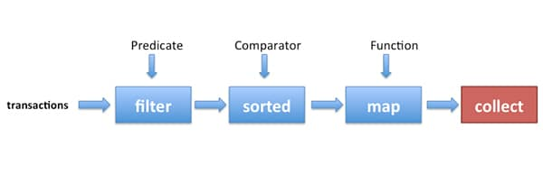
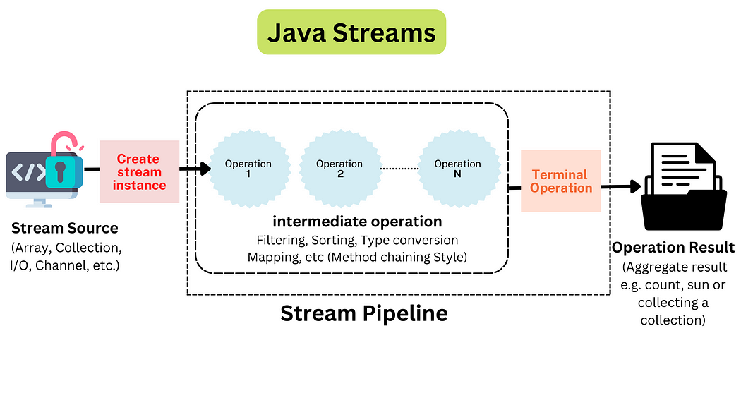
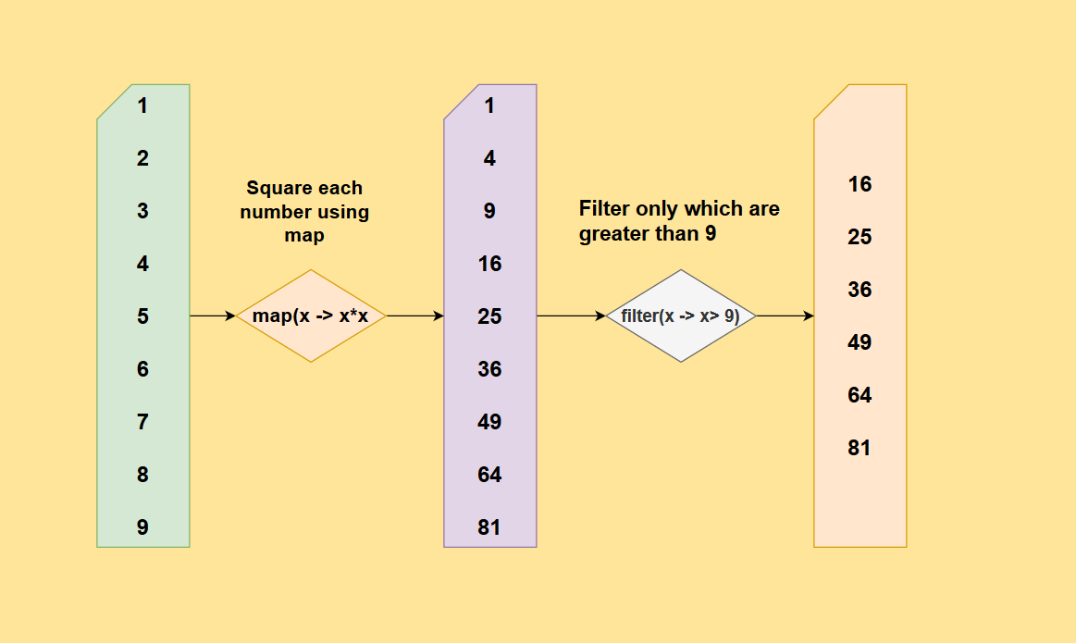
Intermediate Operations
Intermediate operations return a new Stream and are non-terminal, allowing for method chaining (pipelining). They are only executed when a terminal operation is invoked
- filter(Predicate predicate): Selects elements that match a given condition.
- map(Function mapper): Transforms each element of the stream by applying a function to it, resulting in a new stream of the transformed elements.
- flatMap(Function mapper): Transforms each element into a stream and then flattens all generated streams into a single stream.
- distinct(): Returns a stream with unique elements based on the equals() method.
- sorted() / sorted(Comparator comparator): Sorts the elements of the stream.
- limit(long maxSize): Truncates the stream to a maximum number of elements.
- skip(long n): Discards the first n elements of the stream.
- peek(Consumer action): Performs an action on each element as it passes through the pipeline, useful for debugging or logging, without modifying the elements themselves.
- takeWhile(Predicate predicate) (Java 9+): Consumes elements as long as the predicate is true, then stops.
- dropWhile(Predicate predicate) (Java 9+): Skips elements as long as the predicate is true, then keeps the rest.
Terminal Operations
Terminal operations initiate the processing of the entire stream pipeline and produce a non-stream result (e.g., a value, a collection, or a side effect). Once a terminal operation is called, the stream is considered consumed and cannot be used again.
- forEach(Consumer action): Iterates over each element and performs a specified action (a side effect).
- collect(Collector collector): Gathers the processed elements into a mutable container such as a List, Set, or Map. The Collectors class provides many static methods for this purpose (e.g., Collectors.toList()).
- reduce(initialValue, BinaryOperator accumulator): Combines the elements of the stream into a single result using an associative accumulation function.
- count(): Returns the number of elements in the stream.
- min(Comparator comparator) / max(Comparator comparator): Finds the minimum or maximum element in the stream according to a provided Comparator.
- findFirst(): Returns the first element of the stream as an Optional.
- findAny(): Returns an arbitrary element from the stream as an Optional (especially useful in parallel streams for performance).
- anyMatch(Predicate predicate): Checks if any element in the stream matches the given predicate.
- allMatch(Predicate predicate): Checks if all elements in the stream match the given predicate.
- noneMatch(Predicate predicate): Checks if no elements in the stream match the given predicate.
- toArray() / toArray(IntFunction<A[]> generator): Collects the elements into an array.

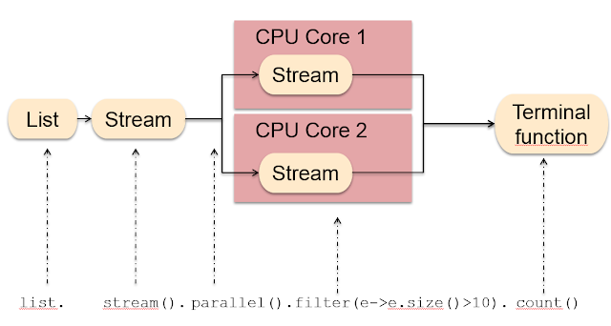

8. Built-in Functional Interfaces
Java provides built-in interfaces in:
java.util.function
Common ones:
Interface | Purpose
Predicate | Returns boolean
Consumer | Takes input, no return
Supplier | Returns value
Function | Input → Output

Predicate Example
import java.util.function.Predicate;

public class Example {

public static void main(String[] args) {

Predicate<Integer> isEven =
n -> n % 2 == 0;

System.out.println(isEven.test(10));
}
}
Output
true

Consumer Example
import java.util.function.Consumer;

public class Example {

public static void main(String[] args) {

Consumer<String> printer =
s -> System.out.println(s);

printer.accept("Hello Lambda");
}
}

Function Example
import java.util.function.Function;

public class Example {

public static void main(String[] args) {

Function<Integer,Integer> square =
x -> x * x;

System.out.println(square.apply(5));
}
}
Output
25

9. Method References
Lambda can be replaced with method references.
Example:
Lambda:
list.forEach(x -> System.out.println(x));
Method reference:
list.forEach(System.out::println);

Types of Method References
Type | Example
Static method | Class::method
Instance method | object::method
Constructor | Class::new

10. Real-World Example
Example: filtering employees.
import java.util.*;

class Employee {

String name;
int salary;

Employee(String name, int salary){
this.name = name;
this.salary = salary;
}
}

public class Example {

public static void main(String[] args) {

List<Employee> employees = Arrays.asList(
new Employee("John",50000),
new Employee("Alice",80000),
new Employee("Bob",40000)
);

employees.stream()
.filter(e -> e.salary > 50000)
.forEach(e -> System.out.println(e.name));
}
}
Output
Alice

11. Advantages of Lambda Expressions
Benefit | Explanation
Less code | Reduces boilerplate
Functional style | Cleaner logic
Parallel processing | Works with streams
Better readability | Concise syntax

12. Common Lambda Interview Questions
- What is a functional interface?
- Difference between lambda vs anonymous class
- What is method reference?
- What are Predicate, Consumer, Supplier, Function?
- What is effectively final variable in lambda?

13. Complete Lambda Example
import java.util.*;
import java.util.function.*;

public class LambdaDemo {

public static void main(String[] args) {

List<Integer> numbers =
Arrays.asList(1,2,3,4,5,6);

numbers.stream()
.filter(n -> n % 2 == 0)
.map(n -> n * n)
.forEach(System.out::println);
}
}
Output
4
16
36
Before Java 8, you often wrote verbose anonymous classes:
Runnable r = new Runnable() {
@Override
public void run() {
System.out.println("Hello");
}
};
new Thread(r).start();
With Lambda (Java 8+):
Runnable r = () -> System.out.println("Hello");
new Thread(r).start();

What Lambda gives you
- Less boilerplate
- Functional (declarative) style
- Better use of Streams & Collections
- Enables functional programming in Java
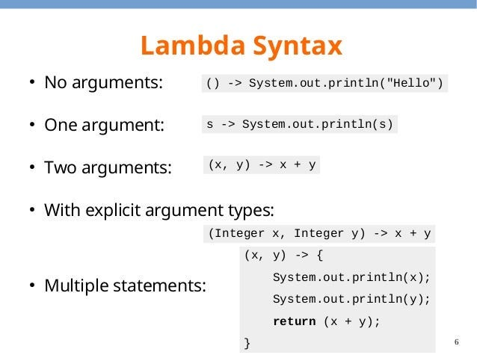
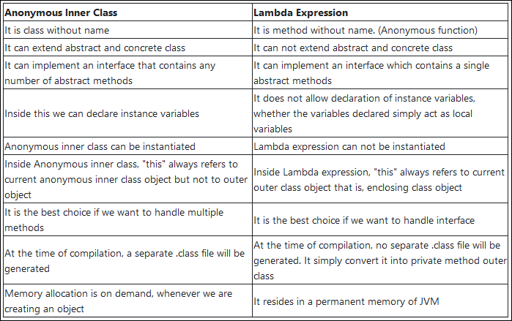

PART 2 — Lambda Syntax (Core Concept)

2.1 General Syntax
(parameters) -> expression
or
(parameters) -> { statements; }

Examples
Old way | Lambda way
void m() { System.out.println("Hi"); }
| () -> System.out.println("Hi")
int add(int a, int b) { return a + b; }
| (a, b) -> a + b
boolean isEven(int x) { return x % 2 == 0; }
| x -> x % 2 == 0

PART 3 — Functional Interfaces (Foundation)
A Functional Interface has exactly ONE abstract method.
Java provides many built-in ones in java.util.function.

3.1 Custom Functional Interface
@FunctionalInterface
interface Calculator {
int add(int a, int b);
}
Using Lambda:
public class LambdaDemo {
public static void main(String[] args) {
Calculator c = (a, b) -> a + b;
System.out.println(c.add(10, 20)); // 30
}
}
@FunctionalInterface is optional but recommended (compiler checks rule).

3.2 Important Built-in Functional Interfaces

(A) Predicate → returns boolean
import java.util.function.Predicate;

Predicate<Integer> isEven = x -> x % 2 == 0;
System.out.println(isEven.test(10)); // true

(B) Function<T, R> → transforms value
import java.util.function.Function;

Function<String, Integer> length = s -> s.length();
System.out.println(length.apply("Java")); // 4

(C) Consumer → takes input, returns nothing
import java.util.function.Consumer;

Consumer<String> printer = s -> System.out.println(s);
printer.accept("Hello Lambda");

(D) Supplier → supplies a value
import java.util.function.Supplier;

Supplier<Double> random = () -> Math.random();
System.out.println(random.get());
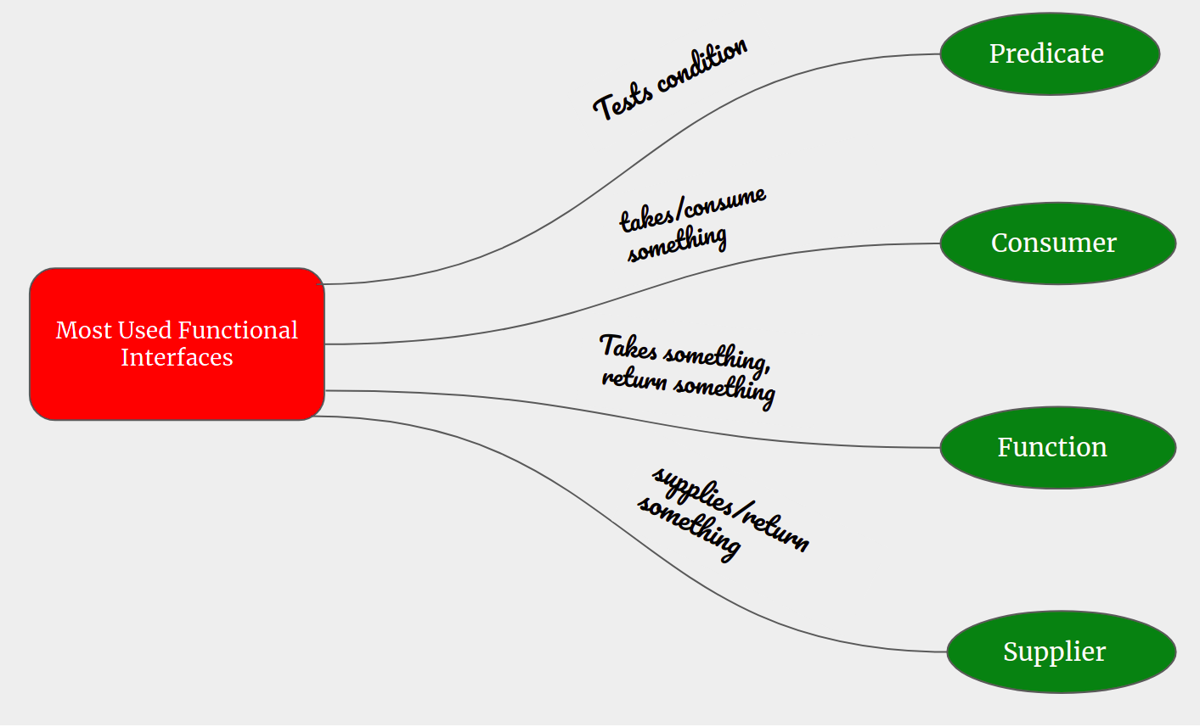
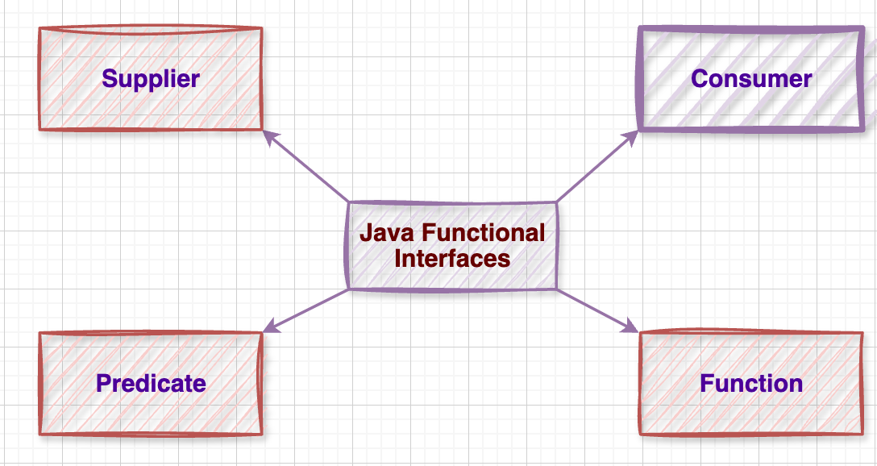

PART 4 — Method References (::)

Method reference is a shorter form of lambda when you already have a method.

4.1 Static Method Reference
class Util {
static int square(int x) {
return x * x;
}
}
Lambda:
Function<Integer, Integer> f1 = x -> Util.square(x);
Method Reference:
Function<Integer, Integer> f2 = Util::square;

4.2 Instance Method Reference
class Printer {
void print(String s) {
System.out.println(s);
}
}
Lambda:
Consumer<String> c1 = s -> new Printer().print(s);
Method Reference:
Printer p = new Printer();
Consumer<String> c2 = p::print;

4.3 Constructor Reference
Supplier<String> s1 = () -> new String();
Supplier<String> s2 = String::new;
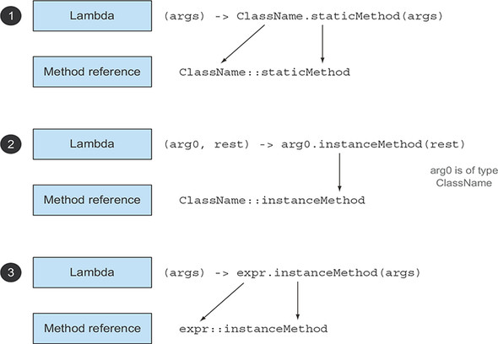
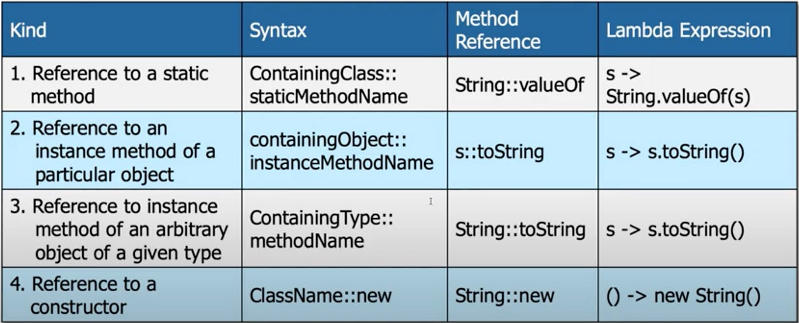

PART 5 — Collections with Lambda

5.1 Iterating with forEach

Before (old style)
List<String> list = Arrays.asList("A", "B", "C");

for (String s : list) {
System.out.println(s);
}

With Lambda
list.forEach(s -> System.out.println(s));

With Method Reference
list.forEach(System.out::println);

5.2 Sorting with Lambda
List<Integer> nums = Arrays.asList(5, 2, 8, 1, 3);

Collections.sort(nums, (a, b) -> a - b);
System.out.println(nums);
Or using List.sort:
nums.sort((a, b) -> b - a); // descending

5.3 Filtering with Predicate
List<Integer> nums = Arrays.asList(1,2,3,4,5,6);

for (int n : nums) {
if (n % 2 == 0) System.out.println(n);
}
With Lambda:
nums.stream()
.filter(n -> n % 2 == 0)
.forEach(System.out::println);

5.4 Mapping with Function
List<String> names = Arrays.asList("java", "lambda", "stream");

names.stream()
.map(String::toUpperCase)
.forEach(System.out::println);
Output:
JAVA
LAMBDA
STREAM

5.5 Reduce (Aggregation)
List<Integer> nums = Arrays.asList(1,2,3,4);

int sum = nums.stream()
.reduce(0, (a, b) -> a + b);

System.out.println(sum); // 10

PART 6 — Realistic Example (Mini Case Study)

Scenario: Bank Transactions List
class Transaction {
String type;
int amount;

Transaction(String type, int amount) {
this.type = type;
this.amount = amount;
}
}
Create list:
List<Transaction> txns = Arrays.asList(
new Transaction("DEBIT", 300),
new Transaction("CREDIT", 500),
new Transaction("DEBIT", 200),
new Transaction("CREDIT", 400)
);

6.1 Filter only DEBIT transactions
txns.stream()
.filter(t -> t.type.equals("DEBIT"))
.forEach(t -> System.out.println(t.amount));

6.2 Get total CREDIT amount
int totalCredit = txns.stream()
.filter(t -> t.type.equals("CREDIT"))
.map(t -> t.amount)
.reduce(0, Integer::sum);

System.out.println("Total Credit: " + totalCredit);

PART 7 — Common Interview Questions

- What is a Functional Interface?
- Difference between Lambda and Anonymous Class?
- When should you use Method References?
- Difference between map() and filter()?
- Can a lambda have multiple statements? (Yes — with {})
- Why are Lambdas important for Streams?

Concept | Example
Lambda | (a, b) -> a + b
Predicate | x -> x > 10
Function | s -> s.length()
Consumer | System.out::println
Supplier | Math::random
Method Ref | ClassName::method
Filter | .filter(x -> x % 2 == 0)
Map | .map(String::toUpperCase)
Reduce | .reduce(0, Integer::sum)

