Below is a comprehensive Docker learning pack containing:
1️⃣ Docker Command Cheat Sheet (50+ commands)
2️⃣ Hands-on Docker Labs (20 real exercises)
3️⃣ Docker Interview Questions (100 questions)
This is structured like a DevOps training reference.

1. Docker Command Cheat Sheet (50+ Commands)

A. Docker Installation & Info
Command | Description
docker --version | Show Docker version
docker info | Display system-wide information
docker help | List all commands
docker system info | Detailed system info

B. Docker Image Commands
Command | Description
docker pull nginx | Download image
docker push repo/image | Push image to registry
docker images | List local images
docker image ls | List images
docker image rm image_id | Remove image
docker rmi image_id | Remove image
docker tag image repo/image:tag | Tag image
docker search nginx | Search images
docker inspect image_id | Inspect image
docker history image | Show image layers
Example:
docker pull nginx
docker images

C. Docker Container Commands
Command | Description
docker run nginx | Run container
docker run -d nginx | Run in background
docker run -p 80:80 nginx | Port mapping
docker run -it ubuntu bash | Interactive container
docker start container | Start container
docker stop container | Stop container
docker restart container | Restart container
docker pause container | Pause container
docker unpause container | Resume container
docker rm container | Remove container
docker kill container | Force stop

D. Container Monitoring
Command | Description
docker ps | Running containers
docker ps -a | All containers
docker logs container | Container logs
docker top container | Running processes
docker stats | Resource usage
docker events | Real-time events
Example:
docker ps
docker logs container_id

E. Container Interaction
Command | Description
docker exec -it container bash | Run command inside container
docker attach container | Attach to container
docker cp file container:/path | Copy file
docker rename old new | Rename container
Example:
docker exec -it mycontainer bash

F. Docker Networking
Command | Description
docker network ls | List networks
docker network create net1 | Create network
docker network inspect net1 | Inspect network
docker network rm net1 | Remove network
docker network connect | Connect container
docker network disconnect | Disconnect container

G. Docker Volumes
Command | Description
docker volume create data | Create volume
docker volume ls | List volumes
docker volume inspect | Inspect volume
docker volume rm | Remove volume
docker run -v data:/app | Mount volume

H. Docker System Cleanup
Command | Description
docker system df | Disk usage
docker system prune | Remove unused data
docker container prune | Remove stopped containers
docker image prune | Remove unused images
docker volume prune | Remove unused volumes

I. Docker Build Commands
Command | Description
docker build -t myapp . | Build image
docker build --no-cache | Build without cache
docker commit container image | Create image from container

J. Docker Compose Commands
Command | Description
docker-compose up | Start services
docker-compose down | Stop services
docker-compose build | Build services
docker-compose ps | Show services
docker-compose logs | View logs

2. Hands-On Docker Labs (20 Exercises)
These labs simulate real DevOps workflows.

Lab 1 – Install Docker
Steps

sudo apt update

sudo apt install docker.io

docker --version

Lab 2 – Run First Container
docker run hello-world
Goal: Verify Docker installation.

Lab 3 – Run Nginx Web Server
docker run -d -p 8080:80 nginx
Open browser
http://localhost:8080

Lab 4 – List Containers
docker ps
docker ps -a

Lab 5 – Stop and Remove Container
docker stop container_id
docker rm container_id

Lab 6 – Pull Ubuntu Image
docker pull ubuntu

Lab 7 – Interactive Container
docker run -it ubuntu bash
Inside container:
apt update

Lab 8 – Build Docker Image
Create Dockerfile:
FROM node:18
WORKDIR /app
COPY . .
CMD ["node","app.js"]
Build:
docker build -t mynodeapp .

Lab 9 – Run Custom Image
docker run mynodeapp

Lab 10 – Container Logs
docker logs container_id

Lab 11 – Docker Volumes
Create volume
docker volume create mydata
Run container
docker run -v mydata:/data ubuntu

Lab 12 – Bind Mount
docker run -v $(pwd):/app node

Lab 13 – Create Network
docker network create appnet
Run containers
docker run --network appnet nginx

Lab 14 – Container Communication
Run Redis
docker run -d --name redis redis
Run app container connected to Redis.

Lab 15 – Docker Compose Setup
Create:
version: '3'

services:
web:
image: nginx

redis:
image: redis
Run:
docker-compose up

Lab 16 – Docker Logs Monitoring
docker logs -f container

Lab 17 – Resource Monitoring
docker stats

Lab 18 – Inspect Container
docker inspect container_id

Lab 19 – Push Image to Registry
Login to Docker Hub
docker login
docker push repo/image

Lab 20 – Multi-Container Application
Run stack:
Frontend (Nginx)
Backend (Node)
Database (MongoDB)
Using Docker Compose.

3. Docker Interview Questions (100)

Basic (1–25)
- What is Docker?
- What is containerization?
- Docker vs Virtual Machine?
- What is Docker image?
- What is Docker container?
- What is Dockerfile?
- What is Docker Hub?
- What is Docker Engine?
- What is Docker daemon?
- What is Docker client?
- What is container lifecycle?
- What is docker run?
- What is port mapping?
- What is Docker registry?
- What is image layering?
- What is base image?
- Difference between CMD and ENTRYPOINT
- What is docker exec?
- What is docker ps?
- What is container isolation?
- What is Docker networking?
- What is Docker volume?
- What is bind mount?
- What is container orchestration?
- What is microservices architecture?

Intermediate (26–60)
- Docker architecture components
- How Docker uses Linux kernel
- Namespaces in Docker
- Control groups (cgroups)
- Copy-on-write filesystem
- Union filesystem
- Docker overlay network
- Bridge network
- Host network
- Macvlan network
- Container storage drivers
- Docker build cache
- Multi-stage builds
- Docker image optimization
- Docker security practices
- Docker secrets
- Docker swarm basics
- Rolling updates
- Health checks
- Container restart policies
- Docker logging drivers
- Docker Compose architecture
- Docker service discovery
- Docker resource limits
- Container scaling
- Docker registry authentication
- Docker image scanning
- Container monitoring
- Docker API usage
- Docker buildx
- Docker plugin architecture
- Image tagging strategies
- Dockerfile best practices
- Container dependency management
- Docker networking troubleshooting

Advanced (61–100)
- Docker vs Kubernetes
- Container orchestration patterns
- Service mesh with containers
- Sidecar pattern
- Blue-green deployment
- Canary deployment
- Immutable infrastructure
- CI/CD integration with Docker
- Docker security vulnerabilities
- Rootless Docker
- Docker runtime (containerd)
- OCI container standards
- Docker storage drivers comparison
- Overlay filesystem internals
- Multi-architecture builds
- Image signing and verification
- Docker registry replication
- Container performance tuning
- Docker networking internals
- Container isolation limitations
- Kernel security modules (AppArmor/SELinux)
- Docker in production architecture
- Kubernetes container runtime interface
- Container autoscaling
- Observability in container environments
- Distributed logging for containers
- Chaos engineering in containers
- Disaster recovery for container clusters
- Container image lifecycle management
- Docker resource scheduling
- Persistent storage strategies
- Stateful containers
- Service discovery mechanisms
- Docker cluster networking
- Container load balancing
- DevSecOps with Docker
- Image vulnerability scanning tools
- Container compliance frameworks
- Container runtime security
- Future of container technologies

1. 50 Real DevOps Troubleshooting Scenarios (Docker)

Container Issues

1. Container exits immediately
Symptom
docker ps
(no container running)
Cause
Main process finished.
Fix
Run container with interactive shell.
docker run -it ubuntu bash

2. Container constantly restarting
Restarting (1) 5 seconds ago
Cause
Application crash loop.
Check
docker logs container_id

3. Container stuck in “Created” state
Cause
Docker daemon problem.
Fix
systemctl restart docker

4. Container cannot access internet
Cause
DNS misconfiguration.
Check:
cat /etc/resolv.conf

5. Container cannot reach another container
Cause
Wrong Docker network.
Fix:
docker network connect mynetwork container

6. Port already allocated
Bind for 0.0.0.0:80 failed
Check port:
lsof -i :80

7. Permission denied inside container
Cause: wrong user.
Fix Dockerfile:
USER root

8. Container consuming high CPU
Check:
docker stats
Limit CPU:
docker run --cpus="1"

9. Container consuming high memory
docker stats
Limit memory:
docker run -m 512m

10. Application works locally but fails in container
Cause: missing dependencies.
Check image layers.
docker history image

Image Issues

11. Docker image too large
Check:
docker images
Use:
- Alpine base images
- Multi-stage builds

12. Docker build extremely slow
Cause: cache invalidation.
Optimize Dockerfile order.

13. Build fails during dependency installation
Check logs:
docker build .

14. Cannot pull image
pull access denied
Login to registry:
docker login

15. Wrong image architecture
Example:
ARM vs x86.
Fix using buildx:
docker buildx build --platform linux/amd64

Networking Issues

16. Container cannot resolve service name
Cause: missing network.
docker network inspect

17. DNS resolution fails
Add DNS:
docker run --dns=8.8.8.8

18. Service unreachable externally
Check port mapping.
docker ps

19. Network conflicts
Remove network.
docker network rm network_name

20. Container cannot access host
Use:
host.docker.internal

Storage Issues

21. Data lost after container restart
Cause: no persistent volume.
Fix:
docker run -v data:/app

22. Permission issues on mounted volume
Fix:
chown -R 1000:1000 folder

23. Disk full
Check Docker disk usage.
docker system df
Cleanup:
docker system prune

24. Volume cannot be removed
Check running containers.
docker ps -a

25. Container cannot write to mounted directory
Cause: read-only mount.

Docker Daemon Issues

26. Docker daemon not starting
systemctl status docker

27. Docker socket permission denied
Fix:
sudo usermod -aG docker $USER

28. Docker service high memory usage
Restart daemon.

29. Docker commands hanging
Check daemon logs.
journalctl -u docker

30. Docker API failure
Check socket.
/var/run/docker.sock

CI/CD Issues

31. Docker build failing in CI pipeline
Cause: missing Docker daemon.
Use Docker-in-Docker.

32. Pipeline cannot push image
Missing credentials.

33. Tag mismatch in deployment
Check version tag.

34. Image not updated in Kubernetes
Use:
imagePullPolicy: Always

35. Pipeline slow due to rebuilds
Use layer caching.

Kubernetes Related

36. Pod stuck in CrashLoopBackOff
Check logs.
kubectl logs pod

37. ImagePullBackOff
Fix registry authentication.

38. Pod cannot reach service
Check service endpoints.

39. Container OOMKilled
Increase memory limits.

40. Pod scheduling failed
Check node resources.

Security Issues

41. Container running as root
Fix Dockerfile.
USER appuser

42. Vulnerable base image
Scan image.
Tools:
- Trivy
- Clair

43. Secrets exposed in image
Use secrets manager.

44. Exposed Docker socket
Avoid mounting:
/var/run/docker.sock

45. Privileged container risk
Avoid:
--privileged

Production Issues

46. Too many containers running
Check resource limits.

47. Container logs filling disk
Rotate logs.

48. Service downtime during deployment
Use rolling updates.

49. Image registry outage
Use mirrored registry.

50. Container startup slow
Use smaller base images.

2. Complete Docker Project (Microservices + CI/CD + Kubernetes)

Architecture
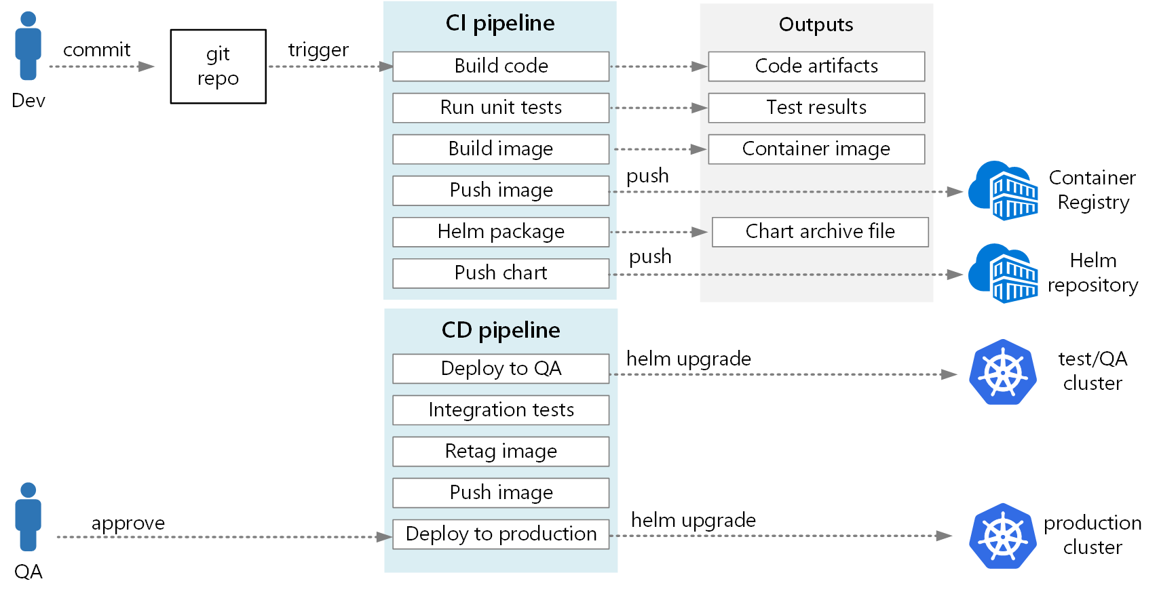
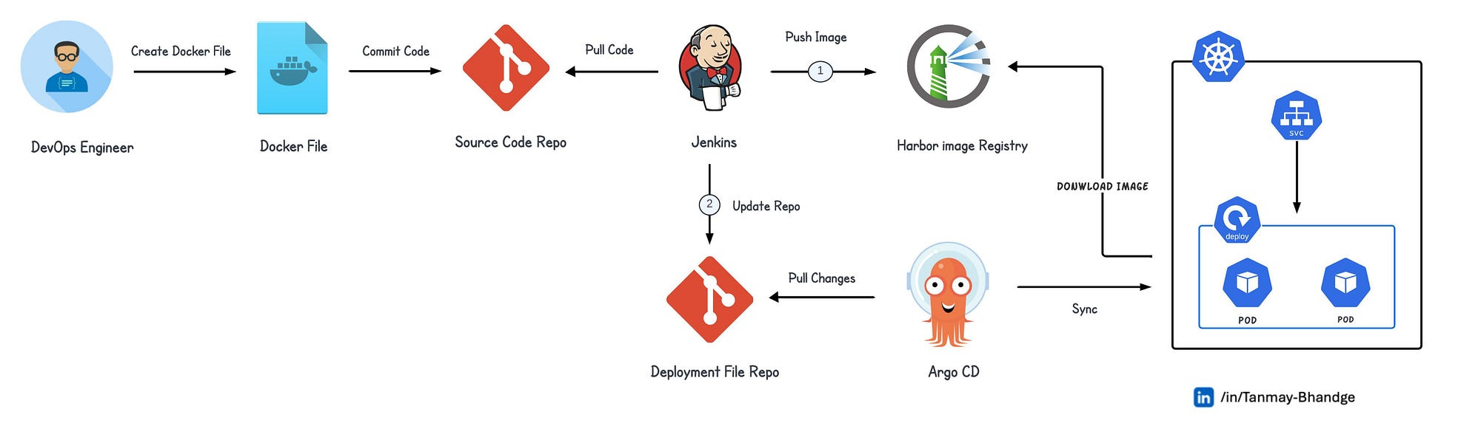

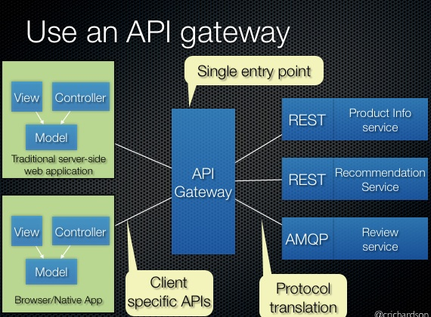

Components
Frontend
Backend API
Authentication service
Database
Message queue
CI/CD pipeline
Example stack:
React Frontend
NodeJS API
Python Auth Service
MongoDB
Redis
Nginx Gateway

Project Folder Structure
microservices-project
│
├── frontend
│ └── Dockerfile
│
├── api-service
│ └── Dockerfile
│
├── auth-service
│ └── Dockerfile
│
├── docker-compose.yml
│
├── k8s
│ ├── deployment.yaml
│ ├── service.yaml
│
└── .github/workflows

Example Dockerfile
FROM node:18-alpine

WORKDIR /app

COPY package*.json ./

RUN npm install

COPY . .

EXPOSE 3000

CMD ["npm","start"]

Docker Compose (Development)
version: "3"

services:

frontend:
build: ./frontend
ports:
- "3000:3000"

api:
build: ./api-service
ports:
- "4000:4000"

db:
image: mongo

redis:
image: redis

CI/CD Pipeline
Example with GitHub
Pipeline stages:
Code Commit
↓
Build Docker Image
↓
Run Tests
↓
Push Image to Registry
↓
Deploy to Kubernetes
Example pipeline:
docker build -t myapp .
docker push repo/myapp
kubectl apply -f deployment.yaml

Kubernetes Deployment
Example:
apiVersion: apps/v1
kind: Deployment

metadata:
name: api-service

spec:
replicas: 3

template:

spec:

containers:
- name: api
image: repo/api
ports:
- containerPort: 4000

Kubernetes Service
apiVersion: v1
kind: Service

metadata:
name: api-service

spec:
type: ClusterIP

selector:
app: api

ports:
- port: 4000

3. Enterprise Dockerfile Best Practices (30 Rules)

Base Image
- Use official images
- Use minimal base images (Alpine)
- Pin image versions
Example
FROM node:18-alpine

Image Size
- Use multi-stage builds
- Remove unnecessary packages
- Clean package caches
- Combine RUN commands
Example
RUN apt-get update && apt-get install -y curl && rm -rf /var/lib/apt/lists/*

Security
- Do not run containers as root
- Create non-root user
- Avoid privileged containers
- Do not store secrets in image
- Scan images for vulnerabilities

Layer Optimization
- Order Dockerfile instructions correctly
- Copy dependency files first
- Use .dockerignore
Example:
node_modules
.git
.env

Build Performance
- Use build cache
- Avoid unnecessary rebuilds
- Use multi-stage builds

Runtime Best Practices
- Use CMD for default commands
- Use ENTRYPOINT for fixed commands
- Expose ports explicitly

Logging
- Write logs to stdout/stderr

Health Monitoring
- Use health checks
Example:
HEALTHCHECK CMD curl --fail http://localhost:3000 || exit 1

Configuration
- Use environment variables
- Do not hardcode configs

Image Maintenance
- Tag images properly
- Avoid latest tag
- Automate builds

Production
- Use read-only file systems
- Monitor container resources

✅ If you'd like, I can also provide advanced DevOps reference guides:
• 100 Kubernetes troubleshooting scenarios
• Complete Kubernetes production architecture
• Ultimate DevOps roadmap (2026 edition)
• 300 Docker + Kubernetes interview questions.

