FLIGHT BOOKING
Contents
1 Problem Statement 2
2 WIREFRAMES 3
3 Application Architecture 4
3.1 Microservice Architecture (Compute and Integration/Presentation/Networking and Content Delivery): 4
4 Cloud Architecture 5
5 Tool Chain 5
6 Business Requirements: 7
7 Proposed Rest Endpoints to be exposed 8
7.1 Rest APIs: 8
8 Key Rubrics/Expected Deliverables 8
8.1 Debugging & Troubleshooting 9
8.2 Code Quality/Optimizations 9
9 Platform 9
10 Methodology 9
10.1 Agile 9

Problem Statement
Build a software system which lets user search for a Flight Ticket and book it & includes Admin related activities. User can also cancel or update the Ticket. Below are the different roles, which need to be supported by above Software System.
- User
- Admin
The scope includes developing the application using tool chain mentioned below.

WIREFRAMES
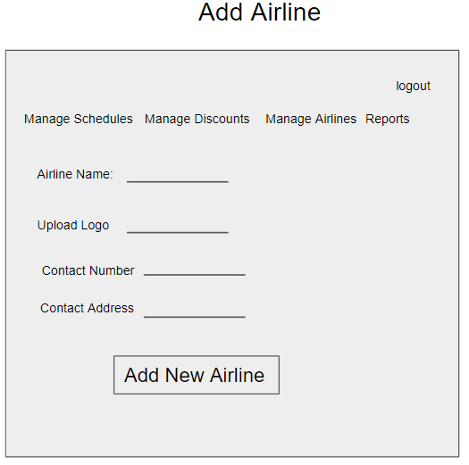
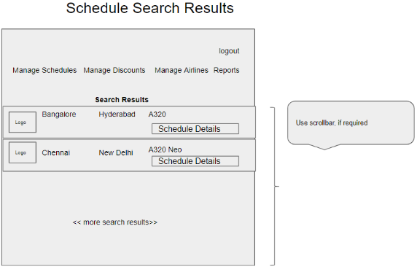
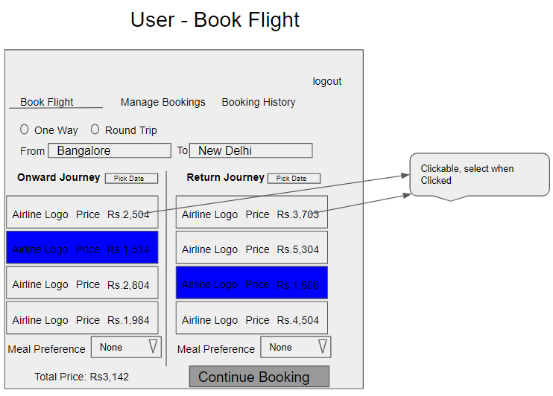
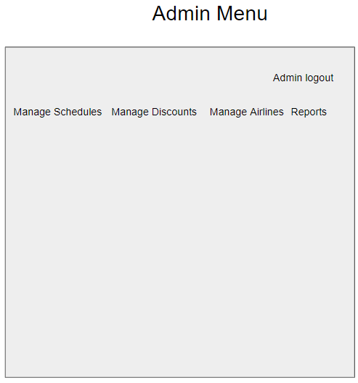
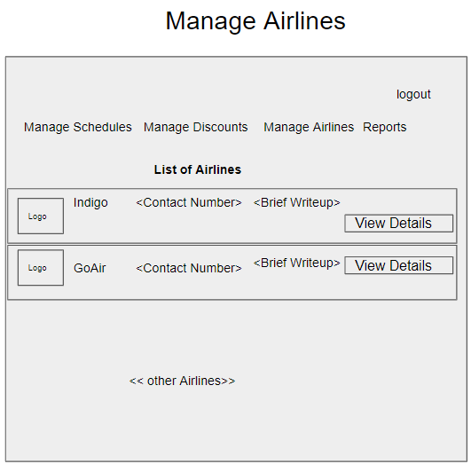
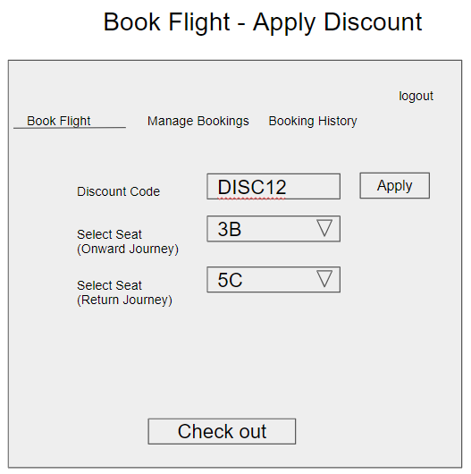
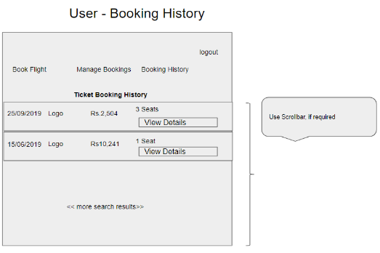
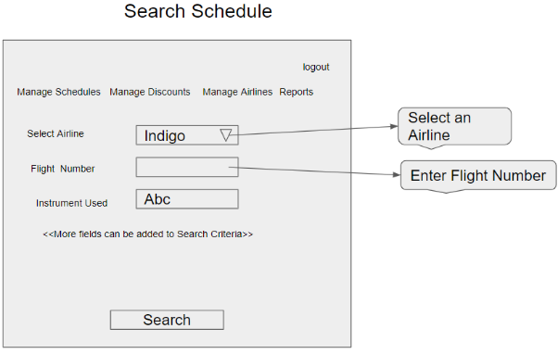
UI needs improvisation and modification as per given use case.
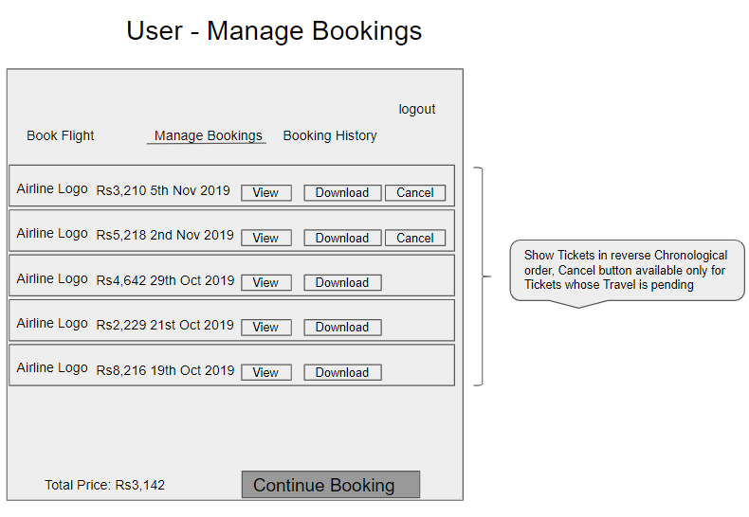

Application Architecture

Microservice Architecture (Compute and Integration/Presentation/Networking and Content Delivery):

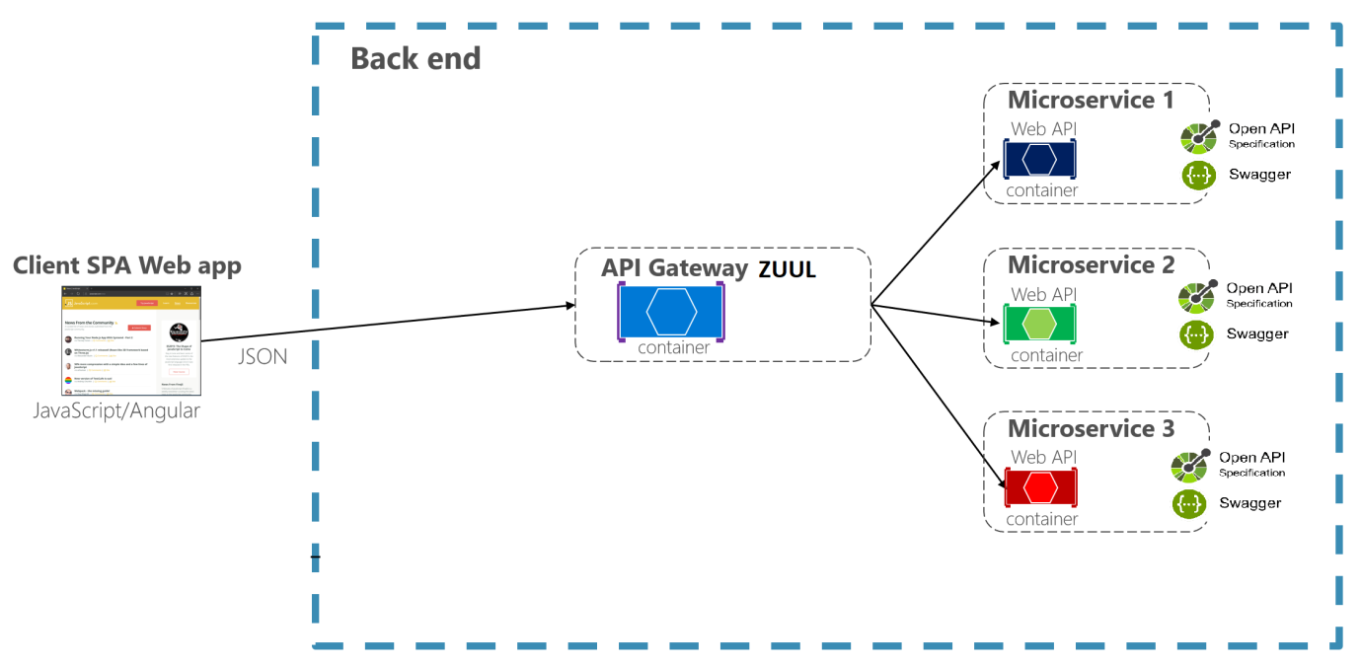

Cloud Architecture
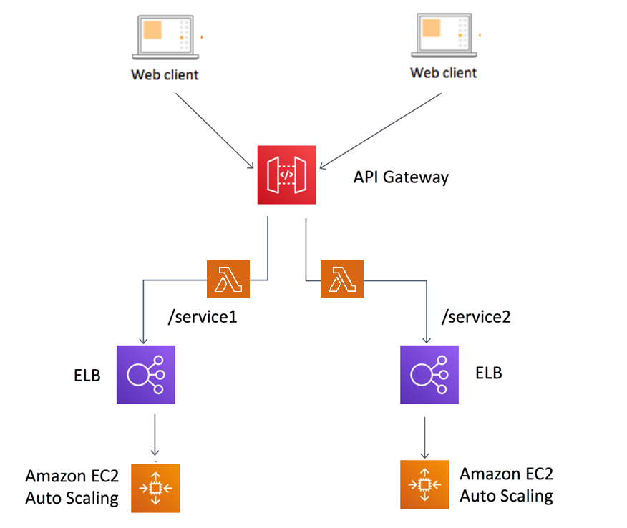

Tool Chain
Competency | Skill | Skill Detail
Engineering Mindset
 | DevOps
 | Code Quality | Sonarqube
Programming Languages | Application Language | Java
Products & Frameworks | Presentation | React
 |  | Javascript/Typescript
 | Networking and Content Delivery | Zuul
 | Compute & Integration | Spring Boot
 |  | Kafka
 | Database & Storage | MySQL
 | Governance & Tooling | Git
 |  | Junit
 |  | Mockito
Platform | Cloud Tools | AWS EC2
 |  | RDS-MySQL/Aurora
 |  | AWS Lambda
 |  | AWS API Gateway
 |  | EKS + ECS
 |  | AWS CloudWatch

Business Requirements:
As an application developer, develop microservices with below guidelines:
User  Story # | User Story Name | User Story
US_01 | User Mode | - User can search for a Flight based on date/time, from place/to place, one way or round trip  - Each Search result need to display Flight Date/time, Airline Name/Logo, Price(to & round trip – TBD)  - From Search results, User should be able to select a specific Flight and go ahead and complete Ticket Booking by providing below details  - Name and Email ID  - Number of seats to book.  - Details of each passenger (NAME:GENDER:AGE)  - Opt for Meal(Veg/Non veg)  - Select Seat Number(s)  - On successful Ticket Booking, PNR number need to be generated, it should be possible to download TicketBooking can be done a Logged in User only  - With email id user should be able to  - view History of Ticket Bookings,  - Cancel a Ticket only prior to a day(24 hrs) before journey date.  - With PNR number view the booked ticket details
US_02 | Admin Mode | - Admin shall be able to login/logout.  - There can be pre-defined username/password for Admin.  - Admin shall be able to add/block an Airline. When Airline is Blocked, Flights belonging to that Airline will not be shown in Ticket Search results.  - Admin shall be able to add Inventory/Schedule of an existing Airline by specifying below details:  - flight number  - Airline  - From Place  - To Place  - Start date time,  - End date time,  - Scheduled Days(Daily, Week Days, Week Ends, For specific days specify the list of Days like Mon, Wed)  - Instrument used(A320, A320 neo, etc…)  - Total number of business class Seats  - Total number of non-business class Seats  - Ticket cost (consider taxes and other charges),  - number of rows,  - meal(none, veg, non veg)

Proposed Rest Endpoints to be exposed

Rest APIs:
POST | /api/v1.0/flight/airline/register | New airline booking
POST | /api/v1.0/flight/admin/login | Admin login
POST | /api/v1.0/flight/airline/inventory/add | Add Inventory/Schedule of an existing Airline
POST | /api/v1.0/flight/search | Searches for flight
POST | /api/v1.0/flight/booking/{flightid} | Book ticket
GET | /api/v1.0/flight/ticket/{pnr} | Get Booked ticket details based on PNR
GET | /api/v1.0/flight/booking/history/{emailId} | Get Booked tickets history based on Email ID
DELETE | /api/v1.0/flight/booking/cancel/{pnr} | Cancel a booked ticket

Key Rubrics/Expected Deliverables
As an application developer:
  - Develop the application as a microservice architecture.
  - Ensure package Structure for project is like com.flightapp.* with proper naming conventions for package and beans.
  - Use application.properties or yaml file to maintain all spring boot config.
  - Implemented the package structure - Controller, Interface, Service, DAO, Testing, Validation, Security etc
  - Implementation as follows:
    - Use Domain Driven Design to implement distributed architecture
    - Follow Single Data Store per microservice practice
    - Document REST endpoints with OpenAPI/ Swagger
    - Expose all rest Endpoints using an API Gateway

Criteria Project  Implementation  (80%) | Meets Specifications | Does Not Meet Specifications
Does the code work? | The code for the assignment compiles and produces no error when executed. | The code produces compilation errors or run-time errors when executed.
Are the entity classes created according to the given database design? | The entity classes include all the attributes with proper annotations and their relationships as per the given database design. | The entity classes and their attributes are not created as per the given database design or proper annotations are not used.
Are the REST API endpoints implemented correctly? | Controller methods are created for each of the API endpoints listed in the project description.  The REST API endpoints fulfil all the conditions given and perform the required functionality.  Proper request and response provided for each of the endpoints as given in the instructions. | Controller methods are not created for each of the API endpoints listed in the project description.  The REST API endpoints neither follow the given conditions nor perform the required functionality.  Proper request and response are not provided for each of the endpoints as given in the instructions.
Are the Service and Repositories created separately? | Separate services and dao classes are created for each functionality.  The dao interface must communicate with the database.  Proper annotations are used in dao and service classes.  The service classes must contain the required business logic and interact with the dao classes for any change required in the database.  Controller class should only interact with service class and not dao directly. | Separate services and dao classes are not created.  The project interacts or accesses the database without dao interfaces.  Proper annotations are not used in dao and service classes.  The business logic is not implemented in the service classes and service classes do not interact with dao classes for any change required in the database.  Controller class interact with the dao interface directly bypassing the service class.
Software Engineering Practices (10%)
Does the student use Git and GitHub to conduct version control on his/her code? | The student uses Git and GitHub to conduct version control on his/her assignment code.  The student makes small, incremental commits.  The student follows the instructions provided for the group collaboration.  The student writes clear and concise commit messages. | The student does not use Git or GitHub to conduct version control on his/her assignment code.  The student makes big commits that contain multiple features or bug fixes.  The student does not follow the instructions provided for the group collaboration.  The student writes short or unclear commit messages.
Does the project code pass all the unit tests? | The code passes all the unit tests written for the project. | The code does not pass all the unit tests written for the project.
Code Readability and Guidelines (10%)
Is the code formatted correctly? | The code is formatted correctly; it uses the right spacing and indentation and follows the formatting guidelines laid out in the Google Java Style Guide. | The code is not formatted correctly. Extra spaces, line breaks, incorrect indentation, and bad formatting are used throughout the code.
Is the code easy to read? | Variables, classes, and function names follow the appropriate upper and lower camelCase.  Classes, functions, and variables are named after the contents or functionalities that they represent.  The code contains good comments that explain how the complicated portions of the code work. | Variable, classes and function names do not follow appropriate upper and lower camelCase.  Classes, functions, and variables are not named after the contents or functionalities that they represent.  The code does not contain any comment, or it contains poor comments that do not properly explain how the complicated portions of the code work.

Debugging & Troubleshooting
- Generate bug report & error logs - Report must be linked with final deliverables which should also suggest the resolution for the encountered bugs and errors.

Code Quality/Optimizations

- Associates should have written clean code that is readable
- Associate should have used the Code Analyzer (PMD/SonarQube) to ensure code quality and standard code style.

Platform
Use User Story-1 from the Business Requirements to implement the below.
      - Use EC2 to deploy application on cloud.
      - Use RDS-MySQL / Aurora(SQL) as a database for the Application.
      - Use AWS Lambda and DB to build a backend process for handling requests for Flight booking App.
      - Use Amazon API Gateway to expose the Lambda functions built in the previous step to be accessible on public internet.
      - Use AWS ELB(Network Load Balancer) to configure the load balancing of the instances
Note : Minimum 2APIs (UI+Backend) to be hosted in cloud

Methodology

Agile
- As an application developer, use project management tool along to update progress as you start implementing solution.
- As an Application developer specify the estimation and planning as a part of Agile process.
- As an application developer, the scope of discussion with mentor is limited to:
  - Q/A
  - New Ideas, New feature implementations and estimation.
  - Any development related challenges
  - Skill Gaps
  - Any other pointers key to UI/UX and Middleware Development

