📘 Java Threads — Tutorial

1) What is a Thread?
A thread is the smallest unit of execution in a process. Java supports multithreading, which allows multiple threads to run concurrently.

Why Threads?
- Better CPU utilization
- Faster execution
- Parallel processing
- Responsive applications (e.g., UI + background work)
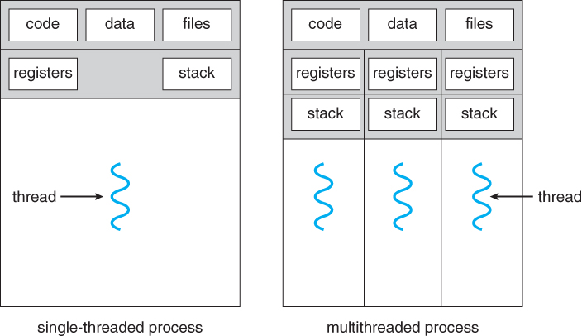
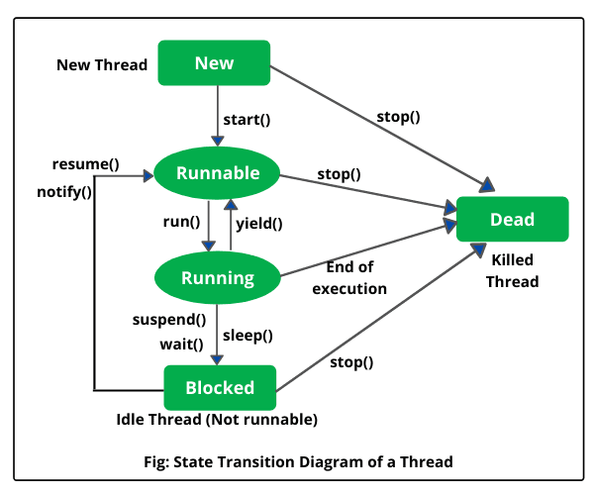

2) Thread vs Process (Concept)
Process | Thread
Heavyweight | Lightweight
Separate memory | Shares memory
Slower context switch | Faster context switch
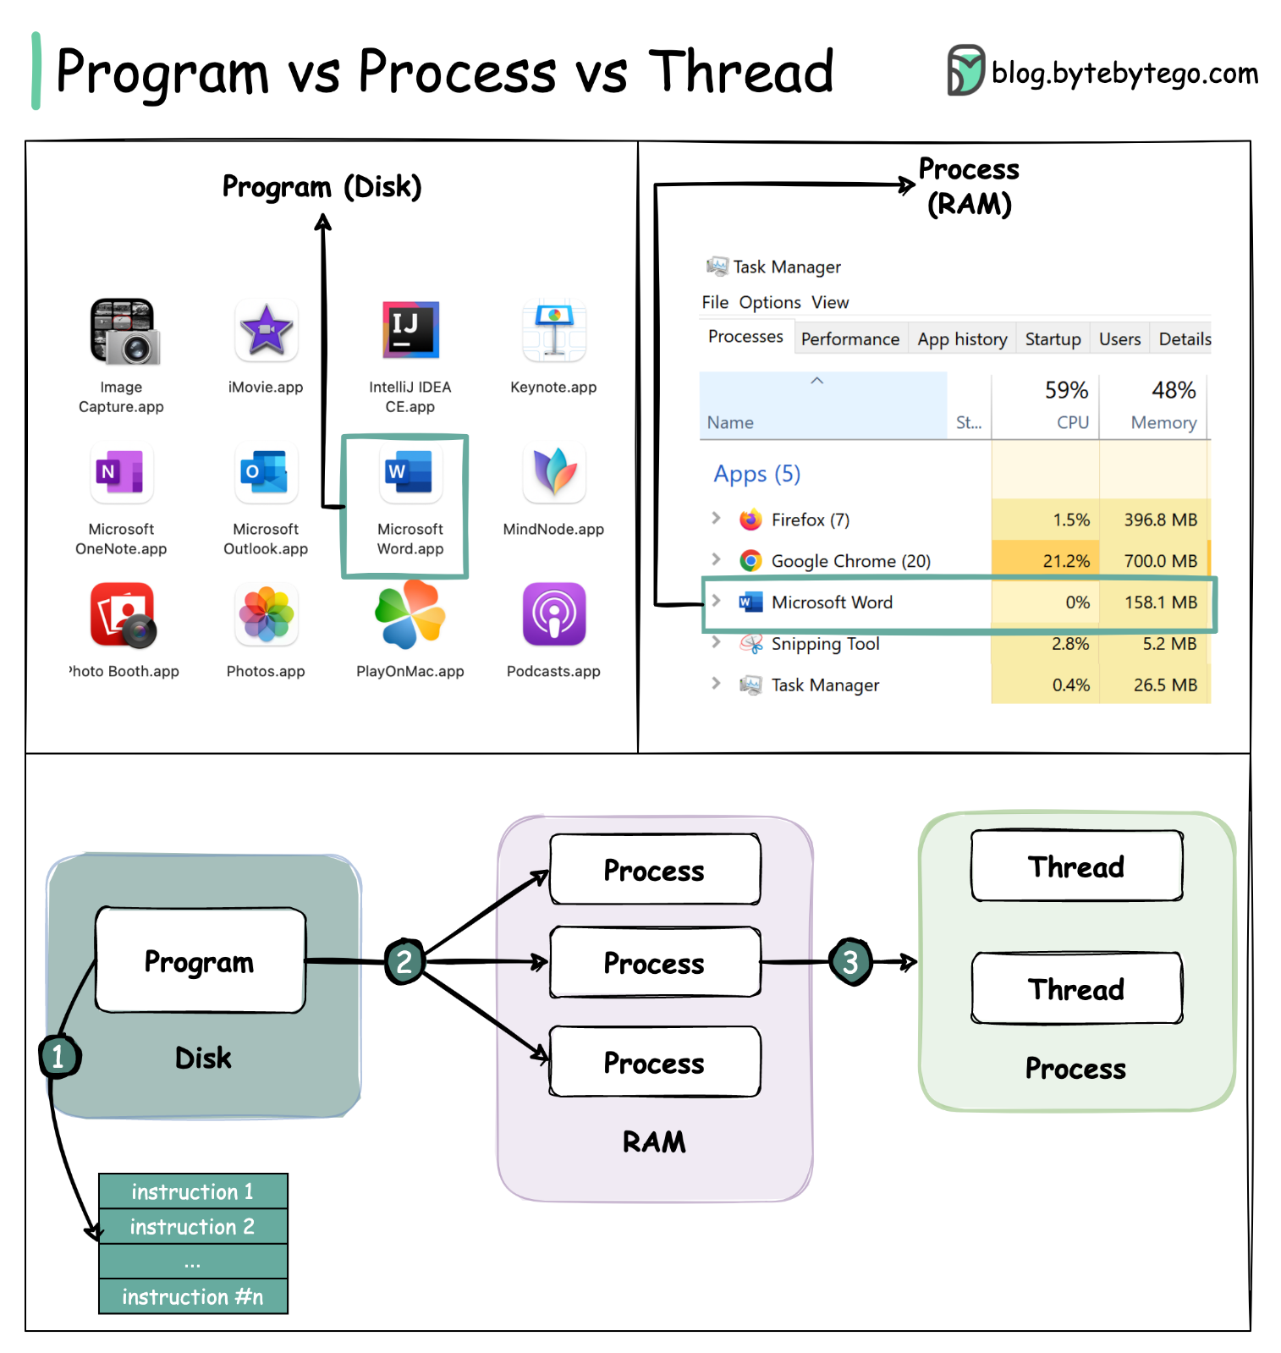
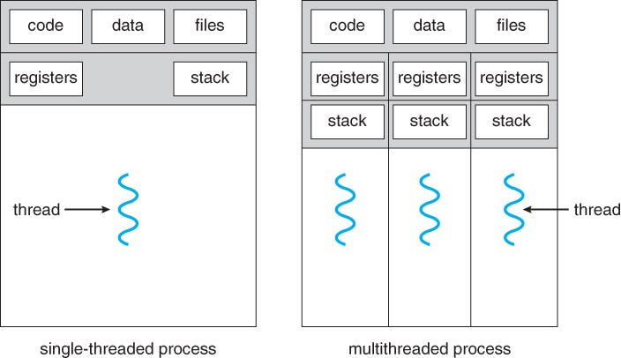

3) Thread Life Cycle (States)
A Java thread goes through these states:
NEW → RUNNABLE → RUNNING → BLOCKED/WAITING → TERMINATED
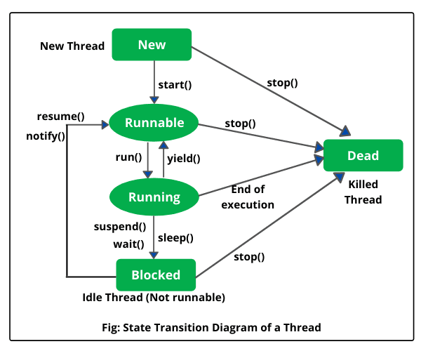

4) Creating Threads (Two Ways)

Method 1 — Extend Thread class
class MyThread extends Thread {
public void run() {
System.out.println("Thread running");
}
}

public class Main {
public static void main(String[] args) {
MyThread t = new MyThread();
t.start(); // Starts new thread
}
}

Method 2 — Implement Runnable (Recommended)
class MyTask implements Runnable {
public void run() {
System.out.println("Task running");
}
}

public class Main {
public static void main(String[] args) {
Thread t = new Thread(new MyTask());
t.start();
}
}
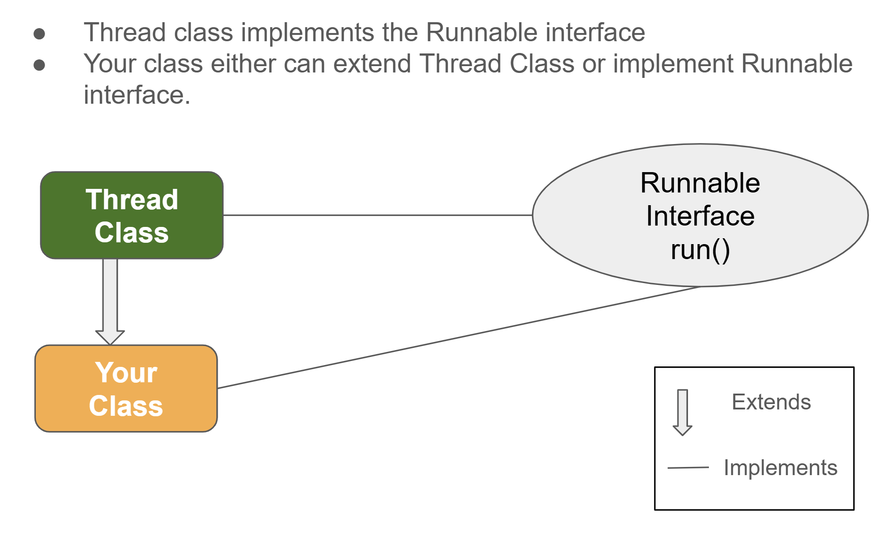
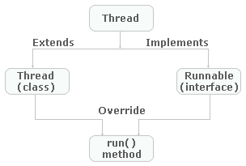

5) start() vs run()
Method | What it does
start() | Creates a new thread and calls run()
run() | Executes in current thread (no new thread)
t.run(); // ❌ No new thread
t.start(); // ✅ New thread created

6) sleep() Method
Pauses a thread for a specified time.
try {
Thread.sleep(1000); // 1 second
} catch (InterruptedException e) {}
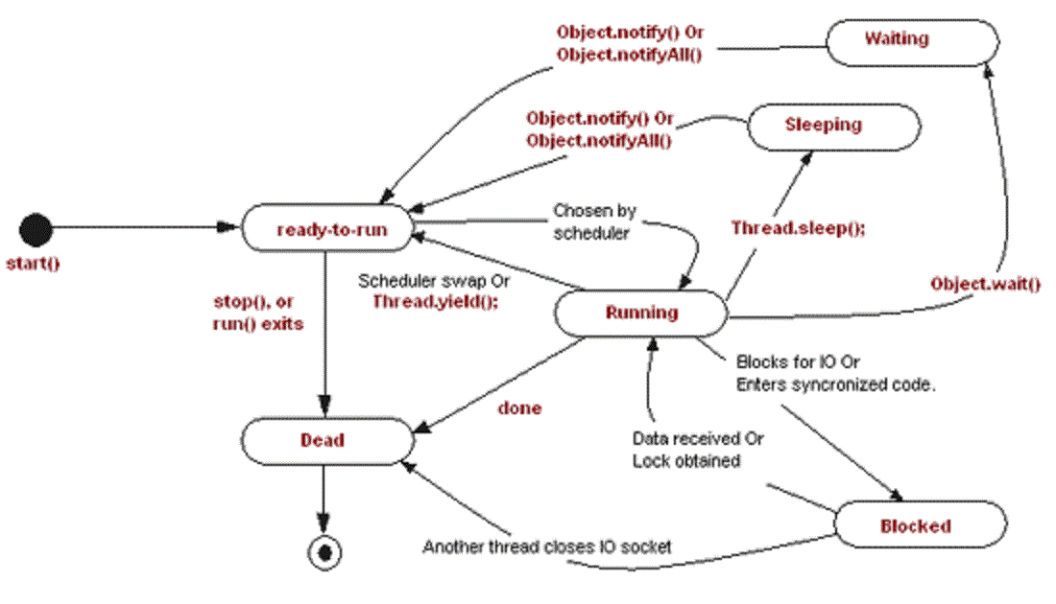
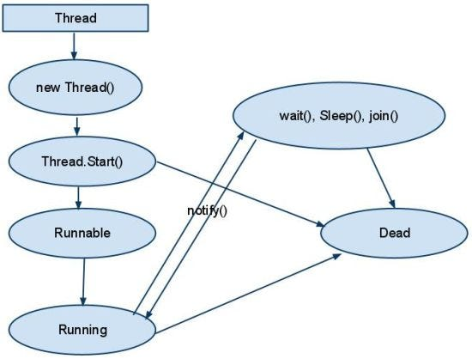

7) join() Method (Wait for Thread)
Main thread waits until worker thread finishes.
Thread t = new Thread(() -> {
System.out.println("Worker done");
});

t.start();
t.join();
System.out.println("Main done");
Output:
Worker done
Main done
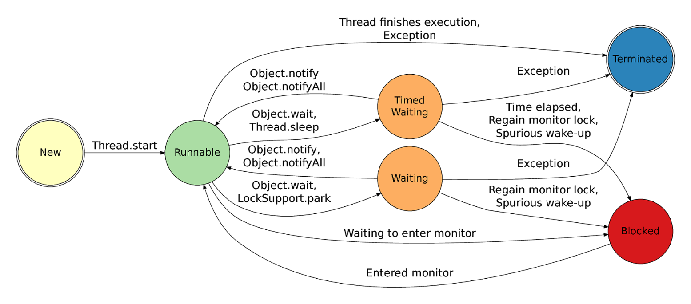
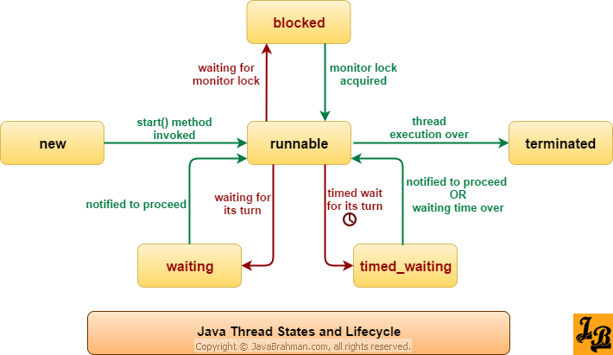

8) Race Condition (Problem)
class Counter {
int count = 0;
void inc() { count++; }
}
Two threads may update count incorrectly → result may be 1 instead of 2.

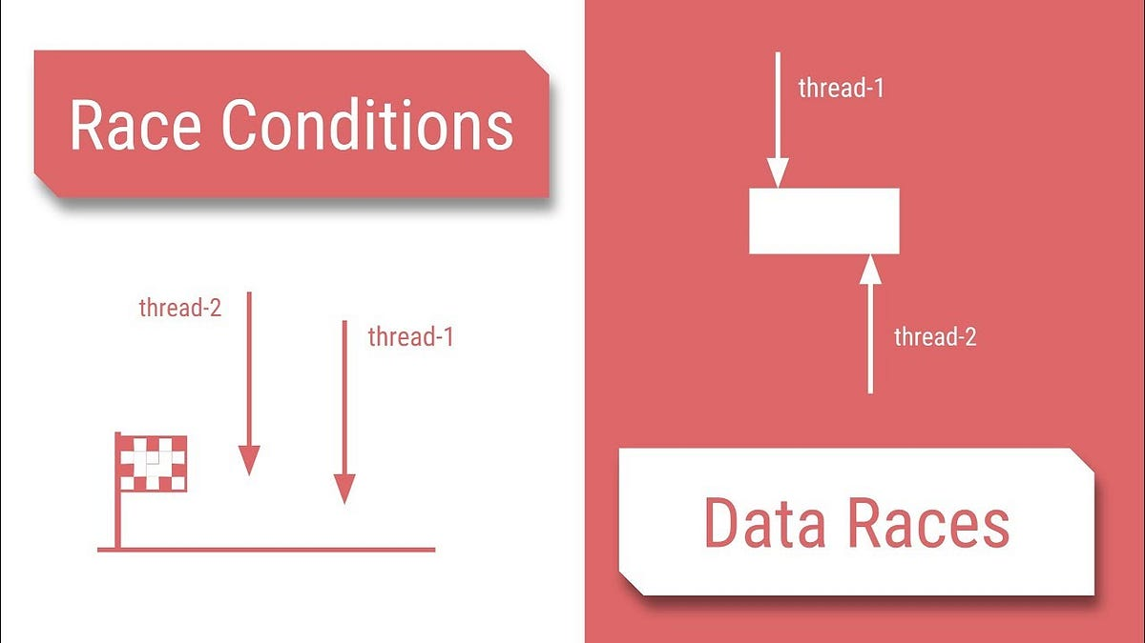

9) Synchronization (Solution)
class Counter {
int count = 0;
synchronized void inc() { count++; }
}
Now result will always be 2.
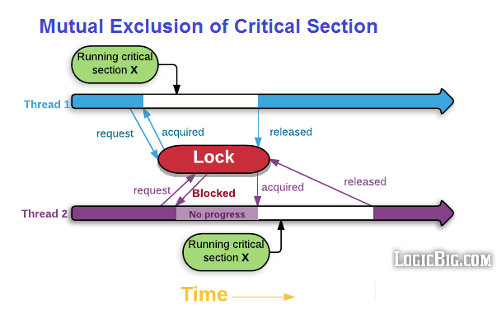
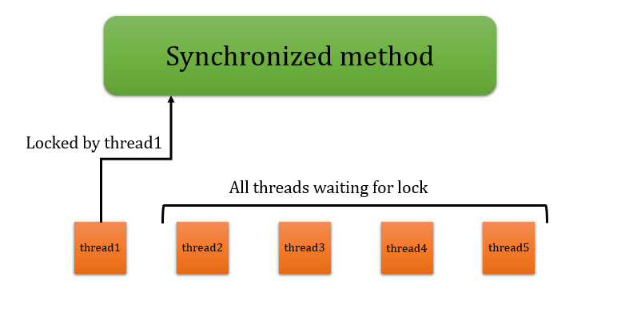

10) Deadlock (Concept)
Two threads wait for each other forever.
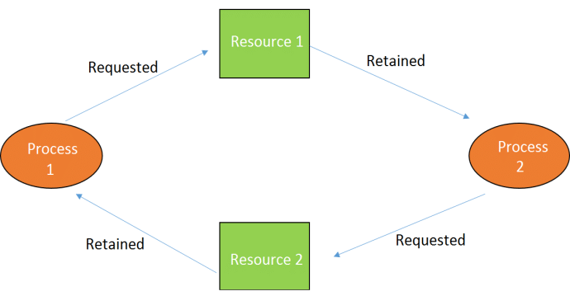
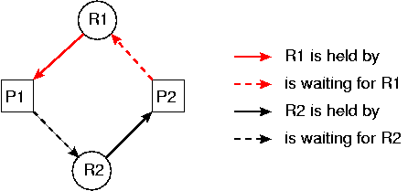
How to avoid deadlock?
- Acquire locks in fixed order
- Use timeouts
- Avoid nested locks

11) Daemon Thread
Background thread that stops when main thread ends.
Thread t = new Thread(() -> {
while(true) System.out.print("X ");
});
t.setDaemon(true);
t.start();

12) Executor Framework (Best Practice)
Preferred way in real applications.
import java.util.concurrent.*;

public class Main {
public static void main(String[] args) {
ExecutorService executor = Executors.newSingleThreadExecutor();

executor.submit(() -> System.out.println("Task running"));

executor.shutdown();
}
}
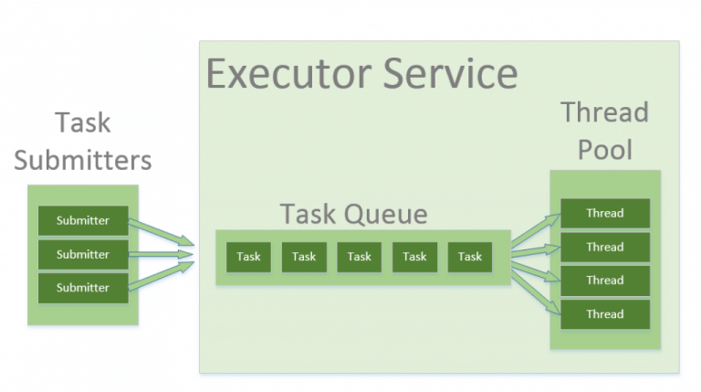
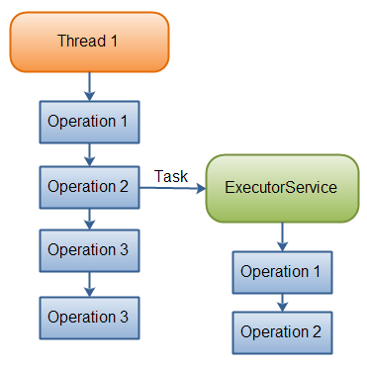

1️⃣ Thread Synchronization — DIAGRAM VERSION


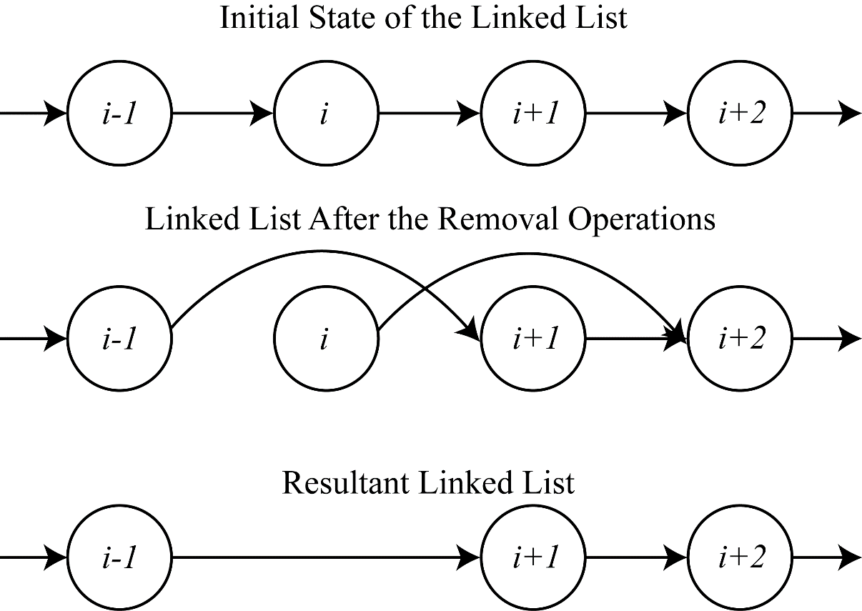

What the diagram means (in one line)
Only one thread at a time can hold the object lock; others must wait.

Minimal code that matches the diagram
class Counter {
int count = 0;

synchronized void increment() {
count++; // Only one thread here at a time
}
}

2️⃣ BANK TRANSFER EXAMPLE (Real-world Synchronization)

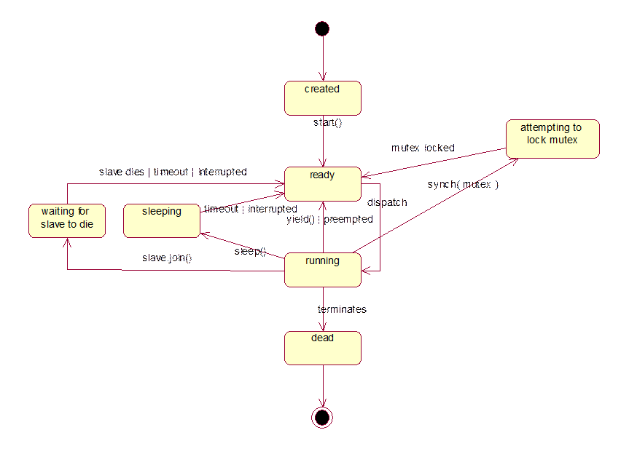

Problem (Without synchronization)
Two threads could withdraw at the same time and overdraw the account.

Correct synchronized version
class BankAccount {
private int balance;

BankAccount(int balance) {
this.balance = balance;
}

synchronized void withdraw(int amount) {
System.out.println(Thread.currentThread().getName() + " trying to withdraw " + amount);

if (balance >= amount) {
System.out.println("Approved for " + Thread.currentThread().getName());
try { Thread.sleep(500); } catch (Exception e) {} // simulate processing
balance -= amount;
System.out.println(Thread.currentThread().getName() + " completed withdrawal");
} else {
System.out.println("Insufficient balance for " + Thread.currentThread().getName());
}
}

int getBalance() {
return balance;
}
}

public class BankDemo {
public static void main(String[] args) throws Exception {
BankAccount acc = new BankAccount(100);

Thread t1 = new Thread(() -> acc.withdraw(80), "T1");
Thread t2 = new Thread(() -> acc.withdraw(80), "T2");

t1.start();
t2.start();
t1.join();
t2.join();

System.out.println("Final balance = " + acc.getBalance());
}
}

Guaranteed correct behavior
Only one thread withdraws 80; the other is rejected.

3️⃣ PRODUCER–CONSUMER DEMO (Classic Synchronization)
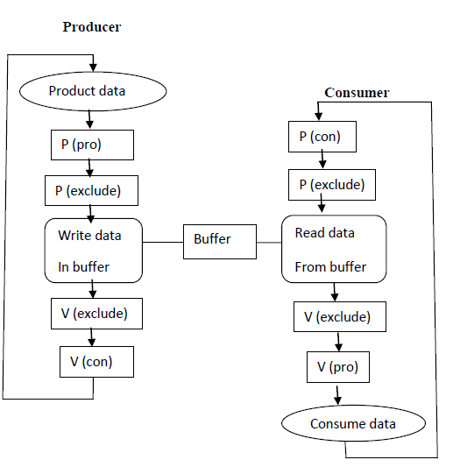
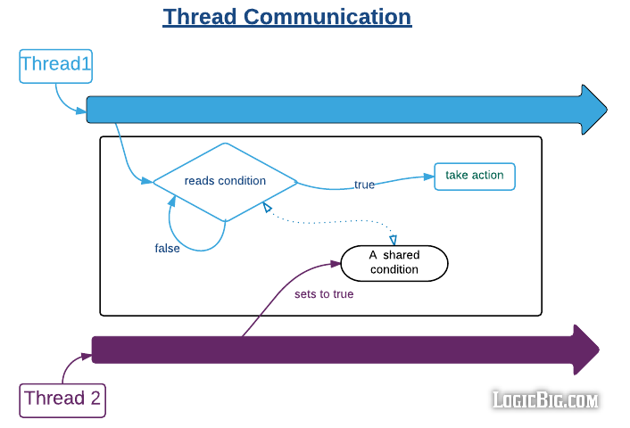

Core idea
- Producer → puts data into a buffer
- Consumer → takes data from buffer
- They coordinate using wait() / notify()

Demo (Single-slot buffer)
class Buffer {
private int data;
private boolean available = false;

synchronized void produce(int value) throws InterruptedException {
while (available) wait(); // wait if buffer full

data = value;
available = true;
System.out.println("Produced: " + value);
notify(); // wake up consumer
}

synchronized int consume() throws InterruptedException {
while (!available) wait(); // wait if buffer empty

available = false;
System.out.println("Consumed: " + data);
notify(); // wake up producer
return data;
}
}

public class ProducerConsumerDemo {
public static void main(String[] args) {
Buffer buffer = new Buffer();

Thread producer = new Thread(() -> {
try {
for (int i = 1; i <= 5; i++) {
buffer.produce(i);
Thread.sleep(500);
}
} catch (Exception e) {}
});

Thread consumer = new Thread(() -> {
try {
for (int i = 1; i <= 5; i++) {
buffer.consume();
Thread.sleep(700);
}
} catch (Exception e) {}
});

producer.start();
consumer.start();
}
}

Typical Output (order may vary slightly)
Produced: 1
Consumed: 1
Produced: 2
Consumed: 2
...

Key synchronization tools used
- synchronized
- wait()
- notify()

Quick Comparison (for exams/interviews)
Example | Main Concept
Diagram | Mutual exclusion (lock)
Bank transfer | Critical section protection
Producer–Consumer | Coordination via wait/notify

