Object-Oriented Programming (OOP)

1. What is OOP?
Object-Oriented Programming (OOP) is a programming paradigm based on objects, which combine data (attributes) and behavior (methods).
Instead of writing programs as a sequence of instructions, OOP organizes software around objects representing real-world entities.

Example real-world mapping
Real World | OOP Representation
Car | Class
My Honda City | Object
Speed, color | Attributes
Drive(), brake() | Methods

2. Class and Object

Class
A class is a blueprint/template used to create objects.
It defines:
- Variables (fields)
- Methods (functions)

Java Example
class Car {
String color;
int speed;

void drive() {
System.out.println("Car is driving");
}
}

Object
An object is an instance of a class.

Example
Car myCar = new Car();
myCar.color = "Red";
myCar.speed = 120;
myCar.drive();

Class–Object Diagram
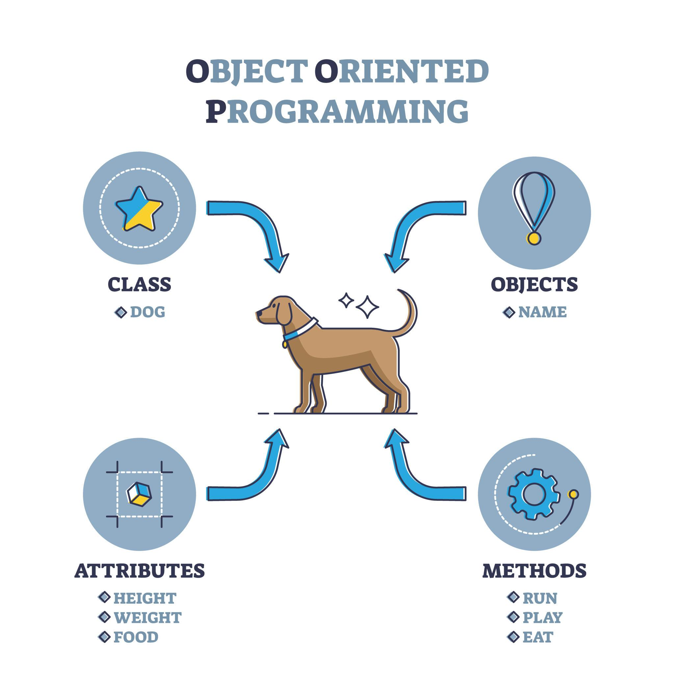
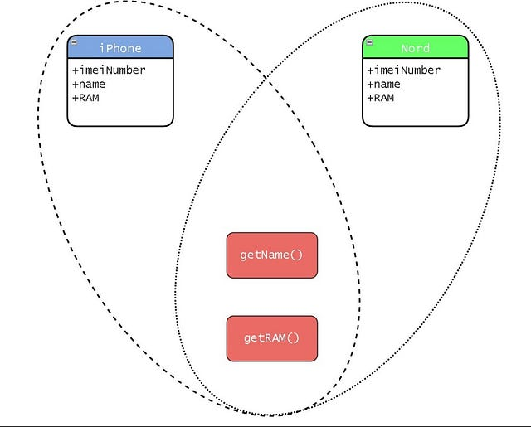
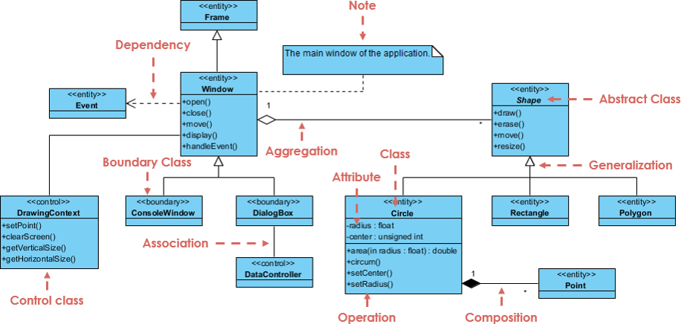
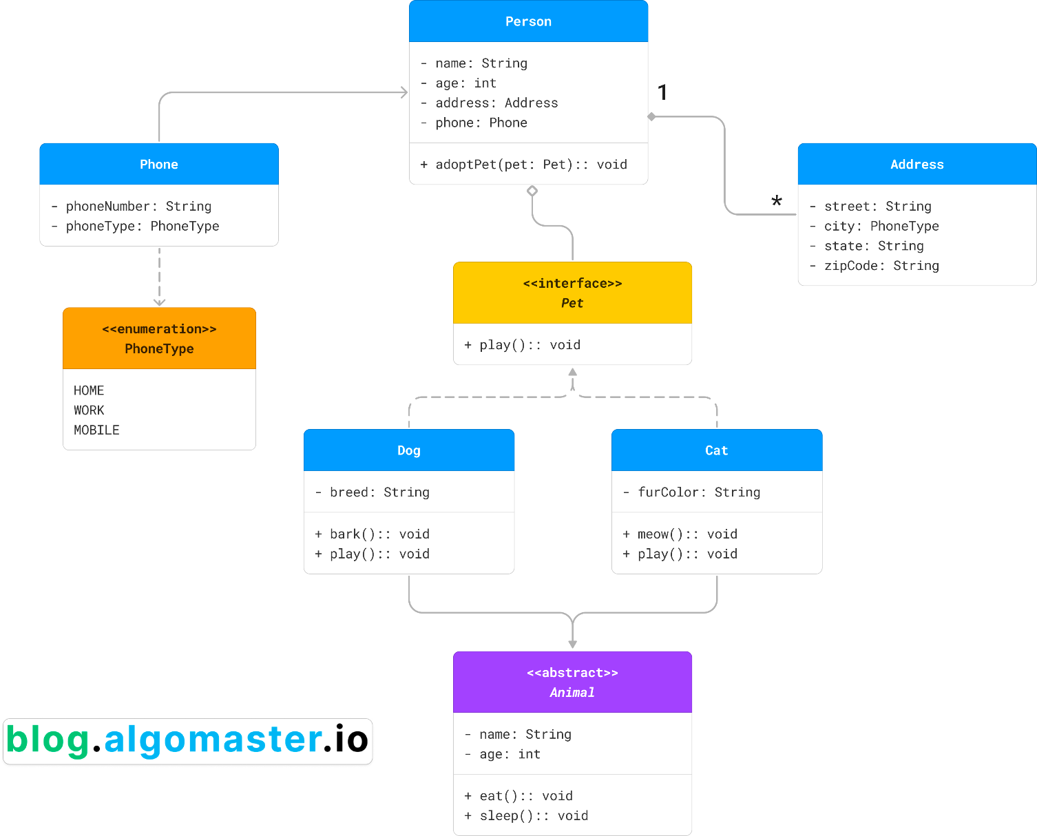

Explanation
- Class defines the structure.
- Multiple objects can be created from one class.
- Each object has its own data values.
Example:
Class: Car

Objects:
Car1 -> color: red
Car2 -> color: blue
Car3 -> color: black

3. Four Pillars of OOP
OOP is built on four main principles:
- Encapsulation
- Inheritance
- Polymorphism
- Abstraction

4. Encapsulation
Encapsulation means bundling data and methods together and restricting direct access to internal data.

Key idea
Data + Methods = Single Unit (Class)

Example
class BankAccount {

private double balance;

public void deposit(double amount){
balance += amount;
}

public double getBalance(){
return balance;
}
}

Why use Encapsulation?
Benefits:
- Data protection
- Code maintainability
- Controlled access
- Improved security

Encapsulation Diagram
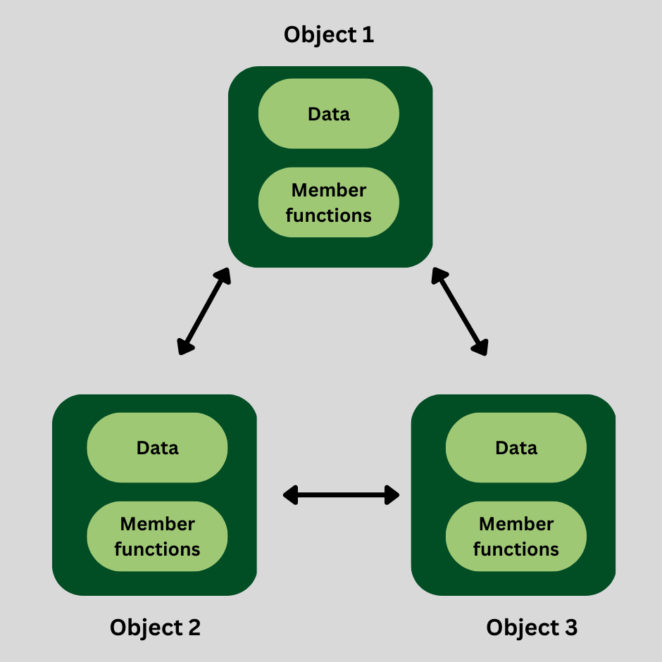

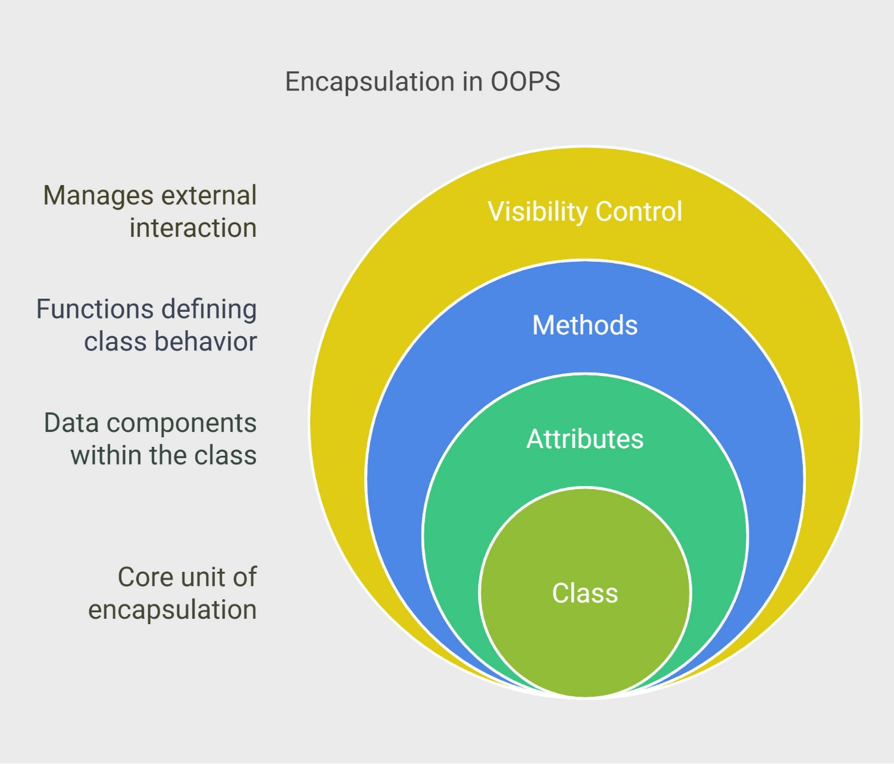
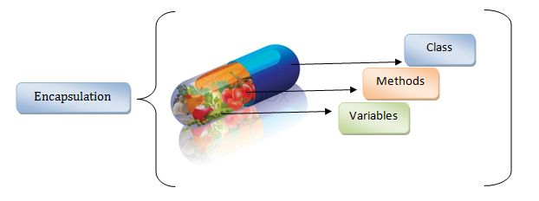

5. Inheritance
Inheritance allows a class to reuse properties and methods of another class.

Syntax
class Animal {
void eat(){
System.out.println("Animal eats");
}
}

class Dog extends Animal {
void bark(){
System.out.println("Dog barks");
}
}
Here:
Dog inherits Animal

Inheritance Diagram


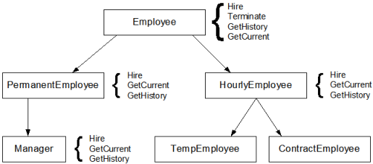
z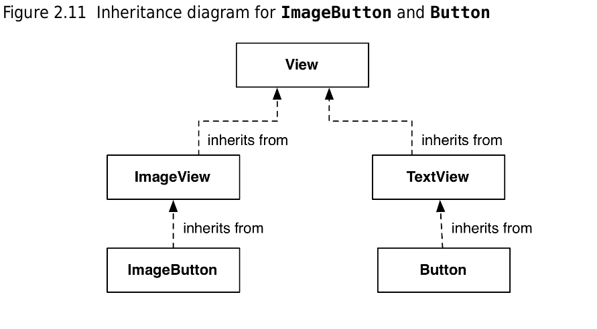

Types of Inheritance
Type | Description
Single | One parent → one child
Multilevel | Grandparent → Parent → Child
Hierarchical | One parent → multiple children
Multiple | Multiple parents (via interfaces in Java)
Example:
Animal
├── Dog
├── Cat
└── Lion

6. Polymorphism
Polymorphism means same method name, different behavior.
Two types:
- Compile-time polymorphism
- Runtime polymorphism

Compile-Time Polymorphism (Method Overloading)
Same method name but different parameters.
class MathUtils {

int add(int a, int b){
return a + b;
}

double add(double a, double b){
return a + b;
}
}

Runtime Polymorphism (Method Overriding)
Child class provides its own implementation.
class Animal {
void sound(){
System.out.println("Animal makes sound");
}
}

class Dog extends Animal {
void sound(){
System.out.println("Dog barks");
}
}

Polymorphism Diagram
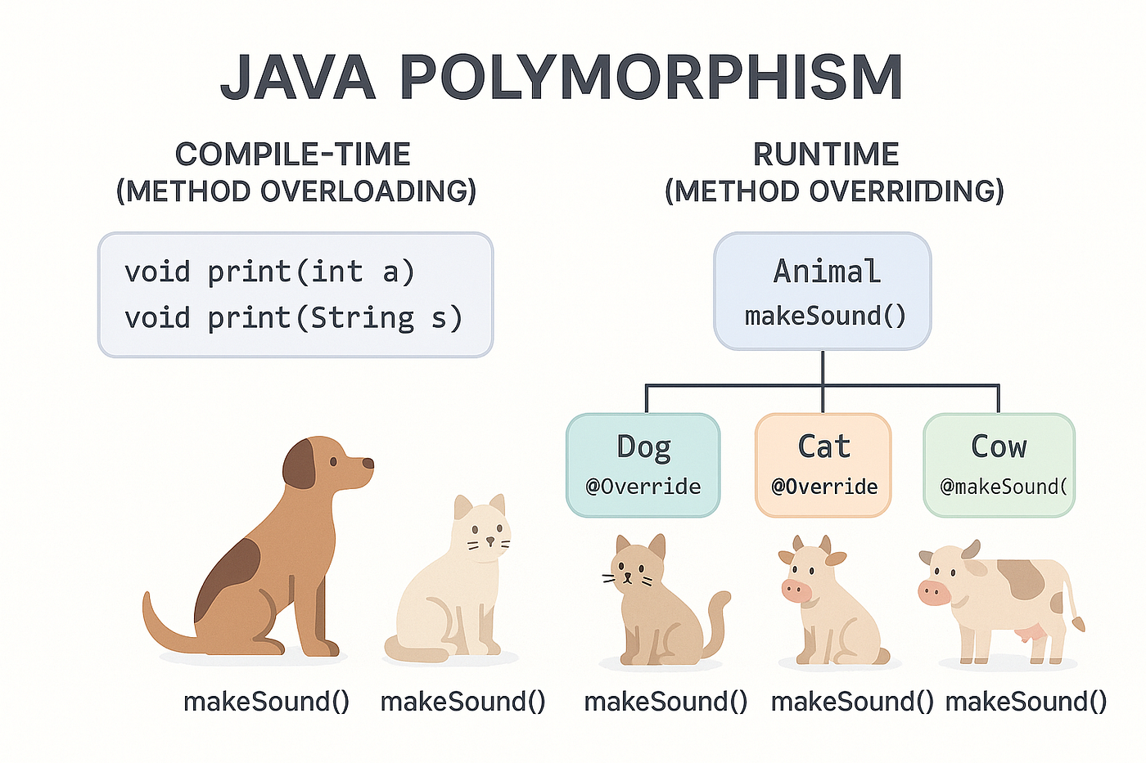
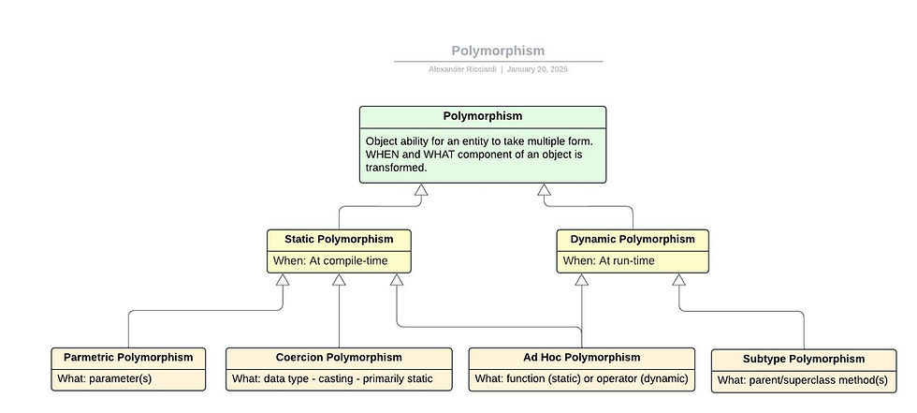
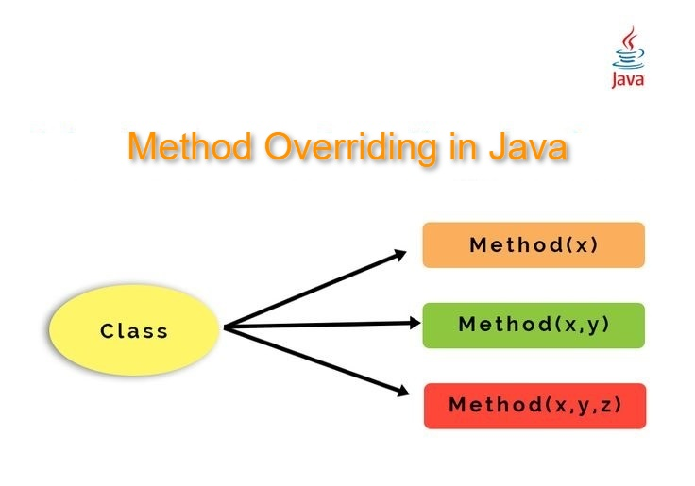
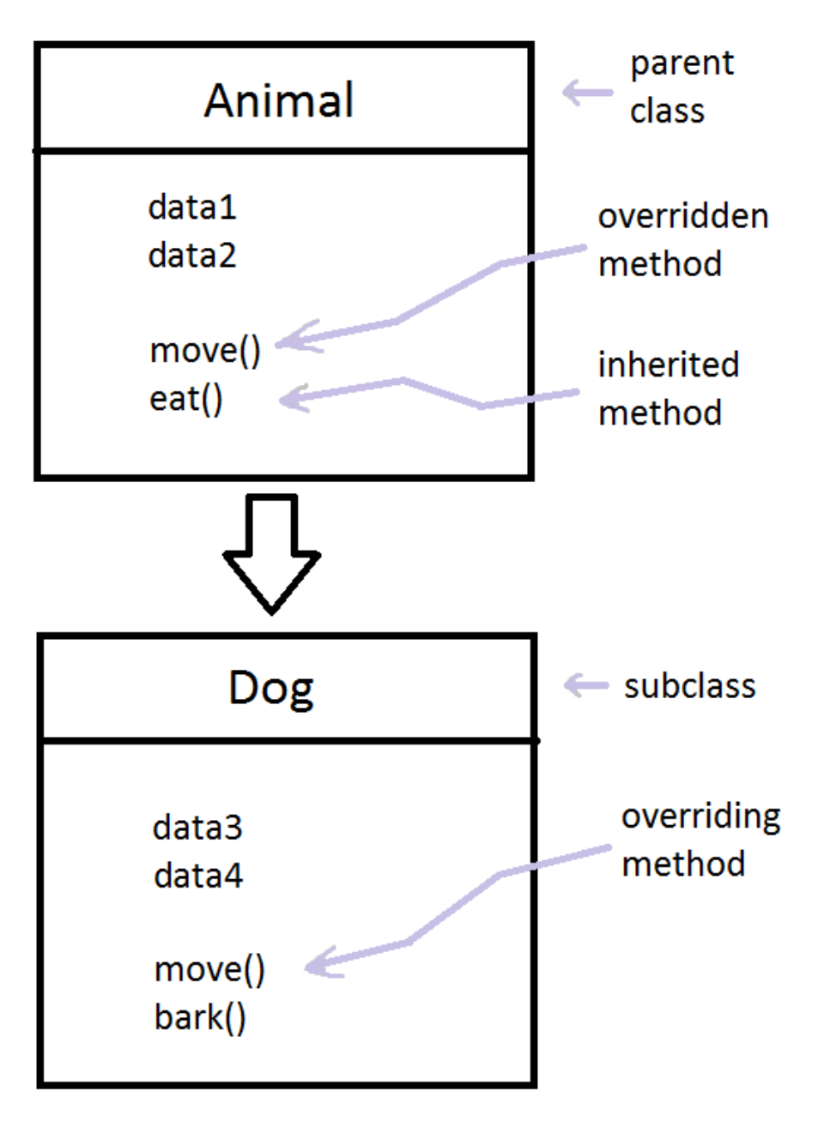

7. Abstraction
Abstraction means showing only essential features and hiding implementation details.
Example:
When you drive a car, you only use:
- steering
- accelerator
- brake
You don’t need to know engine internals.

Achieved using
- Abstract classes
- Interfaces

Abstract Class Example
abstract class Shape {

abstract void draw();
}

class Circle extends Shape {

void draw(){
System.out.println("Drawing circle");
}
}

Abstraction Diagram
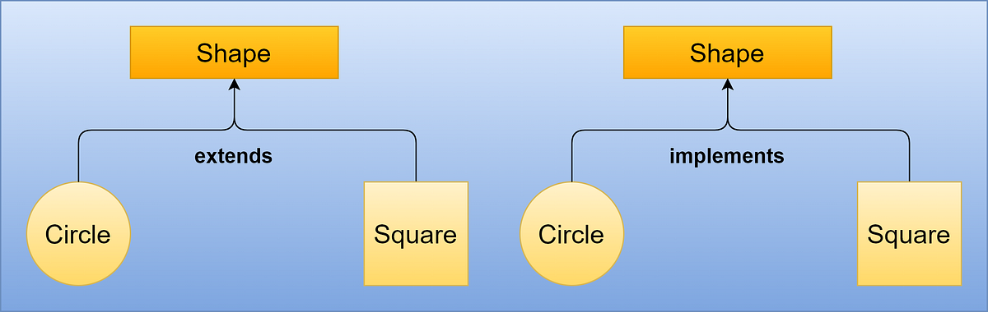
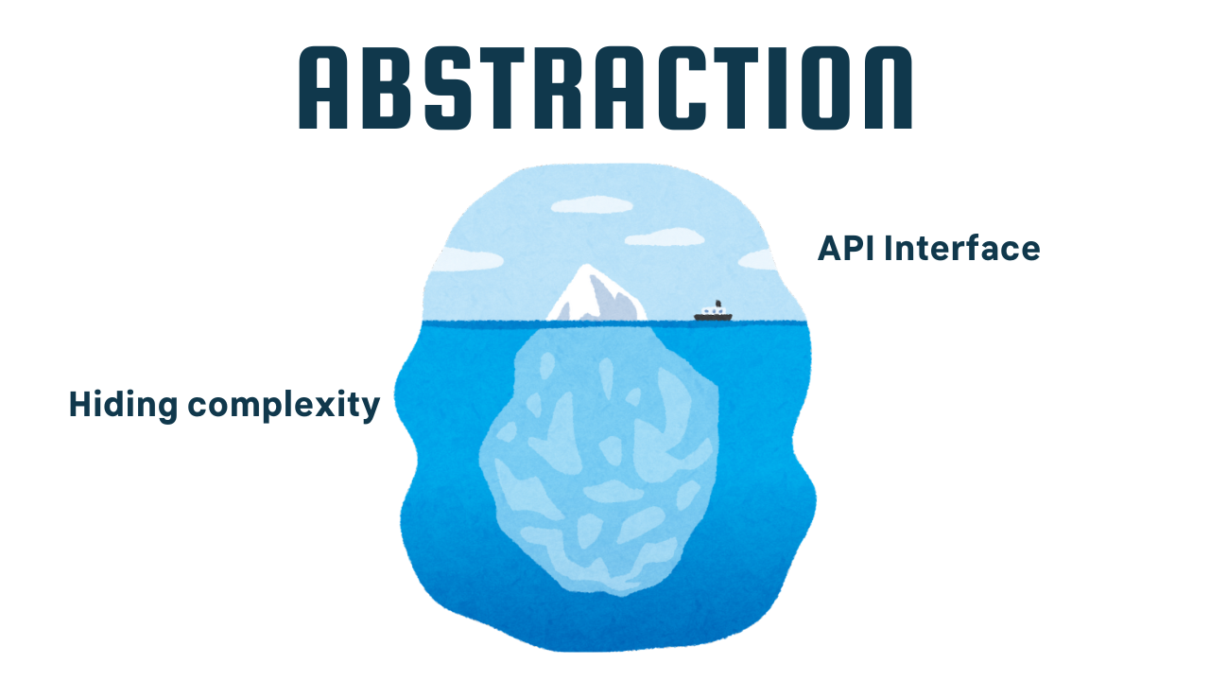
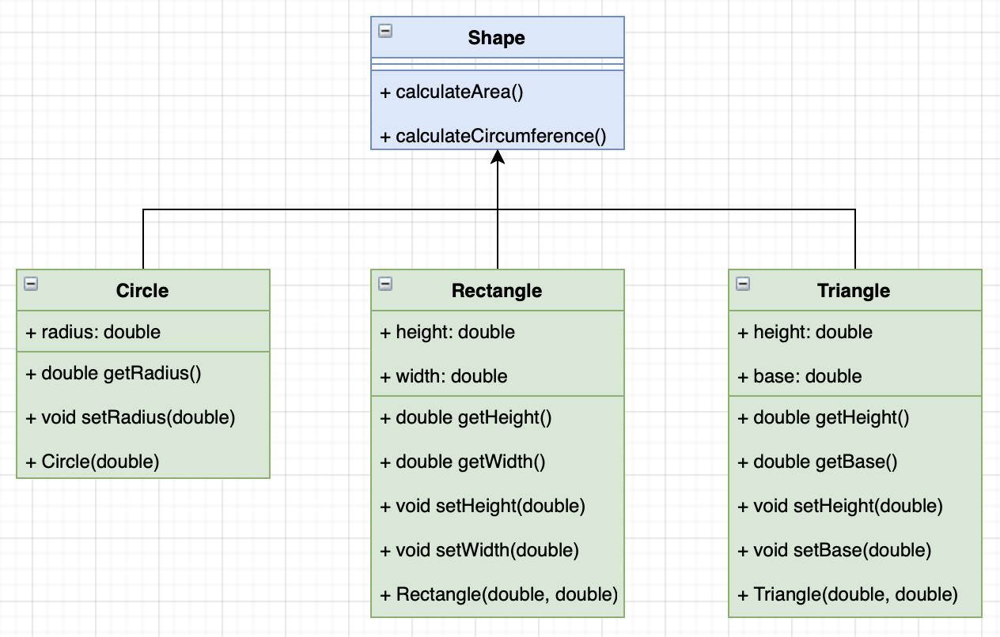
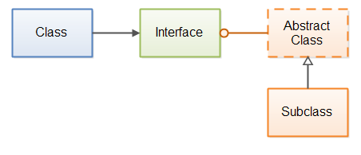

8. Relationships in OOP

Association
General relationship between classes.
Example:
Teacher teaches Student

Aggregation
Weak relationship (has-a relationship).
Example:
Department has Teachers
Teachers can exist without department

Composition
Strong relationship.
Example:
House has Rooms
Rooms cannot exist without House

Relationship Diagram
University
|
Department
|
Teacher
|
Student

9. OOP Design Principles
Beyond basic OOP concepts, good software design follows SOLID principles.

SOLID Principles

1. Single Responsibility Principle (SRP)
A class should have only one reason to change.
Bad:
UserManager
- login()
- sendEmail()
- generateReport()
Good:
AuthService
EmailService
ReportService

2. Open/Closed Principle (OCP)
Software should be:
Open for extension
Closed for modification
Meaning:
You should add new behavior without changing existing code.
Example: using inheritance or interfaces.

3. Liskov Substitution Principle (LSP)
A subclass should replace its parent class without breaking functionality.
Bad example:
Bird
fly()

Penguin extends Bird
Penguin cannot fly, violating LSP.

4. Interface Segregation Principle (ISP)
Clients should not be forced to implement unused methods.
Bad interface:
Machine
print()
scan()
fax()
Good design:
Printer
Scanner
FaxMachine

5. Dependency Inversion Principle (DIP)
High-level modules should not depend on low-level modules.
Both should depend on abstractions.
Example:
PaymentService → PaymentInterface
↑
CreditCardPayment
UpiPayment

10. Example OOP System Design

Online Shopping System
Classes:
User
Product
Order
Payment
Cart

Architecture Diagram
User
|
v
Cart ----> Product
|
v
Order ----> Payment

11. Benefits of OOP
Benefit | Description
Modularity | Code organized into classes
Reusability | Inheritance enables reuse
Maintainability | Easier updates
Scalability | Good for large systems
Security | Encapsulation protects data

12. Real Industry Example
Example: Banking System
Classes:
Customer
Account
Transaction
Loan
ATM
Relationships:
Customer → has → Account
Account → performs → Transaction

13. OOP Interview Questions

Basic
- What is OOP?
- Difference between class and object?
- What is encapsulation?
- What is inheritance?
- What is polymorphism?

Advanced
- Difference between abstraction and encapsulation
- Method overloading vs overriding
- What is SOLID principle?
- What is composition vs inheritance?
- What is dependency injection?

