PART 1 — Why Lambda?
Before Java 8, you often wrote verbose anonymous classes:
Runnable r = new Runnable() {
@Override
public void run() {
System.out.println("Hello");
}
};
new Thread(r).start();
With Lambda (Java 8+):
Runnable r = () -> System.out.println("Hello");
new Thread(r).start();

What Lambda gives you
- Less boilerplate
- Functional (declarative) style
- Better use of Streams & Collections
- Enables functional programming in Java
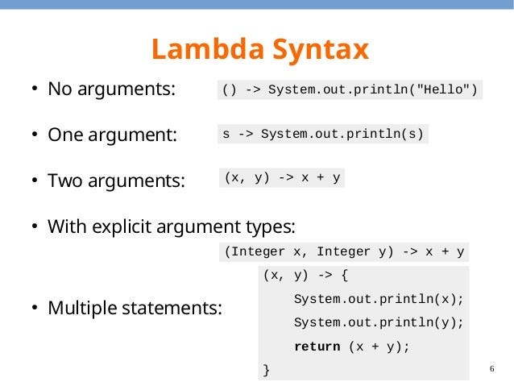
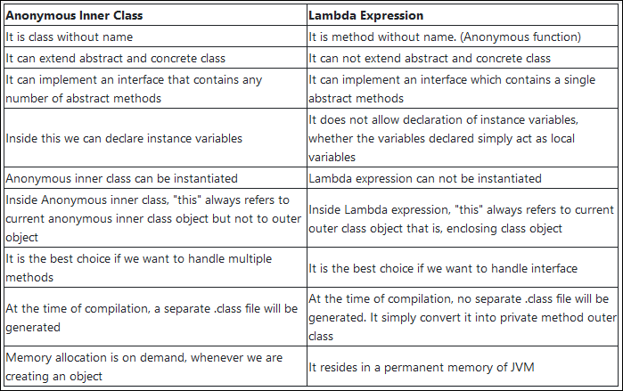

PART 2 — Lambda Syntax (Core Concept)

2.1 General Syntax
(parameters) -> expression
or
(parameters) -> { statements; }

Examples
Old way | Lambda way
void m() { System.out.println("Hi"); }
| () -> System.out.println("Hi")
int add(int a, int b) { return a + b; }
| (a, b) -> a + b
boolean isEven(int x) { return x % 2 == 0; }
| x -> x % 2 == 0

PART 3 — Functional Interfaces (Foundation)

A Functional Interface has exactly ONE abstract method.
Java provides many built-in ones in java.util.function.

3.1 Custom Functional Interface
@FunctionalInterface
interface Calculator {
int add(int a, int b);
}
Using Lambda:
public class LambdaDemo {
public static void main(String[] args) {
Calculator c = (a, b) -> a + b;
System.out.println(c.add(10, 20)); // 30
}
}
@FunctionalInterface is optional but recommended (compiler checks rule).

3.2 Important Built-in Functional Interfaces

(A) Predicate → returns boolean
import java.util.function.Predicate;

Predicate<Integer> isEven = x -> x % 2 == 0;
System.out.println(isEven.test(10)); // true

(B) Function<T, R> → transforms value
import java.util.function.Function;

Function<String, Integer> length = s -> s.length();
System.out.println(length.apply("Java")); // 4

(C) Consumer → takes input, returns nothing
import java.util.function.Consumer;

Consumer<String> printer = s -> System.out.println(s);
printer.accept("Hello Lambda");

(D) Supplier → supplies a value
import java.util.function.Supplier;

Supplier<Double> random = () -> Math.random();
System.out.println(random.get());
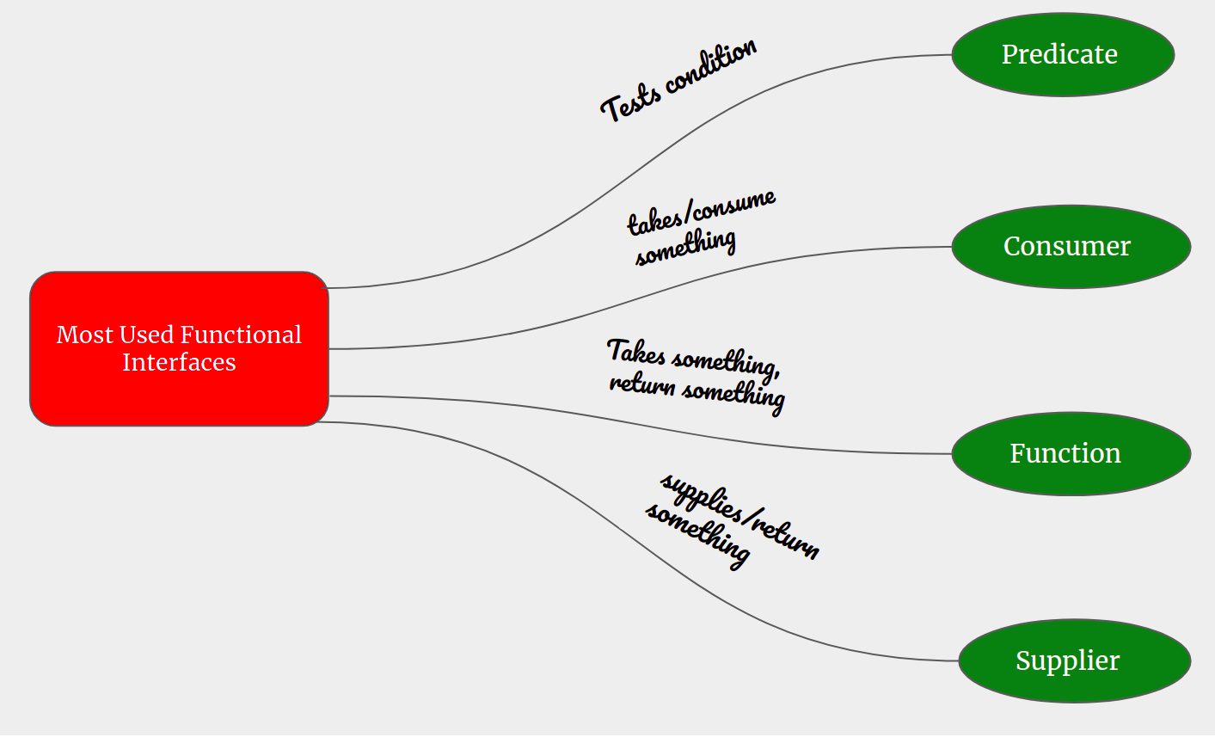
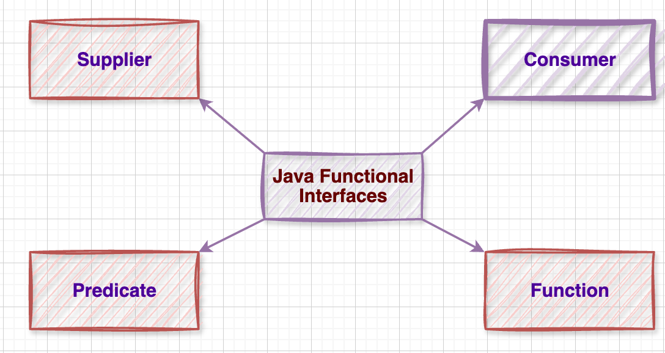

PART 4 — Method References (::)

Method reference is a shorter form of lambda when you already have a method.

4.1 Static Method Reference
class Util {
static int square(int x) {
return x * x;
}
}
Lambda:
Function<Integer, Integer> f1 = x -> Util.square(x);
Method Reference:
Function<Integer, Integer> f2 = Util::square;

4.2 Instance Method Reference
class Printer {
void print(String s) {
System.out.println(s);
}
}
Lambda:
Consumer<String> c1 = s -> new Printer().print(s);
Method Reference:
Printer p = new Printer();
Consumer<String> c2 = p::print;

4.3 Constructor Reference
Supplier<String> s1 = () -> new String();
Supplier<String> s2 = String::new;
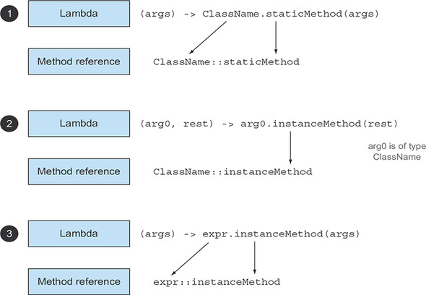
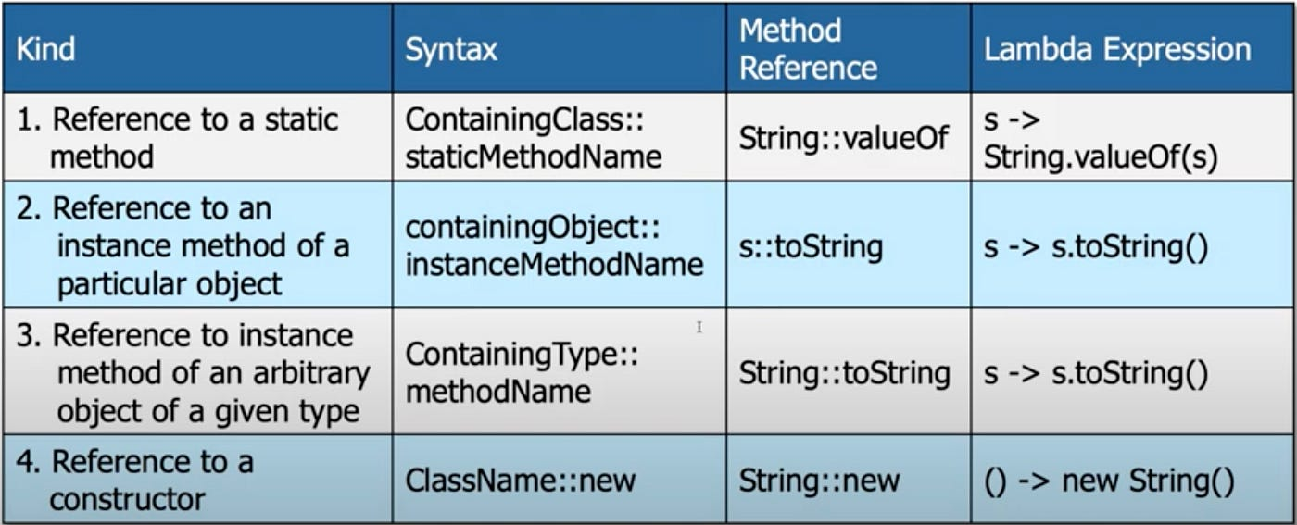

PART 5 — Collections with Lambda

5.1 Iterating with forEach

Before (old style)
List<String> list = Arrays.asList("A", "B", "C");

for (String s : list) {
System.out.println(s);
}

With Lambda
list.forEach(s -> System.out.println(s));

With Method Reference
list.forEach(System.out::println);

5.2 Sorting with Lambda
List<Integer> nums = Arrays.asList(5, 2, 8, 1, 3);

Collections.sort(nums, (a, b) -> a - b);
System.out.println(nums);
Or using List.sort:
nums.sort((a, b) -> b - a); // descending

5.3 Filtering with Predicate
List<Integer> nums = Arrays.asList(1,2,3,4,5,6);

for (int n : nums) {
if (n % 2 == 0) System.out.println(n);
}
With Lambda:
nums.stream()
.filter(n -> n % 2 == 0)
.forEach(System.out::println);

5.4 Mapping with Function
List<String> names = Arrays.asList("java", "lambda", "stream");

names.stream()
.map(String::toUpperCase)
.forEach(System.out::println);
Output:
JAVA
LAMBDA
STREAM

5.5 Reduce (Aggregation)
List<Integer> nums = Arrays.asList(1,2,3,4);

int sum = nums.stream()
.reduce(0, (a, b) -> a + b);

System.out.println(sum); // 10

PART 6 — Realistic Example (Mini Case Study)

Scenario: Bank Transactions List
class Transaction {
String type;
int amount;

Transaction(String type, int amount) {
this.type = type;
this.amount = amount;
}
}
Create list:
List<Transaction> txns = Arrays.asList(
new Transaction("DEBIT", 300),
new Transaction("CREDIT", 500),
new Transaction("DEBIT", 200),
new Transaction("CREDIT", 400)
);

6.1 Filter only DEBIT transactions
txns.stream()
.filter(t -> t.type.equals("DEBIT"))
.forEach(t -> System.out.println(t.amount));

6.2 Get total CREDIT amount
int totalCredit = txns.stream()
.filter(t -> t.type.equals("CREDIT"))
.map(t -> t.amount)
.reduce(0, Integer::sum);

System.out.println("Total Credit: " + totalCredit);

PART 7 — Common Interview Questions

- What is a Functional Interface?
- Difference between Lambda and Anonymous Class?
- When should you use Method References?
- Difference between map() and filter()?
- Can a lambda have multiple statements? (Yes — with {})
- Why are Lambdas important for Streams?

Concept | Example
Lambda | (a, b) -> a + b
Predicate | x -> x > 10
Function | s -> s.length()
Consumer | System.out::println
Supplier | Math::random
Method Ref | ClassName::method
Filter | .filter(x -> x % 2 == 0)
Map | .map(String::toUpperCase)
Reduce | .reduce(0, Integer::sum)

