MedLift-3D: Click-to-3D Lung Nodule Mass and Growth Assessment from Low-Dose Chest Tomosynthesis with Calibrated Uncertainty
By
Jubair Ahmed (011222136)
Foyez Ahammed Naeem (011222011)
Md Motasim Billah (011222016)
Submitted in partial fulfilment of the requirements of the degree of Bachelor of Science in Computer Science and Engineering
October 30, 2026
Department of Computer Science and Engineering
United International University

Abstract
Lung nodules are followed up by measuring how fast they grow, but computed tomography (CT), the standard tool, gives the patient a radiation dose and a cost at every follow-up, while low-dose digital chest tomosynthesis (DTS) cannot resolve depth because its 30° sweep leaves a “missing wedge” of unmeasured information. MedLift-3D is a click-to-3D system that turns one click on a DTS slice into a 3D nodule measurement with a calibrated uncertainty. We first show from projection moments that every DTS view measures a nodule’s mass exactly, while its depth extent, which volume needs, is about 15 times worse conditioned; mass and mass doubling time are therefore the measurements DTS can support. The pipeline simulates low-dose 15-view DTS for 583 LIDC-IDRI patients (1,144 radiologist-annotated nodules), reconstructs a 64 mm prism through the chest around the click, fills the missing wedge with a 17.4-million-parameter conditional 3D diffusion model kept consistent with the X-rays, represents the nodule with 3D Gaussians that give its mass in closed form, and wraps every number in conformal prediction intervals and calibrated size-category probabilities. A learned 3D detector suggests where to click, and a seen/unseen (null-space) analysis explains which part of each measurement comes from the X-rays and which from the learned prior. The system components worked as specified: the diffusion prior raised nodule-region PSNR on held-out data from 11.88 dB to 15.23 dB, the detector reached a CPM of 0.298 against 0.017 for a training-free baseline, conformal intervals reached 95% coverage on 74 test nodules, and calibrated category probabilities lowered the Brier score for a volume of at least 100 mm³ from 0.54 to 0.17. The null-space analysis confirmed that the X-rays measure almost all of a nodule’s mass (0.3% unseen) and that the prior’s unseen content correlates with the truth (skill 0.22). The measurements, however, did not reach the goal: mass was not more accurate than volume, the full method’s volume error (MdAPE 94.6%) was not lower than physics-only reconstruction (87.7–91.2%), and the valid intervals were too wide to be useful. We trace these failures to a prior that shrinks faint nodules, to measuring mass in image space rather than from the projections, and to failed measurements inside the calibration set, and show that better image quality did not imply better measurement. The full study ran on one rented GPU in 15 hours for about US$20, and an interactive demo runs on a free Kaggle notebook.
Keywords: digital tomosynthesis, lung nodule volumetry, diffusion models, 3D Gaussians, conformal prediction, explainable AI

Acknowledgements
This work would not have been possible without the input and support of many people. We would like to express our gratitude to everyone who contributed to it in some way or other.
First, we would like to thank our course teacher, Dr. A.K.M. Muzahidul Islam, Professor, Dept. of CSE, for his guidance on the design project process and its standards.
Our sincere gratitude goes to our supervisor, Mir Moynuddin Ahmed Shibly, Assistant Professor (On Leave), Dept. of CSE, for his advice on the research direction and for encouraging us to narrow the design to what could be measured and verified.
We are also thankful to The Cancer Imaging Archive (TCIA) and the LIDC-IDRI consortium for making their annotated CT collection public, and to the authors of the open-source libraries we used (PyTorch, pylidc, crepes, Gradio).
Last but not the least, we owe to our family including our parents for their unconditional love and immense emotional support.

Table of Contents
Right-click and choose Update Field to build the table of contents.

Chapter 1: Introduction
This chapter states the clinical problem that MedLift-3D solves and why it matters. It then lists the objectives as testable hypotheses, summarises the method and its outcomes, and outlines the rest of the report.

1.1 Project Overview
Lung cancer is the leading cause of cancer death worldwide, with about 2.5 million new cases (12.4% of all cancers) and 1.8 million deaths (18.7% of cancer deaths) in 2022 [1]. Survival depends strongly on the stage at diagnosis: five-year survival is 70–90% for stage I non-small cell lung cancer but only 15–19% for stage IV [2]. Early lung cancer usually appears as a pulmonary nodule, yet most nodules are benign. Radiologists therefore decide by following a nodule over months and measuring how fast it grows, usually as a volume doubling time (VDT) [3, 4].
Computed tomography (CT) is the standard tool for this follow-up, but every scan gives the patient a radiation dose of several millisieverts and costs money and scanner time [5]. Low-dose CT lowers the dose, yet repeated follow-up still adds up: about four radiation-induced cancers per 10,000 screened people, most of it from the follow-up scans [6]. In low-resource settings such as rural Bangladesh, CT is often not available at all.
Digital chest tomosynthesis (DTS) acquires 15–74 low-dose X-ray views during a short tube sweep of about 30°, at roughly 0.1 mSv, on equipment that costs far less than CT [7]. It finds nodules about three times more often than chest radiography [8]. However, a 30° sweep leaves a missing wedge of directions that no X-ray passes through (Figure 1.1), so DTS cannot resolve depth and every 3D size measured from it is partly a guess.
Problem statement. Given a low-dose chest DTS acquisition and one click on a nodule, produce its 3D mass, volume and growth rate together with an uncertainty that is honest, so that a clinician can follow nodules without repeated CT and knows when a measurement cannot be trusted.
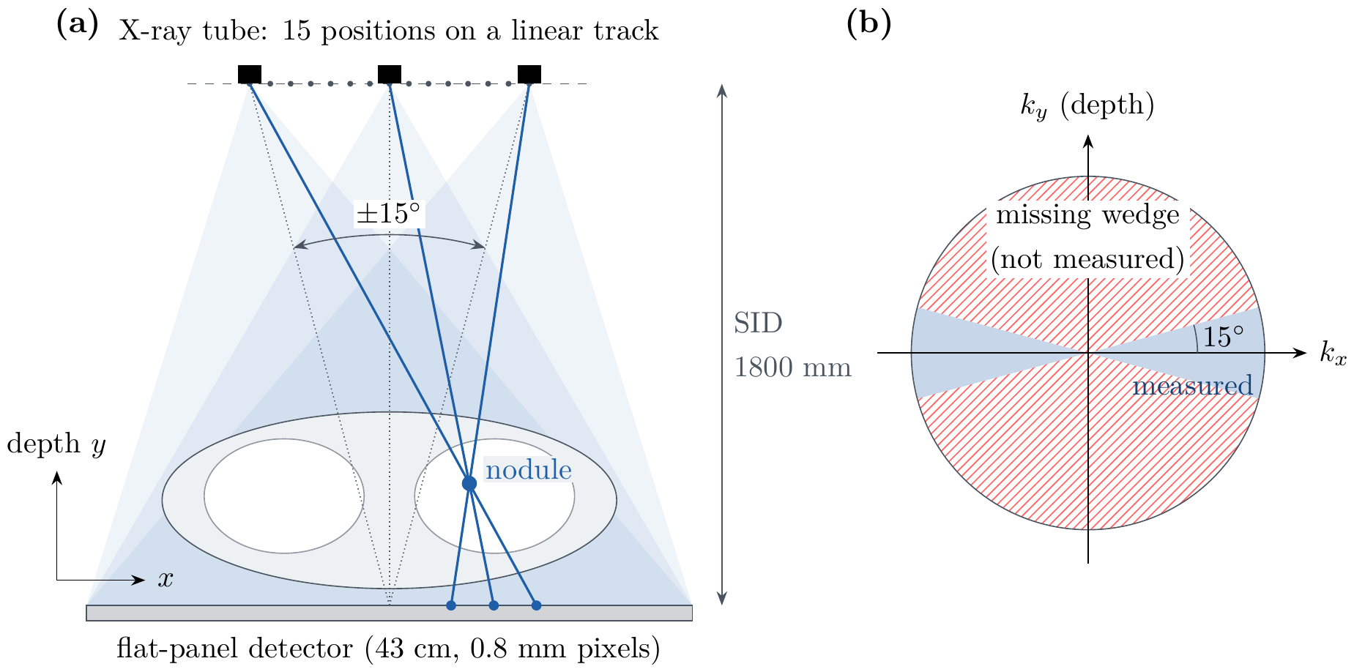
Figure 1.1: Chest DTS acquisition. (a) The X-ray tube moves along a linear track over $±{15}^{∘}$ and the nodule’s shadow shifts on the detector with the tube angle; this shift is the only depth information. (b) In Fourier space each view measures one plane, so a $±{15}^{∘}$ sweep measures only a double wedge around the in-plane axis and leaves the depth frequencies unmeasured.

1.2 Motivation
Four observations motivate this project: nodules must be followed over time, 2D measurement of their size is unreliable, CT follow-up costs radiation and access, and existing reconstruction methods cannot give trustworthy numbers from DTS. A fifth, computational observation shapes the approach we take.

1.2.1 Clinical Importance of Nodule Follow-up
Five-year survival falls from 64% for localised lung cancer to 9% for distant disease [9, 10]. Growth is the key sign separating malignant from benign nodules, and guidelines act on volume and doubling-time categories: $<100$, 100–300 and $≥300$ mm$​^{3}$, and $<400$, 400–600 and $>600$ days [4, 11].

1.2.2 Limits of 2D Measurement
Diameters measured on single slices assume a sphere. Volumes estimated from 2D measurements differ from 3D volumetry by 47–85% on average [12], 2D measurements of small nodules are unreliable [13], and a 1 mm change in diameter is a 33% change in volume [14]. Measurement error larger than the true growth delays treatment.

1.2.3 Radiation and Access
CT follow-up means repeated dose and requires well-equipped centres [5, 15]. In Bangladesh, CT scanners are concentrated in divisional cities and large hospitals, so many patients travel long distances and pay for every follow-up scan, while digital radiography rooms, which can be upgraded to tomosynthesis, are far more widespread. DTS is cheaper, faster and much lower in dose than CT, but today it offers no trustworthy 3D measurement, so a nodule found on DTS is still sent to CT for every follow-up.

1.2.4 Why Existing Reconstruction and AI Are Not Enough
Iterative reconstruction from a 30° sweep smears each nodule 3–5 times longer in depth than in-plane (we measured a median ratio of 3.5 on LIDC nodules). Generative models can fill the missing wedge, but a model that invents anatomy is dangerous for cancer follow-up [16, 17]. Published sparse-view methods report image quality (PSNR, SSIM) rather than calibrated clinical numbers, and none is built for DTS geometry.

1.2.5 Computational Motivation
We asked what DTS can measure, not only what it can show. A derivation from projection moments (Section 3.2) shows that every DTS view measures a nodule’s total excess attenuation, its mass, exactly, while its depth extent, which volume needs, is about 15 times worse conditioned for a $±{15}^{∘}$ sweep. A system for DTS should therefore report mass first, fill depth with a learned prior that stays consistent with the X-rays, and state how uncertain each number is. Mass growth is already an established CT biomarker that detects growth earlier than volume [18].

1.3 Objectives
The objectives are stated as testable hypotheses (H1–H6); any of them could turn out false, and Chapter 4 reports what we found.
- Mass-first measurement (H1). Show, in theory and on data, that nodule mass from DTS has a smaller error than nodule volume.
- Learned prior for the missing wedge (H2). Train a conditional 3D diffusion model that, combined with physics data consistency and 3D Gaussians, reduces volume error compared with physics-only reconstruction.
- Calibrated uncertainty (H3, H5). Give every mass and volume a conformal 90% prediction interval that reaches its nominal coverage on held-out patients, and give calibrated probabilities of the clinical size categories with coverage in every size group.
- Growth (H4). Measure growth on virtual follow-up scans and test whether mass doubling time (MDT) classifies growth more accurately than VDT.
- Explainability (H6). Show for each nodule which part of the 3D result was measured by the X-rays (seen) and which was supplied by the prior (unseen), and test whether the prior’s unseen content recovers the truth rather than inventing it.
- Usable system. Deliver a click-to-3D application with a learned detector that suggests where to click, running on free or low-cost cloud hardware.

1.4 Methodology
MedLift-3D is evaluated as a virtual clinical trial on real patient CT, because no public dataset has chest DTS together with CT ground truth. Figure 3.6 in Chapter 3 shows the full pipeline.
- Data: 583 LIDC-IDRI patients with 1,144 nodules of 4–30 mm marked by at least three of four radiologists [19, 20], split by patient 60/20/20 into training, calibration and test sets.
- DTS simulation: 15 low-dose views over $±{15}^{∘}$ with Poisson noise, reconstructed by SIRT [21].
- Click and prism: the clinician, helped by a learned detector, selects a nodule; a 64 mm column through the whole chest (the prism) is reconstructed around it.
- Diffusion prior: a 17.4-million-parameter conditional 3D U-Net diffusion model [22–24] generates eight CT-like hypotheses of the prism, each kept consistent with the X-rays by SIRT steps inside the sampler.
- 3D Gaussians: each hypothesis is fitted with anisotropic 3D Gaussians [25, 26], which give the nodule’s mass in closed form.
- Uncertainty: the spread of the eight hypotheses is calibrated into conformal intervals and predictive distributions on the calibration patients [27–30].
- Explanation: each result is split into seen and unseen parts by a conjugate-gradient null-space decomposition [16, 31], and the detector is explained with input$×$gradient saliency [32].

1.5 Project Outcome
The project produces outcomes at three levels: a working and verified technical system, a tool that a clinician can use, and research contributions that can be published.

1.5.1 Technical Outcome
A verified, open pipeline of 18 scripted steps, each ending in automatic PASS/FAIL checks, from data download to final tables, figures and an HTML report. It contains a differentiable DTS simulator and projector, whole-chest and prism reconstruction, a trained conditional diffusion prior and nodule detector, Gaussian measurement, conformal calibration and an explainability module, covered by 69 unit tests and documented for rented cloud GPUs and free Kaggle notebooks. The full study runs on one rented GPU in about 15 hours for about US$20.

1.5.2 Clinical Outcome
A click-to-3D application that returns, in under a minute, the nodule’s mass, volume, long-axis diameter and EUPS size category with calibrated probabilities, together with a virtual follow-up for growth. Every number comes with an interval instead of a single value, and a low-confidence flag tells the clinician when the DTS evidence is too weak and a CT is advisable. The tool is meant for following known nodules, the step that today requires repeated CT.

1.5.3 Research Contribution
(i) A projection-moment argument that DTS measures mass but not depth extent; (ii) a data-consistent diffusion prior inside a DTS prism combined with Gaussian mass; (iii) calibrated, decision-level uncertainty for DTS volumetry; (iv) a truth-referenced seen/unseen test of what the prior adds. Section 2.3 states exactly what is and is not new.

1.6 Organization of the Report
Chapter 2 gives the background on DTS, diffusion models, 3D Gaussians, conformal prediction and explainability, reviews similar applications and research, and identifies the gap. Chapter 3 presents the requirements, the context and data flow diagrams, the user interface, the detailed method with the alternatives considered, the project plan and the task allocation. Chapter 4 describes the environment and tools, how each requirement was verified, and the results for H1–H6. Chapter 5 covers standards; societal, health, safety, legal, cultural, ethical, environmental and sustainability considerations; cost; and the complex engineering problem mapping. Chapter 6 summarises the work, its limitations, future work and what we learned.

Chapter 2: Background
This chapter gives the background needed for the rest of the report and reviews existing applications and research. It ends with the gap that MedLift-3D addresses.

2.1 Preliminaries
This section introduces the physics of X-ray projection and tomosynthesis, iterative reconstruction and its null space, diffusion models, Gaussian representations and nodule mass, conformal prediction, and the explainability and detection metrics used in the rest of the report.

2.1.1 X-ray Projection and Digital Tomosynthesis
A detector pixel records the line integral of the linear attenuation coefficient $μ$ along the ray from the source. With $I_{0}$ incident photons the expected count is
I=I0exp−ray​μr dl, I∼PoissonI, 2.1
so fewer photons (lower dose) mean more noise. CT values are expressed in Hounsfield units, $HU=1000 \left(μ−μ_{\text{water}}\right)/μ_{\text{water}}$.
The missing wedge. CT collects projections over 180° or more. Chest DTS moves the tube along a short linear track, typically $±{15}^{∘}$ (GE VolumeRAD) to $±{20}^{∘}$ (Shimadzu SonialVision), with 15–74 views [7]. By the Fourier slice theorem each view measures one plane of the object’s 3D Fourier transform, so a narrow sweep leaves a wedge of depth frequencies unmeasured (Figure 1.1b). Reconstructions are sharp in the coronal plane but every structure is smeared in depth.

2.1.2 Iterative Reconstruction and the Null Space
Writing the projection operator as $A$, the measured line integrals as $b$ and the volume as $x$, SIRT [21, 33] solves $Ax≈b$ by repeated normalised back-projection of the residual:
$$x^{\left(k+1\right)}=x^{\left(k\right)}+λ CA^{⊤}R\left(b−Ax^{\left(k\right)}\right), \left(2.2\right)$$
where $R$ and $C$ hold the inverse row and column sums of $A$. It is stable under noise but cannot recover anything that lies in the null space of $A$.
Seen and unseen parts. Any volume splits uniquely as $x=x_{\text{seen}}+x_{\text{unseen}}$ with $x_{\text{seen}}∈R\left(A^{⊤}\right)$ and $x_{\text{unseen}}∈N\left(A\right)$, i.e. $Ax_{\text{unseen}}=0$. The X-rays determine only the seen part; the unseen part of any reconstruction comes from its prior [16, 31]. Figure 2.1 illustrates this.
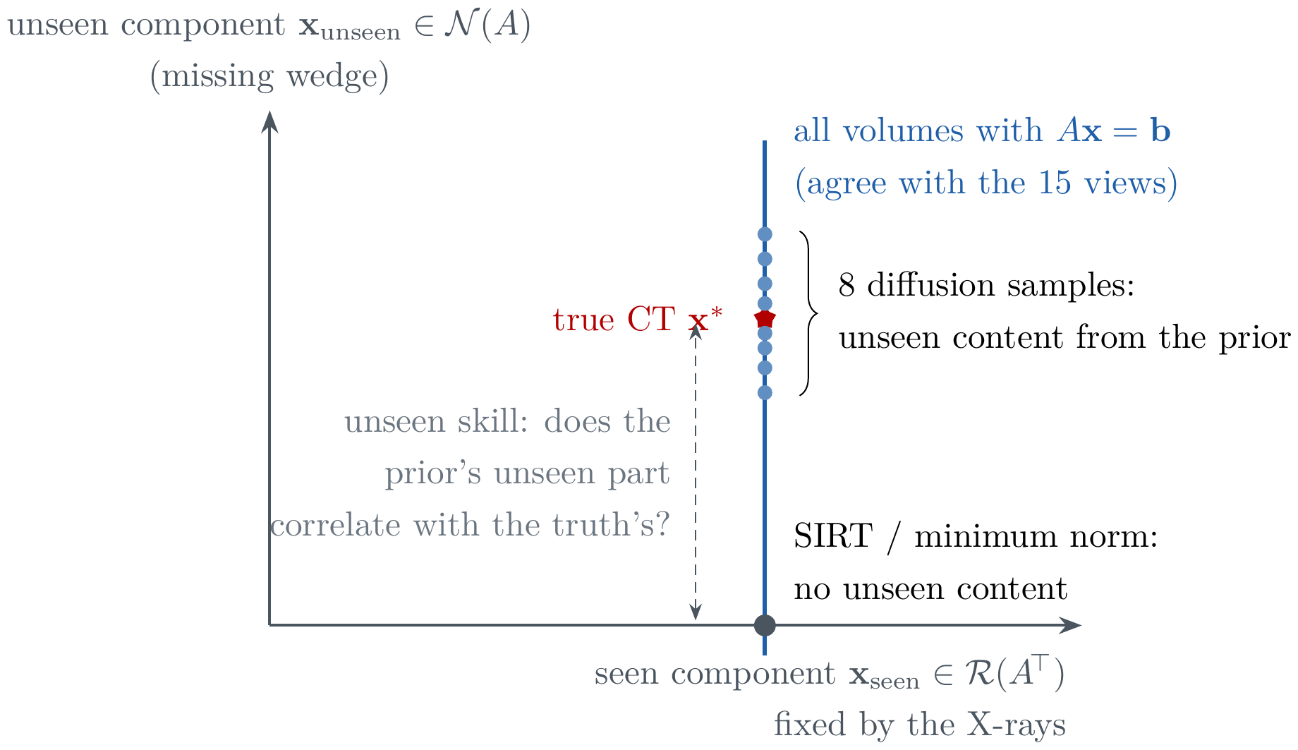
Figure 2.1: Seen (range) and unseen (null-space) components. All volumes on the vertical line agree with the measured views. SIRT returns the minimum-norm point with no unseen content; diffusion samples supply unseen content, which we test against the true CT (unseen skill, Section 3.2).

2.1.3 Denoising Diffusion Models
A diffusion model learns to reverse a gradual noising process [22]. With a cosine noise schedule ${\overset{‾}{α}}_{t}$ [34], a noisy sample is
$$x_{t}=\sqrt{{\overset{‾}{α}}_{t}} x_{0}+\sqrt{1−{\overset{‾}{α}}_{t}} ϵ, ϵ∼N\left(0,I\right). \left(2.3\right)$$
We train the network to predict the velocity $v=\sqrt{{\overset{‾}{α}}_{t}} ϵ−\sqrt{1−{\overset{‾}{α}}_{t}} x_{0}$ (v-prediction [24]), minimising
$$L\left(θ\right)=E_{x_{0},c,t,ϵ} ∥v−{\hat{v}}_{θ}\left(x_{t},c,t\right)∥_{2}^{2}, \left(2.4\right)$$
where the condition $c$ is the DTS reconstruction, so the model learns $p\left(x_{0}∣c\right)$. DDIM [23] samples in tens of steps instead of a thousand, and data-consistency (DC) sampling corrects every denoised estimate with the physics so that samples agree with the measurements [35, 36].

2.1.4 3D Gaussian Representations and Nodule Mass
A volume can be written as a sum of anisotropic Gaussians with centres $μ_{i}$, covariances $Σ_{i}=R_{i}S_{i}S_{i}^{⊤}R_{i}^{⊤}$ and amplitudes $a_{i}$ [25, 26]:
fr=i​aiexp​−12r−μi⊤Σi−1r−μi, M=∫f=i​ai2π3/2si1si2si3, 2.5
where $s_{i1},s_{i2},s_{i3}$ are the Gaussian’s standard deviations. The mass is therefore closed form, and the field can be evaluated on any grid.
Nodule mass. In this report mass is the nodule’s excess attenuation over the surrounding lung, converted to milligrams with the CT density scale (about 0.7–0.85 mg/mm$​^{3}$ on LIDC nodules). Mass doubling time is computed like VDT but from mass; it detects growth of part-solid nodules earlier [18].

2.1.5 Conformal Prediction
Split conformal prediction [27, 30] turns any predictor into intervals with a finite-sample guarantee: if calibration and test cases are exchangeable, a $\left(1−α\right)$ interval contains the truth with probability at least $1−α$. A normalised version scales each interval by a difficulty estimate (here the spread of the diffusion hypotheses); a Mondrian version calibrates within groups (here nodule size groups) so that coverage holds in every group; and conformal predictive systems (CPS) return a full calibrated cumulative distribution for each case [28, 29], from which calibrated probabilities such as $P\left(V≥300 {\text{mm}}^{3}\right)$ follow. Figure 2.2 shows the procedure.
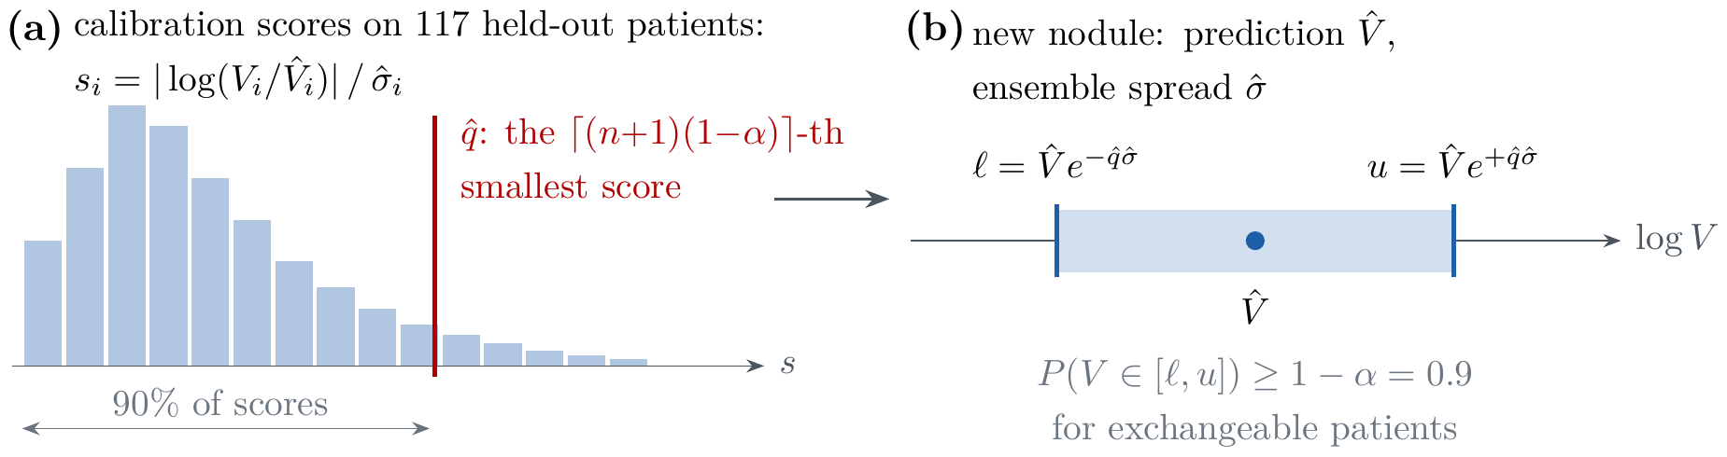
Figure 2.2: Split-conformal calibration (schematic). (a) Normalised scores on held-out calibration patients and their $\left(1−α\right)$ quantile $\hat{q}$. (b) The interval for a new nodule, valid for exchangeable patients without any assumption on the error distribution.

2.1.6 Explainability and Detection Metrics
Input$×$gradient saliency [32] multiplies each input voxel by the gradient of the output with respect to it, showing which voxels drove a detector’s score. Detection is measured by the Competition Performance Metric (CPM), the mean sensitivity at 1/8, 1/4, 1/2, 1, 2, 4 and 8 false positives per scan [37].

2.2 Literature Review
The review has two parts: applications that already address parts of the problem in practice, and research on radiation and screening, nodule measurement, chest DTS, deep priors for sparse-view reconstruction, Gaussian tomography, and trustworthiness and uncertainty.

2.2.1 Similar Applications
Clinical practice already offers tools for parts of the problem, but none measures nodules in 3D from DTS. Chest DTS units from GE and Shimadzu produce coronal slices that radiologists read visually, and nodule size is judged by eye or by a diameter on a single slice. CT nodule software, from scanner vendors and AI companies, segments nodules and reports volume and doubling time, but only on CT. Detection systems such as those compared in the LUNA16 challenge suggest nodule locations without measuring them. General tools such as 3D Slicer and ITK-SNAP allow manual segmentation without any learned prior or uncertainty, and research codes for sparse-view reconstruction produce whole volumes for CT geometry and report image quality only. Table 2.1 summarises these applications and what each lacks for our problem.
Table 2.1: Applications similar to MedLift-3D.
Application | What it does | What it lacks for our problem
Chest DTS units (GE VolumeRAD, Shimadzu SonialVision) | Acquire and reconstruct DTS slices for reading | No 3D nodule measurement; depth smear left to the reader
CT nodule volumetry software (vendor lung packages, AI nodule tools) | Detect and segment nodules on CT, report volume and VDT | Requires CT at every follow-up; no DTS support
CT computer-aided detection (LUNA16-style) [37] | Suggest nodule locations on CT | Detection only; no measurement or uncertainty
3D Slicer, ITK-SNAP | Viewing and manual segmentation | No learned prior, no calibrated numbers
Research sparse-view reconstruction codes (R$​^{2}$-Gaussian, 3DGR-CT) [26, 38] | Reconstruct whole volumes from few views | CT geometry, image metrics only, no clinical numbers

2.2.2 Related Research
Radiation and screening. Mascalchi and Sali [15] reviewed the cumulative dose of low-dose CT screening (9.3–13.0 mSv over ten years) and argued for ALARA and ultra-low-dose methods; Rampinelli et al. [6] estimated the cancer risk from screening and follow-up CT.
3D measurement of nodules. Lee [14] and de Margerie-Mellon et al. [12] showed that volumetry is more reproducible than diameters but varies between software, and Revel et al. [13] showed that 2D measurements of small nodules are unreliable. NELSON [4] and the European position statement [11] define the volume and VDT categories we use. De Hoop et al. [18] showed that mass detects growth of ground-glass nodules earlier than volume or diameter.
Chest DTS. Vikgren et al. [8] found that DTS detected about three times more nodules than chest radiography, and Dobbins and Godfrey [7] described the depth-resolution limit set by the sweep angle. DTS studies measure nodules in 2D or by reader judgement.
Sparse-view CT with deep priors. Score-based and diffusion models have been applied in the sinogram domain [39], with wavelet decompositions [40, 41], for spectral CT [42] and zero-shot with variational solvers [43]; DPS and DDS add data consistency to sampling [35, 36], and foundation models learn lung CT priors from 100,000 scans [44]. Classical iterative reconstruction [33] and compressed sensing [45] suppress noise but over-smooth fine detail, and implicit neural fields [46] are slow per patient. Lighter physics-conditioned diffusion [47], deep image prior with ADMM [48], mixed priors for metal artifacts [49], learned view sampling [50] and unsupervised low-dose denoising [51] address other parts of the problem. All of these report image quality on CT volumes; none produces a calibrated clinical measurement or uses DTS geometry.
3D Gaussians in tomography. 3DGR-CT [38] and R$​^{2}$-Gaussian [26] reconstruct sparse-view CT with Gaussians, and spatiotemporal Gaussians handle motion [52, 53]. They use Gaussians for speed and quality, not for closed-form mass, and have no learned prior for the missing wedge.
Trustworthiness and uncertainty. Bhadra et al. [16] defined hallucinations through the null space of the imaging operator, DDNM [31] uses a range–null-space decomposition inside diffusion sampling, and Zhang et al. [17] used uncertainty estimates to suppress artifacts in limited-data CT. Conformal predictive systems are available in the open-source crepes library [29] but have not been applied to imaging biomarkers from DTS.
Table 2.2: Summary of the most related research.
Work | Method | Key finding | Gap for DTS nodule measurement
Li et al. [38] | FBP-guided 3D Gaussians | Faster than neural fields | Whole-volume CT; no prior; no measurement
Zha et al. [26] | Radiative Gaussian splatting | Accurate volume integration | No learned prior; no uncertainty
Guan et al. [39] | Sinogram-domain diffusion | Handles varying sparsity | 2D; no 3D consistency
He et al. [43] | Zero-shot variational score solver | No paired data needed | Heavy compute; image metrics only
Chung et al. [35, 36] | DPS / DDS sampling | Measurement-consistent samples | Not for DTS; not calibrated
Wang and Guo [44] | Lung CT foundation model | Strong transfer | CT only
Bhadra et al. [16] | Null-space hallucination maps | Formal definition of hallucination | No truth-referenced skill per nodule
Zhang et al. [17] | Progressive artifact learning | Fewer false structures | Uncertainty not calibrated
de Hoop et al. [18] | Nodule mass on CT | Mass detects growth earlier | CT only
Boström [29] | Conformal predictive systems | Valid CDFs for any regressor | Not applied to imaging biomarkers

2.3 Gap Analysis
The review shows four gaps. First, DTS research stops at 2D detection and size; no work argues from the projection physics which 3D quantity DTS can measure. Second, generative sparse-view methods target whole CT volumes and image metrics, not a clinical number for one nodule, and none is built for the DTS sweep. Third, Gaussian tomography uses Gaussians for speed, not for closed-form mass. Fourth, reconstruction uncertainty is usually raw variance, which is not calibrated, and explanations of what a prior invented are not checked against the truth. Table 2.3 compares the closest works.
Table 2.3: Domain comparison: ✓ addressed, ✗ not addressed, $∘$ partially.
Work | DTS geometry | Learned prior | Data consistency | Gaussian mass | Clinical biomarker | Calibrated uncertainty | Seen/unseen explanation
Li et al. [38] | ✗ | ✗ | ✓ | ✗ | ✗ | ✗ | ✗
Zha et al. [26] | ✗ | ✗ | ✓ | ✗ | ✗ | ✗ | ✗
He et al. [43] | ✗ | ✓ | ✓ | ✗ | ✗ | ✗ | ✗
Chung et al. [35] | ✗ | ✓ | ✓ | ✗ | ✗ | ✗ | ✗
Zhang et al. [17] | ✗ | ✓ | ✓ | ✗ | ✗ | $∘$ | ✗
Bhadra et al. [16] | ✗ | ✗ | – | ✗ | ✗ | ✗ | ✓
de Hoop et al. [18] | ✗ | ✗ | – | ✗ | ✓ | ✗ | ✗
MedLift-3D | ✓ | ✓ | ✓ | ✓ | ✓ | ✓ | ✓
What we do not claim. 3D Gaussians in medical imaging, uncertainty for Gaussian reconstructions, conformal prediction in CT and for lung nodules, null-space hallucination analysis and saliency maps all exist already. Our contribution is their combination for DTS nodule measurement, the mass-first argument, and a calibrated, truth-checked evaluation.

2.4 Summary
DTS is low-dose and affordable but blind in depth, and existing AI reconstruction neither respects which quantities DTS can measure nor states how far its numbers can be trusted. MedLift-3D addresses this gap by measuring mass first, filling depth with a data-consistent diffusion prior, calibrating every number with conformal methods, and explaining what was measured and what was supplied by the prior. Chapter 3 turns this into requirements and a design.

Chapter 3: Project Design
This chapter turns the problem into requirements, models the system with context, data flow and decomposition diagrams, and explains the method together with the alternatives we rejected. It ends with the project plan and task allocation.

3.1 Requirement Analysis
Requirements elicitation. Requirements were gathered from four sources: (i) the clinical guidelines that radiologists follow for nodules, namely the EUPS volume categories and the NELSON doubling-time categories [4, 11]; (ii) meetings with our supervisor; (iii) the published limits of DTS and sparse-view reconstruction (Chapter 2); and (iv) the constraints of a student project: public data only, no clinical scanner, a budget of tens of dollars and a fixed deadline. Table 3.1 lists the stakeholders and their needs.
Table 3.1: Stakeholders and their needs.
Stakeholder | Need | How MedLift-3D answers it
Radiologist | A 3D size and growth rate from a low-dose exam, and to know when not to trust it | Mass, volume, category and doubling time, each with a calibrated interval and a low-confidence flag
Patient | Less radiation and cost per follow-up | DTS at about 0.1 mSv instead of CT
Low-resource hospital | Affordable equipment and software | DTS hardware; software runs on a free or US$1.33/hour GPU
Examiner / researcher | Claims that can be checked | Every step ends in PASS/FAIL checks; test patients never used for tuning
Requirements analysis and negotiation. Several requirements conflict; Table 3.2 records how each conflict was resolved.
Table 3.2: Conflicting requirements and their resolution.
Conflict | Decision | Rationale
Low dose vs accuracy | Simulate $I_{0}=2×{10}^{4}$ photons per pixel and view (about 1/20–1/40 of clinical DTS dose) | Conservative: a method that works at this dose works at clinical dose
Clinical view count (60–74) vs compute | 15 views at equal total dose | Measured: the view count barely changes depth smear at equal dose (5.13 vs 5.34)
Fill the missing wedge vs never invent anatomy | Diffusion prior with X-ray data consistency, plus seen/unseen explanation | Every hypothesis agrees with the X-rays; what the prior adds is shown and tested
Single number vs honest uncertainty | Eight hypotheses + conformal calibration | Raw spread is not calibrated; conformal intervals have a coverage guarantee
Whole-volume accuracy vs GPU memory | Reconstruct only a 64 mm prism through the chest at the click | Keeps each ray’s full path (a small box gave 73% error) at $64×128×64$ voxels
Automatic detection vs false positives | The detector only suggests; the clinician clicks | The clinician stays in control; missed nodules can still be measured

3.1.1 Functional and Nonfunctional Requirements
Functional requirements state what the system must do, from loading the data to producing the report; nonfunctional requirements state the qualities it must have: speed, cost, reproducibility, validity, safety, usability, portability and privacy. Each requirement has a measurable acceptance criterion and the pipeline step that checks it (Tables 3.3 and 3.4). The criteria were chosen so that a step script can check them automatically, which makes the verification in Chapter 4 independent of anyone’s judgement; Table 4.4 reports the result for every row.
Table 3.3: Functional requirements.
ID | Requirement | Acceptance criterion | Checked by
FR-01 | Load LIDC-IDRI CT and radiologist annotations; build a consensus mask ($≥$50% of readers); split by patient into train/cal/test | DICOM and pylidc slice positions agree; splits disjoint | Steps 02–04
FR-02 | Simulate low-dose DTS: 15 views, $±{15}^{∘}$, SID 1800 mm, 43 cm panel, Poisson noise | Detector integral equals object mass within 0.1% in every view | Steps 01, 05
FR-03 | Reconstruct the whole chest with SIRT, confined in depth to the patient | Residual below 0.9 of its start; missing wedge visible (depth/in-plane $>1.3$) | Step 06
FR-04 | Suggest nodule candidates with a learned 3D detector | Test CPM higher than a training-free baseline | Step 14
FR-05 | Reconstruct a 64 mm prism around a click | Prism keeps the column’s attenuation (ratio $≈1$) | Step 07
FR-06 | Generate eight X-ray-consistent CT hypotheses with the diffusion prior | Nodule-box PSNR of samples above the physics-only input on held-out pairs | Steps 08, 15
FR-07 | Fit 3D Gaussians; measure mass, volume, 2D diameter and EUPS category | Finite values; failures reported, not hidden | Step 09
FR-08 | Calibrate 90% intervals and category probabilities | Test coverage $90±3\%$; Brier score below the raw ensemble vote | Steps 10, 16
FR-09 | Measure growth on virtual follow-ups (VDT, MDT, NELSON categories) | Doubling-time error and category accuracy reported | Step 11
FR-10 | Explain each result: seen/unseen split, detector saliency, error drivers | Tables and figures produced on test nodules | Step 17
FR-11 | Interactive click-to-3D application and HTML report of all results | Demo self-test passes; report lists every check | Steps 12, 18
Table 3.4: Nonfunctional requirements.
ID | Requirement | Acceptance criterion
NFR-01 Performance | One click gives a result quickly | $≤60$ s per nodule on one GPU
NFR-02 Cost | The full study is affordable for students | $≤$ US$50 of rented GPU
NFR-03 Reproducibility | Same input, same output; checkable steps | Fixed seed, one configuration file, PASS/FAIL checks, unit tests
NFR-04 Validity | No optimistic bias | Test patients unused for training or tuning; simulation and reconstruction on different grids
NFR-05 Safety | Never report a bare number | Every number has an interval; low-confidence flag when fewer than half of the hypotheses find the nodule or the spread exceeds $10×$
NFR-06 Usability | Usable by a clinician without coding | Browser interface, one click per nodule
NFR-07 Portability | Runs on common hardware | CPU smoke test; GPU with $≥24$ GB for training
NFR-08 Privacy | No identifiable patient data | Only de-identified public TCIA data

3.1.2 Context Diagram
The context diagram (Figure 3.1) shows MedLift-3D as a single process with its external entities. At run time the clinician is the only actor: they send a case, a click and a depth, and receive the measurement report. The TCIA archive supplies CT scans with the radiologists’ annotations, and the cloud GPU provider runs the training and evaluation jobs and returns the trained models and results; both are needed to build and evaluate the system, not to use it.
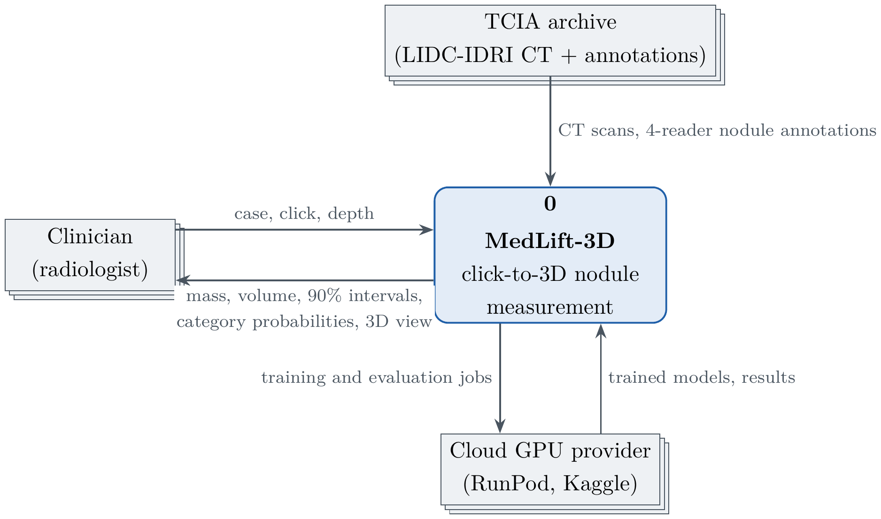
Figure 3.1: Context diagram (DFD level 0) in Gane–Sarson notation.

3.1.3 Data Flow Diagram Level 1
The level-1 DFD (Figure 3.2) decomposes the system into eight processes and four data stores. The upper row runs once to build the cases, train the models and calibrate them; the lower row runs for every click and reads all four stores. Section 3.2 gives the functional decomposition, the entity-relationship model and the data dictionary.
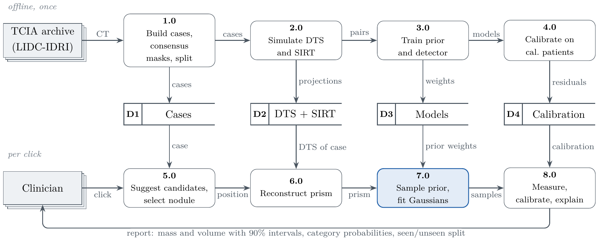
Figure 3.2: Data flow diagram level 1 (offline processes 1.0–4.0, per-click processes 5.0–8.0, data stores D1–D4).

3.1.4 UI Design
The interface is a browser application built around one action: click on the nodule (Figure 3.3). The numbered parts are: (1) case and method selection; (2) the coronal DTS slice with detector suggestions, annotated nodules (for evaluation) and the click; (3) the depth slider, which supplies the third coordinate; (4) the measurement report with mass and volume intervals, the EUPS category probabilities and the low-confidence flag; (5) a 3D view of the nodule and the prism input with its eight samples; and (6) a virtual follow-up that reports VDT and MDT.
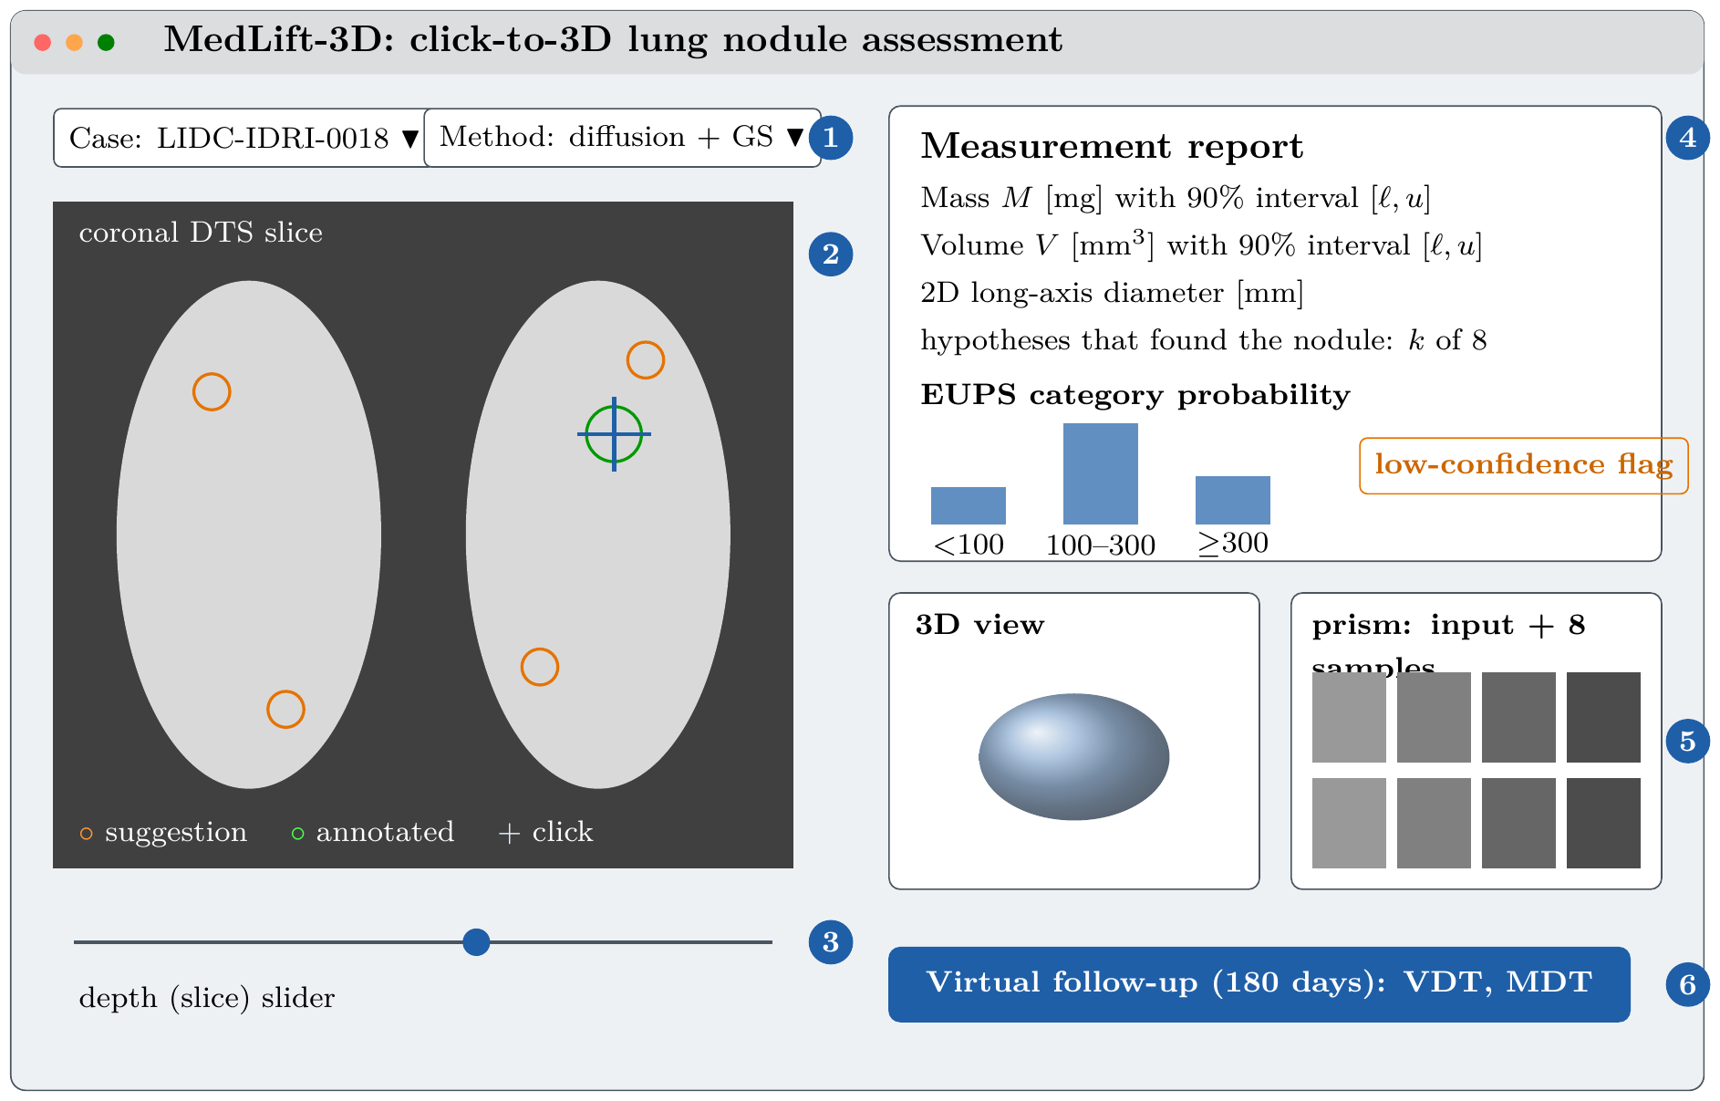
Figure 3.3: User interface design of the click-to-3D application.

3.2 Detailed Methodology and Design
This section decomposes the system into its functions and data, derives what DTS can measure, and describes the proposed architecture, the network and the alternatives considered.

3.2.1 Functional Decomposition Diagram
The system decomposes into five subsystems (Figure 3.4). Data and simulation selects the patients, downloads their CT, builds the cases and simulates DTS. Reconstruction produces the whole-chest SIRT with depth support and the prism around a click. Learned models contains the conditional diffusion prior with its data-consistency sampler, the nodule detector and the fit check. Measurement and UQ fits Gaussians, measures mass, volume and diameter, and calibrates intervals and category probabilities. Interface and reporting provides the click-to-3D application, the virtual follow-up, the explanations and the HTML report. Each function maps to one or more of the 18 scripted steps, so every box can be checked by its PASS/FAIL output.
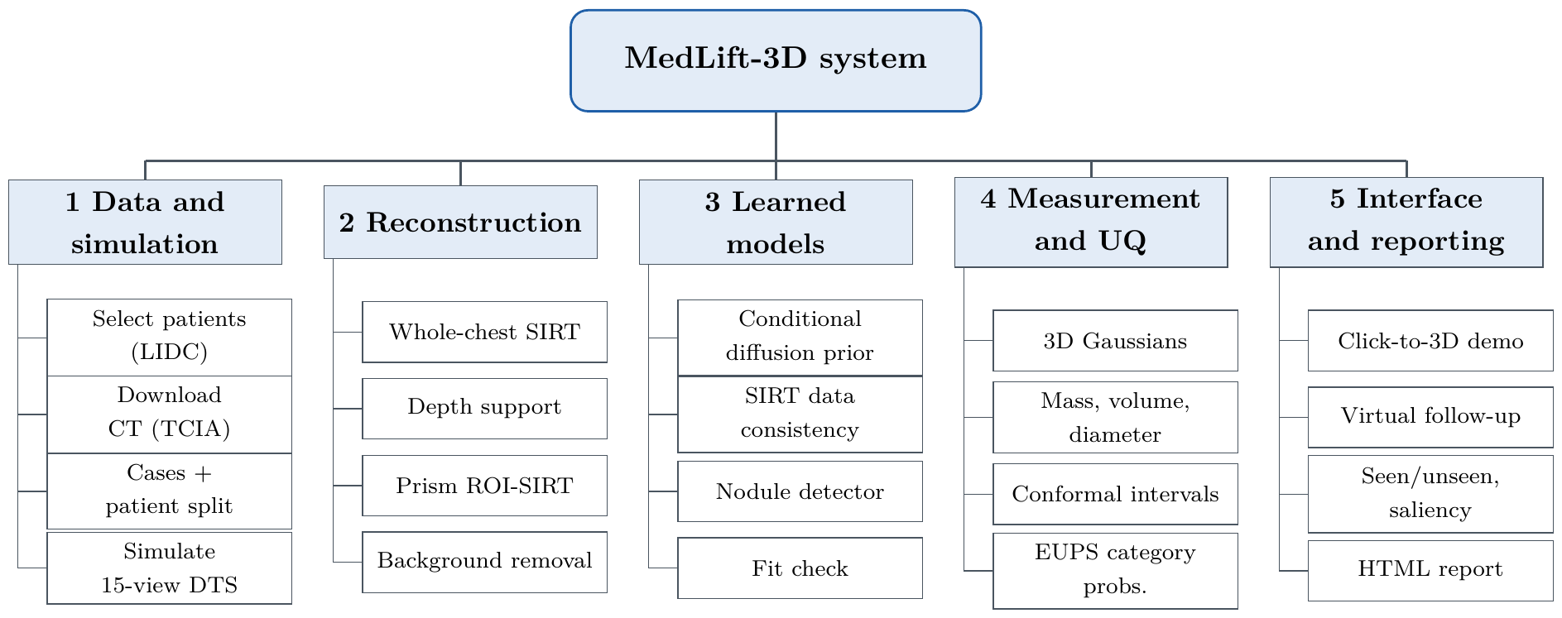
Figure 3.4: Functional decomposition diagram: five subsystems and their functions.

3.2.2 Entity-Relationship Model and Data Dictionary
Figure 3.5 shows the data entities and their relationships: a patient has CT cases, a case contains nodules marked by three or four readers, and each nodule is measured by several methods, each measurement aggregating eight hypotheses that are fitted by Gaussian sets and calibrated per method. Table 3.5 gives the data dictionary.
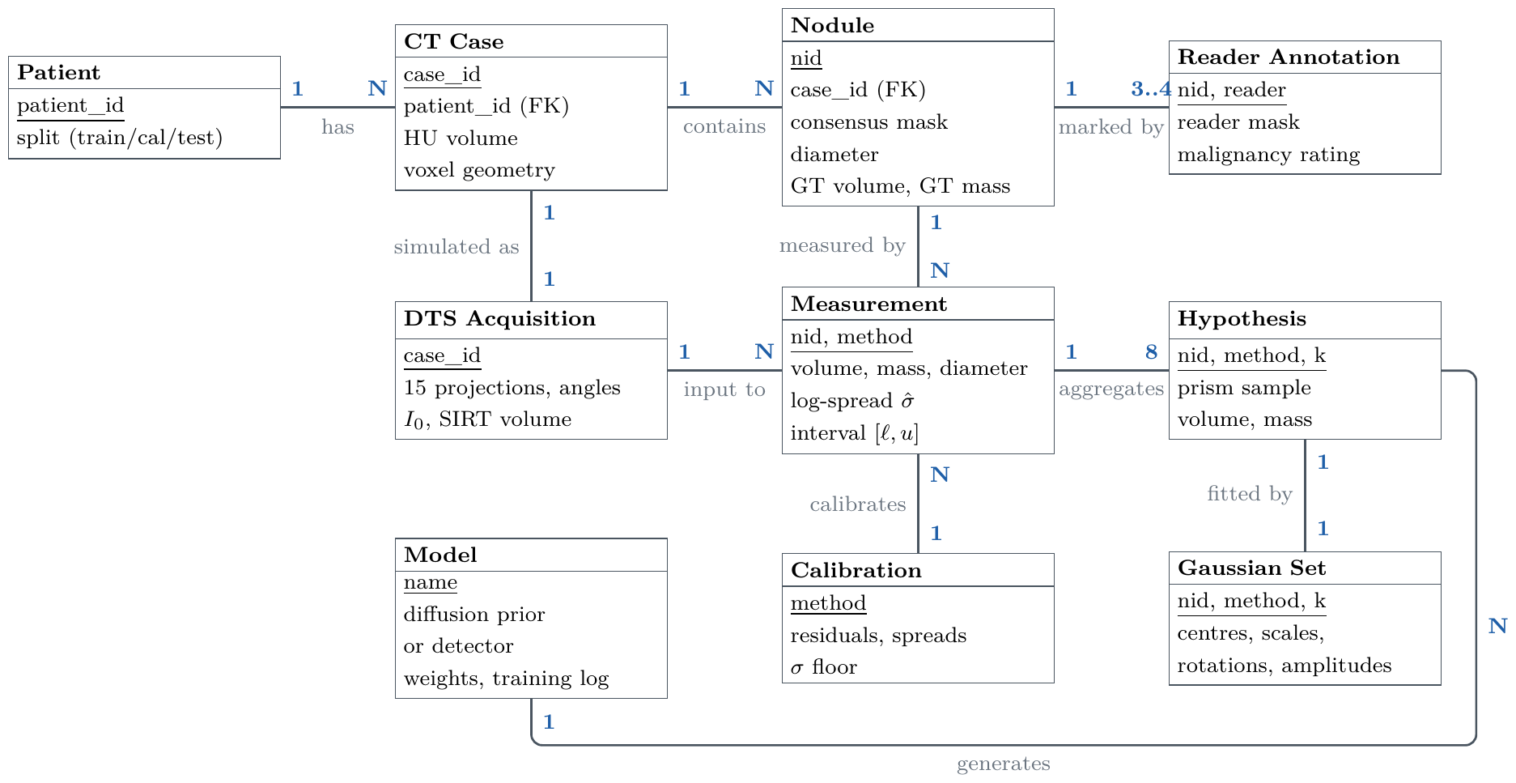
Figure 3.5: Entity-relationship model of MedLift-3D (keys underlined, cardinalities in blue).
Table 3.5: Data dictionary.
Store / item | Format | Contents | Constraint
D1 Case | int16 + packed bits + JSON header | CT in HU, consensus and four reader masks per nodule, voxel geometry, patient ID | HU in $\left[−1024,3071\right]$
Projections | float, $15×536×536$ | Noisy line integrals per view | Finite, max $<15$
D2 SIRT volume | float, 2.5 mm voxels | Whole-chest DTS reconstruction | Patient depth + 5 mm
Prism | float, $64×128×64$, $1×2×1$ mm | Column through the chest at the click | Rays $≥$50% inside
Training pair | float16 | Condition (DTS prism) and target (CT prism) in HU | Train patients only
D3 Diffusion model | PyTorch checkpoint | 17.42 M parameters, EMA weights | Selected on held-out train pairs
D3 Detector | PyTorch checkpoint | 0.34 M parameters, heatmap 3D U-Net | Selected on cal. patients
Gaussians | float32 | Centres ($N×3$), scales ($N×3$), quaternions ($N×4$), amplitudes ($N$) | $N≤30,000$
Result row | JSON lines | Per nodule and method: volume, mass, log-spread, members, ground truth | One row per nodule
D4 Calibration | JSON | Per method: residuals, spreads, $σ$ floor | Cal. patients only
Report | JSON / UI | Mass and volume with intervals, category probabilities, diameter, low-confidence flag, run time | Interval type stated

3.2.3 What DTS Can Measure
Let $f\left(x,y,z\right)$ be the nodule’s excess attenuation, with $y$ the depth axis, and let the view at tube angle $θ$ project along a direction tilted by $θ$ from $y$ in the $y$–$z$ plane, with detector coordinates $\left(x,v\right)$ and $v$ along $e_{θ}=\left(0,−sinθ,cosθ\right)$. The moments of the projection $p_{θ}$ are
$$\begin{matrix}∬p_{θ}\left(x,v\right) dx dv & =M, \left(3.1\right) \\ ∬v p_{θ}\left(x,v\right) dx dv & =−sinθ My_{c}+cosθ Mz_{c}, \left(3.2\right) \\ ∬{\left(v−\overset{‾}{v}\right)}^{2}p_{θ} dx dv & =\sin^{2}θ S_{yy}−2sinθcosθ S_{yz}+\cos^{2}θ S_{zz}, \left(3.3\right)\end{matrix}$$
where $M$ is the mass, $\left(y_{c},z_{c}\right)$ the centroid and $S$ the second central moments (for a cone beam, Eq. (3.1) holds up to a known magnification factor). Every view gives the mass directly (Eq. (3.1)). The depth position enters only through $sinθ≤sin{15}^{∘}$, making it $1/sin{15}^{∘}≈3.9$ times worse conditioned than in-plane position, and the depth extent $S_{yy}$, which volume needs, enters through $\sin^{2}θ$, about $1/\sin^{2}{15}^{∘}≈15$ times worse. Step 01 confirms this numerically: the detector integral matched the mass to 0.03% in all 15 views, and an object three times deeper with equal mass gave the same integrals.

3.2.4 Proposed Architecture
Figure 3.6 gives an overview of the method; its stages are described below.
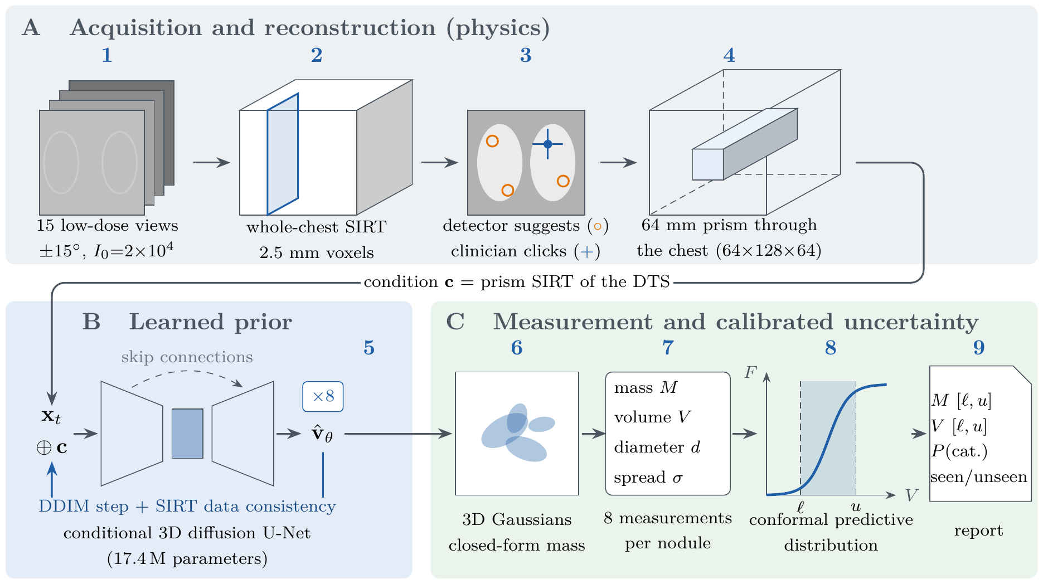
Figure 3.6: MedLift-3D method overview. (A) Physics: low-dose DTS is simulated, reconstructed and cut to a prism around the click. (B) A conditional 3D diffusion prior generates eight hypotheses of the prism, each kept consistent with the X-rays. (C) Gaussians give closed-form mass; the eight measurements are calibrated into intervals and category probabilities.
Stage 1: simulated low-dose DTS. The CT table is removed, then 15 views over $±{15}^{∘}$ are simulated at CT resolution with 0.5 mm ray sampling, SID 1800 mm, a 43 cm flat panel with 0.8 mm pixels, monochromatic attenuation and Poisson noise at $I_{0}=2×{10}^{4}$. The geometry matches the GE VolumeRAD sweep; reconstruction uses different grids than simulation to avoid the inverse crime.
Stage 2: whole-chest SIRT with depth support. SIRT (40 iterations, 2.5 mm voxels) is confined in depth to the patient (body outline + 5 mm). Without this support the reconstruction placed attenuation in the air in front of and behind the patient, and on real chests the prism lost about a third of its attenuation; with it the prism keeps 98.7%.
Stage 3: learned detector. A small 3D U-Net [54] (0.34 M parameters) predicts a nodule heatmap from the SIRT volume, and its peaks are offered as suggestions. A Laplacian-of-Gaussian and Hessian blob detector is the training-free baseline.
Stage 4: prism ROI. Around the click, a $64×64$ mm column through the whole chest ($64×128×64$ voxels at $1×2×1$ mm) is reconstructed by SIRT using only rays that carry at least 50% of their attenuation inside the prism; the rest of the chest is subtracted using the coarse reconstruction. Depth is kept whole because each ray’s attenuation is spread along its full path: a small 3D box around the nodule gave a 73% error against 5–7% for the prism.
Stage 5: conditional 3D diffusion prior. A 3D U-Net (Figure 3.7; base 32 channels, multipliers 1/2/4/4, two residual blocks per level, attention at the lowest level, 17.42 M parameters) learns $p\left(\text{CT prism}∣\text{DTS prism}\right)$ with v-prediction, a cosine schedule over 1000 steps, EMA weights and bf16 mixed precision. Sampling uses 50 DDIM steps; from 60% of the way through, every denoised estimate ${\hat{x}}_{0}$ receives two SIRT data-consistency iterations,
$${\hat{x}}_{0}←{\hat{x}}_{0}+λ CA^{⊤}R \left(b−A{\hat{x}}_{0}\right), \left(3.4\right)$$
before the next DDIM step. Eight samples give eight hypotheses that agree with the X-rays but differ where the X-rays are blind.
Stage 6: 3D Gaussians and measurement. For each hypothesis the nodule box ($40×50×40$ mm) is fitted with anisotropic Gaussians (100 fitting and 100 refinement iterations against the measured projections, the rest of the prism fixed). A seeded half-maximum segmentation, confined to a plausible nodule extent, gives the volume; Eq. (2.5) gives the mass; and the long-axis 2D diameter is kept as the clinical baseline.
Stage 7: uncertainty. The eight hypotheses give a log-scale spread $\hat{σ}$. On the calibration patients this spread is calibrated with (a) split-conformal asymmetric intervals (step 10) and (b) normalised and Mondrian conformal predictive systems with crepes (step 16), which give full predictive distributions, EUPS category probabilities and category sets.
Stage 8: growth. Each nodule is grown in the CT by a known factor, its projections are updated and fresh noise added; VDT and MDT are measured and assigned to the NELSON categories.
Stage 9: explanation. The true CT prism is split into seen and unseen parts by conjugate-gradient least squares (CGLS) [55] on the prism projection operator. We measure how much of the nodule’s mass and shape lies in each part and the prior’s unseen skill, the correlation of its unseen content with the truth’s (Figure 2.1). Input$×$gradient saliency explains the detector, and rank correlations relate the measurement error to nodule size, depth and contrast.

3.2.5 Diffusion Network Architecture
Figure 3.7 shows the conditional 3D U-Net. The noisy prism and the DTS condition enter as two channels; four resolution levels with 32, 64, 128 and 128 channels use two residual blocks each in the encoder and three in the decoder, with skip connections between them; multi-head self-attention runs at the coarsest level ($8×16×8$) and in the bottleneck; and a sinusoidal timestep embedding passed through an MLP is added inside every residual block. The output layer is initialised to zero so that training starts from a stable state.
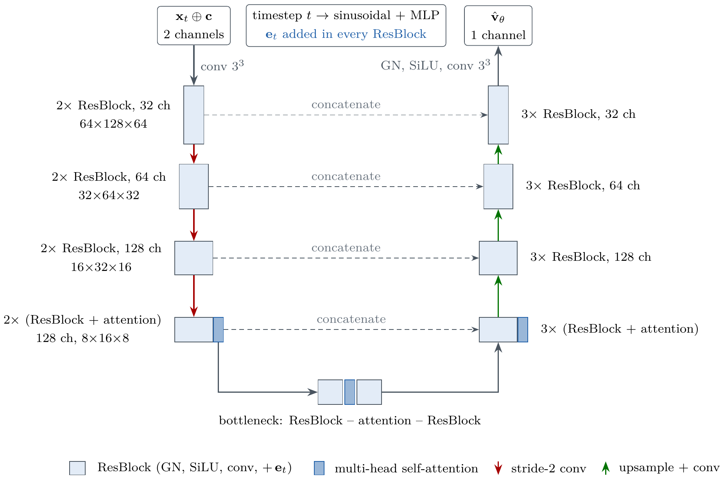
Figure 3.7: Conditional 3D U-Net of the diffusion prior. The noisy prism $x_{t}$ is concatenated with the DTS condition $c$; the timestep embedding is added in every residual block; the network predicts the velocity ${\hat{v}}_{θ}$.

3.2.6 Alternative Solutions
Table 3.6 lists the alternatives and why they were rejected. The initial design of this project generated whole ${512}^{3}$ volumes with a latent diffusion model; it is included in the table because its lessons shaped the final design: a large generator judged by training losses could not show whether a single nodule measurement was right, so the goal was narrowed to clinical numbers that can be verified.
Table 3.6: Alternative solutions and the rationale for the selected design.
Alternative | Why rejected | Selected instead
FBP or SIRT alone | Cannot fill the missing wedge; physics-only volume errors of 80–90% on small nodules | SIRT as input and data-consistency step, plus a learned prior
Neural radiance fields [46] | Slow per-patient optimisation, implicit geometry, no prior for unseen depth | Explicit 3D Gaussians with closed-form mass
Whole-volume latent diffusion at ${512}^{3}$ (initial design) | Too large to train and verify in time and budget; evaluated by generative losses, not clinical numbers | Small conditional prior on a prism, judged by calibrated measurements
Small 3D box ROI | Each ray’s attenuation lies mostly outside the box: 73% error vs 5–7% | Prism through the whole chest
GAN prior | Training instability; one output per input | Diffusion: stable training, many hypotheses
Unconditional prior with posterior sampling only | Slower and weaker for a strongly ill-posed 30° problem | Conditional model + SIRT data consistency
Raw ensemble variance or MC dropout | Not calibrated; no coverage guarantee | Ensemble spread calibrated by conformal prediction
Volume-only reporting | Volume depends on the poorly measured depth | Mass first, volume second, both with intervals

3.3 Project Plan
MedLift-3D was developed over twelve months in an iterative research and development cycle, organised in four phases that match the task groups of the Gantt chart in Figure 3.8. The iterative approach suits the experimental nature of generative AI: the prior, the measurement and the uncertainty layer were revised whenever an intermediate verification step showed a problem.
Phase 1: Inception, data and feasibility (months 1–3). Objective: establish the theoretical basis and a reliable data pipeline. Tasks: 1.1 literature review and ethics, 1.2 dataset acquisition and preprocessing, 1.3 DTS simulation, 1.4 baseline reconstruction. Deliverables: literature review, curated LIDC-IDRI cases with consensus masks, the DTS simulator and baseline SIRT results.
Phase 2: Core generative architecture (months 3–6). Objective: build and train the learned prior. Tasks: 2.1 projection physics and its verification (including the projection-moment analysis), 2.2 prism ROI reconstruction, 2.3 conditional diffusion prior with data consistency, 2.4 diffusion training. Deliverables: verified differentiable projector, prism reconstruction, trained diffusion prior.
Phase 3: Gaussians, detection and uncertainty (months 6–9). Objective: turn reconstructions into calibrated, explainable measurements. Tasks: 3.1 Gaussian parameterisation and closed-form mass, 3.2 nodule detector, 3.3 conformal uncertainty, 3.4 explainability. Deliverables: measurement module, detector, calibrated intervals and probabilities, seen/unseen analysis.
Phase 4: Validation, interface and deployment (months 9–12). Objective: evaluate the complete system and deliver it. Tasks: 4.1 pilot and full-scale evaluation, 4.2 growth and sensitivity studies, 4.3 user interface development, 4.4 documentation and defense. Deliverables: results of the 583-patient study, the click-to-3D application, the final report.
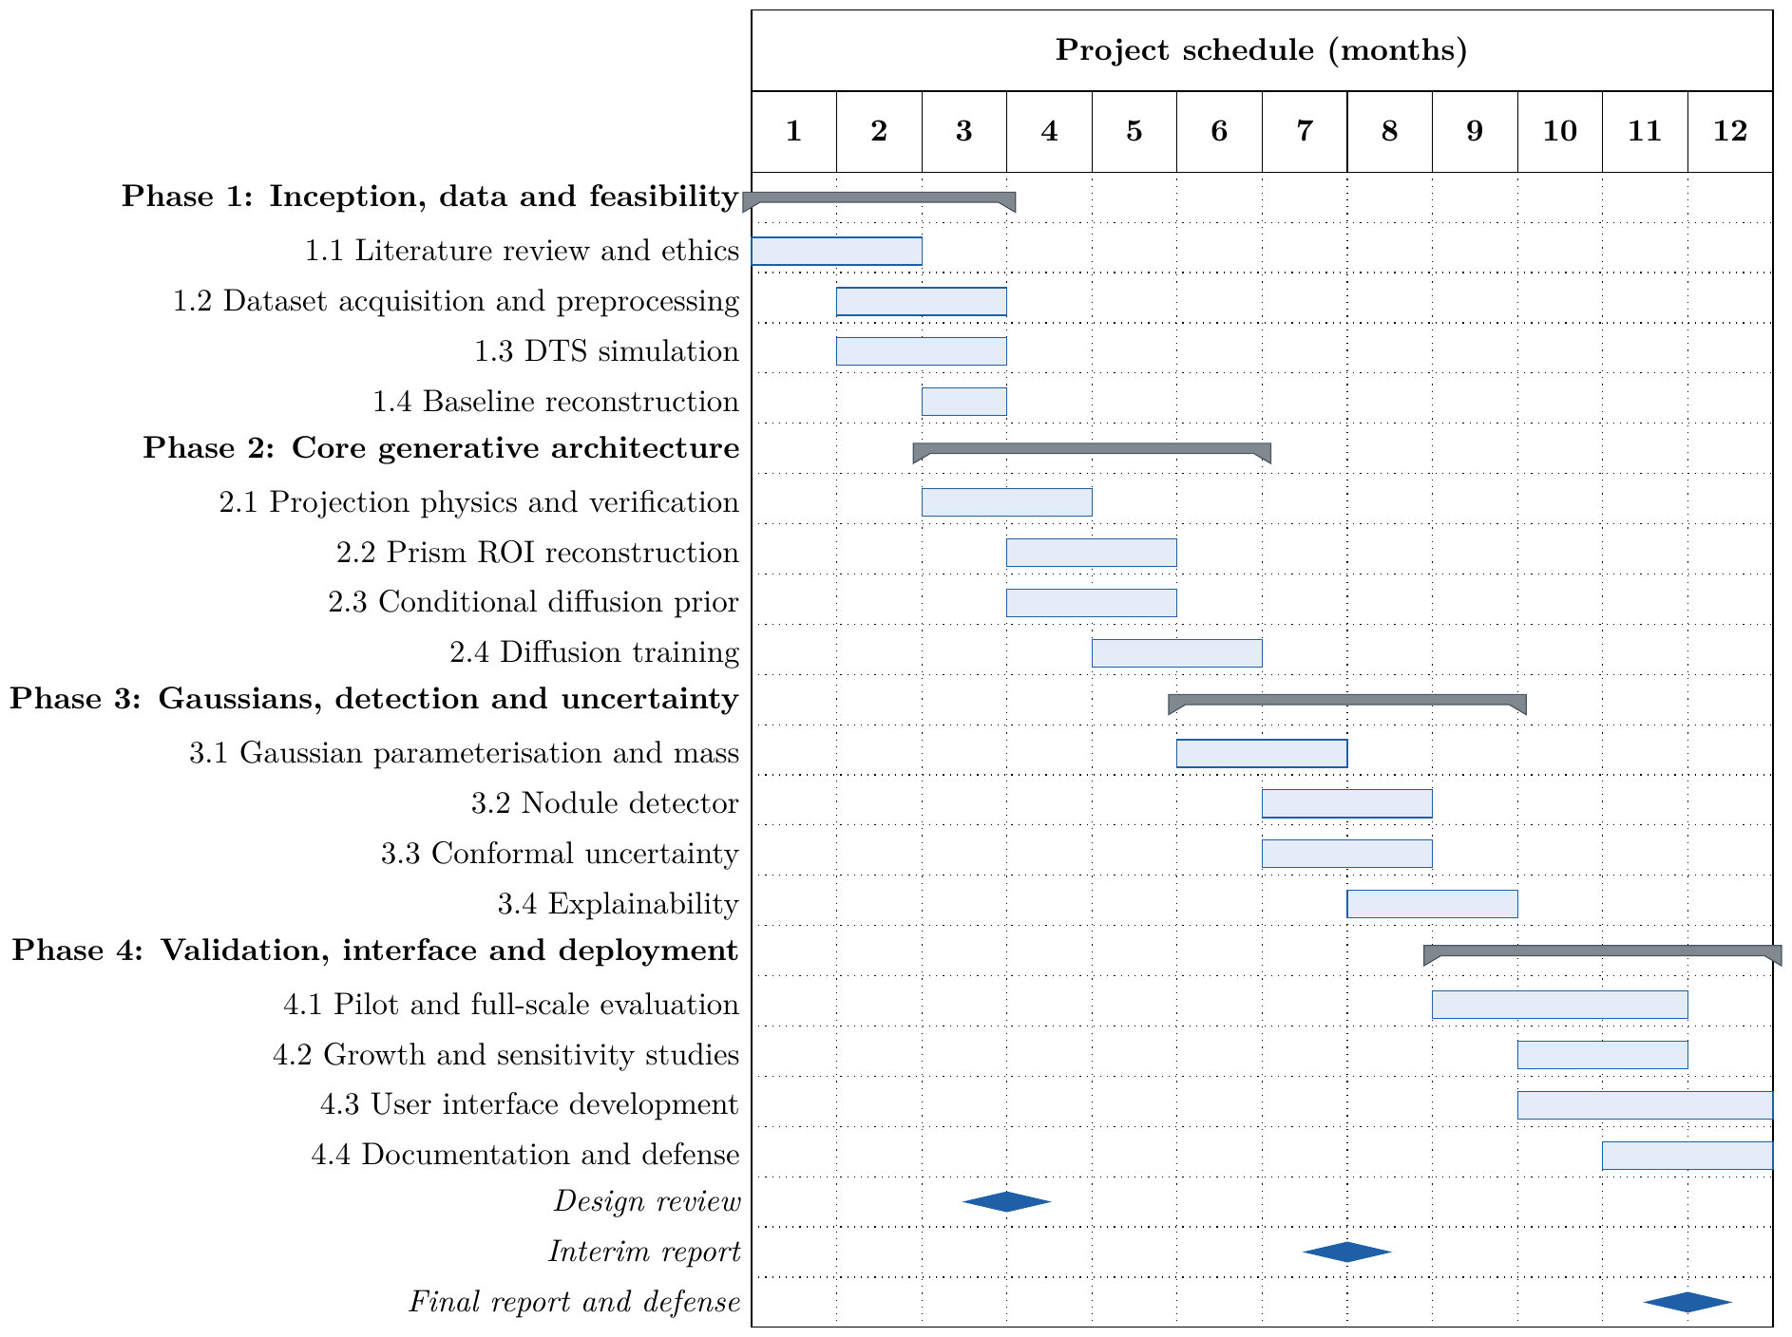
Figure 3.8: Gantt chart of the twelve-month project schedule, by phase and task.

3.4 Task Allocation
Responsibilities were allocated according to the technical area in which each member is strongest, so that the critical paths of theoretical modelling, system optimisation and application engineering could progress in parallel. The mathematically intensive parts (the diffusion prior, its conditioning and data consistency, and the statistical calibration) need a solid theoretical grounding and were led by the lead AI architect. The systems engineer focused on performance and infrastructure, making the volumetric reconstruction feasible in GPU memory and running the computation on cloud GPUs. The full-stack developer connected the algorithms to clinical use, ensuring data quality, the user interface and the evaluation outputs. Every pipeline step has one owner who is accountable for its PASS/FAIL checks, and all members reviewed every step before the full run. Table 3.7 gives the detailed allocation.
Table 3.7: Detailed task allocation matrix.
Team member | Role and focus | Detailed responsibilities
Jubair Ahmed (011222136) | Lead AI architect (theoretical modelling) | • Projection-moment analysis of what DTS can measure  • Design and mathematical formulation of the conditional diffusion prior (v-prediction, cosine schedule, DDIM sampling)  • SIRT data-consistency sampling to suppress anatomical hallucination  • Conformal intervals and calibrated category probabilities
Foyez Ahammed Naeem (011222011) | Systems engineer (optimisation and backend) | • Differentiable DTS projector and memory-efficient prism reconstruction  • GPU optimisation of training and sampling (mixed precision, batch sizing)  • 3D Gaussian fitting and closed-form mass; nodule detector training  • Cloud infrastructure (RunPod CPU and GPU pods, Kaggle), the full run and backups
Md Motasim Billah (011222016) | Full-stack developer (data and visualisation) | • Data curation and preprocessing of LIDC-IDRI (selection, consensus masks, DTS simulation inputs)  • Clinician-facing click-to-3D interface with interactive 3D visualisation  • Automated evaluation pipelines: accuracy, growth and explainability outputs, HTML report
All members | – | Literature review, verification of every PASS/FAIL step, report writing and presentation

3.5 Summary
The requirements were elicited from guidelines, the supervisor and published limits, negotiated where they conflicted, and specified with measurable acceptance criteria. The design measures mass first, reconstructs a prism around the click, fills depth with a data-consistent diffusion prior, measures with Gaussians, and calibrates and explains every number. Chapter 4 verifies each requirement.

Chapter 4: Implementation and Results
This chapter describes the hardware and tools, how every requirement was verified, and the results for hypotheses H1–H6. All numbers come from the full run of October 27, 2026 on held-out test patients unless stated otherwise.

4.1 Environment Setup
This section describes the hardware, the software tools with the reasons for choosing them, the configuration of the pipeline, and the dataset with its preprocessing.

4.1.1 Hardware
Table 4.1 lists the computing resources. CPU-only work (downloading about 64 GB of CT and building the cases) ran on a cheap CPU machine, and both machines shared one network volume so that the GPU machine started from the finished cases.
Table 4.1: Computing resources.
Resource | Used for | Specification | Cost
Laptop / Kaggle CPU | Unit tests; synthetic-phantom smoke test | 4 cores | Free
Kaggle notebook | 40-patient pilot run; final demo and report viewer | $2×$ NVIDIA T4, 16 GB | Free
RunPod CPU pod | Steps 02–04: patient selection, TCIA download, case building | Rented CPU | $<$ US$2
RunPod GPU pod | Steps 05–18: simulation, training, evaluation | NVIDIA L40S, 48 GB | US$1.33/h
RunPod network volume | Shared storage between pods; backup after every step | Persistent volume | included

4.1.2 Software and Tools
All code is written in Python, the standard language of medical AI research. PyTorch was chosen because the whole chain (projector, SIRT, diffusion network, detector and Gaussian fitting) needs automatic differentiation on the GPU in one framework. Instead of an external tomography toolbox we wrote our own ray-driven DTS projector in PyTorch: it reproduces the exact linear-sweep geometry, provides gradients for the Gaussian refinement, and needs no separate CUDA build, which had caused installation problems with toolbox-based setups. LIDC-IDRI is read with pydicom and pylidc, the official tools for its annotations; conformal predictive systems use the peer-reviewed crepes library; and the application uses Gradio, which builds a browser interface directly from Python. Table 4.2 lists the tools with the alternatives considered.
Table 4.2: Software tools and the reasons for choosing them.
Tool | Role | Why chosen (alternative)
Python 3.11+ | All code | Standard for medical AI (MATLAB: licence cost)
PyTorch 2.x | Projector, diffusion U-Net, detector, Gaussians; bf16 mixed precision | Differentiable physics and models in one framework
Own ray-driven projector (PyTorch) | DTS forward and back projection with gradients | Exact DTS geometry, differentiable, no CUDA build (ASTRA: separate build, no autograd)
pydicom, pylidc | LIDC DICOM and the four radiologists’ annotations | Official annotation access
NumPy, SciPy, scikit-image | Morphology, segmentation, metrics | Mature and tested
crepes, scikit-learn | Conformal predictive systems; calibration metrics | Peer-reviewed implementation [29]
Gradio | Browser application | Quick UI in Python (Flask + JavaScript: more work)
Matplotlib, pytest | Figures; 69 unit tests | Standard
bash, tmux | Unattended 15-hour run with resume and backups | Survives disconnections
Git, GitHub | Version control | Team collaboration

4.1.3 Configuration and Pipeline
One YAML file holds every setting (geometry, dose, prism size, network size, sampling steps, number of hypotheses, $α=0.1$) and the random seed is fixed. The pipeline has 18 scripted steps: 00 environment check, 01 physics verification, 02 patient selection, 03 TCIA download, 04 cases and split, 05 DTS simulation, 06 SIRT, 07 training pairs, 08 diffusion training, 09 per-nodule pipeline, 10 evaluation and conformal intervals, 11 growth, 12 demo, 13 geometry sensitivity, 14 detector, 15 fit check, 16 conformal predictive systems, 17 explainability and 18 HTML report. Each step prints PASS/FAIL lines with the expected value.

4.1.4 Dataset and Preprocessing
Source. We used the Lung Image Database Consortium and Image Database Resource Initiative (LIDC-IDRI) collection [19], distributed by The Cancer Imaging Archive (TCIA) under the Creative Commons Attribution 3.0 licence. It contains 1,018 thoracic CT scans from 1,010 patients, collected at seven academic centres and eight medical imaging companies on scanners from several manufacturers. Each scan was read by four experienced thoracic radiologists in a two-phase process: first blinded, then with the other readers’ marks visible. Every reader outlined each nodule of 3 mm or larger and rated its characteristics, including malignancy. LIDC-IDRI is the only large public CT collection with nodule outlines from several radiologists, which is exactly what is needed both as 3D ground truth and to measure inter-reader variability. No public dataset pairs chest DTS with CT, so DTS was simulated from these CT scans.
Selection. Patients were selected with pylidc [20] (Figure 4.1): a scan was kept if its slice thickness was at most 2.5 mm and it contained at least one nodule of 4–30 mm marked by at least three of the four radiologists, the convention used by LUNA16 [37]. This gave 583 patients with 1,144 nodules. Annotations from different readers were grouped into nodules by pylidc’s clustering, and a nodule’s consensus mask is the set of voxels outlined by at least 50% of its readers; the individual reader masks were kept to measure inter-reader variability.
Split. Patients, not nodules, were split 60/20/20 into training (350), calibration (117) and test (116) sets, so that no patient contributes nodules to two sets. The test set contains 225 nodules. The diffusion prior and detector were trained on the training patients, with 10% of them held out to select the diffusion checkpoint; the calibration patients were used to select the detector checkpoint and to calibrate the conformal methods; the test patients were used only for the final results.
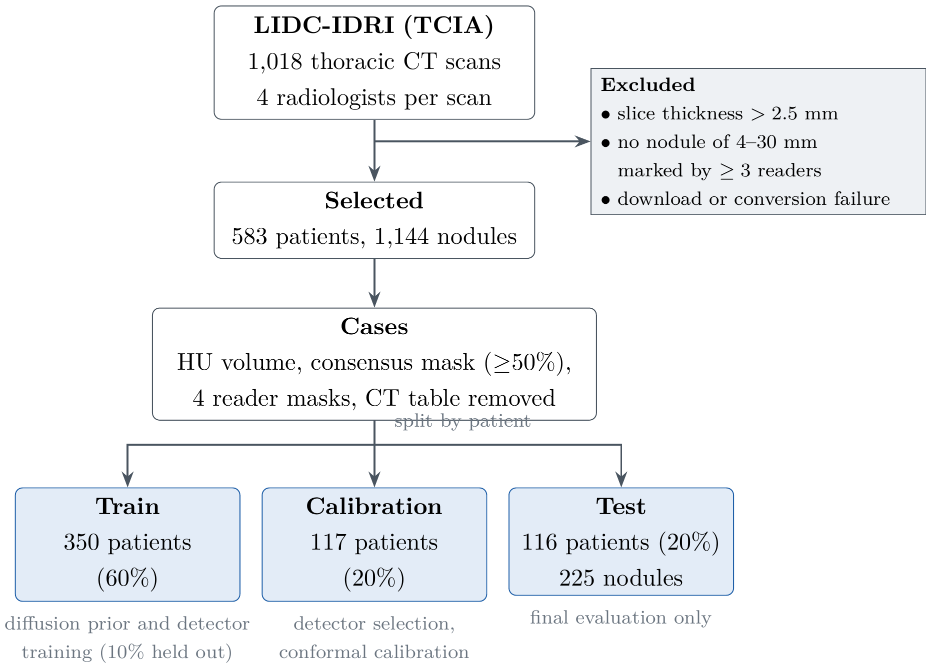
Figure 4.1: Patient selection and split of the LIDC-IDRI dataset.
Preprocessing. About 64 GB of DICOM was downloaded from TCIA and converted into one compact case file per scan: the CT in Hounsfield units (clipped to $\left[−1024,3071\right]$ and stored as 16-bit integers), the consensus and reader masks of every nodule (bit-packed), and a header with the voxel geometry and patient ID, after which the DICOM was deleted. The CT table was removed by keeping the largest connected body component, because a table would not be present in a chest DTS acquisition. We verified that the DICOM slice positions agree with pylidc’s for every scan (difference 0.000 mm), that the consensus masks lie on nodule tissue (median $−202$ HU) and that the consensus volume is on average 0.81 of the mean reader volume.
DTS simulation and training pairs. For each case, 15 projections over $±{15}^{∘}$ were simulated at CT resolution with Poisson noise ($I_{0}=2×{10}^{4}$ photons per pixel and view; median single-view nodule contrast-to-noise ratio 3.3) and reconstructed by whole-chest SIRT. Training pairs for the diffusion prior were cut from the training patients only: for each pair, the prism SIRT of the DTS is the condition and the same prism of the CT is the target, taken around nodules and around nodule-free lung regions so that the prior also learns normal anatomy. This gave 2,522 training pairs and 265 held-out pairs from the training patients; the condition kept the prism’s attenuation (median ratio to CT 0.956, 10–90%: 0.85–1.03), and its PSNR against the CT target was 10.66 dB, the baseline the prior must beat. Figure 4.2 shows the simulated views and the SIRT reconstruction of one patient and Figure 4.4 one training pair.
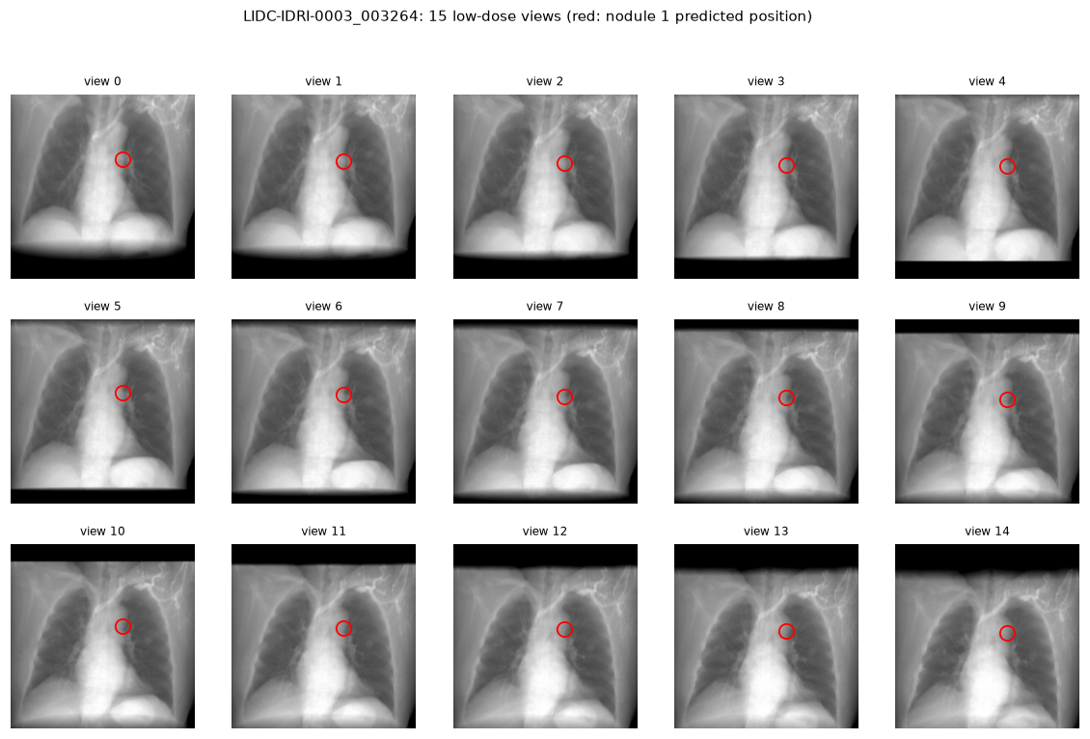
Figure 4.2: The 15 simulated low-dose views of one patient (LIDC-IDRI-0003); the red circle marks a nodule, whose shadow shifts with the tube angle.
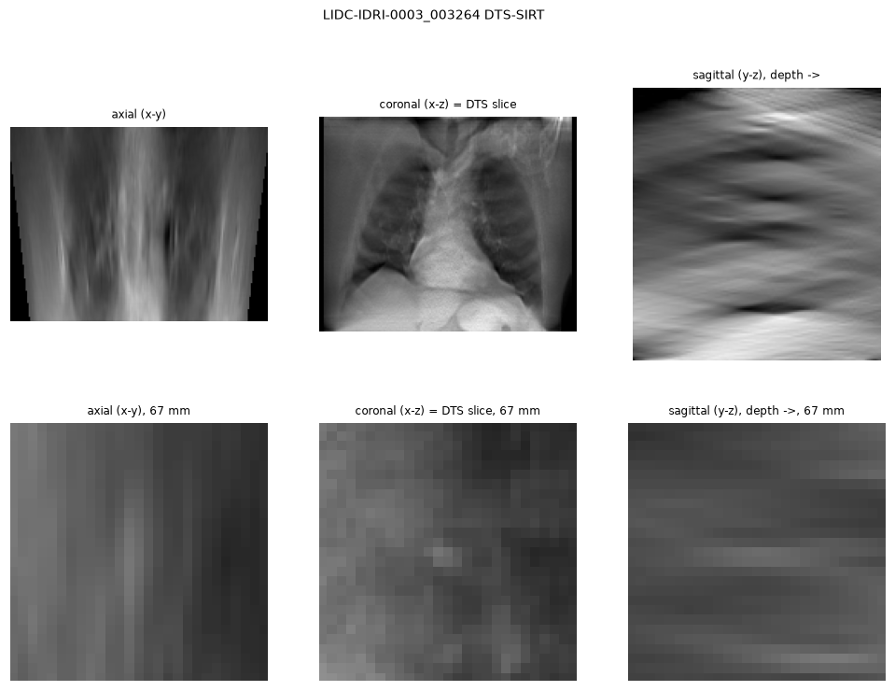
Figure 4.3: Whole-chest SIRT of the same patient: sharp in the coronal (DTS) plane, smeared in depth (sagittal).
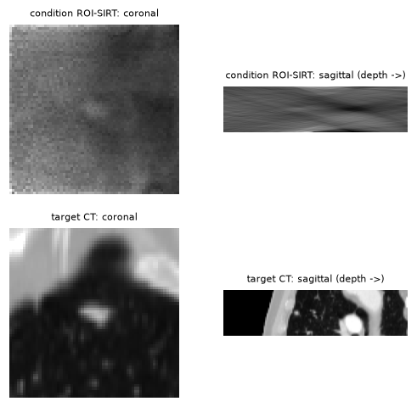
Figure 4.4: A training pair: DTS prism (condition, top) and CT prism (target, bottom), coronal and sagittal views.
Table 4.3 summarises the dataset.
Table 4.3: Dataset characteristics.
Item | Value
LIDC-IDRI patients ($≥$1 nodule of 4–30 mm marked by $≥$3 readers, slices $≤$2.5 mm) | 583
Nodules | 1,144
Train / calibration / test patients | 350 / 117 / 116
Test nodules (detector evaluation) | 225 in 116 scans
Nodules measured in step 09 (cal / test) | 76 / 74
Diffusion training / held-out pairs | 2,522 / 265
Radiologists’ volume disagreement (median CV) | 15%
Consensus volume / mean reader volume | 0.81
Single-view nodule contrast-to-noise ratio (median) | 3.3
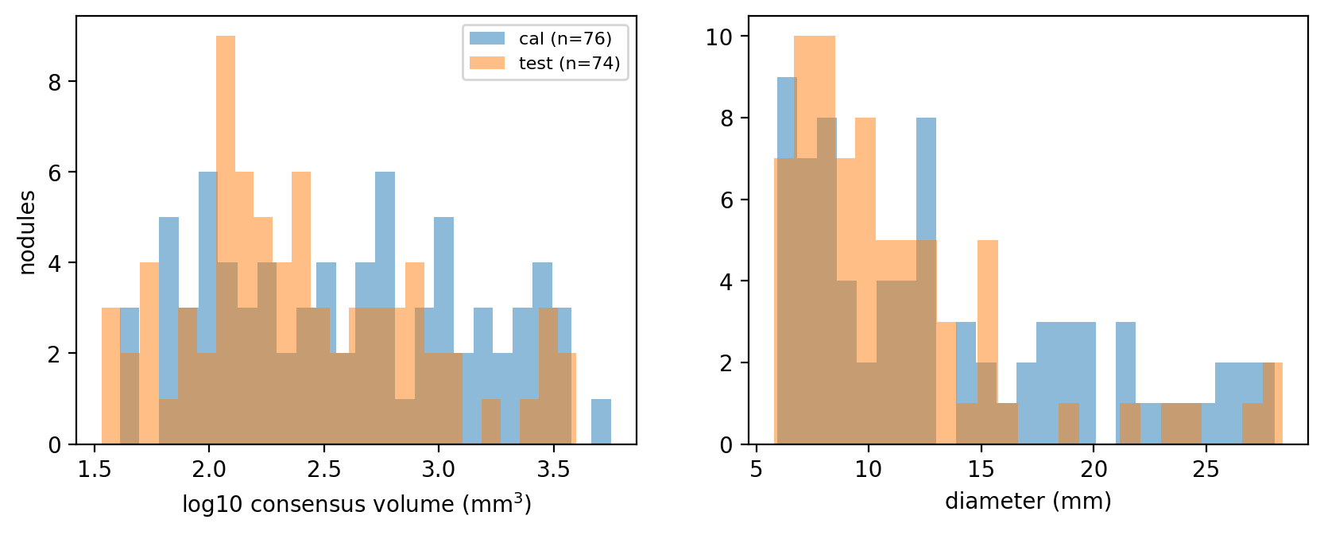
Figure 4.5: Size of the 150 measured nodules (calibration and test): consensus volume (left) and diameter (right).

4.2 Testing and Evaluation
This section describes how the system was tested, how the data were split, which metrics and baselines were used, how every requirement was verified, and which problems were found and fixed.

4.2.1 Verification Strategy
Testing was done at four levels:
- Unit tests (69): projector adjointness and mass conservation, the Gaussian mass formula, conformal coverage on synthetic data, Mondrian group coverage, CPS probabilities against crepes, the CGLS seen/unseen split, and fit-check parsing.
- Smoke test: the full pipeline on synthetic chest phantoms on a CPU in 10–20 minutes.
- Real-data pilots: 4 patients on CPU and 40 patients on Kaggle, which exposed and fixed the depth-support bug (prism attenuation 67–81% $→$ 98.7%).
- Full run: 583 patients with automatic checks after every step and an HTML report listing all checks.

4.2.2 Data Split and Evaluation Protocol
Patients, not nodules, were split 60/20/20: 350 training, 117 calibration and 116 test patients. The diffusion model was selected on 10% of the training patients held out, the detector on the calibration patients, and the conformal methods were calibrated on the calibration patients. Test patients were used only for the final tables.

4.2.3 Metrics and Baselines
Volume and mass error (median signed error, median absolute percentage error MdAPE, Bland–Altman limits), failure rate, nodule-box PSNR, interval coverage and median width, Brier score and expected calibration error (ECE) of category probabilities, doubling-time error and NELSON category accuracy, detection CPM and sensitivity, seen fraction and unseen skill, and run time. Baselines: 2D diameter converted to a sphere volume (clinical practice), coarse SIRT, prism ROI-SIRT, physics-only Gaussians, and diffusion without Gaussians.

4.2.4 Requirement Verification
Each requirement in Tables 3.3 and 3.4 was checked by the step named in its last column; the check prints the measured value next to the expected one. Table 4.4 lists every requirement with its measured result. Fifteen of the sixteen rows are met. FR-08 is met for coverage but only partly for the Brier score, and the measurement accuracy itself, which no single requirement fixes, is discussed with the hypotheses in Section 4.3.
Table 4.4: Requirement verification (traceability).
Req. | Criterion | Result | Met
FR-01 | Positions agree; splits disjoint | DICOM vs pylidc slice positions 0.000 mm; 350/117/116 patients, disjoint | Yes
FR-02 | Integral = mass within 0.1% | 0.03% in all 15 views; deeper object of equal mass indistinguishable | Yes
FR-03 | Residual $<0.9$; depth/in-plane $>1.3$ | Residual 0.02–0.03 of start; depth smear 2–3.5$×$ | Yes
FR-04 | Learned CPM $>$ baseline | 0.298 vs 0.017 | Yes
FR-05 | Prism keeps column attenuation | Median 0.956 of the CT (10–90%: 0.85–1.03) over all training pairs | Yes
FR-06 | Samples beat physics input | Nodule-box PSNR 15.23 vs 11.88 dB (+3.35 dB) | Yes
FR-07 | Finite values; failures reported | 150 nodules processed without errors; failure rates reported per method (3–46%, Table 4.6) | Yes
FR-08 | Coverage $90±3\%$; Brier $<$ vote | Coverage 95% (volume and mass); Brier 0.174–0.234 vs 0.543 for $P\left(V≥100\right)$, 0.284 vs 0.291 for $P\left(V≥300\right)$ | Partly
FR-09 | Growth metrics reported | Category accuracy, doubling-time error and false alarms for 40 pairs (Table 4.9) | Yes
FR-10 | Explanation outputs | Seen/unseen, saliency and error-driver tables on 30 test nodules | Yes
FR-11 | Demo self-test; report | Demo served from Kaggle; HTML report with 13 checked steps | Yes
NFR-01 | $≤60$ s per nodule | Median 45.5 s per nodule for all five methods together on the L40S | Yes
NFR-02 | $≤$ US$50 | about US$20 for the full run | Yes
NFR-03 | Reproducible, checkable | Fixed seed, one configuration, 69 tests, PASS/FAIL logs | Yes
NFR-04 | No optimistic bias | Test patients unused until final tables; separate simulation and reconstruction grids | Yes
NFR-05 | No bare numbers | Every value has an interval and a low-confidence flag | Yes

4.2.5 Issues Found and Fixed
(1) Without a depth support, SIRT placed attenuation in the air around the patient and the prism lost a third of its attenuation as false background; fixed by confining SIRT to the patient. (2) The training-free detector mostly found end-on vessels (recall in the top 10 of 6% in the pilot); replaced by the learned detector. (3) A first CPS implementation capped probabilities at $n/\left(n+1\right)$; fixed with the smoothed mid-point p-value and verified against crepes. (4) In step 10 the asymmetric split-conformal upper bound for some methods became effectively unbounded because calibration nodules where a method found nothing (measured volume $≈0$) produce unbounded log-ratios. This is not fixed in the reported results; its effect on the interval widths is analysed in Section 4.3, and the fix (calibrating only measurable cases) is listed as future work. (5) Three checks of the full run failed and are reported, not hidden: the H1 and H2 checks of step 10 (the hypotheses were not supported) and the virtual-growth construction check of step 11 (7.5% deviation against a 3% limit, caused by vessels near the nodule inside the mass window).

4.3 Results and Discussion
The results are presented in the order of the pipeline: the training and fit of the diffusion prior, nodule detection, measurement accuracy (H1, H2), calibrated uncertainty (H3, H5), growth (H4) and explainability (H6), followed by a discussion of why the measurements failed, the sensitivity to the acquisition geometry, and the run time and cost. The measurement results use 150 nodules (76 calibration, 74 test); detection uses all 225 test nodules.

4.3.1 Diffusion Prior Training and Fit
The prior was trained on 2,522 pairs (265 held out) for 27,610 steps within its 6-hour budget (batch 8, about 0.77 s per step); the loss fell from 0.1186 to 0.0476 (last 10% vs first 10% of steps). On held-out pairs its samples reached 15.23 dB PSNR in the nodule box against 11.88 dB for the physics-only input (+3.35 dB) and 13.74 vs 10.16 dB over the whole prism (Figure 4.6). The fit check (Figure 4.7) gives two messages. The denoising loss at fixed noise levels was nearly the same on training and held-out pairs (0.0342 vs 0.0331, ratio 0.97), so the network did not memorise its inputs; but the sample quality gain was larger on training patients than on held-out ones (+7.00 vs +4.22 dB), so its samples are better for patients it has seen. The held-out gain was still rising at the end (+1.89 to +3.35 dB over the last checks), so the prior is also under-trained.
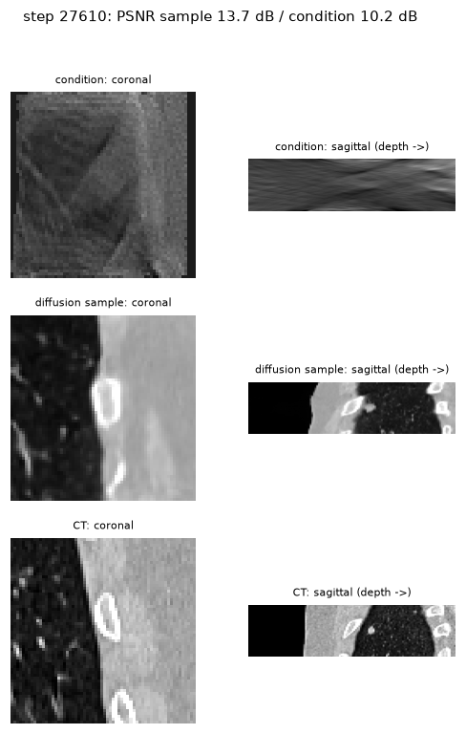
Figure 4.6: A held-out training pair at the end of training: DTS condition (top), diffusion sample (middle) and CT (bottom), coronal and sagittal (depth) views. The sample has realistic anatomy and sharp depth structure.
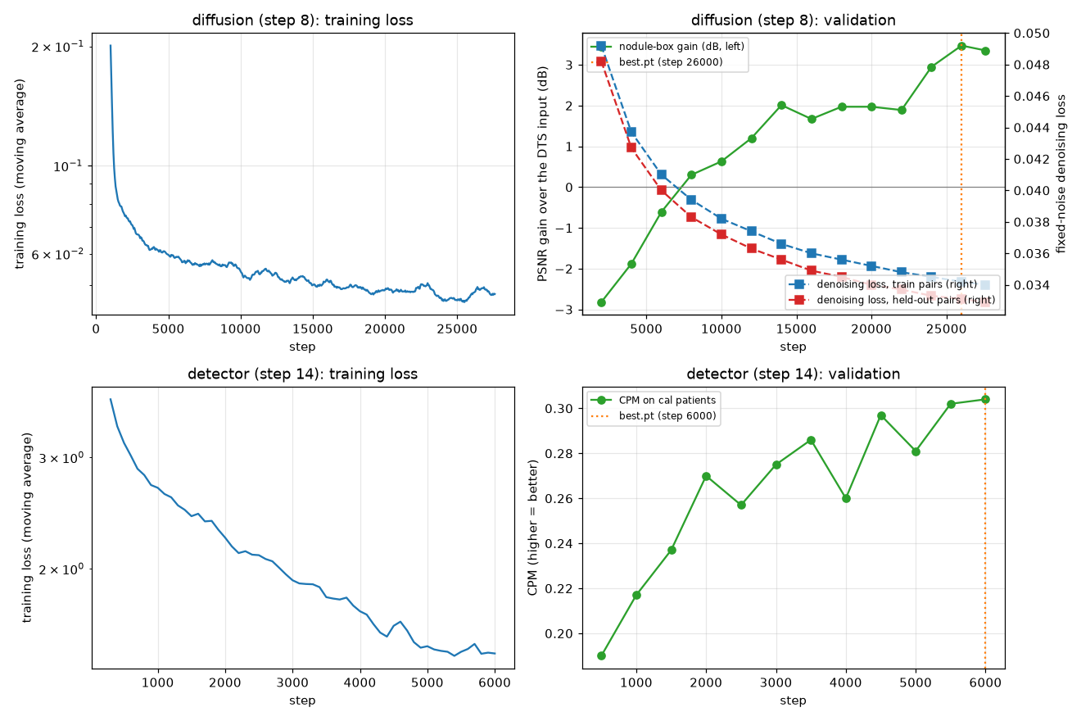
Figure 4.7: Fit check (step 15): training loss and validation of the diffusion prior (top) and of the detector (bottom).

4.3.2 Nodule Detection
Table 4.5: Nodule detection on the 116 test patients (225 nodules).
Detector | CPM | Sensitivity at 1 / 2 / 4 / 8 FP per scan | Recall in top 10
Learned 3D U-Net (ours) | 0.298 | 28% / 35% / 40% / 46% | 48%
Training-free LoG + Hessian | 0.017 | 0% / 1% / 3% / 7% | 8%
Learned, in-plane position only (diagnostic) | 0.300 | 28% / 35% / 40% / 47% | 49%
The learned detector is 17 times better than the training-free baseline by CPM (Tables 4.5 and 4.8). The in-plane-only row is almost identical, so its misses are not suggestions at the wrong depth but nodules that a DTS view does not separate from vessels and chest wall. Its validation CPM had reached a plateau (0.304 at step 6,000), but it scored 0.484 on training patients against 0.329 on calibration patients, so it partly memorised its 350 training patients; more patients, not more steps, would help. A sensitivity of 35% at two false positives per scan is far below CT detectors, which is why the detector only suggests and the clinician can click anywhere.
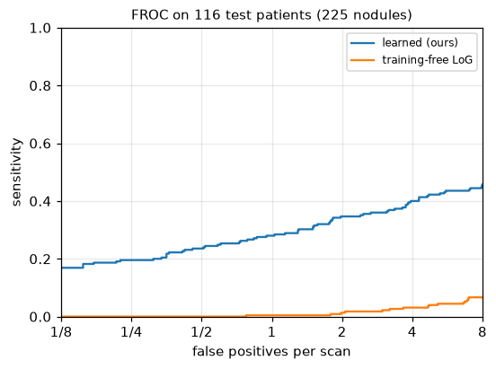
Figure 4.8: FROC curves of the learned and training-free detectors on the test patients (step 14).

4.3.3 Measurement Accuracy (H1, H2)
Each test nodule was measured by six methods: the clinical 2D diameter converted to a sphere volume, the coarse whole-chest SIRT, the prism ROI-SIRT, physics-only Gaussians, the diffusion prior without Gaussians, and the full method (diffusion prior with Gaussians). Volumes are compared with the radiologists’ consensus volume and masses with the CT mass inside the consensus mask plus a 1 mm rim. Table 4.6 reports the failure rate (nothing found at the click), the median signed error (bias) and the median absolute percentage error (MdAPE), in which a failure counts as a 100% error.
Table 4.6: Measurement error on the 74 test nodules (step 10). A failure counts as 100% error in the MdAPE.
 | Volume |  |  |  | Mass
Method | Failed | Bias | MdAPE | Within $±$20% | Failed | Bias | MdAPE | Box PSNR
2D diameter $→$ sphere (clinical) | 15% | $−44\%$ | 88.0% | 7% | – | – | – | –
Coarse DTS SIRT | 46% | $−61\%$ | 100.0% | 5% | 46% | $−66\%$ | 100.0% | 12.28
Prism ROI-SIRT (physics) | 15% | $+10\%$ | 91.2% | 14% | 16% | $+8\%$ | 100.0% | 12.14
Physics-only Gaussians | 7% | $−82\%$ | 87.7% | 3% | 7% | $−43\%$ | 78.0% | 11.99
Diffusion only | 3% | $−58\%$ | 74.5% | 9% | 36% | $−82\%$ | 100.0% | 17.49
Diffusion + Gaussians (ours) | 22% | $−91\%$ | 94.6% | 4% | 22% | $−87\%$ | 97.3% | 14.72
H1 (mass error $<$ volume error) is not supported. Mass had a lower MdAPE than volume only for the physics-only Gaussians (78.0% vs 87.7%); for the other methods it was equal or worse. H2 (the prior reduces volume error) is not supported for the full method: diffusion with Gaussians had a volume MdAPE of 94.6% against 87.7–91.2% for the physics-only methods. The diffusion prior alone had the lowest volume MdAPE (74.5%) and the fewest failures (3%), but a strong negative bias ($−58\%$). No method reached clinically useful accuracy: even the best had only 14% of nodules within $±$20%, and the clinical 2D baseline had an MdAPE of 88%. For comparison, the radiologists’ own volumes differ by a median coefficient of variation of 15%.
Two observations explain these numbers. First, image quality and measurement accuracy disagree: the diffusion prior raised the nodule-box PSNR from about 12 dB to 17.49 dB, yet its volumes are the most biased. Second, all learned methods under-estimate: Figures 4.9 and 4.10 show most diffusion and Gaussian estimates far below the line of identity, and Figure 4.11 shows that the full method’s errors cluster at $−100\%$ (nodules shrunk or erased) with a few large over-estimates. Figure 4.12 shows the error distributions of volume and mass side by side and the volume error against nodule size: errors are large at every size.
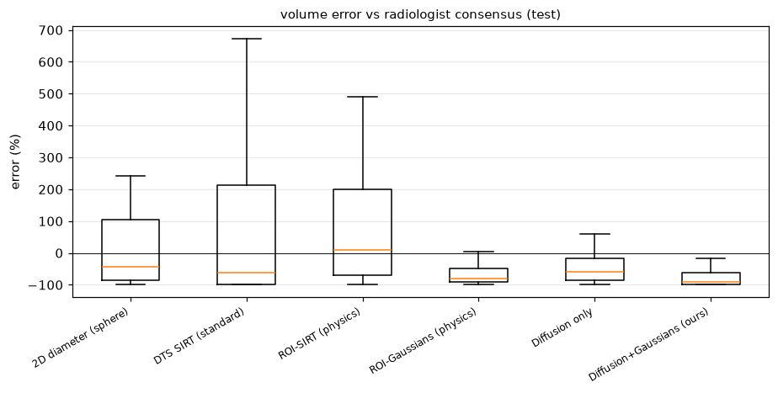
Figure 4.9: Volume error of each method against the radiologist consensus on the test nodules (step 10).
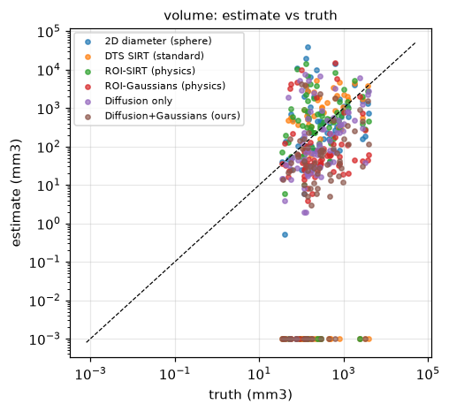
Figure 4.10: Estimated vs consensus volume for all methods (test nodules); failures are shown at ${10}^{−3}$ mm$​^{3}$.
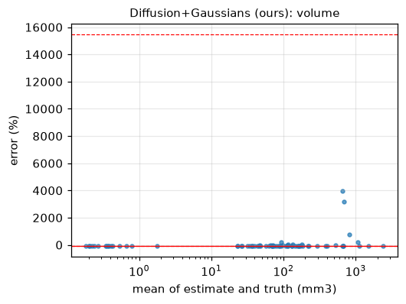
Figure 4.11: Bland–Altman plot of volume for diffusion with Gaussians (test nodules).
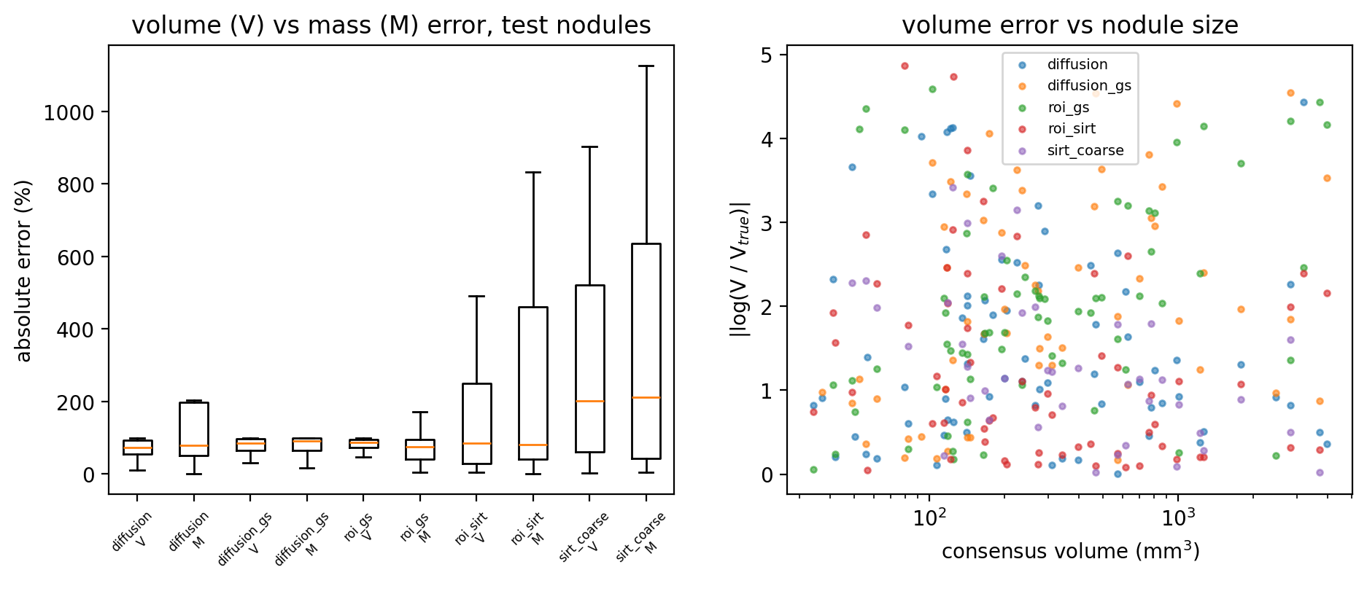
Figure 4.12: Left: absolute error of volume (V) and mass (M) for each method (test nodules, failures excluded). Right: volume error against nodule size.

4.3.4 Calibrated Uncertainty (H3, H5)
Table 4.7 gives the conformal intervals of the full method. All variants calibrated on the 76 calibration nodules reach or exceed the 90% target coverage on the test nodules except the Mondrian variant for volume, so the coverage guarantee of conformal prediction held in practice (Figure 4.13). The raw ensemble spread, used as $±z$ standard deviations, covered only 28% at the 90% level. However, the intervals are not informative. Their median width is many orders of magnitude larger than the estimate, and the normalised variants are effectively unbounded. The reason is the failures: a measurement of zero gives an infinite log-error, so with 22–26% failures among the calibration nodules the conformal quantile lands on infinite scores. The Mondrian variant is the only one with finite widths, at about 58 times the estimate. H3 is therefore supported for validity (coverage) but not for usefulness (width), and its sub-claim that mass intervals are narrower than volume intervals cannot be assessed with unbounded widths.
Table 4.7: Conformal 90% intervals of diffusion with Gaussians on the 74 test nodules (step 16). Width = (upper $−$ lower) / estimate.
 | Volume |  |  | Mass
Variant | Coverage | Median width | Worst size group | Coverage | Median width | Worst size group
Standard | 96% | $1.2×{10}^{8}\%$ | 88% | 96% | $5.1×{10}^{7}\%$ | 89%
Normalised by ensemble spread | 95% | unbounded | 82% | 95% | unbounded | 89%
Mondrian size groups | 78% | 5784% | 67% | 92% | 6208% | 89%
Mondrian + normalised | 88% | $4.9×{10}^{6}\%$ | 79% | 97% | $3.2×{10}^{7}\%$ | 96%
Table 5.4: EUPS category probabilities on the test nodules (step 16). Lower Brier score and ECE are better.
Probabilities from | Brier $P\left(V≥100\right)$ | ECE $P\left(V≥100\right)$ | Brier $P\left(V≥300\right)$ | ECE $P\left(V≥300\right)$ | Most likely category correct
Conformal (normalised) | 0.234 | 0.206 | 0.284 | 0.236 | 38%
Conformal (Mondrian + normalised) | 0.174 | 0.115 | 0.336 | 0.257 | 38%
Ensemble vote (uncalibrated) | 0.543 | 0.583 | 0.291 | 0.253 | 26%
Ensemble spread as log-normal (uncalibrated) | 0.526 | 0.561 | 0.295 | 0.275 | 27%
Point estimate only (0/1) | 0.635 | 0.635 | 0.324 | 0.324 | 27%
H5 is partly supported. Calibration clearly helped the probability that a nodule is at least 100 mm$​^{3}$: the Brier score fell from 0.543 (raw vote) to 0.174 and the ECE from 0.583 to 0.115 (Tables 5.4 and 4.14), and the most likely category was right for 38% of nodules instead of 26%. For the 300 mm$​^{3}$ threshold calibration made almost no difference (0.284 vs 0.291). The category sets from the 90% intervals contained the true category for 99% of nodules but held 2.91 of the 3 categories on average, again valid but uninformative. Mondrian calibration raised the worst size-group coverage for mass from 89% to 96% but not for volume (82% to 79%; Figure 4.15), so size-conditional coverage was achieved for mass only.
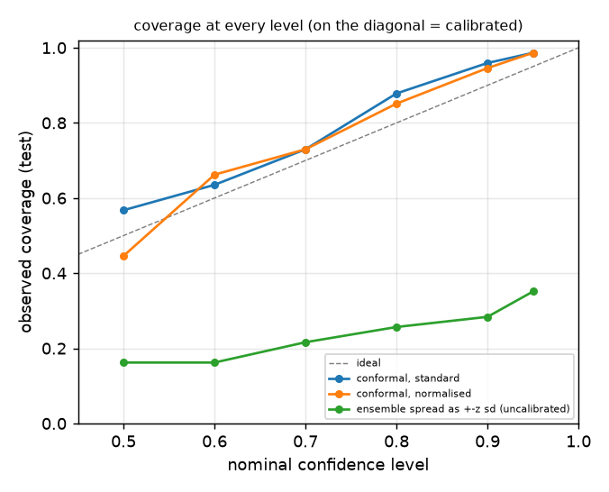
Figure 4.13: Observed coverage at every nominal level for the volume intervals (test nodules): conformal intervals lie on or above the diagonal, the raw ensemble spread far below it.
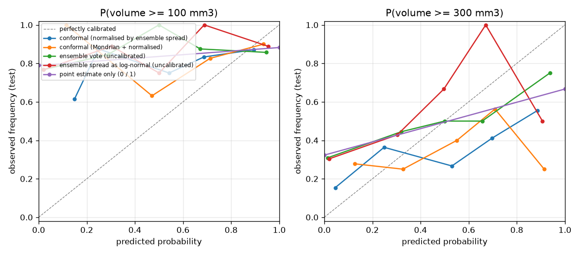
Figure 4.14: Reliability diagrams of the EUPS category probabilities for $P\left(V≥100\right)$ and $P\left(V≥300\right)$ (test nodules).
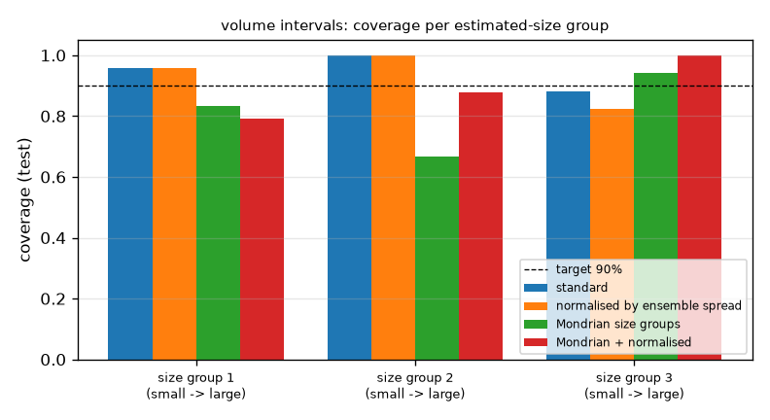
Figure 4.15: Coverage of the volume intervals in three size groups, with and without Mondrian calibration.

4.3.5 Growth (H4)
For the growth experiment each nodule was enlarged inside the CT by a known factor, corresponding to a known true doubling time, and a follow-up DTS acquisition was simulated with fresh noise; 40 growth pairs were evaluated. VDT and MDT were computed from the volume and mass ratios and assigned to the NELSON categories ($<400$, 400–600 and $>600$ days).
Table 4.9: Doubling-time results on 40 virtual growth pairs (step 11).
Method | Quantity | Category accuracy | Median $\left|\log_{2}\left({DT}_{est}/{DT}_{true}\right)\right|$ (growing) | False growth alarms (stable) | Not measurable
Coarse SIRT | VDT / MDT | 35% / 32% | 2.14 / 0.88 | 0% / 0% | 35% / 35%
Prism ROI-SIRT | VDT / MDT | 48% / 50% | 0.82 / 0.77 | 10% / 0% | 18% / 18%
Physics-only Gaussians | VDT / MDT | 42% / 40% | 1.13 / 1.29 | 20% / 20% | 10% / 10%
Diffusion only | VDT / MDT | 48% / 28% | 0.91 / 0.96 | 30% / 30% | 5% / 48%
Diffusion + Gaussians (ours) | VDT / MDT | 30% / 30% | 1.23 / 1.11 | 10% / 20% | 40% / 40%
H4 is not supported for our method (MDT and VDT both 30% category accuracy, with 40% of pairs not measurable). For the physics-only prism reconstruction, MDT was slightly better than VDT (50% vs 48% accuracy, doubling-time error 0.77 vs 0.82 in $\log_{2}$ units, no false growth alarms), and for the coarse SIRT the MDT error was much smaller than the VDT error (0.88 vs 2.14), in line with the mass-first argument; but these differences are small for 40 pairs. One verification check of this step failed: the mass added by the virtual growth deviated from its intended value by up to 7.5% (limit 3%), because the mass window also contains nearby vessels; the growth results are therefore indicative only. Figure 4.16 shows estimated against true doubling times.
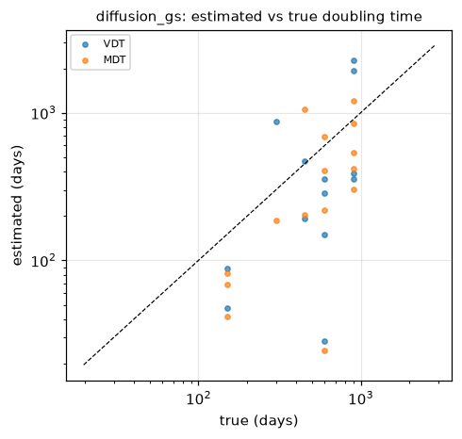
Figure 4.16: Estimated vs true doubling time for diffusion with Gaussians (VDT and MDT).

4.3.6 Explainability (H6)
Table 4.10: Seen/unseen analysis inside the nodule box, median [IQR] over 30 test nodules (step 17). Unseen skill: 1 = the invisible part matches the truth, 0 = no better than leaving it out, $<0$ = invented structure.
Volume | Unseen share of box signal | Unseen share of box mass | Unseen skill vs truth | Seen skill vs truth
CT truth | 0.15 [0.09, 0.27] | 0.00 [0.00, 0.00] | – | –
Prism ROI-SIRT (physics) | 0.00 [0.00, 0.00] | 0.00 [0.00, 0.00] | 0.00 [0.00, 0.01] | 0.39 [0.19, 0.56]
Diffusion (mean of samples) | 0.09 [0.05, 0.15] | 0.00 [0.00, 0.00] | 0.22 [0.14, 0.36] | 0.88 [0.75, 0.93]
Diffusion + Gaussians (ours) | 0.04 [0.02, 0.07] | 0.00 [0.00, 0.00] | 0.09 [0.03, 0.19] | 0.59 [0.39, 0.74]
The split itself is accurate (median $\left|Ax_{\text{unseen}}\right|/\left|Ax\right|=0.002$). The analysis confirms the physics behind H1: only 0.3% of the true nodule’s mass lies in the unseen part, while 15% of the nodule-box signal (its shape in depth) is invisible to the 15 views. H6 is supported for the diffusion prior: its unseen content has a positive skill of 0.22 [0.14, 0.36] against the true CT, so it recovers part of what the views miss rather than inventing structure, and it reproduces the seen part far better than the physics-only reconstruction (0.88 vs 0.39). After Gaussian fitting the skill drops to 0.09, so the Gaussian step discards much of what the prior recovered. Nodules that are less visible to DTS had larger volume errors (Spearman $−0.47$ [$−0.75$, $−0.12$], $n=30$). Figure 4.17 shows one nodule.
Table 4.11: Error drivers for diffusion with Gaussians: Spearman correlation with the absolute error [95% CI], 150 nodules (step 17).
Nodule property | Volume error | Mass error
Diameter (radiologists) | $−0.10$ [$−0.26$, $+0.07$] | $−0.20$ [$−0.34$, $−0.03$]
Solidity (LIDC texture) | $−0.21$ [$−0.36$, $−0.05$] | $−0.17$ [$−0.32$, $−0.01$]
Density (mean HU) | $−0.32$ [$−0.46$, $−0.17$] | $−0.35$ [$−0.49$, $−0.20$]
Radiologists’ disagreement (CV) | $+0.04$ [$−0.13$, $+0.20$] | $+0.09$ [$−0.09$, $+0.27$]
Malignancy rating | $−0.01$ [$−0.19$, $+0.16$] | $−0.12$ [$−0.28$, $+0.04$]
Ensemble spread | $−0.52$ [$−0.65$, $−0.37$] | $−0.50$ [$−0.64$, $−0.35$]
Physics data misfit | $−0.08$ [$−0.24$, $+0.08$] | $−0.04$ [$−0.19$, $+0.12$]
Table 4.11 shows which nodules fail. Faint (low-density) and less solid nodules have larger errors, while size and the radiologists’ own disagreement matter little. The most important finding is the sign of the ensemble spread: it is negatively correlated with the error ($−0.52$). The eight samples agree most when they are most wrong, which happens when they all erase a faint nodule. The spread therefore signals the opposite of what an uncertainty should, which is also why the intervals normalised by it became unbounded.
For the detector, the share of input$×$gradient saliency within 10 mm of the suggestion was 0.15 for true positives and 0.16 for false positives (Figure 4.18): the detector looks at the local region in both cases, and false positives come from local structures that resemble nodules, such as vessels seen end-on, not from attention elsewhere.
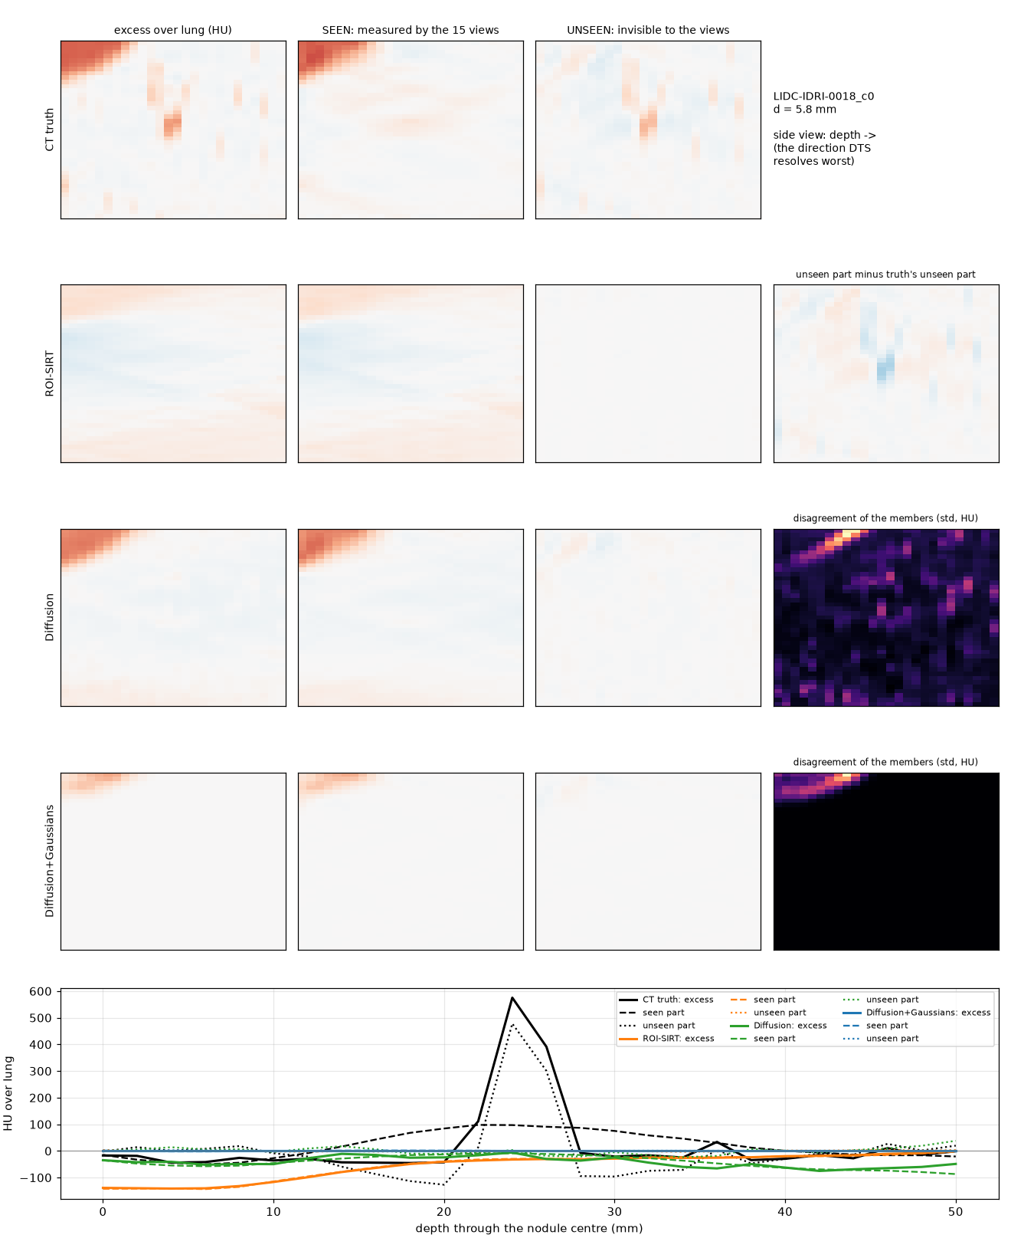
Figure 4.17: Seen/unseen split for one test nodule (LIDC-IDRI-0018): CT truth, ROI-SIRT, diffusion and diffusion with Gaussians, with the excess-attenuation profile through the nodule centre in depth (bottom).
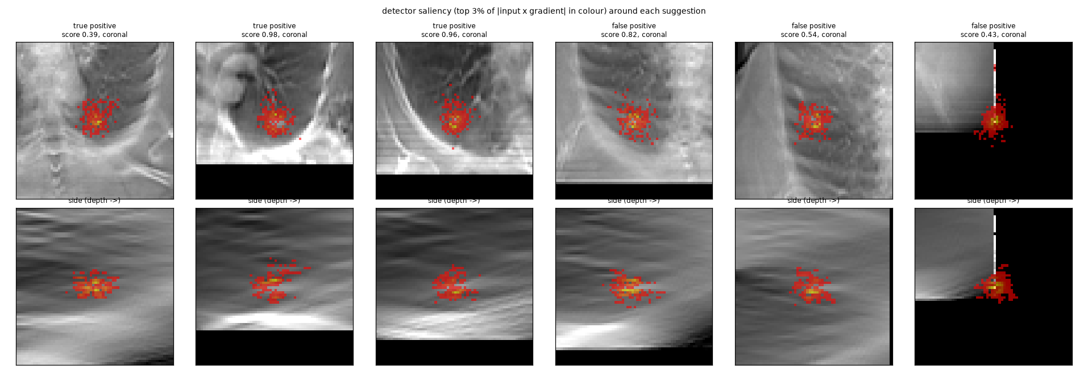
Figure 4.18: Input$×$gradient saliency of the detector for true and false positive suggestions (coronal and depth views).

4.3.7 Why the Measurements Failed
The results point to three causes, each of which suggests a fix.
- The prior shrinks faint nodules. Training pairs were cut around nodules and around nodule-free lung, and the prior was not told that a nodule is present at the click. For faint nodules it often produces plausible normal lung instead, which is consistent with the strong negative bias, the larger errors of low-density nodules and the low ensemble spread on failures. Figure 4.19 shows such a case. A fix is to condition the prior on the click or oversample nodule pairs.
- Mass is measured in image space. Although the X-rays fully determine the mass (0.3% unseen), our measurement integrates the reconstruction inside a segmented window, so segmentation failures and the prior’s shrinkage pass into the mass. A projection-domain mass estimate, which integrates the detector signal directly, would use the H1 physics as intended.
- Failures break the calibration. Measurements of zero give infinite log-errors and unbounded intervals. Treating “not measurable” as a separate outcome, reported with its own probability, and calibrating only the measurable cases would give finite intervals.
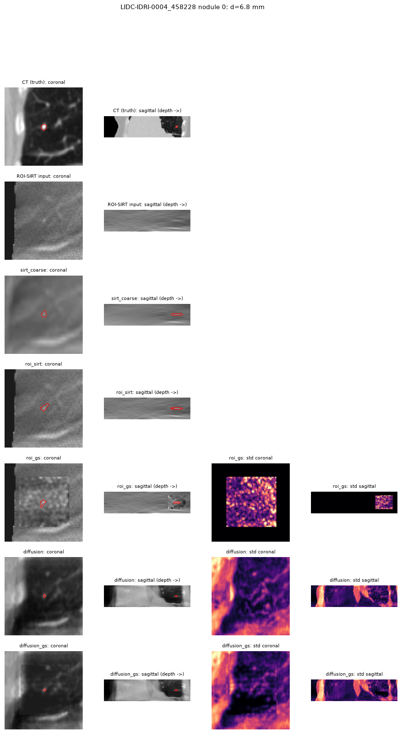
Figure 4.19: One test nodule (LIDC-IDRI-0004, 6.8 mm) through all methods: CT truth, the DTS input, and each reconstruction with its segmentation (red) and sample spread (right).

4.3.8 Acquisition Geometry Sensitivity
On 12 nodules of two test patients, the depth smear (depth over in-plane width of the artifact spread) was 5.13 for 15 views over 30°, 5.34 for 60 views over 30° (four times the compute), 4.69 for 15 views over 40° and 4.61 for 74 views over 40°, against 0.95 for CT. At equal dose the number of views hardly matters, while a 40° sweep reduces the smear by about 9%; our 15-view, 30° setting is therefore the conservative case.

4.3.9 Run Time, Cost and Application
The full run took about 15 hours on one RunPod L40S GPU at US$1.33 per hour, about US$20 in total, including 6 hours of diffusion training and about 18 minutes for the detector; measuring one nodule with all five reconstruction methods took a median of 45.5 s. The application loads the trained models on a free Kaggle notebook and is reached from a browser through an HTTPS tunnel. For a click on an annotated nodule it returns mass and volume with intervals, the EUPS category with probabilities, the prism views with the sample spread, and an interactive 3D view in which the reconstruction is coloured by the disagreement of the eight samples and the radiologists’ nodule is shown in grey (Figure 4.20); in both views the uncertainty is largest in depth, as the physics predicts. A click where no nodule exists returns “no nodule measured at the click” instead of a number, as NFR-05 requires.
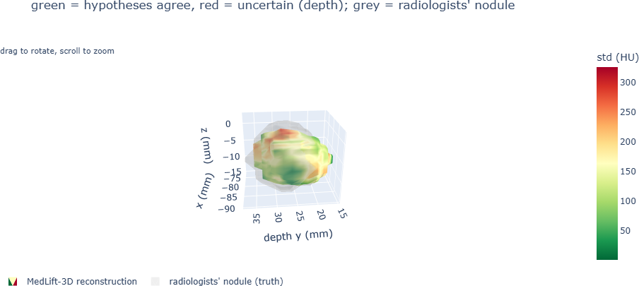
(a)
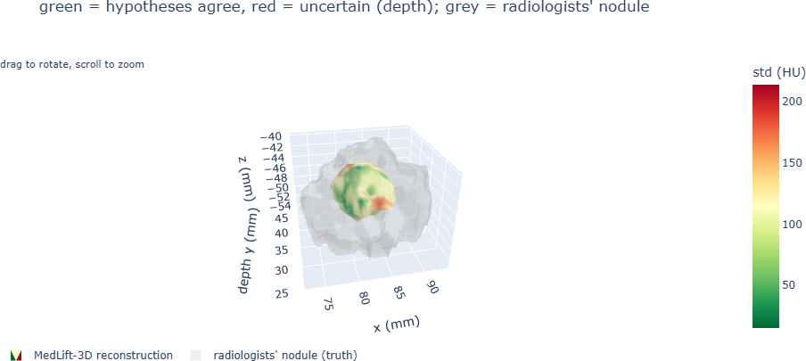
(b)
Figure 4.20: 3D view of the application for two test nodules. The reconstruction is coloured by the disagreement of the eight samples (green: samples agree; red: uncertain, mostly in depth) and the radiologists’ nodule is shown in grey. In (a) the reconstruction matches the consensus nodule; in (b) it is smaller than the consensus nodule, the shrinkage discussed in Section 4.3.
The application also shows the prism around the click in the coronal plane (what DTS shows) and the sagittal plane (depth, where DTS is blind), together with the mean reconstruction, its segmentation and the sample spread (Figure 4.21). For a solid, well-contrasted nodule the segmentation follows the nodule and the spread is concentrated at its border; for a faint nodule the reconstruction is smaller and less certain; and the physics-only Gaussians can fail completely near the chest wall, where the spread is high everywhere and no nodule is found.
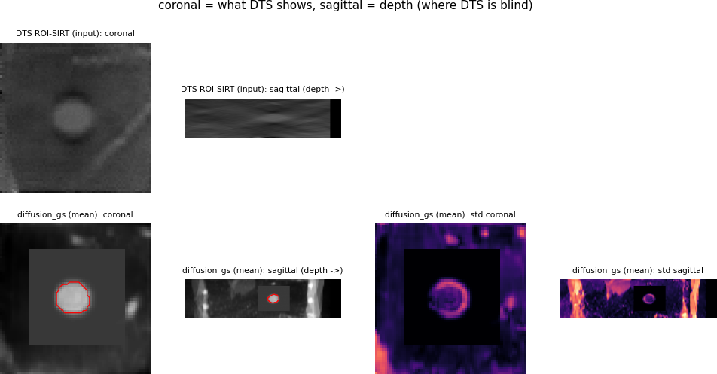
(a) Solid nodule, diffusion with Gaussians.
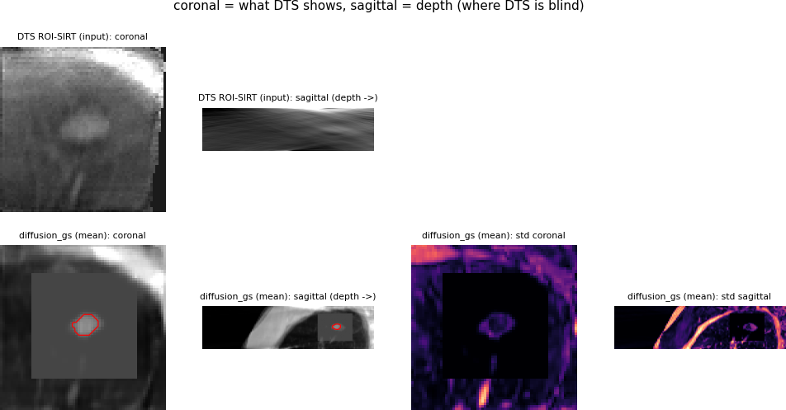
(b) Faint nodule, diffusion with Gaussians.
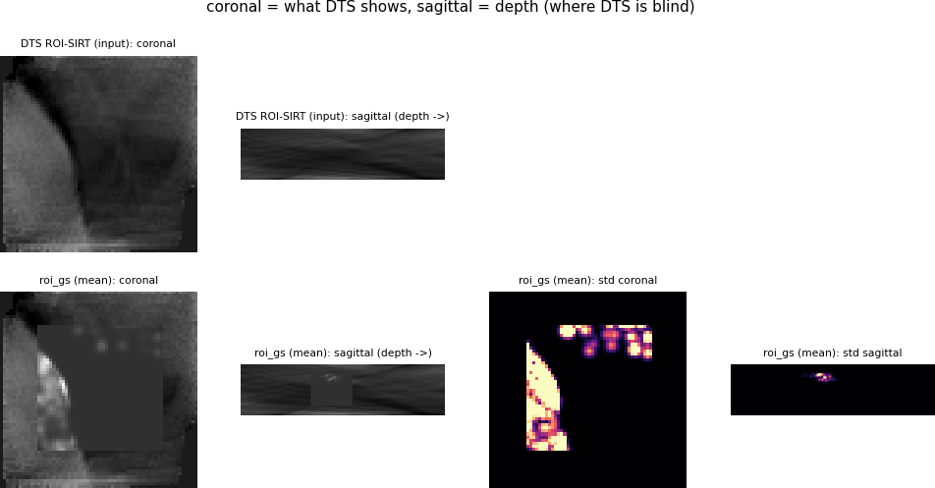
(c) Nodule near the chest wall, physics-only Gaussians: no nodule found.
Figure 4.21: Prism views in the application: DTS input (top row of each panel) and reconstruction with its segmentation (red) and sample standard deviation (bottom row), coronal and sagittal (depth).

4.4 Summary
Every requirement with a fixed criterion was checked automatically. The pipeline, the simulation, the reconstruction, the detector and the uncertainty machinery worked as specified: the learned detector beat the training-free baseline by a factor of 17 in CPM, the diffusion prior improved nodule-region PSNR by 3.35 dB on held-out pairs, conformal intervals reached their target coverage, calibrated category probabilities cut the Brier score for $P\left(V≥100\right)$ from 0.54 to 0.17, and the seen/unseen analysis showed that the nodule’s mass is fully measured by the X-rays and that the prior’s unseen content correlates with the truth. The measurements themselves did not reach the goal: H1 and H2 were not supported, H4 was not supported for our method, and the intervals, although valid, were too wide to be useful. The analysis traced these failures to a prior that shrinks faint nodules, to measuring mass in image space rather than from the projections, and to failed measurements inside the calibration set. These are concrete, testable fixes rather than open questions.

Chapter 5: Standards and Design Constraints
This chapter lists the standards MedLift-3D follows, with the alternatives considered, and analyses its economic, environmental, ethical, health and safety, social, political, legal, cultural and sustainability aspects. It ends with the cost analysis and the complex engineering problem mapping.

5.1 Compliance with the Standards
MedLift-3D is research software intended to become medical-device software, so we followed the standards that such software must eventually meet, even where formal certification is out of scope for a student project. For each standard we state how it is applied, which alternatives were considered with their pros and cons, and why it was selected. The standards are grouped into software, hardware and communication standards.

5.1.1 Software Standards
The software standards cover data formats, the software life cycle, risk and quality management, code quality, numerical precision and licensing (Table 5.1). DICOM is the format in which hospitals store and exchange images, so the input path reads DICOM directly and checks its geometry; intermediate data use compressed NumPy files with JSON headers because they hold each case’s volume, masks and metadata in one self-describing file. IEC 62304 defines the life-cycle processes for medical device software; we are not certified, but we followed its core practices: every requirement is traced to a test, all code is under version control, 69 unit tests run automatically, and anomalies found during development are documented (Chapter 4). ISO 14971 risk management is applied through the hazard analysis in Table 5.4, while ISO 13485 quality management is identified as necessary for a future product. IEEE 754 arithmetic is used deliberately: physics and measurement run in 32-bit precision and only the diffusion network uses bf16, which keeps the 32-bit range and avoids the overflow that fp16 causes in 3D networks. Finally, all data and libraries are used under open licences with attribution.
Table 5.1: Software standards.
Standard | How it is applied | Alternatives (pros / cons) | Rationale
DICOM [56] | Input CT read from DICOM; geometry checked against pylidc (0.000 mm difference) | NIfTI: simpler but loses scanner metadata | Hospitals and PACS store images in DICOM
Compressed NumPy with JSON headers | Cases, pairs and results keep their geometry in a header | NIfTI cannot hold per-nodule reader masks with metadata; HDF5 is a heavier dependency | One self-describing file per case
IEC 62304 [57] (software life cycle) | Not certified; practices followed: requirements traced to tests (Table 4.4), version control, unit tests, documented anomalies | Ad-hoc research code: faster but unverifiable | Needed for any clinical use; tracing now costs little
ISO 14971 [58] (risk management) | Hazard analysis with mitigations (Table 5.4) | No risk analysis | Required by regulators
ISO 13485 [59] (quality management) | Identified as required for a product; out of scope here | – | Applies to a device manufacturer
PEP 8, pytest | Code style; 69 automated tests | No tests: faster now, bugs later | Readable and checkable team code
IEEE 754 | fp32 for physics and measurement; bf16 only inside the network | fp16 overflows in 3D U-Nets; fp64 doubles memory | bf16 keeps the fp32 range
Open licences | LIDC-IDRI under CC BY 3.0 with citation [60]; PyTorch (BSD), crepes (BSD-3), Gradio (Apache 2.0) | Proprietary data or libraries: costly, restrictive | Legal reuse with attribution

5.1.2 Hardware Standards
MedLift-3D is software, so the hardware standards concern the computing platform and the X-ray equipment that would produce real data (Table 5.2). All GPU work uses NVIDIA’s CUDA platform through PyTorch, because CUDA GPUs are the ones offered by every cloud provider we could afford; AMD’s ROCm platform is an open alternative but is rarely available for rent. The safety of the X-ray equipment itself is governed by IEC 60601-1 and its part 2-54 for radiography; these apply to the DTS unit, not to our software, and a clinical deployment would rely on a certified unit. Radiation doses are compared as effective dose following ICRP Publication 103, the standard measure of patient risk.
Table 5.2: Hardware standards.
Standard | How it is applied | Alternatives | Rationale
NVIDIA CUDA platform | All GPU computation through PyTorch’s CUDA backend | AMD ROCm: fewer cloud offers; CPU only: training would take weeks | Widest availability on rented GPUs
IEC 60601-1 / 60601-2-54 (X-ray equipment safety) | Applies to the DTS unit that would produce real data, not to our software | – | We rely on certified DTS hardware
ICRP 103 effective dose [61] | Doses compared in mSv for CT, low-dose CT and DTS | Air kerma: less meaningful for patients | Standard measure of patient risk

5.1.3 Communication Standards
The communication standards concern how the application is reached and how results are exchanged (Table 5.3). The application runs as a web server and is reached over HTTP locally and over an encrypted HTTPS tunnel from outside, so any modern browser can use it without installing software; the usual Gradio share link failed on Kaggle, and SSH port forwarding would require setup on the client. Reports, results and calibration files are written as JSON, which is human-readable and language-neutral, unlike Python pickle files, which are unsafe to load from untrusted sources. Integration with hospital systems would use DICOM networking for images and HL7 FHIR for reports, the standards used by picture archiving and electronic record systems.
Table 5.3: Communication standards.
Standard | How it is applied | Alternatives | Rationale
HTTP/HTTPS with TLS | Application served locally over HTTP and to the browser through an HTTPS tunnel | Gradio share links (failed on Kaggle); SSH port forwarding (client setup) | Encrypted; works from any browser
JSON (RFC 8259) | Reports, results and calibration files | XML: verbose; pickle: unsafe to load | Human-readable, language-neutral
DICOM networking, HL7 FHIR | Future integration with hospital PACS and records | Custom APIs: no interoperability | Required in hospital workflows

5.2 Design Constraints
The design was shaped by economic, environmental, ethical, health and safety, social, political, sustainability, legal and cultural constraints. Each is discussed below together with its effect on the design and the measures taken.

5.2.1 Economic Constraint
The project had no external funding, so all computation had to fit a student budget. Free resources were used wherever possible (laptop CPU, Kaggle GPUs for the pilot and the application), CPU-only steps (3–5 hours of download and case building) were moved to a cheap CPU machine, and GPU training was given a fixed 6-hour budget. The full study cost about US$20 on the GPU and under US$2 on the CPU machine. Clinically, the economic case rests on DTS: a DTS-capable radiography room costs a fraction of a CT scanner and examines patients faster, so follow-up by DTS can lower the cost of each follow-up for hospitals and patients.

5.2.2 Environmental Constraint
Energy and emissions. The L40S GPU has a 350 W power limit, so the 15-hour run used at most about 5.3 kWh on the GPU, roughly 7.5 kWh including CPU, memory and cooling, plus under 1 kWh for the CPU machine. At a world-average grid intensity of about 0.48 kg CO$​_{2}$ per kWh (Bangladesh’s grid is higher, about 0.6), the study emitted roughly 4–5.5 kg CO$​_{2}$, comparable to a 25–35 km car trip. One measurement (about 45 s on the GPU) uses about 0.004 kWh. These are estimates from rated power, following [62], not metered values.
Data storage and waste. The 64 GB of downloaded DICOM was deleted after conversion to compact cases, and intermediate files that can be regenerated were not backed up. No hardware was bought, so the project produced no electronic waste.
Radiation as an environmental factor. Replacing CT follow-ups (about 1.5–6 mSv) with DTS (about 0.1 mSv) reduces the population’s collective radiation dose.
Mitigations. A small model (17.4 M parameters) instead of a large generator; a prism instead of whole-volume generation; fixed compute budgets; CPU work on CPU machines; trained models reused for evaluation and the application instead of retraining; and, for future runs, cloud regions powered by renewable energy.

5.2.3 Ethical Constraint
Professional ethics. We followed the IEEE [63] and ACM [64] codes of ethics, in particular honesty about claims and results.
- Honest claims: all results come from simulated DTS, not real scanners, and Section 2.3 lists what we do not claim.
- Honest results: hypotheses were stated before the results, and the report gives whichever outcome we found, including that H1 and H2 were not supported, that the intervals were too wide to be useful, that the detector sensitivity is only 35% at two false positives per scan, and the failed checks in Chapter 4.
- Credit: all datasets, libraries and ideas we build on are cited, including the data citations required by TCIA.
- Fairness: LIDC-IDRI comes mainly from US patients; performance on other populations, for example patients with healed tuberculosis scars, is unknown and is stated as such.
- Data ethics: only de-identified public data, used under its licence, with no attempt at re-identification.
Professional responsibility. The team owns its decisions and mistakes. When the real-data pilot showed that the prism lost a third of its attenuation, we traced the cause to our own missing depth support and fixed it before the full run; when the first design of the project could not be verified, we narrowed it rather than present training losses as success. Each step’s owner (Table 3.7) is accountable for its checks. The system is decision support: the responsibility for a diagnosis stays with the radiologist.

5.2.4 Health and Safety Constraint
Health impacts. Physical: the main benefit is lower radiation per follow-up (DTS about 0.1 mSv vs about 1.5 mSv for low-dose CT or several mSv for diagnostic CT), which matters because nodule follow-up repeats over years [6, 15]. The main physical risk is a wrong measurement that delays treatment of a growing cancer or leads to an unnecessary biopsy. Mental: living with an indeterminate nodule causes anxiety, and a falsely reassuring or falsely alarming number makes it worse.
Actionable solutions. Every number is reported with a calibrated interval and category probabilities so that the clinician sees when a result is uncertain; a low-confidence flag recommends CT; and results should be explained to patients by the clinician in categories rather than raw numbers. Table 5.4 lists the main hazards.
Table 5.4: Safety risk analysis (ISO 14971 style).
Hazard | Cause | Effect | Mitigation
Underestimated growth | Prior fills depth wrongly | Delayed treatment | Mass-first reporting; intervals; seen/unseen explanation; CT recommended when flagged
Overestimated growth | Vessel or chest wall included | Unnecessary CT or biopsy | Segmentation confined to a plausible extent; leaks reported as not measurable
Hallucinated nodule | Prior invents structure | False alarm | Data consistency with X-rays; clinician confirms
Missed nodule | Detector sensitivity 35% at 2 FP/scan | Nodule not suggested | Clinician can click anywhere; detector is an aid
Out-of-distribution use | Other population, scanner or dose | Silent errors | Validated setting stated; local validation and recalibration required
Over-trust | Automation bias | Clinician stops checking | Intervals and flags shown prominently; user training

5.2.5 Social Constraint
In the short term, DTS-based follow-up could shorten CT waiting lists and reduce travel for patients outside major cities. In the long term it could make nodule surveillance, and later screening, feasible where CT capacity is the bottleneck, improving early diagnosis where the survival gain is largest. From the patient’s perspective this means less dose and cost; from the radiologist’s, a measurement tool with honest uncertainty; from the health system’s, cheaper follow-up that needs training and local validation. Possible negative effects are over-diagnosis if many more people are followed, and a widening gap if only private hospitals adopt the tool; both argue for public-sector deployment and guideline-based use.

5.2.6 Political Constraint
Adoption of health technology depends on public health policy and procurement. In Bangladesh, imaging equipment and software are purchased mainly through government tenders and large private hospital groups, so adoption would need evidence accepted by the health authorities and inclusion in national cancer-control plans. The use of foreign cloud computing for health data is itself a policy question, so a deployment should keep data and computation in the country.

5.2.7 Sustainability
Lifecycle plan. (1) Development and verification (this project); (2) retrospective validation on real DTS with CT ground truth from a partner hospital; (3) a prospective reader study; (4) regulatory registration; (5) deployment with monitoring of measurement errors and interval coverage; and (6) periodic recalibration of the conformal layer, which needs only new calibration cases, not retraining, when scanners or populations change.
Three dimensions. Environmental: small model, low energy per measurement, no special hardware. Economic: runs on one mid-range GPU or a low-cost cloud instance, and open-source code avoids licence fees. Social: documented and tested code that another team can maintain, and a method that extends to other limited-angle modalities.

5.2.8 Legal Considerations
- Data licence: LIDC-IDRI is distributed by TCIA under the Creative Commons Attribution 3.0 Unported licence, which allows commercial, scientific and educational use with attribution. The TCIA data usage policy forbids any attempt to identify or contact the participants and requires every publication to cite both the collection [19] and the TCIA repository [65] [60]. We follow both requirements and made no attempt at re-identification.
- Medical device regulation in Bangladesh: medical devices are regulated by the Directorate General of Drug Administration (DGDA). The Drugs and Cosmetics Act 2023 [66], passed by Parliament in September 2023, replaced the Drugs Act 1940 and the Drugs (Control) Ordinance 1982 and includes provisions on medical devices. Registration follows the DGDA Registration Guidelines for Medical Devices [67], which are based on the Global Harmonization Task Force guidance and define a medical device to include software intended for diagnosis or monitoring. A clinical version of MedLift-3D would therefore be a registrable medical device; implementing rules under the 2023 Act are still being developed, so the current DGDA requirements must be confirmed at the time of submission.
- Other markets: the US FDA (510(k) or De Novo), the EU Medical Device Regulation [68] and the EU AI Act [69], which classes medical AI as high risk, would apply; each requires risk management [58], life-cycle processes [57] and clinical evidence.
- Data protection: Bangladesh’s Personal Data Protection Ordinance 2025 [70], approved on 9 October 2025 and published in the official gazette on 6 November 2025, recognises citizens as the owners of their personal data, makes explicit consent mandatory before personal data is collected, stored, transferred or used, treats health records as sensitive data with stricter rules and penalties, and restricts cross-border transfers; some provisions take effect 18 months after publication. A clinical deployment would have to obtain consent, keep health data within these rules (and GDPR or HIPAA for international data), and preferably compute inside the country. The demonstration uses only de-identified public data.
- Liability: the intended use is decision support; the clinician remains responsible for the diagnosis.

5.2.9 Cultural Considerations
- Language and literacy: a deployed interface should offer Bangla and present results in plain categories, with numbers available for specialists.
- Family-centred decisions: diagnoses are often discussed with the family, so uncertainty should be explained through the clinician in a way the family can follow, not as raw probabilities.
- Stigma: lung cancer is often linked to smoking and blame; communication should avoid blame, and many patients, especially women exposed to cooking smoke, have never smoked.
- Local disease patterns: healed tuberculosis leaves calcified granulomas that resemble nodules. The model was not trained on such patients, so local validation is required before use, which also respects patients’ right to a tool tested on people like them.
- Trust: many patients trust the doctor more than a machine; keeping the clinician in charge respects this.

5.3 Cost Analysis
Actual project budget. Table 5.5 gives the actual cost of the computation (exchange rate assumed: US$1 $≈$ BDT 120).
Table 5.5: Actual project budget.
Item | US$ | BDT
RunPod GPU (L40S, 15 hours at US$1.33 per hour) | $≈20$ | $≈2,400$
RunPod CPU machine (download and case building) | $<2$ | $<240$
Kaggle notebooks (pilot, application) | 0 | 0
LIDC-IDRI data and open-source software | 0 | 0
Total | about 22 | about 2,640
Alternate budget: buy instead of rent. An RTX 4090 (24 GB) graphics card alone costs about BDT 2.4–2.9 lakh at Bangladeshi retailers, so a complete workstation would cost about BDT 4–5 lakh. It would run the study in 20–30 hours but pays off only after hundreds of runs. Renting cost less than 1% of buying and provided a larger 48 GB GPU, so renting was the right choice for a one-off study; buying makes sense only for a centre with continuous use.
Revenue model (illustrative). For a commercial version, assume 18 months of validation and registration and customers among diagnostic centres and hospitals with DTS-capable radiography (Tables 5.6 and 5.7).
Table 5.6: Illustrative revenue (BDT lakh).
Revenue stream (price) | Year 1 | Year 2 | Year 3
Pay per study (BDT 300 per nodule follow-up) | 0 | 18 (6,000 studies) | 60 (20,000 studies)
Hospital subscription (BDT 6 lakh per year) | 0 | 18 (3 hospitals) | 48 (8 hospitals)
Total revenue | 0 | 36 | 108
Table 5.7: Illustrative expenses and cash flow (BDT lakh).
Item | Year 1 | Year 2 | Year 3
Development team (3 engineers) | 25 | 25 | 30
Clinical validation study | 20 | 10 | –
Regulatory registration and quality system | 8 | 4 | 4
Cloud / GPU and hosting | 3 | 5 | 8
Marketing and training | 2 | 6 | 8
Total expenses | 58 | 50 | 50
Net cash flow | $−58$ | $−14$ | $+58$
Cumulative cash flow | $−58$ | $−72$ | $−14$
Under these assumptions the venture breaks even early in year four. The largest uncertainty is the cost and duration of clinical validation, which is why a partnership with a public hospital is the first step.

5.4 Complex Engineering Problem
MedLift-3D is a complex engineering problem: it is ill-posed by physics, combines X-ray physics, generative AI and statistics, has conflicting requirements (dose, accuracy, honesty, cost), and has direct consequences for patients.

5.4.1 Complex Problem Solving
Table 5.8: Mapping with complex problem solving.
P1 Depth of knowledge | P2 Range of conflicting requirements | P3 Depth of analysis | P4 Familiarity of issues | P5 Extent of applicable codes | P6 Stakeholder involvement | P7 Inter- dependence
✓ | ✓ | ✓ | ✓ | ✓ | $∘$ | ✓
P1 – Depth of knowledge. The solution requires X-ray projection physics, linear algebra of range and null spaces, probabilistic diffusion models, conformal statistics and 3D deep learning, beyond the standard curriculum. Table 5.9 maps the knowledge profiles.
Table 5.9: Knowledge profile mapping for P1.
Knowledge profile | Where it is used
WK1 Natural sciences | X-ray attenuation, Poisson photon statistics, radiation dose
WK2 Mathematics | Projection moments and conditioning; CGLS; probability and exchangeability for conformal prediction
WK3 Engineering fundamentals | Numerical methods (SIRT, conjugate gradients), algorithms, data structures
WK4 Specialist knowledge | Tomography, diffusion models, 3D U-Nets, Gaussian representations
WK5 Engineering design | Requirements, prism design, verification steps, application
WK6 Engineering practice | Cloud GPU operation, testing, version control, reproducibility
WK7 Engineering in society | Radiation safety, regulation, ethics, cultural factors
WK8 Research literature | Literature on DTS, sparse-view CT, diffusion, Gaussians and conformal prediction
P2 – Range of conflicting requirements. Dose vs accuracy, filling the missing wedge vs never inventing anatomy, single numbers vs honest intervals, memory vs field of view, and detection recall vs false positives (Table 3.2).
P3 – Depth of analysis. We derived from first principles which quantities DTS can measure, built a 583-patient virtual trial, and analysed calibration, size-group coverage and seen/unseen content rather than image quality alone.
P4 – Familiarity of issues. No standard solution exists for calibrated 3D nodule measurement from DTS; the combination of a data-consistent prior inside a DTS prism, Gaussian mass and conformal calibration had to be designed for this problem.
P5 – Extent of applicable codes. DICOM, IEC 62304, ISO 14971, data licences and medical device regulation (Table 5.1).
P6 – Extent of stakeholder involvement (partial). Clinical needs were taken from guidelines and supervisor feedback; direct evaluation by radiologists is future work.
P7 – Interdependence. Simulation, reconstruction, prior, Gaussians, calibration and detector depend on each other: the depth-support bug in reconstruction, for example, corrupted the training data and every downstream measurement until it was fixed.

5.4.2 Engineering Activities
Table 5.10: Mapping with complex engineering activities.
A1 Range of resources | A2 Level of interaction | A3 Innovation | A4 Consequences for society and environment | A5 Familiarity
✓ | ✓ | ✓ | ✓ | ✓
A1 – Range of resources. A public archive of 583 patients (about 64 GB), rented CPU and GPU machines with shared storage, free Kaggle GPUs and open-source libraries, all within about US$22.
A2 – Level of interaction. Interaction among three team members with distinct roles, the supervisor, the course teacher, published clinical guidelines and open-source communities (crepes, Gradio, pylidc).
A3 – Innovation. The mass-first projection-moment argument for DTS, the prism-based data-consistent diffusion prior with Gaussian mass, decision-level calibrated uncertainty, and a truth-referenced seen/unseen test.
A4 – Consequences for society and environment. Lower radiation and cost per follow-up and wider access to nodule surveillance, balanced against the risk of wrong measurements, which intervals, flags and clinician control address (Table 5.4).
A5 – Familiarity. Diffusion models, conformal predictive systems and null-space analysis go well beyond typical undergraduate projects and were learned during the project.

5.5 Summary
MedLift-3D follows the software, hardware and communication standards relevant to medical imaging software and prepares for IEC 62304 and ISO 14971. Its main impacts are positive (lower dose and cost, wider access), with clear risks (wrong measurements, over-trust, untested populations) that the design mitigates through calibrated intervals, flags, clinician control and a validation plan. The project cost about US$22 and meets the attributes of a complex engineering problem.

Chapter 6: Conclusion
This chapter summarises what MedLift-3D achieved, states its limitations and future work, and reflects on the independent learning the project required.

6.1 Summary
MedLift-3D turns one click on a low-dose chest tomosynthesis image into a 3D nodule measurement with calibrated uncertainty. We showed from projection moments that DTS measures a nodule’s mass in every view but its depth extent about 15 times worse, and built the system around that fact: a prism reconstruction around the click, a 17.4-million-parameter conditional diffusion prior kept consistent with the X-rays, 3D Gaussians that give mass in closed form, conformal intervals and calibrated size-category probabilities, a learned detector to suggest clicks, and a seen/unseen explanation of every result. A verified 18-step pipeline ran a 583-patient virtual clinical trial on LIDC-IDRI in 15 hours for about US$20. The components worked as specified: the prior improved nodule-region PSNR from 11.88 to 15.23 dB on held-out data, the detector reached a CPM of 0.298 against 0.017 for a training-free baseline, conformal intervals reached their target coverage, calibrated probabilities lowered the Brier score for $P\left(V≥100\right)$ from 0.54 to 0.17, and the null-space analysis showed that the X-rays measure almost all of a nodule’s mass and that the prior’s unseen content correlates with the truth. The measurements did not reach the goal: mass was not more accurate than volume (H1), the full method did not beat physics-only reconstruction (H2), MDT did not beat VDT for our method (H4), and the valid intervals were too wide to be useful (H3). Calibrated probabilities (H5) helped at one of two thresholds, and the prior’s positive unseen skill supports H6. The analysis traced the failures to specific causes with specific fixes, and showed that better image quality did not mean better measurement, which is itself a lesson for medical generative AI.

6.2 Limitation
- Simulation only. No public chest DTS dataset with CT ground truth exists; our DTS is simulated from CT with a monochromatic beam and no scatter, so performance on real scanners is unknown.
- Acquisition. 15 views instead of the 60–74 of clinical units (at equal dose) and a conservative 30° sweep; the prior was trained and tested on this geometry only.
- Detector sensitivity. 35% at two false positives per scan is too low for unaided use; the detector is an aid only.
- Growth. Virtual growth scales the nodule uniformly; real nodules grow irregularly.
- Ground truth. LIDC labels vary between radiologists (consensus volume / mean reader volume 0.81), and only nodules of 4–30 mm marked by at least three readers were used.
- Population. LIDC is mostly from US patients; populations with tuberculosis scarring were not represented.
- Measurement accuracy. Volume and mass errors (MdAPE 75–100%) are far from clinical use; the full method under-estimates strongly (bias $−91\%$) and fails on 22% of nodules.
- Uninformative intervals. Failed measurements inside the calibration set made the intervals valid but unbounded; the ensemble spread was negatively correlated with the error.
- Training budget and size. The prior trained for 6 hours and was still improving, and its samples were better for training patients than for new ones (+7.00 vs +4.22 dB); the detector also partly memorised its training patients.
- Sample size. Measurements used 150 nodules (76 calibration, 74 test) and 40 growth pairs, so small differences between methods are not conclusive.
- Patient thickness was taken from the CT body outline; a real DTS unit would have to measure it.

6.3 Future Work
- Nodule-preserving prior: condition the diffusion model on the click position and oversample nodule pairs, so that faint nodules are not replaced by normal lung.
- Projection-domain mass: estimate mass by integrating the detector signal around the nodule’s shadow, which the null-space analysis shows is fully measured, instead of integrating a segmented reconstruction.
- Failure-aware calibration: report “not measurable” as a separate outcome with its own probability and calibrate intervals on measurable cases only, and replace the ensemble spread by a difficulty score that correlates positively with error.
- Real DTS data: partner with a hospital that has a DTS unit to collect paired DTS and CT scans, recalibrate the conformal layer on them, and measure real performance.
- Physics realism: add polychromatic spectra, scatter and the 60–74-view clinical protocols to the simulator.
- Longer and larger training: train the prior longer with augmentation, test larger models, and train the detector with more nodule-free negatives.
- Real growth: use longitudinal CT pairs instead of virtual growth.
- Reader study: measure whether radiologists make better follow-up decisions with MedLift-3D than with DTS alone.
- Deployment: a Bangla interface, DICOM/PACS integration, an on-site GPU option, and a quality system towards regulatory registration.
- Other limited-angle problems: breast tomosynthesis and dental cone-beam CT share the missing-wedge structure.

6.4 Independent Learning and Reflection
The project required knowledge and skills well beyond our coursework. This section reflects on that independent learning under five aspects: curiosity, self-initiative, independence, transfer of past learning, and reflection on what we learned.

6.4.1 Curiosity
The project began as a generative-modelling idea, but we kept asking a deeper question: what can a 30° X-ray sweep actually measure? Following that question into projection moments led to the mass-first design. The same curiosity made us ask whether the prior recovers or invents depth, which became the seen/unseen analysis, and when we found that raw ensemble spread is not a probability we studied conformal prediction until we could produce calibrated category probabilities.

6.4.2 Self-initiative
Beyond the required scope we added a learned detector after the training-free one mostly found vessels, a fit check to show that the prior does not overfit, conformal predictive systems with size-group calibration, explainability with a truth-referenced test, a geometry-sensitivity study to justify the 15-view choice, and an automatic HTML report so that every check is visible to examiners.

6.4.3 Independence
Outside the classroom we learned to run a 15-hour unattended job on rented cloud machines (CPU and GPU pods sharing a network volume, terminal multiplexing, resumable scripts and backups), to download and organise 64 GB of medical images from TCIA, to read radiologist annotations with pylidc, and to serve a GPU application from a Kaggle notebook through an HTTPS tunnel when the usual share link failed.

6.4.4 Transfer of Past Learning
Much of the project rests on knowledge from earlier courses applied to a problem none of them covered. Linear algebra became the tool for separating what the X-rays measure from what the prior supplies; calculus gave the moment argument that founded the design; probability and statistics became calibrated uncertainty; and software engineering became the discipline of a verified pipeline. Table 6.1 lists how each area was applied.
Table 6.1: Earlier coursework applied in MedLift-3D.
Earlier course knowledge | Application in MedLift-3D
Linear algebra (range, null space, least squares) | Seen/unseen split with CGLS; SIRT as an iterative least-squares solver
Calculus and moments | Projection-moment argument: mass is the 0th moment, depth extent the 2nd
Probability and statistics | Poisson noise, conformal prediction, Brier score, rank correlations, bootstrap confidence intervals
Numerical methods | Iterative solvers, numerical stability, mixed precision
Data structures and algorithms | Ray marching, candidate ranking, patient-level splitting
Artificial intelligence and machine learning | Diffusion training, U-Nets, overfitting checks, train/calibration/test discipline
Image processing and computer graphics | Projection geometry, 3D Gaussians, segmentation, saliency maps
Software engineering | Requirements and traceability, unit tests, version control, the verified pipeline
Computer networks | HTTPS tunnels and port forwarding for the application

6.4.5 Reflection on Learning
Our main lesson was that a large architecture with falling training losses does not show that a single clinical measurement is right. Rebuilding the work around measurable clinical numbers, explicit hypotheses and automatic checks changed how we think about engineering: a result counts only if someone else can verify it, and a negative result reported honestly is worth more than a claim that cannot be tested. We also learned to work within real limits of time, money and data, to plan computation like a budget, and to treat uncertainty as part of the answer rather than an embarrassment. These habits, more than any single model, are what we take from the project into our careers.

References
- Freddie Bray, Mathieu Laversanne, Hyuna Sung, Jacques Ferlay, Rebecca L. Siegel, Isabelle Soerjomataram, and Ahmedin Jemal. Global cancer statistics 2022: GLOBOCAN estimates of incidence and mortality worldwide for 36 cancers in 185 countries. CA: A Cancer Journal for Clinicians, 74 (3): 229–263, 2024.
- Sean Blandin Knight, Phil A. Crosbie, Haval Balata, Jakub Chudziak, Tracy Hussell, and Caroline Dive. Progress and prospects of early detection in lung cancer. Open Biology, 7 (9): 170070, 2017.
- Marie-Pierre Revel, Caroline Lefort, Anne Bissery, et al. Pulmonary nodules: preliminary experience with three-dimensional evaluation. Radiology, 231 (2): 459–466, 2004a.
- Nanda Horeweg, Joost van Rosmalen, Marjolein A. Heuvelmans, et al. Lung cancer probability in patients with CT-detected pulmonary nodules: a prespecified analysis of data from the NELSON trial of low-dose CT screening. The Lancet Oncology, 15 (12): 1332–1341, 2014.
- David J. Brenner and Eric J. Hall. Computed tomography – an increasing source of radiation exposure. New England Journal of Medicine, 357 (22): 2277–2284, 2007.
- Cristiano Rampinelli, Paolo De Marco, Daniela Origgi, Patrick Maisonneuve, Monica Casiraghi, Giulia Veronesi, Lorenzo Spaggiari, and Massimo Bellomi. Exposure to low dose computed tomography for lung cancer screening and risk of cancer: secondary analysis of trial data and risk-benefit analysis. BMJ, 356: j347, 2017.
- James T. Dobbins III and Devon J. Godfrey. Digital x-ray tomosynthesis: current state of the art and clinical potential. Physics in Medicine and Biology, 48 (19): R65–R106, 2003.
- Jenny Vikgren, Sara Zachrisson, Angelica Svalkvist, et al. Comparison of chest tomosynthesis and chest radiography for detection of pulmonary nodules: human observer study of clinical cases. Radiology, 249 (3): 1034–1041, 2008.
- World Health Organization. Lung cancer fact sheet. https://www.who.int/news-room/fact-sheets/detail/lung-cancer, 2023.
- National Lung Screening Trial Research Team. Reduced lung-cancer mortality with low-dose computed tomographic screening. New England Journal of Medicine, 365 (5): 395–409, 2011.
- Matthijs Oudkerk, Anand Devaraj, Rozemarijn Vliegenthart, et al. European position statement on lung cancer screening. The Lancet Oncology, 18 (12): e754–e766, 2017.
- Constance de Margerie-Mellon, Benedikt H. Heidinger, and Alexander A. Bankier. 2D or 3D measurements of pulmonary nodules: preliminary answers and more open questions. Journal of Thoracic Disease, 10 (2): 547–549, 2018.
- Marie-Pierre Revel, Anne Bissery, Marc Bienvenu, Laurent Aycard, Caroline Lefort, and Guy Frija. Are two-dimensional CT measurements of small noncalcified pulmonary nodules reliable? Radiology, 231 (2): 453–458, 2004b.
- Ho Yun Lee. Volumetry for lung nodule assessment. Journal of Chest Surgery, 58 (2): 58–59, 2025.
- Mario Mascalchi and Lapo Sali. Lung cancer screening with low dose CT and radiation harm: from prediction models to cancer incidence data. Annals of Translational Medicine, 5 (17): 360, 2017.
- Sayantan Bhadra, Varun A. Kelkar, Frank J. Brooks, and Mark A. Anastasio. On hallucinations in tomographic image reconstruction. IEEE Transactions on Medical Imaging, 40 (11): 3249–3260, 2021.
- J. Zhang, Z. Li, J. Pan, S. Wang, and W. Wu. Trustworthy limited data CT reconstruction using progressive artifact image learning. IEEE Transactions on Image Processing, 34: 1163–1178, 2025.
- Bartjan de Hoop, Hester Gietema, Saskia van de Vorst, Keelin Murphy, Rob J. van Klaveren, and Mathias Prokop. Pulmonary ground-glass nodules: increase in mass as an early indicator of growth. Radiology, 255 (1): 199–206, 2010.
- Samuel G. Armato III, Geoffrey McLennan, Luc Bidaut, et al. The Lung Image Database Consortium (LIDC) and Image Database Resource Initiative (IDRI): a completed reference database of lung nodules on CT scans. Medical Physics, 38 (2): 915–931, 2011.
- Matthew C. Hancock and Jerry F. Magnan. Lung nodule malignancy classification using only radiologist-quantified image features as inputs to statistical learning algorithms: probing the Lung Image Database Consortium dataset with two statistical learning methods. Journal of Medical Imaging, 3 (4): 044504, 2016.
- Peter Gilbert. Iterative methods for the three-dimensional reconstruction of an object from projections. Journal of Theoretical Biology, 36 (1): 105–117, 1972.
- Jonathan Ho, Ajay Jain, and Pieter Abbeel. Denoising diffusion probabilistic models. In Advances in Neural Information Processing Systems (NeurIPS), 2020.
- Jiaming Song, Chenlin Meng, and Stefano Ermon. Denoising diffusion implicit models. In International Conference on Learning Representations (ICLR), 2021.
- Tim Salimans and Jonathan Ho. Progressive distillation for fast sampling of diffusion models. In International Conference on Learning Representations (ICLR), 2022.
- Bernhard Kerbl, Georgios Kopanas, Thomas Leimkühler, and George Drettakis. 3D Gaussian splatting for real-time radiance field rendering. ACM Transactions on Graphics, 42 (4), 2023.
- Ruyi Zha, Tao Jun Lin, Yuanhao Cai, Jiwen Cao, Yanhao Zhang, and Hongdong Li. R$​^{2}$-Gaussian: Rectifying radiative Gaussian splatting for tomographic reconstruction. In Advances in Neural Information Processing Systems (NeurIPS), 2024.
- Vladimir Vovk, Alexander Gammerman, and Glenn Shafer. Algorithmic Learning in a Random World. Springer, 2nd edition, 2022.
- Vladimir Vovk, Jieli Shen, Valery Manokhin, and Min-ge Xie. Nonparametric predictive distributions based on conformal prediction. Machine Learning, 108: 445–474, 2019.
- Henrik Boström. crepes: a Python package for generating conformal regressors and predictive systems. In Proc. Conformal and Probabilistic Prediction with Applications (COPA), volume 179 of PMLR, 2022.
- Anastasios N. Angelopoulos and Stephen Bates. Conformal prediction: a gentle introduction. Foundations and Trends in Machine Learning, 16 (4): 494–591, 2023.
- Yinhuai Wang, Jiwen Yu, and Jian Zhang. Zero-shot image restoration using denoising diffusion null-space model. In International Conference on Learning Representations (ICLR), 2023.
- Avanti Shrikumar, Peyton Greenside, and Anshul Kundaje. Learning important features through propagating activation differences. In International Conference on Machine Learning (ICML), 2017.
- Gabor T. Herman. Fundamentals of Computerized Tomography. Springer, 2nd edition, 2009.
- Alexander Quinn Nichol and Prafulla Dhariwal. Improved denoising diffusion probabilistic models. In International Conference on Machine Learning (ICML), 2021.
- Hyungjin Chung, Jeongsol Kim, Michael T. Mccann, Marc L. Klasky, and Jong Chul Ye. Diffusion posterior sampling for general noisy inverse problems. In International Conference on Learning Representations (ICLR), 2023.
- Hyungjin Chung, Suhyeon Lee, and Jong Chul Ye. Decomposed diffusion sampler for accelerating large-scale inverse problems. In International Conference on Learning Representations (ICLR), 2024.
- Arnaud Arindra Adiyoso Setio, Alberto Traverso, Thomas de Bel, et al. Validation, comparison, and combination of algorithms for automatic detection of pulmonary nodules in computed tomography images: the LUNA16 challenge. Medical Image Analysis, 42: 1–13, 2017.
- Yingtai Li, Xueming Fu, Han Li, Shang Zhao, Ruiyang Jin, and S. Kevin Zhou. 3DGR-CT: Sparse-view CT reconstruction with a 3D Gaussian representation. Medical Image Analysis, 103: 103585, 2025.
- B. Guan, C. Yang, L. Zhang, S. Niu, M. Zhang, and Y. Wang. Generative modeling in sinogram domain for sparse-view CT reconstruction. IEEE Transactions on Radiation and Plasma Medical Sciences, 8 (2): 195–207, 2024.
- K. Xu, S. Lu, B. Huang, W. Wu, and Q. Liu. Stage-by-stage wavelet optimization refinement diffusion model for sparse-view CT reconstruction. IEEE Transactions on Medical Imaging, 43 (10): 3412–3424, 2024.
- W. Wu, Y. Wang, Q. Liu, G. Wang, and J. Zhang. Wavelet-improved score-based generative model for medical imaging. IEEE Transactions on Medical Imaging, 43 (3): 966–979, 2024.
- Y. Liu, X. Zhou, C. Wei, and Q. Xu. Sparse-view spectral CT reconstruction and material decomposition based on multi-channel SGM. IEEE Transactions on Medical Imaging, 43 (10): 3425–3435, 2024.
- Linfeng He et al. Solving zero-shot sparse-view CT reconstruction with variational score solver. IEEE Transactions on Medical Imaging, 44 (9): 3586–3599, 2025.
- T. Wang and Y. Guo. A lung CT vision foundation model facilitating disease diagnosis and medical imaging. Nature Communications, 2025.
- Emmanuel J. Candès, Justin Romberg, and Terence Tao. Robust uncertainty principles: exact signal reconstruction from highly incomplete frequency information. IEEE Transactions on Information Theory, 52 (2): 489–509, 2006.
- Ben Mildenhall, Pratul P. Srinivasan, Matthew Tancik, Jonathan T. Barron, Ravi Ramamoorthi, and Ren Ng. NeRF: Representing scenes as neural radiance fields for view synthesis. In European Conference on Computer Vision (ECCV), 2020.
- R. Vavekanand, G. Kumar, and S. Kurbanova. A lightweight physics-conditioned diffusion multi-model for medical image reconstruction. Biomedical Engineering Communications, 5 (2): 12, 2025.
- J. Chang et al. An unsupervised sparse-view CT reconstruction framework using combination of iterative deep image prior and ADMM. Medical Physics, 52 (7): e17933, 2025.
- X. Jiang, G. J. Gang, and J. W. Stayman. Joint estimation of anatomy and implants in X-ray CT using a mixed prior model. In Proc. SPIE Medical Imaging 2025: Physics of Medical Imaging, volume 13405, page 134051I, 2025.
- L. Yang, J. Huang, Y. Fang, A. I. Aviles-Rivero, C.-B. Schönlieb, D. Zhang, and G. Yang. Learning task-specific sampling strategy for sparse-view CT reconstruction. IEEE Transactions on Instrumentation and Measurement, 74: 4507611, 2025.
- S.-Y. Jeon, W. Kim, and J.-H. Choi. MM-Net: Multiframe and multimask-based unsupervised deep denoising for low-dose computed tomography. IEEE Transactions on Radiation and Plasma Medical Sciences, 7 (3): 296–306, 2023.
- J. Xie, H.-C. Shao, and Y. Zhang. Time-resolved dynamic CBCT reconstruction using prior-model-free spatiotemporal Gaussian representation (PMF-STGR). Physics in Medicine and Biology, 70 (16): 165011, 2025.
- Y. Liu, C. Li, H. Liu, C. Yang, and Y. Yuan. Foundation model-guided Gaussian splatting for 4D reconstruction of deformable tissues. IEEE Transactions on Medical Imaging, 44 (6): 2672–2682, 2025.
- Özgün Çiçek, Ahmed Abdulkadir, Soeren S. Lienkamp, Thomas Brox, and Olaf Ronneberger. 3D U-Net: Learning dense volumetric segmentation from sparse annotation. In Medical Image Computing and Computer-Assisted Intervention (MICCAI), 2016.
- Magnus R. Hestenes and Eduard Stiefel. Methods of conjugate gradients for solving linear systems. Journal of Research of the National Bureau of Standards, 49 (6): 409–436, 1952.
- National Electrical Manufacturers Association. Digital imaging and communications in medicine (DICOM) standard, PS3, 2024.
- International Electrotechnical Commission. IEC 62304:2006+AMD1:2015 medical device software – software life cycle processes, 2015.
- International Organization for Standardization. ISO 14971:2019 medical devices – application of risk management to medical devices, 2019.
- International Organization for Standardization. ISO 13485:2016 medical devices – quality management systems – requirements for regulatory purposes, 2016.
- The Cancer Imaging Archive. TCIA data usage policies and restrictions. https://www.cancerimagingarchive.net/data-usage-policies-and-restrictions/, 2024.
- ICRP. The 2007 recommendations of the international commission on radiological protection. ICRP publication 103. Annals of the ICRP, 37 (2–4), 2007.
- Loı̈c Lannelongue, Jason Grealey, and Michael Inouye. Green algorithms: quantifying the carbon footprint of computation. Advanced Science, 8 (12): 2100707, 2021.
- IEEE. IEEE code of ethics. IEEE Policies, Section 7.8, 2020.
- Association for Computing Machinery. ACM code of ethics and professional conduct, 2018.
- Kenneth Clark, Bruce Vendt, Kirk Smith, John Freymann, Justin Kirby, Paul Koppel, Stephen Moore, Stanley Phillips, David Maffitt, Michael Pringle, Lawrence Tarbox, and Fred Prior. The Cancer Imaging Archive (TCIA): maintaining and operating a public information repository. Journal of Digital Imaging, 26 (6): 1045–1057, 2013.
- Government of the People’s Republic of Bangladesh. Drugs and cosmetics act, 2023 (passed by parliament in september 2023), 2023.
- Directorate General of Drug Administration, Ministry of Health and Family Welfare, Bangladesh. Registration guidelines for medical devices, 2015.
- European Parliament and Council. Regulation (EU) 2017/745 on medical devices, 2017.
- European Parliament and Council. Regulation (EU) 2024/1689 laying down harmonised rules on artificial intelligence (AI act), 2024.
- Government of the People’s Republic of Bangladesh. Personal data protection ordinance, 2025 (gazetted 6 november 2025), 2025.

