Sentence processing in spiking neurons: A biologically plausible left-corner parser

Terrence C. Stewart (tcstewar@uwaterloo.ca)
Xuan Choo (fchoo@uwaterloo.ca)
Chris Eliasmith (celiasmith@uwaterloo.ca)
Center for Theoretical Neuroscience, University of Waterloo
Waterloo, ON, Canada N2L 3G1

Abstract
A long-standing challenge in cognitive science is how neurons could be capable of the flexible structured processing that is the hallmark of cognition. We present a spiking neural model that can be given an input sequence of words (a sentence) and produces a structured tree-like representation indicating the parts of speech of that it has identified and their relations to each other. While this system is based on a standard left-corner parser for constituency grammars, the neural natural of the model leads to new capabilities not seen in classical implementations. For example, the model gracefully decays in performance as the sentence structure gets larger. Unlike previous attempts at building neural parsing systems, this model is highly robust to neural damage, can be applied to any binary constituency grammar, and requires relatively few neurons [insert number here].
Keywords: Neural engineering framework; vector symbolic architectures; left-corner parsing; syntax; binary trees; computational neuroscience

Introduction
Human language processing requires not only the ability to represent complex structures, but also the ability to create these representations out of a serial sequence of words. This system is flexible enough to work for a huge variety of possible sentences, including (crucially), sentences that have never been seen before.
Modern linguistics is founded on the principle that these structured representations are tree-like, and that this tree structure imposes useful order on the sentence. For example, “the dog ran” can be parsed as follows:
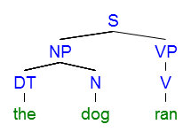
Here the sentence (S) is divided into a noun phrase (NP) and a verb phrase (VP). The noun phrase is divided into a determiner (DT) “the” and a noun (N) “dog”. The verb phrase consists of a single verb (V) “ran”.
To describe the space of possible trees, rules as to what constituents can be found within other constituents can be defined. For example, the above sentence is consistent with the following constituency grammar rules:
S → [NP VP] DT → “the”
NP → [DT N] N → “dog”
VP → [V] V → “ran”
By adding more structural rules (on the left), we can build more complex sentences. By adding more words (on the right), we can increase our vocabulary.

Left-Corner Parsing
As more rules are included in the grammar, parsing becomes more complicated. More rules mean more possibilities, and finding a tree that is consistent with the rules can become computationally expensive. For example, there may be the two rules VP → [V] and VP → [V NP], leading to an explosion of possible structures to search through. Furthermore, a single word may have multiple interpretations, such as N → “dog” and V → “dog”.
One standard approach to addressing this problem is to use a Left-Corner parsing algorithm. The idea here is to combine bottom-up information with top-down information. The top-down information is what part of speech we are currently looking for (a sentence, a noun phrase, a determiner, etc.). The bottom-up information is the single word we are currently processing. So, if we are currently looking for a noun, we will first try interpreting the word “dog” as a noun, rather than a verb. If this does not lead to a successful parse, then the algorithm will backtrack to this point and try the other option. This approach drastically reduces the amount of backtracking needed.
For “the dog ran”, the algorithm proceeds as follows:
- Top-down: look for S
- Bottom-up: see “the”
- Apply rule DT → “the”
- Apply rule NP → [DT N]
- Store the partially completed tree
  - Top-down: look for N for previous rule
  - Bottom-up: see “dog”
  - Apply rule N → “dog”
  - Merge with previously stored tree
- Apply rule S → [NP VP]
- Store the partially completed tree
  - Top-down: look for VP for previous rule
  - Bottom-up: see “ran”
  - Apply rule V → “ran”
  - Apply rule VP → [V]
  - Merge with previously stored tree
As has been pointed out (Johnson-Laird, 1983), this algorithm matches well with observed human sentence comprehension. For example, it has difficulty with “garden-path” sentences such as the classic “the horse raced past the barn fell”, which is difficult for most people to interpret even though it has a similar form as the easier sentence “the deer shot by the hunter fell”. A left-corner parser has the same tendency as people do to connect the ambiguous word “raced” as part of a S → [NP VP] rule.

Previous Models
Cognitive models of left-corner parsing already exist. For example, Lewis and Vasishth (2005) present an implementation using the ACT-R cognitive architecture. In that work, a set of IF-THEN production rules (for selecting grammar rules to apply) are combined with a declarative memory system (for storing the partially completed parts of the tree). The result is a computational model that shows how existing cognitive modules (for which there is strong prior evidence they exist in the human brain) can be re-purposed to perform left-corner parsing. The model's reaction times and error patterns match well to human subjects. However, this work does not offer a neural explanation of how those particular modules and structures could be physically instantiated within the human brain. Indeed, the question of how language could be represented and manipulated by interacting neurons is a long-standing question in cognitive science (e.g. Jackendoff, 2002).
For a neural explanation of this process, van der Velde and de Kamps (2006) offer their Neural Blackboard Architecture. Here, a set of specific neural groups can temporarily come to represent different nouns, verbs, adjectives, and so on. This makes it possible to represent structured information such as sentences. While we have previously argued (Stewart & Eliasmith, 2012) that the neural structures proposed by this approach are inefficient and do not correspond to those seen in real brains, the core difference here is that they have only shown how specific cases of sentence patterns might be parsed, rather than presenting a general method for parsing arbitrary compositional grammar rules, as is attempted here.
Finally, we previously presented a system for parsing highly specific sentence patterns, but using a biologically realistic neural model (Stewart & Eliasmith, 2013). These parsed commands, such as “write two” or “if see eight write three”, could be successfully interpretted as commands and used to guide action (Choo & Eliasmith, 2013). However, as with the work by van der Velde and de Kamps, this model was restricted to parsing highly specific grammatical forms. The purpose of this paper is to generalize to significantly more complex grammars and to connect this neural work to the grammatical structures seen in established linguistic theory.

Neural Engineering Framework

Vector Symbolic Architectures

For example, we can represent the tree for “the dog ran” as follows:
S = the⊛DT⊛NP_{L}⊛S_{L}
+ dog⊛N⊛NP_{R}⊛S_{L}
+ ran⊛V⊛VP⊛S_{R}
This computes a single vector S which store that particular tree. The terms the, dog, and ran are randomly chosen vectors for each of those words. The terms DT, N, NP_{L}, S_{R}, and so on are also randomly chosen vectors. These are used to indicate the structure of the tree. Note that there are different vectors for taking the left or right branch of the tree (the R or L subscript). This is so that the vector for a version of this tree with swapped branched (“ran the dog”) would be different than the vector for this tree (S_{L} and S_{R} would be swapped).
A similar approach could be used for trees with more than just binary branching (i.e. trees where there can be more than two children of a node). However, for the purposes of the left-corner algorithm implemented here, we only consider binary rules. Note that binary constituency rules (e.g. S → [NP VP]) are sufficient to implement the widely used standard X-bar grammars.

Semantic Pointer Architecture

Left-Corner Parsing in SPA
To develop a neurally plausible implementation of left-corner parsing within the Semantic Pointer Architecture, we need to define cortical modules, their functions, and the basal ganglia/thalamus rules that coordinate the flow of information between these modules.
For cortical modules, we only need one basic component: a buffer capable of storing a semantic pointer. This is a module that stores a single high-dimensional vector (for this model, 1000 dimensions is sufficient) over time. We need three of these: one to store the tree being built (tree), one to store the current top-down goal (goal; what part of speech we are looking for), and one to store the partially completed trees (partial). Note that the neural modules needed to visually recognize words, or to move visual attention from one word to the next, are not considered here (although see [ref:vision] and [ref:attention] for potential modules).
Since these buffers store vectors, we can use the approach of Vector Symbolic Architectures to store a tree within them. We assume words are presented sequentially, their vectors being stored in the buffer called tree.
We now need rules for the basal ganglia and thalamus system to cause the model to implement the parsing algorithm. We start with simple rules of the form X → [Y]. For each of these, we need a system that says if we're currently parsing a Y, we should build a tree that consists of an X connected to a Y. In terms of vectors, this means building a new vector that is X + tree⊛X. For example, if the tree buffer contains ran and we have a rule V → ran, we want to compute V + ran⊛V and store that in the tree buffer. This can be written in SPA form as follows:

U_{i}: tree∙Y
E_{i}: tree ← X + tree⊛X

Note that the utility of this rule is the dot product of whatever is in the tree buffer and the Y part of the rule, so it will only be active when the tree looks like Y.
To see how this helps to build up the desired tree, consider what happens if there is another similar rule implementing VP → [V]. Once the first rule is active, the tree buffer will contain V + ran⊛V. This will cause the rule for VP → [V] to have a high utility (since its utility is tree∙V). The effect of the rule is tree ← VP + tree⊛VP, so the result will be VP + (V + ran⊛V)⊛VP. This vector is highly similar to ran⊛V⊛VP, which is part of what we need for parsing the complete tree for “the dog ran”.
We also need to handle rules of the form X → [Y Z], which gives the branching capability to the tree. Here we need to not only build up a tree, but we also need to set a new top-down goal to find a Z. The utility is the same as in the previous rule (we want the rule to be active when tree contains a Y), but we also want to store the partially completed tree and go on to processing the next word. An initial version of this rule's effect would be:
E_{i}: partial ← X + tree⊛X_{L}
tree ← the next word
goal ← Z

This rule would successfully store the partially completed tree in the partial buffer, and then would go on to start trying to parse the next word, trying to find a Z. However, setting this new goal in this way would completely replace the old value in goal. Indeed, setting the new partial tree would completely erase any previous partial tree.
To deal with this, we exploit the vector-based representation to build an approximation of a “stack”. For example, if the goal currently contains the vector for S (a sentence), but due to a rule like NP → [DT N] we now need to look for an N (a noun), we can set the new goal to be N+goal⊛STACK, where STACK is another random vector. In this case, the goal will now be N+S⊛STACK. If we now need to look for a V (a verb), we would compute V+goal⊛STACK, giving V+(N+S⊛STACK)⊛STACK, or V+N⊛STACK+S⊛STACK⊛STACK. Note that to remove an item from the stack, we can compute goal⊛STACK⁻¹, which would give us back an approximation of N+S⊛STACK. This approximation will gradually become worse as the number of items in the stack increases.
The resulting rule for X → [Y Z] is as follows:

U_{i}: tree∙Y
E_{i}: partial ← X + tree⊛X_{L} + partial⊛STACK
tree ← the next word
goal ← Z + goal⊛STACK

Finally, we need a top-down rule to recognize when we have found a part of speech we are looking for. When it does so, we combine it with the partial tree on the stack, remove it from the stack, and continue. For a rule of the form X → [Y Z], we get:

U_{i}: (partial∙X)(goal∙tree)
E_{i}: tree ← partial + X_{R}⊛tree
goal ← goal⊛STACK⁻¹
partial ← partial⊛STACK⁻¹

So, if we are on the last word of “the dog ran”, the stored value in partial will be close to the⊛DT⊛NP_{L}⊛S_{L} + dog⊛N⊛NP_{R}⊛S_{L} and the value in tree will get built up to approximately ran⊛V⊛VP, as indicated previously. The goal will be VP. This means that the utility for this top-down version of the S → [NP VP] rule will be high (since partial∙S will be large and goal∙tree will be large). The resulting tree will be partial + S_{R}⊛tree, or approximately the⊛DT⊛NP_{L}⊛S_{L} + dog⊛N⊛NP_{R}⊛S_{L} + ran⊛V⊛VP⊛S_{R}. This is the desired vector for the correct parse of the tree.
This algorithm will work for arbitrary binary construction grammar rules. However, it needs to be extended to deal with multiple possible rules that could be applied at once (ambiguous sentences), as is discussed below.

Parsing Results

VP → [V NP]
S → [VP]
S → [NP VP]
NP → [DET N]
NP → [N]

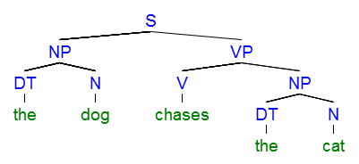

S → [SBAR VP]
SBAR → [IN S]
IN: subordinating conjunction (“if”)
SBAR: subordinating conjunction phrase
(connect to Choo & Eliasmith, 2013)

[IF_EQ]
S = if⊛IN⊛SBAR_{L}⊛S_{L}
+ see⊛V⊛VP_{L}⊛S⊛SBAR_{R}⊛S_{L}
+ square⊛N⊛NP⊛VP_{R}⊛S⊛SBAR_{R}⊛S_{L}
+ write⊛V⊛VP_{L}⊛S_{R}
+ two⊛N⊛NP⊛VP_{R}⊛S_{R}

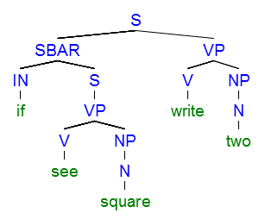

NP → [PRP]
PRP: personal pronoun

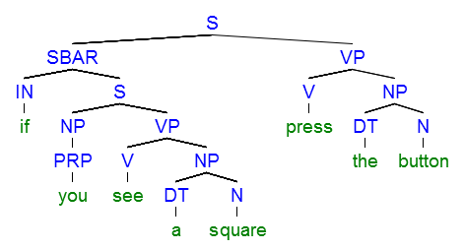

Parsing Accuracy
(how much accuracy do we need in the representation? What does that translate to in terms of needed numbers of neurons in the buffers? Lots of graphs. Something about depth would be good, too. Maybe another version of the prob/retries plot for a more complex sentence.)

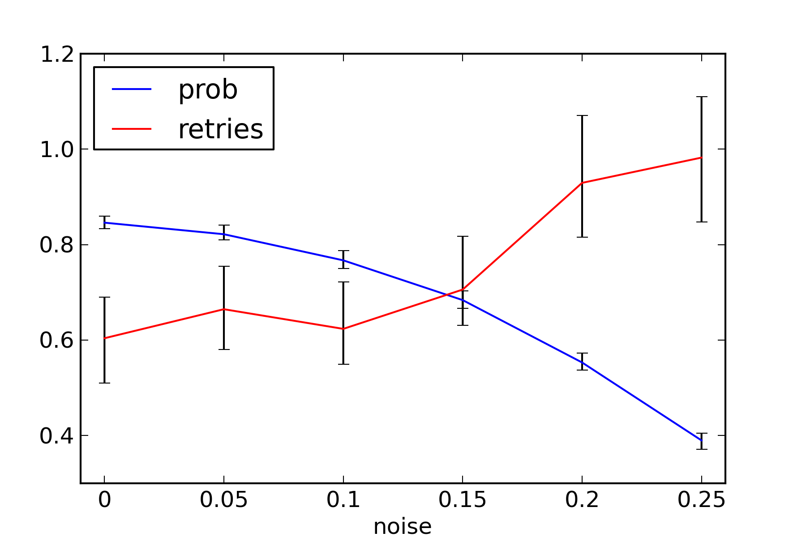
Figure: probability of correctly parsing and number of retries needed as the amount of noise changes

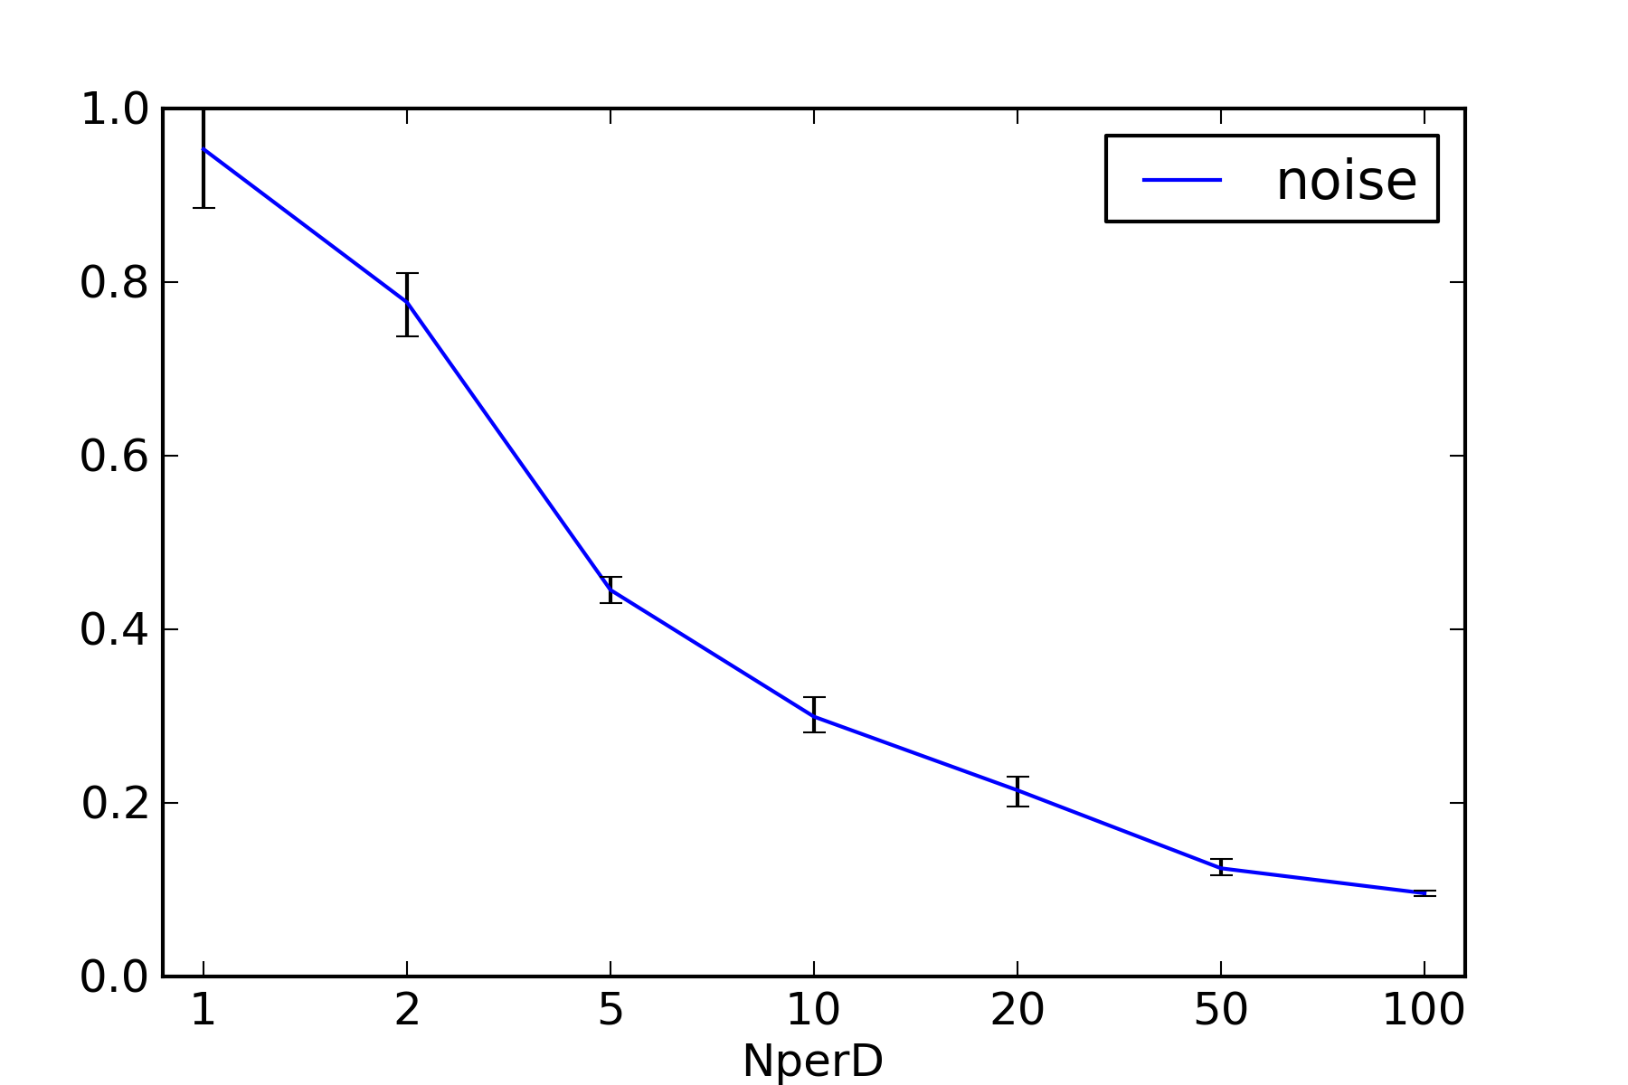
Number of neurons needed per dimension to get a certain level of noise

(mention how this shows that neural death will gradually decrease accuracy)

Using Parsed Commands
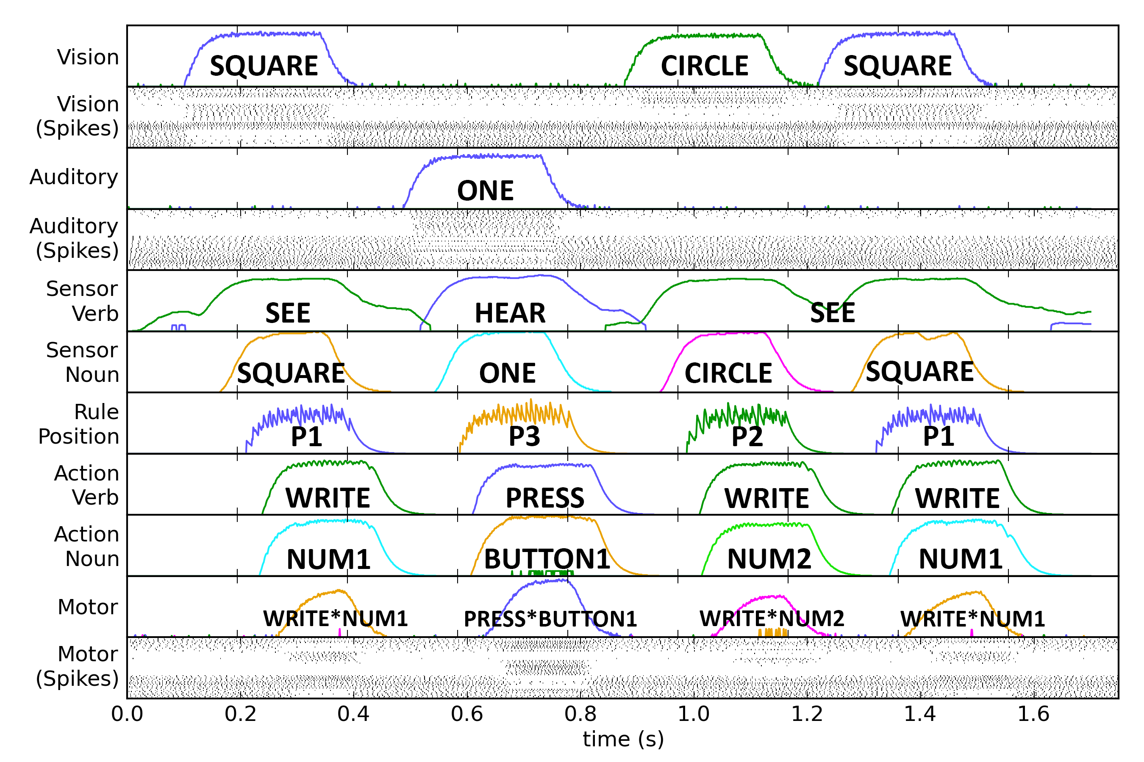Figure 1: Neural response data for a four-choice instruction task (see accompanying text for instruction details). Shown are the decoded representations of the visual and auditory systems, the sensor verb and noun terms associated with the stimuli, <the retrieved rule position>, the action verb and noun terms extracted from the parsed sentence SP, and the SP provided to the motor system.

In <cite instruction paper>, we presented a spiking neural model that is capable of processing arbitrary instructions that consist of multiple rules of the form:

“If antecedent conditions, consequent actions.”

These instructions are encoded as semantic pointers (SP), from which the model is able to extract the necessary information needed to complete said instructions. For example, the instruction “if see square, write two; if see circle, write one” is encoded as:

SP = P1⊛(ant(SENSE⊛vision +
SENSE_DATA⊛square) +
con(MOTOR⊛write +
MOTOR_DATA⊛two)) +
P2⊛(ant(SENSE⊛vision +
SENSE_DATA⊛circle) +
con(MOTOR⊛write +
MOTOR_DATA⊛one))

<cite instruction paper> did not however, elaborate on how these instruction SPs are be constructed. The work presented in this paper provides such a mechanism. Using <IF_EQ>, the instruction “if see square write two; if see circle write one” can then be constructed as:

SP = P1⊛(S_{if_see_square_write_two}) +
P2⊛(S_{if_see_circle_write_one})

where S_{if_see_square_write_two} and S_{if_see_circle_write_one} are the SPs for the sentences “if see square write two”, and “if see circle write one” respectively. Comparing the format of the parsed SP and the instruction SP, we see that the parsed SP can be transformed into an instruction SP with the following mapping:

ant = S_{L}
SENSE = V⊛VP_{L}⊛S⊛SBAR_{R}
SENSE_DATA = N⊛NP⊛VP_{R}⊛S⊛SBAR_{R}
cons = S_{R}
MOTOR = V⊛VP_{L}
MOTOR_DATA = N⊛NP⊛VP_{R}

Figure <MODEL_FIG> demonstrates the instruction processing model using and processing SPs generated with the sentence parsing algorithm presented previously. The instruction provided to the model in the figure above is:

- If see square write 1
- If see circle write 2
- If hear one press button1
- If hear two press button2

From the figure, it can be seen that extended instruction processing model is able to successfully use the parsed SPs as instruction SP.

**What else do we want to say here??
**Caveats: Currently limited to a specific sentence format. Will need to improve this in future models.

Future Directions
Automatically learning utilities to handle repair/recovery

Conclusions

Acknowledgments
This work was funded by... (ONR, ?)

References
Ball, J. (2011). A Pseudo-Deterministic Model of Human Language Processing. 33rd Cog. Sci. Society Conference.
Choo, X and Eliasmith, C. (2013). General Instruction Following in a Large-Scale Biologically Plausible Brain Model. 35th Cog. Sci. Society Conference.
Eliasmith, C. (2013). How to build a brain. Oxford University Press, New York, NY.
Eliasmith, C. & Anderson, C. (2003). Neural Engineering. Cambridge: MIT Press.Eliasmith et al., 2012
Gayler, R. (2003). Vector Symbolic Architectures Answer Jackendoff’s Challenges for Cognitive Neuroscience, in Slezak, P. (ed). Int. Conference on Cognitive Science, Sydney: University of New South Wales, 133–138.
Jackendoff, R. (2002). Foundations of language: Brain, meaning, grammar, evolution. Oxford, UK.
Johnson-Laird, P. N. (1983). Mental models. Cambridge, MA: Harvard University Press.
Lewis and Vasishth (2005)
Plate, T. (2003). Holographic Reduced Representations, CSLI Publications, Stanford, CA.
Stewart, T.C., Choo, X., and Eliasmith, C. (2010). Dynamic Behaviour of a Spiking Model of Action Selection in the Basal Ganglia. 10th Int. Conf. on Cognitive Modeling.
Stewart, T.C., and Eliasmith, C. (2012). Compositionality and biologically plausible models. In Oxford Handbook of Compositionality. Oxford University Press, 2012.
Terrence C. Stewart and Chris Eliasmith. Parsing sequentially presented commands in a large-scale biologically realistic brain model. In 35th Annual Conference of the Cognitive Science Society, 3460-3467. Cognitive Science Society, 2013.
van der Velde and de Kamps (2006)

