stmdsp Guide
v0.2

Written by
Clyne Sullivan
Table of Contents
Introduction 3
The stmdsp add-on board 4
Overview 4
Supported development boards 5
How to load the stmdsp firmware 5
The stmdspgui program 6
Overview 6
Menu Overview 7
File 7
Run 8
Code 9
Installation 10
Examples 11
Writing algorithms for stmdsp 11
Using the signal generator 13
Testing and analyzing algorithms 13
Viewing algorithm disassembly 13
Measuring algorithm execution time 14
Viewing the input and output waveforms 15
Recording the output signal to a file 15
Device configuration options 16

Introduction
The stmdsp project is a pairing of software and a hardware add-on board that enables STM32 Nucleo development boards to be used for designing digital signal processing (DSP) algorithms.
Some key features of the project:
- Algorithms are written in C++, and can be instantly uploaded to the development board without reprogramming the processor.
- Signals in the ±3.3V range can be sampled, at rates between 8kS/s and 96kS/s.
- Working with audio: the add-on board uses audio-focused operational amplifiers and low-pass filters to target the 20Hz – 20kHz frequency range.
- Two on-board potentiometers can be used to provide real-time inputs for algorithms.
- An on-board signal generator can produce an input signal from a data list, mathematical formula, or audio file (.wav).
- The stmdspgui graphical user interface (GUI) can be used for advanced algorithm testing and analysis, including:
  - Measuring algorithm execution time in processor clock cycles.
  - Configuring sampling rate and sample buffer size.
  - Plotting input and output signal data in real-time.
  - Capturing output signal data to a comma-separated (.csv) file.

The primary goal of the stmdsp project is to be an educational tool for teaching DSP with real-world examples.

The stmdsp add-on board

Overview
The add-on board provides the necessary input and output elements for the stmdsp project. The below image highlights the primary elements of the board:
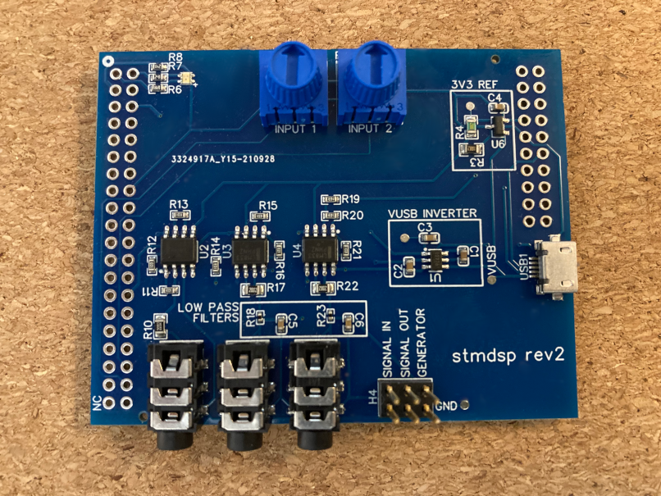
1.
2.
3.
4.
5.
- Status LED (RGB).
- Algorithm parameter knobs: Used to control custom algorithm parameters.
- USB power and communication port.
- 3.5mm jacks for input and output signals. Matches order of signal pins; from left to right: input signal, output signal, signal generator output.
- Input and output signal pins. Top row is for the signals, bottom row is ground. Note: Input signal ground is independent of output grounds.

The signal pins are designed to accept voltages in the ±3.3V range.

Supported development boards
The stmdsp add-on board is designed to interface with STM’s “Nucleo” line of development boards. The following boards are fully supported by the project:
- NUCLEO-L476RG
The following boards have previously seen full support for stmdsp, but are not up to date:
- NUCLEO-H743ZI
Many other “Nucleo-64” and “Nucleo-144” boards are capable of supporting stmdsp. There are only two requirements for compatibility: building the firmware for the development board, and confirming that the board’s pin arrangement is compatible with the add-on board.

How to load the stmdsp firmware
Loading the firmware requires the program OpenOCD.

The stmdspgui program

Overview
The stmdspgui provides a simple, yet robust environment for designing and testing DSP algorithms. The program is designed to support both Windows and Linux operating systems.

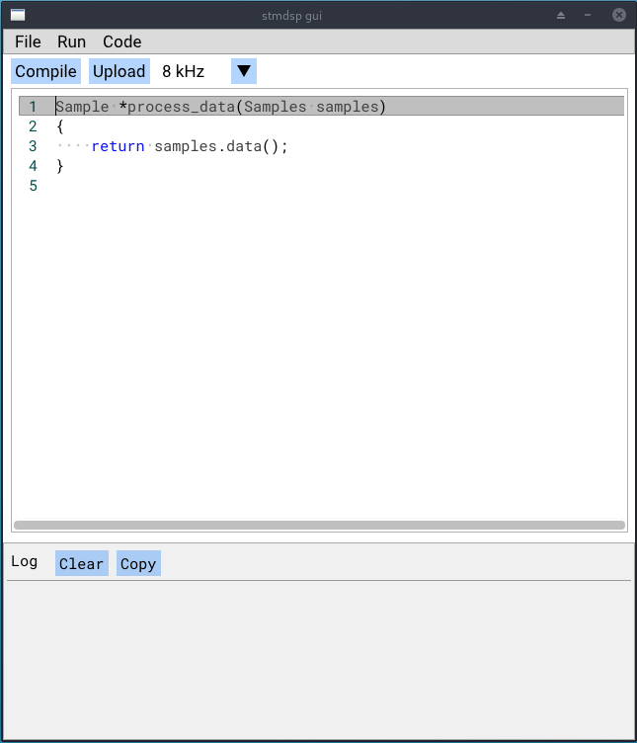

Menu Overview

File
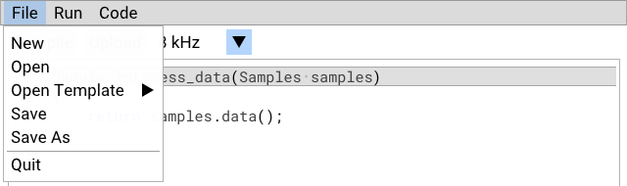
New: Closes the current file (if any), and puts the algorithm starting template into the text editor.
Open: Opens an existing algorithm file; these are simply C++ source files with the .cpp extension.
Open Template: Provides a list of algorithm examples and templates that can be used as the basis of a new algorithm.
Save: Saves the current algorithm.
Save As: Saves the current algorithm as if it is a new file.
Quit: Exits the application. Do not exit while an stmdsp device is connected and running an algorithm.

Run
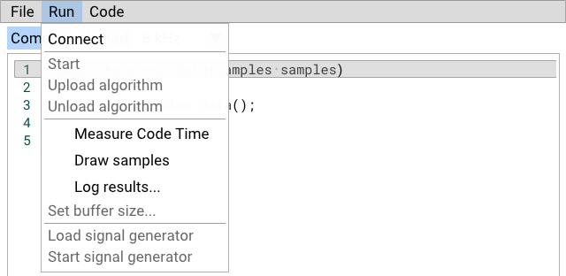
Connect: Connects to an stmdsp device if it is plugged into the computer. If a device is connected, this menu option becomes “Disconnect”.
Start: Begins running the currently loaded algorithm, or runs in “passthrough” mode if no algorithm is loaded. When an algorithm is running, this menu option becomes “Stop”.
- “Passthrough” mode transfers input signal data directly to the output.
- If an error occurs while an algorithm is running (e.g. due to an improperly written algorithm), the device will automatically unload the algorithm and stop signal processing.
Upload algorithm: Uploads the most recently compiled version of the current algorithm. The current algorithm must be compiled before it can be uploaded to the device.
Unload algorithm: Unloads the currently loaded algorithm, if one is loaded.
Measure Code Time: Enables or disables the measurement of algorithm execution time.
Draw samples: Enables or disables input/output signal visualization.
Log results…: Enables or disables the logging of output signal sample data to a file.
Set buffer size…: Allows for changing the size of the sample buffer that algorithms work with.
Load signal generator: Opens a prompt for loading sample data into the signal generator.
Start signal generator: Turns on the signal generator. With the exception of audio streaming, the generator can be run independent from the rest of the device. This menu entry becomes “Stop signal generator” when the generator is running.

Code
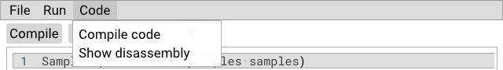
Compile code: Compiles the algorithm code currently in the text editor into a program file. Algorithms are loaded to the device in the form of program files, so this step is necessary in order to run an algorithm.
- Algorithm compilation may fail if there is an error in the algorithm code. In this case, the log view below the text editor should provide details on the errors that were encountered.
- After successful compilation, the log view will show algorithm code and data size. Algorithms have a limited amount of available memory to work with, so monitoring code and data size is important.
Show disassembly: Shows the disassembly of the most recently compiled algorithm.

Feature descriptions

Measure Code Time
This option tells the device to approximately measure the execution time of the loaded algorithm. The measurement takes place on the first execution of the algorithm. Execution time is measured in processor clock cycles; dividing by processor clock frequency can convert this value to seconds. Note that the measurement is approximate, and may vary between tests.
Measurement results are reported in the log view below the text editor. An example is shown below: the algorithm took 164,723 cycles to complete. On the NUCLEO-L476RG board, the processor runs at 72MHz, meaning this algorithm took 164,723 ÷ 72,000,000 = 2.2878 milliseconds to run.
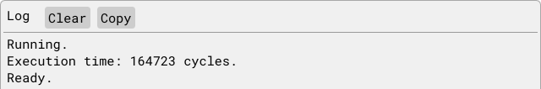

Draw Samples
stmdspgui is capable of reading input and output signal data from the device while it is running an algorithm. This allows for visual analysis of the signals, just as would be done with an oscilloscope.
The “Draw Samples” window runs while the device has been started. A screenshot of this window is shown below. By default, the output signal is displayed with an X range of one second and a Y range of ±3.3V. Options are available to overlay the input signal and modify the X or Y ranges. Range adjustments are made in factors of two, allowing for a time range of ~8 milliseconds to 32 seconds and a Y range of ±0.05V to ±3.3V.
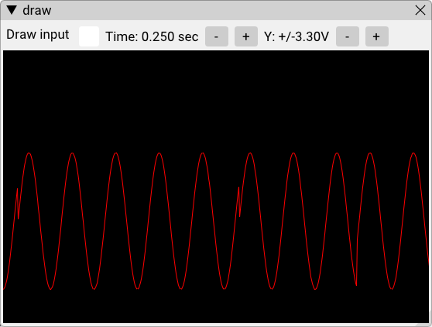

Log Results
This feature allows for the recording of output signal samples while an algorithm is being run. The sample data is recorded to a comma-separated (.csv) file that is chosen when this option is enabled. Recording ends once the algorithm is stopped. Repeated algorithm starts will append to the currently chosen .csv file.

Set Buffer Size
The size of the buffer passed into the algorithm can be set within the range of 100 to 4,096 samples. By default, algorithms use the maximum buffer size of 4,096 samples. Some algorithms benefit from smaller sample sizes; however, decreasing the buffer size will also decrease the amount of time between algorithm function calls. It is important to ensure that the algorithm can complete before the next buffer of samples is ready for processing.
If the algorithm is too slow, the device will stop running the algorithm.

Signal Generator
S

Algorithm Disassembly
S

Installation
stmdspgui uses the GNU compiler toolchain to compile algorithms. Download the latest toolchain installer from the link below:
https://developer.arm.com/tools-and-software/open-source-software/developer-tools/gnu-toolchain/gnu-rm/downloads
Follow the installation instructions, and on the final screen be sure to check the option for “Add path to environment variable,” as below:
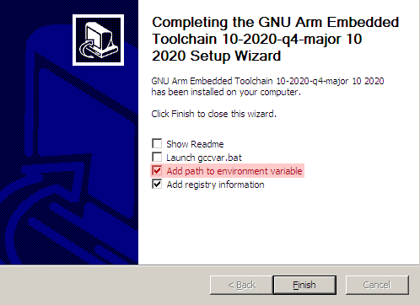
The first two options are unnecessary, and may be unchecked.

Once the toolchain is installed, stmdspgui can be downloaded from the Releases page on its online source code repository:
https://github.com/tcsullivan/stmdspgui/releases

Examples

Writing algorithms for stmdsp
This tutorial will guide you through writing your own custom DSP algorithms for the stmdsp device.
Algorithms are written in the programming language C++. The following C++ resources may be useful:
- C++ tutorial: https://www.cplusplus.com/doc/tutorial/
- C++ language reference: https://en.cppreference.com/w/

When you create a new algorithm, the following template is given:
Sample *process_data(Samples samples)
{
return samples.data();
}
The function process_data is responsible for transforming the incoming signal. Samples from the input signal are provided in the samples parameter; the function is then expected to return a pointer to the transformed sample data. In the above template, the input samples are simply provided as the output, creating a signal "passthrough".
- The amount of samples in the samples parameter can be set by the GUI, defaulting to the maximum of 4096.
- Signal samples are 12-bit integers: the lowest sample value is zero (-3.3 volts) while the highest values is 4095 (+3.3 volts).
Here is another example of an algorithm that halves the values of the input samples:
Sample *process_data(Samples samples)
{
// This line is a comment.
// Half the value of every sample in the buffer:
for (int i = 0; i < samples.size(); i++) {
samples[i] = samples[i] / 2;
}

return samples.data();
}

Some algorithms may require the input data to be preserved. In this case, a buffer for the algorithm’s output data can be created and used:
Sample *process_data(Samples samples)
{
// Create an array of samples:
static Sample output[samples.size()];

for (int i = 0; i < samples.size(); i++) {
// Use the output buffer in case we’ll need the original input
// samples later.
output[i] = samples[i] / 2;
}

return output;
}

- The Samples object is based on C++'s std::span object, which wraps over a regular Sample array. std::span provides useful utilities for more complex algorithms.
- These algorithms use two different types of memory: stack memory and program memory. By default, variables in your algorithm will be in stack memory; however, the amount of stack memory available is small compared to the available program memory. Larger variables, like sample buffers, should be placed in program memory by declaring them with the static keyword.

Using the signal generator
The stmdsp device provides a single-channel signal generator in case an external signal source is not available. The generator can be initialized in three ways:
- Sample list: A list of sample values (ranged zero to 4095) separated by any non-digit characters.
For example, a list could be generated in a spreadsheet then simply copy/pasted into the GUI.
- Formula: An "f(x)" function can be supplied to generate a 4096-sample buffer. Remember that the function should provide values in the zero to 4095 sample value range.
- Audio: A .wav file can be loaded and played through the signal generator. The audio data is sent to the generator when the algorithm is started.
The signal will be produced at the current sample rate.

Testing and analyzing algorithms
The GUI is provides numerous features to study your algorithm's performance:

Viewing algorithm disassembly
After you have successfully compiled your algorithm, you can view your algorithm's disassembly. This allows you to see the processor instructions that make up your algorithm, and can be studied to determine an algorithm's efficiency. To view the disassembly, click the "Show disassembly" option under the Code menu. The disassembly will be displayed in the terminal pane, as shown below:

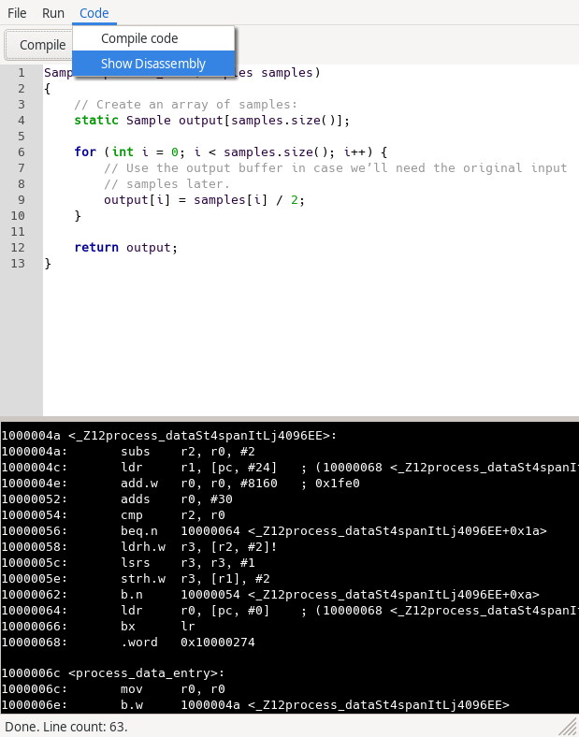
Device configuration options
The GUI allows for the configuration of the device's sampling rate and algorithm buffer size, which may affect the performance of your algorithm.
The sampling rate determines the frequency at which the device samples the incoming signal. Higher sampling rates have benefits including improved input and output signal detail, as well as the ability to detect higher frequency signals. However, high sample rates come at the cost of less time available for algorithm execution, restricting an algorithm's capabilities.
Setting the sample rate is simply achieved using the drop down box above the code editor:
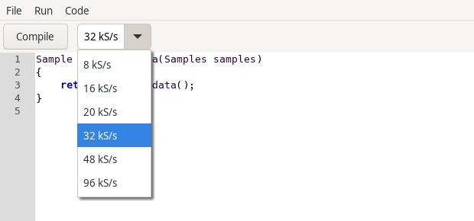
Note that the selected sampling rate also applies to the signal generator; that is, the generator will create its signal at the same rate.

