NANYANG POLYTECHNIC
ITI113 MACHINE LEARNING & OPERATIONS PROJECT

FINAL REPORT
Explainable Diabetes Risk Screening
Using Machine Learning and MLOps
Binary classification of BRFSS 2015 health indicators for
prediabetes/diabetes screening support

Item | Details
Module | ITI113 Machine Learning & Operations Project
Team / Group Number | Team 2
Student 1 | Djony Pamudji (2730358J) – Model A (Logistic Regression)
Student 2 | Fong Siang Yi (8440104B) – Model B (XGBoost)
Student 3 | Teh Tze Chee (1552444F) – MLOps Developer
Dataset | Diabetes Health Indicators Dataset
Submission Date | 27 August 2026

Intended use: Academic prototype for preliminary diabetes screening support and health awareness. It is not intended for medical diagnosis, treatment decisions, insurance or employment decisions, or prediction of future disease onset.

Table of Contents
1. ML Formulation (Djony + Siang Yi + Tze Chee) 4
2. Data Preparation & Feature Engineering (Djony + Siang Yi) 4
2.1 Dataset, Target Definition and Data Quality (Djony + Siang Yi) 4
2.2 EDA Findings and Data Preparation Decisions (Djony + Siang Yi) 4
2.3 Feature Engineering and Model-Specific Preparation (Djony + Siang Yi) 5
2.4 Class Imbalance, Bias and Representativeness (Djony + Siang Yi) 5
2.5 Data Lineage and Reproducibility (Djony + Siang Yi) 6
3. Modelling & Experiments (Djony + Siang Yi) 6
3.1 Problem Formulation and Modelling Objective (Djony + Siang Yi) 6
3.2 Baseline Model and Experimental Hypothesis (Djony + Siang Yi) 6
3.3 Logistic Regression Experimental Design and Evaluation Plan (Djony) 7
3.4 Model A Development and Final Results (Djony) 7
3.5 XGBoost Model Design and Rationale (Siang Yi) 10
3.6 Experimental Design and Tuning Strategy (Siang Yi) 10
3.7 Experimental Findings and Model Behaviour (Siang Yi) 11
3.8 Error Analysis (Siang Yi) 12
3.9 Performance Tuning and Trade-offs (Siang Yi) 12
3.10 Final / Champion Model Justification (Djony + Siang Yi) 13
4. MLOps Pipeline and Deployment (Tze Chee) 14
4.1 End-to-End MLOps Architecture (Tze Chee) 14
4.2 Experiment Tracking and Reproducibility (Siang Yi + Tze Chee) 15
4.3 Model Registry, Human Approval and Deployment (Tze Chee) 15
4.4 CI/CD, Scalability and Model Updating (Tze Chee) 16
4.5 Monitoring and Lifecycle Management (Tze Chee) 17
4.6 Demo Application and Inference Architecture (Tze Chee) 17
4.7 Testing, Governance and Limitations (Tze Chee + Djony + Siang Yi) 18
5. AI Governance and Final Solution Testing (Tze Chee + Siang Yi + Djony) 19
5.1 Governance Scope and Validation Boundary (Tze Chee + Djony + Siang Yi) 19
5.2 Fairness Testing and Residual Bias Risk (Siang Yi + Djony + Tze Chee) 20
5.3 Explainability and Transparency Testing (Siang Yi + Djony + Tze Chee) 20
5.4 Robustness and Final-Solution Validation (Siang Yi + Tze Chee) 21
5.5 Governance Position and Residual Risk (Tze Chee + Siang Yi + Djony) 21
6. Individual Contributions / Evidence (Djony + Siang Yi + Tze Chee) 22
7. Issues, Lessons and Next Steps (Djony + Siang Yi + Tze Chee) 23
Appendix A1 — Dataset Source and Target Definition Evidence 24
Appendix A2 — Schema Validation and Duplicate-Safe Split Evidence 25
Appendix A3 — Outlier and Prevalence Evidence 26
Appendix A4 — Correlation Evidence 27
Appendix B1 — Feature Engineering Definitions and Validation Evidence 28
Appendix B2 — Data Type Optimisation Evidence 29
Appendix B3 — Class-Imbalance Strategy Evidence 30
Appendix B4 — Artifact Persistence and Lineage Evidence 30
Appendix B5: Logistic Regression Experiment Workflow, Model Artifact and Staging Handoff Evidence 31
Appendix C1 – Modelling and Experimental Evidence 33
Appendix D1 — MLOps Pipeline, Experiment Tracking and Reproducibility 42
Appendix D2 — CI/CD, Scalability and Model Updating 50
D2.1 Controlled S3 Change-Trigger Demonstration 50
D2.2 Trigger Execution Evidence 52
D2.3 Scalability and Production Evolution 53
D2.4 Model Updating and Governance Boundary 55
D2.5 CI/CD Implementation Status 56
Appendix D3 — Demo Application Architecture, Governance and Testing 57
Appendix E1 — Fairness and Explainability Test Evidence 64
Appendix E2 — Robustness, Deployment and Governance Evidence 71

1. ML Formulation (Djony + Siang Yi + Tze Chee)
The project frames diabetes risk screening as a supervised binary classification problem. Given a respondent's health profile, the model estimates whether the record is associated with no diabetes or with the combined prediabetes/diabetes risk class. The objective is to support early risk awareness and screening prioritisation rather than provide a clinical diagnosis.
The model input consists of 21 BRFSS health indicators, covering health history, BMI, lifestyle behaviours, healthcare access, general health and demographic/socioeconomic characteristics. The prediction target is Diabetes_binary, where 0 represents no diabetes and 1 represents prediabetes or diabetes. Logistic Regression is used as the interpretable baseline, while XGBoost is evaluated as the non-linear alternative and selected as the final champion based on the project's comparative modelling and evaluation.
The problem objective and ML objective are therefore directly linked. From an application perspective, the system should identify individuals whose profiles warrant further screening while avoiding excessive unnecessary alerts. From an ML perspective, this requires effective discrimination of the minority positive class and careful management of false negatives, rather than maximising overall accuracy on an imbalanced dataset. PR-AUC is therefore used as the primary model-selection metric, supported by ROC-AUC, recall, precision, F1-score, balanced accuracy and subgroup analysis to assess the broader trade-offs relevant to screening.

2. Data Preparation & Feature Engineering (Djony + Siang Yi)

2.1 Dataset, Target Definition and Data Quality (Djony + Siang Yi)
The project uses a Kaggle-hosted cleaned derivative of the CDC 2015 Behavioral Risk Factor Surveillance System (BRFSS). The three-class extract was selected because it preserves the natural population distribution and includes prediabetes, giving 253,680 records and 21 predictors. Diabetes_binary maps Diabetes_012=0 to class 0 and Diabetes_012 in {1,2} to class 1, producing a 15.76% positive rate consistent with the Proposal. Diabetes_012 is removed before modelling and a hard check prevents it from appearing with the derived target, avoiding direct target leakage. All source columns passed pre-declared schema, range and null checks. However, the Kaggle cleaning had already removed BRFSS 'don't know' and 'refused' responses, so zero nulls should not be interpreted as complete population coverage. Dataset selection, target validation and schema evidence are provided in Appendix A1 (Tables A1-1 to A1-2; Figure A1-1) and Appendix A2 (Table A2-1).

2.2 EDA Findings and Data Preparation Decisions (Djony + Siang Yi)
EDA was used to drive preparation and modelling decisions rather than only describe distributions. Exact duplicate analysis identified 23,899 duplicate rows, with 35,086 records (13.83%) belonging to duplicate-profile groups. Because repeated low-risk profiles are more common, deleting duplicates could distort the natural class distribution. The team therefore retained all observations but assigned identical feature-target profiles to a single partition, producing a leakage-safe stratified 70/15/15 split with stable positive rates (Appendix A2, Table A2-2). BMI also shows a long right tail (maximum 98; 99th percentile 50), while MentHlth and PhysHlth are top-coded at 30 days; these were treated as valid survey characteristics rather than data errors (Appendix A3, Figure A3-1). Correlation and prevalence analysis found no dominant single predictor and no predictor pair above |r|=0.80. GenHlth and HighBP are among the strongest raw correlates, while HeartDiseaseorAttack, DiffWalk, HighBP and Stroke show the largest positive prevalence gaps (Appendix A3, Figure A3-2; Appendix A4, Figure A4-1).
The strongest modelling insight is the joint increase in diabetes/prediabetes prevalence across BMI category and poorer self-rated general health, rising from about 1% to 61% across the observed extremes. This interaction supports engineered cumulative-risk features and the use of XGBoost as a nonlinear challenger.
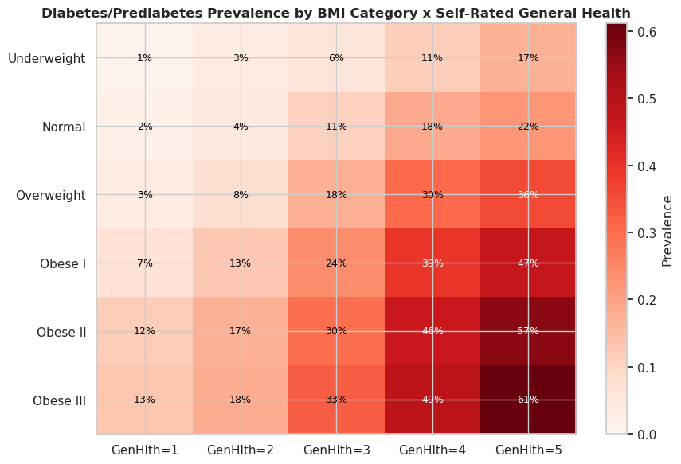
Figure 1. Diabetes/prediabetes prevalence by BMI category × self-rated general health. Prevalence rises from 1% (Underweight, GenHlth=1) to 61% (Obese III, GenHlth=5), demonstrating a super-additive interaction effect.

2.3 Feature Engineering and Model-Specific Preparation (Djony + Siang Yi)
Seven deterministic features were engineered from validated inputs: BMI_Category, Comorbidity_Score, Unhealthy_Days, Healthy_Lifestyle_Score, Healthcare_Access_Barrier, Age_Midpoint and BMI_HighBP_Interaction. They translate the EDA findings into model-ready signals for cumulative comorbidity, BMI leverage, unhealthy-day burden, lifestyle, access barriers, age and interaction effects. Quantitative validation shows Comorbidity_Score (r=0.347) and BMI_HighBP_Interaction (r=0.306) exceed the strongest raw feature, GenHlth (r=0.301); Healthcare_Access_Barrier is retained for governance analysis despite near-zero linear correlation (Appendix B1, Tables B1-1 and B1-2). After schema validation, safe type downcasting reduced memory usage from 44.5 MB to 6.8 MB (85%) without altering values (Appendix B2, Table B2-1).
The same data lineage supports model-specific preprocessing: XGBoost receives the raw/tree-ready feature set, while Logistic Regression standardises continuous and ordinal variables using a StandardScaler fitted on training data only; binary indicators remain unscaled. The canonical pipeline artifacts use the duplicate-safe 70/15/15 split. The later head-to-head model experiment uses a separate 80/20 stratified holdout with 5-fold cross-validation so both algorithms are compared on identical held-out rows; this experiment-specific split does not replace the canonical pipeline split.

2.4 Class Imbalance, Bias and Representativeness (Djony + Siang Yi)
The training partition has a 5.34:1 negative-to-positive ratio, so class weights and XGBoost scale_pos_weight were computed from training data only and reused unchanged. No SMOTE or synthetic resampling was applied, avoiding additional distribution and calibration distortion (Appendix B3, Table B3-1). Representativeness remains a material limitation: the dataset is a 2015 U.S.-only, self-reported telephone survey and lacks laboratory measurements, medication history, family history and geographic context. Prior removal of non-response categories may also introduce selection effects. These risks support the project's screening-not-diagnosis scope, subgroup fairness testing, explicit model limitations and continued human oversight rather than assuming preprocessing can remove historical or representation bias.

2.5 Data Lineage and Reproducibility (Djony + Siang Yi)
Processed train/validation/test artifacts, the deduplicated sensitivity dataset, data dictionary, data-quality report and JSON lineage record are persisted locally and to the shared SageMaker S3 location. The lineage record captures the target definition, split strategy, engineered features and train-only imbalance settings, providing a traceable and reproducible hand-off from data preparation to modelling and MLOps (Appendix B4, Table B4-1).

3. Modelling & Experiments (Djony + Siang Yi)

3.1 Problem Formulation and Modelling Objective (Djony + Siang Yi)
The modelling task is a supervised binary classification problem using 21 self-reported clinical, lifestyle, healthcare-access and demographic indicators to predict diabetes/prediabetes risk. The original three-class diagnosis label is collapsed into a binary target because both prediabetes and diabetes warrant the same downstream action—referral for confirmatory clinical testing—while the distinction between them should be made clinically rather than by a self-report screening model.
The key modelling challenge is class imbalance, with roughly five negative cases for every positive case. Accuracy is therefore unsuitable as the primary metric because a classifier predicting only the majority class could appear accurate while providing no screening value.
Model selection is consequently based primarily on PR-AUC, which better reflects minority-class discrimination than ROC-AUC under imbalance. Recall, precision, F1 and balanced accuracy are reported as threshold-dependent complements. This distinction is important because the baseline and challenger models have similar ROC-AUC values but differ more meaningfully in PR-AUC performance (Appendix C2, Table C2-7).
Recall remains particularly important because false negatives may delay confirmatory testing and intervention, whereas false positives mainly incur an unnecessary follow-up test. F2 is therefore used as a secondary metric because it places greater weight on recall. Balanced accuracy and specificity are also reported to ensure that improved recall is not achieved by indiscriminately classifying excessive cases as positive.

3.2 Baseline Model and Experimental Hypothesis (Djony + Siang Yi)
Logistic Regression was selected as the baseline because it provides a simple and interpretable reference for testing whether non-linear modelling improves diabetes-risk prediction. As a linear model, it assumes that features contribute additively to the log-odds of the outcome and does not automatically capture interactions between risk factors.
This limitation formed the basis of the experimental hypothesis: an ensemble model capable of learning non-linear relationships and feature interactions should improve identification and ranking of positive diabetes cases compared with the linear baseline. The expected improvement was primarily in minority-class-sensitive metrics such as PR-AUC, recall and F1, rather than necessarily across all performance measures.
The baseline therefore provides a meaningful low-complexity benchmark against which the additional predictive value of XGBoost can be evaluated.

3.3 Logistic Regression Experimental Design and Evaluation Plan (Djony)
The experimental design provides a controlled and reproducible comparison between Model A (Logistic Regression) and Model B (XGBoost). Both models use the same cleaned dataset, binary target definition, data-profile logic and split strategy so that performance differences mainly reflect the modelling approach rather than different data inputs.
- Data split and stratification: The final experiment uses the 100% data profile (253,680 records) with a reproducible 80/20 stratified split: 202,944 training and 50,736 held-out records. Stratification is required because the positive Diabetes_binary class represents about 15.76% of the data, and it helps preserve a similar class distribution across the training and held-out partitions. Model development within the training set uses Stratified 5-Fold Cross-Validation.
- Leakage prevention: Diabetes_012 is excluded from the modelling features because Diabetes_binary is derived from this original label; including it would introduce direct target leakage. Hyperparameter selection and threshold optimization are performed using training data only. The held-out set is reserved until the model hyperparameters and operating threshold have been fixed.
- Model and threshold selection: Logistic Regression evaluates 12 configurations formed from six C values and two class_weight settings using 5-fold CV. Candidates are ranked first by mean CV PR-AUC and then by mean CV ROC-AUC as the tie-breaker. After the hyperparameters are fixed, the classification threshold is optimized using training-only out-of-fold probabilities. The F1-based search selects a threshold of 0.59, with balanced accuracy and recall used as tie-breakers.
- Evaluation metrics: PR-AUC is prioritized because the positive class is imbalanced and the project is concerned with identifying respondents who may require follow-up. ROC-AUC, recall, precision, F1, balanced accuracy and accuracy are also reported to assess ranking performance and the trade-off between missed positive cases and false-positive screening flags.
Held-out evaluation: The final Logistic Regression model achieves PR-AUC 0.4327 and ROC-AUC 0.8176 on the held-out set and exceeds the predefined ROC-AUC quality gate of ≥ 0.75. The same leakage-control and evaluation discipline is applied to Model B to support a fair comparison between the two model families.

3.4 Model A Development and Final Results (Djony)
Model A develops the untuned Logistic Regression baseline into the final tuned candidate using the full 100% data profile, the same split logic and the same evaluation controls. The baseline showed reasonable ranking ability but weak positive-class detection, with recall of approximately 0.18. Model A therefore evaluates whether class weighting and regularization tuning can improve minority-class detection without materially reducing ranking performance.
Tuning objective: evaluate two modelling decisions, regularization strength (C) and class weighting, while holding the remaining Logistic Regression settings fixed. This allows the relative effect of each setting on model performance to be assessed.
Search design: 12 configurations were evaluated from six C values (0.001, 0.01, 0.1, 1, 10 and 100) crossed with class_weight=None and class_weight='balanced'. All candidates used L2 penalty, lbfgs and max_iter=3000.
Why class weighting was tested: the positive Diabetes_binary class represents about 15.76% of records. The balanced setting gives greater weight to minority-class errors during model fitting and directly addresses the baseline's poor positive-class recall.
Validation and leakage control: all 12 candidates were compared using training-only Stratified 5-Fold CV. Candidates were ranked by mean CV PR-AUC first and mean CV ROC-AUC second. The held-out test set was not used for hyperparameter selection or threshold selection.
Tuning result: class weighting produced the dominant improvement in minority-class detection. At the default threshold of 0.50, CV recall increased from 0.1837 for the unweighted baseline to 0.7615 with the selected balanced configuration, while CV PR-AUC changed from 0.431205 to 0.429813 and CV ROC-AUC from 0.817191 to 0.817737. Changes in C among the leading balanced configurations had much smaller effects on the headline ranking metrics.
Selected candidate: lr_candidate_12, with C=100 and class_weight='balanced'. On the 100% data profile, mean CV PR-AUC was 0.429813 and mean CV ROC-AUC was 0.817737. At the default threshold of 0.50, CV balanced accuracy was 0.742089, F1 was 0.469485, precision was 0.339358 and recall was 0.761491.
Threshold optimization: after the hyperparameters were fixed, training-only out-of-fold probabilities were evaluated over thresholds from 0.05 to 0.95 in 0.01 increments. A grid search using F1 as the primary objective selected 0.59, giving OOF F1 0.4827, precision 0.3813, recall 0.6575 and balanced accuracy 0.7290. The threshold is an F1-based operating compromise and should not be interpreted as a clinically validated screening threshold.
Final held-out result at threshold 0.59: ROC-AUC 0.8176, PR-AUC 0.4327, balanced accuracy 0.7284, F1 0.4820, precision 0.3807, recall 0.6567, specificity 0.8002, FPR 0.1998 and FNR 0.3433. The held-out ROC-AUC of 0.8176 exceeds the project's predefined quality gate of 0.75.
Interpretation: Model A retains essentially the same ranking performance as the untuned baseline while substantially improving positive-class detection. The near-unchanged PR-AUC and ROC-AUC indicate that class weighting mainly changed the classification operating point rather than materially improving the model's ability to rank positive cases above negative cases. The higher recall comes at the cost of lower precision and more false-positive follow-up flags, consistent with the intended screening-support use case rather than diagnosis.
Consistency check: 100% CV ROC-AUC (0.817737) and held-out ROC-AUC (0.8176) are closely aligned, providing an initial indication of consistent ranking performance. This should not be interpreted as proof of external generalization; further validation would be required before production use.
Experiment traceability: detailed MLflow run, artifact, threshold-search and model-handoff evidence is retained in Appendix B5.
Key finding: within the tested configurations, class weighting provides the largest practical improvement in Logistic Regression, while changes in C and increasing the data profile have much smaller effects on headline metrics. The final Model A configuration is C=100, class_weight='balanced' and threshold 0.59 using the 100% data profile. The Logistic Regression model remains a Model A candidate pending comparison with the XGBoost challenger.
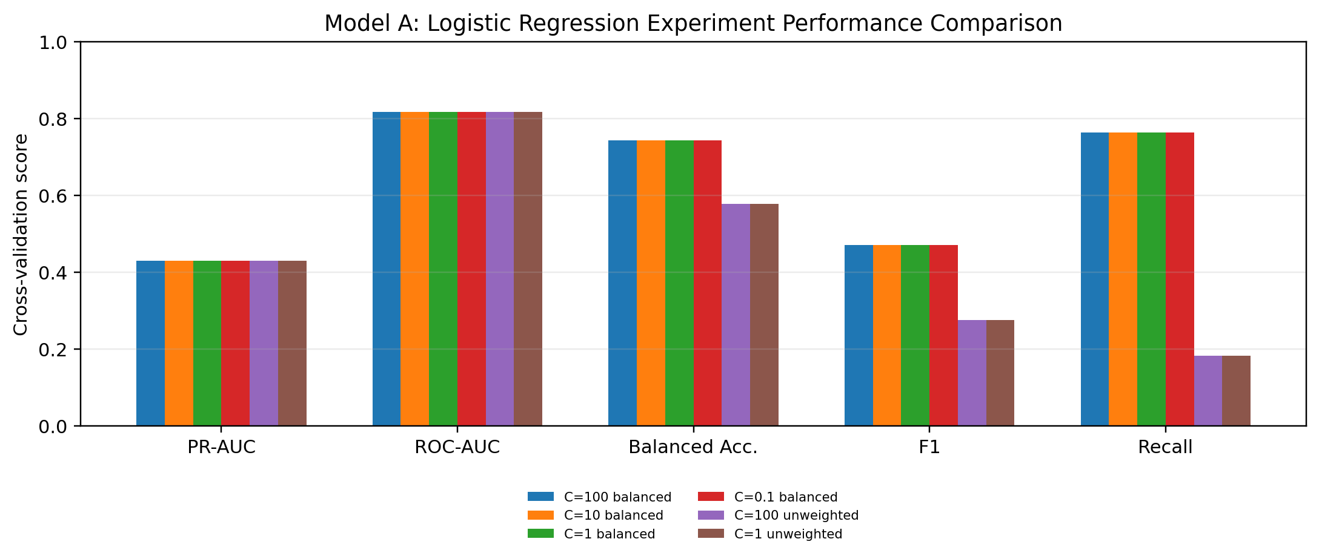
Figure 2. Model A performance comparison across Logistic Regression experiment configurations (Stratified 5-Fold CV).

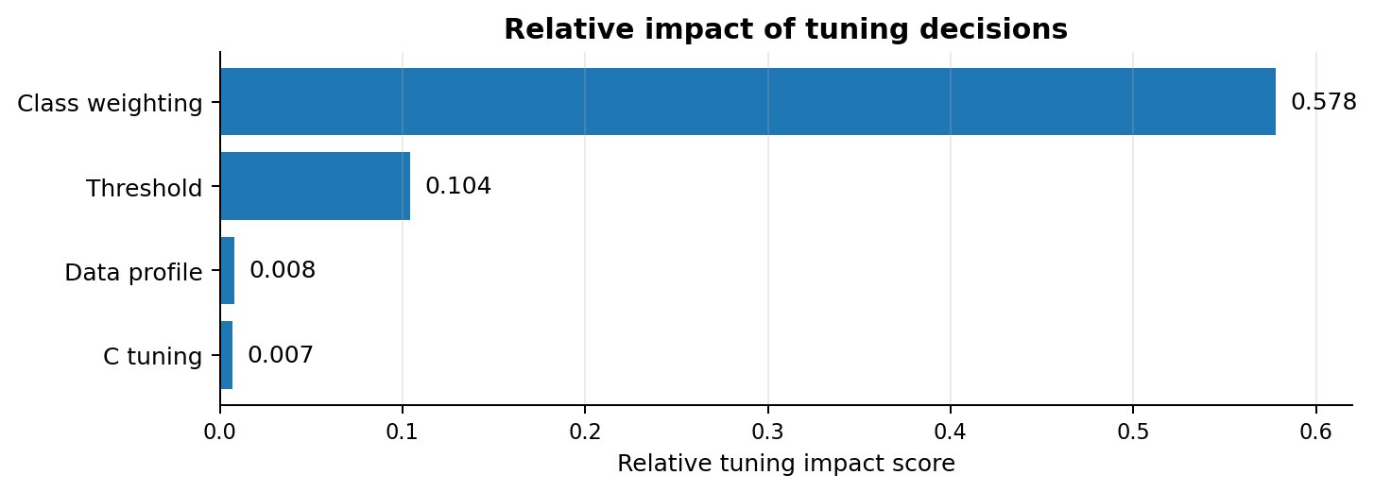
Figure 3. Relative impact of tuning decisions, corresponding to the comparison shown on slide 4.

The relative-impact comparison reinforces that class weighting is the dominant tuning lever (0.578), followed by threshold tuning (0.104), while data-profile and C-tuning effects are much smaller (0.008 and 0.007). These scores are comparative impact scores from the experiment summary, not percentage-point changes in PR-AUC or ROC-AUC.
Key interpretation: The near-unchanged PR-AUC and ROC-AUC indicate that class weighting mainly changed the classification operating point rather than materially improving the model's ability to rank positive cases above negative cases.
Additional final-report evidence
• Robustness: 200 held-out bootstrap resamples gave 95% CIs of 0.8131–0.8224 for ROC-AUC and 0.4210–0.4444 for PR-AUC. F1 remained 0.4740–0.4905.
• Subgroup analysis: the Sex FNR gap was small (0.0017), while the maximum FNR gaps were 0.7890 for Age, 0.3649 for Education and 0.4065 for Income. These are descriptive disparities, not proof of unfairness, and should be investigated before deployment.
• Explainability: the strongest positive coefficients were CholCheck, HighBP, HighChol and GenHlth; the strongest negative coefficient was HvyAlcoholConsump. These are model associations, not causal effects, and coefficient magnitude is affected by the stored feature coding.

3.5 XGBoost Model Design and Rationale (Siang Yi)
XGBoost was selected as the main challenger because its tree-based structure can automatically capture non-linear relationships and interactions between features without requiring them to be manually engineered. This directly addresses the main limitation identified in the Logistic Regression baseline.
Class imbalance was also considered in the model design. XGBoost’s positive-class weighting mechanism was used to increase the influence of minority-class observations during training, providing a comparable approach to the class-weighted baseline while avoiding changes to the underlying training data.
Model complexity was controlled through parameters such as tree depth, minimum child weight and L1/L2 regularisation. These were treated as tuning targets to balance predictive performance against overfitting. The number of boosting rounds was also considered as part of the tuning process.
The trade-off for using XGBoost was increased computational complexity and reduced native interpretability compared with Logistic Regression. Therefore, model selection was based not only on predictive performance but also on whether the performance improvement justified the additional complexity. Subsequent experiments and error analysis evaluate this trade-off using the same validation framework and minority-class-focused metrics.

3.6 Experimental Design and Tuning Strategy (Siang Yi)
Both candidate models were evaluated on an identical held-out test partition, constructed once from the cleaned dataset and verified as byte-identical between the two model workstreams via a shared checksum (Appendix C1, Table C1-1), so that any observed difference in performance could be attributed to the models rather than to an accidental difference in the data each was shown. Within the training partition, all hyperparameter and threshold selection was conducted using cross-validation on out-of-fold predictions; the held-out test partition was evaluated exactly once, after every modelling decision had already been fixed, which is the principal safeguard against test-set leakage in this experimental design.
The XGBoost tuning strategy was deliberately structured as a two-stage search rather than a single undifferentiated grid. The first stage varied five structural configurations — spanning tree depth, learning rate, minimum child weight, and row/column subsampling — crossed with six settings of the positive-class weighting parameter, chosen to span a moderate range rather than the full empirical imbalance ratio, on the basis that an earlier, less constrained search had been observed to trade an unreasonable amount of precision and calibration for recall gains that did not translate into a proportionate PR-AUC improvement. Candidate selection within this search deliberately avoided treating the single highest cross-validated PR-AUC score as automatically superior: a near-best band was defined around the top score, and the final candidate was chosen from within that band using a secondary tie-breaking criterion (cross-validated F1 and balanced accuracy), on the reasoning that a difference this small between top candidates is more plausibly attributable to cross-validation noise than to a genuine underlying difference in generalisation (Appendix C1, Table C1-2). A second, separate tuning stage then examined the number of boosting rounds in isolation, holding the selected structural configuration fixed, to characterise where additional trees ceased to yield a proportionate return (Appendix C1, Table C1-4).
Threshold selection for both models was treated as a distinct decision from hyperparameter selection and was optimised against out-of-fold F1 rather than fixed at the conventional 0.50 default by assumption. This distinction matters analytically: it allows the experiment to determine, independently for each model, whether the conventional threshold happens to coincide with the empirically optimal one, rather than assuming it does. Logistic Regression's regularisation strength and class-weighting were tuned jointly across a comparable candidate set, with the same principle applied — the highest cross-validated PR-AUC candidate was not automatically preferred where a near-equivalent candidate offered a materially different operating point (Appendix C1, Table C1-6).

3.7 Experimental Findings and Model Behaviour (Siang Yi)
The experimental evidence provides partial, rather than unconditional, support for the hypothesis stated in Section 3.2. XGBoost's improvement over the Logistic Regression baseline is concentrated in exactly the metrics the hypothesis predicted it should affect — PR-AUC, precision, and specificity — while the baseline remains competitive, and in fact superior, on recall and the recall-weighted F2 score (Appendix C1, Table C1-7). This is a materially different finding from a claim that the challenger is uniformly superior, and it is reported as such: the observed PR-AUC gain is real but modest in absolute terms, and the corresponding ROC-AUC gap between the two models is smaller still, which is consistent with the metric-selection reasoning in Section 3.1 that ROC-AUC would be expected to understate whatever genuine separation exists on the minority class. The pattern is therefore interpreted as evidence that the non-linear ensemble does capture some additional structure the linear baseline cannot, but that the magnitude of this advantage is moderate rather than decisive, and is not free of a countervailing cost in recall.
A further finding concerns model calibration, assessed via the Brier score, which is not uniformly favourable to either model across the project's history and is discussed here because it illustrates a broader methodological point: the Logistic Regression baseline's calibration was substantially better under an earlier configuration than under its current, independently re-tuned configuration, to the extent that the ordering between the two models on this metric has reversed over the course of the project (Appendix C1, Table C1-7). This is treated as evidence that calibration comparisons between two independently evolving models are only as current as the most recent joint re-evaluation, rather than as evidence that either model has a stable, model-family-intrinsic calibration advantage.
Threshold behaviour differed structurally between the two models in a way that is itself an informative finding. XGBoost's out-of-fold threshold search converged back to the conventional 0.50 default, indicating that its precision–recall operating point had already been substantially set by the class-weighting applied during training; Logistic Regression's optimal threshold, by contrast, diverged materially from the default, indicating that its operating point was set primarily at the post-hoc threshold-selection stage rather than during training (Appendix C1, Table C1-5). Neither behaviour is evidence of a superior or inferior modelling approach; it demonstrates that the two model families reached broadly comparable operating points through different mechanisms, which is a relevant consideration for any future re-tuning of either model, since altering one model's training-time class weighting and the other's decision threshold are not interchangeable interventions.

3.8 Error Analysis (Siang Yi)
The confusion matrices for both models on the held-out test partition reveal that the two models do not merely differ in aggregate error rate but in the composition of their errors (Appendix C1, Table C1-8; Figure C1-3). XGBoost produces fewer false positives than the Logistic Regression baseline but a correspondingly larger number of false negatives; Logistic Regression exhibits the inverse pattern. Given the asymmetric cost structure established in Section 3.1 — in which a false negative is the more consequential error for a screening application — this composition difference is analytically more significant than either model's aggregate accuracy or error count, and it is the direct quantitative basis for treating recall as a first-order, not secondary, consideration in the champion decision in Section 3.10.
Qualitative inspection of the model's most confidently incorrect predictions indicates that the errors are not randomly distributed across the feature space but cluster around two identifiable failure modes. The model's most confident false positives correspond to respondents presenting an elevated but not diagnostic combination of established risk indicators — for example, concurrent hypertension, elevated cholesterol, and a poor self-rated general health score — who do not currently carry a diabetes diagnosis; this pattern indicates that the model's false-positive errors are driven by genuine risk-factor co-occurrence rather than by an arbitrary or spurious association, which is a reassuring rather than concerning characteristic of the failure mode. Conversely, the model's most confident false negatives correspond to comparatively young respondents with normal-range body-mass index and self-reported general health, who nonetheless carry the positive label; this is a materially more concerning failure mode, since it represents exactly the atypical, low-conventional-risk presentation that a self-report screening instrument built on these indicators would be structurally least likely to detect, irrespective of which model family is deployed.
A further error-analysis finding concerns the model's behaviour near its decision threshold. A non-trivial share of held-out predictions fall within a narrow band around the selected threshold, and the outcome composition within this band is markedly more balanced across the four confusion-matrix categories than the dataset's overall class distribution, indicating that these are genuinely ambiguous cases for the model rather than confidently resolved ones that happen to sit near an arbitrary cut-point (Appendix C1, Table C1-5). This finding has a direct operational implication independent of which model is ultimately selected: any deployed interface built on either model's output should treat this threshold-adjacent population as a distinct, lower-confidence category rather than resolving it to a binary flag with the same implied confidence as predictions further from the boundary.

3.9 Performance Tuning and Trade-offs (Siang Yi)
The tuning evidence indicates that not every increase in model complexity produced a proportionate return, and the experimental record was deliberately structured to make this diminishing-returns pattern visible rather than to obscure it. Within the near-best band of the structural hyperparameter search, cross-validated PR-AUC varied only marginally across candidates that differed substantially in tree depth, learning rate, and regularisation strength, while the same candidates varied considerably in recall and precision as the class-weighting parameter changed (Appendix C1, Table C1-2; Figure C1-4). The clear implication is that, for this dataset, the class-imbalance weighting parameter is the dominant lever governing the model's operating characteristics, while the remaining structural and regularisation hyperparameters chiefly determine the model's position within a comparatively narrow band of achievable ranking quality. This is a materially useful finding for any future retuning effort, since it indicates where further search effort is likely to be productive and where it is not.
The boosting-round refinement exhibited an explicit and quantifiable point of diminishing returns: cross-validated PR-AUC continued to improve as the number of trees increased, but the marginal gain from the largest tested increment was negligible relative to the associated increase in training cost, and the more parsimonious configuration was selected in preference to the marginally higher-scoring but substantially more expensive one (Appendix C1, Table C1-4). This decision reflects a deliberate weighting of deployment practicality against a fractional performance gain, rather than a default preference for the highest-scoring configuration regardless of cost.
Considered as a whole, the tuning evidence does not support an unqualified claim that the additional complexity of the XGBoost model is decisively justified by its performance. The challenger's advantage is real on the metrics most relevant to this project's stated success criterion, but it is a moderate advantage obtained at the cost of a measurable recall deficit, a substantially larger tuning and training burden, and the loss of native interpretability. Whether this trade-off is acceptable depends on which evaluation criterion is treated as primary, which is precisely the judgment made explicit, rather than left implicit, in the champion-model justification that follows.

3.10 Final / Champion Model Justification (Djony + Siang Yi)
The champion decision in this project was governed by a metric hierarchy fixed in advance of the final held-out evaluation, specifically to prevent the selection from being rationalised after the fact around whichever model happened to score more favourably on an unplanned criterion. Under this predeclared hierarchy, PR-AUC was designated the primary selection metric on the grounds established in Section 3.1: it is the least distorted available measure of ranking quality on the minority class under this project's class imbalance. On this criterion, evaluated on the held-out test partition, XGBoost outperforms the Logistic Regression baseline, and this result is corroborated by a set of supporting metrics — ROC-AUC, F1, precision, and specificity — on which the challenger also leads (Appendix C1, Table C1-7; Table C1-9).
This evidence is not treated as unconditionally decisive. A defined set of secondary considerations — recall, the recall-weighted F2 score, false-negative rate, and balanced accuracy — all favour the Logistic Regression baseline, and this project's own cost-asymmetry reasoning (Section 3.1) identifies recall as the metric most directly tied to the application's actual harm profile. These secondary results are reported here as an explicit, acknowledged trade-off rather than as disqualifying evidence, on the basis that they were not designated hard selection gates in advance of the evaluation; retroactively elevating them to blocking status only after observing that they favoured the alternative model would itself constitute a form of post-hoc metric selection that the predeclared hierarchy was specifically designed to prevent. Two further governance-relevant checks — whether the challenger's calibration and subgroup fairness behaviour are materially worse than the baseline's — were also evaluated as conditions attached to the decision rather than as inputs to it, and neither indicates a material deterioration relative to the baseline under its current configuration (Appendix C1, Table C1-9).
On the totality of this evidence, XGBoost is justified as the champion model, but the justification is qualified rather than absolute: the margin of improvement on the primary metric is real but moderate, the model carries a genuine and quantified recall cost relative to the alternative, and its practical advantage over a substantially simpler and cheaper baseline should be understood in those terms rather than as an unqualified verdict of superiority. This characterisation — a defensible but non-decisive advantage, obtained at a specified and monitored cost — is what is carried forward into the model's registration and hand-off for deployment, where the identified recall trade-off and the threshold-adjacent case population identified in Section 3.8 are flagged as the specific items warranting continued monitoring rather than being treated as resolved by the champion decision itself.

4. MLOps Pipeline and Deployment (Tze Chee)

4.1 End-to-End MLOps Architecture (Tze Chee)
Team02 implemented an integrated MLOps lifecycle that connects final modelling evidence to a controlled diabetes-risk screening-support deployment. The workflow is: S3 data ingestion → data validation → deterministic preprocessing and split reconstruction → frozen champion training → independent held-out evaluation → experiment and lineage tracking → quality gate → SageMaker Model Registry → human approval → serverless deployment → endpoint validation → application inference → monitoring → human review and controlled model update.
This directly addresses the ITI113 Final Report requirement to explain the data pipeline, model registry, CI/CD, drift monitoring, deployment and demo application as one lifecycle. The complete component flow is provided in Figure D1-1 and Table D1-1.
The canonical input is the cleaned BRFSS binary diabetes dataset in Amazon S3, containing 253,680 records and 21 predictors. Before training, the pipeline validates schema, feature order, coded domains, numeric values, row count, missing-value assumptions and the dataset fingerprint. The multiclass source target Diabetes_012 is excluded from the model input contract to prevent leakage.
The final v5 implementation reconstructs a deterministic stratified 80/20 train/test split with random state 42, giving 202,944 training and 50,736 held-out records. Model-development validation uses Stratified 5-Fold Cross-Validation on the training partition only. Dataset, training-split and held-out-split fingerprints are recorded so Notebook 03 reproduces the modelling lineage rather than creating a new preparation workflow during operationalisation.
Experimentation is deliberately separated from MLOps operationalisation. Hyperparameter optimisation and cross-model comparison occur upstream; Notebook 03 consumes the selected champion configuration without another model search. The lifecycle is therefore experimentation → champion selection → frozen champion handoff → managed retraining → independent deployment regression testing.
XGBoost is the final champion, with Logistic Regression retained as runner-up and interpretable baseline. Using the predefined primary metric, held-out PR-AUC, XGBoost achieved approximately 0.464397 versus 0.432749 for Logistic Regression; the baseline's higher recall is retained as an explicit trade-off.
During SageMaker operationalisation, the frozen XGBoost model was independently evaluated on the reconstructed held-out partition, achieving approximately PR-AUC 0.465125, ROC-AUC 0.825419, recall 0.626391 and F1 0.493813. These results provide deployment-regression evidence that the managed build remained consistent with the selected model; they do not redefine champion selection.
Scalability is provided by managed AWS components: S3 for shared data and artifacts; SageMaker Processing and Training for isolated compute stages; SageMaker Pipeline for repeatable orchestration; Model Registry for release candidates; and Serverless Inference for serving. The same lifecycle can therefore be rerun for an approved future model or dataset version without manually reconstructing the workflow. This matters for assessment because scalability is evidenced through separation of storage, orchestration, training and serving responsibilities rather than asserted as a future possibility.

4.2 Experiment Tracking and Reproducibility (Siang Yi + Tze Chee)
Experiment traceability uses MLflow with machine-readable configuration, lineage and evaluation artifacts so an assessor can identify which experiment produced the champion, which data and preprocessing were used, which parameters were frozen, and which pipeline execution created the deployed model.
The champion configuration version is 2026-08-22-cross-model-champion-v5 with decision threshold 0.50. Its XGBoost settings include 450 estimators, maximum depth 4, learning rate 0.03, scale_pos_weight=3.0, subsampling, column sampling and regularisation; full values remain in Table D1-2 and Table D1-3.
Lineage covers candidate experimentation, estimator refinement, threshold tuning, the final modelling run and the downstream MLOps handoff. The final modelling run ID is 057bb58d81564c0db9a628b224eab8f9, with additional run and pipeline identifiers linking this handoff to the managed workflow. Figure D1-2 shows the experiment-to-deployment lineage.
Data reproducibility is strengthened through explicit versions and cryptographic fingerprints. The final data version is brfss2015-diabetes-binary-6244bec277fe and the preprocessing version is brfss-binary-v1-stratified-80-20-rs42. Evidence records the S3 URI plus full-dataset, training-split and held-out-split fingerprints, allowing the pipeline to detect changed files or partitions presented as the same experiment.
The feature contract is also versioned: the same ordered 21 predictors are required for training, endpoint inference and Streamlit payload construction, reducing training-serving skew.
Machine-readable artifacts include the champion configuration, reproducibility manifest, model handoff and experiment-comparison evidence, SageMaker Pipeline definition and evaluation output, completed lineage, approval information, endpoint evidence and monitoring configuration. Together they make the deployed champion substantially reproducible across model family, parameters, data version, feature contract, split method, threshold, modelling run, pipeline execution and Registry package.
One packaging gap remains: the two modeller experiment-export CSVs referenced by recorded hashes should be included directly in the final evidence archive so an assessor can verify the complete upstream comparison without external files. This traceability approach is consistent with ISAGO guidance on data lineage, reproducibility, model versioning, audit trails and review documentation. The evidence also makes the operational handoff auditable: the selected configuration is not merely copied into a deployment notebook, but tied to dataset signatures and execution identifiers that can be checked against the upstream modelling record. This supports reproducibility at both the experimentation and deployment stages and reduces the risk that an operational run is mistaken for the original model-selection experiment.

4.3 Model Registry, Human Approval and Deployment (Tze Chee)
The final SageMaker Pipeline team02-diabetes-risk operationalises five controlled stages: preprocessing, training, independent evaluation, quality gating and model registration. Registration is conditional on a deployment-regression gate of held-out ROC-AUC ≥ 0.75. The independent SageMaker evaluation achieved approximately 0.825419 and therefore passed.
This gate is separate from champion selection: held-out PR-AUC was the upstream metric used to select XGBoost over Logistic Regression, whereas ROC-AUC ≥ 0.75 prevents a materially degraded or incorrectly reproduced build from being registered.
A passing technical gate does not deploy automatically. The model is first registered in SageMaker Model Package Group team02-diabetes-risk as Model Package version 3 with status PendingManualApproval. The team reviews model quality, subgroup fairness, lineage and operational evidence before explicitly changing the package to Approved and allowing deployment.
This human-over-the-loop release boundary matches the completed Team02 ISAGO checklist: training may be automated, while approval and deployment remain human-controlled so an unsuitable retrained model cannot silently replace the approved screening champion. The approval step therefore acts as a governance control in addition to a technical release step: model quality, fairness evidence and lineage remain reviewable before the serving endpoint changes.
The approved package was deployed to the SageMaker Serverless Endpoint team02-diabetes-risk, which reached InService status with 2,048 MB memory and maximum concurrency 5. The release linkage is approved model package → serverless endpoint configuration → deployed endpoint → validated inference response, as shown in Figure D2-1.

4.4 CI/CD, Scalability and Model Updating (Tze Chee)
A full production CI/CD implementation using GitHub Actions, AWS EventBridge or Lambda was not activated because of AWS security configuration and project time constraints. Instead, the prototype demonstrates the core data-triggered update workflow through controlled S3 polling integrated with the existing SageMaker Pipeline.
S201_1552444F_S3_Dataset_Copy.ipynb creates a timestamped copy of the approved cleaned dataset under the monitored S3 trigger prefix, simulating arrival of a new approved object without modifying the source. S201_1552444F_s3_polling_trigger_team02_UPDATED_FINAL_v2.ipynb polls every 60 seconds and detects new or replaced objects using the key, ETag, size and last-modified timestamp.
Two safeguards run before training. First, the poller verifies that the deployed team02-diabetes-risk Pipeline matches the final v5 contract, including required parameters, processing/training/evaluation/quality-gate steps and model/configuration tags; the demonstrated check returned PASS. Second, the incoming dataset must reproduce the approved lineage: 253,680 rows, the exact 21-feature-plus-target schema, valid binary targets, the approved full-dataset SHA-256 and deterministic 80/20 split signatures. This prevents arbitrary or corrupted files from silently retraining the assessed champion.
When checks pass, the poller calls SageMaker start_pipeline_execution with the S3 input URI, frozen dataset and split signatures, and the minimum ROC-AUC threshold. In the demonstrated run, the timestamped object was detected, lineage validation reported “Exact final-v5 dataset and split lineage reproduced”, and a new execution started automatically and later completed with Succeeded status. This provides end-to-end evidence that an S3 change can initiate automated processing, training, evaluation and registration. Importantly, the trigger reuses the same frozen champion configuration and validation controls instead of creating a parallel retraining path, which reduces configuration drift between the assessed pipeline and the update mechanism.
Automation intentionally stops at model registration. New packages remain PendingManualApproval, while approval and deployment are separate human-controlled actions. This preserves human-over-the-loop governance while automating repetitive technical stages.
Because the trigger is separated from the parameterised SageMaker Pipeline, production EventBridge/Lambda, S3 Event Notifications or repository-based CI/CD could replace the notebook poller without redesigning training and release logic. The active-kernel poller is therefore an assessment CI/CD simulation rather than a production event service. This limitation is stated explicitly so the report distinguishes implemented automation from the production architecture that would replace the notebook-based trigger. Detailed trigger architecture, evidence and the scalability pathway are provided in Appendix D2 (Figures E2-1–E2-2 and Tables E2-1–E2-2).

4.5 Monitoring and Lifecycle Management (Tze Chee)
Monitoring covers four distinct layers: operational health, data drift, labelled model-performance degradation, and model/configuration drift.
Operational monitoring checks SageMaker Pipeline and step status, endpoint InService status and CloudWatch endpoint logs. Failures therefore trigger infrastructure or serving investigation rather than immediate retraining.
Data drift uses Population Stability Index (PSI) across all 21 features, with warning at PSI ≥ 0.10 and alert at PSI ≥ 0.25. The supplied snapshot compares training and held-out partitions to validate the monitoring calculation; all features remained below warning, with the largest PSI approximately 0.00208 for BMI. This confirms the calculation and reporting mechanism, not live production drift, because no future production population is used.
Performance monitoring is separate because degradation requires ground-truth labels. Future labelled outcomes are compared with champion baselines for PR-AUC, ROC-AUC and recall, with example alerts for ROC-AUC below 0.75, absolute PR-AUC degradation of at least 0.05, or recall degradation of at least 0.05. Data drift does not by itself demonstrate concept drift: input distributions may change without harming predictive relationships, while performance can deteriorate even with modest feature PSI.
Model/configuration drift is detected by asserting the expected model run ID, configuration version, data version and decision threshold at the endpoint and relay. Unexpected metadata causes validation failure rather than silent acceptance of a stale or incorrect deployment. This complements infrastructure monitoring because a technically healthy endpoint could still serve the wrong model or configuration.
Monitoring never replaces the model automatically. The lifecycle is signal or alert → investigation → human decision → approved pipeline rerun where justified → evaluation → Registry → approval → controlled redeployment. This aligns with ISAGO guidance on post-deployment review, performance and input-distribution monitoring, and human oversight. The feedback loop is shown in Figure D2-2 and Table D2-2. These controls also preserve the distinction between detection and treatment: alerts provide evidence for review, while retraining and redeployment remain governed decisions rather than automatic reactions to a single metric.

4.6 Demo Application and Inference Architecture (Tze Chee)
The champion is exposed through a separated frontend/backend architecture: User → Streamlit → HTTPS/ngrok → FastAPI/Uvicorn → boto3 SageMaker Runtime → SageMaker Serverless Endpoint → XGBoost champion → validated response → Streamlit. The final endpoint is team02-diabetes-risk.
The separation keeps AWS credentials out of the user-facing Streamlit environment. Streamlit stores only the relay URL and relay API key, while FastAPI runs in the SageMaker environment and invokes the endpoint through its AWS execution role.
The application supports single-person and CSV/batch screening. Frontend validation enforces the exact 21-feature contract, names, coded domains, numeric values and ranges. For original BRFSS-format CSVs, the source target may be retained for testing or comparison but is removed from the inference payload to prevent leakage.
Streamlit builds the ordered 21-feature JSON payload and sends it over HTTPS with x-api-key authentication. FastAPI applies a second validation boundary before calling SageMaker Runtime. The endpoint returns probability, screening classification and lineage metadata, and the relay confirms the model run ID, configuration version, data version and decision threshold against the approved champion before returning the result. This creates two validation boundaries—frontend input validation and backend serving/lineage validation—so malformed inputs and mismatched deployments are rejected at different points in the inference path.
Executed evidence shows the endpoint InService, successful direct invocation with expected champion lineage, and HTTP 200 responses for public ngrok/FastAPI /health and /predict calls with successful lineage validation. These executed checks demonstrate that the application path reaches the same approved model package represented by the deployment evidence rather than a disconnected demo model.
Error handling covers relay timeouts, connection failures, invalid credentials, malformed payloads, common 4xx/5xx responses, malformed JSON and incomplete response objects so the screening application fails visibly instead of silently showing unreliable output.
User-facing language is deliberately non-diagnostic: outputs such as “No warning detected” and “Follow-up suggested” are accompanied by a statement that results are not diagnosis or treatment advice. This matches the completed ISAGO system profile, which limits the prototype to academic screening support and health awareness rather than diagnosis, treatment, employment, insurance or future-onset decisions. Figure D3-1, Figure D3-2 and Table D3-1 provide the detailed architecture and prediction sequence.

4.7 Testing, Governance and Limitations (Tze Chee + Djony + Siang Yi)
Validation covers the full operational lifecycle, not only predictive performance. Data tests verify dataset identity, schema, feature domains, target exclusion and deterministic splits. Model tests cover held-out performance, confusion-matrix behaviour and subgroup results. Pipeline and deployment tests verify preprocessing, training, evaluation, quality gates, Registry creation, approval, endpoint readiness, invocation and lineage. API tests cover relay health and prediction calls, while monitoring checks PSI and configuration drift.
Frontend automated tests validate CSV inputs, leakage prevention, payload construction, coded domains, headers, error handling and inference contracts. 106 core frontend tests passed in the earlier review. The Streamlit smoke-test suite could not run because Streamlit was unavailable in that environment; therefore, UI tests should be reported as implemented coverage unless final execution evidence is captured.
AI governance is embedded in these controls. The Team02 checklist documents intended use, human-over-the-loop oversight, data lineage, dataset limitations, bias risks and the system's non-diagnostic scope.
Fairness testing covers Sex, Age, Education and Income. Sex showed relatively small disparity, whereas Age, Education and Income showed materially larger recall and false-positive-rate differences. Approximate recall gaps were 0.007, 0.736, 0.398 and 0.395, respectively. These findings do not establish fairness; instead, they identify residual risks requiring investigation of representation, subgroup size, socioeconomic effects, proxy relationships and model behaviour before broader use.
Logistic Regression remains directly interpretable through coefficients, while XGBoost requires supplementary explanation. SHAP is identified in the governance documentation as the intended explanation method, but it should only be described as operational where corresponding execution evidence is available.
The solution should therefore be presented as an assessment-ready MLOps screening-support prototype, not a production clinical system. Production hardening would require managed API infrastructure, stronger authentication and secrets management, evidenced CI/CD, scheduled drift and performance monitoring, alerting and rollback, stronger audit records and fully executed explainability evidence. These limitations clearly define the system's intended use, residual risks and controls required before broader deployment.

5. AI Governance and Final Solution Testing (Tze Chee + Siang Yi + Djony)
The detailed governance assessment is provided separately in ITI113_Team02_ISAGO_Checklist_Filled_Final.docx. This section therefore does not repeat the checklist. Instead, it presents the new evidence produced by final modelling, testing and MLOps implementation, and interprets the residual risks identified before deployment.
Governance is implemented through reproducible data/model lineage, leakage-controlled evaluation, subgroup testing, explainability, controlled model registration and deployment, serving-time lineage validation and monitoring. The combined evidence supports deployment only as an academic screening-support prototype. It is not a medical diagnosis or treatment system, and human oversight remains necessary.

5.1 Governance Scope and Validation Boundary (Tze Chee + Djony + Siang Yi)
The system estimates whether a BRFSS-style record is associated with the no-diabetes or prediabetes/diabetes risk class from 21 health, behavioural, healthcare-access and demographic indicators. Its intended purpose is screening awareness and prioritisation rather than autonomous clinical decision-making.
A human-over-the-loop control is retained at the deployment boundary. Training completion does not itself authorise release: candidate registration, approval and deployment remain separate deliberate actions, while monitoring signals trigger investigation rather than automatic retraining or replacement. The deployed relay additionally validates the expected 21-feature contract and frozen model, data, configuration and threshold lineage before accepting the response.
Final testing uses a deterministic stratified 80/20 design with 202,944 training observations and 50,736 held-out observations. Hyperparameter and threshold selection are performed through Stratified 5-Fold cross-validation on training data only, leaving the held-out partition for final comparison and governance testing.
The underlying CDC BRFSS 2015/Kaggle data remains an important deployment limitation. It is self-reported, US-based, historical and class-imbalanced, and may contain response, selection and representation biases. The project therefore makes no claim of clinical validation or direct generalisability to a contemporary Singapore population.

5.2 Fairness Testing and Residual Bias Risk (Siang Yi + Djony + Tze Chee)
Fairness was evaluated empirically rather than inferred from aggregate model performance. The held-out test set was assessed across Sex, Age, Education and Income, using subgroup recall, false-positive rate and precision together with AI-Verify-aligned Disparate Impact Ratio, Equal Opportunity Difference, Equalized Odds Difference and False Discovery Rate gap measures. Equal opportunity is particularly relevant because missed positive cases represent an important screening risk.
The results show that fairness cannot be claimed uniformly. Age, Education and Income were flagged, with maximum recall gaps of 0.727, 0.373 and 0.389, and false-positive-rate gaps of 0.329, 0.377 and 0.347, respectively. Sex did not trigger the same material subgroup-gap warning. Detailed evidence is provided in Appendix E1, Table E1-1 and Figures E1-1–E1-2.
These gaps are not, by themselves, proof of algorithmic discrimination. Diabetes prevalence differs with age, while education and income may correlate with healthcare access, health literacy and other underlying conditions. However, these explanations do not remove the governance concern because the model may also be learning proxy relationships.
The appropriate conclusion is therefore that subgroup disparity remains a residual risk. Potential mitigation includes investigating healthcare-access variables such as AnyHealthcare, NoDocbcCost and CholCheck, repeating subgroup analysis after model or data changes, and retaining governance review before any subgroup-specific thresholding or re-weighting is introduced.

5.3 Explainability and Transparency Testing (Siang Yi + Djony + Tze Chee)
The XGBoost champion was explained using SHAP TreeExplainer at global and local levels. Global analysis identified GenHlth, HighBP, BMI, Age and HighChol as the five strongest contributors, followed by Income and Sex. The prominence of established health indicators provides useful face-validity evidence, while Income and Sex reinforce the need to interpret explanations together with subgroup fairness results. Detailed rankings and visualisations are provided in Table E1-2 and Figures E1-3–E1-4.
Explainability was also tested for stability rather than relying on one visualisation. SHAP rankings from two independently sampled 300-record held-out subsets achieved a Spearman rank correlation of 0.996, exceeding the predefined 0.80 stability criterion. The dominant features remained almost unchanged across samples, supporting the use of the global explanation for reporting and governance review. See Table E1-3.
Local SHAP explanations were examined for correct, incorrect and borderline predictions (Figures E1-5–E1-10). These cases demonstrate both the value and limitation of explainability: a model can produce a plausible explanation even when its classification is wrong. SHAP is therefore presented strictly as model feature contribution, not medical causation.

5.4 Robustness and Final-Solution Validation (Siang Yi + Tze Chee)
Robustness testing addressed three deployment-relevant questions: sensitivity to uncertainty in self-reported inputs, sensitivity to missing information, and consistency for identical or near-identical observations.
First, Gaussian perturbations with 7.5% standard deviation were applied to BMI, MentHlth and PhysHlth over all 50,736 held-out observations. The prediction-flip rate was 3.52%, with a mean absolute probability change of 0.0226. Most predictions were therefore stable under moderate input variation. However, false-positive cases had a substantially higher flip rate (12.02%) than true negatives (1.33%), showing that robustness is weaker for already uncertain or incorrect cases. Detailed results are in Table E2-1 and Figure E2-1.
Second, important features were individually replaced using training-set median or mode values to approximate incomplete input. GenHlth was most sensitive, with a 12.19% prediction-flip rate, followed by BMI at 9.81% and HighBP at 8.84%. This indicates that high-impact fields should not be silently treated as optional; missing or substituted values should either be rejected or clearly communicated as reducing result reliability. See Table E2-2 and Figure E2-2.
Finally, repeated predictions for identical inputs were identical, confirming deterministic inference. A more demanding 0.1% near-duplicate perturbation caused probability changes of at least 0.05 for 1,001 of 50,736 observations (1.97%). The model is therefore reproducible, but a small proportion of near-threshold cases remains sensitive to very small input changes. Such results should be interpreted as screening estimates rather than sharply distinct clinical states. See Table E2-3.
Operational testing further verified the deployed team02-diabetes-risk SageMaker Serverless Endpoint and FastAPI relay. The relay fixes the endpoint server-side, validates the exact 21-feature request schema and verifies model type, model run ID, configuration version, data version and decision threshold against the frozen champion configuration. These checks establish that successful inference is linked to the intended model rather than only proving that an HTTP request completed. Deployment evidence is summarised in Table E2-4.

5.5 Governance Position and Residual Risk (Tze Chee + Siang Yi + Djony)
The final evidence shows that responsible-AI controls are integrated into the technical lifecycle rather than maintained only as documentation. Held-out evaluation and lineage controls address reproducibility and leakage risk; subgroup testing exposes fairness risk; SHAP provides interpretable model evidence; robustness tests identify sensitivity to imperfect inputs; and human-controlled registration and deployment prevent model training from automatically becoming a release decision.
However, the testing also identifies unresolved risks. The strongest concerns are Age, Education and Income subgroup disparities, reliance on historical US self-reported data, sensitivity of some high-impact features to missing information, and a small subset of near-threshold predictions that react materially to very small input changes.
These risks are managed through scope restriction, transparency, human oversight, monitoring, serving-time validation and controlled model approval, rather than being presented as eliminated. The completed ISAGO checklist remains the project's primary governance assessment, while the tests in this section provide empirical evidence supporting and extending that assessment. A cross-reference is provided in Appendix E2, Table E2-5.
The final governance position is therefore that the solution is suitable as an educational screening-support prototype, but not as an autonomous or clinically validated healthcare decision system.

6. Individual Contributions / Evidence (Djony + Siang Yi + Tze Chee)
Evidence available from the reviewed materials: the EDA notebook/report, the MLflow Logistic Regression notebook/report and the completed XGBoost Experiment Report.
A per-member breakdown of who completed which specific section was not present in the documents reviewed for this progress check. Insert each member's name and evidence below before submission.
Member Name | Section(s) Completed | Evidence
Djony Pamudji | 1, 2.1, 2.2 , 2.3, 2.4, 2.5, 3.1, 3.2, 3.3, 3.4, 3.10, 4.7, 5.1, 5.2, 5.3, 5.5, 7 | Appendix A1 to A4; Appendix B1 to B5; Appendix E1, E2
Fong Siang Yi | 1, 2.1, 2.2 , 2.3, 2.4, 2.5, 3.1, 3.2, 3.5, 3.6, 3.7, 3.8, 3.9, 3.10, 4.2, 4.7, 5.1, 5.2, 5.3, 5.4, 5.5, 7 | Appendix A1 to A4; Appendix B1 to B4; Appendix C1; Appendix E1, E2
Teh Tze Chee | 1, 4.1, 4.2, 4.3, 4.4, 4.5, 4.6, 4.7, 5.1, 5.2, 5.3, 5.4, 5.5, 7 | Appendix D1, D2, D3; Appendix E1, E2

7. Issues, Lessons and Next Steps (Djony + Siang Yi + Tze Chee)
A) Logistic Regression — Djony
Issues / Limitations. Logistic Regression remained interpretable and achieved relatively strong recall, but its linear structure limited its ability to capture complex feature interactions. Class weighting and threshold optimisation improved positive-class detection but increased false positives, while subgroup disparities remained for Age, Education and Income.
Lesson Learned. Class weighting and threshold selection had greater practical impact than regularisation tuning, showing that model evaluation must consider recall, precision and error trade-offs rather than accuracy alone.
Next Steps. Validate the threshold on newer external data, investigate interaction features and calibration, and continue subgroup fairness analysis.
B) XGBoost — Siang Yi
Issues / Limitations. XGBoost achieved the highest PR-AUC and was selected as champion, but its improvement over Logistic Regression was moderate and came with lower recall, greater complexity and reduced native interpretability. Fairness and near-threshold prediction risks also remain.
Lesson Learned. Greater model complexity does not automatically provide proportionate benefit. Class weighting and operating-threshold decisions had substantial influence on the precision–recall trade-off, while SHAP was necessary to support interpretation of the champion model.
Next Steps. Further investigate recall improvement, calibration, subgroup fairness and borderline predictions, and validate the model on newer and more representative data.

C) MLOps and Deployment — Tze Chee
Issues / Limitations. The SageMaker pipeline, Registry, deployment and monitoring controls were implemented, but the notebook-based S3 polling trigger is an assessment CI/CD simulation rather than production automation. Live production drift monitoring, stronger API security and complete Streamlit smoke-test execution also remain future work.
Lesson Learned. Reliable ML deployment requires reproducible data/model lineage, validation, monitoring and controlled approval in addition to model performance. Automation should not bypass human governance decisions.
Next Steps. Replace notebook polling with event-driven CI/CD, strengthen API authentication and secrets management, implement scheduled drift/performance/fairness monitoring and alerts, and complete production-level testing and rollback controls.
Overall, the project demonstrates a functional academic screening-support prototype, while external validation, production hardening and continued governance review are required before any clinical or autonomous use.

Appendix A1 — Dataset Source and Target Definition Evidence
Supporting evidence for Section 2.1. Values are drawn from the Project Proposal's preliminary file inspection and Notebook 01 execution output.
Table A1-1. Candidate Dataset Comparison
Dataset | Rows | Target Distribution | Exact Duplicate Rows
Three-class dataset (selected) | 253,680 | No diabetes: 213,703 | Prediabetes: 4,631 | Diabetes: 35,346 | 23,899
Balanced binary dataset | 70,692 | Negative: 35,346 | Positive: 35,346 | 1,635
Full binary dataset | 253,680 | Negative: 218,334 | Positive: 35,346 | 24,206
Table A1-1. All three candidate files contain 21 predictor features and no missing values. The three-class dataset was selected as the primary modelling source; the balanced file was excluded as a training source because its artificial 50:50 split does not reflect the natural population.

Table A1-2. Derived Binary Target Distribution (Cross-Checked)
Derived Class | Source Mapping | Respondents | Percentage
0: no diabetes | Diabetes_012 = 0 | 213,703 | 84.24%
1: prediabetes or diabetes | Diabetes_012 ∈ {1, 2} | 39,977 | 15.76%
Table A1-2. Independently recomputed in Notebook 01 and cross-checked against the Proposal figures (84.24% / 15.76%): PASS.

Figure A1-1. Binary Class Distribution
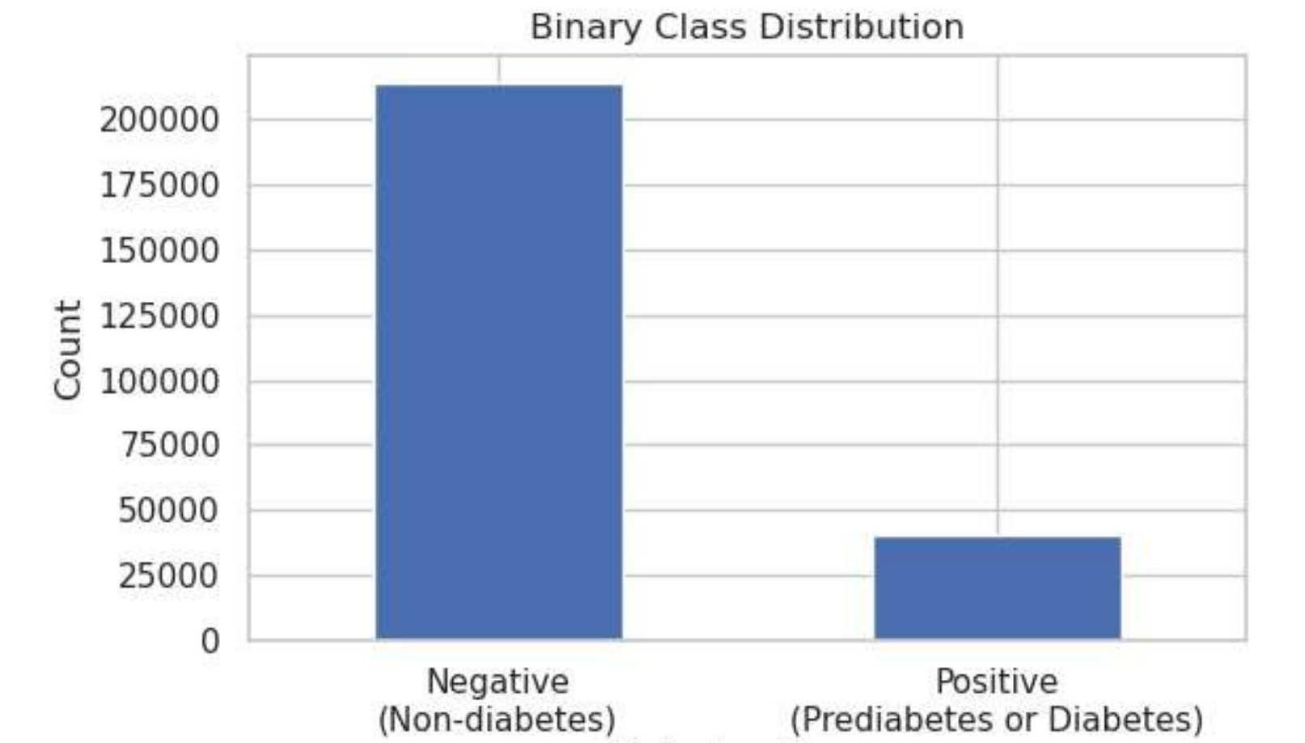
Figure A1-1. Visual confirmation of the derived binary target's class imbalance (213,703 negative vs 39,977 positive), underlying the class-imbalance handling strategy detailed in Appendix B3.

Appendix A2 — Schema Validation and Duplicate-Safe Split Evidence
Supporting evidence for Sections 2.2 and 2.3.
Table A2-1. Schema and Range Validation Summary (Selected Columns)
Column | Nulls | Expected Range | Actual Range | Result
Diabetes_012 | 0 | [0, 2] | [0.0, 2.0] | PASS
BMI | 0 | documented continuous | [12.0, 98.0] | PASS
GenHlth | 0 | [1, 5] | [1.0, 5.0] | PASS
MentHlth | 0 | [0, 30] | [0.0, 30.0] | PASS
PhysHlth | 0 | [0, 30] | [0.0, 30.0] | PASS
Age | 0 | [1, 13] | [1.0, 13.0] | PASS
Education | 0 | [1, 6] | [1.0, 6.0] | PASS
Income | 0 | [1, 8] | [1.0, 8.0] | PASS
All remaining 14 binary indicators | 0 (each) | [0, 1] | [0.0, 1.0] (each) | PASS
Table A2-1. Full validation covers all 22 columns against a pre-declared codebook; result: SCHEMA VALIDATION PASS.

Table A2-2. Duplicate-Safe Stratified 70/15/15 Split Summary
Partition | Rows | Row Share | Positive Rate
Train | 177,494 | 69.97% | 15.7701%
Validation | 38,258 | 15.08% | 15.6882%
Test | 37,928 | 14.95% | 15.7773%
Table A2-2. Full-dataset positive rate for reference: 15.7588%. Leakage guard: PASS — no feature-target profile appears in more than one partition. Referenced again from Section 3.4 (not duplicated there).

Appendix A3 — Outlier and Prevalence Evidence
Supporting evidence for Sections 2.4 and 2.5.
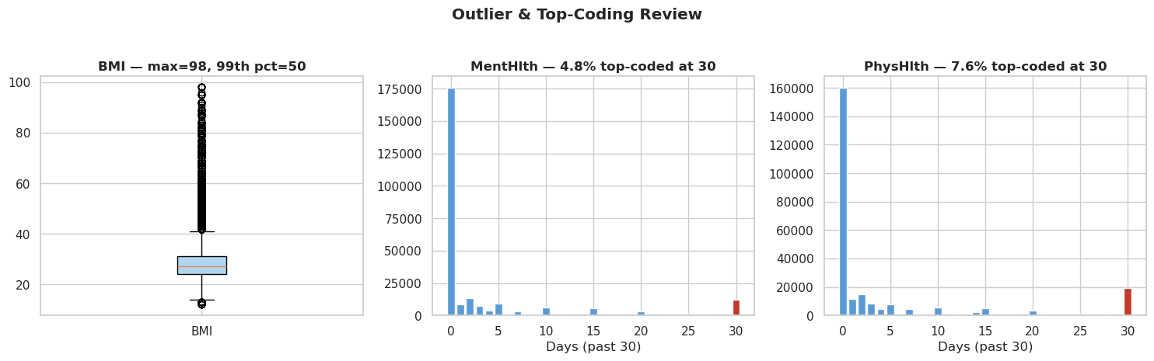
Figure A3-1. BMI shows a long right tail (max = 98, 99th percentile = 50); MentHlth and PhysHlth both show a top-coding spike at exactly 30 days (4.8% and 7.6% of respondents respectively), consistent with the survey instrument's recall-period cap.

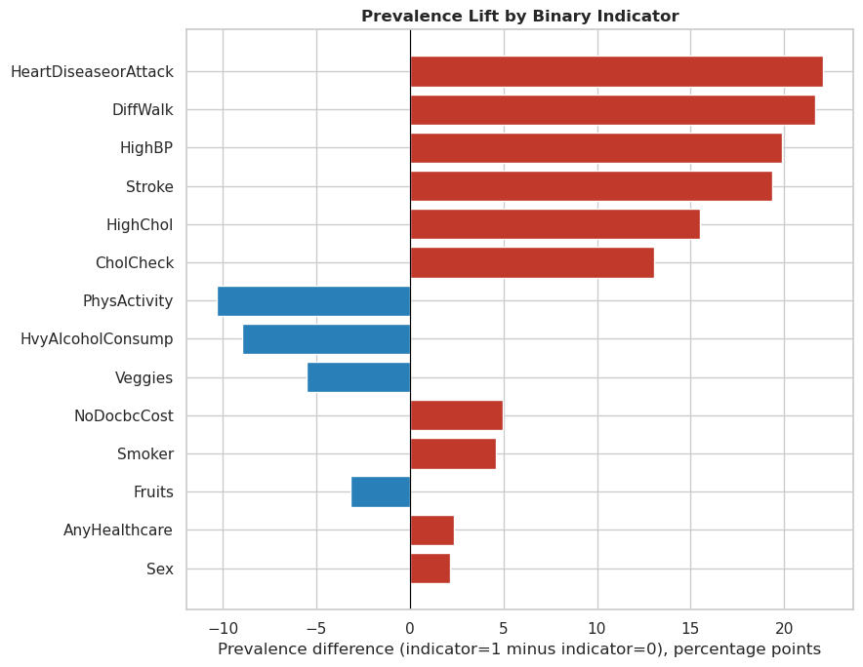
Figure A3-2. Percentage-point difference in positive-class prevalence between indicator = 1 and indicator = 0, for each binary feature. HeartDiseaseorAttack, DiffWalk, HighBP and Stroke show the largest positive gaps; PhysActivity, HvyAlcoholConsump and Veggies show the largest negative gaps.

Appendix A4 — Correlation Evidence
Supporting evidence for Section 2.5.
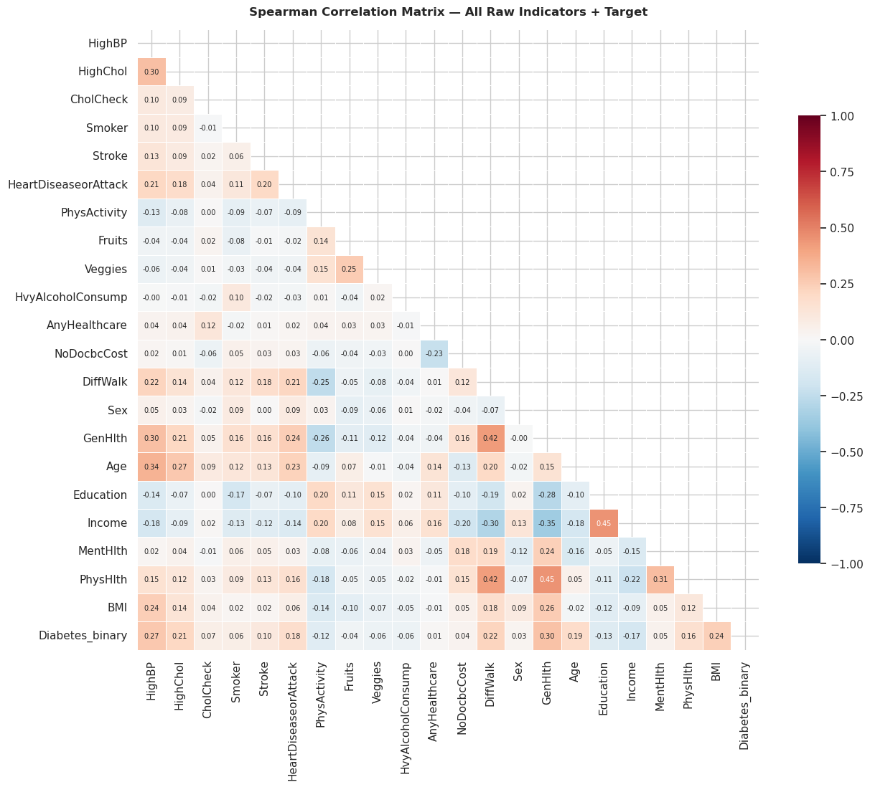
Figure A4-1. Spearman correlation matrix, all raw indicators and target. No single raw indicator exceeds a weak-to-moderate correlation with Diabetes_binary; GenHlth (0.30), HighBP (0.27) and Age are the strongest individually, well below the engineered composite features in Table 1 and Appendix B1.

Appendix B1 — Feature Engineering Definitions and Validation Evidence
Supporting evidence for Sections 3.2 and 3.3.

Table B1-1. Engineered Feature Definitions and Justifications
Feature | Definition / Formula | Justification
BMI_Category | WHO/CDC bands: Underweight, Normal, Overweight, Obese I–III | Standard clinical bucketing; caps leverage of extreme BMI outliers
Comorbidity_Score | HighBP + HighChol + Stroke + HeartDiseaseorAttack + DiffWalk (0–5) | Operationalises the rule-based heuristic baseline as a model feature; cumulative clinical burden
Unhealthy_Days | MentHlth + PhysHlth, capped at 30 | Combines mental/physical unwell-days into one burden signal; capping avoids over-weighting the ceiling effect
Healthy_Lifestyle_Score | PhysActivity + Fruits + Veggies − Smoker − HvyAlcoholConsump (−2 to 3) | Single protective/risk composite from five weak binary signals
Healthcare_Access_Barrier | 1 if NoDocbcCost=1 AND AnyHealthcare=0, else 0 | Compounded access barrier; named fairness/governance dimension
Age_Midpoint | BRFSS age category mapped to approximate midpoint (years) | Numeric-years proxy for interpretable linear-model coefficients
BMI_HighBP_Interaction | BMI × HighBP | Explicit interaction term for Logistic Regression; matched feature set with XGBoost
Table B1-1. All seven features are deterministic, row-wise functions of already-validated raw indicators — no external data and no fitted parameters, so safe to compute before the train/validation/test split.

Table B1-2. Engineered Feature Correlation Validation
Feature | Pearson r with Target
Comorbidity_Score | 0.347
BMI_HighBP_Interaction | 0.306
BMI_Category | 0.236
Age_Midpoint | 0.187
Unhealthy_Days | 0.155
Healthy_Lifestyle_Score | −0.104
Healthcare_Access_Barrier | 0.003 (retained for governance, not predictive value)
Table B1-2. For reference, the strongest raw single-feature correlations observed anywhere in the dataset are GenHlth (0.301), HighBP (0.270) and BMI (0.224) — both Comorbidity_Score and BMI_HighBP_Interaction exceed all three.

Appendix B2 — Data Type Optimisation Evidence
Supporting evidence for Section 3.1.
Table B2-1. Type Casting and Memory Optimisation
Metric | Before | After
In-memory size (full dataset) | 44.5 MB | 6.8 MB (85% reduction)
Binary / ordinal indicators | float64 | int8
Count features (MentHlth, PhysHlth) | float64 | int16
BMI | float64 | float32
Target columns (Diabetes_012, Diabetes_binary) | float64 | int8
Table B2-1. Downcasting performed only after Section 2.2's schema/range validation confirmed every value is integral and within its documented range — lossless by construction.

Appendix B3 — Class-Imbalance Strategy Evidence
Supporting evidence for Section 3.5.
Table B3-1. Class-Imbalance Strategy (Training Partition Only)
Statistic | Value
Training negatives / positives | 149,503 / 27,991
Imbalance ratio (negative:positive) | 5.34:1
sklearn class_weight dict | {0: 1.0, 1: 5.341}
XGBoost scale_pos_weight | 5.3411
Resampling applied | None (class weighting only; no SMOTE or synthetic rows)
Table B3-1. Computed exclusively from the training partition; the notebook explicitly instructs downstream notebooks to reuse these values as-is rather than recompute on validation/test data.

Appendix B4 — Artifact Persistence and Lineage Evidence
Supporting evidence for Section 3.6, including the deduplicated sensitivity dataset referenced in the Section 2 Technical Mentor's Assessment.
Table B4-1. Processed Artifact and Persistence Summary
Artifact Group | Contents | Destination
Model-specific features | train/val/test × {raw, scaled} feature sets (6 files) | Local + S3 (nyp-26s1-iti113/iti113/team02/data/.../processed)
Labels | train/val/test × {binary, retained multiclass} labels (6 files) | Local + S3
Sensitivity dataset | Deduplicated training features/labels (160,798 of 177,494 rows, 90.6% retained) — for the planned leakage/inflation check | Local + S3
Governance artefacts | Data dictionary, data-quality report, JSON lineage record | Local + S3
Table B4-1. All artifacts are written locally first and mirrored to the team's shared S3 prefix when running inside SageMaker, giving Notebook 02 and the wider MLOps pipeline a single, versioned source of processed data.

Appendix B5: Logistic Regression Experiment Workflow, Model Artifact and Staging Handoff Evidence
Source evidence: 02_Logistic_Regression_Experiments_MLflow_with_Evidence.ipynb. This appendix provides the detailed audit trail for the controlled Logistic Regression experiment, from the untuned baseline through the 12-candidate C × class-weight search, training-only threshold optimization, full-data held-out validation, tuning-impact comparison, and MLflow staging handoff. It supports the Section 6 conclusion that class weighting was the dominant practical tuning lever, while fine changes in C and the increase to the 100% data profile had much smaller effects on headline metrics.
Stage | Evidence / outcome
1. Setup and controls | Team02 SageMaker MLflow; 100% data profile with 253,680 rows; stratified 80/20 split (202,944 train; 50,736 held-out); positive class ~15.76%; held-out data protected until final evaluation.
2. Untuned baseline | Logistic Regression, C=1, class_weight=None. 100% CV PR-AUC=0.431205, ROC-AUC=0.817191 and recall=0.183666, confirming weak minority-class detection.
3. Hyperparameter search | 12 configurations: C=0.001-100 × class_weight=None/balanced; training-only Stratified 5-Fold CV; PR-AUC primary, ROC-AUC tie-breaker. Balanced weighting drives the recall/F1 gain.
4. Formal selection | MLflow selects lr_candidate_12: C=100, class_weight=balanced, L2, lbfgs. 100% CV PR-AUC=0.429813, ROC-AUC=0.817737, balanced accuracy=0.742089, F1=0.469485, recall=0.761491.
5. Threshold optimization | Training-only OOF grid search from 0.05-0.95 in 0.01 steps. F1 objective selects 0.59: OOF F1=0.4827, precision=0.3813, recall=0.6575, balanced accuracy=0.7290.
6. Held-out evaluation | At threshold 0.59: ROC-AUC=0.8176, PR-AUC=0.4327, balanced accuracy=0.7284, F1=0.4820, precision=0.3807, recall=0.6567, specificity=0.8002, FPR=0.1998, FNR=0.3433. ROC-AUC gate ≥0.75 passes.
7. Artifact logging | Final MLflow run logs model and plots. best_model.json stores candidate, parameters, threshold, CV/final metrics, quality gate, run IDs, model URI and data profile.
8. Staging handoff | MLflow model reload and smoke test succeed. Portable artifact includes model plus environment metadata. Final full-data evidence is complete; team-level promotion still requires comparison with the XGBoost challenger.

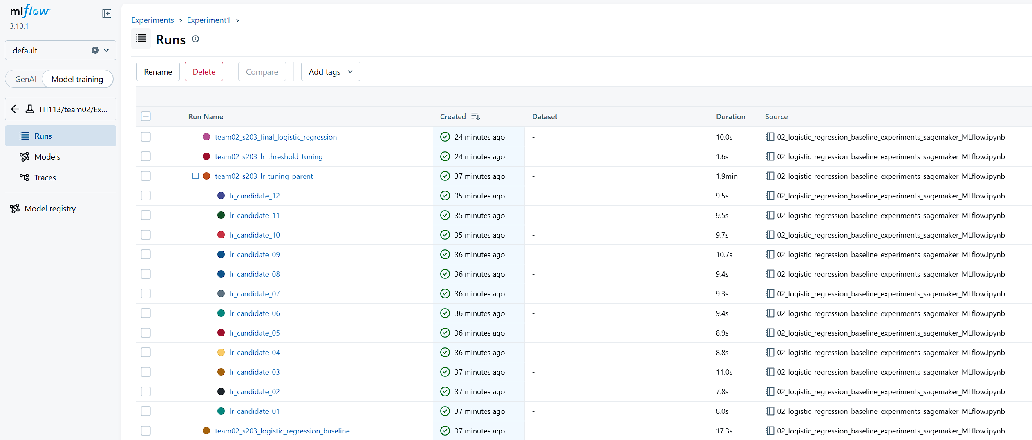
Figure B5-1: Logistic Regression Experiment on MLFlow

B5.x Tuning Parameter Impact
The experiment compared the relative impact of class weighting, threshold selection, data profile and regularization strength (C). The impact scores below are relative tuning-impact measures and should not be interpreted as percentage-point or percentage improvements in AUC.
Parameter | Relative impact
Class weight | 0.578
Threshold | 0.104
Data profile | 0.008
C tuning | 0.007

Figure B5-2: Relative impact of tested tuning parameters

Key observation: Class weighting has by far the largest practical impact among the tested tuning factors. The near-unchanged PR-AUC and ROC-AUC indicate that class weighting mainly changed the classification operating point rather than materially improving the model's ability to rank positive cases above negative cases.
Interpretation: Class weighting produced the dominant improvement in minority-class detection. Threshold selection had the next-largest practical effect because it determines the precision–recall operating point. The tested data-profile change and C tuning had comparatively small effects on the headline predictive metrics.

Appendix C1 – Modelling and Experimental Evidence
All values in this appendix are drawn directly from the executed notebook's logged outputs and the associated MLflow experiment evidence exports (S202 XGBoost and S203 Logistic Regression). No value has been estimated, interpolated, or fabricated. Row/column subsets are shown where the full experiment log exceeds what can be usefully tabulated; the omission is noted where it occurs.
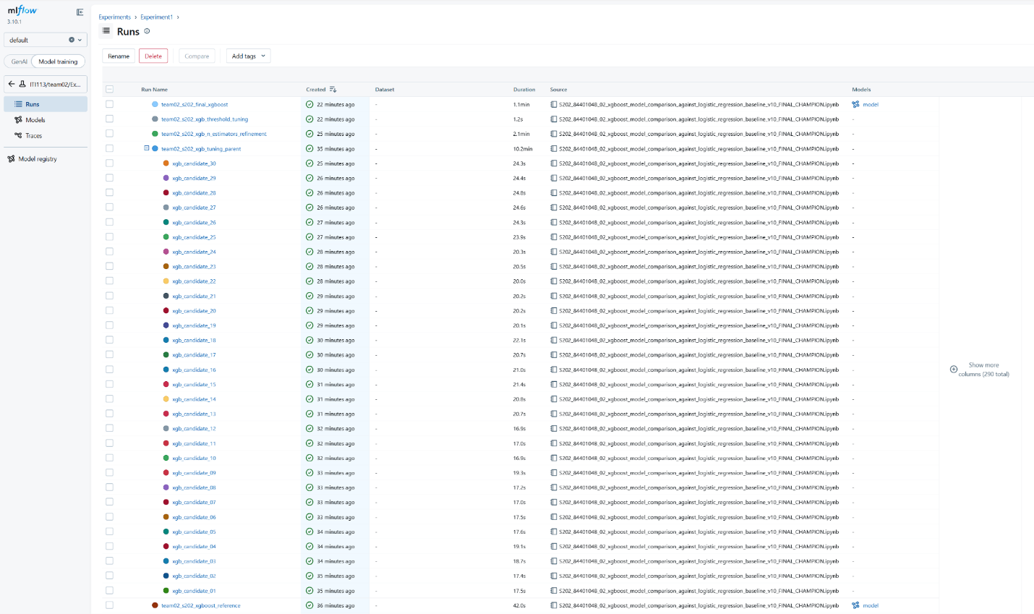
Figure C1-1 MLFlow Logged Experiments
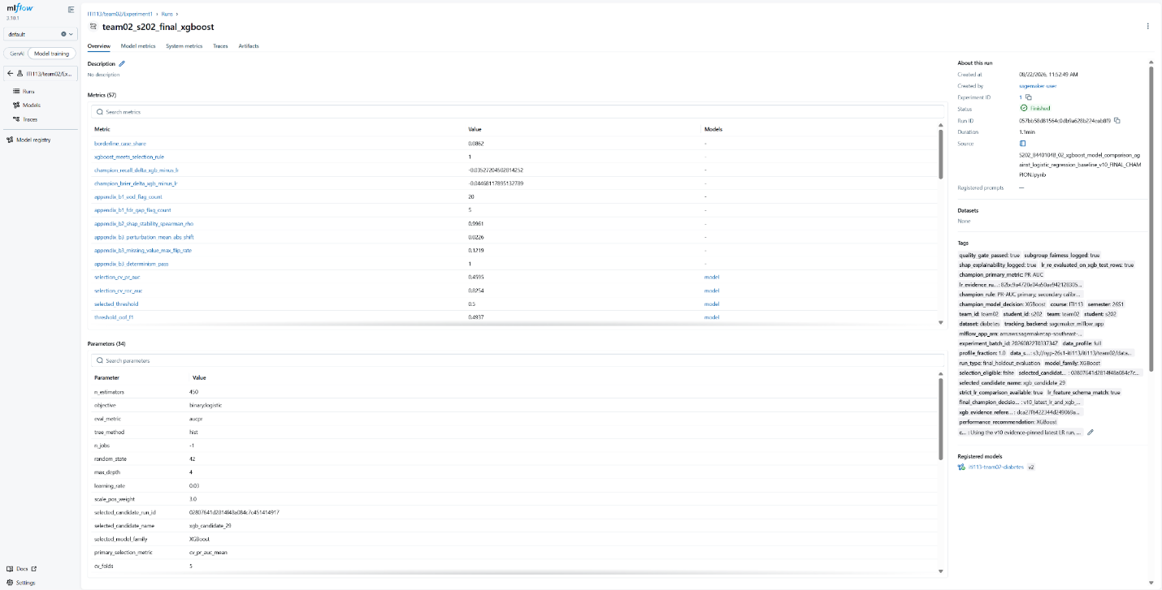
Figure C1-2 MLFLow Logged Final XGBoost

Figure C1-3 MLFlow Model Registry
Table C1-1. Held-Out Data Partition and Class Imbalance Summary
Item | Value
Full cleaned dataset (rows) | 253,680
Train partition (rows) | 202,944
Held-out test partition (rows) | 50,736
Split protocol | Stratified 80/20, independently re-derived by both model notebooks
Test-partition checksum (SHA-256, truncated) | 12de3cf4…
Checksum verified identical across both model workstreams | Yes
Positive-class prevalence (test partition) | ≈15.8%
Approximate class imbalance ratio | ≈5.3 : 1 (negative:positive)

Interpretation: This table substantiates the class-imbalance claim underpinning the entire metric-selection argument in Section 3.1, and the checksum verification substantiates the "identical held-out rows" claim underpinning the model-comparison argument in Sections 3.6 and 3.7. Referenced from: §3.1, §3.6.

Table C1-2. XGBoost Structural Hyperparameter Search — Near-Best Candidate Band
(Twelve of thirty evaluated candidates fall within 0.002 cross-validated PR-AUC of the best-observed score of 0.460; all twelve are shown, spanning two structural families crossed with six class-weighting settings.)
Candidate | Structural family | Max depth | Learning rate | Class weight (scale_pos_weight) | CV PR-AUC | CV F1 | CV Recall | CV Precision
29 (selected) | A | 4 | 0.03 | 3.0 | 0.4595 | 0.4927 | 0.626 | 0.407
23 | B | 3 | 0.05 | 3.0 | 0.4593 | 0.4922 | 0.622 | 0.407
28 | A | 4 | 0.03 | 2.5 | 0.4599 | 0.4889 | 0.559 | 0.435
22 | B | 3 | 0.05 | 2.5 | 0.4597 | 0.4880 | 0.556 | 0.435
27 | A | 4 | 0.03 | 2.0 | 0.4599 | 0.4681 | 0.468 | 0.469
21 | B | 3 | 0.05 | 2.0 | 0.4596 | 0.4676 | 0.466 | 0.470
26 | A | 4 | 0.03 | 1.5 | 0.4600 | 0.4175 | 0.350 | 0.517
20 | B | 3 | 0.05 | 1.5 | 0.4598 | 0.4175 | 0.350 | 0.517
24 | B | 3 | 0.05 | 4.0 | 0.4593 | 0.4859 | 0.715 | 0.368
30 | A | 4 | 0.03 | 4.0 | 0.4597 | 0.4858 | 0.716 | 0.368
19 | B | 3 | 0.05 | 1.0 | 0.4598 | 0.2998 | 0.202 | 0.584
25 | A | 4 | 0.03 | 1.0 | 0.4600 | 0.2936 | 0.196 | 0.587

Interpretation: Across this band, CV PR-AUC varies by only 0.0007 while CV recall varies from 0.20 to 0.72 as the class-weighting parameter changes — direct numerical support for the claim in §3.9 that class weighting, not structural configuration, is the dominant lever governing this model's operating characteristics within the near-best region. Candidate 29 was selected via the secondary tie-break (CV F1, balanced accuracy) described in §3.6. Referenced from: §3.6, §3.9.

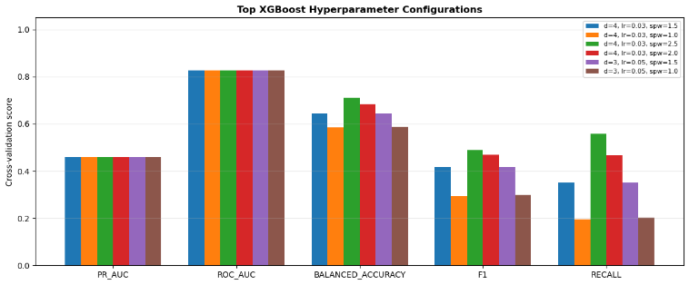
Figure C1-4. Cross-Validated Metric Comparison Across Top Near-Best Hyperparameter Configurations
(Content: grouped bar chart plotting CV PR-AUC, CV ROC-AUC, CV balanced accuracy, CV F1, and CV recall for the six most competitive candidates from Table C1-2.)

Interpretation: The chart makes visually explicit what Table C1-2 shows numerically — PR-AUC and ROC-AUC bars are near-flat across configurations, while F1 and recall bars vary substantially. This figure is the visual counterpart cited in §3.9 to support the diminishing-returns/dominant-lever argument. Referenced from: §3.9.

Table C1-3. Selected XGBoost Configuration (Candidate 29) — Final Registered Hyperparameters

Hyperparameter | Value
max_depth | 4
learning_rate | 0.03
min_child_weight | 5.0
subsample | 0.8
colsample_bytree | 0.8
reg_lambda (L2) | 10.0
reg_alpha (L1) | 0.1
gamma | 0.05
scale_pos_weight | 3.0
n_estimators | 450
Classification threshold | 0.50

Interpretation: This is the exact, reproducible configuration referenced throughout §3.5–§3.6 as "the selected candidate," included here so that the tuning narrative in the Main Content can be verified against a concrete specification without repeating these values in prose. Referenced from: §3.5, §3.6.

Table C1-4. Boosting-Round (n_estimators) Refinement

n_estimators | CV PR-AUC | CV F1 | CV ROC-AUC
150 | 0.4552 | 0.4911 | 0.8237
250 | 0.4583 | 0.4923 | 0.8250
350 | 0.4595 | 0.4927 | 0.8254
450 (selected) | 0.4603 | 0.4937 | 0.8256
600 | 0.4606 | 0.4933 | 0.8257

Interpretation: The increment from 450 to 600 trees yields a CV PR-AUC gain of only 0.0003 for a 33% increase in ensemble size — the quantitative basis for the diminishing-returns and deployment-practicality argument in §3.9. Referenced from: §3.9.

Table C1-5. Decision-Threshold Sensitivity (XGBoost, Out-of-Fold)
Threshold | OOF F1 | OOF Recall | OOF Precision | OOF Specificity
0.49 | 0.4928 | 0.639 | 0.401 | 0.822
0.50 (selected) | 0.4937 | 0.626 | 0.408 | 0.830
0.51 | 0.4932 | 0.612 | 0.413 | 0.838
0.52 | 0.4932 | 0.599 | 0.419 | 0.845
0.53 | 0.4919 | 0.583 | 0.425 | 0.853

Approximate scale of the threshold-adjacent (borderline) population on the held-out test set: ~8.6% of all 50,736 predictions fall within a narrow band around the selected threshold, with a class-outcome mix markedly more balanced than the dataset's overall distribution.

Interpretation: F1 is essentially flat within ±0.02 of the selected threshold, confirming that 0.50 is a genuine, evidence-based local optimum rather than an unexamined default — the basis for the threshold-behaviour discussion in §3.7. The borderline-population figure substantiates the threshold-adjacent error-analysis finding in §3.8. Referenced from: §3.7, §3.8.

Table C1-6. Logistic Regression Baseline — Tuning Candidate Summary (Selected Entries)
Candidate | C | Class weight | CV PR-AUC | CV Recall | CV Precision
Highest CV PR-AUC (unweighted) | 100 | none | 0.4312 | 0.184 | 0.552
Selected (final configuration) | 100 | balanced | 0.4298 | 0.761 | 0.339
Unweighted reference (C=1) | 1 | none | 0.4312 | 0.184 | 0.552

Interpretation: Regularisation strength (C) has negligible effect on CV PR-AUC across four orders of magnitude, while the class-weighting setting produces a large shift in recall for a 0.0014 reduction in CV PR-AUC — the direct evidence for the claim in §3.6 that the baseline's near-best candidates were not selected by PR-AUC alone. Referenced from: §3.6.

Table C1-7. Held-Out Test Set Performance — Full Model Comparison

Model | PR-AUC | ROC-AUC | Recall | Precision | F1 | F2 | Specificity | FPR | Balanced Acc. | Brier
Majority-class (reference) | 0.158 | — | 0.000 | 0.000 | 0.000 | 0.000 | 1.000 | 0.000 | 0.500 | 0.133
Rule-based heuristic (reference) | 0.364 | — | 0.893 | 0.250 | 0.390 | 0.589 | 0.498 | 0.502 | 0.695 | 0.177
Logistic Regression (baseline) | 0.4327 | 0.8176 | 0.6567 | 0.3807 | 0.4820 | 0.5735 | 0.8002 | 0.1998 | 0.7284 | 0.1786
XGBoost (champion) | 0.4644 | 0.8248 | 0.6214 | 0.4078 | 0.4924 | 0.5625 | 0.8312 | 0.1688 | 0.7263 | 0.1339
Interpretation: The reference rows quantify the accuracy-is-misleading argument in §3.1 (the majority-class model scores non-trivial accuracy-adjacent statistics while providing zero recall). Comparing the two trained models directly: XGBoost leads PR-AUC, ROC-AUC, precision, F1, specificity and Brier; Logistic Regression leads recall, F2 and balanced accuracy. This is the primary evidentiary table underpinning §3.7 (experimental findings) and §3.10 (champion justification). Referenced from: §3.1, §3.7, §3.10.

Table C1-8. Held-Out Confusion Matrices

Model | True Negative | False Positive | False Negative | True Positive
Logistic Regression | 34,202 | 8,539 | 2,745 | 5,250
XGBoost | 35,527 | 7,214 | 3,027 | 4,968

Interpretation: Moving from Logistic Regression to XGBoost trades 1,325 fewer false positives for 282 more false negatives. Given this project's cost asymmetry (a false negative is the more consequential error), this table is the quantitative anchor for the error-composition argument in §3.8. Referenced from: §3.8.
Figure C1-5. Confusion Matrix Comparison — Logistic Regression vs. XGBoost, Held-Out Test Set

(Content: side-by-side 2×2 confusion-matrix heat maps for both models, annotated with the values in Table C1-8.)
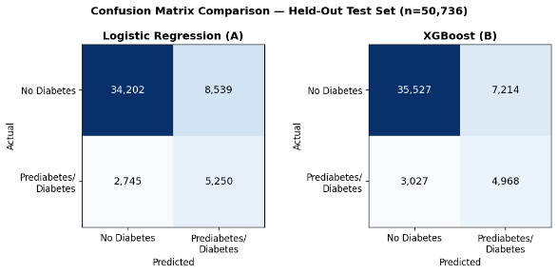
Interpretation: Visualises the error-composition trade-off described in §3.8 and referenced in the champion-decision discussion in §3.10. Referenced from: §3.8, §3.10.

Table C1-9. Champion Decision Record — Hard Gates, Supporting Metrics, and Trade-offs

Check | Category | Outcome
Verified exact-row comparison (checksum match) | Hard gate | Passed
XGBoost quality gate (test ROC-AUC ≥ 0.75) | Hard gate | Passed (0.825)
SHAP explainability logged | Hard gate | Passed
PR-AUC improves over baseline (primary metric) | Selection criterion | Passed (+0.032)
ROC-AUC, F1, precision, specificity vs. baseline | Supporting metrics | All favour XGBoost
Recall, F2, FNR, balanced accuracy vs. baseline | Secondary trade-off metrics | All favour Logistic Regression
Calibration materially worse than baseline? | Governance observation | No (currently favours XGBoost)
Subgroup fairness materially worse than baseline? | Governance observation | No
Interpretation: This record is the operational evidence for the champion-justification argument in §3.10: it shows explicitly that the decision was reached via a predeclared hierarchy (hard gates, then primary metric, then supporting/trade-off metrics considered but not treated as blocking, then governance observations), rather than by an informal comparison of whichever numbers looked most favourable. Referenced from: §3.10.

Table C1-10. SHAP Global Feature Importance — Top 10 Drivers, With Cross-Model Comparison
Feature | XGBoost mean |SHAP| | XGBoost rank | Logistic Regression |coefficient| rank
GenHlth | 0.572 | 1 | 5
HighBP | 0.446 | 2 | 2
BMI | 0.413 | 3 | 11
Age | 0.391 | 4 | 8
HighChol | 0.306 | 5 | 4
Income | 0.132 | 6 | 13
Sex | 0.103 | 7 | 6
CholCheck | 0.071 | 8 | 1
HeartDiseaseorAttack | 0.061 | 9 | 7
HvyAlcoholConsump | 0.049 | 10 | 3

(SHAP ranking stability, assessed on two independent held-out subsamples: Spearman rank correlation = 0.996.)

Interpretation: Three of the top five XGBoost drivers are shared with Logistic Regression's top five, indicating convergent, not merely model-specific, signal. The largest rank divergence is BMI (rank 3 for XGBoost vs. rank 11 for Logistic Regression), which is consistent with the interaction-capture rationale in §3.5: XGBoost can exploit BMI's interaction with other comorbidity indicators directly, whereas the linear model can only draw on BMI's smaller standalone coefficient. The stability statistic supports treating this ranking as a genuine model property rather than a sampling artefact. Referenced from: §3.5, §3.7.

Appendix D1 — MLOps Pipeline, Experiment Tracking and Reproducibility
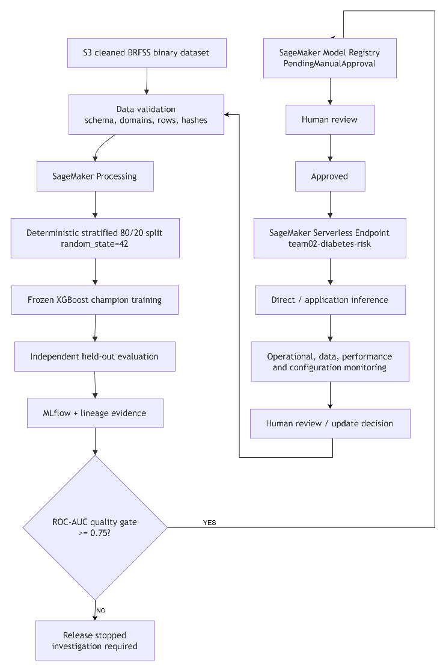
Figure D1-1 — End-to-End MLOps Architecture

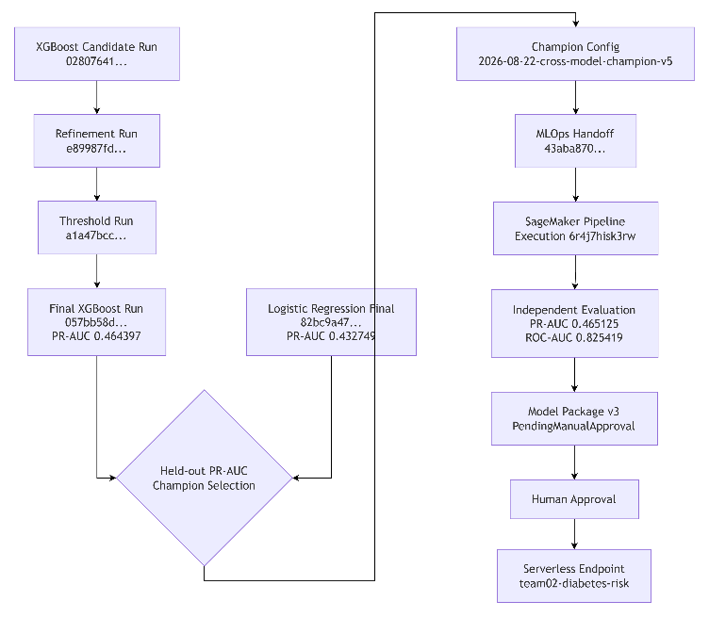
Figure D1-2 — Experiment-to-Deployed-Model Lineage
Table D1-1 — End-to-End MLOps Pipeline Stage Mapping
Stage | Component | Input | Main Control / Processing | Output / Evidence | Next Stage
Data ingestion | Amazon S3 | Cleaned binary BRFSS CSV | Fixed URI and data version | 253,680-record source | Validation
Data validation | Notebook preflight + Processing | S3 dataset | Schema, feature order, domains, numeric validity, missing values, target leakage, row count, hash | Validated canonical source | Split reconstruction
Preprocessing | SageMaker Processing | Validated dataset | Target mapping, exact 21-feature contract, stratified 80/20, seed 42 | 202,944 train / 50,736 held-out + hashes | Training
Development validation | Modelling workflow | Training partition | Stratified 5-Fold CV on training only | Experiment evidence | Champion selection
Champion handoff | Modelling evidence + Notebook 03 | LR and XGB results | Held-out PR-AUC ranking | Frozen XGBoost champion | Managed training
Training | SageMaker Training | Training partition | Frozen XGBoost configuration; no further search | Model artifact | Evaluation
Evaluation | SageMaker Processing | Model + held-out data | PR-AUC, ROC-AUC, recall, F1/F2, confusion matrix, subgroup metrics | pipeline_evaluation.json | Quality gate
Experiment tracking | MLflow + machine-readable files | Parameters, metrics, hashes, IDs | Versioning and lineage | Handoff/pipeline runs | Registry
Quality gate | SageMaker ConditionStep | Evaluation JSON | test_auc_roc >= 0.75 | Pass/fail decision | Model Registry
Registration | SageMaker Model Registry | Passing model | Version package as PendingManualApproval | Package v3 | Human review
Approval | Human control | Registry package + evidence | Performance/fairness/lineage review | Approved status | Deployment
Deployment | SageMaker Serverless | Approved package | Endpoint creation and serving configuration | team02-diabetes-risk | Validation
Endpoint validation | SageMaker Runtime | Test 21-feature payload | Response, threshold and lineage assertions | Direct inference evidence | Application
Application inference | Streamlit/FastAPI | Validated 21-feature request | Authenticated relay and model invocation | Screening result + lineage | User
Monitoring | CloudWatch/policy/lineage | Operational and inference evidence | Health, PSI, performance, config drift | Alert/investigation | Human review/update

Table D1-2 — Reproducibility and Experiment-Tracking Evidence
Requirement | Recorded Evidence | Final Value / Identifier | Evidence Artifact | Reproducibility Purpose
Parameters | Frozen champion hyperparameters | XGB 450 estimators; depth 4; learning rate 0.03; scale_pos_weight=3.0; regularisation/subsampling controls | team02_champion_model_config.json | Recreates final training setup
Selection metrics | Model comparison | XGB PR-AUC 0.464397 vs LR 0.432749 | best_model_experiment_comparison.csv | Explains champion choice
Pipeline metrics | Independent evaluation | PR-AUC 0.465125; ROC-AUC 0.825419 | pipeline_evaluation.json | Detects operational regression
Model family | Champion | XGBoost | Champion config | Unambiguous model identity
Configuration version | Frozen model config | 2026-08-22-cross-model-champion-v5 | Champion config/manifest | Prevents silent parameter changes
Candidate run | XGB candidate | 02807641d2814f48a084c7c451414917 | Manifest/config | Experiment provenance
Refinement run | Estimator refinement | e89987fd9aec4a11a1108c8afaf6561b | Manifest/config | Parameter-refinement provenance
Threshold run | Threshold tuning | a1a47bcc23d844539d92f3a3ed8fec1e | Manifest/config | Operating-point lineage
Final modelling run | Final XGB | 057bb58d81564c0db9a628b224eab8f9 | Manifest/config | Deployed champion identity
MLOps handoff run | Final handoff | 43aba870c78a4b26ab068ad2454d3bf2 | MLflow/notebook evidence | Connects development to MLOps
Pipeline evidence run | Pipeline logging | bf29ec58c0d84010b55248c39829b2ec | S201_Sagemaker_Experiments.csv | Links execution evidence
Pipeline execution | SageMaker execution | …/team02-diabetes-risk/execution/6r4j7hisk3rw | Completed lineage JSON | Identifies exact pipeline run
Dataset URI | Canonical S3 source | s3://nyp-26s1-iti113/iti113/team02/data/diabetes/cleaned/diabetes_binary_cleaned_dataset.csv | Reproducibility manifest | Locates exact source
Data version | Dataset identity | brfss2015-diabetes-binary-6244bec277fe | Manifest | Version tracking
Dataset row count | Full profile | 253,680 | Manifest/processing | Detects truncated profile
Dataset SHA-256 | Dataset fingerprint | 6244bec277fe3cefce56d46c583a4c5eb73f179ef64c8a1b18557fd0200105c5 | Manifest | Detects data substitution
Training split SHA-256 | Train partition fingerprint | 93531a7b366471a63d29fd970abad6c5d04a2f933f9ffb2aa38dce1c7b286d65 | Manifest | Reconstructs exact training set
Held-out split SHA-256 | Test fingerprint | 12de3cf4074e8656a059c938acbe27143794910116dda3dc217a101698a368c1 | Manifest | Protects held-out lineage
Preprocessing version | Transformation contract | brfss-binary-v1-stratified-80-20-rs42 | Manifest | Prevents preprocessing drift
Feature contract | Ordered model input | Exact 21 predictors | Manifest/frontend | Training-serving consistency
Split method | Data separation | Stratified 80/20, seed 42 | Manifest | Repeatable partitioning
Validation method | Development validation | Stratified 5-Fold CV on training only | Modelling lineage | Avoids validation leakage
Class imbalance | XGBoost weighting | scale_pos_weight=3.0 | Champion config | Reproduces imbalance treatment
Artifacts | Audit trail | Configs, manifests, pipeline JSONs, evaluation, registry/deployment evidence | Evidence package | Supports audit/review
Runtime version | SageMaker XGBoost | 2.1.4 | Pipeline evaluation/MLflow | Runtime reproducibility

Table D1-3 — Champion Model Evidence
Item | Champion Evidence | Interpretation
Selected model | XGBoost | Final deployment champion
Runner-up | Logistic Regression | Interpretable comparison baseline
Primary selection metric | Held-out PR-AUC | Predefined cross-model criterion
XGBoost held-out PR-AUC | 0.464397 | Higher than Logistic Regression
Logistic Regression held-out PR-AUC | 0.432749 | Runner-up result
Difference | +0.031649 | Supports XGBoost selection
XGBoost ROC-AUC | 0.824820 | Strong secondary discrimination
XGBoost recall | 0.621388 | Important screening trade-off
Logistic Regression recall | 0.656660 | Baseline has higher recall
XGBoost F1 | 0.492442 | Threshold-dependent balance
XGBoost F2 | 0.562475 | Recall-weighted performance
Decision threshold | 0.50 | Frozen deployment threshold
Final model run | 057bb58d81564c0db9a628b224eab8f9 | Champion lineage identifier
Independent pipeline PR-AUC | 0.465125 | Operational reproduction evidence
Independent pipeline ROC-AUC | 0.825419 | Passed quality gate
Quality gate | ROC-AUC ≥0.75 | Deployment regression control
Configuration version | 2026-08-22-cross-model-champion-v5 | Frozen champion configuration

Table D1-4 — SageMaker MLOps Pipeline Execution Evidence
No. | MLOps Stage | AWS Resource Type | Resource Name
1 | Data Preprocessing | SageMaker Processing Job | pipelines-6r4j7hisk3rw-team02-preprocess-da-xSuR2eLKo1
2 | Model Training | SageMaker Training Job | pipelines-6r4j7hisk3rw-team02-train-model-moIzIPQLOk
3 | Model Evaluation | SageMaker Processing Job | pipelines-6r4j7hisk3rw-team02-evaluate-mode-vlN5WSr3w2
4 | Test Deployment Model | SageMaker Model Resource | team02-diabetes-risk-model-1787378425
5 | Initial Deployment | SageMaker Endpoint | team02-diabetes-risk

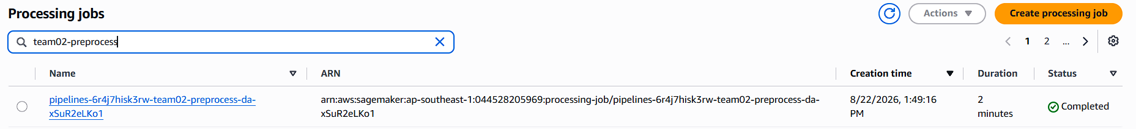
Figure D1-3:Data Preprocessing

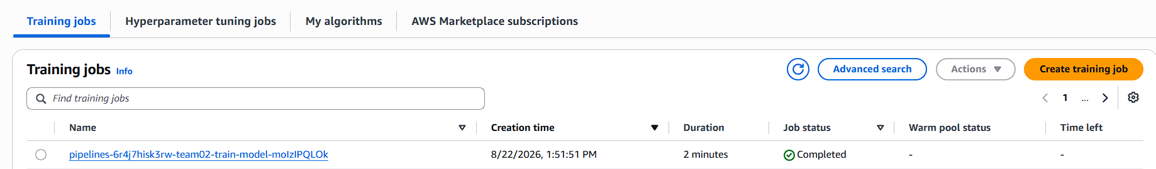
Figure D1-4:Model Training


Figure D1-5: Model Evaluation

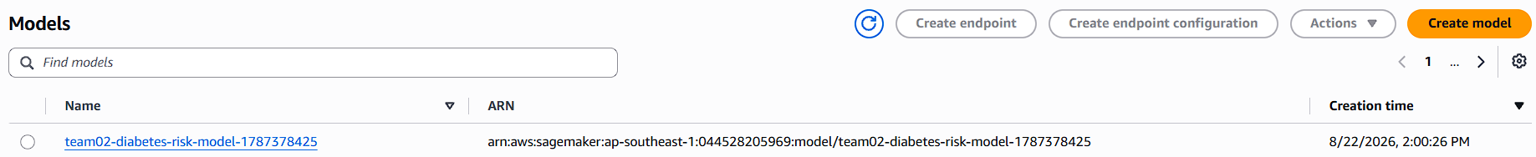
Figure D1-6: Test Deployment Model

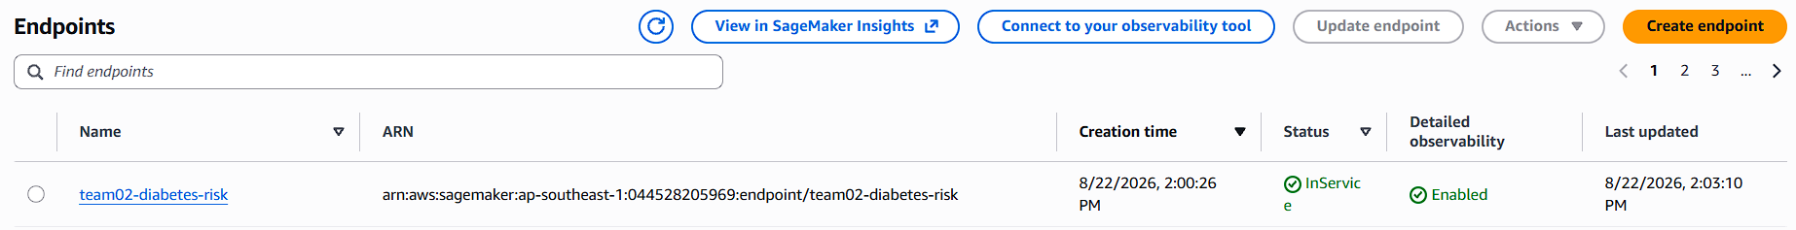
Figure D1-7: Sagemaker Endpoint

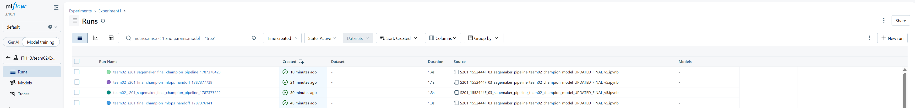
Figure D1-8: MLOPS Experiment Evidence

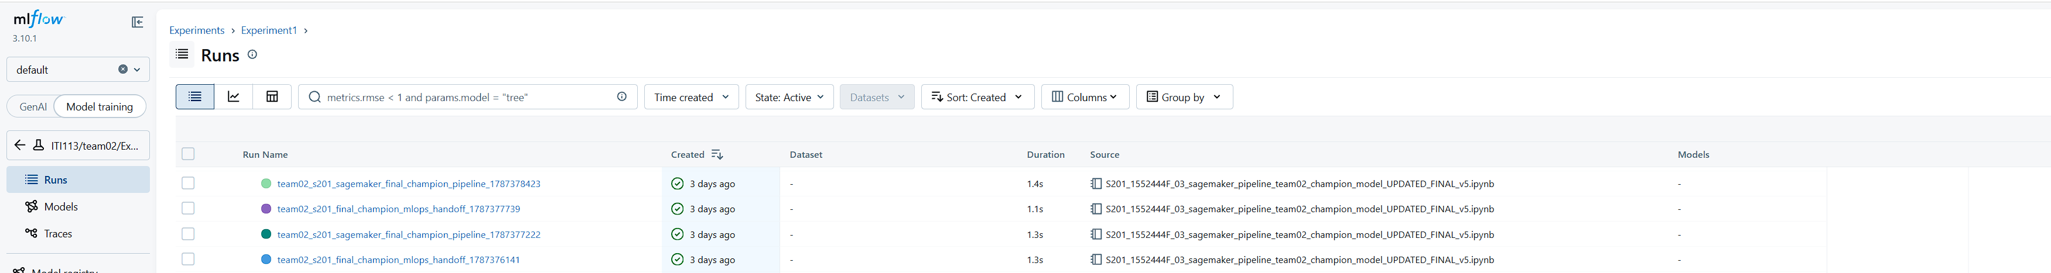
Figure D1-9 – MLFlow Logged Experiments from MLOps
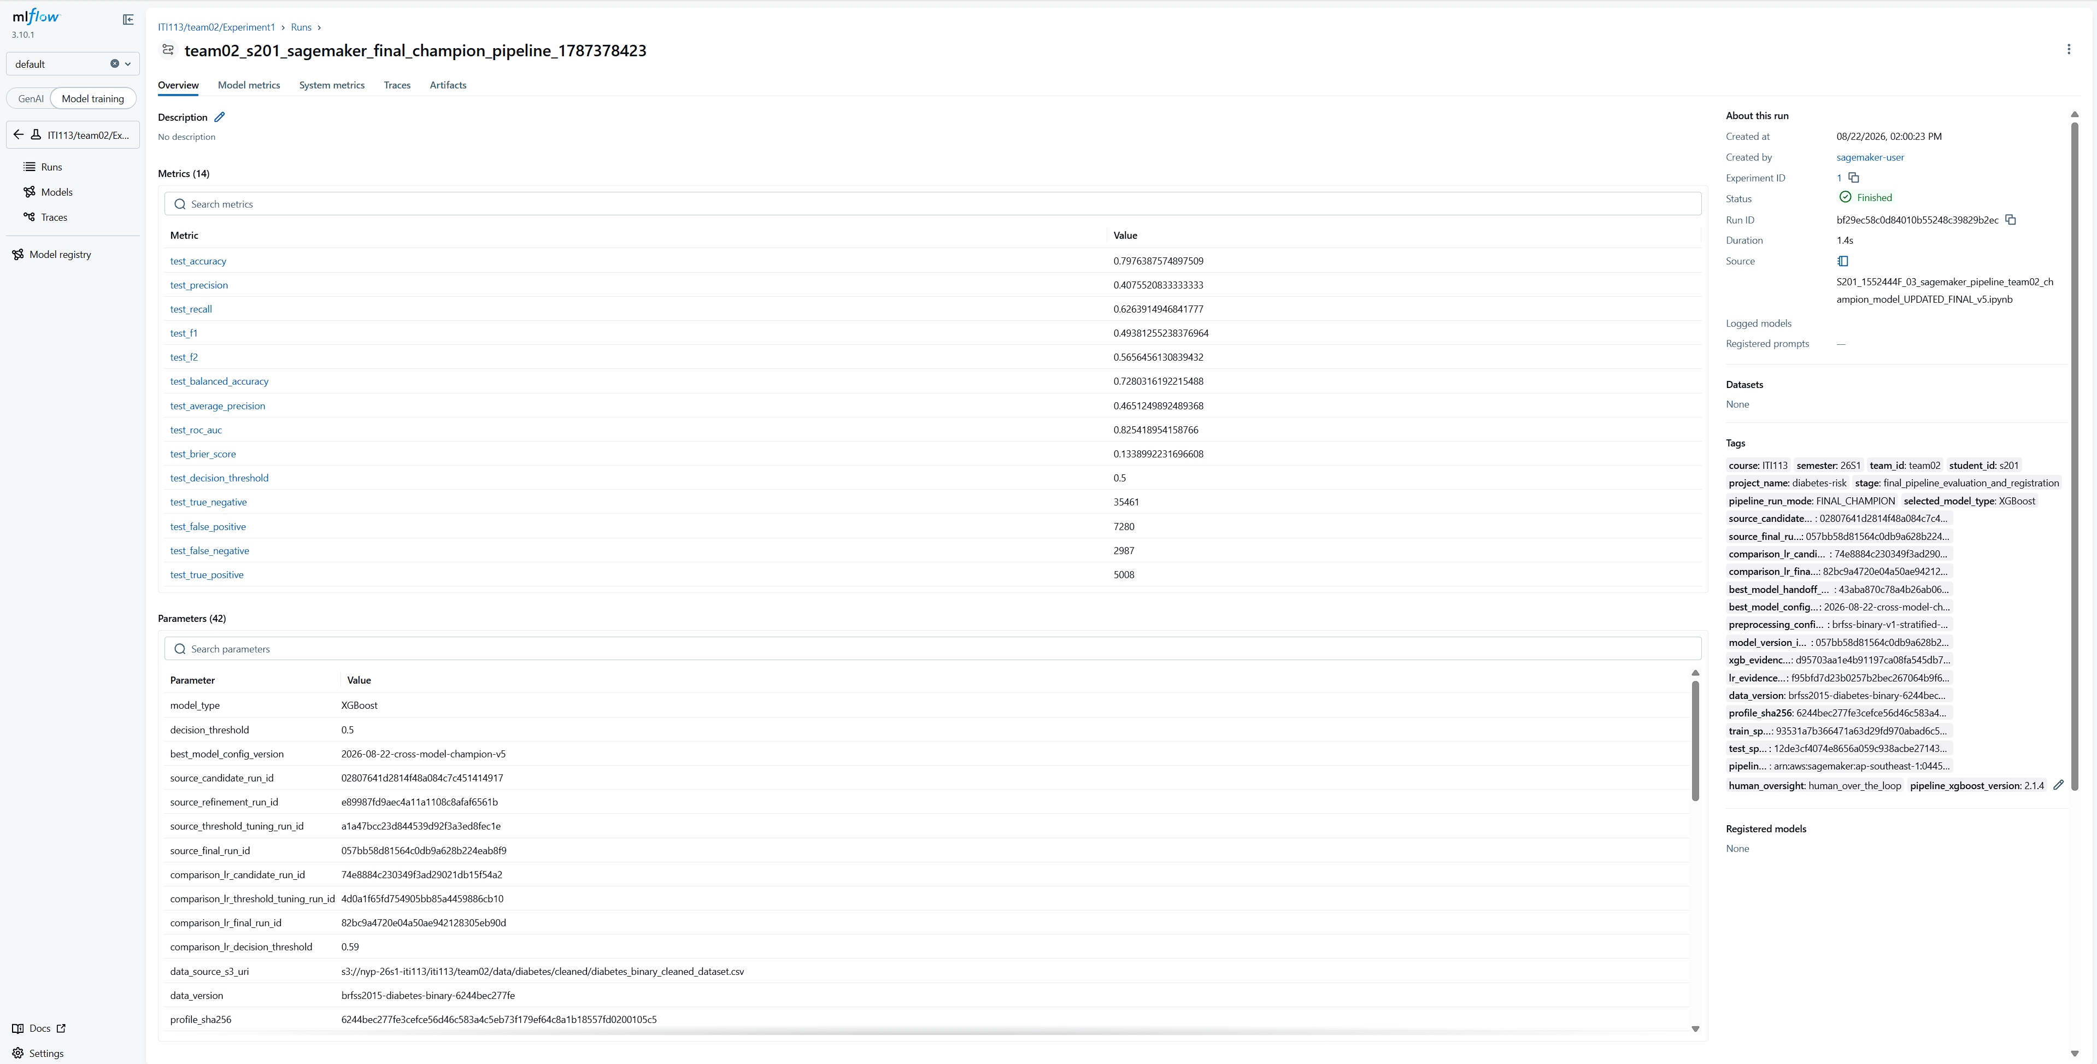
Figure D1-10 - MLFlow Logged Experiments Final Champion Pipelines

Appendix D2 — CI/CD, Scalability and Model Updating
D2.1 Controlled S3 Change-Trigger Demonstration
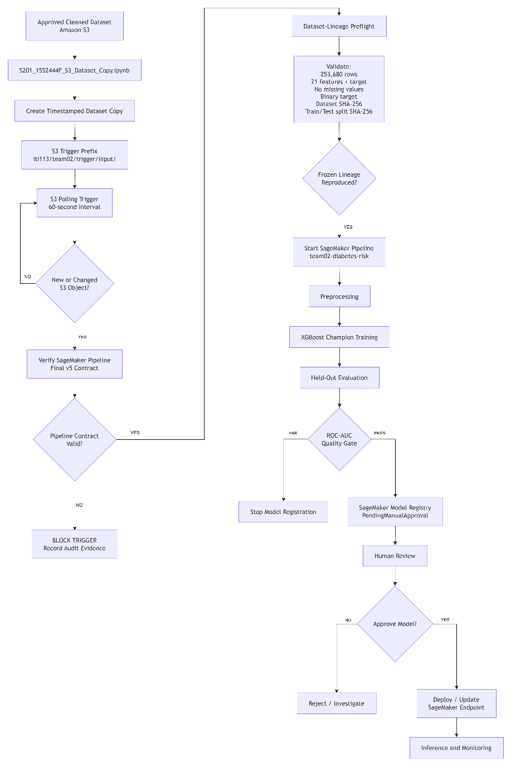
Figure D2-1 — S3 Change-Triggered MLOps and Controlled Model Release
Figure D2-1 show that the S3 polling mechanism simulates a data-triggered CI/CD workflow while retaining the controls of the final SageMaker Pipeline. A detected object cannot trigger training until both the SageMaker Pipeline contract and the frozen dataset lineage have been validated. Successful pipeline execution automates preprocessing, training, evaluation and registration, while approval and deployment remain human-controlled. The implementation explicitly states that a trigger starts the pipeline only and does not automatically approve or deploy the resulting model package.
Table D2-1 — CI/CD Demonstration and Execution Evidence
CI/CD Stage | Team02 Implementation | Demonstrated Evidence | Automation Level | Control / Purpose
Trigger preparation | Timestamped copy of approved cleaned dataset | Trigger file successfully created in iti113/team02/trigger/input/ | Manual initiation | Simulates arrival of a new approved dataset without altering the source dataset
Change monitoring | S3 polling every 60 seconds | Continuous polling executed against Team02 trigger prefix | Automated while notebook is running | Detects newly created or changed S3 objects
Duplicate/change detection | Object fingerprint based on key, ETag, size and last-modified time | Fingerprint included in trigger audit | Automated | Prevents accidental duplicate processing and detects replacement of an object at the same key
Pipeline contract validation | Validates required parameters, steps and tags against final v5 pipeline | PIPELINE CONTRACT: PASS | Automated | Prevents an obsolete or incorrect SageMaker Pipeline from being triggered
Dataset preflight | Validates row count, schema/order, missing values, target values and SHA-256 lineage | Preflight returned True with exact final-v5 dataset/split lineage | Automated | Prevents arbitrary or corrupted data from silently retraining the final model
Pipeline invocation | start_pipeline_execution() on team02-diabetes-risk | Pipeline execution ARN generated | Automated | Connects S3 change detection to the managed MLOps pipeline
Pipeline execution | SageMaker processing → training → evaluation → quality gate | Triggered execution returned Succeeded | Automated | Demonstrates an end-to-end triggered MLOps execution
Model registration | SageMaker Model Registry | Successful model remains subject to PendingManualApproval | Automated registration | Creates a traceable candidate without automatically releasing it
Model approval | Explicit team review | Separate approval step | Manual | Allows performance, fairness, explainability and operational evidence to be reviewed
Deployment | Approved package deployed to endpoint | Performed separately from trigger notebook | Manual controlled action | Prevents unreviewed model replacement
Audit trail | Local JSONL trigger audit | Records S3 URI, model/config/data identity, preflight result and execution ARN | Automated | Provides traceability from trigger event to SageMaker execution
The demonstrated trigger event recorded the champion model, champion run ID, data version, input S3 object, preflight result, action and pipeline execution ARN.

D2.2 Trigger Execution Evidence
The final demonstration used the approved XGBoost champion configuration associated with:
- Pipeline: team02-diabetes-risk
- Champion model: XGBoost
- Champion MLflow run ID: 057bb58d81564c0db9a628b224eab8f9
- Configuration version: 2026-08-22-cross-model-champion-v5
- Data version: brfss2015-diabetes-binary-6244bec277fe
- Model Package Group: team02-diabetes-risk
- Final endpoint: team02-diabetes-risk
These identifiers are frozen in the polling notebook and are used to prevent a stale pipeline or incorrect model configuration from being triggered.
The trigger passes five parameters into the pipeline:
- InputDataUrl
- ExpectedProfileSHA256
- ExpectedTrainSplitSHA256
- ExpectedTestSplitSHA256
- MinTestRocAuc
The final quality-gate parameter is set to a minimum held-out ROC-AUC of 0.75.
During the demonstrated execution, the poller detected:
diabetes_binary_cleaned_dataset_trigger_20260822_131302.csv
The dataset passed the frozen-lineage preflight and triggered:
team02-s3-trigger-20260822-131341
with SageMaker execution:
arn:aws:sagemaker:ap-southeast-1:044528205969:pipeline/team02-diabetes-risk/execution/smp86sip3ek6
The execution later returned:
PipelineExecutionStatus: Succeeded.

D2.3 Scalability and Production Evolution
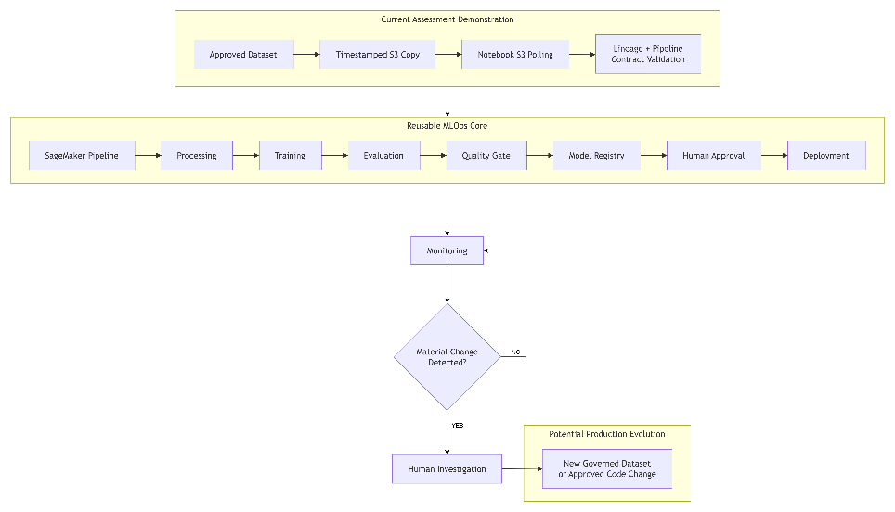
Figure D2-2 — Evolution from Assessment Trigger to Production CI/CD
Figure D2-2 shows that the SageMaker Pipeline is independent of the mechanism used to initiate it. The course demonstration uses notebook-based S3 polling because it can be implemented within the available AWS environment, while a production architecture could replace only the trigger layer with an event-driven or repository-based service. The downstream preprocessing, training, evaluation, Model Registry and approval controls remain reusable. The polling notebook itself notes that it cannot operate when its kernel is stopped, making it suitable for a course demonstration rather than a permanent production event architecture.
Table D2-2 — Scalability and Model-Update Design
Design Area | Current Team02 Demonstration | Scalability Benefit | Production Evolution
Data storage | Amazon S3 | Durable shared object storage separates data from notebook execution | Governed/versioned data lake or production S3 prefixes
Trigger mechanism | Notebook polls S3 every 60 seconds | Trigger logic is independent from the ML pipeline | Replace with S3 Event Notifications, EventBridge/Lambda or repository CI/CD
Pipeline | Parameterised SageMaker Pipeline | Same managed workflow can be executed repeatedly using different invocation mechanisms | Retain pipeline as central ML orchestration layer
Processing | SageMaker managed processing | Compute is provisioned for pipeline execution rather than coupled to local development | Scale processing instance type/count according to workload
Training | SageMaker managed XGBoost training | Training workload is separated from the trigger notebook | Scale training resources or introduce distributed training if required
Data lineage | SHA-256 dataset and split validation | Repeated execution can verify that approved experimental lineage is unchanged | Introduce governed dataset-version registration instead of disabling lineage controls
Quality control | Automated ROC-AUC quality gate | Unsuitable models can be prevented from progressing automatically | Expand gates to performance, fairness and operational acceptance criteria
Model versioning | SageMaker Model Registry | Each accepted pipeline result can become a traceable model package | Integrate registry with formal release/change-management workflow
Approval | PendingManualApproval | Automation scales without removing human governance | Retain human approval for high-impact model replacement
Deployment | Separate controlled endpoint update | Serving lifecycle remains independent from training | Automate deployment after authorised approval where governance permits
Auditability | Trigger JSONL + SageMaker execution ARN | Creates traceable link from data event to pipeline execution | Centralise logs in CloudWatch/S3/audit platform
Model updating | Approved trigger initiates repeatable retraining of frozen champion | Demonstrates reproducible retraining | Introduce governed new-data versioning, challenger evaluation, drift/fairness review and approval

D2.4 Model Updating and Governance Boundary
The demonstrated mechanism should be interpreted as controlled reproducible retraining, rather than unrestricted continuous learning. The final v5 pipeline is intentionally lineage-frozen; therefore, an arbitrary newly arriving production dataset will fail the approved dataset and split signatures and will not trigger model training.
For the assessed system, this restriction protects reproducibility because an S3 trigger cannot silently replace the dataset used to establish the final champion. A future continuous-training architecture would instead require a governed process in which a new dataset is versioned, validated for schema and data quality, assessed for drift, assigned a new train/validation/test lineage, and used for champion-versus-challenger performance and fairness evaluation. Only a model that passes these checks should progress to human approval and possible replacement of the deployed champion.
Accordingly, the model-update lifecycle is:
This design combines automation for repeatable technical operations with human control for release decisions, which is consistent with the project's human-over-the-loop governance approach. The project governance checklist similarly states that training may run automatically, while successful training does not automatically approve or deploy a model; model packages remain PendingManualApproval until evidence has been reviewed.

D2.5 CI/CD Implementation Status
For reporting accuracy, the implementation should be classified as follows:
Capability | Final Status
Timestamped S3 change simulation | Executed / Demonstrated
S3 change polling | Executed / Demonstrated
60-second automatic detection | Executed / Demonstrated
Final v5 pipeline contract validation | Executed / Demonstrated
Dataset and split lineage preflight | Executed / Demonstrated
Automated SageMaker Pipeline invocation | Executed / Demonstrated
Trigger-to-pipeline audit trail | Executed / Demonstrated
SageMaker pipeline execution | Executed — Succeeded
Processing, training, evaluation and quality gate | Implemented through SageMaker Pipeline
Model Registry handoff | Implemented
Automatic model approval | Intentionally not implemented
Automatic production deployment | Intentionally not implemented
GitHub Actions / repository CI/CD | Template / future production option
S3 EventBridge/Lambda event trigger | Future production option
Fully autonomous continuous training | Not implemented by design
This classification prevents the assessment report from overstating the prototype as a fully operational production CI/CD system while demonstrating that the core change detection → validation → pipeline invocation → controlled release workflow was successfully implemented and tested.

Appendix D3 — Demo Application Architecture, Governance and Testing
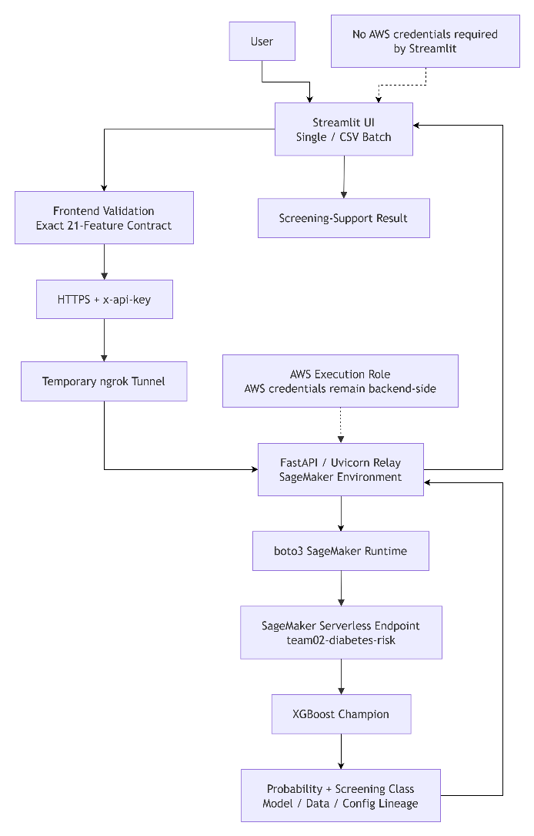
Figure D3-1 — Demo Application Architecture
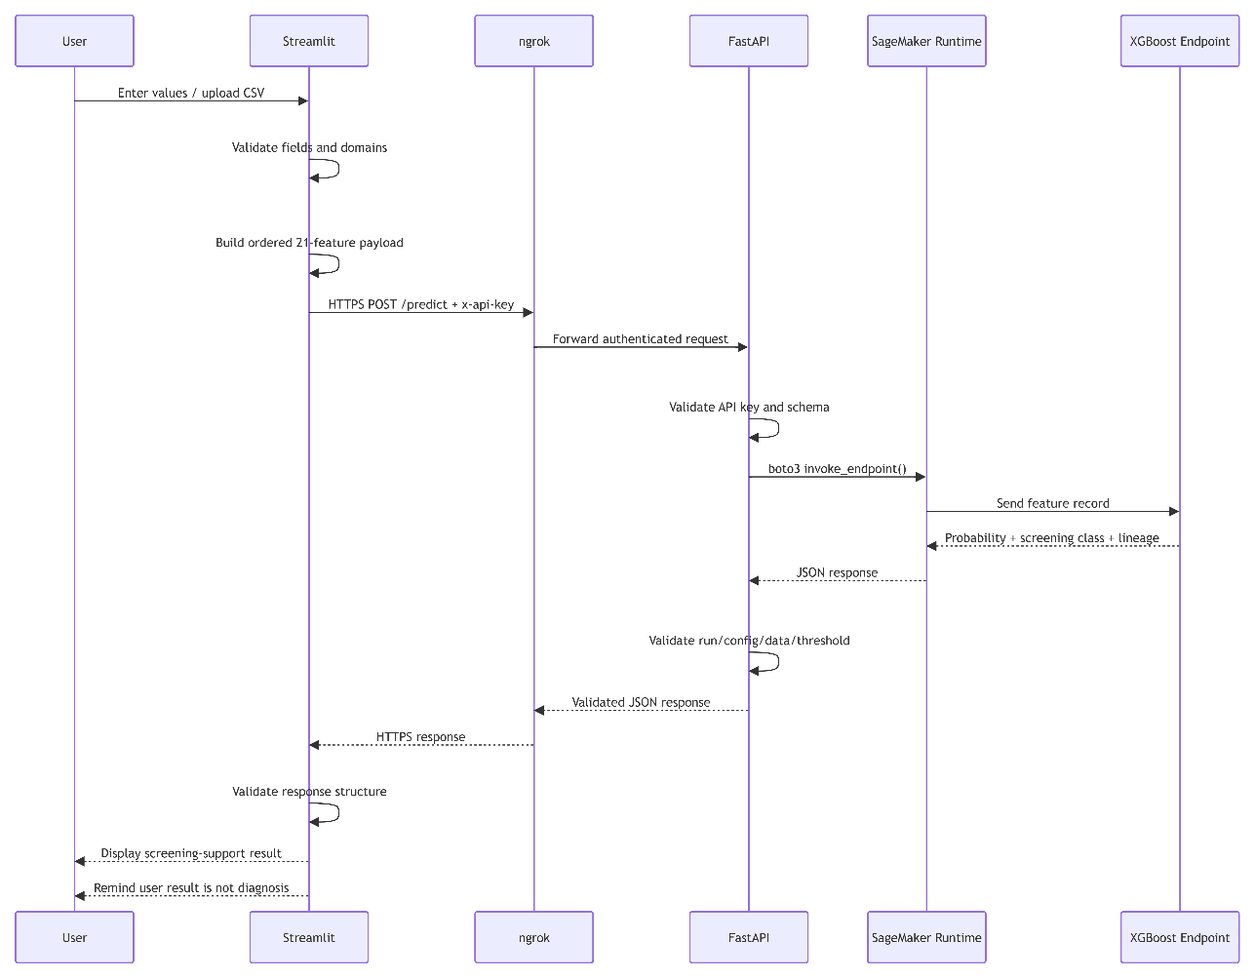
Figure D3-2 — Prediction Request Sequence

Table D3-1 — Application Technology Stack
Layer | Technology | Responsibility | Integration | Security / Governance Role
Frontend | Streamlit | User input, single/batch screening, results | Calls relay | Presents intended-use limitation
Application logic | Python | Validation, mapping, payload construction | Shared frontend logic | Leakage and domain controls
Data processing | pandas | CSV parsing and results | Streamlit/core | Target excluded from payload
HTTP client | requests | Relay calls | Streamlit → ngrok | Timeouts and error handling
Public bridge | ngrok | Temporary HTTPS ingress | Public → FastAPI | Demo-only exposure
Backend API | FastAPI | Authentication/schema checks | ngrok → boto3 | API-key protection
Runtime | Uvicorn | Runs FastAPI | Backend environment | Controlled application runtime
AWS SDK | boto3 | SageMaker invocation | Relay → Runtime API | Uses AWS execution role
Serving | SageMaker Serverless Endpoint | Hosts approved model | Runtime API | Registry-controlled deployment
Model | XGBoost | Risk probability | SageMaker endpoint | Frozen configuration
Experiment tracking | MLflow | Parameters/metrics/artifacts | Modelling/MLOps | Traceability
Release governance | Model Registry | Package/version approval | Pipeline → deployment | Human release control
Testing | pytest | Core/frontend validation | Offline tests | Regression and leakage checks

Table D3-2 — Application Test Coverage and Results
Test Area | Scenario | Expected Behaviour | Executed Evidence / Test Coverage | Status
Feature contract | 21 required predictors | Correct ordered payload | Core automated test | Passed
Target leakage | Source target present | Target never enters inference | Multiple tests | Passed
Valid model CSV | 21-column dataset | Accepted | Automated test | Passed
BRFSS source CSV | Target + predictors | Accepted, target removed from payload | Automated test | Passed
Headerless CSV | Valid 21/22-column structure | Correct interpretation | Automated test | Passed
Missing columns | Required feature absent | Validation error | Automated test | Passed
Unexpected columns | Extra field | Explicit validation feedback | Automated test | Passed
Invalid binary values | Binary feature outside 0/1 | Rejected | Parameterised tests | Passed
Invalid coded ranges | Age/Education/Income outside domain | Rejected | Parameterised tests | Passed
Blank/non-numeric values | Invalid input | Rejected | Automated tests | Passed
Payload types | Numeric types | Correct serialisation | Automated test | Passed
API-key header | Prediction request | Header supplied | Client test | Passed
Health timeout | Relay unavailable/slow | Error surfaced | Client test | Passed
Prediction timeout | Slow response | Error surfaced | Client test | Passed
4xx/5xx responses | Relay/service error | User-safe error | Parameterised tests | Passed
Offline relay | Connection failure | Clear connection error | Client test | Passed
Malformed JSON | Invalid response body | Reject invalid response | Automated test | Passed
Missing fields | Incomplete model response | Reject result | Automated tests | Passed
Invalid probability/class | Out-of-contract result | Reject response | Automated tests | Passed
Non-diagnostic wording | Streamlit UI | Screening wording visible | UI smoke test implemented | Implemented; execution evidence required
Streamlit modes | Single/CSV/About | All application modes available | UI smoke test implemented | Implemented; execution evidence required
Technical details | Assessor details collapsed | Not exposed unnecessarily | UI test implemented | Implemented; execution evidence required
Environment config | Relay URL/API key | Read via environment | UI test implemented | Implemented; execution evidence required
Threshold control | No obsolete frontend threshold | Backend response used | UI test implemented | Implemented; execution evidence required
Recorded execution evidence: the core frontend suite produced 106 passing tests during the prior execution review. The complete Streamlit UI suite should be rerun and captured in the final configured project environment before submission.

Table D3-3 — AI Governance Controls Across the MLOps Lifecycle
Lifecycle Stage | Risk | Governance Control | Evidence | Residual Limitation / Mitigation
Intended use | Output treated as medical diagnosis | Screening-support framing and non-diagnostic wording | ISAGO + application | Clinical validation required for medical use
Human oversight | Unsuitable model automatically released | PendingManualApproval + explicit approval | Model Registry | Maintain approval boundary
Dataset provenance | Wrong dataset used | Fixed S3 URI, version and hash | Reproducibility manifest | Formal change approval for future dataset
Data quality | Invalid schema/domain | Processing validation | Pipeline evidence | Continue checks for future versions
Dataset currency | U.S. 2015 data used for later/Singapore context | Limitation documented | ISAGO | External/local validation required
Data integrity | Silent file modification | SHA-256 fingerprints | Manifest | Recompute only under approved version change
Split leakage | Development contaminates held-out test | Training-only CV + frozen held-out partition | Pipeline/model evidence | Correct stale ISAGO split wording
Target leakage | Target supplied to model | Target exclusion in pipeline/frontend | Automated tests | Preserve contract after UI changes
Representation bias | BRFSS population differs from target users | Explicit limitation and subgroup testing | Governance evidence | More representative data required
Historical bias | Dataset reflects historical health/social conditions | Bias documented | ISAGO | Investigate before external use
Omission bias | Important variables absent | Document limitations | Governance checklist | Further dataset assessment
Proxy bias | Demographic/socioeconomic predictors encode structural factors | Sex/Age/Education/Income subgroup testing | Pipeline fairness output | Causal/proxy analysis required
Sex fairness | Different subgroup errors | Recall/FPR comparison | Recall gap ≈0.007 | Small gap ≠ fairness proof
Age fairness | Large disparity | Subgroup metrics + human review | Recall gap ≈0.736 | Significant governance concern
Education fairness | Material disparity | Subgroup metrics + review | Recall gap ≈0.398 | Requires investigation/mitigation
Income fairness | Material disparity | Subgroup metrics + review | Recall gap ≈0.395 | Requires investigation/mitigation
Overfitting | Model performs only on training patterns | 5-Fold CV + held-out evaluation | Experiment/pipeline evidence | Future experiments need untouched evidence
Class imbalance | Majority-class dominance | PR-AUC primary; scale_pos_weight=3.0 | Champion config | Threshold trade-offs remain
Model-selection bias | Post-hoc winner selection | Predefined held-out PR-AUC | Comparison evidence | Preserve criterion for future challengers
Explainability | XGBoost complexity | Model metadata; SHAP designated future approach | ISAGO | SHAP not demonstrated in final execution
Technical approval | Metric gate mistaken for release approval | Quality gate separated from Registry approval | Pipeline/Registry | Preserve distinction
Deployment integrity | Wrong model package | Approved Registry package used | Deployment evidence | Add formal rollback
Model drift | Wrong model served | Run-ID assertion | Endpoint/relay validation | Synchronise after approved update
Config drift | Wrong config/threshold | Config/data/threshold assertions | Endpoint response validation | Maintain versioned contract
Credential exposure | AWS credentials on user client | Streamlit uses no AWS credentials | Architecture/source | Production managed auth recommended
Unauthorized access | Public relay abuse | x-api-key | FastAPI relay | Shared demo key not production-grade
Public ingress | ngrok left open | Temporary tunnel + shutdown | Demo runbook | Use managed API Gateway for production
Data drift | Input population changes | PSI 0.10/0.25 thresholds | Monitoring policy | Current evidence is plumbing test
Performance degradation | Model accuracy changes | PR-AUC/ROC-AUC/recall monitoring | Monitoring policy | Requires future labelled outcomes
Model update | Automatic unsafe retraining | Human investigation and approval | Lifecycle design | No scheduled update workflow yet
Auditability | Cannot reconstruct deployed model | MLflow, hashes, pipeline ARN, package version, endpoint lineage | Evidence package | Include all upstream experiment exports
The governance controls align with the completed Team02 ISAGO themes of defined purpose, human oversight, data management, bias analysis, separate evaluation and explainability. The broader ISAGO guidance also emphasises traceability, subgroup evaluation, monitoring, reproducibility and explanation of deployed AI systems.

Appendix E1 — Fairness and Explainability Test Evidence
Primary evidence source:
S202_8440104B_02_xgboost_model_comparison_against_logistic_regression_baseline_v10_FINAL_CHAMPION_EVIDENCE.ipynb
Table E1-1. Final Subgroup Fairness Test Summary
Attribute | Maximum Recall Gap | Maximum FPR Gap | 0.10 Review Threshold | Governance Finding
Sex | Below material threshold | Below material threshold | Not triggered | No material subgroup-gap flag
Age | 0.727 | 0.329 | Triggered | Investigation required
Education | 0.373 | 0.377 | Triggered | Investigation required
Income | 0.389 | 0.347 | Triggered | Investigation required
Test design: 29 subgroup values across four attributes were evaluated on the held-out test set at the final XGBoost threshold of 0.50. Subgroups with fewer than 30 observations were excluded from gap calculations to avoid over-interpreting unstable small samples.
Interpretation: The tests identify material group differences but do not establish their cause. Prevalence differences, socioeconomic effects, healthcare access and learned proxy relationships should be investigated before any production deployment.
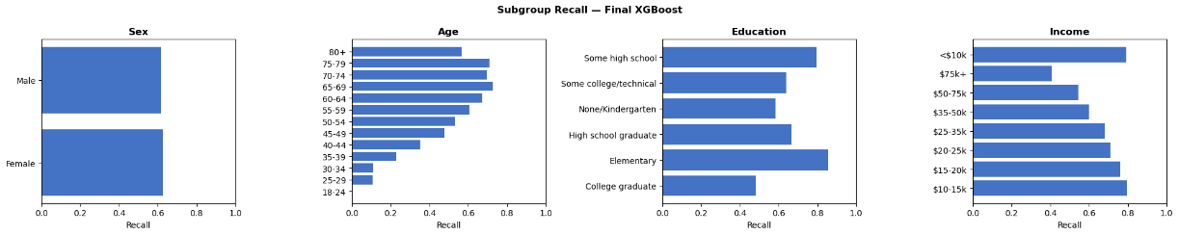
Figure E1-1. Subgroup Recall — Final XGBoost
Purpose: compares positive-class detection rates across Sex, Age, Education and Income groups.
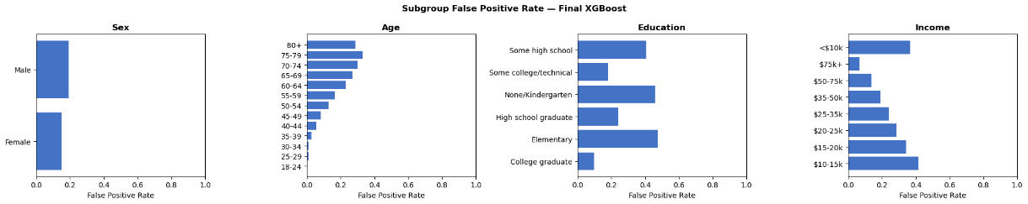
Figure E1-2. Subgroup False-Positive Rate — Final XGBoost
Purpose: identifies groups that receive positive screening classifications disproportionately often when the observed target is negative.
Table E1-2. Global SHAP Feature Importance
Rank | Feature | Mean |SHAP|
1 | GenHlth | 0.5723
2 | HighBP | 0.4465
3 | BMI | 0.4127
4 | Age | 0.3906
5 | HighChol | 0.3063
6 | Income | 0.1325
7 | Sex | 0.1028
8 | CholCheck | 0.0710
9 | HeartDiseaseorAttack | 0.0607
10 | HvyAlcoholConsump | 0.0490
11 | DiffWalk | 0.0423
12 | Education | 0.0391
13 | MentHlth | 0.0365
14 | PhysActivity | 0.0219
15 | Smoker | 0.0190
Interpretation: Health indicators dominate the global model explanation, but the appearance of socioeconomic and demographic features among influential variables warrants continued fairness and proxy-risk review.
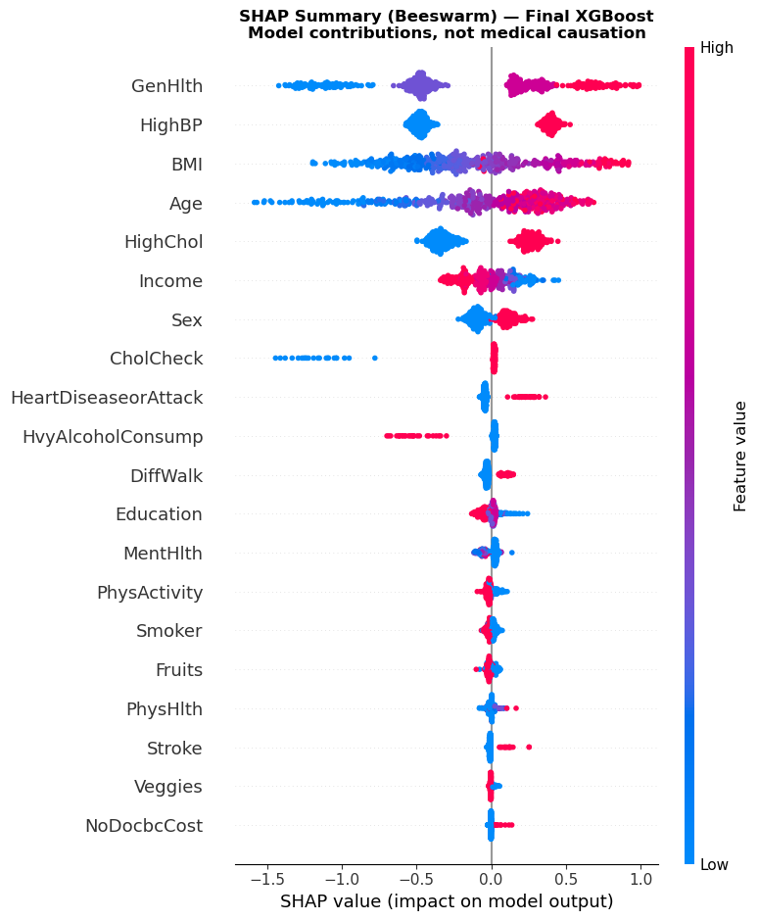
Figure E1-3. SHAP Summary Beeswarm — Final XGBoost
Shows both the magnitude and direction of feature contributions across sampled held-out observations.
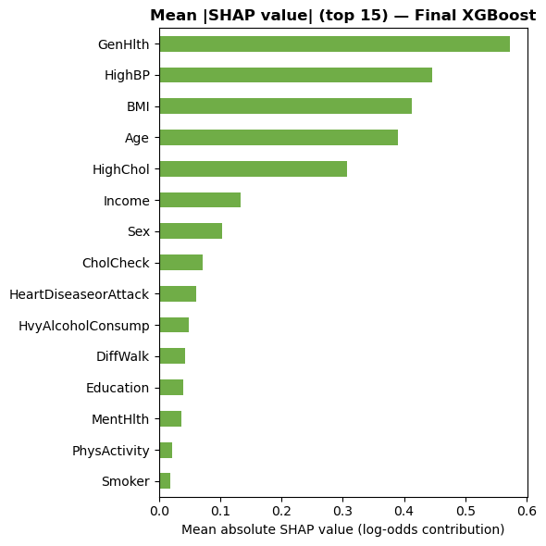
Figure E1-4. Mean Absolute SHAP Importance — Final XGBoost
Shows the overall ranking of model drivers by mean absolute SHAP contribution.
Table E1-3. SHAP Explanation Stability
Feature | Rank Sample A | Rank Sample B | Mean |SHAP| A | Mean |SHAP| B
GenHlth | 1 | 1 | 0.5841 | 0.5855
HighBP | 2 | 2 | 0.4453 | 0.4463
BMI | 3 | 3 | 0.4005 | 0.3865
Age | 4 | 4 | 0.3879 | 0.3571
HighChol | 5 | 5 | 0.3058 | 0.3000
Income | 6 | 6 | 0.1407 | 0.1335
Sex | 7 | 7 | 0.1044 | 0.1053
HeartDiseaseorAttack | 8 | 9 | 0.0601 | 0.0590
HvyAlcoholConsump | 9 | 10 | 0.0512 | 0.0431
CholCheck | 10 | 8 | 0.0512 | 0.0626
Spearman rank correlation across all 21 features: ρ = 0.996, p < 0.0001
Predefined criterion: ρ ≥ 0.80
Result: PASS
Interpretation: The global explanation is stable across independently selected held-out samples and is not dependent on one particular SHAP sample.

Local SHAP Evidence
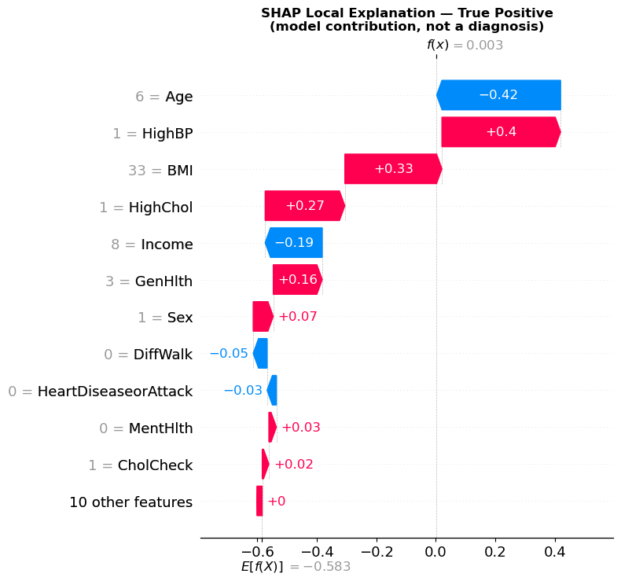
Figure E1-5. Local SHAP — True Positive
Provides an example of feature contributions for a correctly detected positive case.
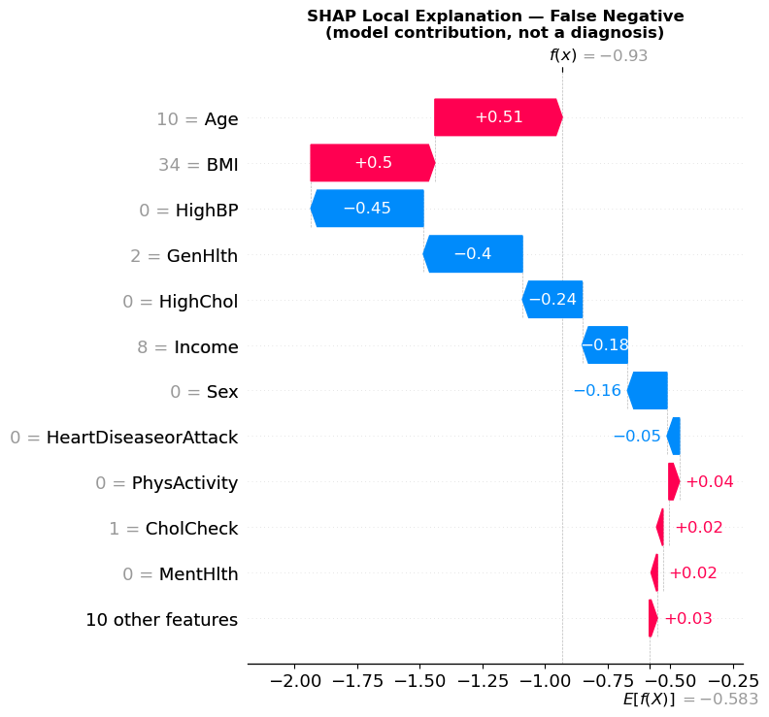
Figure E1-6. Local SHAP — False Negative
Illustrates how apparently lower-risk feature values can drive a missed positive case.
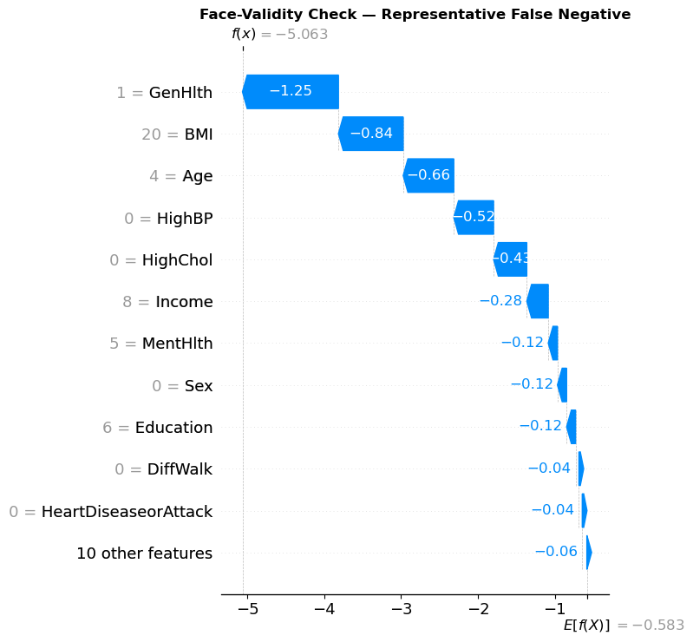
Figure E1-7. Representative False Negative
Used as a face-validity check of model reasoning for a confidently incorrect negative prediction.
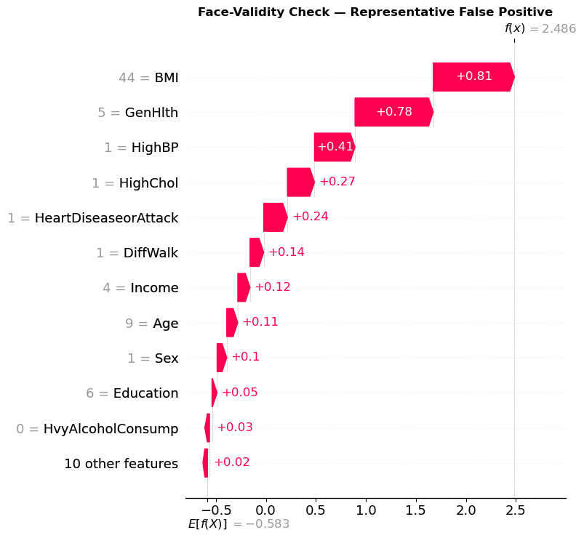
Figure E1-8. Representative False Positive
Shows how strong adverse health indicators can produce a high predicted probability despite a negative observed target.
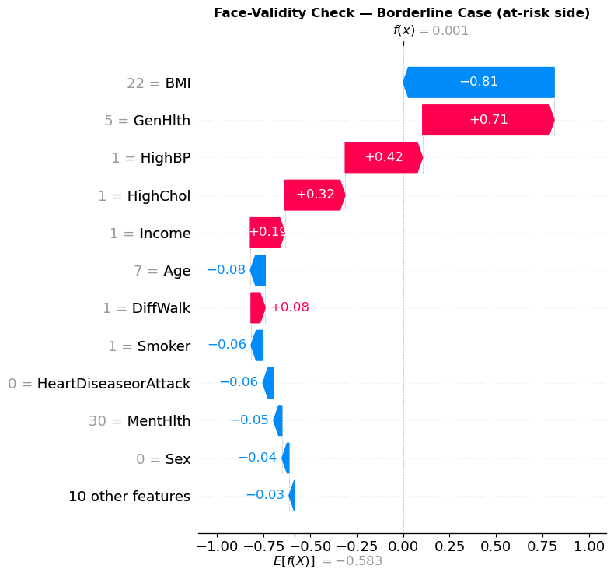
Figure E1-9. Borderline At-Risk Prediction
Shows competing positive and negative contributions around the decision boundary.
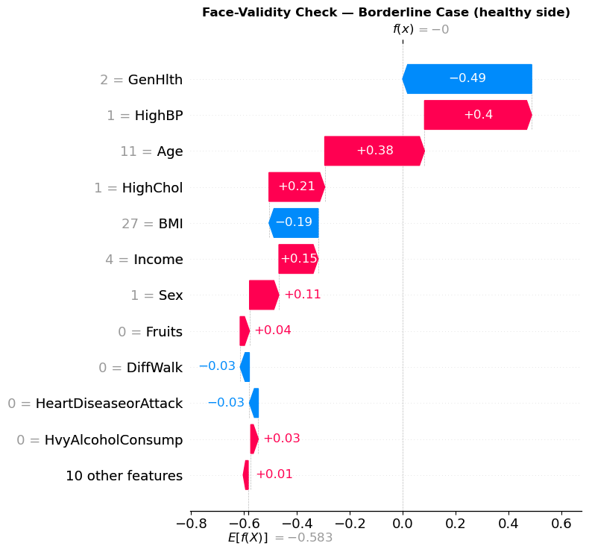
Figure E1-10. Borderline Healthy Prediction
Demonstrates why predictions close to the threshold require cautious interpretation.
Overall local-explanation conclusion: These figures demonstrate that understandable explanations can be produced for both correct and incorrect outputs. SHAP therefore supports transparency but does not prove prediction correctness or medical causation.

Appendix E2 — Robustness, Deployment and Governance Evidence
Table E2-1. Perturbation Robustness
Test Measure | Result
Held-out observations | 50,736
Perturbed features | BMI, MentHlth, PhysHlth
Gaussian noise standard deviation | 7.5%
Prediction flip rate | 3.52%
Mean absolute probability shift | 0.0226
Median absolute probability shift | 0.0103
Maximum probability shift | 0.3424
True-negative flip rate | 1.33%
False-positive flip rate | 12.02%
False-negative flip rate | 4.03%
True-positive flip rate | 6.50%
Interpretation: Population-level stability is good under moderate self-report variation, but predictions that were already incorrect—particularly false positives—are substantially more sensitive.
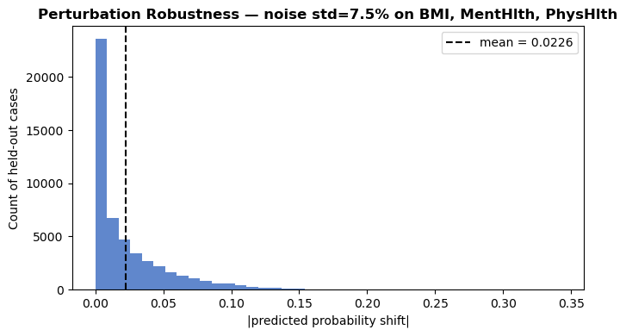
Figure E2-1. Probability Shift Under 7.5% Input Perturbation
Shows the distribution of absolute prediction-probability changes following perturbation.
Table E2-2. Missing-Value Robustness
Feature Simulated Missing | Replacement | Prediction Flip Rate | Mean Probability Shift | Maximum Shift
GenHlth | Median = 2 | 12.19% | 0.0792 | 0.4945
BMI | Median = 27 | 9.81% | 0.0625 | 0.4132
HighBP | Mode = 0 | 8.84% | 0.0505 | 0.3655
HighChol | Mode = 0 | 6.30% | 0.0398 | 0.3085
Age | Median = 8 | 5.70% | 0.0532 | 0.5077
Income | Median = 7 | 2.68% | 0.0199 | 0.2264
Sex | Mode = 0 | 2.14% | 0.0151 | 0.2049
HeartDiseaseorAttack | Mode = 0 | 0.87% | 0.0048 | 0.2367
Education | Median = 5 | 0.67% | — | —
MentHlth | Median = 0 | 0.54% | — | —
PhysHlth | Median = 0 | 0.48% | — | —
DiffWalk | Mode = 0 | 0.45% | — | —
Interpretation: GenHlth, BMI and HighBP are particularly sensitive to unavailable information. These fields should preferably be mandatory rather than silently imputed in a deployed intake workflow.
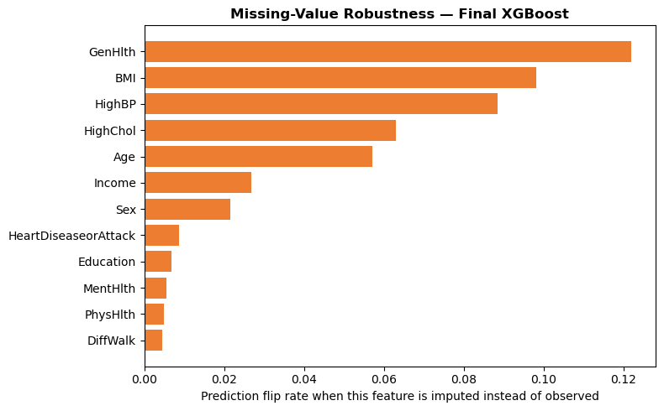
Figure E2-2. Prediction Flip Rate When Individual Features Are Missing
Ranks input fields by their effect on classification when replaced with median/mode values.
Table E2-3. Determinism and Near-Duplicate Consistency
Test | Result
Identical classifications across repeated inference | True — PASS
Identical probabilities across repeated inference | True — PASS
Near-duplicate input perturbation | 0.1%
Mean absolute probability shift | 0.00697
Maximum probability shift | 0.19924
Material-change criterion | ≥ 0.05
Cases meeting criterion | 1,001 / 50,736
Percentage | 1.97%
Interpretation: Exact inputs are fully reproducible, satisfying the deterministic-inference requirement. Approximately 2% of observations nevertheless show material sensitivity to very small changes, principally relevant to borderline predictions.
Table E2-4. Final Deployment and Serving-Lineage Validation
Control / Test | Final Evidence | Governance Significance
Final endpoint | team02-diabetes-risk | Removes ambiguity with earlier test endpoints
Serving technology | SageMaker Serverless Inference | Final managed inference layer
Model family | XGBoost | Matches selected champion
Final model run ID | 057bb58d81564c0db9a628b224eab8f9 | Experiment-to-serving traceability
Decision threshold | 0.50 | Frozen serving configuration
Config version | 2026-08-22-cross-model-champion-v5 | Configuration lineage
Data version | brfss2015-diabetes-binary-6244bec277fe | Data lineage
Request schema | Exact 21 features | Rejects missing or unexpected fields
Relay authentication | x-api-key | Restricts public demo access
AWS credentials | Remain server-side | Streamlit client does not receive AWS credentials
Returned lineage | Validated against frozen values | Detects stale or incorrect model serving
Intended-use wording | Screening support, not diagnosis | Reduces clinical over-reliance
Automatic retraining/deployment | Not used | Human oversight retained
Interpretation: Deployment validation tests more than availability. It checks whether the application is serving the expected model, data and configuration lineage and fails the request if lineage does not match.
Table E2-5. Governance Evidence Cross-Reference
Governance Area | Primary Governance Evidence | Final Technical Evidence
Intended use and human oversight | Completed ISAGO checklist | Controlled registration/deployment and non-diagnostic application wording
Data governance and lineage | Completed ISAGO checklist | Dataset/version hashes, fixed feature contract and serving lineage
Evaluation integrity | Completed ISAGO checklist | Training-only CV + held-out final evaluation
Fairness | Completed ISAGO checklist | Table E1-1; Figures E1-1–E1-2
Explainability | Completed ISAGO checklist | Tables E1-2–E1-3; Figures E1-3–E1-10
Robustness | Final model test evidence | Tables E2-1–E2-3; Figures E2-1–E2-2
Deployment integrity | MLOps / relay evidence | Table E2-4
Monitoring and review | Completed ISAGO checklist + MLOps design | Drift/performance/configuration signals trigger human investigation
Residual risk | This report + ISAGO | Subgroup disparity, population mismatch, missing-input sensitivity and borderline instability
Appendix E2 Overall Conclusion
The final test evidence demonstrates that governance principles have been translated into measurable technical controls. The model is explainable and deterministic, broadly stable under moderate perturbation, and traceable through deployment. However, fairness differences and specific robustness weaknesses remain visible rather than being treated as resolved.
The evidence therefore supports the same deployment boundary established in the main report: an assessment-ready academic screening-support prototype with human oversight, not a production clinical diagnostic system.

