Vending Machine – State Design pattern

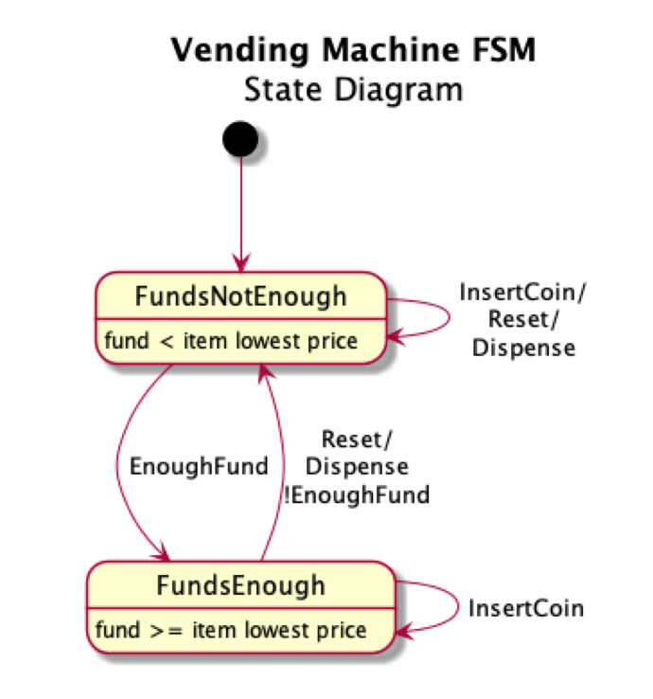

* Using State Design Pattern to implement the vending machine.
* Keep it simple with two states: FundsNotEnoughState and FundsEnoughState. Starting with FundsNotEnoughState. When inserted fund is enough for lowest-priced item, machine moves to FundsEnoughState.
* Wrapper class handles the 'reset' and max_fund(100 cents) check which are common in both states.
* Three coin types (5, 10, 25 cents) are loaded in inventory, 5 counts of each, used to return the change.
* Use PlantUML eclipse plugin to draw the above state diagram (code found at the end of Main.java)

CLI is as below. User to enter a choice from list of choices. Total fund of currently inserted coins is displayed at the prompt [FUND=0c], starting from 0 cent.

------------------------Inventory Counts------------------------

NICKLE(5c) = 5 DIME(10c) = 5 QUARTER(25c) = 5

Item1(55c) = 10 Item2(70c) = 10 Item3(75c) = 10

----------------------------------------------------------------

CHOICES: n=nickle, d=dime, q=quarter, r=reset, 1=item1, 2=item2, 3=item3

Please enter your choice[FUND=0c]: