VLAN Configuration Lab

Jacob Cockrill

**Introduction**: In this lab there are three separate LANs each of which needs two VLANs configured. You will need to configure the VLANs on each switch and sub-interfaces on each router to allow the devices to communicate within their network and across networks.

The steps below outline the basic process for VLAN configuration. It does not list the specific commands used to configure the devices. If you need additional help, refer to the device configuration shown at the end of this document.

**Step 1:** Subnetting for the VLANs

Each of the LANs has been provided a network and the number of users per VLAN is listed. Using the same method as for a LAN, subnet for the VLANs.

*It may be helpful to list the IP address, subnet mask, and default gateway (which will be the IP of the sub-interface on the router, as discussed later) in a note.

**Step 2:** Configure the Switches

The switches will use a combination of access and trunk ports to transport data. Interfaces connected to end devices, fa0/1 and fa0/2 in this case, will be access and the interface connecting to the router, fa0/24, will be a trunk link.

To configure the interfaces, do the following:

1. Go to the interface in the switch.
2. Set the interface as either an access or trunk port.
3. Allow the necessary VLAN(s) on the interface.

**Step 3:** Configure the routers for interVLAN routing

The routers need to be able to route traffic between both the VLANs on the same network and the different networks.

The following steps need to be completed:

1. Create the sub-interface on the router.
2. Use encapsulation dot1Q to enable routing between the VLANs
3. Set an IP address on the sub-interface. This will later be used as the default gateway on the PCs.

**Step 4:** Configure the PCs

The PCs will need to be set up with an IP address within it’s VLAN’s subnet. The default gateway for each will be the IP address configured on the router for that VLANs sub-interface.

1. Access the computer and select “Desktop” then “IP Configuration”.
2. Assign an IP address and subnet mask. The default gateway will be the IP address assigned to that VLANs sub-interface on the router.

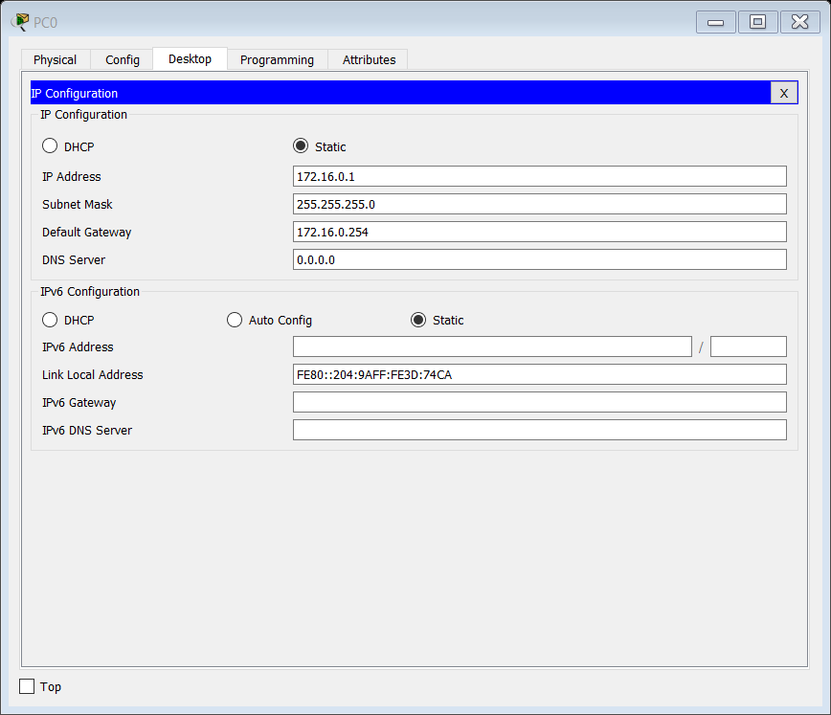

Screenshot of PC0 for reference

**Step 5:** Verify Connectivity

Ping between PCs within and between networks to ensure they can communicate. If the ping fails initially, try it a second time, sometimes it takes more than one attempt. If it continues to fail, check the configurations below to help resolve the issue.

*Refer to the configurations listed on the following pages if you need help.

# Device Configurations

The following commands are used to configure each of the devices in the network. For the switches the commands should be the exact same. For the routers, the commands may vary slightly depending on what you set as the IP address.

**Switches**

Since all the switches have the same interfaces connected to the same devices and the same VLANs, the configuration for each will be identical. Here is a sample of how the switches should be configured

Switch>en

Switch#conf t

Switch(config)#int vlan 10

Switch(config-if)#vlan 10

Switch(config-vlan)#name Student

Switch(config-vlan)#ex

Switch(config)#int vlan 30

Switch(config-if)#vlan 30

Switch(config-vlan)#name Faculty

Switch(config-vlan)#ex

Switch(config)#int f0/1

Switch(config-if)#switchport mode access

Switch(config-if)#switchport access vlan 10

Switch(config-if)#ex

Switch(config)#int f0/2

Switch(config-if)#switchport mode access

Switch(config-if)#switchport access vlan 30

Switch(config-if)#ex

Switch(config)#int f0/24

Switch(config-if)#sw

Switch(config-if)#switchport mode trunk

Switch(config-if)#switchport trunk allow vlan 10,30

**Router 0**

Router>en

Router#conf t

Router(config)#int f0/0.10

Router(config-subif)#encapsulation dot1q 10

Router(config-subif)#ip add 172.16.0.254 255.255.255.0

Router(config-subif)#ex

Router(config)#int f0/0.30

Router(config-subif)#encapsulation dot1q 30

Router(config-subif)#ip add 172.16.1.62 255.255.255.192

Router(config-subif)#ex

Router(config)#int f0/0

Router(config-if)#no shut

**Router 1**

Router>en

Router#conf t

Router(config)#int f0/0.10

Router(config-subif)#encapsulation dot1q 10

Router(config-subif)#ip add 172.16.2.126 255.255.255.128

Router(config-subif)#ex

Router(config)#int f0/0.30

Router(config-subif)#encapsulation dot1q 30

Router(config-subif)#ip add 172.16.2.190 255.255.255.192

Router(config-subif)#ex

Router(config)#int f0/0

Router(config-if)#no shut

**Router 2**

Router>en

Router#conf t

Router(config)#int f0/0.10

Router(config-subif)#encapsulation dot1q 10

Router(config-subif)#ip add 172.16.3.62 255.255.255.192

Router(config-subif)#ex

Router(config)#int f0/0.30

Router(config-subif)#encapsulation dot1q 30

Router(config-subif)#ip add 172.16.3.94 255.255.255.224

Router(config-subif)#ex

Router(config)#int f0/0

Router(config-if)#no shut