TN 275 Command Guide

**James Glover**

**Chapter 2: Configure a Network Operating System**

? Command - - - - - - - - - - - - - - - - - - - - - - - - - - - - - - - - - - - - - - - - - - - - - - - - - - - - - - - - - - 3

Enable Command - - - - - - - - - - - - - - - - - - - - - - - - - - - - - - - - - - - - - - - - - - - - - - - - - - - - - - 4

Configure Terminal Command  - - - - - - - - - - - - - - - - - - - - - - - - - - - - - - - - - - - - - - - - - - - - 4

Exit Command - - - - - - - - - - - - - - - - - - - - - - - - - - - - - - - - - - - - - - - - - - - - - - - - - - - - - - - - 5

Show Clock Command  - - - - - - - - - - - - - - - - - - - - - - - - - - - - - - - - - - - - - - - - - - - - - - - - - - 5

Clock Set Command - - - - - - - - - - - - - - - - - - - - - - - - - - - - - - - - - - - - - - - - - - - - - - - - - - - - 6

Show Running-Config Command - - - - - - - - - - - - - - - - - - - - - - - - - - - - - - - - - - - - - - - - - - 7

Hostname Command - - - - - - - - - - - - - - - - - - - - - - - - - - - - - - - - - - - - - - - - - - - - - - - - - - - 8

Line Console Command - - - - - - - - - - - - - - - - - - - - - - - - - - - - - - - - - - - - - - - - - - - - - - - - - 8

Password Command - - - - - - - - - - - - - - - - - - - - - - - - - - - - - - - - - - - - - - - - - - - - - - - - - - - 9

Login Command - - - - - - - - - - - - - - - - - - - - - - - - - - - - - - - - - - - - - - - - - - - - - - - - - - - - - - - 9

Enable Password Command - - - - - - - - - - - - - - - - - - - - - - - - - - - - - - - - - - - - - - - - - - - - - - 10

Enable Secret Command - - - - - - - - - - - - - - - - - - - - - - - - - - - - - - - - - - - - - - - - - - - - - - - - 11

Service Password-Encryption Command - - - - - - - - - - - - - - - - - - - - - - - - - - - - - - - - - - - - - 12

Banner Command - - - - - - - - - - - - - - - - - - - - - - - - - - - - - - - - - - - - - - - - - - - - - - - - - - - - - 12

Copy Running-config Startup-config - - - - - - - - - - - - - - - - - - - - - - - - - - - - - - - - - - - - - - - - 13

Interface Command - - - - - - - - - - - - - - - - - - - - - - - - - - - - - - - - - - - - - - - - - - - - - - - - - - - - 14

IP Address Command - - - - - - - - - - - - - - - - - - - - - - - - - - - - - - - - - - - - - - - - - - - - - - - - - - - 15

Shutdown Command - - - - - - - - - - - - - - - - - - - - - - - - - - - - - - - - - - - - - - - - - - - - - - - - - - - 15

Show IP Interface Brief Command - - - - - - - - - - - - - - - - - - - - - - - - - - - - - - - - - - - - - - - - - 16

**Chapter 5: Ethernet**

Show Arp Command - - - - - - - - - - - - - - - - - - - - - - - - - - - - - - - - - - - - - - - - - - - - - - - - - - - 17

Show Mac-Address-Table Command - - - - - - - - - - - - - - - - - - - - - - - - - - - - - - - - - - - - - - - 17

**Chapter 6: Network Layer**

Show Interface Command - - - - - - - - - - - - - - - - - - - - - - - - - - - - - - - - - - - - - - - - - - - - - - - 18

Show Startup-Config Command - - - - - - - - - - - - - - - - - - - - - - - - - - - - - - - - - - - - - - - - - - - 20

Show Flash Command - - - - - - - - - - - - - - - - - - - - - - - - - - - - - - - - - - - - - - - - - - - - - - - - - - 21

Copy Startup-Config Flash Command - - - - - - - - - - - - - - - - - - - - - - - - - - - - - - - - - - - - - - - 21

Show IP Route Command - - - - - - - - - - - - - - - - - - - - - - - - - - - - - - - - - - - - - - - - - - - - - - - - 22

Description Command - - - - - - - - - - - - - - - - - - - - - - - - - - - - - - - - - - - - - - - - - - - - - - - - - - 23

**Chapter 7: IP Addressing**

IPv6 Unicast-Routing Command - - - - - - - - - - - - - - - - - - - - - - - - - - - - - - - - - - - - - - - - - - - 24

IPv6 Address Command - - - - - - - - - - - - - - - - - - - - - - - - - - - - - - - - - - - - - - - - - - - - - - - - - 24

Show IPv6 Interface Brief Command - - - - - - - - - - - - - - - - - - - - - - - - - - - - - - - - - - - - - - - - 26

**Chapter 11: Build a Small Network**

IP Domain-Name Command - - - - - - - - - - - - - - - - - - - - - - - - - - - - - - - - - - - - - - - - - - - - - - 27

Username Command - - - - - - - - - - - - - - - - - - - - - - - - - - - - - - - - - - - - - - - - - - - - - - - - - - - 27

Crypto Key Generate RSA Command - - - - - - - - - - - - - - - - - - - - - - - - - - - - - - - - - - - - - - - - 29

Login Block-For Command - - - - - - - - - - - - - - - - - - - - - - - - - - - - - - - - - - - - - - - - - - - - - - - 30

Line Vty Command - - - - - - - - - - - - - - - - - - - - - - - - - - - - - - - - - - - - - - - - - - - - - - - - - - - - - 30

Transport Input Ssh Command - - - - - - - - - - - - - - - - - - - - - - - - - - - - - - - - - - - - - - - - - - - - 30

Login Local Command - - - - - - - - - - - - - - - - - - - - - - - - - - - - - - - - - - - - - - - - - - - - - - - - - - 31

Copy Tftp Running-Config Command - - - - - - - - - - - - - - - - - - - - - - - - - - - - - - - - - - - - - - - 31

Copy Flash Tftp Command - - - - - - - - - - - - - - - - - - - - - - - - - - - - - - - - - - - - - - - - - - - - - - - 31

Show Version Command - - - - - - - - - - - - - - - - - - - - - - - - - - - - - - - - - - - - - - - - - - - - - - - - 32

Show Protocols Command - - - - - - - - - - - - - - - - - - - - - - - - - - - - - - - - - - - - - - - - - - - - - - - 33

Show Users Command - - - - - - - - - - - - - - - - - - - - - - - - - - - - - - - - - - - - - - - - - - - - - - - - - - 35

**Chapter 2 Configure a Network Operating System**

**? Command**

|  |  |
| --- | --- |
| *Hostname* #**?** | Lists all commands available in the current command mode |
| *Hostname* #**show ?** | Shows all commands that start with *show* |

In any mode, you can obtain a list of commands available on that mode by entering a question mark (?). It can also tell you which commands start with specific characters or group of characters, and which arguments and keywords are available to particular commands.

*Command is used for packet tracer 2.1.4.6

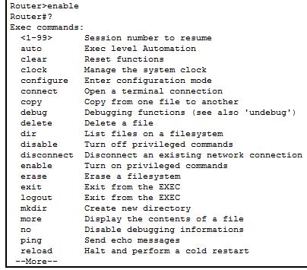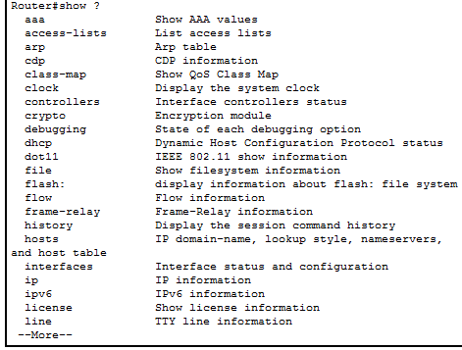

**Enable Command**

|  |  |
| --- | --- |
| *Hostname* >**enable**  *Hostname #* | Moves the user from user EXEC mode to privileged mode |

*Command is used for packet tracer 2.1.4.6

**Configure Terminal Command**

|  |  |
| --- | --- |
| *Hostname* #**configure terminal**  *Hostname (config) #* | Moves to global configuration mode |

*Command is used for packet tracer 2.1.4.6

|  |  |
| --- | --- |
| *Hostname* > | User mode |
| *Hostname* # | Privileged mode |
| *Hostname* (config-if) # | Interface mode |
| *Hostname* (config-line) # | Line mode |

**Exit Command**

|  |  |
| --- | --- |
| *Hostname* #**exit**  *Hostname >* | Moves you from Privileged mode to User mode |
| *Hostname* (config) #**exit**  *Hostname #* | Moves you from Interface mode to Privileged mode |
| *Hostname* (config-if) #**exit**  *Hostname (config) #* | Moves you from Line mode to Interface mode |

*Command is used for packet tracer 2.1.4.6



**Show Clock Command**

|  |  |
| --- | --- |
| *Hostname* #**show clock** | Displays the time and date from the system software clock |

*Command is used for packet tracer 2.1.4.6

**show** **clock** [ **trace** { **timezone_config | timezone_notify** } { **all***| trace-name* } **location***node-id* *[trace-attribute]*]

Syntax Description

|  |  |
| --- | --- |
| *trace-name* | Trace buffer name. |
| **timezone_config** | Displays timezone configuration traces. |
| **timezone_notify** | Displays timezone notify traces. |
| **location** *node-id* | Specifies the target location. The *node-id*argument is expressed in the *rack*/*slot*notation. |
| *trace-attribute* | Trace attribute. |
| **all** | Displays all the details. |



**Clock Set Command**

|  |  |
| --- | --- |
| *Hostname* #**clock set** | Manually sets the system hardware clock. The time is set using military (24-hour) format. The hardware clock runs continuously, even if the router is powered off or rebooted. |

*Command is used for packet tracer 2.1.4.6

**clock** **set** *hh***:***mm***:***ss* { *day* *month* | *month* *day* } *year*

Syntax Description

|  |  |
| --- | --- |
| *hh*:*mm*:*ss* | Current time in hours (24-hour format), minutes, and seconds. Colons are required between values. |
| *day* | Current day (by date) in the month. |
| *month* | Current month (by name). |
| *year* | Current year (no abbreviation). Enter a valid four-digit year. |



**Show Running-Config Command**

|  |  |
| --- | --- |
| *Hostname* #**show running-config** | Displays the configuration that is currently running |

*Command is used for packet tracer 2.2.3.4

**show running-config [all] [*command*]**

Syntax Description

|  |  |
| --- | --- |
| **all** | Displays the entire operating configuration, including defaults. |
| *command* | Displays the configuration associated with a specific command. |

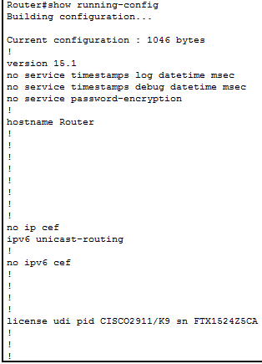

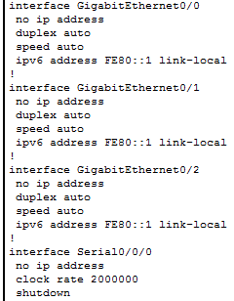

**Hostname Command**

|  |  |
| --- | --- |
| *Hostname* (config) #**hostname *R1***  *R1(config)#* | Changes the host name of the router |
| *Hostname* (config) #***no hostname R1*** | Restores the default hostname |

*Command is used for packet tracer 2.2.3.4

**hostname***name*

**no hostname**[*name*]

Syntax Description

|  |  |
| --- | --- |
| *name* | Specifies a hostname up to 63 characters. A hostname must start and end with a letter or digit, and have as interior characters only letters, digits, or a hyphen. |



**Line Console Command**

|  |  |
| --- | --- |
| *Hostname* (config) #**line console 0** | Enters line console mode |

*Command is used for packet tracer 2.2.3.4



**Password Command**

|  |  |
| --- | --- |
| *Hostname* (config-line) #**password (*password*)** | Sets a login password |
| *Hostname*(config-line) #**no password (password)** | Removes the login password |

*Command is used for packet tracer 2.2.3.4

{**passwd** | **password**}*password*[**encrypted**]

**no**{**passwd** | **password**} *password*

Syntax Description

|  |  |
| --- | --- |
| encrypted | (Optional) Specifies that the password is in encrypted form. The password is saved in the configuration in encrypted form, so you cannot view the original password after you enter it. If for some reason you need to copy the password to another adaptive security appliance but do not know the original password, you can enter the **passwd** command with the encrypted password and this keyword. Normally, you only see this keyword when you enter the **show running-config passwd** command. |
| **passwd | password** | You can enter either command; they are aliased to each other. |
| *password* | Sets the password as a case-sensitive string of up to 80 characters. The password must not contains spaces. |



**Login Command**

|  |  |
| --- | --- |
| *Hostname* (config-line) #**login** | Logs into privileged EXEC mode using the local user database (see the username command) or to change user names |

*Command is used for packet tracer 2.2.3.4



**Enable Password Command**

|  |  |
| --- | --- |
| *Hostname* (config) #**enable password (*password*)** | Sets the enable password for privileged EXEC mode |
| *Hostname* (config) #**no enable password (*password*)** | Removes the password |

*Command is used for packet tracer 2.2.3.4

**enable password***password***[level***level*] [**encrypted**]

**no enable password level***level*

Syntax Description

|  |  |
| --- | --- |
| encrypted | (Optional) Specifies that the password is in encrypted form. The password is saved in the configuration in encrypted form, so you cannot view the original password after you enter it. If for some reason you need to copy the password to another adaptive security appliance but do not know the original password, you can enter the **enable password**command with the encrypted password and this keyword. Normally, you only see this keyword when you enter the **show running-config enable** command. |
| **level***level* | (Optional) Sets a password for a privilege level between 0 and 15. |
| *password* | Sets the password as a case-sensitive string of 3 to 32 alphanumeric and special characters. You can use any character in the password except a question mark or a space. |



**Enable Secret Command**

|  |  |
| --- | --- |
| *Hostname* (config) #**enable secret (*password*)** | Sets the encrypted secret password to give an extra layer of security |
| *Hostname* (config) #**no** **enable secret (*password*)** | Removes the password |

*Command is used for packet tracer 2.2.3.4

**enable secret [level *level*] {*password*| [*encryption-type*] *encrypted-password*}**

**no enable secret [level *level*]**

Syntax Description

|  |  |
| --- | --- |
| **level***level* | (Optional) Level for which the password applies. You can specify up to sixteen privilege levels, using numbers 0 through 15. Level 1 is normal EXEC-mode user privileges. If this argument is not specified in the command or in the **no** form of the command, the privilege level defaults to 15 (traditional enable privileges). The same holds true for the **no** form of the command. |
| *password* | Password for users to enter enable mode. This password should be different from the password created with the **enable password** command. |
| *encryption-type* | (Optional) Cisco-proprietary algorithm used to encrypt the password. Currently the only encryption type available for this command is 5. If you specify *encryption-type*, the next argument you supply must be an encrypted password (a password encrypted by a Cisco router). |
| *encrypted-password* | Encrypted password you enter, copied from another router configuration. |



**Service Password-Encryption Command**

|  |  |
| --- | --- |
| *Hostname* (config) #s**ervice password-encryption** | Clear text passwords will be hidden using a weak encryption algorithm |
| *Hostname* (config) #**no service password-encryption** | Restores to default |

*Command is used for packet tracer 2.2.3.4



**Banner Command**

|  |  |
| --- | --- |
| *Hostname* (config) #**banner motd (“message”)** | Configures the ASDM, session, login, or message-of-the-day banner |

*Command is used for packet tracer 2.2.3.4

**banner {asdm | exec | login | motd***text*}

**[no] banner {asdm | exec | login | motd [*text***]}

Syntax Description

|  |  |
| --- | --- |
| **asdm** | Configures the system to display a banner after you successfully log in to ASDM. The user is prompted to either Continue to complete logging in, or to Disconnect. This option lets you require users to accept the terms of a written policy before connecting. |
| **exec** | Configures the system to display a banner before displaying the enable prompt. |
| **login** | Configures the system to display a banner before the password login prompt when accessing the adaptive security appliance using Telnet. |
| **motd** | Configures the system to display a message-of-the-day banner when you first connect. |
| *text* | Line of message text to display. |



**Copy Running-config Startup-config**

|  |  |
| --- | --- |
| *Hostname* #**copy running-config startup-config** | Saves the configuration to NVRAM |

*Command is used for packet tracer 2.2.3.4

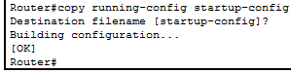

**Interface Command**

|  |  |
| --- | --- |
| *Hostname* (config) #**interface *(interface)*** | Enters interface configuration mode |

*Command is used for packet tracer 2.3.2.5

**interface***physical_interface*

Syntax Description

|  |  |
| --- | --- |
| *physical_interface* | Specifies the physical interface type, slot, and port number as *type*[*slot***/**]*port*. A space between the type and slot/port is optional.  The physical interface types include the following:  •https://www.cisco.com/c/dam/en/us/td/i/templates/blank.gif**ethernet**  •https://www.cisco.com/c/dam/en/us/td/i/templates/blank.gifgigabitethernet  •https://www.cisco.com/c/dam/en/us/td/i/templates/blank.gif**tengigabitethernet**  •https://www.cisco.com/c/dam/en/us/td/i/templates/blank.gif**management**  Enter the type followed by slot/port, for example, **gigabitethernet 0/1**. Interfaces that are built into the chassis are assigned to slot 0, while interfaces on an interface card, such as the 4GE SSM (or a built-in 4GE SSM), are assigned to slot 1.  The management interface is a Fast Ethernet interface designed for management traffic only, and is specified as **management 0/0 or 0/1**. You can, however, use it for through traffic if desired (see the **management-only** command). In transparent firewall mode, you can use the management interface in addition to the two interfaces allowed for through traffic. You can also add subinterfaces to the management interface to provide management in each security context for multiple context mode.  See the hardware documentation that came with your model to identify the interface type, slot, and port number. |



**IP Address Command**

|  |  |
| --- | --- |
| *Hostname* (config-if) #**ip address *(ip address) (netmask)*** | Sets the IP address and netmask for switch |
| *Hostname* (config-if) #**no** **ip address *(ip address) (subnet mask)*** | Removes the IP address and netmask |

*Command is used for packet tracer 2.3.2.5

**ip address***ip_address* [*mask*]

**no ip address**[*ip_address*]

Syntax Description

|  |  |
| --- | --- |
| *ip_address* | The IP address for the interface (routed mode) or the management IP address (transparent mode). |
| *mask* | (Optional) The subnet mask for the IP address. If you do not set the mask, the adaptive security appliance uses the default mask for the IP address class. |

interface.PNG

**Shutdown Command**

|  |  |
| --- | --- |
| *Hostname* (config-if) #**shutdown** | Turns the virtual interface off |
| *Hostname* (config-if) #**no shutdown** | Turns the virtual interface on |

*Command is used for packet tracer 2.3.2.5

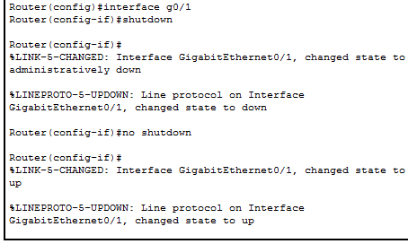

**Show IP Interface Brief Command**

|  |  |
| --- | --- |
| *Hostname* #**show ip interface brief** | Displays a summary of all interfaces, including status and IP address assigned |

*Command is used for packet tracer 2.3.2.5

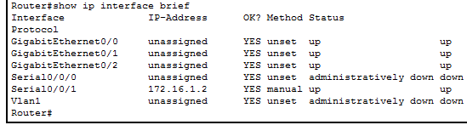

**Chapter 5 Ethernet**

**Show Arp Command**

|  |  |
| --- | --- |
| *Hostname* #**show arp** | Displays the Address Resolution Protocol ARP (table) |

*Command is used for packet tracer 5.3.2.8

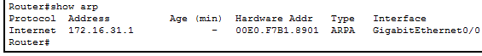

**Show Mac-Address-Table Command**

|  |  |
| --- | --- |
| *Hostname* #**show mac-address-table** | Displays the current MAC address table |

*Command is used for packet tracer 5.3.2.8

**show mac-address-table [***interface_name*| **count** |**static**]

Syntax Description

|  |  |
| --- | --- |
| **count** | (Optional) Lists the total number of dynamic and static entries. |
| *interface_name* | (Optional) Identifies the interface name for which you want to view MAC address table entries. |
| **static** | (Optional) Lists only static entries. |

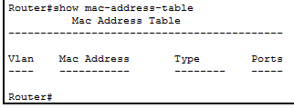

**Chapter 6 Network Layer**

**Show Interface Command**

|  |  |
| --- | --- |
| *Hostname* #**show interface (serial 0/0/0)** | Displays statistics for all interfaces  Displays statistics for a specific interface |

*Command is used for packet tracer 6.3.1.8

Show interface [{*physical_interface* | redundant *number*}[.*subinterface*] |*mapped_name*| *interface_name |*vlan*number*] [stats | detail]

Syntax Description

|  |  |
| --- | --- |
| detail | (Optional) Shows detailed interface information, including the order in which the interface was added, the configured state, the actual state, and asymmetrical routing statistics, if enabled by the asr-group command. If you show all interfaces, then information about the internal interfaces for SSMs displays, if installed on the ASA 5500 series adaptive security appliance. The internal interface is not user-configurable, and the information is for debugging purposes only. |
| *interface_name* | (Optional) Identifies the interface name set with the nameifcommand. |
| *mapped_name* | (Optional) In multiple context mode, identifies the mapped name if it was assigned using the allocate-interface command. |
| *physical_interface* | (Optional) Identifies the interface ID, such as gigabitethernet 0/1. See the interface command for accepted values. |
| redundant *number* | (Optional) Identifies the redundant interface ID, such as redundant1. |
| stats | (Default) Shows interface information and statistics. This keyword is the default, so it is optional. |
| *subinterface* | (Optional) Identifies an integer between 1 and 4294967293, designating a logical subinterface. |
| vlan *number* | (Optional) For models with a built-in switch, such as the ASA 5505 adaptive security appliance, specifies the VLAN interface. |

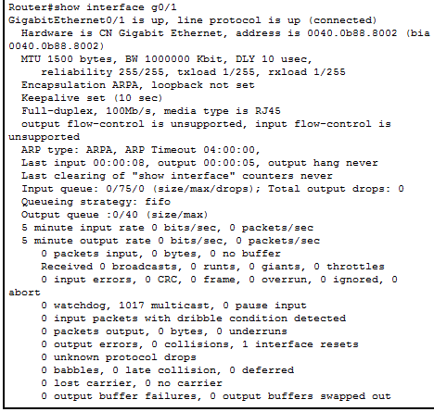

**Show Startup-Config Command**

|  |  |
| --- | --- |
| *Hostname* #**show startup-config** | Displays the startup configuration or any errors when the startup configuration is loaded |

*Command is used for packet tracer 6.4.1.3

**show startup-config**[**errors**]

Syntax Description

|  |  |
| --- | --- |
| **errors** | (Optional) Shows any errors that were generated when the adaptive security appliance loaded the startup configuration. |

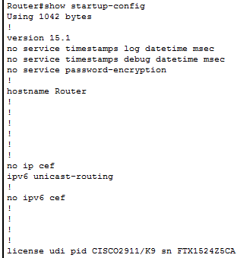



**Show Flash Command**

|  |  |
| --- | --- |
| *Hostname* #**show flash** | Displays information about the internal flash memory |

*Command is used for packet tracer 6.4.1.3

**show flash: all**|**controller**|**filesys**

Syntax Description

|  |  |
| --- | --- |
| **all** | Displays all Flash information. |
| **controller** | Displays file system controller information. |
| **filesys** | Displays file system information. |

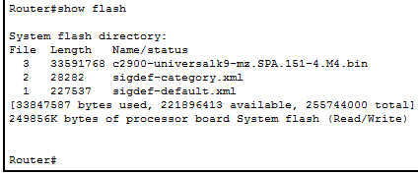

**Copy Startup-Config Flash Command**

|  |  |
| --- | --- |
| *Hostname* #**copy startup-config flash** | Saves the startup configuration file to flash |

*Command is used for packet tracer 6.4.1.3

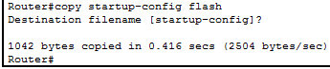

**Show IP Route Command**

|  |  |
| --- | --- |
| *Hostname* # **show ip route** | Displays the contents of the IP routing table |

*Command is used for packet tracer 6.4.3.3

**show route** [*interface_name*[*ip_address*[*netmask*[**static**]]]]

Syntax Description

|  |  |
| --- | --- |
| **static** | (Optional) Limits the display to static routes. |
| *interface_name* | (Optional) Limits the display to route entries that use the specified interface. |
| *ip_address* | (Optional) Limits the display to routes to the specified destination. |
| *netmask* | (Optional) Network mask to apply to *ip_address*. |

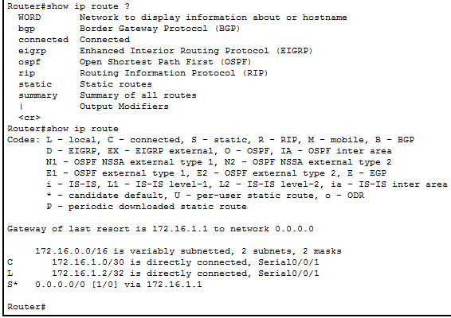

**Description Command**

|  |  |
| --- | --- |
| *Hostname* (config-if) #**description** | Used to add a description to something such as an interface |
| *Hostname* (config-if) #**no** **description** | Removes description |

*Command is used for packet tracer 6.4.3.3

**description** *text*

**no description**

Syntax Description

|  |  |
| --- | --- |
| *text* | Sets the description as a text string up to 200 characters in length. For dynamic-access-policy-record mode the maximum length is 80 characters.  If you want to include a question mark (?) in the string, you must type **Ctrl-V**before typing the question mark so you do not inadvertently invoke CLI help. |



**Chapter 7 IP Addressing**

**IPv6 Unicast-Routing Command**

|  |  |
| --- | --- |
| *Hostname* (config) #**ipv6 unicast-routing** | Enables the forwarding of IPv6 unicast datagrams globally on the router |
| *Hostname* (config) #**no ipv6 unicast-routing** | Disables the forwarding of IPv6 unicast datagrams |

*Command is used for packet tracer 7.2.4.9

**ipv6 unicast-routing**

**no ipv6 unicast-routing**

ipv6 unicast.PNG

**IPv6 Address Command**

|  |  |
| --- | --- |
| *Hostname* (config-if) #**ipv6 address (address)**  *Hostname* (config-if) #**ipv6 address (address) link-local** | Configures a global IPv6 address on the interface and enables IPv6 processing on the interface  Configures a specific link-local IPv6 address in the interface instead of the one that is automatically configured when IPv6 is enabled on the interface |
| *Hostname* (config-if) #**no** **ipv6 address (address)** | Removes IPv6 address |

*Command is used for packet tracer 7.2.4.9

**ipv6 address**{**autoconfig** | {*ipv6-prefix*/*prefix-length* [**eui-64**] [**standby** *ipv6-prefix*]}} | {*ipv6-address* **link-local** [**standby** *ipv6-address*]}

**no ipv6 address**{**autoconfig** | {*ipv6-prefix*/*prefix-length* [**eui-64**] [**standby** *ipv6-prefix*]}} | {*ipv6-address* **link-local** [**standby** *ipv6-address*]}

Syntax Description

|  |  |
| --- | --- |
| **autoconfig** | Enables automatic configuration of IPv6 addresses using stateless autoconfiguration on an interface. Not supported for transparent firewall mode. |
| **eui-64** | (Optional) Specifies the use of the interface ID in the low order 64 bits of the IPv6 address. |
| *ipv6-address* | The IPv6 link-local address assigned to the interface. |
| *ipv6-prefix* | The IPv6 network address assigned to the interface. |
| **link-local** | Specifies that the address is a link-local address. |
| *prefix-length* | Indicates how many of the high-order, contiguous bits of the address comprise the IPv6 prefix (the network portion of the IPv6 address). |
| **standby** | (Optional) Specifies the interface address used by the secondary unit or failover group in a failover pair. If the **eui-64**option is used, you do not need to specify the standby addres; the link-local address of the interface will be used. |

ipv6 address.PNG

**Show IPv6 Interface Brief Command**

|  |  |
| --- | --- |
| *Hostname* #**show ipv6 interface brief** | Displays a summary of all interfaces, including status and IPv6 address assigned |

*Command is used for packet tracer 7.3.2.6

**show ipv6 interface**[**brief**] [*if_name* [**prefix**]]

Syntax Description

|  |  |
| --- | --- |
| **brief** | Displays a brief summary of IPv6 status and configuration for each interface. |
| *if_name* | (Optional) The internal or external interface name, as designated by the **nameif** command. The status and configuration for only the designated interface is shown. |
| **prefix** | (Optional) Prefix generated from a local IPv6 prefix pool. The prefix is the network portion of the IPv6 address. |

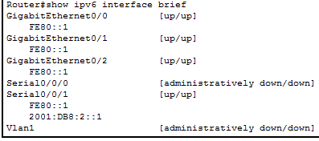

**Chapter 11 Build a Small Network**

**IP Domain-Name Command**

|  |  |
| --- | --- |
| *Hostname* (config) #**ip domain-name (*name*)** | Configures the IP domain name of the network |

*Command is used for packet tracer 11.2.4.5ip domain name.PNG

**Username Command**

|  |  |
| --- | --- |
| *Hostname* (config) #**username (username)** | Adds a user to the adaptive security appliance database |
| *Hostname* (config) #**no username (username)** | Removes username |

*Command is used for packet tracer 11.2.4.5

**username** *name* {**nopassword** | **password** *password* [**mschap** |**encrypted**|**nt-encrypted**]} [**privilege** *priv_level*]

**no** **username** *name*

Syntax Description

|  |  |
| --- | --- |
| **encrypted** | Indicates that the password is encrypted (if you did not specify **mschap**). When you define a password in the **username** command, the adaptive security appliance encrypts it when it saves it to the configuration for security purposes. When you enter the **show running-config**command, the **username** command does not show the actual password; it shows the encrypted password followed by the **encrypted** keword. For example, if you enter the password "test," the **show running-config**command output would appear to be something like the following:  username pat password rvEdRh0xPC8bel7s encrypted  The only time you would actually enter the **encrypted** keyword at the CLI is if you are cutting and pasting a configuration to another adaptive security appliance and you are using the same password. |
| **mschap** | Specifies that the password will be converted to unicode and hashed using MD4 after you enter it. Use this keyword if users are authenticated using MSCHAPv1 or MSCHAPv2. |
| *name* | Specifies the name of the user as a string from 4 to 64 characters in length. |
| **nopassword** | Indicates that this user needs no password. |
| **nt-encrypted** | Indicates that the password is encrypted for use with MSCHAPv1 or MSCHAPv2. If you specified the **mschap** keyword when you added the user, then this keyword is displayed instead of the **encrypted**keyword when you view the configuration using the **show running-config** command.  When you define a password in the **username** command, the adaptive security appliance encrypts it when it saves it to the configuration for security purposes. When you enter the **show running-config**command, the **username** command does not show the actual password; it shows the encrypted password followed by the **nt-encrypted** keword. For example, if you enter the password "test," the **show running-config**display would appear to be something like the following:  username pat password DLaUiAX3l78qgoB5c7iVNw== nt-encrypted  The only time you would actually enter the **nt-encrypted** keyword at the CLI is if you are cutting and pasting a configuration to another adaptive security appliance and you are using the same password. |
| **password***password* | Sets the password as a string from 3 to 32 characters in length. |
| **privilege***priv_level* | Sets a privilege level for this use from 0 to 15 (lowest to highest). The default privilege level is 2. This privilege level is used with command authorization. |

username.PNG

**Crypto Key Generate RSA Command**

|  |  |
| --- | --- |
| *Hostname* (config) #**crypto key generate rsa** | Generates RSA key pairs for identity certificates |

*Command is used for packet tracer 11.2.4.5

**crypto key generate rsa**[**usage-keys | general-keys**] [**label***key-pair-label*] [**modulus** *size*] [**noconfirm**]

Syntax Description

|  |  |
| --- | --- |
| **general-keys** | Generates a single pair of general purpose keys. This is the default key-pair type. |
| **label** *key-pair-label* | Specifies the name to be associated with the key pair(s). This key pair must be uniquely labeled. If you attempt to create another key pair with the same label, the adaptive security appliance displays an warning message. If no label is provided when the key is generated, the key pair is statically named <Default-RSA-Key>. |
| **modulus***size* | Specifies the modulus size of the key pair(s): 512, 768, 1024, and 2048. The default modulus size is 1024. |
| **noconfirm** | Suppresses all interactive prompting. |
| **usage-keys** | Generates two key pairs, one for signature use and one for encryption use. This implies that two certificates for the corresponding identity are required. |

**Login Block-For Command**

|  |  |
| --- | --- |
| *Hostname* (config) #**login block-for (*time period in seconds*) attempts (*fail attempts max value*) within (*time period in seconds*)** | Blocks login attempts for a certain amount of time after so many failed attempts within a certain amount of time |
| *Hostname* (config) #**no login block-for** | Removes blocking login attempts |

*Command is used for packet tracer 11.2.4.5

login block-for.PNG

**Line Vty Command**

|  |  |
| --- | --- |
| *Hostname* (config) #**line vty (*first line number*) (*last line number*)** | Enters line vty mode for virtual ports |

*Command is used for packet tracer 11.2.4.5

line vty.PNG

**Transport Input Ssh Command**

|  |  |
| --- | --- |
| *Hostname* (config-line) #**transport input ssh** | Enables inbound SSH sessions |

*Command is used for packet tracer 11.2.4.5transport input ssh.PNG

**Login Local Command**

|  |  |
| --- | --- |
| *Hostname* (config-line) #login local |  |

*Command is used for packet tracer 11.2.4.5login local.PNG

**Copy Tftp Running-Config Command**

|  |  |
| --- | --- |
| *Hostname* #**copy tftp running-config** | Merges the configurationfile from the TFTP server with the running-config file in DRAM |

*Command is used for packet tracer 11.2.5.7

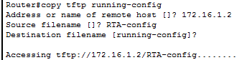

**Copy Flash Tftp Command**

|  |  |
| --- | --- |
| **copy flash tftp** | Copies the IOS in flash to the TFTP server |

*Command is used for packet tracer 11.2.5.7

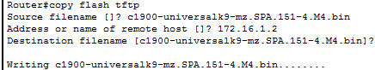

**Show Version Command**

|  |  |
| --- | --- |
| *Hostname* #**show version** | Displays information about the software version, hardware configuration, license key, and related uptime data |

*Command is used for packet tracer 11.3.3.3

**show version**

Cisco ASR 1000 Series Routers

show version [*rp-slot*] [installed [user-interface] | provisioned | running]

Cisco Catalyst 6500 Series Routers

show version [epld *slot*]

Syntax Description

|  |  |
| --- | --- |
| *rp-slot* | Specifies the software of the RP in a specific RP slot of a Cisco ASR 1000 Series Router. Options include:  •https://www.cisco.com/c/dam/en/us/td/i/templates/blank.gifr0—the RP in RP slot 0.  •https://www.cisco.com/c/dam/en/us/td/i/templates/blank.gifr1—the RP in RP slot 1.  •https://www.cisco.com/c/dam/en/us/td/i/templates/blank.gifrp active—the active RP.  •https://www.cisco.com/c/dam/en/us/td/i/templates/blank.gifrp standby—the standby RP. |
| installed | Specifies information on the software installed on the RP |
| user-interface | Specifies information on the files related to the user-interface. |
| provisioned | Specifies information on the software files that are provisioned. |
| running | Specifies information on the files currently running. |
| epld *slot* | (Optional) Specifies the software of the EPLD slot of a Cisco Catalyst 6500 Series Router. |

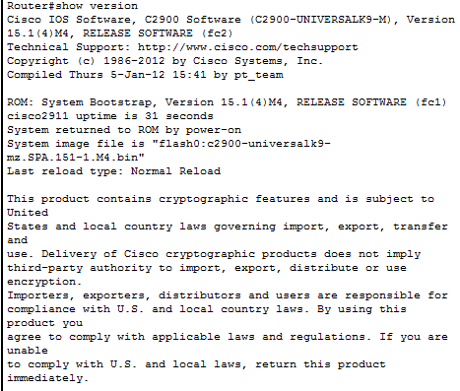

**Show Protocols Command**

|  |  |
| --- | --- |
| *Hostname* # **show protocols** | Displays the status of configured Layer 3 protocols |

*Command is used for packet tracer 11.3.3.3

**show protocols** [*interface-name* *interface-number*]

Syntax Description

|  |  |
| --- | --- |
| *interface-name* | (Optional) The type of interfaces. It can be one of the following values:  •https://www.cisco.com/c/dam/en/us/td/i/templates/blank.gif**ATM**—ATM interface  •https://www.cisco.com/c/dam/en/us/td/i/templates/blank.gif**Async**—Async interface  •https://www.cisco.com/c/dam/en/us/td/i/templates/blank.gif**Auto-Template**—Auto-Template interface  •https://www.cisco.com/c/dam/en/us/td/i/templates/blank.gif**BVI**—Bridge-Group Virtual Interface  •https://www.cisco.com/c/dam/en/us/td/i/templates/blank.gif**CDMA-Ix**—CDMA Ix interface  •https://www.cisco.com/c/dam/en/us/td/i/templates/blank.gif**Container**—Container interface  •https://www.cisco.com/c/dam/en/us/td/i/templates/blank.gif**CTunnel**—CTunnel interface  •https://www.cisco.com/c/dam/en/us/td/i/templates/blank.gif**Dialer**—Dialer interface  •https://www.cisco.com/c/dam/en/us/td/i/templates/blank.gif**Ethernet**—Institute of Electrical Electronics Engineers (IEEE) 802.3  •https://www.cisco.com/c/dam/en/us/td/i/templates/blank.gif**FastEthernet**—FastEthernet IEEE 802.3  •https://www.cisco.com/c/dam/en/us/td/i/templates/blank.gif**EsconPhy**—ESCON interface  •https://www.cisco.com/c/dam/en/us/td/i/templates/blank.gif**fcpa**—Fiber Channel  •https://www.cisco.com/c/dam/en/us/td/i/templates/blank.gif**Filter**—Filter interface  •https://www.cisco.com/c/dam/en/us/td/i/templates/blank.gif**multiservice**—Multiservice interface  •https://www.cisco.com/c/dam/en/us/td/i/templates/blank.gif**Pos-channel**—POS Channel interfaces  •https://www.cisco.com/c/dam/en/us/td/i/templates/blank.gif**SBC**—Session Border Controller  •https://www.cisco.com/c/dam/en/us/td/i/templates/blank.gif**SYSCLOCK**—Telecom-Bus Clock Controller  •https://www.cisco.com/c/dam/en/us/td/i/templates/blank.gif**Tunnel**—Tunnel interface  •https://www.cisco.com/c/dam/en/us/td/i/templates/blank.gif**Vif**—PGM Multicast Host interface  •https://www.cisco.com/c/dam/en/us/td/i/templates/blank.gif**Virtual-Access**—Virtual access interface  •https://www.cisco.com/c/dam/en/us/td/i/templates/blank.gif**Virtual-PPP**—Virtual PPP interface  •https://www.cisco.com/c/dam/en/us/td/i/templates/blank.gif**Virtual-Template**—Virtual template interface  •https://www.cisco.com/c/dam/en/us/td/i/templates/blank.gif**Virtual-TokenRing**—Virtual TokenRing  •https://www.cisco.com/c/dam/en/us/td/i/templates/blank.gif**Vlan**—Catalyst VLANs  •https://www.cisco.com/c/dam/en/us/td/i/templates/blank.gif**vmi**—Virtual Multipoint Interface |
|
|
|
|  | •https://www.cisco.com/c/dam/en/us/td/i/templates/blank.gif**voaBypassIn**—VOA-Bypass-In interface  •https://www.cisco.com/c/dam/en/us/td/i/templates/blank.gif**voaBypassOut**—VOA-Bypass-Out interface  •https://www.cisco.com/c/dam/en/us/td/i/templates/blank.gif**voaFilterIn**—VOA-Filter-In interface  •https://www.cisco.com/c/dam/en/us/td/i/templates/blank.gif**voaFilterOut**—VOA-Filter-Out interface  •https://www.cisco.com/c/dam/en/us/td/i/templates/blank.gif**voaIn**—VOA-In interface  •https://www.cisco.com/c/dam/en/us/td/i/templates/blank.gif**voaOut**—VOA-Out interface |
| *interface-number* | (Optional) Interface number. |

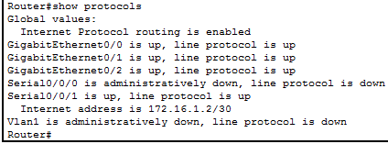

**Show Users Command**

|  |  |
| --- | --- |
| *Hostname* #**show users** | Displays all users connected to the device |

*Command is used for packet tracer 11.3.3.3

