Q4: Robustness:

For SVM_MC

We trained the model using the transformed data (randomly translated and rotated data) for values in

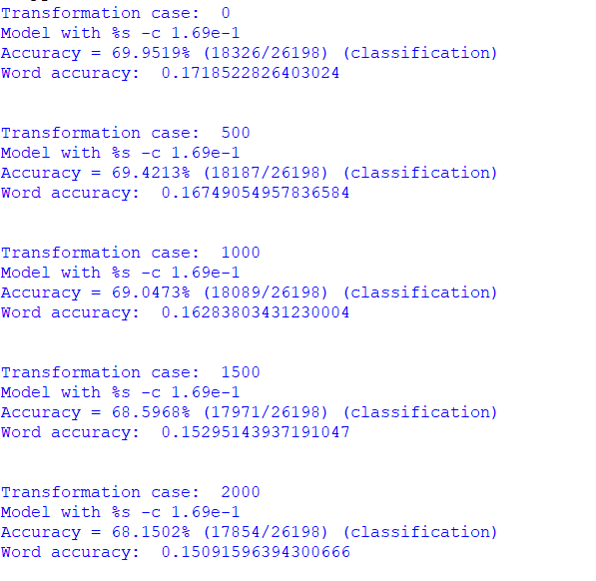[0, 500, 1000, 1500, 2000] along with some original data. Results are just little less accurate than the actual results without transformations. This suggests robustness is our model.