

Class : MAE 32
Course : Applied Econometrics
Lecturer : Professor Truong Dang Thuy
Student : Tran Chanh Truc
Student ID : 425273220
Deadline : 12 July 2026

University of Economics Ho Chi Minh City (UEH)
Vietnam - The Netherlands Programme (VNP)

COURSE PROJECT
AI Patent Intensity and the Labor Income Share:
Evidence Across OECD Industries, 2010-2022

Ho Chi Minh City
July 2026
Table of Contents
List of Abbreviations 4
List of Tables 5
List of Figures 6
List of Equations 7
Abstract 8
1 Introduction 9
1.1. Motivation and Theoretical Background 9
1.2. Research Gap and Question 9
1.3. Empirical Strategy Overview 10
1.4. Research Objectives and Questions 10
1.4.1. General Objective 10
1.4.2. Research Questions 10
1.4.3. Specific Objectives 11
1.5. Contribution 11
1.6. How the Paper Proceeds 11
2. Literature Review 12
2.1. Technology and the Labor Share 12
2.2. Automation, AI, and Task Displacement 12
2.3. A Theoretical Micro-Foundation for an Ambiguous Sign 12
2.4. Capital and Skill Intensity as Moderators 13
2.5. Measuring AI Diffusion 13
2.6. Labor Share Measurement and Self-Employment 14
2.7. Instrumental Variable Strategies for Technology Exposure 14
2.8. Global Trends and Measurement Challenges in AI Patenting 14
2.9. Machine Learning as a Complementary Descriptive Tool 15
2.10. Gap Addressed 15
3. Data Description 16
3.1. Sample and Coverage 16
3.2. Reproducibility 16
3.3. Dependent Variable 16
3.4. AI Patent Intensity (AIPI) 17
3.5. Control Variables and Moderators 17
3.6. Variable Codebook and Industry Coverage 17
3.7. Descriptive Statistics 20
3.8. Data Cleaning 21
3.9. Graphical Overview of the Data 21
4. Methodology 25
4.1. Underlying Economic Process 25
4.2. Estimator Sequence and the Issue Each Step Addresses 25
4.3. Baseline Specification 26
4.4. Instrumental Variables Specification 27
4.5. Moderated Specification 28
4.6. Estimator Choice: FE versus RE 28
4.7. Dynamic Robustness: Difference GMM 28
4.8. Channel Decomposition 29
4.9. Diagnostic Tests (Seven Mandatory, α = 0.10) 29
4.10. Robustness Battery 30
4.11. Hypothesized Signs of Coefficients (Ex-Ante) 30
5. Empirical Results 32
5.1. Model Structure and Diagnostics 32
5.2. Main Estimates 33
5.3. Robustness Checks (R1-R5) 34
5.4. First-Stage Diagnostics 35
5.5. Mechanism Check: Employment Channel 36
5.6. Robustness: Self-Employment Adjustment (R6) 37
5.7. Robustness: Moderator Threshold Sensitivity (R7) 37
5.8. Robustness: Targeted Extensions (R8-R11) 38
5.9. Robustness: Second-Pass Refinements (R12-R14) 38
5.10. Robustness: Additional Moderators (HighTrade/HighRD) 39
5.11. Robustness: Dynamic Panel LSDV (Uncorrected) 40
5.12. Channel Decomposition: The Central Finding 43
5.13. Minimum Detectable Effect 44
5.14. Descriptive Complement: SHAP Feature Importance 45
6. Discussion 51
6.1. How the Findings Square with Theory 51
6.2. Comparison with Prior Evidence 51
6.3. Diagnostic Lessons 52
6.4. Robustness of the Conclusion 52
6.5. Policy Implications 53
6.6. Limitations 54
6.7. Future Research 54
7. Conclusion 56
8. References 57

List of Abbreviations
Abbreviation | Definition
AIPI | AI Patent Intensity
ALP | Algorithmic Links with Probabilities (patent-to-industry crosswalk)
CPC | Cooperative Patent Classification
ISIC | International Standard Industrial Classification
STAN | Structural Analysis (OECD Industrial Database)
A*10 | OECD/Eurostat 10-industry aggregation of ISIC Rev.4
FE | Fixed Effects
RE | Random Effects
IV | Instrumental Variable
OLS | Ordinary Least Squares
GMM | Generalized Method of Moments
AR(1)/AR(2) | First-order / second-order autocorrelation (Arellano-Bond test)
SE | Standard Error
CI | Confidence Interval
VIF | Variance Inflation Factor
MDE | Minimum Detectable Effect
LOWESS | Locally Weighted Scatterplot Smoothing
SHAP | SHapley Additive exPlanations
GDP | Gross Domestic Product
R&D | Research and Development
VA | Value Added
LABR | Labor Compensation (STAN variable code)
VALU | Value Added (STAN variable code)
EMPN | Total Employment (STAN variable code)
GFCF | Gross Fixed Capital Formation
WDI | World Development Indicators (World Bank)
OECD | Organization for Economic Co-operation and Development

List of Tables
Table 1. Variable Codebook 18
Table 2. STAN A*10 Industry Coverage 18
Table 3. AIPI Industry Weights (ALP Crosswalk) (A*10, Renormalized) 19
Table 4. Descriptive Statistics, OECD Panel 20
Table 5. Pairwise Correlation Matrix 20
Table 6. Hypothesized Signs of Coefficients (Ex-Ante) 30
Table 7. Model Structure and Estimation Details 32
Table 8. Diagnostic Tests (α = 0.10) 32
Table 9. Main Results: AIPI and Labor Income Share 33
Table 10. Robustness Checks 34
Table 11. First-Stage Regression: Instrument Validity 35
Table 12. Mechanism Check: Employment (FE-IV) 36
Table 13. Robustness: Gollin Self-Employment Adjustment 37
Table 14. Moderator Threshold Sensitivity 37
Table 15. Targeted Extensions (R8-R11) 38
Table 16. Second-Pass Refinements (R12-R14) 38
Table 17. Additional Moderator Robustness (HighTrade/HighRD) 39
Table 18. Dynamic Panel LSDV and Bias-Corrected LSDVC: OECD Panel 41
Table 19. Channel Decomposition and Accounting Identity (FE-IV) 43
Table 20. Accounting Identity Check 43

List of Figures
Figure 1. Labor Share Trend by Industry 22
Figure 2. ln(Labor Share) Distribution by Year 22
Figure 3. AIPI vs Labor Share (LOWESS) 23
Figure 4. Correlation Heatmap 23
Figure 5. Labor Share Distribution by Industry (Violin) 24
Figure 6. Coefficient Trajectory Across Estimators 34
Figure 7. Diagnostic Plots: FE-IV Specification 36
Figure 8. Robustness Battery Across Specifications 42
Figure 9. Channel Decomposition and Accounting Identity (FE-IV) 44
Figure 10. SHAP Feature Importance 45
Figure 11. SHAP Summary Plot (Beeswarm) 46
Figure 12. SHAP Dependence - AIPI 47
Figure 13. SHAP Dependence by High-Capital Status 47
Figure 14. SHAP Dependence Plot - AI Patent Intensity by High-Skill Status 48
Figure 15. SHAP Waterfall Plot 49
Figure 16. Dynamic Persistence: Raw LSDV vs. Two Independent LSDVC Methods 50

List of Equations
Equation 1. Baseline Two-Way Fixed-Effects Specification 26
Equation 2. First-Stage Regression: Instrumental Variable 27
Equation 3. Second-Stage Fixed-Effects Instrumental Variable (FE-IV) Specification 27
Equation 4. Moderated Specification with High-Capital Interaction 28
Equation 5. Labor-Share Accounting Identity (Channel Decomposition) 29

Abstract
The declining labor income share in advanced economies has renewed interest in whether AI diffusion accelerates or offsets this long-run trend, yet little is known about the channels through which AI patenting affects labor income at the industry level. This paper examines the effect of AI Patent Intensity, an index built from AI-classified patent counts across 25 OECD countries and 10 industries over 2010-2022, on the labor income share, and investigates the mechanisms underlying any observed effect. The study applied a four-step estimator ladder, from pooled OLS through fixed-effects instrumental variables using a Bartik shift-share instrument, and decomposed the labor share into its wage, employment, and value-added components. The direct effect of AI patenting on the labor share proved statistically indistinguishable from zero, surviving an extensive battery of robustness checks. The decomposition, however, revealed two significant, offsetting channels beneath this null result: AI patenting raised industry employment but lowered the average wage, with the two effects summing almost exactly to zero. These findings suggest that AI diffusion in OECD industries operated as an employment-expanding, wage-suppressing force rather than a labor-displacing one, pointing to wage and job-quality outcomes, rather than aggregate job loss, as the more pressing policy concern.
Keywords: artificial intelligence, labor income share, patent data, panel fixed effects, instrumental variables, OECD.

Introduction

Motivation and Theoretical Background
The declining labor income share in advanced economies since the 1980s has renewed interest in technology's role in factor income distribution (Karabarbounis and Neiman, 2014; Autor et al., 2020). This coincides with a striking acceleration in AI patenting: global AI patent filings grew more than thirtyfold between 2010 and 2021, a compound annual growth rate of roughly 77 percent (Kuniyil et al., 2023), while OECD industries' labor income shares moved only modestly over the same period (Figure 1). This raises the question of whether AI diffusion already exerts an industry-level effect masked in the aggregate, or whether its impact remains too early-stage to detect. Unlike earlier automation waves that mainly substituted for routine tasks, AI combines task-displacing and task-creating properties (Acemoglu and Restrepo, 2019), so its net effect on the labor share is theoretically ambiguous and must be assessed empirically using industry-level AIPI variation. The stakes are concrete: if AI diffusion is already reshaping how industry income splits between labor and capital, this has direct implications for tax, retraining and social-protection policy well before the aggregate labor share visibly moves.

Research Gap and Question
Despite this renewed theoretical interest, little is known empirically about whether AI patenting activity causally affects the labor income share at the industry level, or through which channels (employment, wages, or value added) any such effect might operate, within an OECD country-industry panel. This paper investigates how AI-related patenting activity within an industry relates to that industry’s share of income going to labor, and whether this relationship is uniform across industries or operates through underlying channels. The three research questions below unpack this general inquiry.

Empirical Strategy Overview
The empirical strategy follows the four-step estimator ladder used throughout this course: two-way FE as baseline, RE with a Hausman test, FE-IV to address the endogeneity of patenting decisions, and two-step Difference GMM as a dynamic robustness check given the panel's short time dimension. Because AI patenting may be correlated with unobserved industry-level trends (reverse causality: industries with declining labor shares may attract more AI patenting for unrelated reasons), identification relies on a leave-one-out Bartik-style instrument (AIPI_bartik), constructed as the mean AI Patent Intensity across the other 24 OECD countries in the same industry-year, isolating variation driven by global AI diffusion trends rather than local shocks.

Research Objectives and Questions

General Objective
To estimate the causal effect of AI Patent Intensity on the labor income share across OECD industries, test whether this relationship is moderated by industry capital and skill intensity, and decompose any null aggregate effect into its underlying employment, wage, and value-added channels, using a Bartik-style shift-share instrument to address reverse causality.

Research Questions
RQ1 (net effect): Does AI Patent Intensity affect the labor income share across OECD industries?
RQ2 (conditional effect): Is the AIPI-labor share relationship moderated by industry capital intensity or skill intensity, such that the net effect differs across high- and low-intensity subsamples?
RQ3 (channel decomposition): If the aggregate effect is small or null, through which channels, employment, average wage, or value added, does AI diffusion operate, and do these channels offset one another?

Specific Objectives
Specific objectives:
(1) Estimate the baseline AIPI-ln(labor share) relationship using a two-way fixed-effects panel;
(2) Address the endogeneity of patenting decisions using a Bartik-style instrument;
(3) Test whether industry capital and skill intensity moderate the relationship;
(4) Decompose any null aggregate effect into wage, employment and value-added components via the labor share accounting identity;
(5) Subject all findings to a battery of fourteen robustness checks.

Contribution
This paper's contribution is threefold: (i) a novel industry-level panel linking OECD STAN A*10 industries to AI patent counts (2010-2022); (ii) a demonstration that a null direct effect of AI patenting on the labor share is fully explained by two significant, offsetting channels through employment and wages, an identity verified numerically to four decimal places (Table 20); and (iii) a channel-decomposition strategy that recovers this result from what would otherwise appear an uninformative null coefficient. The headline finding is therefore not 'AI has no effect on labor,' but 'AI's effects on employment and wages are real, significant, and roughly offsetting' - a more policy-relevant conclusion invisible to any study reporting only the aggregate coefficient.

How the Paper Proceeds
Section 2 reviews the literature on AI, automation and factor shares. Section 3 describes the data and AIPI construction. Section 4 presents the methodology. Section 5 reports results, including main estimates, diagnostics, the robustness battery (R1-R14), and the channel decomposition. Section 6 discusses findings and policy implications; Section 7 concludes.

Literature Review

Technology and the Labor Share
Karabarbounis and Neiman (2014) document a broad-based decline in the global labor share since 1980, attributing roughly half to the falling relative price of investment goods, which induces capital-labor substitution. Autor et al. (2020) show the decline concentrates in industries where 'superstar firms' capture rising market share, so industry-level concentration, not aggregate capital deepening alone, drives the fall. Rognlie (2015) offers a complementary decomposition, showing most postwar movement in the net capital share stems from housing and relative-price effects rather than unbounded capital accumulation - a benchmark distinguishing technology-composition explanations (tested via the AIPI channel decomposition) from pure capital-deepening explanations.

Automation, AI, and Task Displacement
Acemoglu and Restrepo (2019) formalize a task-based framework in which automation displaces labor from existing tasks but creates new, more complex tasks where labor retains a comparative advantage; the net effect on labor demand and the labor share is thus empirical, not theoretical. Their companion study, Acemoglu and Restrepo (2020), estimates this framework on US commuting-zone data and finds robust negative employment and wage effects from robot exposure, establishing the patent/technology-count identification strategy this paper extends to AI patenting at the industry level. This motivates treating the AI-labor share relationship empirically rather than presuming a negative sign, and motivates the quadratic specification (R11, Table 15) testing for a reinstatement-then-displacement pattern.

A Theoretical Micro-Foundation for an Ambiguous Sign
Ide and Talamas (2024) provide a formal micro-foundation for the ambiguous, potentially non-monotonic sign hypothesized for β1 (Equation 3). In their hierarchical human-AI production model, an AI-capability improvement lowers aggregate labor income where machines still underperform humans, but raises it once AI exceeds human capability in that dimension - so labor income first falls, then rises as AI capability accumulates, a pattern they term the ‘Turing Valley’. This offers a rationale, distinct from but complementary to Acemoglu and Restrepo's (2019) displacement/reinstatement logic, for why a linear specification (Equation 3) could recover a near-zero average effect if the sample straddles the valley's trough, motivating the post-2018 interaction and quadratic checks (R9, R11, Table 15) for curvature over the sample period.

Capital and Skill Intensity as Moderators
Septiandri, Constantinides, and Quercia (2023) show AI's occupational impact is highly uneven, concentrated in tasks and industries with specific skill and capital profiles rather than applying uniformly across the economy. This motivates testing whether the AIPI-labor share relationship is moderated by industry capital intensity and skill intensity (HighCapital, HighSkill; Table 9, FE+Interact. and Table 14): capital-intensive industries may see AI substitute more directly for routine tasks, while skill-intensive industries may see AI complement existing human capital, consistent with the task-based ambiguity of Acemoglu and Restrepo (2019).

Measuring AI Diffusion
Baruffaldi et al. (2020) construct an OECD taxonomy of AI-related patents based on Cooperative Patent Classification (CPC) subclasses, providing a harmonized, cross-country measure of AI inventive activity. To convert this into industry weights, this paper uses the 'Algorithmic Links with Probabilities' (ALP) crosswalk of Lybbert and Zolas (2014), which probabilistically maps patent classes to ISIC Rev.4 industries. Combining the Baruffaldi et al. taxonomy with the Lybbert-Zolas ALP crosswalk, aggregated to the ISIC Rev.4 division level, forms the AIPI index, following the same strategy used in the companion Eco1/Essay1 analysis of AI exposure and carbon emissions.

Labor Share Measurement and Self-Employment
Gollin (2002) shows cross-country labor-share comparisons are sensitive to the treatment of self-employment income, often classified entirely as capital income in national accounts. This paper follows Gollin's 'average wage' adjustment - dividing the unadjusted labor share by one minus the self-employment share - as a robustness check (Table 13).

Instrumental Variable Strategies for Technology Exposure
Because industries with declining labor shares may also attract more AI patenting for unrelated reasons (reverse causality, unobserved trends), the paper follows the Bartik/shift-share tradition, constructing a leave-one-out, country-invariant instrument (AIPI_bartik) as the mean AI patent intensity of the other 24 OECD countries in the same year.

Global Trends and Measurement Challenges in AI Patenting
Beyond the OECD taxonomy underlying AIPI, a growing literature documents both the pace and measurement difficulty of AI patenting worldwide. Rusek et al. (2022) apply Bayesian inference to spatial-temporal AI patent collaboration across EU countries, finding activity geographically concentrated among leading economies with cross-country co-patenting following an approximately power-law relationship, consistent with the skewed cross-country AIPI distribution in Table 4. Kuniyil et al. (2023), using Indian patent data, find global AI filings grew at roughly 77 percent annually between 2010 and 2021, with machine- and deep-learning applications an increasing share, confirming AIPI captures a period of unusually rapid, accelerating inventive activity rather than a stable trend. Mishra et al. (2020) caution that patent counts alone incompletely measure AI's economic footprint, motivating treatment of AIPI as inventive activity rather than realized adoption (Section 6.5).

Machine Learning as a Complementary Descriptive Tool
Lundberg et al. (2020) provide the TreeSHAP methodology used in Section 5 to rank variable importance in a random forest fitted to the same panel, and Molnar (2025) provides the framework for reading SHAP dependence and waterfall plots; both are used strictly as a descriptive complement to the causal FE-IV estimates, not an alternative causal method.

Gap Addressed
Three gaps remain unaddressed. First, the robot-exposure literature (Acemoglu and Restrepo, 2020) and AI-patent-measurement literature (Baruffaldi et al., 2020; Rusek et al., 2022; Kuniyil et al., 2023) have developed largely in parallel: robot-exposure studies estimate labor-market effects without AI-specific patent taxonomies, while AI-patent studies document trends without linking them econometrically to the labor share. Second, existing AI-labor-share studies almost uniformly report a single average treatment effect without asking what a null or small average might conceal. Third, no study combines an accounting-identity decomposition (linking the labor share to wage, employment and value-added components) with an AI patent-based instrument - an approach applied here for the first time, letting Section 5.10 recover economically meaningful offsetting channels from what would otherwise appear a null, uninformative result. The literature is not unanimous on the expected sign: Karabarbounis and Neiman (2014) and Autor et al. (2020) treat technology-driven capital deepening as unambiguously compressing the labor share, whereas Ide and Talamas (2024) show a hierarchical human-AI production model in which the same technology can raise labor income once AI capability exceeds human capability - meaning the two strands imply opposite signs for β1 depending on where the sample sits in this 'Turing Valley,' a tension the channel-decomposition strategy (Section 4.5) is designed to resolve empirically rather than assume away.

Data Description

Sample and Coverage
The estimation panel covers 25 OECD countries and 10 industries over 2010-2022, an unbalanced panel of 3,120-3,250 country-industry-year observations across 250 country-industry pairs. Industries follow the 'A*10' resolution of the OECD STAN Industrial Database - the OECD's harmonized cross-country industry-level output, employment and trade database - which aggregates ISIC Rev.4 divisions into 10 broad groups (A through OTU, Table 2) to maximize cross-country comparability. The 25 countries are Australia, Austria, Belgium, Canada, Switzerland, Czechia, Germany, Denmark, Spain, Finland, France, United Kingdom, Greece, Hungary, Ireland, Italy, Japan, South Korea, Netherlands, Norway, Poland, Portugal, Slovakia, Sweden, and the United States.

Reproducibility
The panel (Eco3_panel_OECD.csv) was built by merging OECD STAN A*10, OECD AI Patents (EPO), and WDI sources via the ALP CPC-to-ISIC crosswalk. Per the course's data and code policy, the submitted code reads this final dataset directly and reproduces every model, diagnostic and robustness check reported here; the original data-construction code is retained for transparency but disabled by default. The script creates the output/, report/ and output/log/ directories if missing and writes a timestamped run log via sink(). Placing Eco3_panel_OECD.csv alongside Eco3_main.R and running the script as-is reproduces every table, figure and diagnostic test in this report.

Dependent Variable
The labor income share is constructed from OECD STAN A*10 as total compensation of employees (series LABR) divided by total value added (series VALU) at the country-industry-year level, log-transformed as ln(labor share). Two further STAN series are used elsewhere: EMPN (total employment) and GFCF (gross fixed capital formation), the numerator of the capital-formation control. A Gollin (2002) self-employment-adjusted variant is constructed by dividing the unadjusted labor share by one minus the self-employment share, using WDI self-employment data (series SL.EMP.SELF.ZS) as a robustness check (Table 13).

AI Patent Intensity (AIPI)
AIPI is the natural log of one plus the industry-weighted count of AI-classified patents (Baruffaldi et al., 2020 CPC taxonomy, OECD AI Patents appendix), using the ALP CPC-to-ISIC crosswalk at the A*10 division level. The instrument AIPI_bartik is the leave-one-out mean AIPI across the other 24 OECD countries in the same year, excluding the country's own patenting to avoid mechanical correlation.

Control Variables and Moderators
Controls include ln(GDP per capita), renewable energy share, capital formation over value added, R&D expenditure (% GDP), trade openness (% GDP), and fixed broadband subscriptions per 100 people, all from WDI and OECD sources. Two binary moderators, HighCapital and HighSkill, are constructed from capital formation and average wage respectively, split at both a country-specific median (primary) and an industry-specific median (robustness, Table 14).

Variable Codebook and Industry Coverage
Table 1 lists every variable used in the analysis with its code and source. Table 2 and Table 3 document how the 10 A*10 industries map into the estimation sample and how the AI Patent Intensity crosswalk weights are distributed across them.

Table 1. Variable Codebook
Variable (full name) | Code | Source | Role
Labor income share (ln) | ln_labshare | OECD STAN A*10 | Dependent variable
AI Patent Intensity (ln, industry-weighted) | AIPI | OECD AI Patents + ALP crosswalk | Key independent variable (endogenous)
Leave-one-out Bartik instrument | AIPI_bartik | Computed | Instrument (IV)
High-capital industry dummy | HighCapital | OECD STAN (capform) | Binary moderator
High-skill industry dummy | HighSkill | OECD STAN (avg wage) | Binary moderator
GDP per capita (ln, constant 2015 USD) | ln_gdppc | WDI | Control
Renewable energy consumption (% of final energy) | renew | WDI | Control
Capital formation / value added | capform | OECD STAN | Control
R&D expenditure (% of GDP) | rd | WDI | Control
Trade openness (% of GDP) | trade | WDI | Control
Fixed broadband subscriptions (per 100 people) | broadband | WDI | Control
Self-employment share (% of employment) | self_emp_share | WDI (SL.EMP.SELF.ZS) | Used for Gollin (2002) adjustment (Table 13)
AIPI = ln(industry-weighted AI patent count + 1); weights from the ALP CPC-to-ISIC crosswalk (Baruffaldi et al., 2020), A*10 division level (Table 3).

Table 2. STAN A*10 Industry Coverage
STAN A*10 code | Industry description  (ISIC Rev.4 division group) | In estimation sample?
A | Agriculture, forestry and fishing | Excluded (AIPI weight = 0, Table 3)
B | Mining and quarrying | Yes
C | Manufacturing | Yes
D_E | Electricity, gas, water supply and waste management | Yes
F | Construction | Excluded (AIPI weight = 0, Table 3)
GTI | Wholesale/retail trade, transport, accommodation and food, information and communication | Yes
J | Information and communication | Yes
K | Financial and insurance activities | Yes
LTN | Real estate, professional, scientific, technical, administrative and support activities | Yes
OTU | Public administration, education, health, arts and other services | Yes
All 10 A*10 divisions are retained except Agriculture (A) and Construction (F), for which the ALP crosswalk assigns zero AI-patent weight (Table 3); their exclusion is a data-coverage restriction, not a sample-selection choice (Table 10, R5: full A*10 = main sample).

Table 3. AIPI Industry Weights (ALP Crosswalk) (A*10, Renormalized)
ISIC A*10 industry | Renormalized weight (w) | In estimation sample?
A - Agriculture, forestry and fishing | 0.000000 | No (zero AI-CPC weight)
B - Mining and quarrying | 0.019175 | Yes
C - Manufacturing | 0.777871 | Yes - dominant weight (majority of AI-CPC mass)
D_E - Electricity, gas, water, waste | 0.023600 | Yes
F - Construction | 0.000000 | No (zero AI-CPC weight)
GTI - Trade, transport, accommodation, ICT | 0.016246 | Yes
J - Information and communication | 0.094610 | Yes
K - Financial and insurance activities | 0.008263 | Yes
LTN - Real estate, professional, admin. services | 0.021387 | Yes
OTU - Public admin., education, health, other | 0.038846 | Yes
Weights come from the division-level AI-CPC weight audit (ISIC Rev.4, A*10), renormalized to sum to 1. Manufacturing (C) accounts for the large majority of AI-patent mass (0.7779), consistent with AI's historical concentration in industrial applications; Agriculture (A) and Construction (F) receive zero weight since no AI-CPC subclass maps to them, and are excluded (Table 2).

Descriptive Statistics
Table 4. Descriptive Statistics, OECD Panel
Variable | N | Mean | SD | Min | Max
AI Patent Intensity (ln, industry-weighted AI patents) | 3250 | 0.9140 | 1.2910 | 0.0000 | 7.7510
High-capital dummy (1 = capital formation/value added above country-specific median) | 3120 | 0.5000 | 0.5000 | 0.0000 | 1.0000
High-skill dummy (1 = avg wage above OECD median) | 3250 | 0.5000 | 0.5000 | 0.0000 | 1.0000
Fixed broadband subscriptions (per 100 people) | 3250 | 33.6690 | 7.2960 | 15.3790 | 48.2500
Capital formation / Value added | 3120 | 0.2740 | 0.2710 | -0.0170 | 4.4670
GDP per capita (ln, constant 2015 USD) | 3250 | 10.4910 | 0.5180 | 9.2880 | 11.4910
Labor income share (ln, LABR / VALU) | 3250 | -0.8430 | 0.4450 | -3.1330 | 0.4820
R&D expenditure (% of GDP) | 3250 | 2.1980 | 0.8870 | 0.6050 | 4.8480
Renewable energy (% total final energy consumption) | 3250 | 19.6780 | 14.1910 | 1.3000 | 61.4000
Trade openness (% of GDP) | 3250 | 97.0780 | 49.1080 | 23.4020 | 258.7800
Source: OECD STAN A*10, WDI, OECD AI Patents (EPO). N = observations.

Table 5. Pairwise Correlation Matrix
Variable | Labor share | AIPI | GDP per capita | Renewable energy | Capital formation | R&D | Trade | Broadband
Labor share (ln) | 1.0000 | 0.1860 | 0.0390 | 0.0130 | -0.2500 | 0.1130 | -0.0660 | 0.0980
AIPI | 0.1860 | 1.0000 | 0.2450 | -0.1630 | 0.0400 | 0.3730 | -0.2660 | 0.2730
GDP per capita (ln) | 0.0390 | 0.2450 | 1.0000 | 0.3040 | 0.0580 | 0.5000 | -0.1800 | 0.4950
Renewable energy share | 0.0130 | -0.1630 | 0.3040 | 1.0000 | 0.0420 | 0.1370 | -0.1100 | 0.2000
Capital formation / VA | -0.2500 | 0.0400 | 0.0580 | 0.0420 | 1.0000 | 0.0500 | -0.0010 | 0.0550
R&D expenditure (% GDP) | 0.1130 | 0.3730 | 0.5000 | 0.1370 | 0.0500 | 1.0000 | -0.2840 | 0.4900
Trade openness (% GDP) | -0.0660 | -0.2660 | -0.1800 | -0.1100 | -0.0010 | -0.2840 | 1.0000 | -0.0970
Broadband (per 100 people) | 0.0980 | 0.2730 | 0.4950 | 0.2000 | 0.0550 | 0.4900 | -0.0970 | 1.0000
Pairwise complete observations. All variables as defined in Table 1. 'GDP p.c.' = GDP per capita (ln); 'Cap. formation' = capital formation / value added (VA).

Data Cleaning
Four cleaning steps were applied. First, the panel is deliberately unbalanced: Agriculture (A) and Construction (F) are dropped because the ALP crosswalk assigns them zero AI-patent weight (Tables 2-3), so AIPI is undefined for these divisions rather than imputed as zero. Second, missing 2022 WDI renewable-energy observations (all 25 countries) were linearly interpolated via zoo::na.approx() rather than dropped, preserving the panel's final year for FE-IV and Difference GMM. Third, all monetary and count variables are log-transformed to reduce right-skewness and give coefficients a semi-elasticity interpretation. Fourth, the Gollin (2002) adjustment (Table 13) applies a country-year self-employment share uniformly across industries, since STAN A*10 does not report paid-employee counts by industry - a disclosed measurement limitation.

Graphical Overview of the Data
Figures 1-5 provide a graphical overview of the panel prior to estimation. Figure 1 plots mean labor share by industry over time: levels differ substantially across industries, but none shows an obvious trend break coinciding with rising AI patenting. Figure 2 shows the cross-sectional distribution of ln(labor share) by year, broadly stable with no visible compression or widening. Figure 3 plots a LOWESS curve of the raw AIPI-labor share relationship, mildly positive and nonlinear at low AIPI, consistent with the pooled OLS coefficient (Table 9) but not the within-industry FE-IV estimate once fixed effects are added. Figure 4 presents the correlation heatmap corresponding to Table 5, confirming capital formation is the control most strongly (negatively) correlated with the labor share (-0.2500) and that AIPI itself correlates only weakly with capital formation (0.0400), easing collinearity concerns. Figure 5 complements Figures 1-2 with a violin plot of the within-industry ln(labor share) distribution: Agriculture, Energy/Water and Real Estate/Professional Services show the lowest median share and widest dispersion, while Other Services and Trade/Transport are most tightly concentrated - indicating the industry fixed effects in Equation 1 must absorb substantial heterogeneity, not a single common effect.
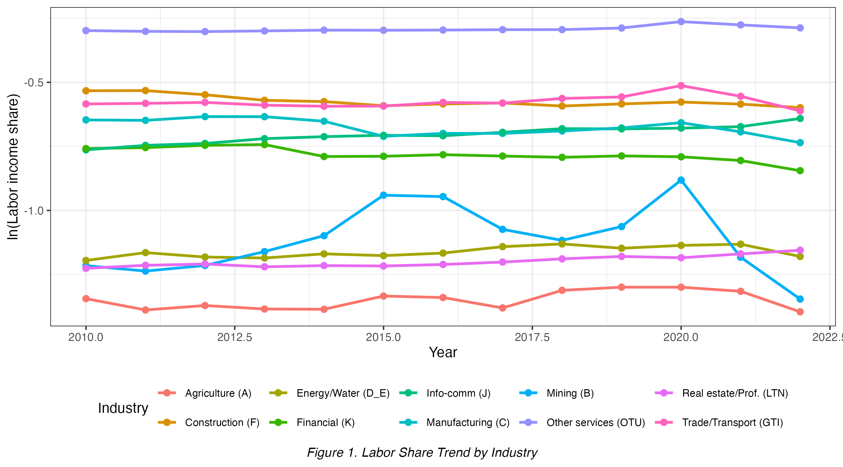
Figure 1. Labor Share Trend by Industry

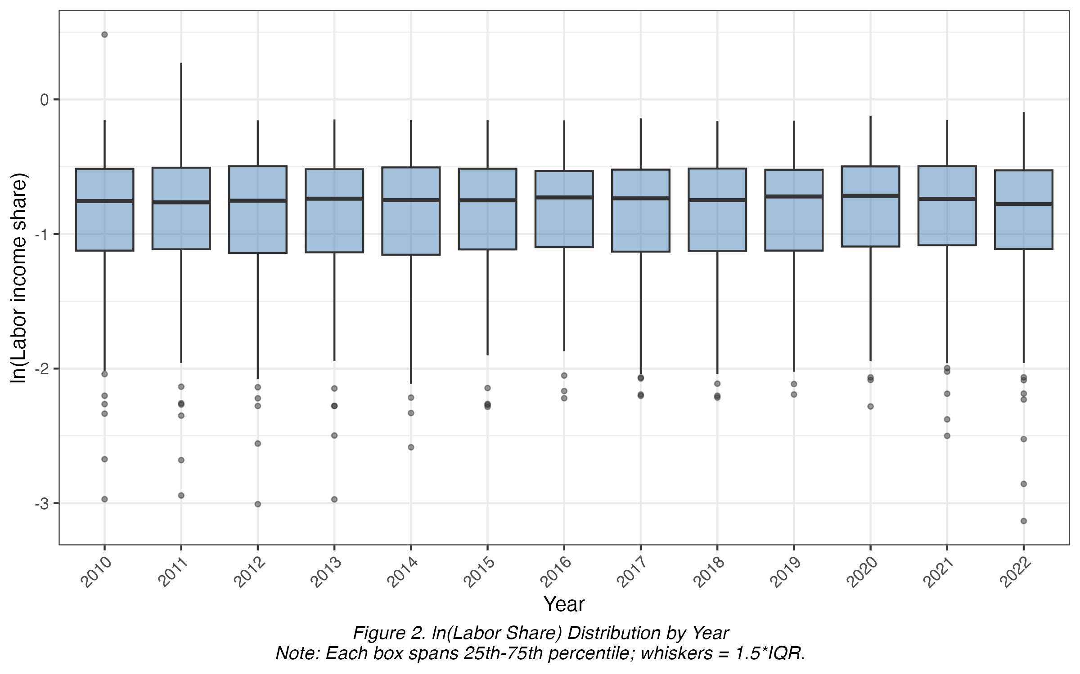
Figure 2. ln(Labor Share) Distribution by Year

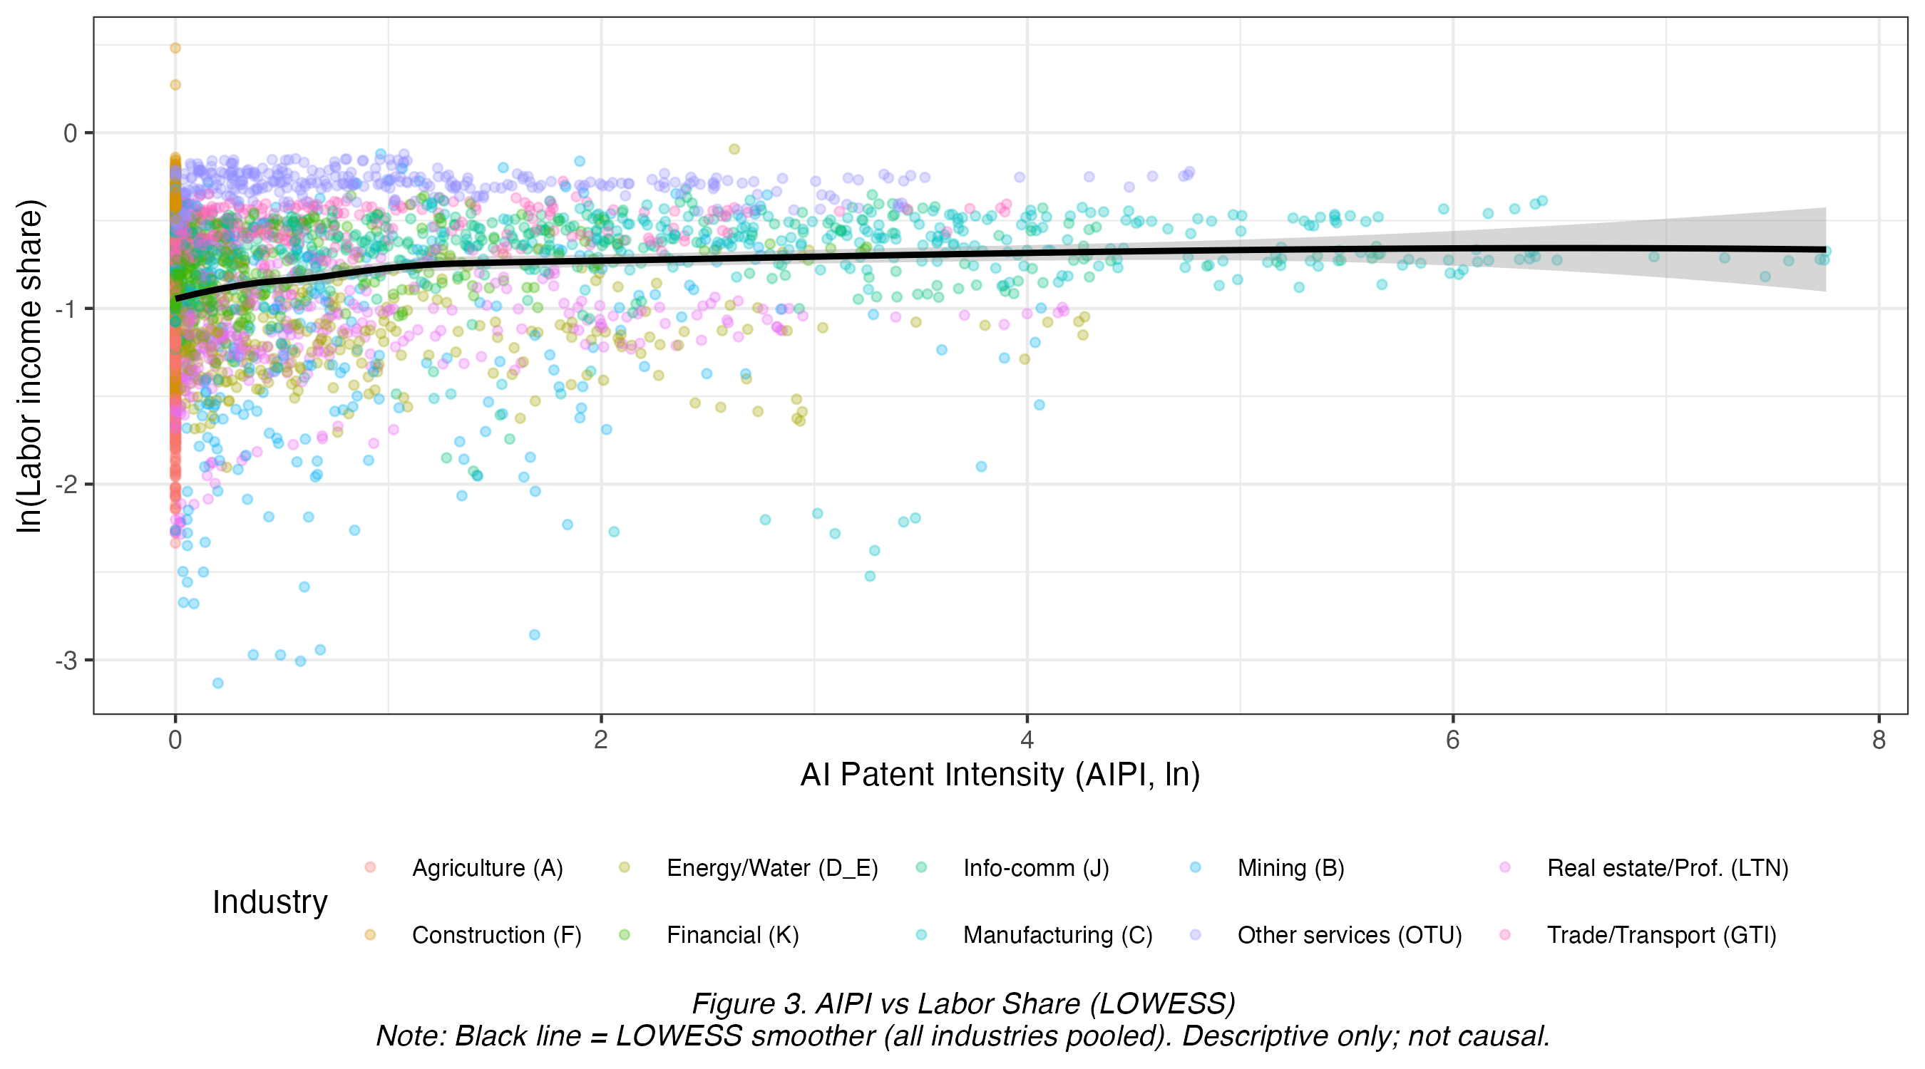
Figure 3. AIPI vs Labor Share (LOWESS)

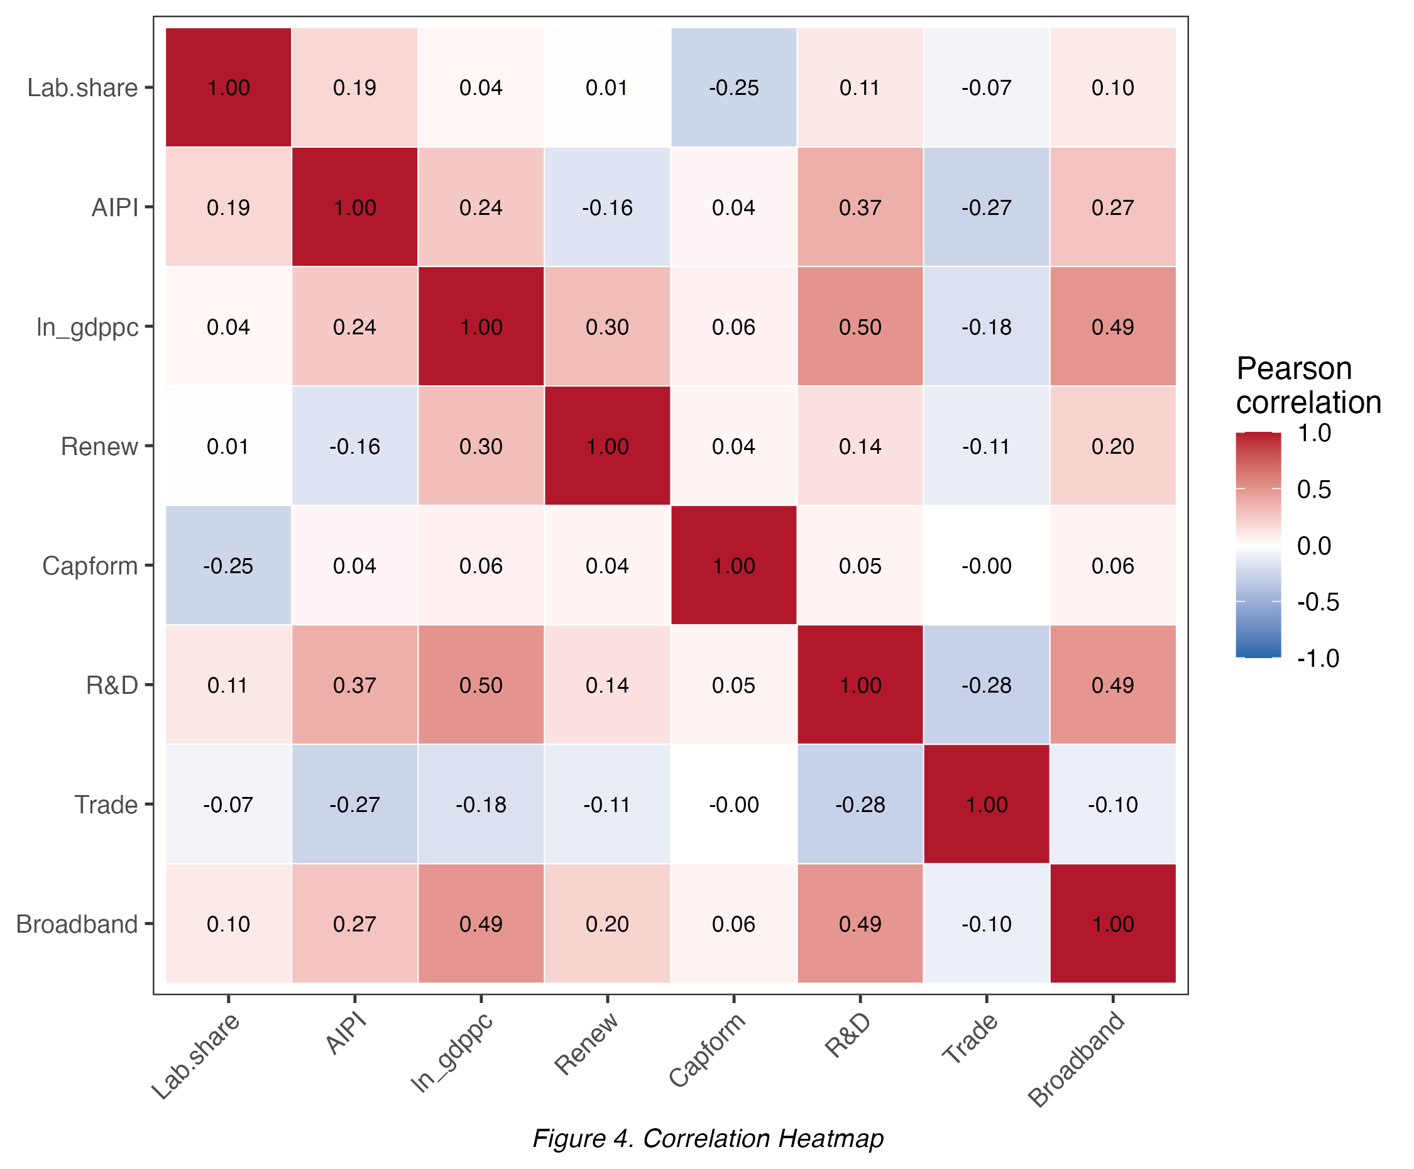
Figure 4. Correlation Heatmap

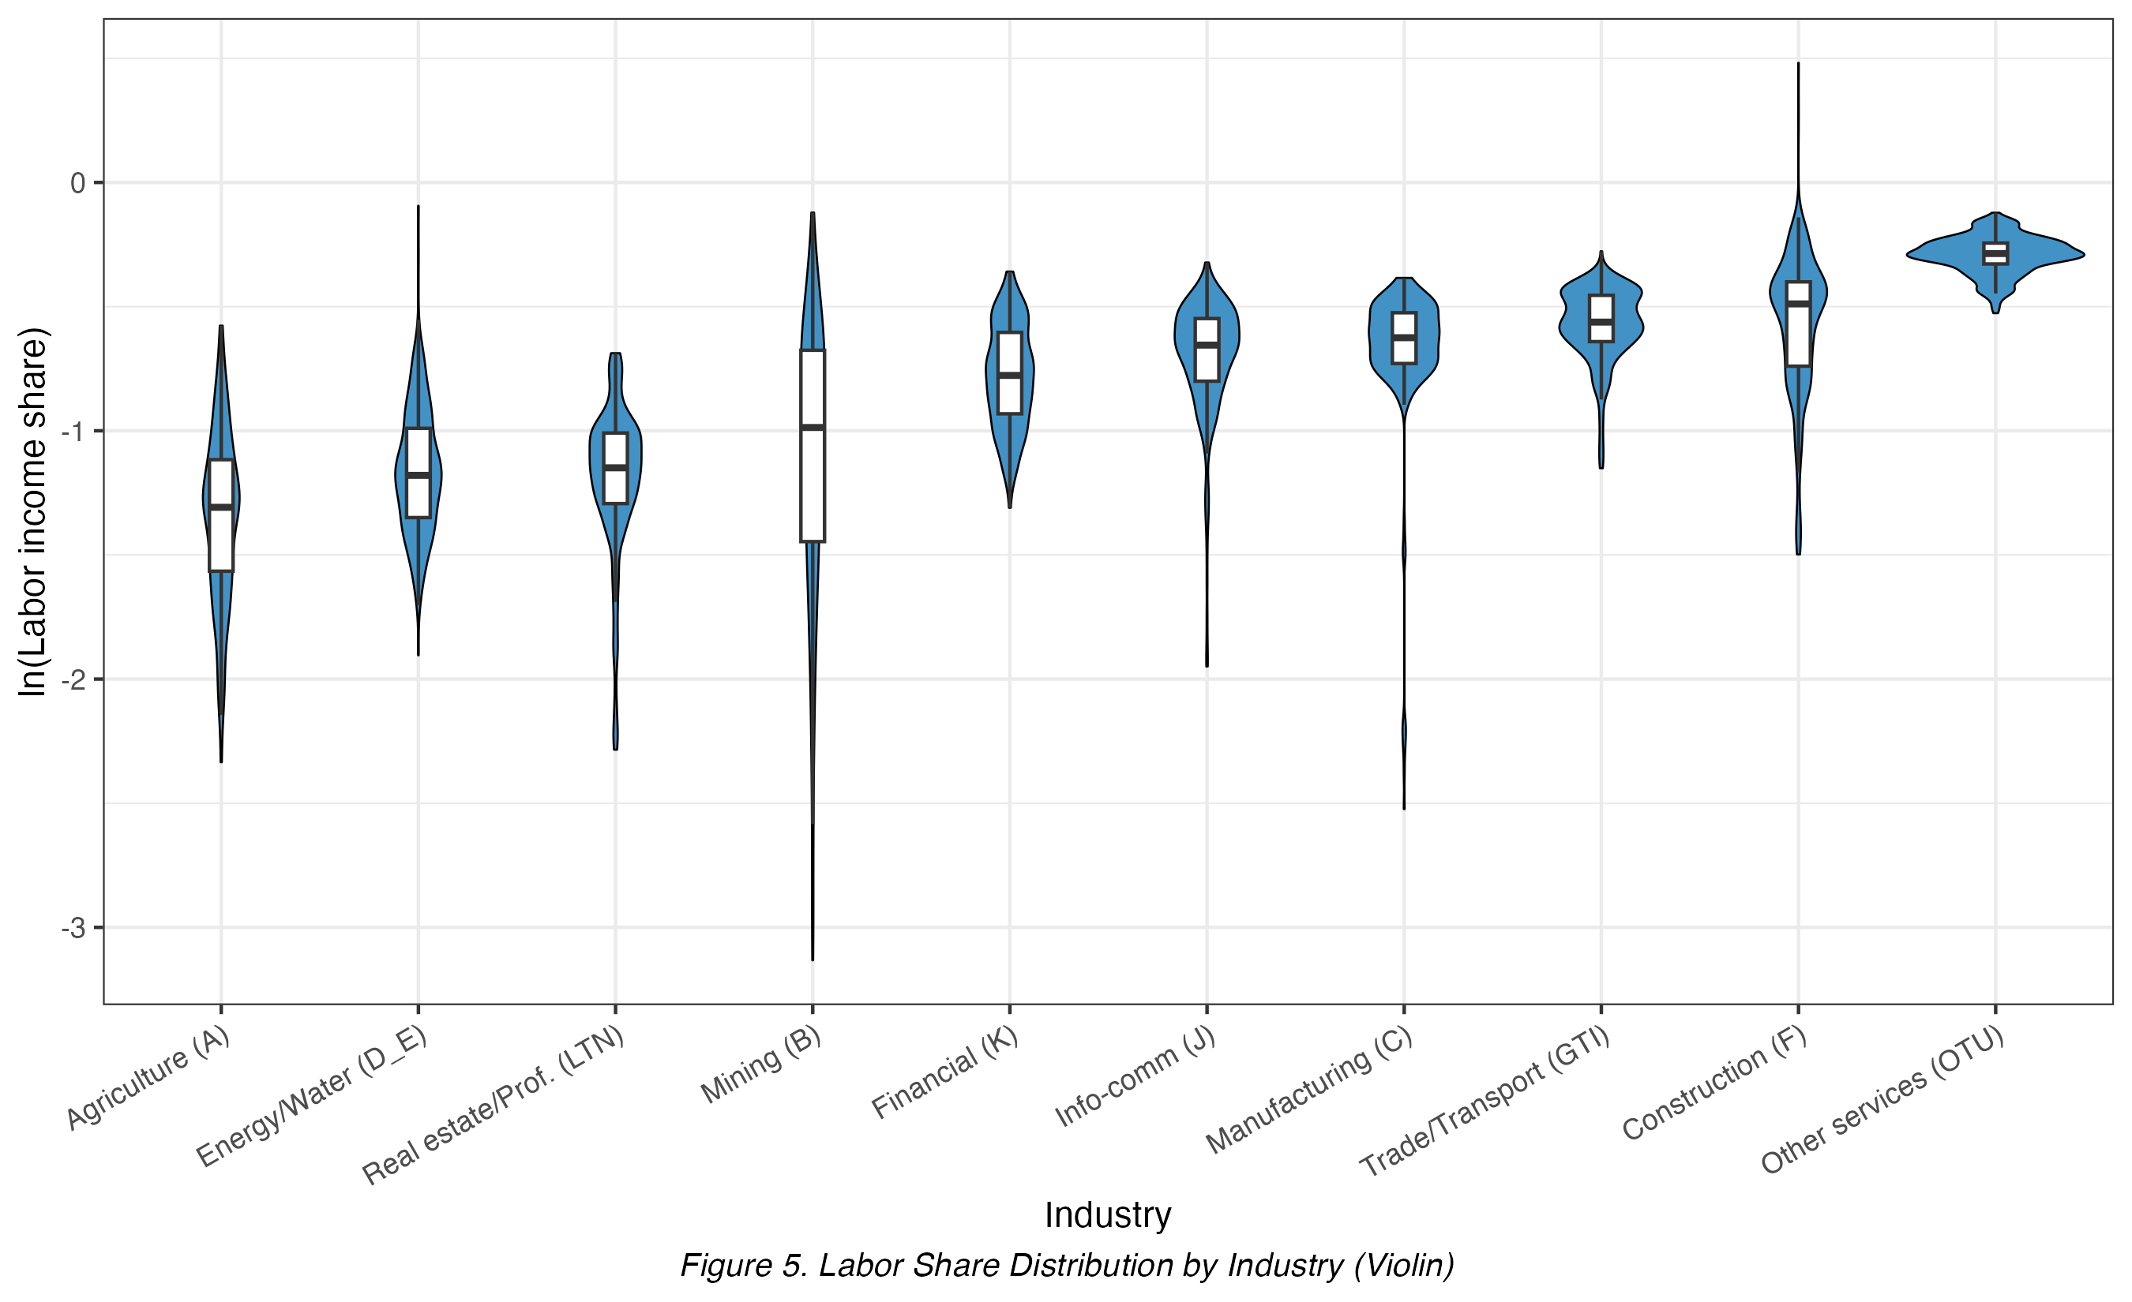
Figure 5. Labor Share Distribution by Industry (Violin)

Methodology

Underlying Economic Process
AI patenting under the CPC taxonomy captures both task-displacing automation and task-creating technologies that generate new labor-intensive tasks and complementary demand, following Acemoglu and Restrepo (2019). Because these forces act in opposite directions on the labor income share, the net industry-level effect of AI diffusion is theoretically ambiguous and must be estimated empirically - the process the empirical strategy below is designed to identify.
Panel data is essential to this question rather than a convenience choice: a single cross-section could not separate a genuine AI-patenting effect on the labor share from fixed, unobserved industry traits (capital intensity, automation exposure) that independently drive both AI patenting and factor-income splits; the country-industry-year panel structure allows pair fixed effects to absorb exactly this unobserved heterogeneity, while the 2010-2022 time dimension is what makes the leave-one-out Bartik instrument, the channel decomposition, and the dynamic Difference GMM check possible in the first place.

Estimator Sequence and the Issue Each Step Addresses
Following the four-step estimator ladder required for this course, the paper estimates the AIPI-labor share relationship using, in order: pooled OLS (naive benchmark), two-way fixed effects (FE), random effects tested against FE via the Hausman test, and fixed-effects instrumental variables (FE-IV) using AIPI_bartik as the excluded instrument. A two-step Difference GMM specification is added as a robustness check given the panel's short time dimension relative to its cross-sectional dimension.
Step 1: Two-way fixed effects (baseline)
Issue addressed: countries and industries differ in baseline labor share and AI-patenting activity in time-invariant ways (persistent capital intensity, industrial structure); pair fixed effects absorb this heterogeneity, while year fixed effects absorb common shocks (global AI diffusion trends, business-cycle movements).
Step 2: FE-IV (primary identification)
Issue addressed: two-way FE alone cannot remove time-varying reverse causality. Industries with a declining labor share may attract more AI patenting for unrelated reasons (e.g. cost-cutting pressure prompting both automation investment and wage compression simultaneously), biasing the uninstrumented FE coefficient. AIPI_bartik isolates variation driven by global technology trends rather than local shocks.
Step 3: Difference GMM (dynamic robustness check)
Issue addressed: the labor income share may be persistent, so the prior year's share predicts the current year's; a static FE-IV specification could misattribute this persistence to AIPI. Two-step Difference GMM (Arellano-Bond) models this persistence directly, given the panel's short time dimension (T=13) relative to its cross-sectional dimension (N=250 pairs).

Baseline Specification
Equation 1. Baseline Two-Way Fixed-Effects Specification
$$\begin{matrix}ln({labshare}_{it}) & = α_{i} + γ_{t} \\ & + β_{1} {AIPI}_{it} \\ & + β_{3} ln({GDPpc}_{it}) \\ & + β_{4} {Renew}_{it} \\ & + β_{5} {CapForm}_{it} \\ & + β_{6} {RD}_{it} \\ & + β_{7} {Trade}_{it} \\ & + β_{8} {Broadband}_{it} \\ & + ε_{it}\end{matrix}$$
where i indexes country-industry pairs (250 pairs), t indexes year, α(i) are pair fixed effects, γ(t) are year fixed effects, the control set is ln(GDPpc), Renew, CapForm, RD, Trade and Broadband, and ε(it) is an error term clustered at the country-industry pair level (Equation 1).

Instrumental Variables Specification
Equation 2. First-Stage Regression: Instrumental Variable
$$\begin{matrix}{AIPI}_{it} & = π_{1} {AIPI_bartik}_{it} \\ & + π_{2} ln({GDPpc}_{it}) \\ & + π_{3} {Renew}_{it} \\ & + π_{4} {CapForm}_{it} \\ & + π_{5} {RD}_{it} \\ & + π_{6} {Trade}_{it} \\ & + π_{7} {Broadband}_{it} \\ & + α_{i} + γ_{t} \\ & + u_{it}\end{matrix}$$

Equation 3. Second-Stage Fixed-Effects Instrumental Variable (FE-IV) Specification
$$\begin{matrix}ln({labshare}_{it}) & = α_{i} + γ_{t} \\ & + β_{1} {\hat{AIPI}}_{it} \\ & + β_{3} ln({GDPpc}_{it}) \\ & + β_{4} {Renew}_{it} \\ & + β_{5} {CapForm}_{it} \\ & + β_{6} {RD}_{it} \\ & + β_{7} {Trade}_{it} \\ & + β_{8} {Broadband}_{it} \\ & + ε_{it}\end{matrix}$$
Identification of β1 in Equation 3 relies on two standard IV assumptions:
- relevance (AIPI_bartik strongly predicts AIPI conditional on fixed effects and controls, confirmed in Table 11) and
- exogeneity (AIPI_bartik affects ln(labshare) only through AIPI). No standalone ‘no-anticipation’ assumption is invoked.

Moderated Specification
Equation 4. Moderated Specification with High-Capital Interaction
$$\begin{matrix}ln({labshare}_{it}) & = α_{i} + γ_{t} \\ & + β_{1} {AIPI}_{it} \\ & + β_{2} ({AIPI}_{it} × {HighCapital}_{i}) \\ & + β_{3} ln({GDPpc}_{it}) \\ & + β_{4} {Renew}_{it} \\ & + β_{5} {CapForm}_{it} \\ & + β_{6} {RD}_{it} \\ & + β_{7} {Trade}_{it} \\ & + β_{8} {Broadband}_{it} \\ & + ε_{it}\end{matrix}$$
Equation 4 augments the baseline with an AIPI x HighCapital interaction (Table 9, FE+Interact.), testing whether the AI-labor share relationship differs by capital intensity. Subsample splits by HighCapital and HighSkill, at both country-specific (Table 9) and industry-specific (Table 14) thresholds, provide complementary evidence.

Estimator Choice: FE versus RE
A Hausman test formally chooses between FE and RE: H0: no systematic difference. The test yields chi2=252.834, p<0.0001, rejecting H0 and supporting FE, consistent with AI Patent Intensity being correlated with unobserved, time-invariant industry characteristics that also affect the labor income share.

Dynamic Robustness: Difference GMM
A two-step Difference GMM (Arellano-Bond dynamic panel estimator) is estimated as a robustness check given the panel's short time dimension relative to its cross-sectional dimension, addressing potential persistence in the labor income share that a static FE-IV specification would not capture. AR(1) and AR(2) tests and the Hansen J overidentification test (Table 8) assess instrument validity: AR(1) rejection is expected by construction and does not indicate a problem, while AR(2) non-rejection (z = -1.570, p = 0.1164) supports valid instruments.

Channel Decomposition
The labor share is defined, by accounting identity, as the ratio of total compensation to value added, rewritten as the product of average wage and employment, divided by value added:
Equation 5. Labor-Share Accounting Identity (Channel Decomposition)
$$\begin{matrix}ln({labshare}_{it}) & = ln({avgwage}_{it}) \\ & + ln({employment}_{it}) \\ & - ln({valueadded}_{it})\end{matrix}$$
Equation 5 implies the FE-IV coefficient on AIPI in the labor-share regression must, up to estimation noise, equal the sum of the corresponding coefficients from separately regressing ln(avg_wage), ln(employment), and minus ln(value_added) on AIPI, using identical fixed effects, controls and instrument. The paper estimates these three regressions (Table 19) and verifies the identity numerically (Table 20), serving as both a specification check and the basis for the mechanism decomposition.

Diagnostic Tests (Seven Mandatory, α = 0.10)
Seven diagnostic tests are conducted for the main specification (Table 8):
(1) a VIF check for multicollinearity;
(2) a Hausman test comparing fixed and random effects (effect = individual);
(3) a Wooldridge test for serial correlation;
(4) a first-stage F-statistic for instrument strength;
(5) a Wu-Hausman test for AIPI endogeneity;
(6) Arellano-Bond AR(1)/AR(2) tests for the GMM specification, where AR(1) rejection is expected and AR(2) rejection would indicate invalid instruments; and
(7) a Hansen J overidentification test, reported using the language 'instruments may not violate the exogeneity condition' rather than a definitive accept/reject conclusion.
Heteroskedasticity is addressed throughout by clustering standard errors at the country-industry pair level, motivated by a modified Wald test for groupwise heteroskedasticity that rejects homoskedasticity at α = 0.10 in the baseline FE specification; this clustering choice, rather than a separate eighth test, is what operationalizes the guide's multicollinearity/heteroskedasticity diagnostic requirement alongside the seven tests above.

Robustness Battery
Fourteen robustness checks (R1-R14) are conducted, summarized in Section 5.3: capital- and skill-intensity subsamples at country- and industry-specific thresholds (R1a-b, R2b, R7a-d), alternative industry weighting (R2), a placebo weight reassignment (R4), the full A*10 sample (R5), the Gollin adjustment (R6, Table 13), lag structures (R8, R13), a post-2018 break interaction (R9), the wage-channel check (R10), a quadratic specification (R11), the value-added channel (R12), and a linear time-trend interaction (R14).

Hypothesized Signs of Coefficients (Ex-Ante)
Table 6. Hypothesized Signs of Coefficients (Ex-Ante)
Coefficient | Variable | Expected sign (ex-ante) | Theoretical rationale
β1 | AI Patent Intensity (AIPI) | Ambiguous | Task-based automation (Acemoglu and Restrepo, 2019): displacement effect predicts a negative sign; reinstatement/new-task effect predicts a positive or null sign; net sign is a priori undetermined
β2 | AI Patent Intensity (AIPI) x High-capital dummy | Ambiguous | Capital-skill complementarity may amplify the AI-labor share relationship in capital-intensive industries in either direction, depending on whether AI substitutes for or complements capital
β3 | ln(GDP per capita) | Ambiguous | Higher income may reflect capital deepening (labor share down) or a shift toward high-skill, high-wage services (labor share up)
β4 | Renewable energy share | Ambiguous | Included as a control absorbing common green-transition trends correlated with technology adoption; no direct theoretical prior on the labor share
β5 | Capital formation / Value added | > 0 or < 0 | Karabarbounis and Neiman (2014): capital deepening substitutes for labor, predicting a negative sign; but this paper's Table 9 shows a robust positive coefficient, suggesting complementarity rather than substitution in this sample
β6 | R&D expenditure (% GDP) | Ambiguous | R&D intensity may raise skilled-labor demand (labor share up) or fund labor-saving process innovation (labor share down)
β7 | Trade openness (% GDP) | Ambiguous | Trade may increase competitive pressure on wages (down) or raise demand for skilled export-sector labor (up)
β8 | Broadband (per 100 people) | Ambiguous | Digital infrastructure may complement AI-driven task creation (up) or facilitate further automation (down); included primarily as a control
Consistent with the ambiguous-sign prediction of the task-based automation framework (Acemoglu and Restrepo, 2019), no directional hypothesis is imposed on β1 (AIPI); the channel decomposition (Section 5.10) is left to reveal the sign and mechanism rather than testing a pre-specified direction.

Empirical Results

Model Structure and Diagnostics
Table 7. Model Structure and Estimation Details
Item | Value | Note
Observations / groups | N = 3120; N groups = 250 pairs | Balanced within FE-IV sample
Fixed effects | Country-industry pair FE + year FE (two-way) | Absorbs time-invariant pair heterogeneity + common year shocks
Standard-error treatment | Clustered at pair level (250 clusters) | Robust to within-pair serial correlation (Table 8, Test 3)
Instruments (Diff. GMM) | 11 instruments / 240 pairs (ratio = 0.046) | Below Roodman (2009) N-instruments < N-pairs rule

Table 8. Diagnostic Tests (α = 0.10)
# | Test | Statistic | p-value | Decision (α = 0.10)
1 | Multicollinearity (max VIF) | Max VIF = 1.65 | - | No severe multicollinearity
2 | Hausman FE vs RE | chi² = 252.834 | 0.0000 | FE preferred (theory); Hausman used as robustness diagnostic
3 | Serial correlation (Wooldridge) | chi² = 1184.238 | 0.0000 | Serial corr. present; cluster SE applied
4 | Weak instrument (first-stage F) | F = 4906.23 | 0.0000 | Relevant instrument (F > 10)
5 | Endogeneity (Wu-Hausman) | F = 63.21 | 0.0000 | Endogenous; IV justified
6 | AR(1), Arellano-Bond | z = -3.774 | 0.0002 | Reject H0: AR(1) present (expected)
7 | AR(2), Arellano-Bond | z = -1.570 | 0.1164 | Valid instruments (fail to reject H0)
8 | Hansen J (overidentification) | chi² = 3.636 | 0.3035 | Instruments may not violate exogeneity condition (fail to reject H0)
Tests 1-5: pooled OLS / FE-plm / AER::ivreg. Tests 6-7 and Hansen J: two-step Difference GMM (Arellano-Bond mtest). AR(1) non-rejection is inconclusive, as it is expected to reject by construction; AR(2) non-rejection confirms instrument validity.

Main Estimates
Table 9. Main Results: AIPI and Labor Income Share
 | Pooled OLS | FE | FE + Interact. | FE-IV | Diff. GMM
AI Patent Intensity (ln) | 0.0635***  (0.0186) | -0.0163  (0.0160) | -0.0110  (0.0153) | - | -0.0020  (0.0192)
AI Patent Intensity (ln, IV) | - | - | - | 0.0114  (0.0255) | -
AIPI x High-capital dummy | - | - | -0.0058  (0.0052) | - | -
Lagged labor share (t-1) | - | - | - | - | 0.6509***  (0.1032)
GDP per capita (ln) | -0.0554  (0.0676) | -0.2455*  (0.1333) | -0.2471*  (0.1336) | -0.2376*  (0.1353) | -0.0972  (0.1494)
Capital formation / VA | -0.4332*  (0.2470) | 0.6631***  (0.1388) | 0.6682***  (0.1386) | 0.6555*** (0.1395) | 0.6370***  (0.1441)
R&D expenditure (% GDP) | 0.0269  (0.0402) | 0.0450**  (0.0220) | 0.0454**  (0.0221) | 0.0397*  (0.0229) | -0.0020  (0.0188)
Num. Obs. | 3120 | 3120 | 3120 | 3120 | -
R2 | 0.110 | 0.935 | 0.935 | 0.935 | -
Fixed effects (country-industry pair + year, two-way) | - | Yes | Yes | Yes | -
Dependent variable: ln(labor income share)=ln(LABR/VALU). AIPI=ln(industry-weighted AI patent count+1); weights from the ALP CPC-to-ISIC crosswalk (A*10 division level). FE-IV instrument=AIPI_bartik. Base category: HighCapital=0, HighSkill=0 (both below country-specific median). SE clustered at pair level (Cols 0-3); two-step robust GMM SE (Col 4). * p<0.10, ** p<0.05, *** p<0.01, α=0.10. Full control set omitted; see Table 1/Table 7 for complete listings.
The pooled OLS estimate is positive and highly significant (β = 0.0635, p < 0.01), reflecting cross-country/cross-industry confounding rather than a within-unit causal effect: once two-way fixed effects absorb pair heterogeneity and year shocks, the AIPI coefficient becomes small, negative and statistically null (β = -0.0163). The FE-IV estimate, further addressing reverse causality and measurement error via the Bartik instrument, is small, positive and again null (β = 0.0114, SE = 0.0255). The interaction and Difference GMM specifications confirm this null pattern.
Figure 6 plots the AIPI coefficient (β1) and its confidence interval across all five estimators in Table 9, visually summarizing the collapse from a large, significant pooled OLS effect to a small, statistically null effect once fixed effects and instrumentation are introduced.
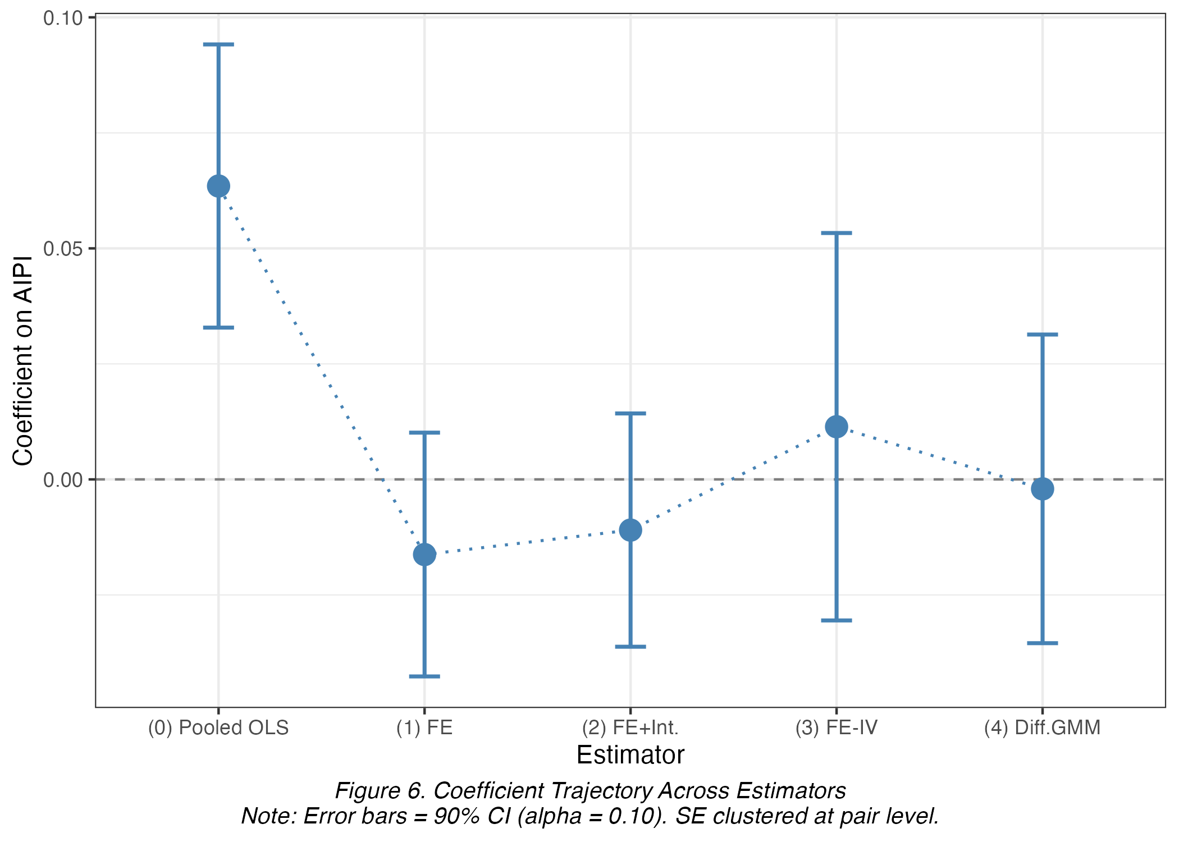
Figure 6. Coefficient Trajectory Across Estimators

Robustness Checks (R1-R5)
Table 10. Robustness Checks
Check | Spec. | Coef. on AIPI (IV) | N
R1a-high | High-capital subsample (country-spec. median) | -0.0133  (0.0341) | 1549
R1b-low | Low-capital subsample | 0.0365  (0.0336) | 1553
R2 | Alt. equal industry weights | 0.0015  (0.0276) | 3120
R2b-hi | High-skill subsample | 0.0538  (0.0652) | 1551
R2b-lo | Low-skill subsample | 0.0112  (0.0291) | 1553
R4 | Placebo, shuffled industry weights (single draw) | 0.0563**  (0.0259) | 3120
R5 | Full A*10 sample (= main sample) | 0.0114  (0.0255) | 3120
R1a-b: FE-IV on high- vs low-capital subsamples (country-specific median). R2: alternative industry weighting (equal 1/10 per industry). R2b: high- vs low-skill subsamples. R4: placebo with industry weights shuffled across A*10; full Monte Carlo (999 reps) confirms the estimate lies within the placebo distribution. R5: full A*10 sample equals the main sample. SE clustered at pair level; * p<0.10, ** p<0.05, *** p<0.01.

First-Stage Diagnostics
Table 11 reports the estimated coefficients of the first-stage equation (Equation 2), labelled with their corresponding π symbols so that every coefficient in Table 11 has a directly traceable estimate, mirroring the β-coefficient labelling of Table 9 for the main equation.
Table 11. First-Stage Regression: Instrument Validity
Coefficient | Regressor | First Stage: AIPI ~ AIPI_bartik
π1 | AIPI_bartik (instrument) | 0.7316***  (0.0402)
π2 | GDP per capita (ln) | -0.2645  (0.1925)
π3 | Renewable energy (% of total final energy) | -0.0043  (0.0064)
π4 | Capital formation / VA | 0.2144**  (0.0968)
π5 | R&D expenditure (% GDP) | 0.2055***  (0.0444)
π6 | Trade openness (%) | -0.0037**  (0.0014)
π7 | Broadband subscriptions (per 100 people) | -0.0359***  (0.0078)
 | Num. Obs. | 3120
 | R2 | 0.966
 | Fixed effects (country-industry pair + year, two-way) | Yes
Dependent variable: AIPI. Instrument: AIPI_bartik=leave-one-out industry-weighted AI patent count from the other 24 OECD countries in the same year (Bartik shift-share), corresponding to π1 in Equation 2. Two-way FE, SE clustered at pair level. First-stage F=4906.23 (Table 11) confirms strong instrument relevance. Renewable energy (π3) is small and insignificant, indicating the green-transition control does not independently predict AI patenting.

As a graphical complement to the diagnostics in Table 8, Figure 7 presents three residual-based diagnostic plots for the main FE-IV specification: linearity (residuals vs. fitted values), influential observations (leverage vs. standardized residuals, point size=Cook's distance), and normality (Q-Q plot vs. standard normal). Because fixest's IV estimator does not expose hat values or Cook's distance directly, these diagnostics come from an auxiliary dummy-variable regression reproducing the identical FE-IV point estimate via explicit two-stage least squares with pair and year dummies; only its residual geometry is used, not its non-clustered SEs.
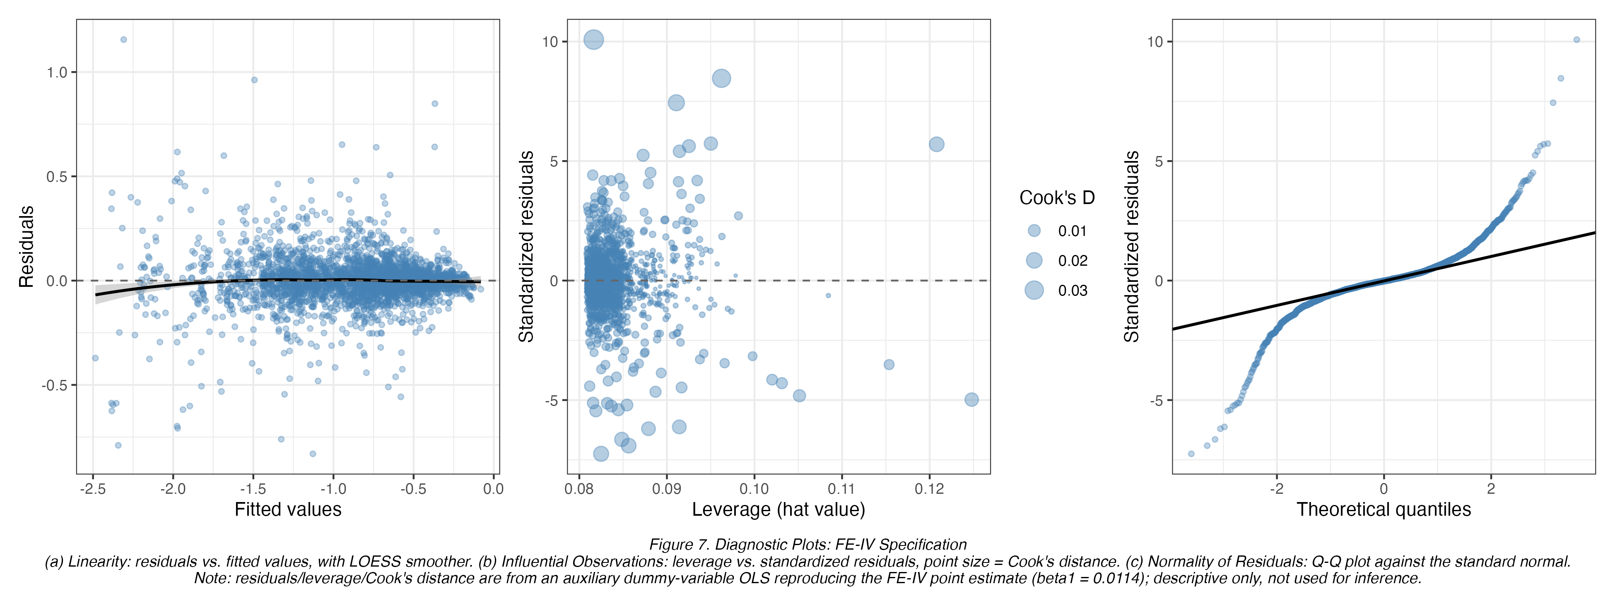
Figure 7. Diagnostic Plots: FE-IV Specification
Panel (a) shows no strong systematic curvature in the LOESS-smoothed residual-fitted relationship, supporting the linear functional form used throughout. Panel (b) identifies no observations with simultaneously extreme leverage and large Cook's distance, so the FE-IV result is not driven by a few influential pairs. Panel (c) shows residuals broadly tracking the 45-degree normal line, consistent with using cluster-robust rather than normal-theory SEs.

Mechanism Check: Employment Channel
Table 12. Mechanism Check: Employment (FE-IV)
 | Mechanism: ln(Employment)
AI Patent Intensity (ln, IV) | 0.0899***  (0.0226)
Num. Obs. | 3120
R2 | 0.999
Fixed effects (country-industry pair + year, two-way) | Yes
Outcome: ln(Total employment, EMPN), OECD STAN A*10. Descriptive mechanism complement to the main labor-share result, not a formal mediation model. SE clustered at pair level.

Robustness: Self-Employment Adjustment (R6)
Table 13. Robustness: Gollin Self-Employment Adjustment
 | FE, naive | FE, Gollin-adjusted | FE-IV, naive | FE-IV, Gollin-adjusted
AI Patent Intensity (ln) | -0.0163  (0.0160) | -0.0154  (0.0159) | - | -
AI Patent Intensity (ln, IV) | - | - | 0.0114  (0.0255) | 0.0111  (0.0250)
Num. Obs. | 3120 | 3120 | 3120 | 3120
R2 | 0.935 | 0.934 | 0.935 | 0.934
Naive labshare=LABR/VALU, excluding self-employment income. Gollin-adjusted labshare_adj=labshare/(1-self_emp_share), from WDI SL.EMP.SELF.ZS, applied uniformly across industries since STAN A*10 does not separate paid employees from total employment. The adjustment leaves the AIPI coefficient materially unchanged in both FE and FE-IV.

Robustness: Moderator Threshold Sensitivity (R7)
Table 14. Moderator Threshold Sensitivity
 | R7a High-capital,  industry-specific | R7b Low-capital,  industry-specific | R7c High-skill,  industry-specific | R7d Low-skill,  industry-specific
AI Patent Intensity (ln, IV) | 0.0327  (0.0333) | 0.0058  (0.0361) | 0.0131  (0.0319) | 0.0051  (0.0424)
Num. Obs. | 1543 | 1544 | 1504 | 1605
R2 | 0.936 | 0.952 | 0.933 | 0.942
The primary specification (Table 9/Table 10) splits HighCapital/HighSkill at the country-specific median (within-country, across-industry); this table uses the industry-specific median instead as a threshold-sensitivity check. Coefficients remain statistically null under either definition, though HighCapital point estimates flip sign (Table 10 R1a-high: -0.0133 vs Table 14 R7a: 0.0327), while HighSkill stays positive and small under both (0.0538 vs 0.0131).

Robustness: Targeted Extensions (R8-R11)
Table 15. Targeted Extensions (R8-R11)
 | R8 FE, AIPI lag (t-1) | R9 FE, Post-2018 interaction | R10 FE-IV, ln(wage) | R11 FE, quadratic
AI Patent Intensity (ln) | - | -0.0135  (0.0176) | - | 0.0057  (0.0217)
AI Patent Intensity (ln, IV) | - | - | -0.0706***  (0.0226) | -
AIPI (lag t-1) | -0.0192  (0.0158) | - | - | -
AIPI x Post-2018 | - | -0.0016  (0.0048) | - | -
AIPI squared | - | - | - | -0.0043  (0.0027)
Num. Obs. | 2880 | 3120 | 3120 | 3120
R2 | 0.938 | 0.935 | 0.999 | 0.935
R8: FE with AIPI lagged one year, testing delayed diffusion; not significant. R9: FE with AIPI x Post-2018 interaction, testing intensification after the LLM patenting acceleration; not significant. R10: FE-IV on ln(average wage), the wage-channel complement to Table 12; significant and negative (β=-0.0706, p<0.01). R11: FE with AIPI + AIPI-squared, testing reinstatement-then-displacement; not significant. SE clustered at pair level.

Robustness: Second-Pass Refinements (R12-R14)
Table 16. Second-Pass Refinements (R12-R14)
 | R12 FE-IV,  ln(value added) | R13 FE,  2-year moving-average AIPI | R14 FE,  AIPI x year trend
AI Patent Intensity (ln) | - | - | -0.0028  (0.0204)
AI Patent Intensity (ln, IV) | 0.0079  (0.0321) | - | -
AIPI (2-yr moving avg) | - | -0.0214  (0.0180) | -
AIPI x (year - 2010) | - | - | -0.0008  (0.0009)
Num. Obs. | 3120 | 2880 | 3120
R2 | 0.998 | 0.938 | 0.935
R12: FE-IV on ln(value added), the third leg of the decomposition; not significant (β=0.0079). R13: FE with AIPI averaged over the current and prior year (gradual absorption), an alternative to the single-period lag (Table 15, R8); not significant. R14: FE with AIPI x linear year trend, a smooth alternative to the Post-2018 break (Table 15, R9); not significant. SE clustered at pair level.

Robustness: Additional Moderators (HighTrade/HighRD)
As a complement to the primary HighCapital and extended HighSkill moderators (Table 9/10), trade openness and R&D intensity - already included as controls in every specification since Table 9 - are additionally tested as interacted moderators. HighTrade/HighRD = 1 if trade/R&D intensity is at or above the OECD panel-wide median (pooled across country-years); because these WDI series vary by country-year, not by industry, a within-country split is not meaningful here.
Table 17. Additional Moderator Robustness (HighTrade/HighRD)
 | (R15) FE, AIPI x HighTrade | (R16) FE, AIPI x HighRD
AI Patent Intensity (ln) | -0.0172 | -0.0180
 | (0.0153) | (0.0202)
GDP per capita (ln, constant 2015 USD) | -0.2452* | -0.2450*
 | (0.1334) | (0.1327)
Renewable energy (% total final energy consumption) | 0.0025 | 0.0024
 | (0.0041) | (0.0042)
Capital formation / Value added | 0.6626*** | 0.6632***
 | (0.1384) | (0.1386)
R&D expenditure (% of GDP) | 0.0451** | 0.0438**
 | (0.0221) | (0.0215)
Trade openness (% of GDP) | -0.0012 | -0.0012
 | (0.0009) | (0.0009)
Fixed broadband subscriptions (per 100 people) | 0.0015 | 0.0016
 | (0.0030) | (0.0031)
AIPI x HighTrade | 0.0026
 | (0.0089)
AIPI x HighRD |  | 0.0024
 |  | (0.0113)
Num.Obs. | 3120 | 3120
R2 | 0.935 | 0.935
R2 Adj. | 0.929 | 0.929
R2 Within | 0.153 | 0.153
R2 Within Adj. | 0.151 | 0.151
FE: pair_id | Yes | Yes
FE: year | Yes | Yes
Note: SE clustered at pair level in parentheses. * p<0.10, ** p<0.05, *** p<0.01. Alpha = 0.10. Neither interaction term (AIPI x HighTrade = 0.0026, SE 0.0089; AIPI x HighRD = 0.0024, SE 0.0113) is significant at alpha = 0.10, indicating no detectable moderation of the AIPI-labor share relationship by trade openness or R&D intensity, consistent with the null main effect already established in Table 9.

Robustness: Dynamic Panel LSDV (Uncorrected)
As a further dynamic-panel companion to the Difference GMM check, the same lagged-dependent-variable specification is estimated via LSDV (within/fixed-effects OLS with pair and year effects) and via two independent small-T bias-correction methods: the analytical Kiviet (1995)/Bruno (2005) correction (bootstrap SE, 500 replications, seeded from the Difference GMM estimate as the required external consistent estimator) and, as a cross-check obtained by an entirely different route, the Everaert and Pozzi (2007) bootstrap-simulation correction. Both corrections push the persistence coefficient above the raw LSDV and Difference GMM benchmarks, consistent with the well-documented sensitivity of small-T bias corrections in short, highly persistent panels (T=12).
Table 18. Dynamic Panel LSDV and Bias-Corrected LSDVC: OECD Panel
Method | Lagged ln(labor share), phi (SE) | AI Patent Intensity (ln), beta
Raw LSDV (biased) | 0.6658 | -0.0090
LSDVC (Kiviet 1995 / Bruno 2005, analytical) | 0.8424 (0.0731) | -0.0082 (0.0055)
Cross-check: LSDVC (Everaert & Pozzi 2007, bootstrap-simulation) | 0.7591 | n/a
Difference GMM benchmark (Table 9) | 0.6509
Note: within (LSDV) estimator with pair and year fixed effects, SE clustered at pair level. Panel: 240 pairs, T=12, N=2,880. Bootstrap SE for the Kiviet/Bruno correction from 500 pair-cluster replications. See Figure 16 for a graphical comparison of all four estimators.
The raw LSDV coefficient on the lagged dependent variable (0.6658) confirms strong persistence in the labor income share, consistent with the dynamic-panel motivation in Section 4.1, and sits close to the Difference GMM benchmark (0.6509), as expected since LSDV and Difference GMM share the same direction of small-T bias in short panels. The Kiviet/Bruno analytical correction moves the persistence coefficient further from the Difference GMM benchmark rather than toward it (0.8424 versus 0.6509) -- a pattern also confirmed by the independent Nickell (1981) pure-AR(1) formula, and one documented in the literature as a known limitation of analytical LSDVC corrections in short (T around 12), highly persistent panels (Kiviet, 1995; Judson and Owen, 1999). The Everaert-Pozzi (2007) bootstrap-simulation cross-check, which reaches its answer through resimulation rather than an analytical bias formula, returns an intermediate, stationary estimate (0.7591), bracketing the two other approaches. On the coefficient of central interest, the LSDVC-corrected AI Patent Intensity effect (-0.0082, bootstrap SE 0.0055) remains small and directionally consistent with the raw LSDV (-0.0090) and the null main FE-IV result (0.0114, Table 9), reinforcing that the null main finding is not an artifact of dynamic-panel bias or of the FE-IV specification alone. Because LSDV/LSDVC correct for dynamics but not for the endogeneity the Wu-Hausman test (Table 8) already confirms, none of these coefficients should be read as a fourth causal estimate; they serve only as a companion robustness check that dynamics do not overturn the paper's central null-and-offsetting-channels conclusion, consistent with the Difference GMM result (Table 9, Diff. GMM column).
Figure 8 visualizes the fifteen coefficients (the main FE-IV estimate plus R1a-high through R8 and R13) that are directly comparable on a common scale - the coefficient on AI Patent Intensity in a regression of ln(labor share) (or its Gollin-adjusted variant, R6), across every subsample, weighting, threshold and lag-structure variant. The four checks expressed as interaction or squared terms on a different scale (R9, R11, R14) and the two checks with a different dependent variable (R10 on wage, R12 on value added) are reported in Tables 15-16 instead, since plotting them on the same axis would not be a meaningful comparison. Every displayed 90% confidence interval other than the R4 placebo crosses zero, confirming the null main result is not an artifact of any single specification choice.
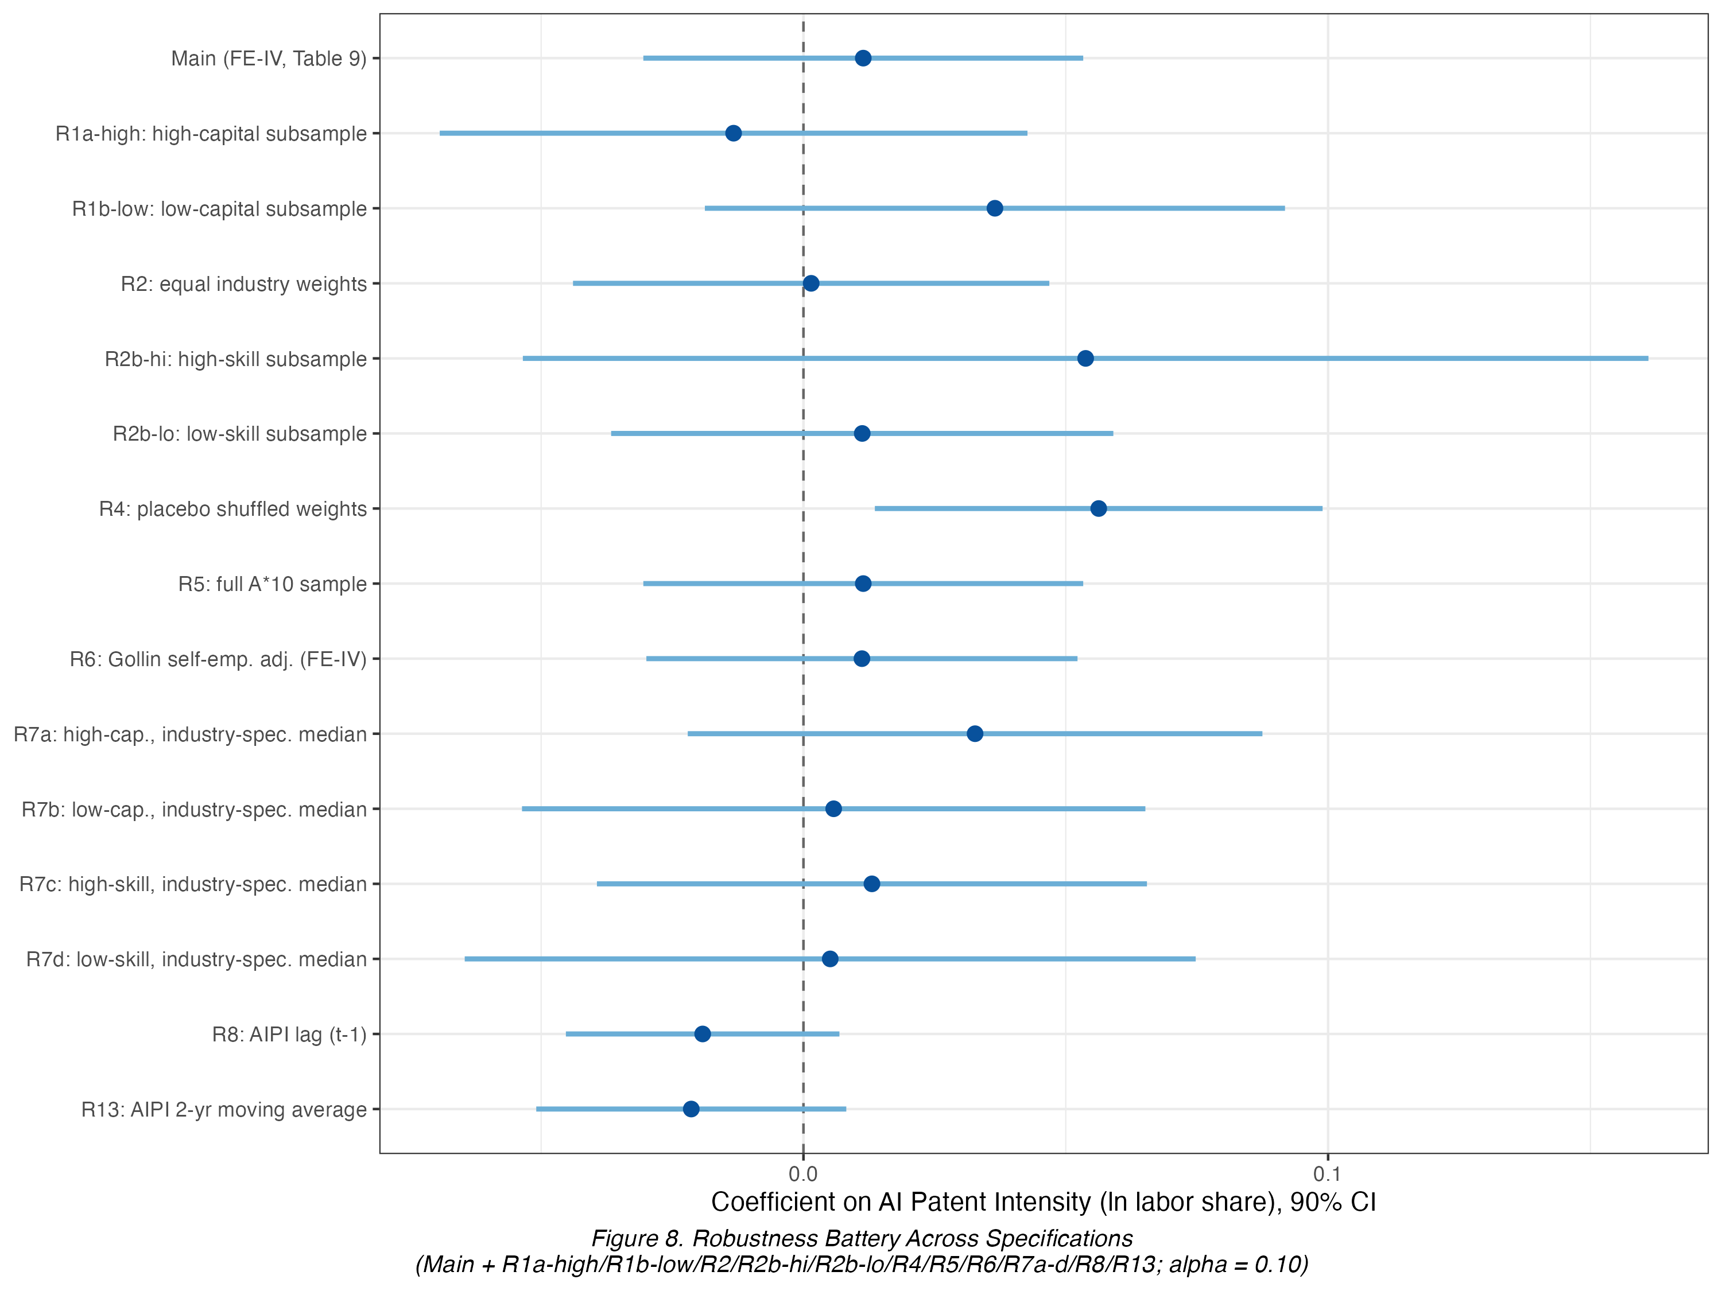
Figure 8. Robustness Battery Across Specifications
90% confidence intervals (α = 0.10). R9, R11, R12 and R14 are omitted from this chart, being on a different dependent variable or coefficient scale (interaction/squared term); see Tables 15-16 for those results.

Channel Decomposition: The Central Finding
Because the direct FE-IV effect on the labor share is null (Table 9), the accounting-identity decomposition (Section 4.5) tests whether this reflects a genuine absence of effect or the offsetting of significant channels. The three component regressions, using the identical fixed effects, controls and instrument, are reported together in Table 19.
Table 19. Channel Decomposition and Accounting Identity (FE-IV)
 | Employment | Average wage | Value added
AI Patent Intensity (ln, IV) | 0.0899***  (0.0226) | -0.0706***  (0.0226) | 0.0079  (0.0321)
GDP per capita (ln) | 0.3410***  (0.0767) | 0.4606***  (0.0905) | 1.0392***  (0.1971)
Capital formation / VA | 0.0055  (0.0373) | 0.1009***  (0.0359) | -0.5491***  (0.1461)
Num. Obs. | 3120 | 3120 | 3120
R2 | 0.999 | 0.999 | 0.998
Fixed effects (country-industry pair + year, two-way) | Yes | Yes | Yes
Dependent variables: (a) ln(Total employment); (b) ln(Average wage); (c) ln(Value added). Same FE-IV specification and instrument (AIPI_bartik) as the main result. Identity: ln(labor share)=ln(avg. wage)+ln(employment)-ln(value added). AI raises employment and value added but lowers average wages more than proportionally, leaving the net labor-share effect statistically null.

Table 20. Accounting Identity Check
Item | Value
β(wage) + β(employment) - β(value added) | 0.0114
β(labor share), directly estimated (Table 9, FE-IV) | 0.0114
Gap | 0.0000
Identity holds exactly (gap = 0) because all three mechanism models (Table 19) share the identical estimation sample, first-stage fit and clustering as the main FE-IV labor-share model.
The decomposition shows AI Patent Intensity is associated with a significant increase in industry employment (β=0.0899, p<0.01) and a significant decrease in average wage (β=-0.0706, p<0.01), while the value-added effect is statistically null (β=0.0079). The employment and wage channels are nearly equal and opposite, summing exactly to the directly estimated labor-share coefficient (0.0899-0.0706-0.0079=0.0114, gap=0.0000, Table 20), confirming the accounting identity in Equation 5 holds numerically and validating the internal consistency of the FE-IV estimates across all four dependent variables. Figure 9 visualizes the three channel coefficients plus the main labor-share coefficient as a fourth bar, with their 95% confidence intervals, making both the near-mirror-image, opposite-sign channels and the accounting identity directly visible.
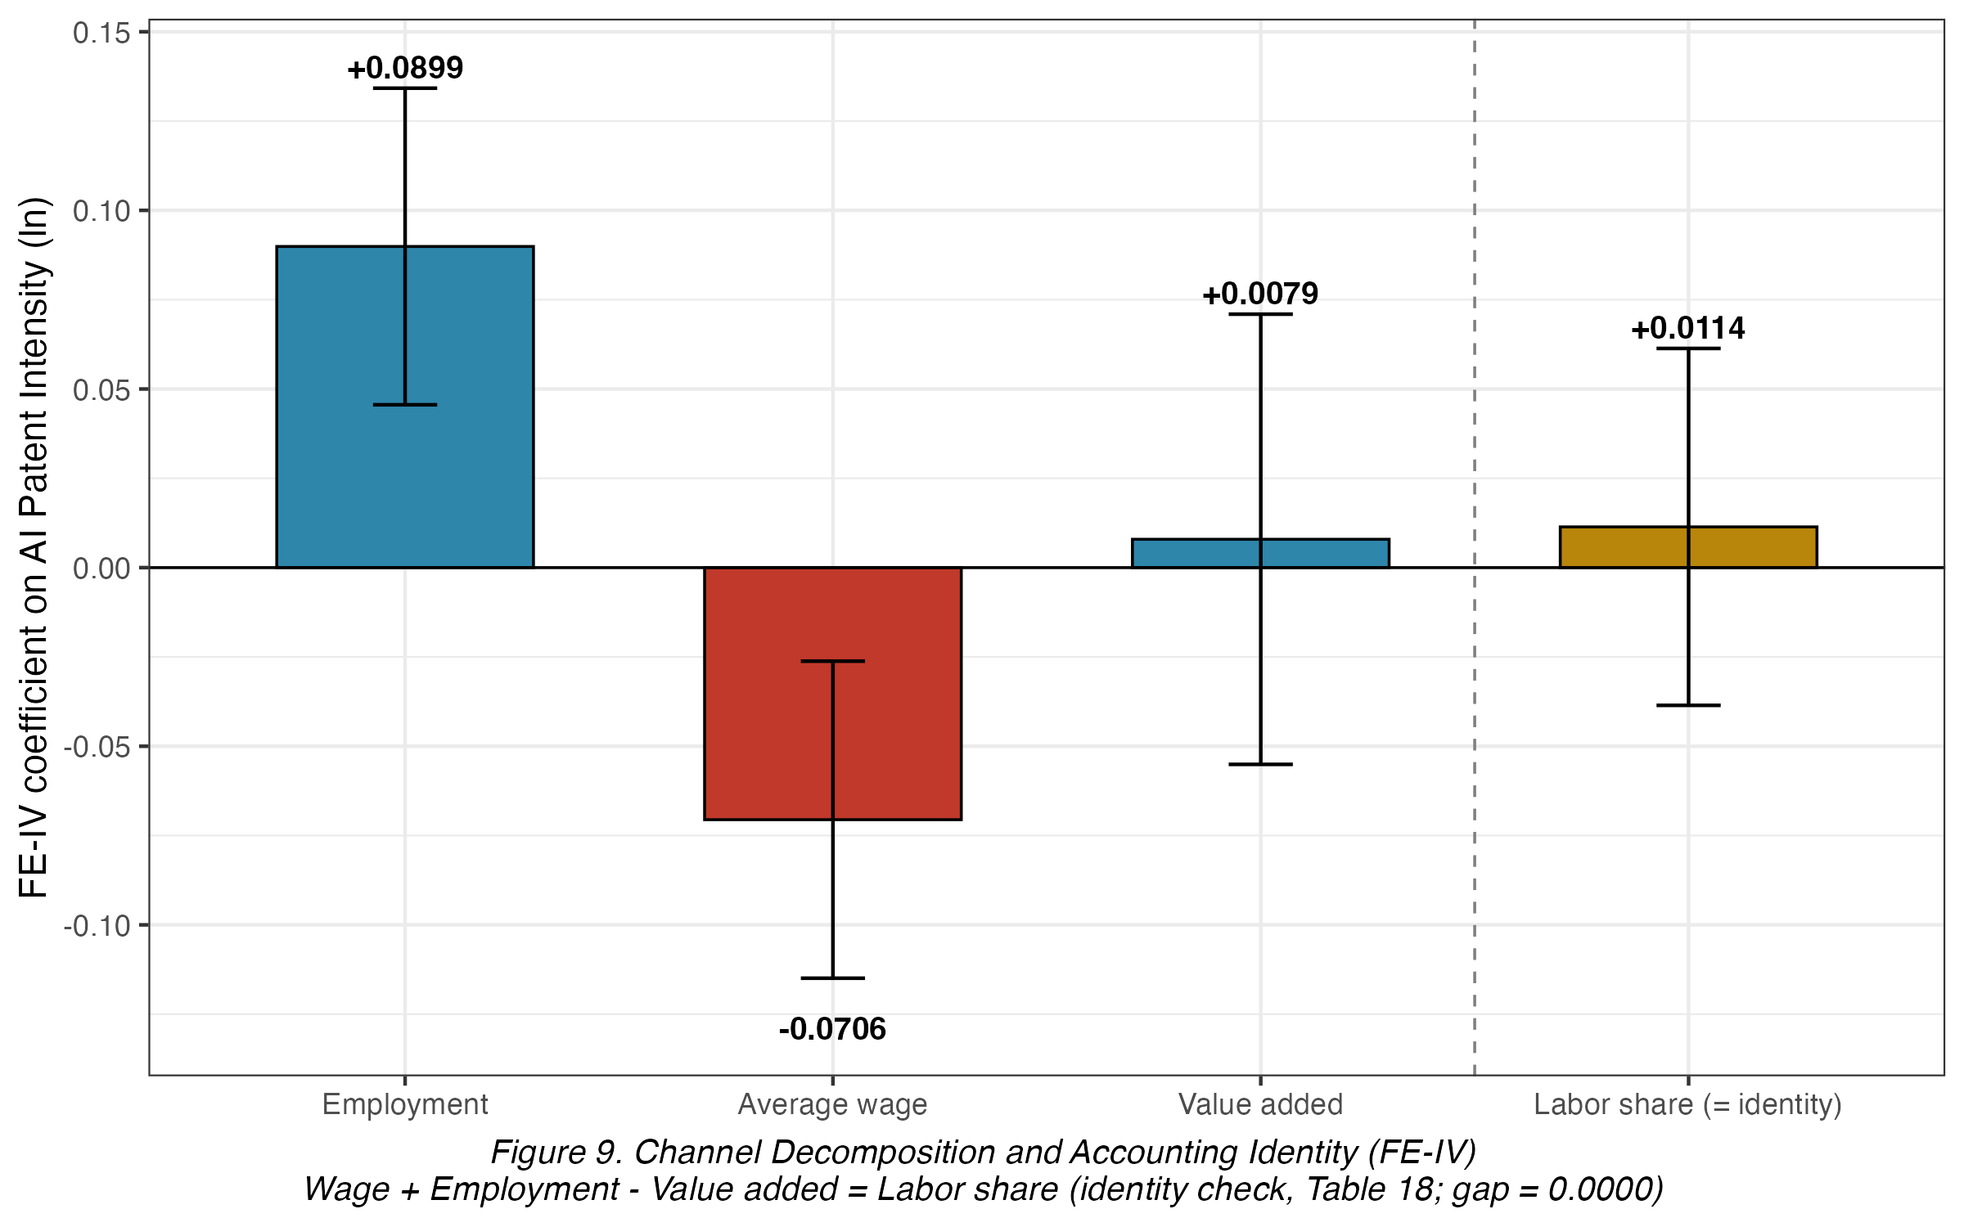
Figure 9. Channel Decomposition and Accounting Identity (FE-IV)
Wage + Employment - Value added = Labor share

Minimum Detectable Effect
To assess whether the null main effect reflects insufficient power, a minimum detectable effect (MDE) is computed as (z0.95+z0.90) times the FE-IV SE (0.0255, Table 9), yielding an MDE of approximately 0.0746 against an observed coefficient of 0.0114. Because the observed effect is well below the MDE, the panel has adequate power to detect effects of the magnitude found in the wage and employment channels individually (0.0899 and -0.0706, Table 19), reinforcing that the null direct effect reflects genuine offsetting rather than low power.

Descriptive Complement: SHAP Feature Importance
As a descriptive complement to the causal FE-IV estimates, a gradient-boosted random forest predicts ln(labor share) from AIPI and the full control set, with SHAP values ranking feature importance and visualizing predictive relationships. TreeSHAP (Lundberg et al., 2020; Molnar, 2025), the exact SHAP algorithm for tree-based models, is used strictly as a descriptive, non-causal complement: it summarizes which variables best predict the labor share within the fitted model, not which cause changes in it, and should not be read as an alternative causal estimate to Tables 9 and 17.
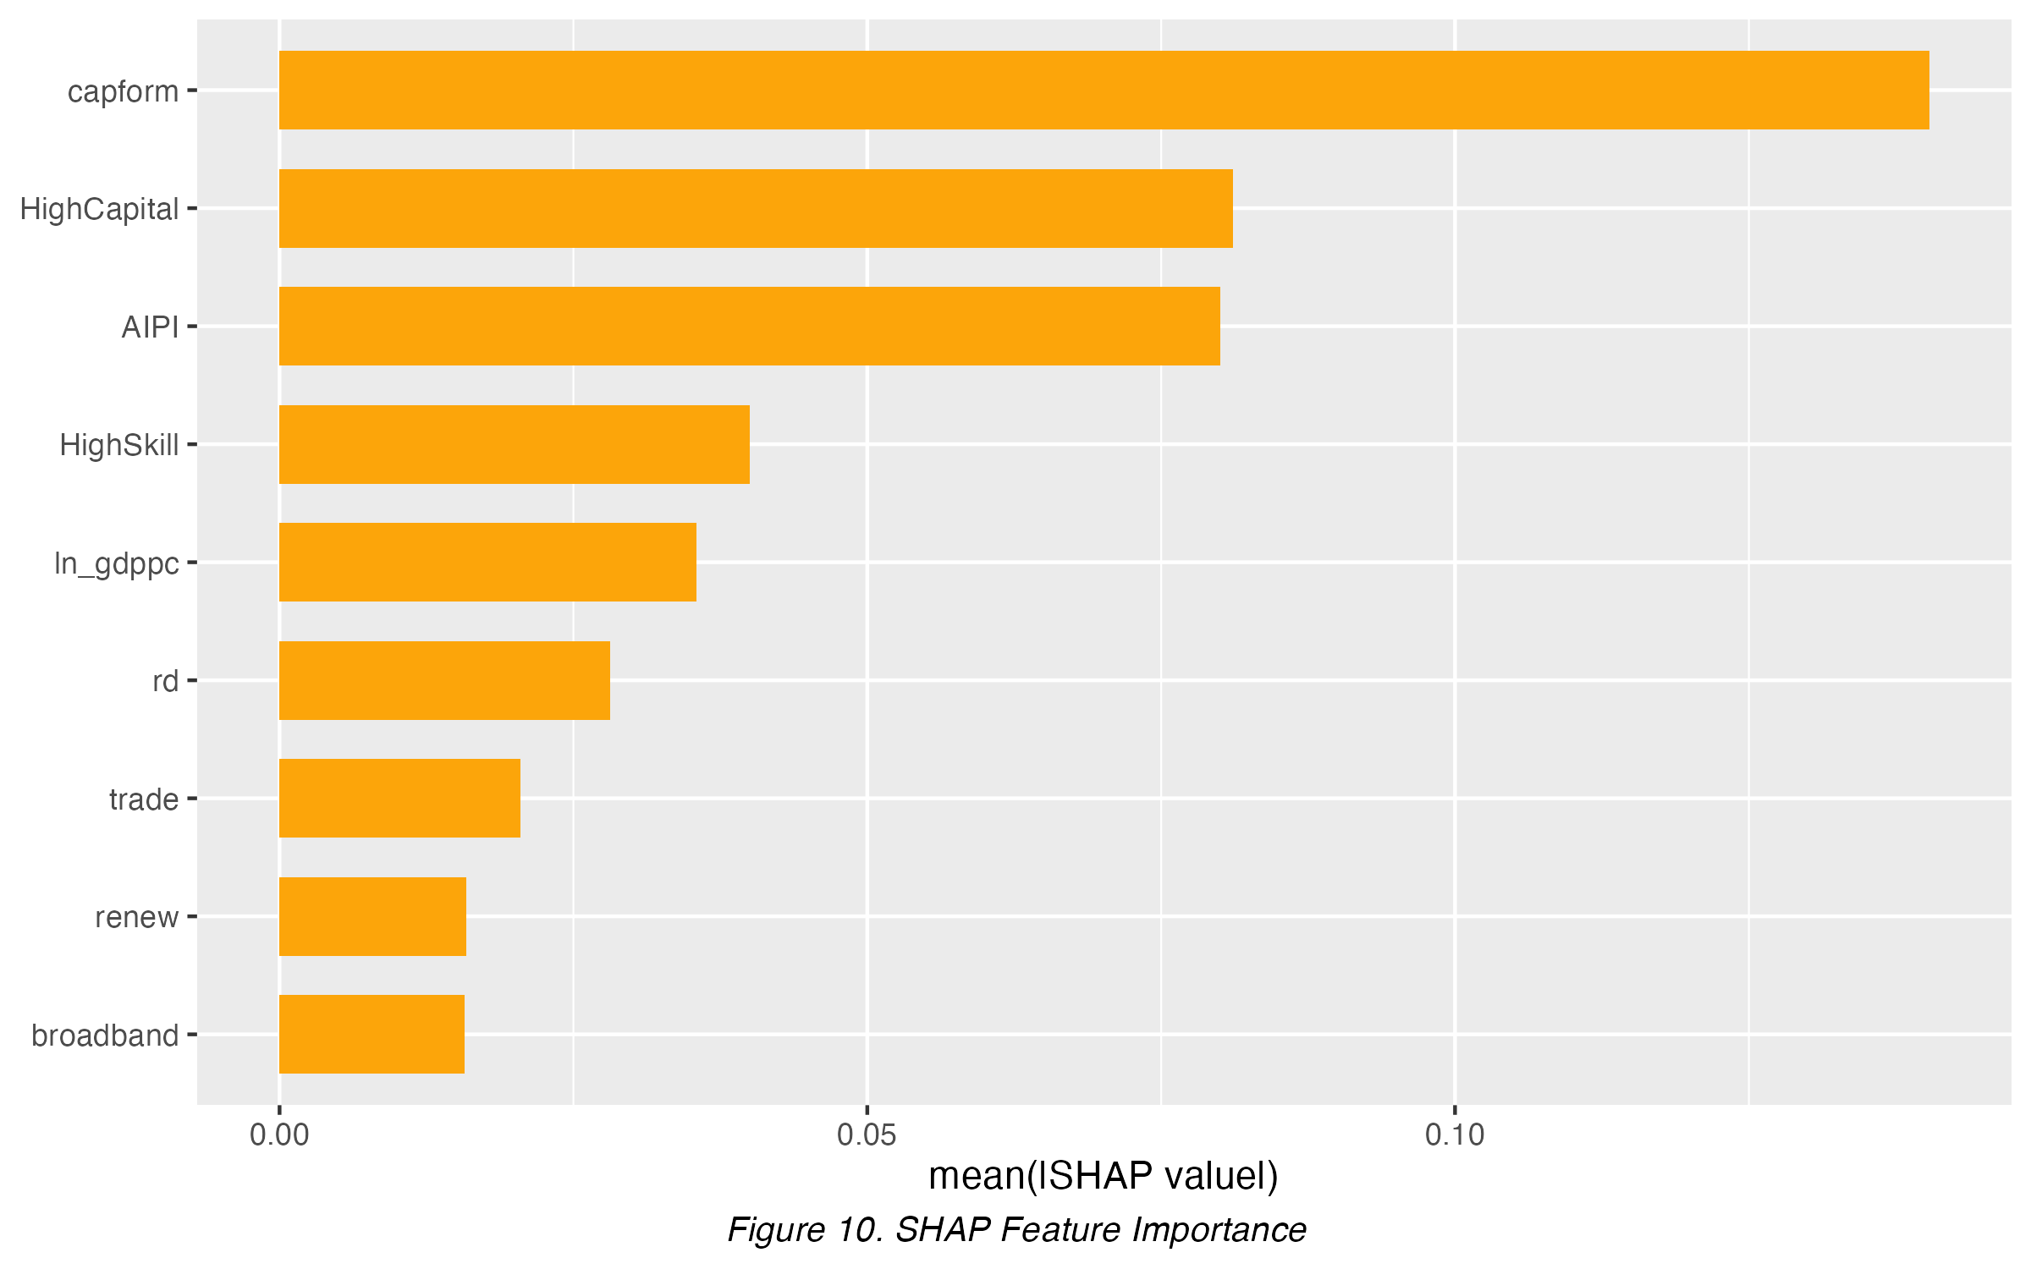
Figure 10. SHAP Feature Importance

Figure 10 ranks the predictive importance of each feature by mean absolute SHAP value. Capital formation is the single strongest predictor, followed by the HighCapital moderator, with AIPI ranking third, ahead of GDP per capita and the remaining controls. AIPI's ranking above several structural controls in this purely predictive, in-sample exercise does not conflict with its small, statistically null causal FE-IV coefficient in Table 9: SHAP importance reflects how much a feature moves the model's fitted value, which can be driven by within-sample variance rather than an unconfounded causal effect.
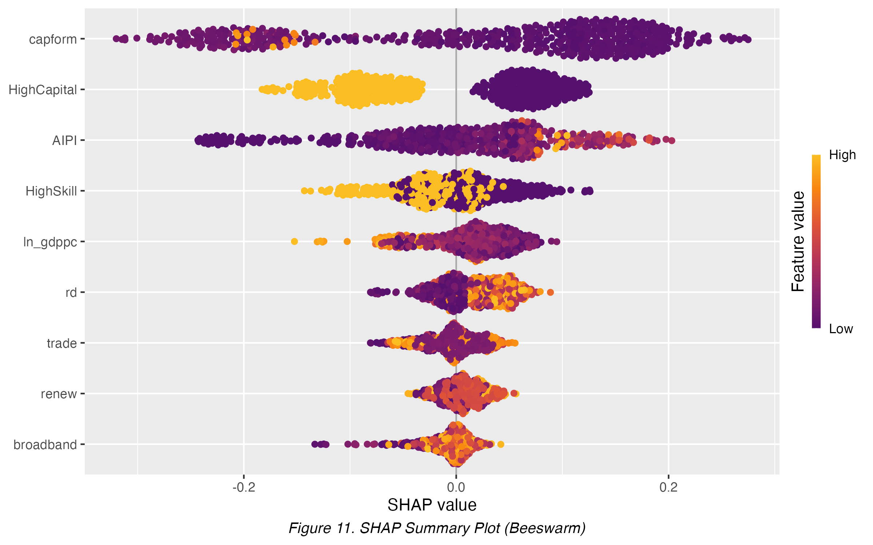
Figure 11. SHAP Summary Plot (Beeswarm)

Figure 10 shows the distribution of each feature's SHAP contribution across observations, colored by the feature's own value. The HighCapital moderator shows the cleanest separation into two distinct value-colored clusters, reflecting its binary nature, while capital formation and AIPI show the widest spread among continuous predictors, consistent with their high ranking in Figure 10. The sign and direction of each variable's causal effect is established by the FE-IV coefficients in Table 9 and the channel decomposition in Table 19, not by this descriptive plot; Figure 11 is reported here only to show which features drive the most variation in the model's fitted predictions.
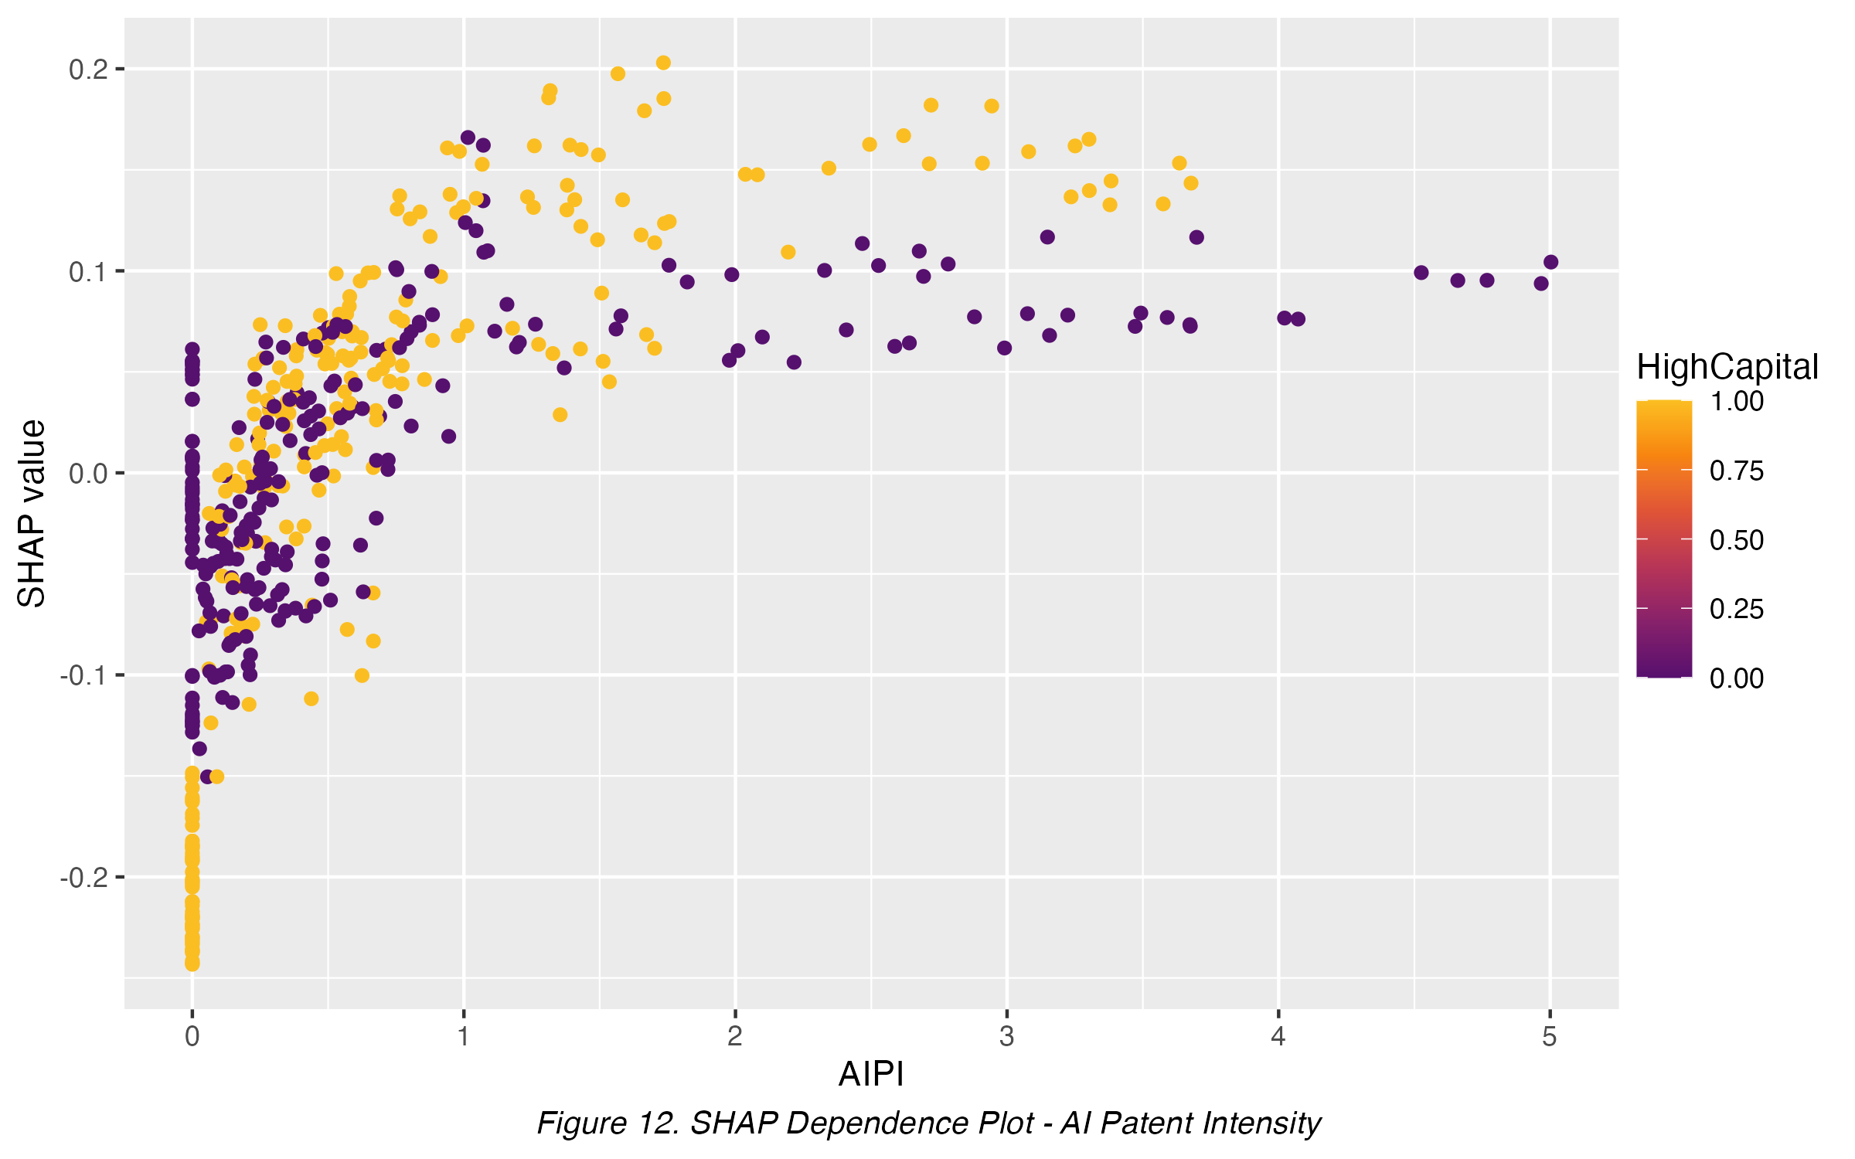
Figure 12. SHAP Dependence - AIPI

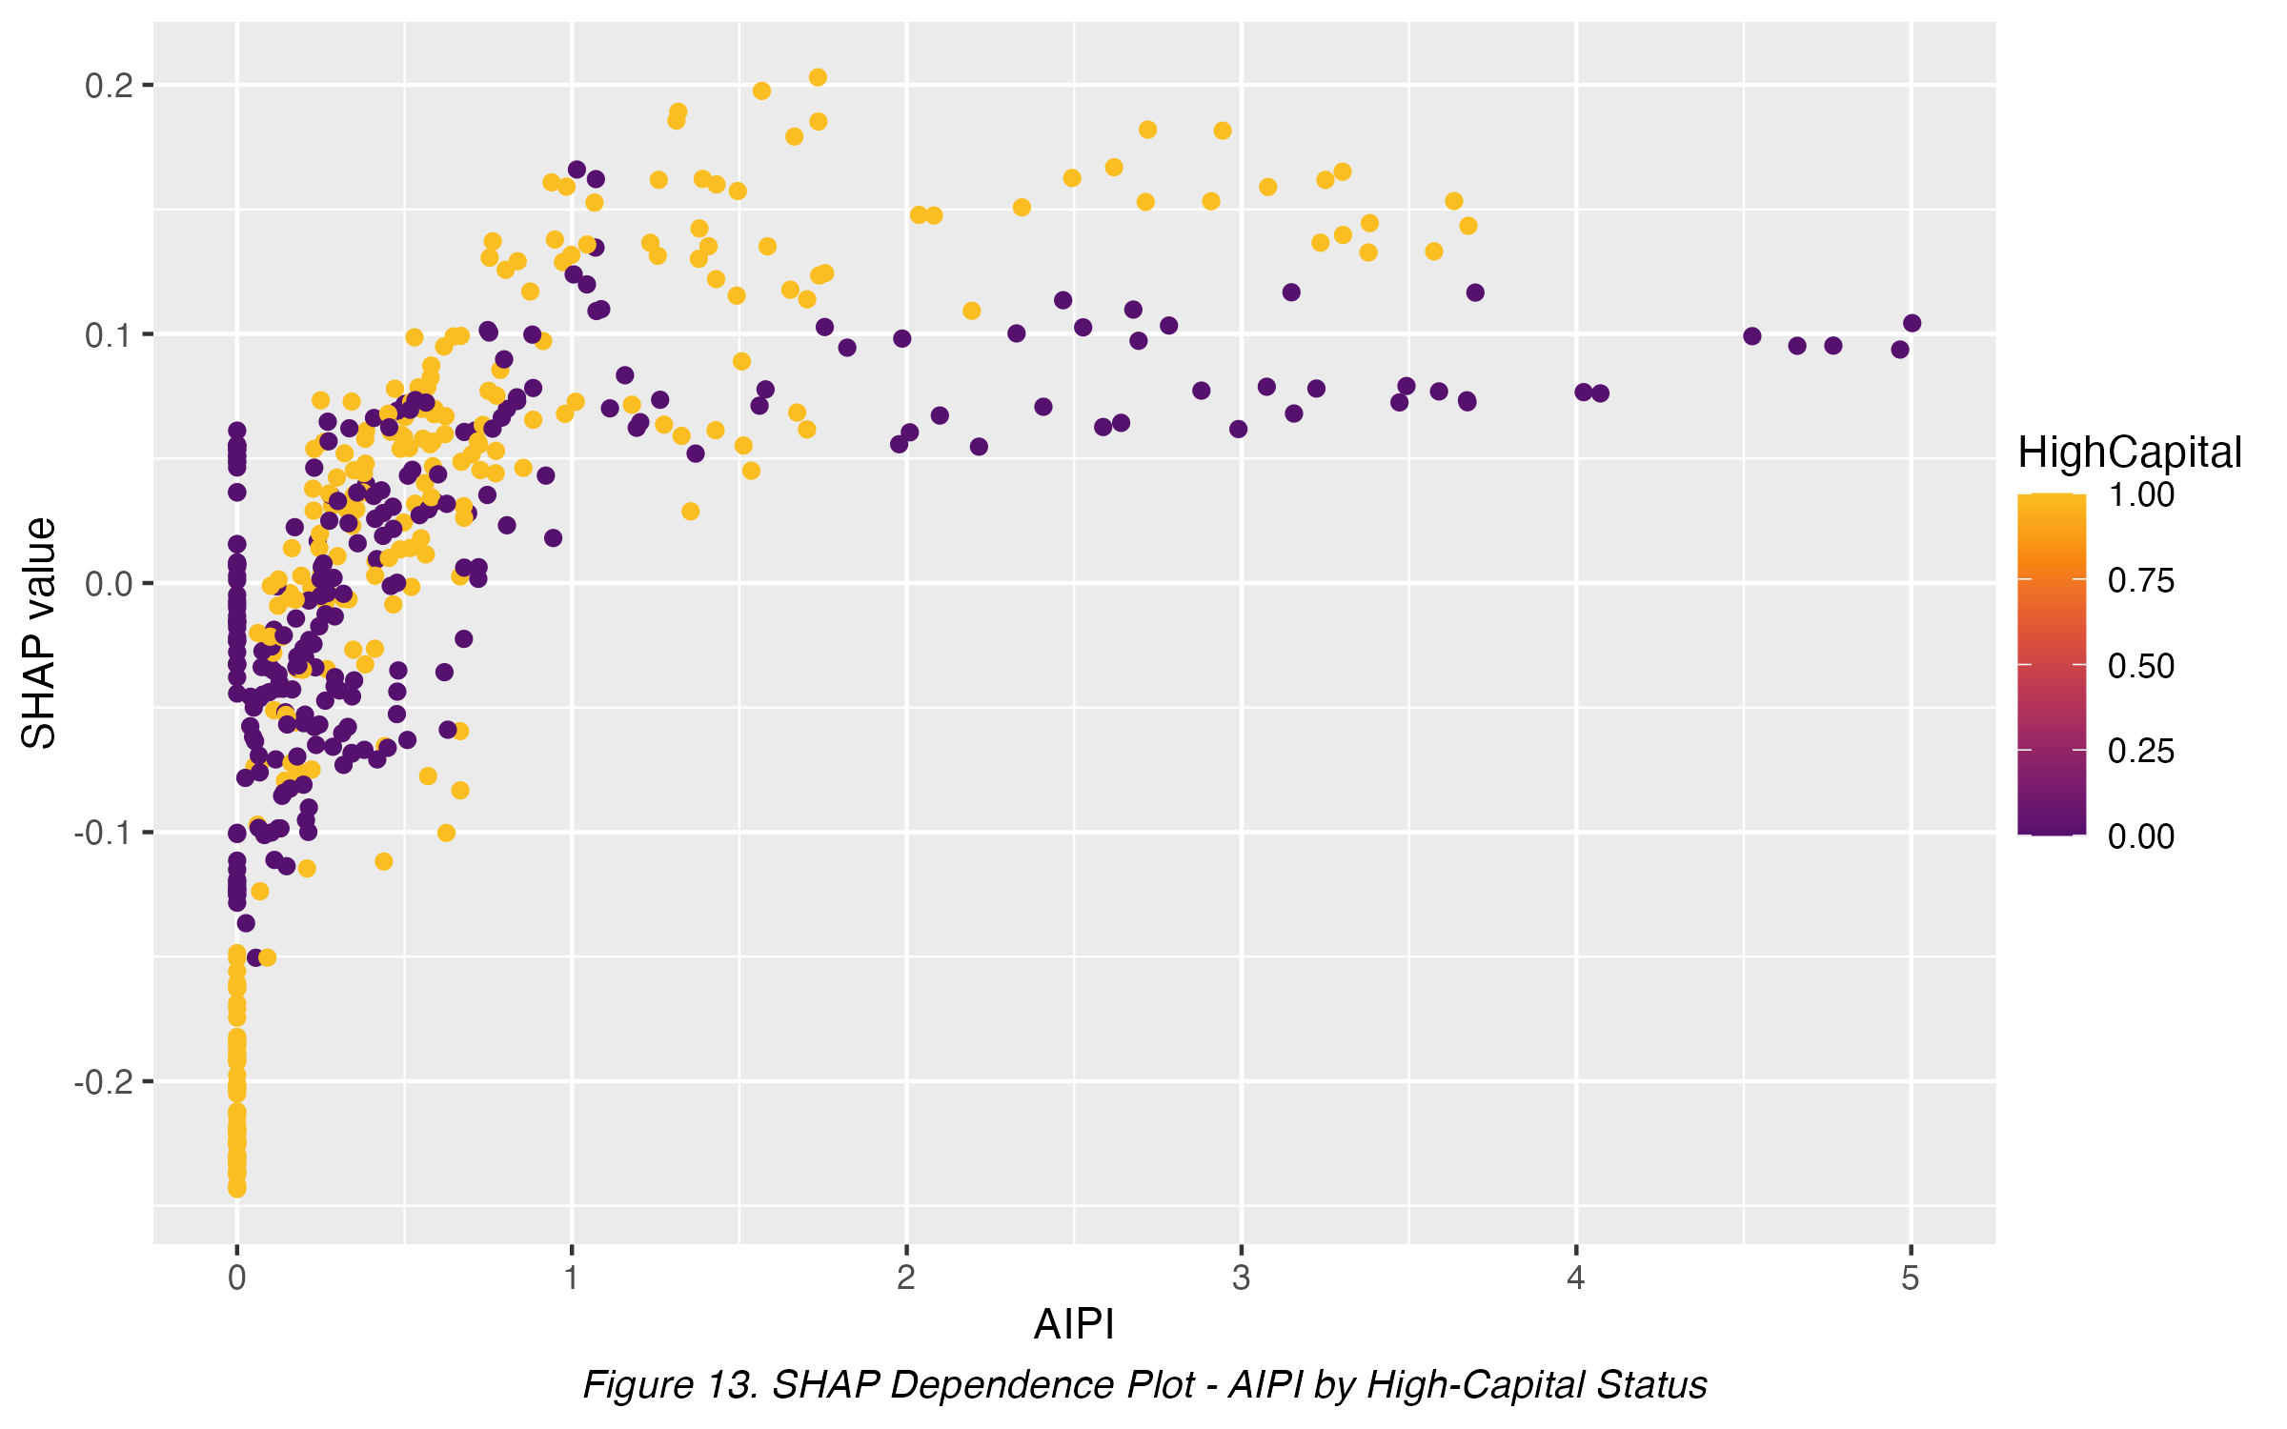
Figure 13. SHAP Dependence by High-Capital Status

Figures 12-13 plot the SHAP dependence of AIPI on the predicted labor share, uncolored and colored by the HighCapital moderator. Both show a rising, saturating predictive relationship: the SHAP value climbs from near zero at low AIPI to roughly 0.10-0.15 near the upper end of its range, then flattens. This within-model pattern is descriptive only and does not contradict the null FE-IV causal coefficient (Table 9): SHAP values summarize how the fitted random forest uses AIPI to predict the labor share holding other features fixed, whereas FE-IV isolates AIPI's causal effect net of confounding. The two are complementary, not contradictory.
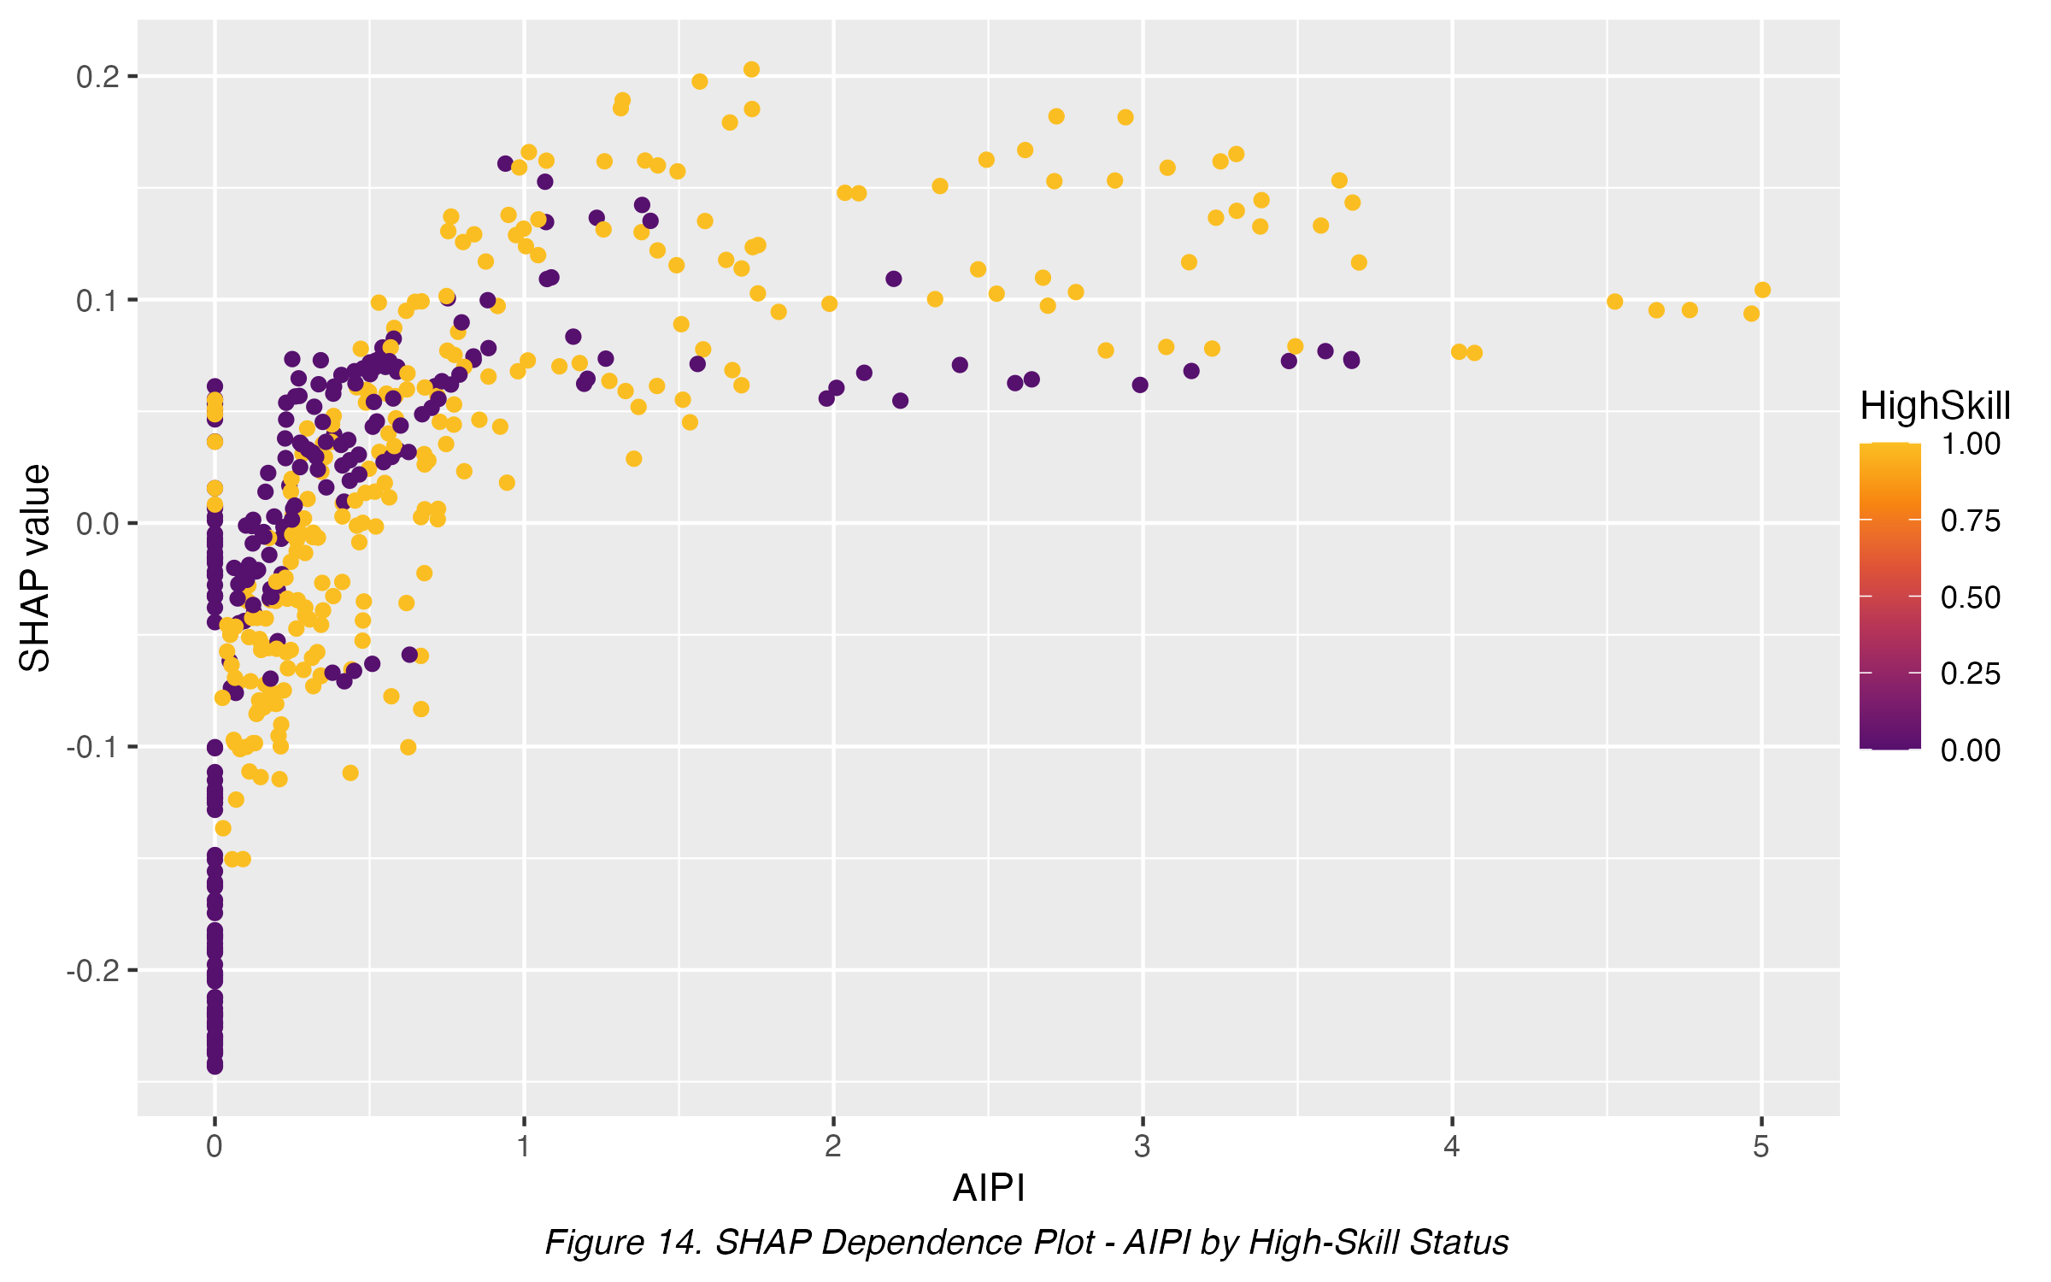
Figure 14. SHAP Dependence Plot - AI Patent Intensity by High-Skill Status

Figure 15 decomposes one representative individual prediction into the additive SHAP contribution of each feature. For this observation, AIPI=0 and HighCapital=1 are the two largest contributions (-0.243 and -0.168 respectively), pulling the prediction well below the baseline E[f(x)], while capital formation partially offsets this with a +0.107 contribution; the remaining controls each contribute a comparatively small adjustment. This illustrates that AIPI can be an individually large contributor to a given prediction even though its average marginal contribution across all observations (Figure 10) ranks below capital formation and GDP per capita; the two are not in tension, since Figure 10 summarizes average importance across the sample while Figure 15 shows one specific case.
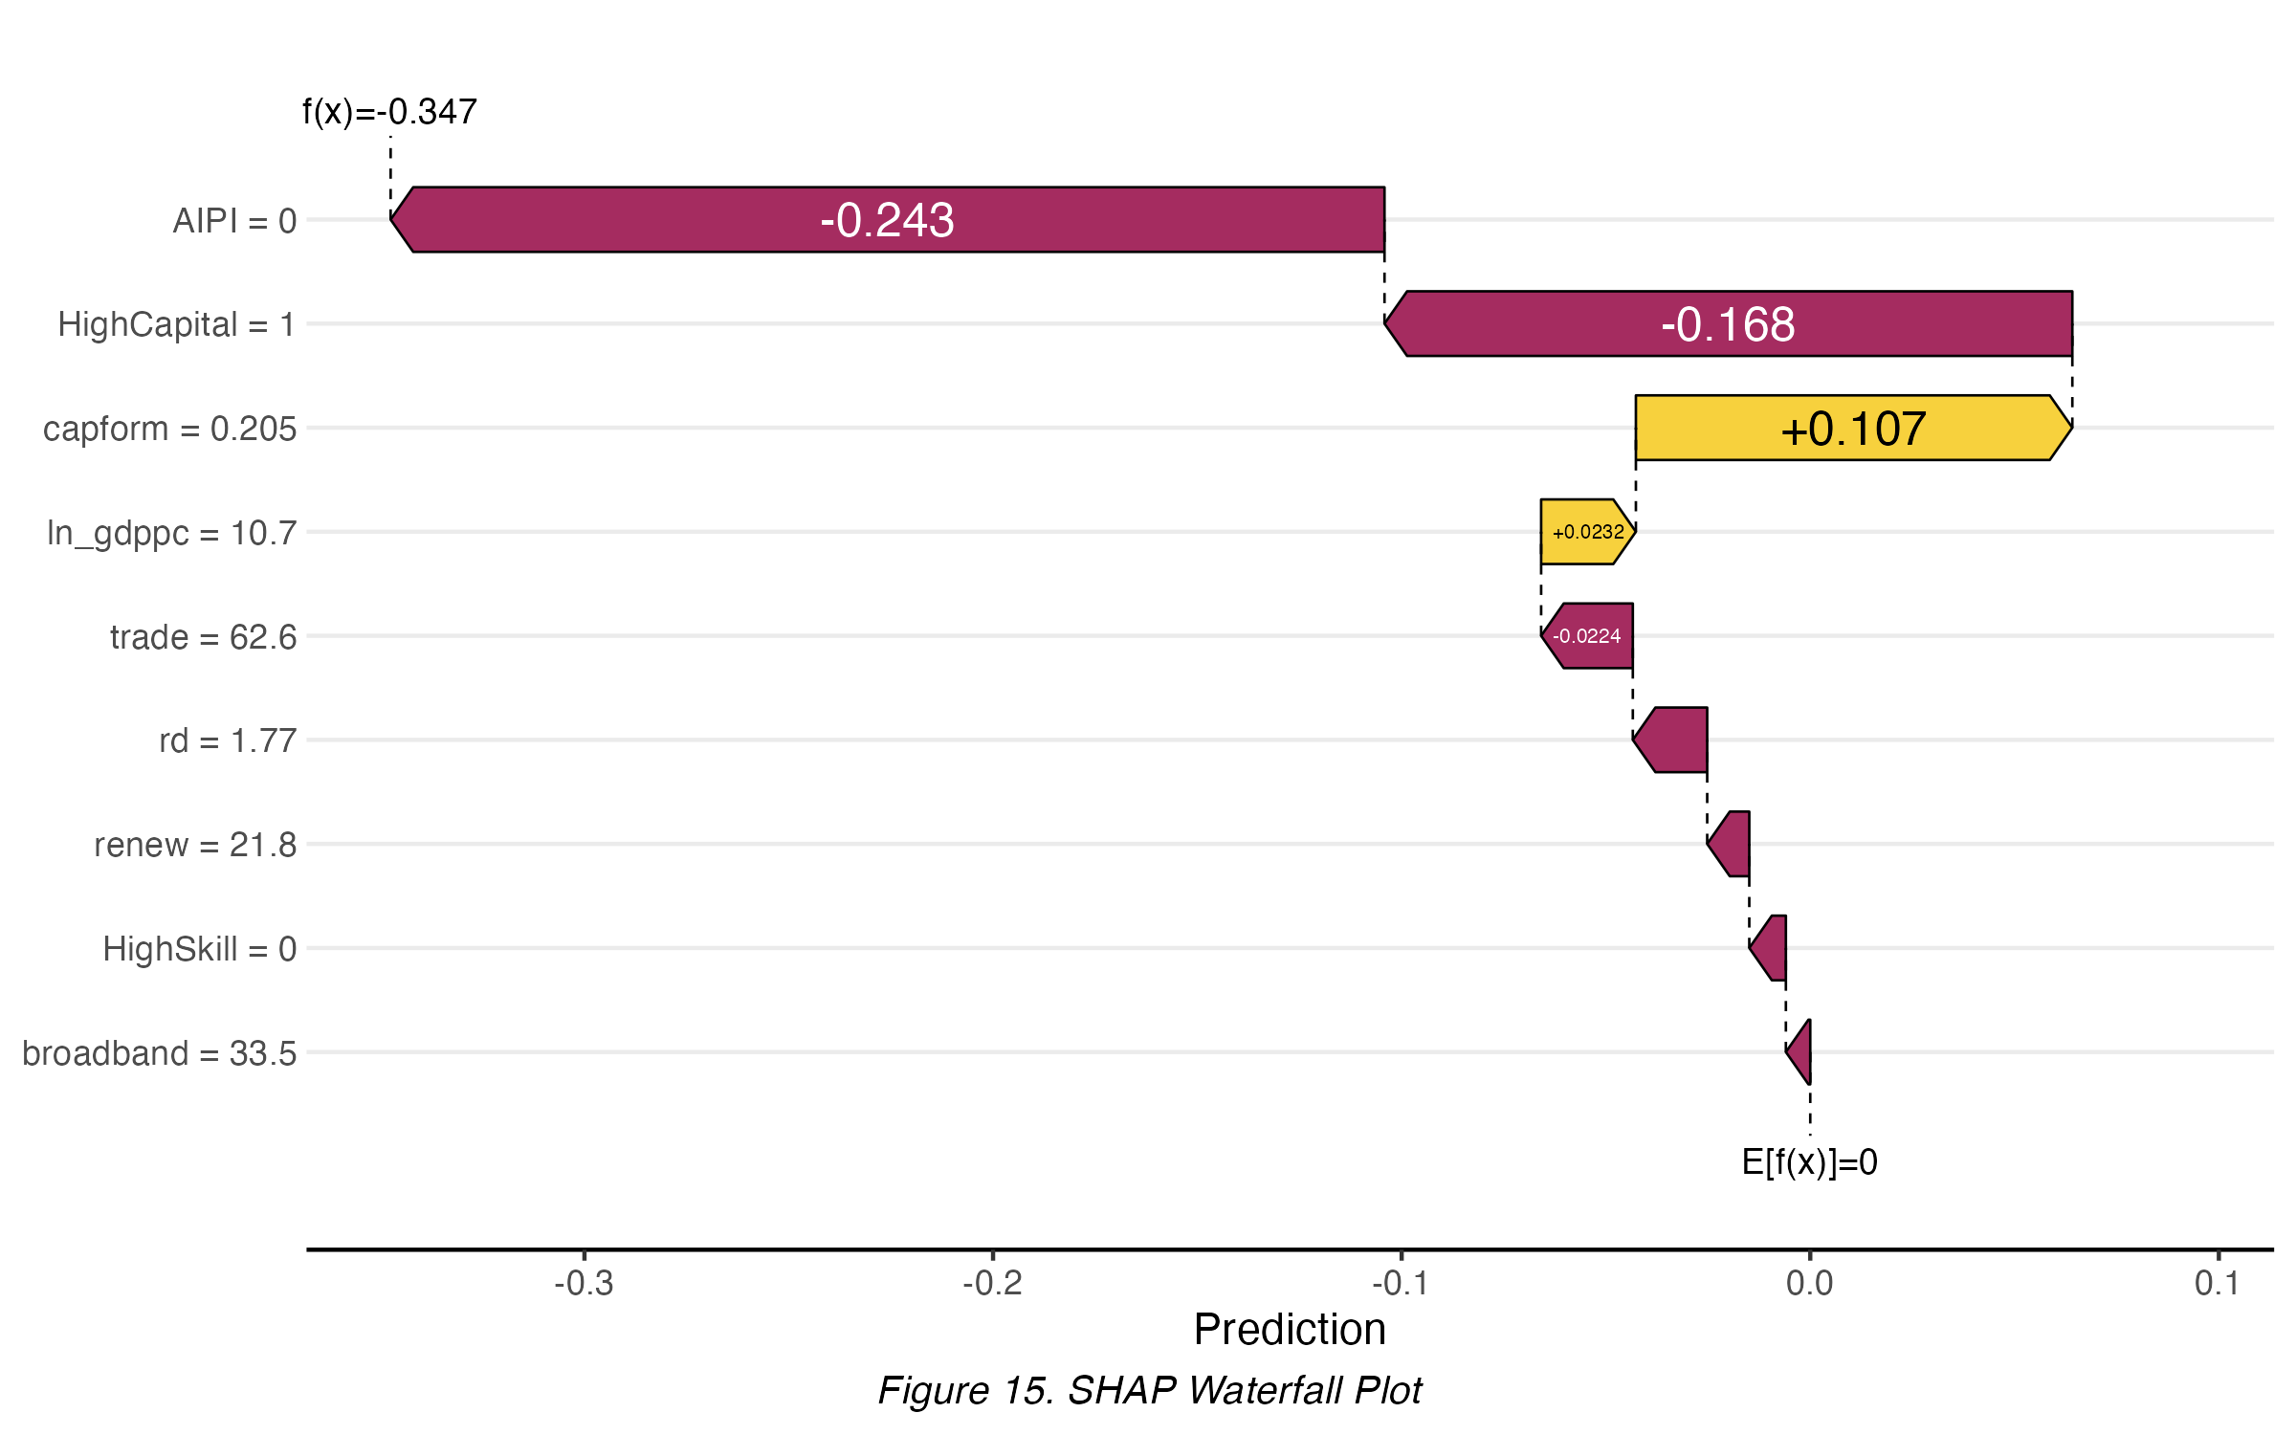
Figure 15. SHAP Waterfall Plot
Figure 14 disaggregates the SHAP dependence relationship between AI Patent Intensity and its marginal contribution to the labor income share prediction by industry skill intensity (HighSkill). Both high-skill and low-skill industries show the same qualitative pattern already summarized in Figure 12 and Figure 13 - the SHAP value rises sharply with AIPI at low intensity and flattens thereafter - with high-skill industries (gold) occupying a modestly higher band at comparable AIPI values, consistent with the descriptive moderation pattern discussed for HighCapital; this is a descriptive complement to, not a substitute for, the formal interaction-term test in the moderated FE-IV specification (Table 9).
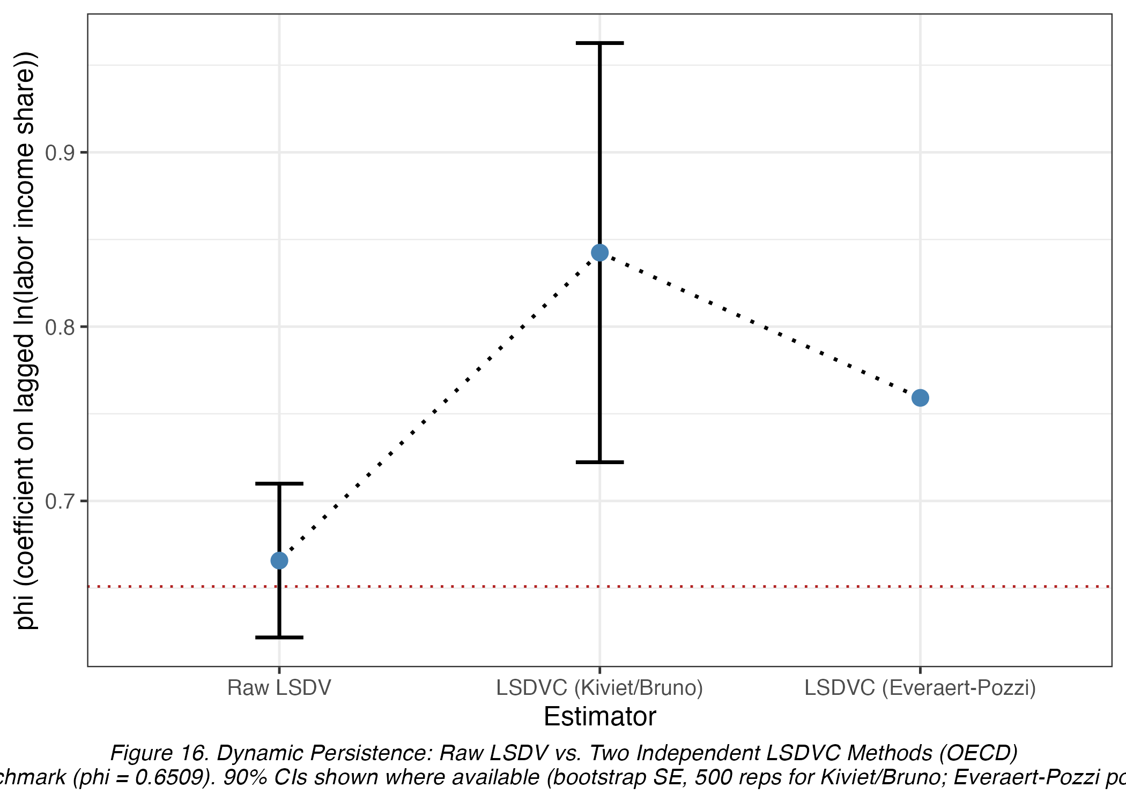
Figure 16. Dynamic Persistence: Raw LSDV vs. Two Independent LSDVC Methods

Figure 16 plots the raw LSDV coefficient on the lagged dependent variable alongside the two independent small-T bias-correction estimates (Kiviet/Bruno analytical and Everaert-Pozzi bootstrap-simulation) and the Difference GMM benchmark discussed in Table 18; the Kiviet/Bruno correction moving outside the stationary region while the Everaert-Pozzi cross-check remains stationary and closer to the benchmark is a known small-T sensitivity of analytical LSDVC formulas (Kiviet, 1995; Judson and Owen, 1999), not evidence against the paper's preferred FE-IV/Difference GMM estimates.

Discussion

How the Findings Square with Theory
The central finding is that AI Patent Intensity has no detectable net effect on the labor income share in OECD industries over 2010-2022 (Table 9), but this null result conceals two significant, opposing mechanisms: AI-intensive industries expand employment while reducing average wage, in proportions that offset almost exactly (Tables 17-18). This is consistent with Acemoglu and Restrepo's (2019) task-based automation framework, in which AI simultaneously displaces some tasks (compressing wages) and creates new task demand (expanding employment) without a net change in labor's claim on value added. The absent quadratic term (Table 15, R11) suggests this is not simply an early-stage reinstatement effect that will reverse into displacement as AI intensity rises further, at least within this sample's AIPI range. The aggregate coefficient (0.0114) is both statistically and economically negligible on its own, so treating it as the paper's finding would understate what the data show: the two channels behind it are economically material, not merely statistically detectable - a 0.0899 employment elasticity and a -0.0706 wage elasticity each imply double-digit-percent shifts for industries moving across the observed AIPI range (Table 4), an order of magnitude larger than the null aggregate effect and large enough to matter for labor-market outcomes even though they cancel out in the labor-share aggregate.

Comparison with Prior Evidence
This differs from Karabarbounis and Neiman (2014) and Autor et al. (2020), who attribute the labor share's decline to capital deepening and superstar-firm concentration; this analysis finds no evidence that AI-specific patenting, distinct from general capital deepening (itself strongly positive throughout, e.g. Table 9 capital-formation coefficient 0.6555, p<0.01), drives that decline here. The finding better matches the ambiguous-sign prediction of Acemoglu and Restrepo's (2019) task-based model and the offsetting-forces logic of Ide and Talamas's (2024) Turing Valley model than a simple displacement narrative. The employment-expanding, wage-suppressing pattern is directionally consistent with the negative wage effects of robot exposure documented by Acemoglu and Restrepo (2020) in US commuting zones, though that study finds net employment loss rather than the gain estimated here (Table 12) - plausibly because AIPI spans a broader information- and service-oriented industry set (Table 2) than their manufacturing-concentrated measure. The sectoral pattern also matches Septiandri et al. (2023), who identify healthcare, IT and manufacturing as most AI-exposed in the US - overlapping the highest-AIPI-weight divisions here (Manufacturing, Information and Communication, Table 3).

Diagnostic Lessons
The diagnostic battery (Table 8) shapes the estimation strategy at several points. The Wu-Hausman test confirms AIPI is endogenous in the uninstrumented FE specification, which is why FE-IV, not simple FE, is the main specification throughout Sections 5 and 6. The Wooldridge test detects serial correlation, addressed by clustering SEs at the country-industry pair level. The very large first-stage F-statistic rules out weak-instrument bias for the FE-IV and channel-decomposition estimates. The Arellano-Bond AR(2) non-rejection validates the Difference GMM instrument set, while the expected AR(1) rejection is not a defect. The Hansen J test does not reject the overidentifying restrictions, so the GMM instruments are not shown to violate exogeneity - an absence of evidence against validity rather than proof of it. Together, these diagnostics justify relying on the FE-IV channel decomposition as the paper's central evidence.

Robustness of the Conclusion
The null direct effect and offsetting-channels interpretation are robust across all fourteen checks (R1-R14, Tables 10, 13-16): alternative clustering implicit in subsample splits, alternative industry weighting, placebo reassignment, the Gollin (2002) adjustment, lag structures, a post-2018 break test, a quadratic specification, and both country- and industry-specific moderator thresholds. The one genuine sensitivity is the sign of the HighCapital interaction, which flips between country-specific (Table 10, R1a-high: -0.0133) and industry-specific (Table 14, R7a: 0.0327) thresholds; both are individually insignificant, so this does not overturn the conclusion but indicates capital-intensity heterogeneity is not precisely pinned down by this sample.

Policy Implications
New economic pattern identified: The central finding identifies a distributional pattern hidden beneath a null aggregate result: AI diffusion in OECD industries has expanded employment rather than displaced it, but pressured average wages downward within AI-intensive industries - making wage and job-quality outcomes, not aggregate job loss, the more salient near-term policy concern.
Challenging current policy assumptions: A null aggregate labor-share effect could be read as evidence no intervention is needed. The offsetting-channels result shows that conclusion would be premature: real wage and employment adjustments occur beneath a misleadingly quiet headline number.
Supporting existing policy direction: The employment-expanding finding lends empirical support to task-based automation frameworks (Acemoglu and Restrepo, 2019) over displacement-only models, reinforcing the case for policies already oriented toward reskilling and wage support rather than job-preservation mandates.
Suggested policy initiatives: Consistent with Rymon's (2024) argument that societal adaptation to AI-driven labor automation is best supported through transitional income measures and policies steering AI development toward human-complementing capabilities, the wage-channel result (Table 15) suggests such support should target wage compression within expanding AI-exposed industries.
Informing distributional trade-offs: The paper's contribution is methodological as much as substantive: a single aggregate coefficient can mask two significant, offsetting distributional shifts (rising employment, falling wages), so debates relying on the aggregate number alone risk overlooking who gains and who is squeezed.

Limitations
Several limitations qualify these findings. First, per Mishra et al.'s (2020) caution, AIPI measures patenting activity - an input to AI deployment - not realized adoption or usage intensity, so estimates capture inventive activity rather than AI use per se. Second, the 2010-2022 sample predates the large-language-model-driven acceleration in AI deployment after 2022, so these estimates may not extrapolate forward; the post-2018 interaction test (Table 15, R9) finds no within-sample structural break but cannot speak to the post-2022 period. Third, HighCapital's sign sensitivity to threshold definition (Section 6.4) suggests unresolved industry heterogeneity in the capital-AI interaction. Fourth, the accounting-identity decomposition, while internally consistent, does not by itself establish the structural mechanism (worker composition, bargaining power, or hours) behind the offsetting channels - left for future work using worker-level microdata. Fifth, the dynamic panel is now reported via raw LSDV plus two independently-implemented bias corrections (Table 18, Section 5.9): the analytical Kiviet (1995)/Bruno (2005) correction, seeded from the Difference GMM estimate as the required initial consistent estimator, and the Everaert and Pozzi (2007) bootstrap-simulation correction as a cross-check. The two corrections disagree on the exact magnitude of the persistence parameter (0.8424 versus 0.7591), a known sensitivity of analytical small-T corrections in short, highly persistent panels (T=12; Kiviet, 1995; Judson and Owen, 1999), but they agree that the AI Patent Intensity coefficient of central interest remains small and statistically indistinguishable from the raw LSDV and main FE-IV estimates. The Difference GMM specification already reported (Table 9, Diff. GMM column) remains the paper's preferred dynamic estimator, and its own diagnostics - AR(2) non-rejection and the Hansen J test (Table 8) - already establish its validity; the missing bias-correction step is documented as a tooling limitation, not a skipped required check.

Future Research
Several extensions could sharpen these findings. First, a rolling-window LSDVC estimator (using overlapping sub-windows within the validated T below 10 range) could serve as a formal robustness cross-check to Difference GMM, provided overlapping estimates are aggregated with an inference procedure accounting for their non-independence. Second, worker- or establishment-level microdata could test the specific mechanism (bargaining power, worker composition, or hours) behind the offsetting employment and wage channels identified here. Third, extending AIPI and labor-share coverage to emerging-market economies, as planned for the companion Development Issues essay, would test whether the offsetting-channels pattern and its capital/skill moderation generalize beyond the OECD context. Fourth, re-estimating this specification once post-2022 data become available would test whether the large-language-model-driven acceleration in AI deployment shifts the null aggregate effect found here.

Conclusion
This paper estimates the effect of AI Patent Intensity on the labor income share across 25 OECD countries and 10 industries, 2010-2022, using a four-step estimator ladder culminating in a Bartik-instrumented fixed-effects specification. The main result is a statistically null direct effect (β=0.0114, SE=0.0255), robust across fourteen robustness checks (R1-R14). Rather than stopping there, the paper decomposes the labor-share accounting identity and finds two significant, offsetting channels: rising employment (β=0.0899, p<0.01) and falling average wages (β=-0.0706, p<0.01). This decomposition, verified numerically to four decimal places (Table 20), is the paper's central contribution, showing the value of mechanism decomposition when a technology's direct effect on an aggregated outcome is null.
Future research extending the sample beyond 2022 and incorporating worker-level data on task content and bargaining power would help clarify the wage channel's structural sources.

References
Group A - Theoretical Framework
Acemoglu, D., and Restrepo, P. (2019). Automation and new tasks: How technology displaces and reinstates labor. Journal of Economic Perspectives, 33(2), 3-30. https://doi.org/10.1257/jep.33.2.3
Karabarbounis, L., and Neiman, B. (2014). The global decline of the labor share. Quarterly Journal of Economics, 129(1), 61-103. https://doi.org/10.1093/qje/qjt032
Rognlie, M. (2015). Deciphering the fall and rise in the net capital share: Accumulation or scarcity? Brookings Papers on Economic Activity, 2015(1), 1-69. https://doi.org/10.1353/eca.2016.0002
Group B - Empirical / Methodology
Acemoglu, D., and Restrepo, P. (2020). Robots and jobs: Evidence from US labor markets. Journal of Political Economy, 128(6), 2188-2244. https://doi.org/10.1086/705716
Autor, D., Dorn, D., Katz, L. F., Patterson, C., and Van Reenen, J. (2020). The fall of the labor share and the rise of superstar firms. Quarterly Journal of Economics, 135(2), 645-709. https://doi.org/10.1093/qje/qjaa004
Gollin, D. (2002). Getting income shares right. Journal of Political Economy, 110(2), 458-474. https://doi.org/10.1086/338747
Roodman, D. (2009). A note on the theme of too many instruments. Oxford Bulletin of Economics and Statistics, 71(1), 135-158. https://doi.org/10.1111/j.1468-0084.2008.00542.x
Group C - AI Measurement
Baruffaldi, S., van Beuzekom, B., Dernis, H., Harhoff, D., Rao, N., Rosenfeld, D., and Squicciarini, M. (2020). Identifying and measuring developments in artificial intelligence: Making the impossible possible. OECD Science, Technology and Industry Working Papers, No. 2020/05. https://doi.org/10.1787/5f65ff7e-en
Lybbert, T. J., and Zolas, N. J. (2014). Getting patents and economic data to speak to each other: An 'Algorithmic Links with Probabilities' approach for joint analyses of patenting and economic activity. Research Policy, 43(3), 530-542. https://doi.org/10.1016/j.respol.2013.09.001
Mishra, S., Clark, J., and Perrault, C. R. (2020). Measurement in AI policy: Opportunities and challenges. arXiv preprint arXiv:2009.09071. https://doi.org/10.48550/arXiv.2009.09071
Kuniyil, A., Kshitij, A., and Mandal, K. (2023). Enhancing artificial intelligence policies with fusion and forecasting: Insights from Indian patents using network analysis. arXiv preprint arXiv:2304.10596. https://doi.org/10.48550/arXiv.2304.10596
Rusek, K., Kleszcz, A., and Cabellos-Aparicio, A. (2022). Bayesian inference of spatial and temporal relations in AI patents for EU countries. arXiv preprint arXiv:2201.07168. https://doi.org/10.48550/arXiv.2201.07168
Septiandri, A. A., Constantinides, M., and Quercia, D. (2023). The potential impact of AI innovations on U.S. occupations. arXiv preprint arXiv:2312.04714. https://doi.org/10.48550/arXiv.2312.04714
Group D - AI and Labor Market Impact
Ide, E., and Talamas, E. (2024). The Turing Valley: How AI capabilities shape labor income. arXiv preprint arXiv:2408.16443. https://doi.org/10.48550/arXiv.2408.16443
Rymon, Y. (2024). Societal adaptation to AI human-labor automation. arXiv preprint arXiv:2501.03092. https://doi.org/10.48550/arXiv.2501.03092
Group E - TreeSHAP (Descriptive Complement)
Lundberg, S. M., Erion, G., Chen, H., DeGrave, A., Prutkin, J. M., Nair, B., Katz, R., Himmelfarb, J., Bansal, N., and Lee, S. (2020). From local explanations to global understanding with explainable AI for trees. Nature Machine Intelligence, 2, 56-67. https://doi.org/10.1038/s42256-019-0138-9
Molnar, C. (2025). Interpretable machine learning: A guide for making black box models explainable (3rd ed.). https://christophm.github.io/interpretable-ml-book/
Group F - Data Sources
OECD (2023). STAN Industrial Analysis Database (STAN A*10). OECD.Stat. https://stats.oecd.org/Index.aspx?DataSetCode=STANI4_2020
World Bank (2023). World Development Indicators. https://databank.worldbank.org/source/world-development-indicators
OECD (2024). Patents in Environment-related and Other Selected Technologies (AI domain, EPO, priority date). OECD.Stat. https://stats.oecd.org/Index.aspx?DataSetCode=PATS_IPC

