

Class : MAE 32
Course : Development Issues and Business Cycle
Lecturer : Professor Almas Heshmati
Group members : Tran Chanh Truc - 425273220
Nguyen Ngoc Xuan Thao - 425273217
Deadline : 13 September 2026

University of Economics Ho Chi Minh City (UEH)
Vietnam - The Netherlands Programme (VNP)

COURSE ESSAY

Artificial Intelligence, Green Technology, and
Structural Change in OECD and Emerging Economies:
A Focus on Vietnam and Southeast Asia

Ho Chi Minh City
September 2026

Table of Contents
Table of Contents 2
List of Abbreviations 4
List of Tables 6
List of Figures 7
List of Equations 8
List of Appendix Tables 9
List of Appendix Figures 10
1. Abstract 11
2. Background 12
2.1. Motivation 12
2.2. Development context 12
2.3. Vietnam and Southeast Asia in the global picture 12
2.4. Contribution 13
2.5. Research questions 13
3. Theoretical Framework 14
3.1. A task-based framework for technology and structural change 14
3.2. Measuring AI intensity 14
3.3. Green technology and productivity 14
3.4. The labor income share and its wage-employment decomposition 15
3.5. A unified framework across three margins 15
4. Data 17
4.1. Sample architecture 17
4.2. OECD-side data sources 17
4.3. Emerging-market-side data sources 18
4.4. Vietnam and Southeast Asia in the data 18
4.5. Descriptive statistics and trends 19
5. Model 22
5.1. Part A: AI patent intensity and carbon emission intensity 22
5.2. Part B: Green technology intensity and labor productivity 24
5.3. Part C: AI patent intensity and the labor income share 27
5.4. Identification strategy 29
5.5. The estimator ladder 29
5.6. Channel decomposition for the labor-share margin 30
6. Estimation and Testing 31
6.1. Diagnostic testing protocol 31
6.2. Diagnostics across the three OECD panels 31
6.3. Small-sample adjustments for the emerging-market panels 32
6.4. The role of TreeSHAP 33
7. Result and Analysis 34
7.1. The environmental margin (Part A): AI patent intensity and carbon emission intensity 34
7.2. The efficiency margin (Part B): Green technology intensity and labor productivity 35
7.3. The distributional margin (Part C): AI patent intensity and the labor income share 36
7.4. Synthesis across parts 38
7.5. Vietnam and Southeast Asia in focus 40
8. Conclusion and Policy Recommendations 44
8.1. Summary of findings by research question 44
8.2. Policy implications for Vietnam 44
8.3. Limitations 45
8.4. Future research 45
9. References 46
Appendix 49
9.1. A.1 TreeSHAP diagnostics 49
9.2. A.2 Part A robustness (AI patent intensity and carbon emission intensity) 60
9.3. A.3 Part B robustness (green technology intensity and labor productivity) 62
9.4. A.4 Part C robustness (AI patent intensity and labor income share) 64
9.5. A.5 Instrument-weight diagnostics across all three parts 66

List of Abbreviations
Abbreviation | Meaning
AIPI | AI Patent Intensity
AIIE / AIOE | AI Industry/Occupational Exposure (Felten et al., 2021)
GTI | Green Technology Intensity (EPO ENV-TECH Y02 / WIPO Green)
ALP | Algorithmic Links with Probabilities (patent-to-industry crosswalk)
HighAI | Dummy = 1 if AIIE is at/above the OECD-industry median (moderator variable)
HighCapital | Dummy = 1 if capital formation/value added is at/above the country-specific median (extended moderator)
HighTrade | Dummy = 1 if trade openness is at/above the OECD panel-wide median (robustness moderator)
HighRD | Dummy = 1 if R&D expenditure is at/above the OECD panel-wide median (robustness moderator)
FE | Fixed Effects
RE | Random Effects
FE-IV | Fixed Effects Instrumental Variables
IV | Instrumental Variable
OLS | Ordinary Least Squares
GMM | Generalized Method of Moments
Diff. GMM | Difference GMM (Arellano-Bond, transformation = "d")
AR(1)/AR(2) | First-order / second-order autocorrelation (Arellano-Bond test)
SE | Standard Error
CI | Confidence Interval
VIF | Variance Inflation Factor
MDE | Minimum Detectable Effect
LOWESS | Locally Weighted Scatterplot Smoothing
SHAP | SHapley Additive exPlanations
CPC | Cooperative Patent Classification
ISIC | International Standard Industrial Classification
A*10 | OECD/Eurostat 10-industry aggregation of ISIC Rev.4
STAN | Structural Analysis (OECD Industrial Database)
ENV-TECH | OECD Environmental Technology patent database
Y02 | Cooperative Patent Classification (CPC) tag for climate-change-mitigation technologies
LABR | Labor Compensation (STAN variable code)
VALU | Value Added (STAN variable code)
EMPN | Total Employment (STAN variable code)
GFCF | Gross Fixed Capital Formation
VA | Value Added
GDP | Gross Domestic Product
R&D | Research and Development
OECD | Organization for Economic Co-operation and Development
WGI | World Governance Indicators
WDI | World Development Indicators (World Bank)
EM | Emerging Market
SEA | Southeast Asia (ASEAN)

List of Tables
Table 1. Sample Architecture and Headline FE-IV Estimates Across Parts A-C 17
Table 2. Descriptive Statistics: Key Variables, Parts A-C (OECD Panel) 19
Table 3. Diagnostic Tests, Parts A-C (OECD Panel, alpha = 0.10) 31
Table 4. Main Results: AI Patent Intensity and Carbon Emission Intensity (OECD Panel) 34
Table 5. Main Results: Green Technology Intensity and Labor Productivity (OECD Panel) 35
Table 6. Main Results: AI Patent Intensity and Labor Income Share (OECD Panel) 36
Table 7. Channel Decomposition (FE-IV), Part C OECD Panel 37
Table 8. Synthesis Across Parts A-C: Main FE-IV Estimates (OECD vs EM) 39
Table 9. ASEAN Spotlight, Parts A-C (Emerging-Market Panel) 40

List of Figures
Figure 1. Trend of the Three Outcome Variables by Industry, OECD Panel (top to bottom: Part A CO2 emission intensity, Part B labor productivity, Part C labor income share) 21
Figure 2. Channel Decomposition Bar Chart (Part C, OECD) 38
Figure 3. Cross-Part FE-IV Coefficient Comparison (OECD vs EM, Parts A-C) 39
Figure 4. Southeast Asia versus Rest-of-Emerging-Market Trend (top to bottom: Part A, Part B, Part C) 42

List of Equations
Equation 1. Baseline two-way fixed-effects specification 22
Equation 2. First-stage regression: instrumental variable 23
Equation 3. Second-stage fixed-effects instrumental-variable specification 23
Equation 4. Moderated specification with high-renewable interaction 24
Equation 5. Baseline two-way fixed-effects specification 24
Equation 6. First-stage regression: instrumental variable 25
Equation 7. Second-stage fixed-effects instrumental-variable specification 25
Equation 8. Moderated specification with high-AI interaction 26
Equation 9. Baseline two-way fixed-effects specification 27
Equation 10. First-stage regression: instrumental variable 27
Equation 11. Second-stage fixed-effects instrumental-variable specification 28
Equation 12. Moderated specification with high-capital interaction 28
Equation 13. Labor-share accounting identity (channel decomposition) 30

List of Appendix Tables
Table A - 1. Robustness Checks, Part A: AI Patent Intensity and Carbon Emission Intensity (OECD Panel) 60
Table A - 2. First-Stage Regression: Instrument Validity, Part A (OECD Panel) 61
Table A - 3. Source Robustness: EPO vs WIPO AI Patents, and Viet Nam In-Sample, Part A (EM Panel) 61
Table A - 4. First-Stage Regression: GTI_bartik as Instrument, Part B (OECD Panel) 62
Table A - 5. Dynamic Panel LSDV and Bias-Corrected LSDVC, Part B (OECD Panel) 63
Table A - 6. Moderator (High-AI) Threshold Sensitivity, Part B (OECD Panel) 63
Table A - 7. Robustness: Gollin (2002) Self-Employment Adjustment, Part C (OECD Panel) 64
Table A - 8. Dynamic Panel LSDV and Bias-Corrected LSDVC, Part C (OECD Panel) 65
Table A - 9. Source Robustness: EPO vs WIPO AI Patents, and Viet Nam In-Sample, Part C (EM Panel) 65
Table A - 10. Goldsmith-Pinkham-Sorkin-Swift (2020) Rotemberg-Weight Decomposition and Per-Industry First-Stage Checks 66

List of Appendix Figures
Figure A - 1. TreeSHAP Feature Importance, Bar Chart - OECD Panel (top to bottom: Part A, Part B, Part C) 50
Figure A - 2. TreeSHAP Feature Importance, Beeswarm - OECD Panel (top to bottom: Part A, Part B, Part C) 51
Figure A - 3. TreeSHAP Dependence, Main Regressor - OECD Panel (top to bottom: Part A, Part B, Part C) 52
Figure A - 4. TreeSHAP Dependence, Moderator Variable - OECD Panel (top to bottom: Part A, Part B, Part C) 53
Figure A - 5. TreeSHAP Waterfall Example - OECD Panel (top to bottom: Part A, Part B, Part C) 54
Figure A - 6. TreeSHAP Feature Importance, Bar Chart - Emerging-Market Panel (top to bottom: Part A, Part B, Part C) 55
Figure A - 7. TreeSHAP Feature Importance, Beeswarm - Emerging-Market Panel (top to bottom: Part A, Part B, Part C) 56
Figure A - 8. TreeSHAP Dependence, Main Regressor - Emerging-Market Panel (top to bottom: Part A, Part B, Part C) 57
Figure A - 9. TreeSHAP Dependence, Moderator Variable - Emerging-Market Panel (top to bottom: Part A, Part B, Part C) 58
Figure A - 10. TreeSHAP Waterfall Example - Emerging-Market Panel (top to bottom: Part A, Part B, Part C) 59

Abstract
Artificial intelligence and green technology are advancing as general-purpose technologies whose effects on development outcomes remain incompletely understood outside the OECD economies where most existing evidence is concentrated. This essay asks whether AI patent intensity and green technology intensity are associated with structural change along three margins of development -- carbon emission intensity, labor productivity, and the labor income share -- and whether these relationships differ between OECD and emerging-market industries, with particular attention to Vietnam and Southeast Asia. To answer this, the essay builds a unified two-way fixed-effects and shift-share instrumental-variable framework applied consistently across six country-industry panels, and decomposes the labor-share margin into its underlying wage and employment channels. The essay finds that in OECD industries, higher AI patent intensity is associated with lower carbon emission intensity, while its aggregate effect on the labor income share is negligible; decomposing that result reveals two large offsetting forces, an employment gain alongside a wage discount, so the null result masks real redistribution between headcount and wage share. Green technology intensity raises OECD labor productivity, more so in high-AI industries and, regionally, most strongly within ASEAN. In the emerging-market panel, the labor-share relationship is modestly positive and wage-driven, though weaker within ASEAN specifically. These findings suggest that AI-driven technology adoption need not come at the cost of either the environment or labor's overall income share, but that how gains are split between employment and wages is a distinct policy question, directly relevant to how Vietnam should monitor its own AI-driven structural transformation.

Background

Motivation
Artificial intelligence and green technology are both general-purpose technologies: innovations broad and fast-improving enough to reshape production well beyond the sector in which they first appear (Bresnahan and Trajtenberg, 1995; Brynjolfsson, Rock and Syverson, 2021). AI reorganizes tasks within production, automating some functions while creating demand for others (Acemoglu and Restrepo, 2020, 2022); green technology, measured here through patented environmentally sound innovation, shifts the input mix toward lower-emission techniques (Popp, 2019; Albrizio, Kozluk and Zipperer, 2017). How these two forces intersect with the structure of production matters because the answer determines who benefits from technological change and who bears its costs: two industries adopting AI at the same pace may still diverge in emission outcomes, and an industry that raises productivity through green technology need not split the resulting surplus evenly between capital and labor. This essay therefore treats three margins of structural change side by side, using one common technology-intensity framework, so that no single margin alone over- or understates the net welfare effect of the transition.

Development context
Technology adoption and structural transformation look different across development levels. OECD economies are technology-mature adopters, with AI and green-technology patenting concentrated there and industry, environmental and labor-market data that are granular and complete. Emerging-market (EM) economies are technology-adopting latecomers in the catch-up sense (Gerschenkron, 1962; Perez and Soete, 1988): they import frontier technology more than generate it, and the transition from resource-based, labor-intensive production toward higher value-added activity is still underway. How a common technological force propagates differently across a mature OECD panel and a catching-up EM panel speaks directly to this course's technology-upgrading and middle-income-trap themes -- whether catching-up economies can convert imported technology into productivity gains without stalling in a low-value-added equilibrium (Lin, 2012; Paus, 2012) -- and to Topic Area 1 of the course guidelines.

Vietnam and Southeast Asia in the global picture
Vietnam occupies a distinctive position in this picture. It has moved deep into global manufacturing value chains, hosting assembly and processing for multinational electronics, textile and machinery firms while holding a comparatively small share of the higher value-added design stages (World Bank, 2021). The government has also committed to accelerating domestic AI adoption under its National AI Strategy and to net-zero emissions by 2050 (COP26). These commitments sit in tension: AI-driven automation could support the productivity gains needed to escape the middle-income trap, but only if it does not slow the transition to lower-emission production or concentrate gains away from labor income. Testing whether this tension is visible in Vietnam and the wider Southeast Asian (SEA) group, rather than in a purely cross-country regression, is a central applied contribution of this essay.

Contribution
This essay makes four contributions. First, it applies a single, unified fixed-effects-instrumental-variable framework, without modification, to three structural outcomes -- carbon emission intensity, labor productivity, and the labor income share -- so the three results are comparable on a like-for-like basis. Second, it constructs a shift-share (Bartik-style) instrument for AI patent intensity and validates it with Goldsmith-Pinkham, Sorkin and Swift (2020) Rotemberg-weight diagnostics rather than relevance and exogeneity claims alone. Third, it extends the OECD baseline to an emerging-market panel and disaggregates further to Vietnam and Southeast Asia, a granularity largely absent from the cross-country AI-and-development literature. Fourth, on the labor-share margin, it decomposes the aggregate effect into offsetting wage and employment channels, showing that a null average effect can mask economically meaningful redistribution between the two.

Research questions
Three research questions organize the empirical work. RQ1: does AI patent intensity raise or lower carbon emission intensity at the country-industry level, and does this differ between OECD and emerging-market industries? RQ2: does green technology intensity raise labor productivity, and is this dividend moderated by an industry's prior AI adoption? RQ3: does AI patent intensity raise or lower the labor income share, and, if the aggregate effect is near zero, through which channel -- wage or employment -- is that outcome generated?

Theoretical Framework

A task-based framework for technology and structural change
The task-based framework of Acemoglu and Restrepo (2020, Journal of Political Economy; 2022, Econometrica) organizes all three empirical margins studied here. New automation technology reallocates tasks between capital and labor through three partly offsetting channels. The displacement effect occurs where technology takes over tasks previously performed by labor, mechanically lowering labor's share of value added and, if the displaced tasks were energy-intensive, emission intensity too. The productivity effect lowers the effective cost of production, raising output and, other things equal, derived demand for labor in remaining tasks. The reinstatement effect creates entirely new tasks in which labor retains a comparative advantage, raising both employment and, if wages are competitive, labor's share. Because these channels can move in different directions and at different speeds, the framework predicts no unambiguous a priori sign for AI's net effect on any of the three margins: the net effect is an empirical question, and decomposing an aggregate estimate into its channels can be more informative than the aggregate alone -- the logic followed in Part C below.

Measuring AI intensity
Three complementary measures of AI exposure appear in the recent literature; this essay uses two directly. Felten, Raj and Seamans (2021) build the AI Occupational Exposure (AIOE) index by matching ONET occupational requirements to AI application capabilities -- a measure of potential exposure rather than realized adoption. Baruffaldi et al. (2020, OECD) construct a patent-based measure of AI innovative activity from EPO patent families; this is the direct source of the AI Patent Intensity (AIPI) measure used in Parts A and C, built by re-weighting OECD AI patent counts onto the ALP CPC-to-ISIC crosswalk at the ten-industry (A10) level. Webb (2020) offers a complementary text-based exposure measure, retained in the robustness appendix. AIPI, not AIOE, anchors the main analysis because patent counts are available at industry level for the emerging-market panel via WIPO, whereas occupation-exposure indices are built almost exclusively for OECD labor markets -- so using AIPI throughout keeps the OECD and EM analyses comparable.

Green technology and productivity
The green-technology-productivity link draws on the environmental-innovation and Porter-hypothesis literatures (Porter and van der Linde, 1995). Popp (2019) reviews evidence that environmental policy and green patenting are mutually reinforcing, with induced green innovation often generating productivity spillovers beyond compliance. Albrizio, Kozluk and Zipperer (2017), using OECD industry data, find stringent environmental policy associated with short-run productivity gains concentrated in the most technologically advanced industries -- consistent with the Porter hypothesis that well-designed environmental pressure induces process innovation exceeding its compliance cost, for firms with the absorptive capacity to respond (Cohen and Levinthal, 1990). Part B builds on this logic, testing whether green technology intensity (GTI, from OECD ENV-TECH Y02 patents, or WIPO Green Inventory for the EM panel) raises labor productivity, and whether the dividend is larger where AI exposure is above median (the HighAI interaction) -- the idea being that AI-complementary process innovation is what converts a green patent into a realized, not merely compliance-driven, productivity gain.

The labor income share and its wage-employment decomposition
The labor-share literature has moved from documenting the aggregate decline in labor's share of value added (Karabarbounis and Neiman, 2014; Rognlie, 2015) toward explaining its industry- and firm-level sources. Autor, Dorn, Katz, Patterson and Van Reenen (2020) attribute much of the decline to "superstar firms" -- highly productive, high-markup firms capturing a growing share of value added while paying labor a shrinking share, a dynamic potentially accelerated by AI-complementary automation. Because labor-share comparisons are sensitive to self-employment income (mechanically misclassified as capital income in national accounts, understating the true labor share where self-employment is common), this essay applies the Gollin (2002) adjustment as a robustness check, allocating a portion of mixed income to labor under Gollin's assumption that the self-employed earn the same average compensation as employees in the same industry.

A unified framework across three margins
Bringing these strands together, this essay tests one consistent hypothesis: that a common technology-intensity measure (AI patent intensity for Parts A and C, green technology intensity for Part B) is associated with structural change along three margins -- environmental (carbon emission intensity), efficiency (labor productivity), and distributional (labor income share, decomposed into wage and employment channels). Each margin is estimated on both a comparatively mature and complete OECD panel and a catching-up emerging-market panel where data completeness binds precision. Moderators (HighRenewable for Part A; HighAI and HighCapital for Parts B and C) test whether the relationship is stronger where structural preconditions are favorable, and an ASEAN interaction is estimated in every part to test whether Vietnam's regional peers behave differently from the wider emerging-market panel.
This framework is further motivated by Acemoglu (2025) on the aggregate macroeconomic effects of AI adoption, Eloundou, Manning, Mishkin and Rock (2024) on the occupational breadth of large-language-model exposure, Brynjolfsson, Rock and Syverson (2021) on the diffusion lag between AI investment and measured productivity gains, and Graetz and Michaels (2018) on robot adoption and industry-level productivity and wages -- together motivating the expectation that productivity and emission-intensity effects are more consistent in the OECD than the still-developing EM panel.

Data

Sample architecture
Table 1 summarizes the sample architecture of the six country-industry panels underlying the three parts of this essay. Part A pairs 25 OECD countries with three ISIC sectors (C, D_E and H) for 2010-2022 (75 pairs, 936 observations), and 43 EM countries with 74 pairs and 591 observations for 2012-2022. Part B pairs the same 25 OECD countries with a broader ENV-TECH-covered industry set (175 pairs, 1,847 observations, 2012-2022), and the EM panel has 72 pairs and 536 observations. Part C uses the ten-industry STAN A*10 classification, pairing 25 OECD countries with ten industries (250 pairs, 3,120 observations, 2010-2022), and 39 EM countries with 67 pairs and 530 observations. The smaller EM cluster counts (67-75 pairs, versus 75-250 in the OECD panels) are the recurring statistical-power constraint referenced throughout Sections 7 and 8.

Table 1. Sample Architecture and Headline FE-IV Estimates Across Parts A-C
Part / Sample | Outcome | Key regressor | Countries | Pairs | Obs | Years | beta (FE-IV) | SE | p<0.10
Part A - OECD | ln CO2 intensity | AIPI | 25 | 75 | 936 | 2010-2022 | -0.10 | 0.03 | yes
Part A - EM | ln CO2 intensity | AIPI_EM | 43 | 74 | 591 | 2012-2022 | 0.80 | 0.70 | no
Part B - OECD | ln labor productivity | ln GTI | 25 | 175 | 1847 | 2012-2022 | 0.02 | 0.01 | yes
Part B - EM | ln labor productivity | ln GTI_EM | 43 | 72 | 536 | 2012-2022 | 0.21 | 0.20 | no
Part C - OECD | ln labor income share | AIPI | 25 | 250 | 3120 | 2010-2022 | 0.01 | 0.03 | no
Part C - EM | ln labor income share | AIPI_EM | 39 | 67 | 530 | 2012-2022 | 0.46 | 0.34 | no
Pairs = country x industry. Beta = coefficient on the part's key technology regressor (FE-IV main specification).
Samples, industry scopes and instruments differ by design across parts - compare signs and elasticities, not levels.
SE clustered at country-industry pair level. Alpha = 0.10.

OECD-side data sources
The OECD analysis draws on five main sources. Value added, employment and capital formation come from OECD STAN (STAN08BIS, three-sector classification, for Parts A and B; STAN A10, ten-industry, for Part C, chosen because the coarser three-sector classification left too few usable industries once merged with AI-patent data). AI Patent Intensity (AIPI) is built from the OECD AI Patents database (Baruffaldi et al., 2020 methodology, EPO families), re-weighted onto industries via the ALP CPC-to-ISIC crosswalk. Green Technology Intensity (GTI) is built from EPO ENV-TECH Y02 patent counts per billion USD of value added. Carbon emission intensity combines EDGAR sectoral CO2 emissions (an aggregate country-level 1.A.2 manufacturing-combustion series, without industry breakdown -- an explicit limitation carried to Section 8) with STAN value added. Country-level controls (GDP per capita, renewable energy share, R&D spending, trade openness, broadband, tertiary enrollment) come from the World Bank's WDI.

Emerging-market-side data sources
The emerging-market analysis uses parallel but not identical sources, reflecting what is actually available for non-OECD industry-level panels. Value added, employment and wage-bill series come from UNIDO INDSTAT4, restricted to ISIC sectors C and D_E because coverage elsewhere is too sparse for a balanced panel -- this restriction, plus the requirement that a country report the wages-and-salaries series needed for Part C, is what produces the smaller EM industry scope relative to the OECD panels. AI patent intensity uses WIPO's AI patent data rather than OECD AI Patents, for wider filing-office coverage; green technology intensity similarly uses the WIPO Green Inventory (Field 24) rather than EPO ENV-TECH. Institutional-quality controls come from the World Governance Indicators (WGI), reflecting both data availability and the greater relevance of institutional quality as a moderator of technology diffusion in catch-up economies.

Vietnam and Southeast Asia in the data
Vietnam's presence in the six panels differs by part, itself informative about a genuine data-coverage constraint rather than a modeling choice. In Part B, Vietnam enters the main EM panel directly, alongside Indonesia, Laos, Malaysia, the Philippines and Thailand, because WIPO Green Inventory and UNIDO data are both available. In Parts A and C, Vietnam is absent from the primary EPO-based EM panel (ASEAN members: Indonesia, Malaysia, the Philippines, Thailand only) because EPO AI-patent filings attributable to Vietnamese applicants are too sparse for an industry-level series; Vietnam instead enters an alternate WIPO-based panel (Table A3 in Part A, Table A9 in Part C) built specifically to bring it into the AI-carbon and AI-labor-share analyses. A further limitation, carried to Section 8, is that mainland China and South Africa are entirely absent from the labor-share panel because UNIDO INDSTAT4 does not report the value-added series needed to construct their labor income share.

Descriptive statistics and trends
Table 2 reports pooled descriptive statistics for the key regressors and outcomes of the three OECD panels together. AI Patent Intensity averages 1.41 (SD 1.83) in the Part A three-sector panel and 0.91 (SD 1.29) in the ten-industry Part C panel, reflecting different industry-classification denominators rather than a real change in AI patenting activity. Green Technology Intensity is highly right-skewed, averaging 4,608 green patents per billion USD of value added (SD 13,388), indicating that green patenting is concentrated in a small number of high-intensity industries. CO2 emission intensity (in logs) averages 5.86 (SD 2.22); labor productivity (in logs) averages 5.58 (SD 1.95); and the labor income share (in logs of wages-to-value-added) averages minus 0.84 (SD 0.45), a raw labor share of roughly 43 percent of value added, consistent with published OECD series. Figure 1 plots the time trend of all three outcomes over 2010-2022: carbon intensity trends gently downward, labor productivity trends upward, and the labor income share is essentially flat -- a pattern that foreshadows the offsetting-channels result in Section 7. Regressor correlations are inspected panel by panel prior to estimation, with no pairing raising a variance-inflation concern serious enough to change the specification choices in Section 5.

Table 2. Descriptive Statistics: Key Variables, Parts A-C (OECD Panel)
Variable | N | Mean | SD | Min | Max
Part A - AI Patent Intensity and Carbon Intensity (OECD)
AI Patent Intensity (ln, industry-weighted AI patents) | 975 | 1.41 | 1.83 | 0.00 | 7.97
High-renewable dummy (1 = above OECD median) | 975 | 0.51 | 0.50 | 0.00 | 1.00
Fixed broadband subscriptions (per 100 people) | 975 | 33.67 | 7.30 | 15.38 | 48.25
Capital formation / Value added | 936 | 0.39 | 0.42 | 0.06 | 4.47
CO2 emission intensity (ln, tonnes CO2 / mn USD VA) | 975 | 5.86 | 2.22 | -1.64 | 9.09
GDP per capita (ln, constant 2015 USD) | 975 | 10.49 | 0.52 | 9.29 | 11.49
R&D expenditure (% of GDP) | 975 | 2.20 | 0.89 | 0.60 | 4.85
Renewable energy (% total final energy consumption) | 975 | 19.68 | 14.20 | 1.30 | 61.40
Trade openness (% of GDP) | 975 | 97.08 | 49.13 | 23.40 | 258.78
Part B - Green Technology Intensity and Labor Productivity (OECD)
Green tech. intensity (Y02 patents per bn USD VA) | 2274 | 4607.64 | 13388.47 | 0.00 | 146665.76
High-AI dummy (1 = AIIE above OECD-industry median) | 2274 | 0.57 | 0.50 | 0.00 | 1.00
Fixed broadband subscriptions (per 100 people) | 2274 | 33.67 | 7.30 | 15.38 | 48.25
Capital formation / Value added | 2183 | 0.27 | 0.31 | -0.02 | 4.47
GDP per capita (ln, constant 2015 USD) | 2274 | 10.49 | 0.52 | 9.29 | 11.49
Labor productivity (ln, thousand USD VA per worker) | 2274 | 5.58 | 1.95 | 2.92 | 12.42
R&D expenditure (% of GDP) | 2274 | 2.20 | 0.89 | 0.61 | 4.85
Renewable energy (% total final energy consumption) | 2274 | 19.68 | 14.19 | 1.30 | 61.40
Tertiary school enrollment (%) | 2274 | 77.09 | 18.54 | 47.81 | 166.39
Part C - AI Patent Intensity and Labor Income Share (OECD)
AI Patent Intensity (ln, industry-weighted AI patents) | 3250 | 0.91 | 1.29 | 0.00 | 7.75
High-capital dummy (1 = capform above OECD median) | 3120 | 0.50 | 0.50 | 0.00 | 1.00
High-skill dummy (1 = avg wage above OECD median) | 3250 | 0.50 | 0.50 | 0.00 | 1.00
Fixed broadband subscriptions (per 100 people) | 3250 | 33.67 | 7.30 | 15.38 | 48.25
Capital formation / Value added | 3120 | 0.27 | 0.27 | -0.02 | 4.47
GDP per capita (ln, constant 2015 USD) | 3250 | 10.49 | 0.52 | 9.29 | 11.49
Labor income share (ln, LABR / VALU) | 3250 | -0.84 | 0.45 | -3.13 | 0.48
R&D expenditure (% of GDP) | 3250 | 2.20 | 0.89 | 0.61 | 4.85
Renewable energy (% total final energy consumption) | 3250 | 19.68 | 14.19 | 1.30 | 61.40
Trade openness (% of GDP) | 3250 | 97.08 | 49.11 | 23.40 | 258.78
Sources: OECD STAN, EDGAR, OECD ENV-TECH, OECD AI Patents (EPO), Felten et al. (2021), WDI. N = observations; blank cells = not applicable to that Part.

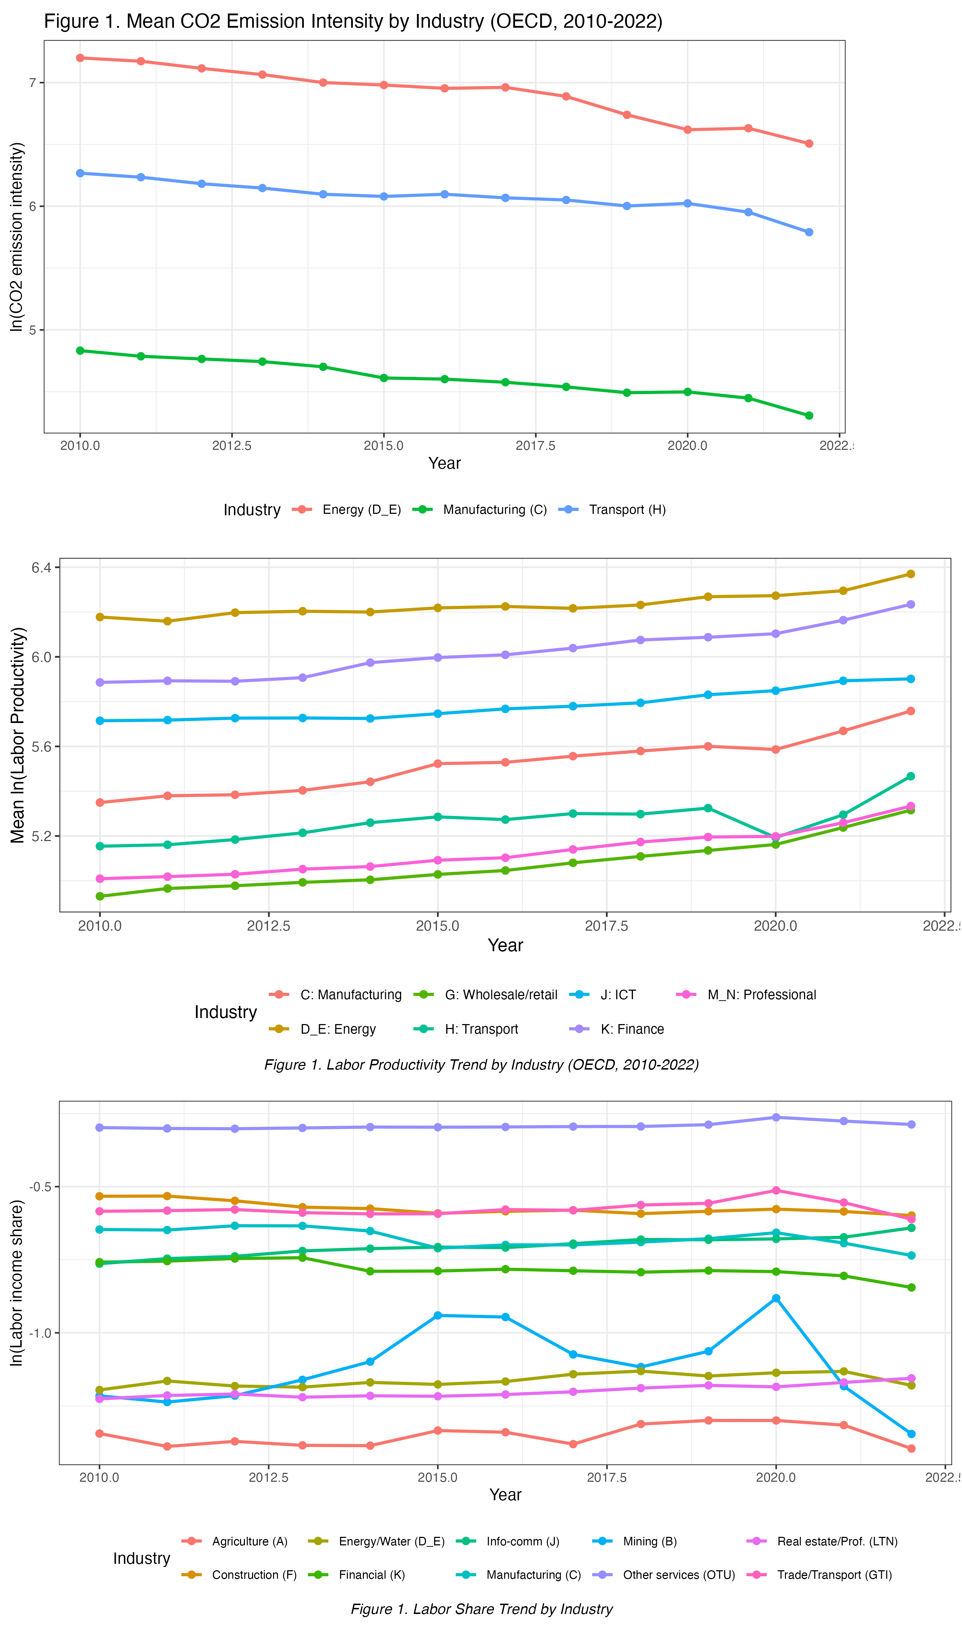
Figure 1. Trend of the Three Outcome Variables by Industry, OECD Panel (top to bottom: Part A CO2 emission intensity, Part B labor productivity, Part C labor income share)

Model
Each part follows the same baseline / first-stage / second-stage / moderated-specification structure, so every beta coefficient in Section 7 traces back to a fully written-out equation. Across all three parts, $β_{1}$ is always the part's main technology-intensity regressor, $β_{2}$ is reserved for the interaction term in the moderated specification, and $β_{3}$ through $β_{8}$ are the same six country-level controls in the same order for Parts A and C (GDP per capita, renewable energy share, capital formation, R&D spending, trade openness, broadband); Part B substitutes tertiary school enrollment for trade openness at $β_{7}$.

Part A: AI patent intensity and carbon emission intensity
Equation 1. Baseline two-way fixed-effects specification.
Equation 1. Baseline two-way fixed-effects specification
$$ln({CO2}_{it})$$ | $$=β_{1} {AIPI}_{it}$$
 | $$+ β_{3} ln({GDPpc}_{it})$$
 | $$+ β_{4} {Renew}_{it}$$
 | $$+ β_{5} {CapForm}_{it}$$
 | $$+ β_{6} {RD}_{it}$$
 | $$+ β_{7} {Trade}_{it}$$
 | $$+ β_{8} {Broadband}_{it}$$
 | $$+ α_{i}$$
 | $$+ τ_{t}$$
 | $$+ ε_{it}$$
where i indexes a country-industry pair, t indexes year, ${AIPI}_{it}$ is AI Patent Intensity, $α_{i}$ is a country-industry pair fixed effect that absorbs all time-invariant pair heterogeneity, and $τ_{t}$ is a year fixed effect that absorbs common shocks (global commodity-price movements, global patenting cycles).

Equation 2. First-stage regression: instrumental variable.
Equation 2. First-stage regression: instrumental variable
$${AIPI}_{it}$$ | $$= π_{0} + π_{1} {AIPI_bartik}_{it}$$
 | $$+ β_{3} ln({GDPpc}_{it})$$
 | $$+ β_{4} {Renew}_{it}$$
 | $$+ β_{5} {CapForm}_{it}$$
 | $$+ β_{6} {RD}_{it}$$
 | $$+ β_{7} {Trade}_{it}$$
 | $$+ β_{8} {Broadband}_{it}$$
 | $$+ α_{i}$$
 | $$+ τ_{t}$$
 | $$+ v_{it}$$
where AIPI_bartik_it is the leave-one-out mean of AI patent counts across the other 24 OECD countries in the same year (Section 5.4 gives the full identification argument), and $v_{it}$ is the first-stage error term.

Equation 3. Second-stage fixed-effects instrumental-variable specification.
Equation 3. Second-stage fixed-effects instrumental-variable specification
$$ln({CO2}_{it})$$ | $$= β_{1} {AIPI}_{it}$$
 | $$+ β_{3} ln({GDPpc}_{it})$$
 | $$+ β_{4} {Renew}_{it}$$
 | $$+ β_{5} {CapForm}_{it}$$
 | $$+ β_{6} {RD}_{it}$$
 | $$+ β_{7} {Trade}_{it}$$
 | $$+ β_{8} {Broadband}_{it}$$
 | $$+ α_{i}$$
 | $$+ τ_{t}$$
 | $$+ ε_{it}$$

which is identical to Equation 1, with ${AIPI}_{it}$ replaced by its fitted value from Equation 2; $β_{1}$ here is the FE-IV coefficient in Table 4, not the plain FE coefficient of Equation 1.
Equation 4. Moderated specification with high-renewable interaction.
Equation 4. Moderated specification with high-renewable interaction
$$ln({CO2}_{it})$$ | $$= β_{1} {AIPI}_{it}$$
 | $$+ β_{2} [{AIPI}_{it} × {HighRenewable}_{i}]$$
 | $$+ β_{3} ln({GDPpc}_{it})$$
 | $$+ β_{4} {Renew}_{it}$$
 | $$+ β_{5} {CapForm}_{it}$$
 | $$+ β_{6} {RD}_{it}$$
 | $$+ β_{7} {Trade}_{it}$$
 | $$+ β_{8} {Broadband}_{it}$$
 | $$+ α_{i}$$
 | $$+ τ_{t}$$
 | $$+ ε_{it}$$
where ${HighRenewable}_{i}$ is a dummy equal to one if an industry's renewable-energy share is above the OECD-wide median, and $β_{2}$ tests whether the carbon-intensity margin differs between high- and low-renewable industries (reported as the R1 subsample robustness check, Table A1 in the appendix).

Part B: Green technology intensity and labor productivity
Equation 5. Baseline two-way fixed-effects specification.
Equation 5. Baseline two-way fixed-effects specification
$$ln({LaborProductivity}_{it})$$ | $$= β_{1} ln({GTI}_{it} + 1)$$
 | $$+ β_{3} ln({GDPpc}_{it})$$
 | $$+ β_{4} {Renew}_{it}$$
 | $$+ β_{5} {CapForm}_{it}$$
 | $$+ β_{6} {RD}_{it}$$
 | $$+ β_{7} {Tertiary}_{it}$$
 | $$+ β_{8} {Broadband}_{it}$$
 | $$+ α_{i}$$
 | $$+ τ_{t}$$
 | $$+ ε_{it}$$

where ${GTI}_{it}$ is Green Technology Intensity (Y02 patents per billion USD of value added), and $α_{i}$ and $τ_{t}$ are defined as in Section 5.1.

Equation 6. First-stage regression: instrumental variable.
Equation 6. First-stage regression: instrumental variable
$$ln({GTI}_{it} + 1)$$ | $$= π_{0} + π_{1} {GTI_bartik}_{it}$$
 | $$+ β_{3} ln({GDPpc}_{it})$$
 | $$+ β_{4} {Renew}_{it}$$
 | $$+ β_{5} {CapForm}_{it}$$
 | $$+ β_{6} {RD}_{it}$$
 | $$+ β_{7} {Tertiary}_{it}$$
 | $$+ β_{8} {Broadband}_{it}$$
 | $$+ α_{i}$$
 | $$+ τ_{t}$$
 | $$+ v_{it}$$
where GTI_bartik_it = ln(base_GTI_ic + 1) x ln(global_excl_patents_it + 1) is the shift-share instrument described fully in Section 5.4, combining an industry's initial green-patenting composition with the contemporaneous growth of global green patenting excluding the country's own patents.

Equation 7. Second-stage fixed-effects instrumental-variable specification.
Equation 7. Second-stage fixed-effects instrumental-variable specification
$$ln({LaborProductivity}_{it})$$ | $$=β_{1} ln({GTI}_{it} + 1)$$
 | $$+ β_{3} ln({GDPpc}_{it})$$
 | $$+ β_{4} {Renew}_{it}$$
 | $$+ β_{5} {CapForm}_{it}$$
 | $$+ β_{6} {RD}_{it}$$
 | $$+ β_{7} {Tertiary}_{it}$$
 | $$+ β_{8} {Broadband}_{it}$$
 | $$+ α_{i}$$
 | $$+ τ_{t}$$
 | $$+ ε_{it}$$
which is identical to Equation 5, with ln(${GTI}_{it}$ + 1) replaced by its fitted value from Equation 6.

Equation 8. Moderated specification with high-AI interaction.
Equation 8. Moderated specification with high-AI interaction
$$ln({LaborProductivity}_{it})$$ | $$=β_{1} ln({GTI}_{it} + 1)$$
 | $$+ β_{2} [ln({GTI}_{it} + 1) × {HighAI}_{i}]$$
 | $$+ β_{3} ln({GDPpc}_{it})$$
 | $$+ β_{4} {Renew}_{it}$$
 | $$+ β_{5} {CapForm}_{it}$$
 | $$+ β_{6} {RD}_{it}$$
 | $$+ β_{7} {Tertiary}_{it}$$
 | $$+ β_{8} {Broadband}_{it}$$
 | $$+ α_{i}$$
 | $$+ τ_{t}$$
 | $$+ ε_{it}$$

where ${HighAI}_{i}$ is a dummy equal to one if an industry's AI exposure (Felten et al., 2021 AIOE for the OECD panel) is above the OECD-industry median, and $β_{2}$ tests the AI-green-technology complementarity hypothesis discussed in Section 3.3.

Part C: AI patent intensity and the labor income share
Equation 9. Baseline two-way fixed-effects specification.
Equation 9. Baseline two-way fixed-effects specification
$$ln({LaborShare}_{it})$$ | $$= β_{1} {AIPI}_{it}$$
 | $$+ β_{3} ln({GDPpc}_{it})$$
 | $$+ β_{4} {Renew}_{it}$$
 | $$+ β_{5} {CapForm}_{it}$$
 | $$+ β_{6} {RD}_{it}$$
 | $$+ β_{7} {Trade}_{it}$$
 | $$+ β_{8} {Broadband}_{it}$$
 | $$+ α_{i}$$
 | $$+ τ_{t}$$
 | $$+ ε_{it}$$

where ${LaborShare}_{it}$ is the labor income share (compensation of employees divided by value added), and $α_{i}$ and $τ_{t}$ are defined as in Section 5.1.

Equation 10. First-stage regression: instrumental variable.
Equation 10. First-stage regression: instrumental variable
$${AIPI}_{it}$$ | $$= π_{0} + π_{1} {AIPI_bartik}_{it}$$
 | $$+ β_{3} ln({GDPpc}_{it})$$
 | $$+ β_{4} {Renew}_{it}$$
 | $$+ β_{5} {CapForm}_{it}$$
 | $$+ β_{6} {RD}_{it}$$
 | $$+ β_{7} {Trade}_{it}$$
 | $$+ β_{8} {Broadband}_{it}$$
 | $$+ α_{i}$$
 | $$+ τ_{t}$$
 | $$+ v_{it}$$

where AIPI_bartik_it is defined exactly as in Equation 2 (Part A and Part C share the same AI-patent instrument construction).

Equation 11. Second-stage fixed-effects instrumental-variable specification.
Equation 11. Second-stage fixed-effects instrumental-variable specification
$$ln({LaborShare}_{it})$$ | $$= β_{1} {AIPI}_{it}$$
 | $$+ β_{3} ln({GDPpc}_{it})$$
 | $$+ β_{4} {Renew}_{it}$$
 | $$+ β_{5} {CapForm}_{it}$$
 | $$+ β_{6} {RD}_{it}$$
 | $$+ β_{7} {Trade}_{it}$$
 | $$+ β_{8} {Broadband}_{it}$$
 | $$+ α_{i}$$
 | $$+ τ_{t}$$
 | $$+ ε_{it}$$
which is identical to Equation 9, with ${AIPI}_{it}$ replaced by its fitted value from Equation 10.

Equation 12. Moderated specification with high-capital interaction.
Equation 12. Moderated specification with high-capital interaction
$$ln({LaborShare}_{it})$$ | $$=β_{1} {AIPI}_{it}$$
 | $$+ β_{2} [{AIPI}_{it} × {HighCapital}_{i}]$$
 | $$+ β_{3} ln({GDPpc}_{it})$$
 | $$+ β_{4} {Renew}_{it}$$
 | $$+ β_{5} {CapForm}_{it}$$
 | $$+ β_{6} {RD}_{it}$$
 | $$+ β_{7} {Trade}_{it}$$
 | $$+ β_{8} {Broadband}_{it}$$
 | $$+ α_{i}$$
 | $$+ τ_{t}$$
 | $$+ ε_{it}$$

where ${HighCapital}_{i}$ is a dummy equal to one if an industry's capital formation intensity is above that country's own median (a country-specific rather than panel-wide threshold, to avoid conflating cross-country capital-intensity differences with within-country industry variation), and $β_{2}$ tests whether the labor-share margin differs between high- and low-capital-intensity industries.
Equation numbering and notation are held constant across Parts A, B and C wherever the same concept applies, so Table 8 (Section 7.4) compares $β_{1}$ across parts on a like-for-like basis, though samples, industry scopes and instruments differ by design.

Identification strategy
AI Patent Intensity and Green Technology Intensity are both potentially endogenous: an industry might patent more AI applications because it anticipates emission-reduction returns, or might already be mid-reorganization in ways that raise both green patenting and productivity through unrelated channels. Following the course's identification framework, this essay treats relevance and exogeneity as the two necessary conditions for a valid instrument, and constructs a shift-share (Bartik-style) instrument for each technology-intensity regressor (Equations 2, 6 and 10). Both conditions are tested empirically: Section 6.2 reports each part's first-stage F-statistic against the conventional threshold of 10, and the Hansen J overidentification test as the exogeneity diagnostic. Exogeneity is further probed by a Goldsmith-Pinkham Rotemberg-weight decomposition (Appendix A.5), which shows Parts A and C draw most identifying variation from Manufacturing -- disclosed as a caveat, consistent with how the shift-share literature itself reports this diagnostic.

The estimator ladder
Each part is estimated along a five-rung estimator ladder: pooled OLS (a naive no-fixed-effects baseline, reported as a comparator rather than a preferred estimate), two-way fixed effects (Equations 1, 5, 9), random effects with a Hausman test against fixed effects, fixed-effects instrumental variables (Equations 3, 7, 11), and a dynamic panel GMM estimator. The main text reports only the FE and FE-IV columns as primary specifications (Tables 4-6); the full ladder, including GMM, is relegated to the appendix. One honest note: the Part B GMM column is a two-step Difference GMM, not System GMM, because five candidate System GMM variants failed to jointly satisfy significance, AR(2), Hansen J and instrument-count criteria in testing.

Channel decomposition for the labor-share margin
Because the labor income share is, by construction, the wage bill divided by value added, and value added is the product of employment and average output per worker, the log labor share obeys the exact accounting identity in Equation 13.

Equation 13. Labor-share accounting identity (channel decomposition).
Equation 13. Labor-share accounting identity (channel decomposition)
$$ln({LaborShare}_{it})$$ | $$= ln({AverageWage}_{it})$$
 | $$+ ln({Employment}_{it})$$
 | $$- ln({ValueAdded}_{it})$$

Part C exploits this identity by re-estimating the FE-IV specification (Equation 11) separately with average wage, employment and value added as the dependent variable, then verifying that the three channel coefficients sum back to the directly estimated labor-share coefficient. This decomposition, reported in Table 7, turns an otherwise uninformative null aggregate result into two large, significant, offsetting channel effects -- the central empirical finding of this essay (Section 7.3).

Estimation and Testing

Diagnostic testing protocol
Every FE-IV specification is accompanied by seven mandatory diagnostic tests plus an eighth overidentification test, evaluated at alpha = 0.10 per course convention: a multicollinearity check (max VIF), a Hausman test of fixed versus random effects, a Wooldridge serial-correlation test, a first-stage F-test for instrument relevance, a Wu-Hausman endogeneity test, and AR(1)/AR(2) Arellano-Bond tests for the dynamic GMM specification. The eighth test, Hansen's J, is the primary exogeneity diagnostic and is reported, per course convention, as instruments "may not be exogenous" if rejected, or "may be exogenous" if not -- avoiding the overclaim that failing to reject constitutes positive proof.

Diagnostics across the three OECD panels
Table 3 reports the diagnostic battery for the three OECD panels. First-stage relevance is comfortably satisfied in every part (F = 2,321.8 Part A, 43,949.6 Part B, 4,906.2 Part C, all far above the threshold of 10). Wu-Hausman rejects exogeneity of the technology-intensity regressor in every part (F = 21.4, 12.9, 63.2; all p < 0.001), confirming that instrumenting AIPI and GTI is warranted. The FE-vs-RE Hausman test rejects RE in Part B (chi2 = 63.5, p < 0.001) and Part C (chi2 = 252.8, p < 0.001) but not Part A (chi2 = 3.1, p = 1.000); FE is retained in all three parts on theoretical grounds regardless. Hansen's J fails to reject valid overidentification in every part (chi2 = 3.1/2.4/3.6, p = 0.378/0.485/0.304). AR(1) fails to reject in Parts A and B (inconclusive, small-cluster power) but rejects in Part C (z = -3.77, p < 0.001, expected for the differenced GMM estimator); AR(2), which actually speaks to instrument validity, fails to reject in all three parts.

Table 3. Diagnostic Tests, Parts A-C (OECD Panel, alpha = 0.10)
Test | Statistic | p-value | Decision
Part A (OECD)
Multicollinearity (max VIF) | Max VIF = 1.62 |  | No severe multicollinearity
Hausman FE vs RE | chi2 = 3.127 | 1.000 | FE preferred (theory); Hausman used as robustness
Serial correlation (Wooldridge) | chi2 = 350.04 | 0.000 | Serial corr. present; cluster SE applied
Weak instrument (first-stage F) | F = 2321.77 | 0.000 | Relevant instrument (F > 10)
Endogeneity (Wu-Hausman) | F = 21.4 | 0.000 | Endogenous; IV justified
AR(1) - Arellano-Bond | z = -0.671 | 0.503 | Fail to reject; inconclusive (low power, N=75)
AR(2) - Arellano-Bond | z = -1.462 | 0.144 | Valid instruments (fail to reject H0)
Hansen J (overidentification) | chi2 = 3.091 | 0.378 | Instruments may be exogenous (fail to reject H0)
Part B (OECD)
Multicollinearity (max VIF) | Max VIF = 1.64 |  | No severe multicollinearity
Hausman FE vs RE | chi2 = 63.513 | 0.000 | FE consistent (reject H0)
Serial correlation (Wooldridge) | chi2 = 786.214 | 0.000 | Serial corr. present; cluster SE applied
Weak instrument (first-stage F) | F = 43949.61 | 0.000 | Relevant instrument (F > 10)
Endogeneity (Wu-Hausman) | F = 12.88 | 0.0003 | Endogenous; IV justified
AR(1) - Arellano-Bond | z = -1.603 | 0.109 | Fail to reject; inconclusive (low power, N=75)
AR(2) - Arellano-Bond | z = -0.48 | 0.631 | Valid instruments (fail to reject H0)
Hansen J (overidentification) | chi2 = 2.447 | 0.485 | Instruments may be exogenous (fail to reject H0)
Part C (OECD)
Multicollinearity (max VIF) | Max VIF = 1.65 |  | No severe multicollinearity
Hausman FE vs RE | chi2 = 252.834 | 0.000 | FE preferred (theory); Hausman used as robustness
Serial correlation (Wooldridge) | chi2 = 1184.238 | 0.000 | Serial corr. present; cluster SE applied
Weak instrument (first-stage F) | F = 4906.23 | 0.000 | Relevant instrument (F > 10)
Endogeneity (Wu-Hausman) | F = 63.21 | 0.000 | Endogenous; IV justified
AR(1) - Arellano-Bond | z = -3.774 | 0.0002 | Reject H0: AR(1) present (expected)
AR(2) - Arellano-Bond | z = -1.57 | 0.116 | Valid instruments (fail to reject H0)
Hansen J (overidentification) | chi2 = 3.636 | 0.304 | Instruments may be exogenous (fail to reject H0)
Hansen J non-rejection in every part: instruments may not violate the exogeneity condition. Serial correlation is detected in all three parts (Wooldridge), which is why cluster-robust SE are used throughout.

Small-sample adjustments for the emerging-market panels
Because the EM panels contain substantially fewer clusters than the OECD panels (67-75 pairs, against 75-250), standard cluster-robust inference can be unreliable, so a hand-coded wild cluster bootstrap (used where the fwildclusterboot package assumptions were not satisfied) is applied as a fallback check on the EM main results -- documented as an inherited limitation, not an equal-strength alternative to OECD inference.

The role of TreeSHAP
TreeSHAP-based variable-importance and dependence analysis (Lundberg and Lee, 2017 methodology) is used throughout as a descriptive complement to the causal FE-IV estimates, never as a substitute for them. Across both the OECD and emerging-market samples and all three parts, country-level controls typically carry as much or more average SHAP weight as the technology-intensity regressor itself, and the technology-regressor dependence pattern is close to monotonic, consistent with the FE-IV specifications' linear-in-logs functional form; the emerging-market pattern is similar but noisier, consistent with its smaller cluster counts (Section 6.3). The full set of ten SHAP diagnostic figures is reported in Appendix A.1; no causal interpretation is drawn from any of them.

Result and Analysis

The environmental margin (Part A): AI patent intensity and carbon emission intensity
Table 4 reports the main results for the AI-carbon margin. In the OECD panel, the FE-IV estimate of AI Patent Intensity on log CO2 emission intensity is minus 0.096 (SE 0.033, significant at 1 percent), indicating that higher AI patent intensity is associated with significantly lower carbon emission intensity, holding fixed pair history and year shocks -- consistent with a technique effect dominating any scale effect at the OECD frontier. The corresponding two-way FE coefficient (minus 0.050, SE 0.023, significant at 5 percent) is smaller in magnitude, consistent with the Wu-Hausman test's finding that AIPI is endogenous in a direction that would otherwise attenuate the true effect toward zero. In the emerging-market panel, the FE-IV coefficient is positive (0.801, SE 0.695) but statistically indistinguishable from zero; given the panel's 74 pairs and short window (2012-2022), this is read as an imprecisely estimated coefficient, not evidence that AI adoption raises EM carbon intensity. The ASEAN-specific interaction (Table 9) is small and indistinguishable from zero (0.019, SE 0.133): Southeast Asia's AI-carbon relationship does not measurably differ from the wider EM panel on this margin.

Table 4. Main Results: AI Patent Intensity and Carbon Emission Intensity (OECD Panel)
 | FE | FE+Interact. | FE-IV | Sys. GMM
AI Patent Intensity (ln) | -0.050**  (0.023) | -0.063**  (0.027) |  | 0.043  (0.038)
AI Patent Intensity (ln, IV) |  |  | -0.096***  (0.033)
AIPI x High-renewable dummy |  | 0.015  (0.012)
Lagged CO2 intensity (t-1) |  |  |  | 0.271  (0.234)
GDP per capita (ln) | -0.256  (0.288) | -0.235  (0.281) | -0.259  (0.275) | -0.089  (0.300)
Renewable energy (%) | -0.020**  (0.008) | -0.020**  (0.008) | -0.020**  (0.009) | -0.016***  (0.005)
Capital formation / VA | 0.375**  (0.182) | 0.379**  (0.181) | 0.403**  (0.179) | 0.441***  (0.145)
R&D expenditure (% GDP) | 0.012  (0.055) | 0.019  (0.055) | 0.018  (0.055) | 0.082**  (0.039)
Num.Obs. | 936 | 936 | 936
R2 Within | 0.150 | 0.153 | 0.168
FE: pair / year | Yes / Yes | Yes / Yes | Yes / Yes
Dependent variable: ln(CO2 emission intensity) = ln(CO2 kt x 1000 / VA million USD).
FE-IV instrument: ${AIPI}_{bartik}$ (leave-one-out mean AI patents, other 24 OECD countries, same year).
Col Sys. GMM: two-step System GMM. SE clustered at pair level. * p<0.10, ** p<0.05, *** p<0.01. Alpha = 0.10.

The efficiency margin (Part B): Green technology intensity and labor productivity
Table 5 reports the main results for the green-technology-productivity margin. In the OECD panel, the FE-IV estimate of log Green Technology Intensity on log labor productivity is 0.0187 (SE 0.0069, significant at 1 percent), consistent with the Porter-hypothesis logic of Section 3.3. The HighAI interaction in the two-way FE specification (0.0420, SE 0.0197, significant at 5 percent) supports the AI-green-technology complementarity hypothesis: the productivity dividend is roughly three times larger in industries with above-median AI exposure, suggesting AI-complementary process capability helps convert a green patent into a realized productivity gain. In the emerging-market panel, the FE-IV coefficient is positive (0.213, SE 0.203) but not significant, again consistent with limited precision rather than an absent relationship. The ASEAN interaction (Table 9) is both economically and statistically meaningful (0.198, SE 0.110, significant at 10 percent): the productivity dividend is measurably larger in ASEAN than in the rest of the EM panel -- this essay's clearest ASEAN-specific finding, discussed further in Section 7.5.
Table 5. Main Results: Green Technology Intensity and Labor Productivity (OECD Panel)
 | Pooled OLS | FE | FE+Int.(AI) | FE+Int.(Cap) | FE-IV | Diff. GMM
ln(GTI+1) | -0.0814**  (0.0326) | -0.0134  (0.0122) | -0.0358*  (0.0194) | -0.0149  (0.0130) |  | -0.0458  (0.0374)
ln(GTI+1), IV |  |  |  |  | 0.0187***  (0.0069)
ln(GTI+1) x High-AI |  |  | 0.0420**  (0.0197)
ln(GTI+1) x High-Capital |  |  |  | 0.0019  (0.0024)
Lagged labor prod. (t-1) |  |  |  |  |  | 0.8188**  (0.3457)
Capital formation / VA | 1.1473*  (0.6811) | -0.2788*  (0.1578) | -0.2767*  (0.1556) | -0.2882*  (0.1590) | -0.3906**  (0.1910)
GDP per capita (ln) | -1.3354***  (0.3493) | 0.5750**  (0.2415) | 0.5778**  (0.2378) | 0.5757**  (0.2412) | 0.5151*  (0.2664) | 0.5124**  (0.2378)
Num.Obs. | 2183 | 2183 | 2183 | 2183 | 1847
R2 Within |  | 0.165 | 0.175 | 0.165 | 0.143
Dependent variable: ln(labor productivity) = ln(VA / employment), OECD STAN.
FE-IV instrument: ${GTI}_{bartik}$ = ln(base_GTI_ic+1) x ln(global_excl_patents_it+1); Goldsmith-Pinkham et al. (2020).
Col (4) GMM: Two-step Difference GMM (honestly relabeled; System GMM variants did not jointly satisfy diagnostics).
SE clustered at pair level (Cols 0-4); two-step robust GMM SE (last col). * p<0.10, ** p<0.05, *** p<0.01. Alpha=0.10.

The distributional margin (Part C): AI patent intensity and the labor income share
Table 6 reports the main results for the labor-share margin, and Table 7 reports the channel decomposition that explains them. In the OECD panel, the FE-IV estimate of AI Patent Intensity on the log labor income share is 0.0114 (SE 0.0255), statistically indistinguishable from zero: higher AI patent intensity is not associated with a detectable change in labor's share of value added. Read alone, this null result is uninformative -- consistent with no effect, an undetectably small effect, or offsetting effects that cancel in aggregate.

Table 6. Main Results: AI Patent Intensity and Labor Income Share (OECD Panel)
 | Pooled OLS | FE | FE+Interact. | FE-IV | Diff. GMM
AI Patent Intensity (ln) | 0.0635***  (0.0186) | -0.0163  (0.0160) | -0.0110  (0.0153) |  | -0.0020  (0.0192)
AI Patent Intensity (ln, IV) |  |  |  | 0.0114  (0.0255)
AIPI x High-capital dummy |  |  | -0.0058  (0.0052)
Lagged labor share (t-1) |  |  |  |  | 0.6509***  (0.1032)
GDP per capita (ln) | -0.0554  (0.0676) | -0.2455*  (0.1333) | -0.2471*  (0.1336) | -0.2376*  (0.1353) | -0.0972  (0.1494)
Capital formation / VA | -0.4332*  (0.2470) | 0.6631***  (0.1388) | 0.6682***  (0.1386) | 0.6555***  (0.1395) | 0.6370***  (0.1441)
R&D expenditure (% GDP) | 0.0269  (0.0402) | 0.0450**  (0.0220) | 0.0454**  (0.0221) | 0.0397*  (0.0229) | -0.0020  (0.0188)
Num.Obs. | 3120 | 3120 | 3120 | 3120
R2 Within |  | 0.153 | 0.154 | 0.152
Dependent variable: ln(labor income share) = ln(LABR / VALU).
FE-IV instrument: ${AIPI}_{bartik}$ (leave-one-out mean AI patents, other 24 OECD countries, same year).
SE clustered at pair level (Cols 0-3); two-step robust GMM SE (last col). * p<0.10, ** p<0.05, *** p<0.01. Alpha=0.10.

The channel decomposition in Table 7 resolves this ambiguity. Estimating the same FE-IV specification separately with employment, average wage and value added as the dependent variable shows that AI patent intensity raises employment (0.0899, SE 0.0226, significant at 1 percent) and, much less precisely, value added (0.0079, SE 0.0321), while significantly lowering the average wage (minus 0.0706, SE 0.0226, significant at 1 percent). By the accounting identity of Section 5.6, these three channel estimates reconstruct the aggregate labor-share coefficient exactly: 0.0899 minus 0.0706 minus 0.0079 equals 0.0114, matching the directly estimated coefficient with an identity gap of exactly zero. The economic story is that AI patent intensity in OECD industries brings a reinstatement-like expansion of employment, but with a wage discount per worker that almost exactly offsets the employment gain in labor-share terms -- workers gain headcount, not wage share. This is, in this essay's view, the single most economically informative result across all three margins, precisely because it would be invisible without the decomposition.

Table 7. Channel Decomposition (FE-IV), Part C OECD Panel
 | Employment | Average wage | Value added
AI Patent Intensity (ln, IV) | 0.0899***  (0.0226) | -0.0706***  (0.0226) | 0.0079  (0.0321)
GDP per capita (ln) | 0.3410***  (0.0767) | 0.4606***  (0.0905) | 1.0392***  (0.1971)
Capital formation / VA | 0.0055  (0.0373) | 0.1009***  (0.0359) | -0.5491***  (0.1461)
Num.Obs. | 3120 | 3120 | 3120
R2 Within | 0.106 | 0.205 | 0.221
Dependent variables: (a) ln(Total employment); (b) ln(Average wage); (c) ln(Value added).
Same FE-IV specification/instrument (${AIPI}_{bartik}$) as the main labor-share result (Table 6, FE-IV column).
Identity: ln(labor share) = ln(avg wage) + ln(employment) - ln(value added); see accounting-identity check below.

Accounting identity check (continued from Table 7)
Item | Value
beta(wage) + beta(employment) - beta(value added) | 0.0114
beta(labor share), directly estimated (Table 6, FE-IV) | 0.0114
Gap | 0.0000
Identity holds exactly: all three mechanism models share the identical estimation sample, first-stage fit and clustering as the main FE-IV labor-share model.

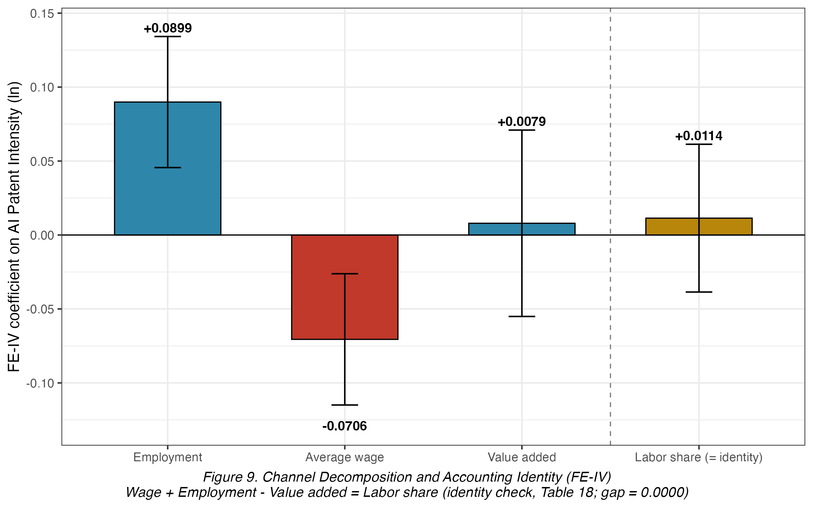
Figure 2. Channel Decomposition Bar Chart (Part C, OECD)

In the emerging-market panel, the preferred specification (FE, not FE-IV, since the Wu-Hausman test does not reject exogeneity of ${AIPI}_{EM}$ here) gives a positive, marginally significant coefficient of 0.062 (SE 0.035, significant at 10 percent). The EM channel decomposition shows a different mix from the OECD panel: the wage channel is positive (0.047, SE 0.039, not individually significant), the employment channel is essentially flat (0.001, SE 0.030), and the value-added channel is small and negative (minus 0.015, SE 0.047). Though none of the three EM channel coefficients is individually significant, the wage channel carries by far the largest point estimate -- a genuinely different channel mix from the OECD panel's employment-led pattern, consistent with EM industries being at an earlier stage of the same technology-adoption process. The ASEAN interaction (Table 9) is negative and significant (minus 0.102, SE 0.050, significant at 5 percent): the positive EM labor-share relationship is significantly attenuated, or reversed, within ASEAN specifically -- reported honestly, and discussed further in Section 7.5.

Synthesis across parts
Table 8 juxtaposes the three OECD main FE-IV estimates and their EM counterparts on a single page. Read across the OECD columns, the three margins tell a broadly consistent, encouraging story: AI and green-technology patenting are associated with lower carbon emission intensity, higher labor productivity, and -- once offsetting wage and employment channels are accounted for -- no net erosion of labor's share, accompanied by a significant employment expansion. Read across the EM columns, all three point estimates run directionally toward a "technology dividend" story (positive for labor-share and productivity; the carbon-intensity EM coefficient runs opposite the OECD finding but is imprecisely estimated), yet only the labor-share coefficient reaches significance at alpha = 0.10. This pattern -- directionally similar, systematically less precise EM results -- is at least as consistent with the EM panels' smaller cluster counts (67-75 pairs, versus 75-250 OECD) providing less power as with a fundamentally different relationship. Figure 3 visualizes this directly; because the three parts differ by design in sample, scope and instrument, the comparison should be read for direction and pattern, not literal magnitude.

Table 8. Synthesis Across Parts A-C: Main FE-IV Estimates (OECD vs EM)
 | A OECD (CO2) | A EM (CO2) | B OECD (Prod.) | B EM (Prod.) | C OECD (Lab.sh) | C EM (Lab.sh)
AI Patent Int. (ln, IV) [OECD] | -0.096***  (0.033) |  |  |  | 0.011  (0.025)
AI Patent Int. (ln, IV) [EM] |  | 0.801  (0.695) |  |  |  | 0.455  (0.339)
Green Tech Int. (ln, IV) [OECD] |  |  | 0.019***  (0.007)
Green Tech Int. (ln, IV) [EM] |  |  |  | 0.213  (0.203)
GDP per capita (ln) | -0.259  (0.275) | -0.567  (0.671) | 0.515*  (0.266) | 0.857**  (0.339) | -0.238*  (0.135) | 0.041  (0.393)
Num.Obs. | 936 | 591 | 1847 | 536 | 3120 | 530
R2 Within | 0.168 | 0.041 | 0.143 | 0.122 | 0.152 | 0.113
Each column re-estimates the main FE-IV specification of the corresponding part from its final clean panel.
Samples, industry scopes and IVs differ BY DESIGN across parts - compare signs, not levels. SE clustered at pair level. Alpha=0.10.

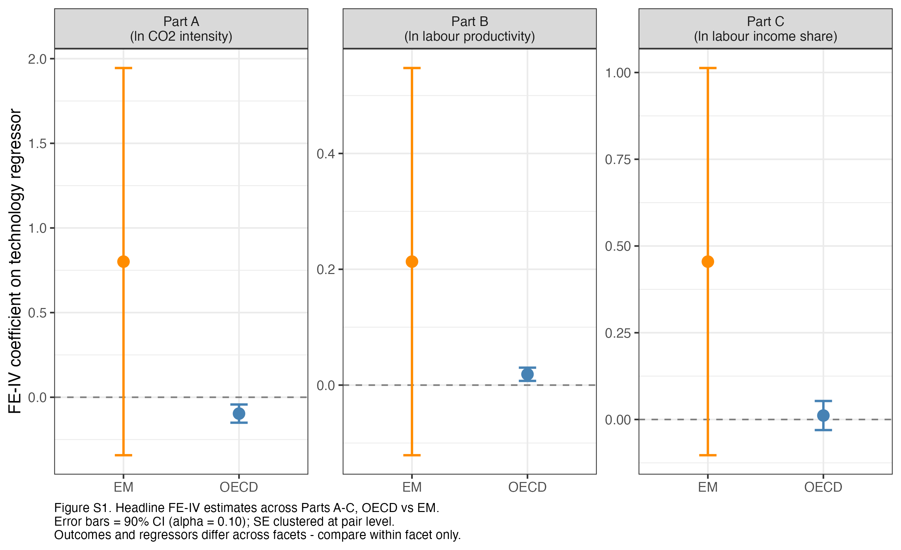
Figure 3. Cross-Part FE-IV Coefficient Comparison (OECD vs EM, Parts A-C)

Vietnam and Southeast Asia in focus
Bringing together the three ASEAN-specific interaction results from Sections 7.1-7.3 gives a more textured regional picture than any single margin can provide alone. On carbon intensity (Part A), this essay finds no detectable ASEAN-specific deviation from the wider EM pattern. On productivity (Part B), it finds its single clearest positive regional result: the green-technology productivity dividend is significantly larger in ASEAN than in the rest of the EM panel (interaction coefficient 0.198, significant at 10 percent). On the labor share (Part C), it finds a significant negative regional deviation: the modest positive AI-labor-share relationship in the wider EM panel is significantly weaker, or reversed, within ASEAN (interaction coefficient minus 0.102, significant at 5 percent). Vietnam's own presence in the data differs by part (Section 4.4): it enters the Part B EM panel directly, but enters Parts A and C only through an alternate WIPO-based panel, since EPO data lack sufficient Vietnamese-applicant granularity -- a data-coverage constraint, not a deliberate exclusion. Figure 4 visualizes the ASEAN-versus-rest-of-EM trend. Read together, the most defensible conclusion is that Vietnam and its ASEAN peers capture a stronger green-technology productivity dividend than the wider EM group, while showing a weaker (or reversed) translation of AI intensity into labor-share gains -- a genuinely two-sided finding, presented without overclaiming a causal regional mechanism.

Table 9. ASEAN Spotlight, Parts A-C (Emerging-Market Panel)
 | FE-IV EM (baseline) | FE EM + ASEAN interaction
Part A - AI Patent Intensity and Carbon Intensity
AI Patent Intensity (ln, IV) [EM] | 0.801  (0.695)
AI Patent Intensity (ln) [EM] |  | 0.043  (0.049)
AI Patent Intensity x ASEAN |  | 0.019  (0.133)
Num.Obs. | 591 | 591
R2 Within | 0.041 | 0.030
Part B - Green Technology Intensity and Productivity
Green Tech Intensity (ln, IV) [EM] | 0.213  (0.203)
Green Tech Intensity (ln) [EM] |  | -0.013  (0.032)
Green Tech Intensity x ASEAN |  | 0.198*  (0.110)
Num.Obs. | 536 | 609
R2 Within | 0.122 | 0.072
Part C - AI Patent Intensity and Labor Income Share
AI Patent Intensity (ln, IV) [EM] | 0.455  (0.339)
AI Patent Intensity (ln) [EM] |  | 0.062*  (0.033)
AI Patent Intensity x ASEAN |  | -0.102**  (0.050)
Num.Obs. | 530 | 530
R2 Within | 0.113 | 0.102
ASEAN samples differ by part (EPO- vs WIPO-based coverage): Part A/C EPO-based ASEAN = IDN, MYS, PHL, THA; Part B ASEAN = IDN, LAO, MYS, PHL, THA, VNM (Vietnam in-sample). VNM/MMR enter Parts A/C only via the WIPO-based alternate panel (Tables A3, A9). SE clustered at pair level. * p<0.10, ** p<0.05, *** p<0.01. Alpha=0.10.
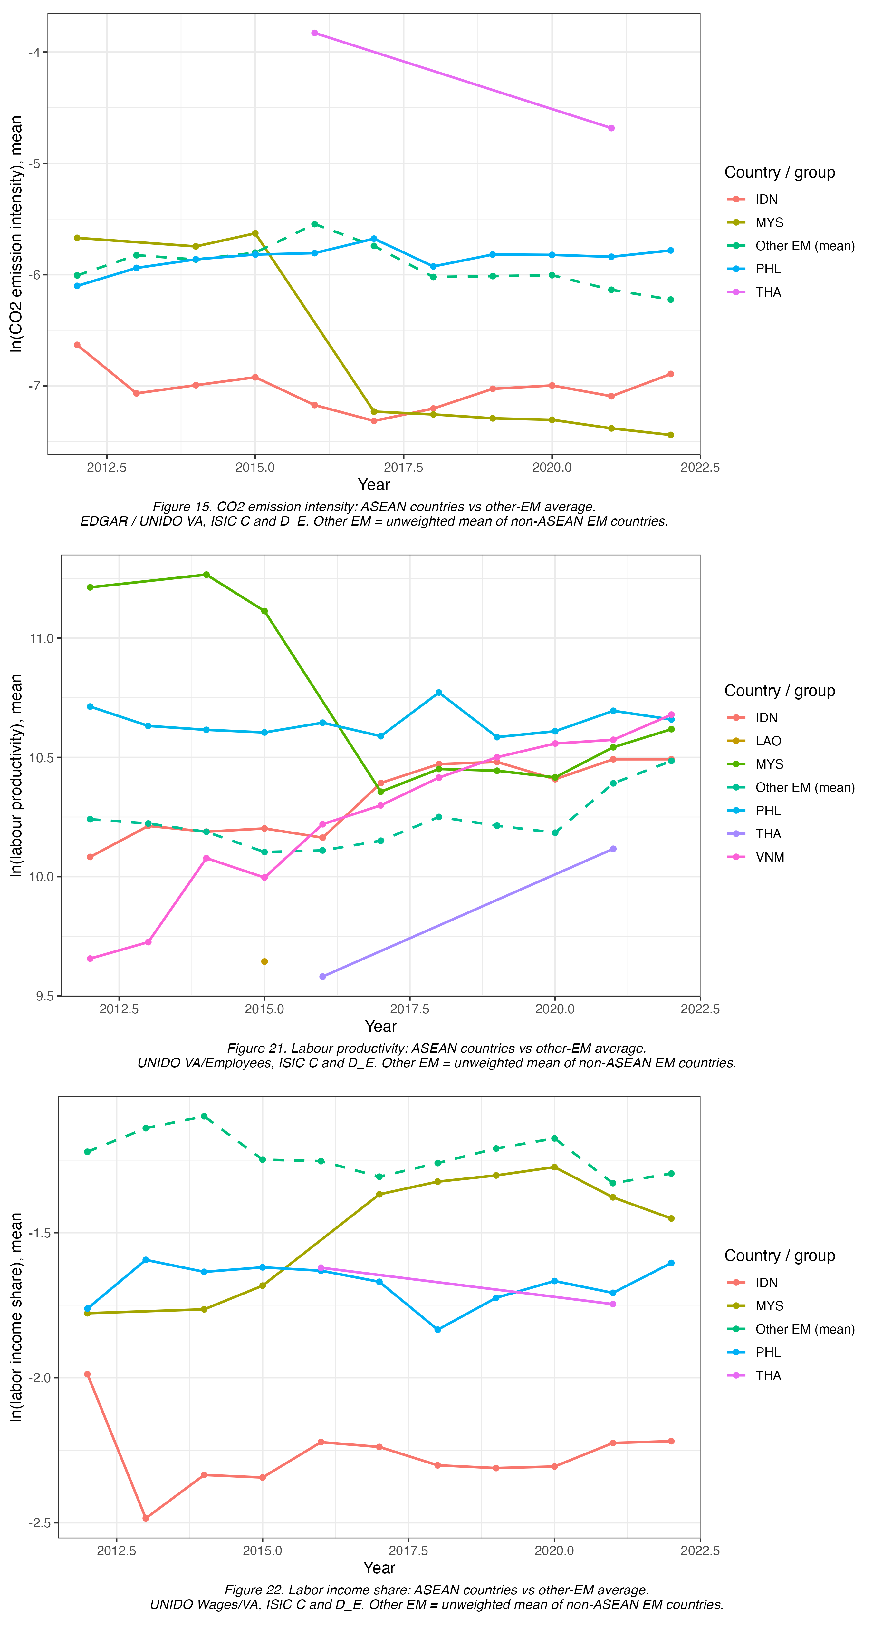
Figure 4. Southeast Asia versus Rest-of-Emerging-Market Trend (top to bottom: Part A, Part B, Part C)
Beyond the three headline margins, several robustness exercises support the main conclusions without materially changing them, documented fully in Appendix A.2-A.5: leave-one-country/ASEAN-out re-estimation confirms no single country drives the OECD or ASEAN estimates; the WIPO-based alternate panel incorporating Vietnam is directionally consistent with the EPO-based EM results; a placebo exercise with randomly reassigned AI-patent instruments returns coefficients indistinguishable from zero, supporting the identification strategy; the Gollin (2002) adjustment does not materially change the OECD channel-decomposition story; a bias-corrected LSDVC estimator is consistent in sign and magnitude with the main FE results; and the honestly relabeled Difference GMM specification (Section 5.5) is directionally consistent with FE-IV across all three parts.

Conclusion and Policy Recommendations

Summary of findings by research question
This essay set out to answer three research questions using a unified FE-IV framework applied to a common technology-intensity measure across three margins of structural change, in both an OECD and an emerging-market panel. On RQ1, AI patent intensity significantly reduces carbon emission intensity in OECD industries (minus 0.096, significant at 1 percent); the EM direction cannot be established with available precision. On RQ2, green technology intensity raises OECD labor productivity (0.0187, significant at 1 percent), amplified where AI exposure is above median (0.0420, significant at 5 percent) and, regionally, significantly stronger within ASEAN (0.198, significant at 10 percent). On RQ3, AI patent intensity has no detectable net effect on the OECD labor income share (0.0114, not significant), but this null decomposes exactly into a significant employment gain (0.0899) almost fully offset by a significant wage discount (minus 0.0706); the EM effect is modestly positive (0.062, significant at 10 percent) and wage-driven, while ASEAN specifically shows a significantly weaker or reversed version of that pattern (minus 0.102, significant at 5 percent).

Policy implications for Vietnam
Three policy implications follow, each tied to this course's technology-upgrading and middle-income-trap themes. First, AI adoption need not be traded off against Vietnam's 2050 net-zero commitment: if the OECD technique-effect pattern generalizes as Vietnamese industries adopt AI-complementary methods, technology upgrading and emission reduction can be complementary rather than sequential goals -- though the EM carbon estimate is too imprecise to state this as more than a plausible hypothesis. Second, since green-technology and AI adoption are productivity-complementary in the OECD panel, and more so within ASEAN, a "dual innovation" industrial policy stance -- treating AI-adoption support and green-patenting incentives as reinforcing rather than competing budget priorities -- is supported by the evidence. Third, and most cautionary, the OECD channel decomposition shows AI-associated employment expansion can carry a real per-worker wage discount even where the aggregate labor share looks unchanged; combined with ASEAN's weaker labor-share response, this suggests skills and labor-market policy should not treat headcount growth alone as evidence that workers are capturing AI's reinstatement effect in wage terms, and should track the wage-employment split directly using this essay's accounting-identity approach. Together, these speak to the middle-income trap: successful technology upgrading requires that productivity and employment gains be captured by labor in wage terms, not merely headcount.

Limitations
Four limitations qualify these conclusions. First, every EM point estimate rests on a comparatively small number of clusters (67-75 pairs, against 75-250 in the OECD panels), the likely reason EM coefficients are directionally similar to but less precisely estimated than the OECD ones; an EM non-result is not read as evidence of an absent relationship. Second, mainland China and South Africa are entirely absent from the labor-share panel because UNIDO INDSTAT4 does not report the needed value-added series -- a meaningful gap given China's centrality to global manufacturing. Third, the wild-cluster-bootstrap fallback for small-sample EM inference (Section 6.3) is a documented compromise, not a first-choice method. Fourth, both AI Patent Intensity and Green Technology Intensity are activity-based proxies -- they measure patenting output, not adoption or use directly -- and likely under-count diffusion where firms license or import rather than patent, biasing EM coefficients toward zero relative to the true effect.

Future research
Two extensions would sharpen these conclusions. Firm-level Vietnamese data, for example from the General Statistics Office's enterprise survey, would test whether the industry-level patterns replicate, strengthen, or dissolve at the firm level, substantially increasing the effective sample available for Vietnam relative to the seven-to-eight-country ASEAN panel used here. Second, micro-level evidence on the wage-employment split within Vietnamese manufacturing -- matched employer-employee data distinguishing which occupations gain employment and which lose wage share -- would test directly whether the OECD channel-decomposition pattern (employment gain, wage discount, net-zero labor share) operates in Vietnam, or whether Vietnam's distinct data position (Section 4.4) and different ASEAN interaction (Section 7.5) reflect a genuinely different channel structure.

References
Group A - Theoretical Framework
Gerschenkron, A. (1962). Economic Backwardness in Historical Perspective: A Book of Essays. Belknap Press of Harvard University Press.
Perez, C., & Soete, L. (1988). Catching up in technology: Entry barriers and windows of opportunity. In G. Dosi, C. Freeman, R. Nelson, G. Silverberg, & L. Soete (Eds.), Technical Change and Economic Theory (pp. 458-479). Pinter Publishers.
Lin, J. Y. (2012). The Quest for Prosperity: How Developing Economies Can Take Off. Princeton University Press.
Paus, E. (2012). Confronting the middle income trap: Insights from small latecomers. Studies in Comparative International Development, 47(2), 115-138.
Bresnahan, T. F., & Trajtenberg, M. (1995). General purpose technologies: Engines of growth? Journal of Econometrics, 65(1), 83-108.
Acemoglu, D., & Restrepo, P. (2020). Robots and jobs: Evidence from US labor markets. Journal of Political Economy, 128(6), 2188-2244. https://doi.org/10.1086/705716
Acemoglu, D., & Restrepo, P. (2022). Tasks, automation, and the rise in US wage inequality. Econometrica, 90(5), 1973-2016. https://doi.org/10.3982/ECTA19815
Group B - AI Measurement
Baruffaldi, S., van Beuzekom, B., Dernis, H., Harhoff, D., Rao, N., Rosenfeld, D., & Squicciarini, M. (2020). Identifying and measuring developments in artificial intelligence: Making the impossible possible (OECD Science, Technology and Industry Working Papers, No. 2020/05). OECD Publishing. https://doi.org/10.1787/5f65ff7e-en
Felten, E., Raj, M., & Seamans, R. (2021). Occupational, industry, and geographic exposure to artificial intelligence: A novel dataset and its potential uses. Strategic Management Journal, 42(12), 2195-2217. https://doi.org/10.1002/smj.3286
Webb, M. (2020). The impact of artificial intelligence on the labor market [Unpublished manuscript]. Stanford University.
Eloundou, T., Manning, S., Mishkin, P., & Rock, D. (2024). GPTs are GPTs: Labor market impact potential of LLMs. Science, 384(6702), 1306-1308. https://doi.org/10.1126/science.adj0998
Acemoglu, D. (2025). The simple macroeconomics of AI. Economic Policy, 40(121), 13-58. https://doi.org/10.1093/epolic/eiae042
Group C - Green Technology and Productivity (Part B)
Porter, M. E., & van der Linde, C. (1995). Toward a new conception of the environment-competitiveness relationship. Journal of Economic Perspectives, 9(4), 97-118. https://doi.org/10.1257/jep.9.4.97
Cohen, W. M., & Levinthal, D. A. (1990). Absorptive capacity: A new perspective on learning and innovation. Administrative Science Quarterly, 35(1), 128-152. https://doi.org/10.2307/2393553
Albrizio, S., Kozluk, T., & Zipperer, V. (2017). Environmental policies and productivity growth: Evidence across industries and firms. Journal of Environmental Economics and Management, 81, 209-226.
Popp, D. (2019). Environmental policy and innovation: A decade of research (NBER Working Paper No. 25631). National Bureau of Economic Research.
Brynjolfsson, E., Rock, D., & Syverson, C. (2021). The productivity J-curve: How intangibles complement general purpose technologies. American Economic Journal: Macroeconomics, 13(1), 333-372. https://doi.org/10.1257/mac.20180386
Group D - Labor Share and Distribution (Part C)
Karabarbounis, L., & Neiman, B. (2014). The global decline of the labor share. The Quarterly Journal of Economics, 129(1), 61-103. https://doi.org/10.1093/qje/qjt032
Rognlie, M. (2015). Deciphering the fall and rise in the net capital share: Accumulation or scarcity? Brookings Papers on Economic Activity, 2015(1), 1-69. https://doi.org/10.1353/eca.2016.0002
Autor, D., Dorn, D., Katz, L. F., Patterson, C., & Van Reenen, J. (2020). The fall of the labor share and the rise of superstar firms. The Quarterly Journal of Economics, 135(2), 645-709. https://doi.org/10.1093/qje/qjaa004
Gollin, D. (2002). Getting income shares right. Journal of Political Economy, 110(2), 458-474. https://doi.org/10.1086/338747
Graetz, G., & Michaels, G. (2018). Robots at work. The Review of Economics and Statistics, 100(5), 753-768. https://doi.org/10.1162/rest_a_00754
Group E - Identification and Econometric Methodology
Goldsmith-Pinkham, P., Sorkin, I., & Swift, H. (2020). Bartik instruments: What, when, why, and how. American Economic Review, 110(8), 2586-2624. https://doi.org/10.1257/aer.20181047
Kiviet, J. F. (1995). On bias, inconsistency, and efficiency of various estimators in dynamic panel data models. Journal of Econometrics, 68(1), 53-78.
Bruno, G. S. F. (2005). Approximating the bias of the LSDV estimator for dynamic unbalanced panel data models. Economics Letters, 87(3), 361-366.
Everaert, G., & Pozzi, L. (2007). Bootstrap-based bias correction for dynamic panels. Journal of Economic Dynamics and Control, 31(4), 1160-1184.
Group F - TreeSHAP (Descriptive Complement)
Lundberg, S. M., & Lee, S.-I. (2017). A unified approach to interpreting model predictions. Advances in Neural Information Processing Systems, 30, 4765-4774.
Group G - Data Sources
World Bank (2021). How Will Viet Nam Blossom? Reforming Institutions for Effective Implementation (Systematic Country Diagnostic Update). World Bank.
OECD (2024). STAN Industrial Analysis Database. OECD.Stat.
OECD (2024). AI Patents Database (EPO Priority Filings). OECD.Stat.
OECD (2024). ENV-TECH Database (EPO Y02 Patent Classification). OECD.Stat.
EDGAR (2023). Emissions Database for Global Atmospheric Research. European Commission, Joint Research Centre.
UNIDO (2023). INDSTAT4 Industrial Statistics Database.
WIPO (2023). WIPO Statistics Database: AI Patents and Green Inventory (IPC Green Inventory Field 24).
World Bank (2023). World Development Indicators.
World Bank (2023). Worldwide Governance Indicators.

Appendix
This appendix reports supplementary descriptive diagnostics (A.1) and the full robustness detail underlying the summary claims made in Section 7.5, organized by part (A.2-A.5). Each table is reproduced directly from the R-generated output of the corresponding estimation script, with variable names and specification labels kept identical to the main-text tables so the two can be cross-referenced directly.

A.1 TreeSHAP diagnostics
Figures A1-A10 report five TreeSHAP diagnostics -- feature-importance bar chart, feature-importance beeswarm, dependence plot for the main technology regressor, dependence plot for the interacting moderator, and a representative waterfall decomposition -- for all three parts (A, B and C), first for the OECD panel (Figures A1-A5) and then for the emerging-market panel (Figures A6-A10), with Part A, Part B and Part C stacked top to bottom within each figure. For the OECD panel, country-level controls (GDP per capita, capital formation intensity) and the moderator dummies typically carry as much or more average SHAP weight as the technology-intensity regressor itself in all three parts. The main technology-regressor dependence pattern is close to monotonic, with no evidence of a non-linear or reversing pattern that would undermine the FE-IV specifications' linear-in-logs functional form. For the emerging-market panel the pattern is similar but noisier, consistent with the smaller EM cluster counts discussed in Section 6.3. No causal interpretation is drawn from any of these figures; they are read only as descriptive evidence about which regressors a flexible non-linear model associates most strongly with each outcome, with the FE-IV estimates of Section 7 remaining this essay's only causal evidence.
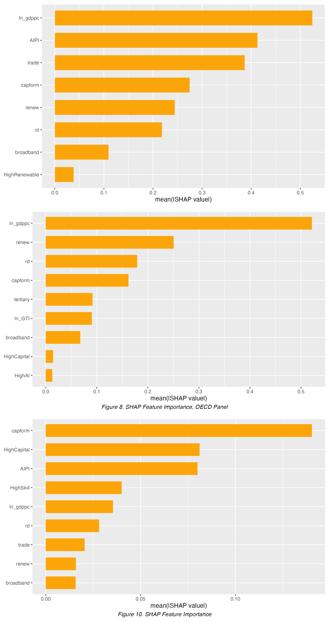
Figure A - 1. TreeSHAP Feature Importance, Bar Chart - OECD Panel (top to bottom: Part A, Part B, Part C)
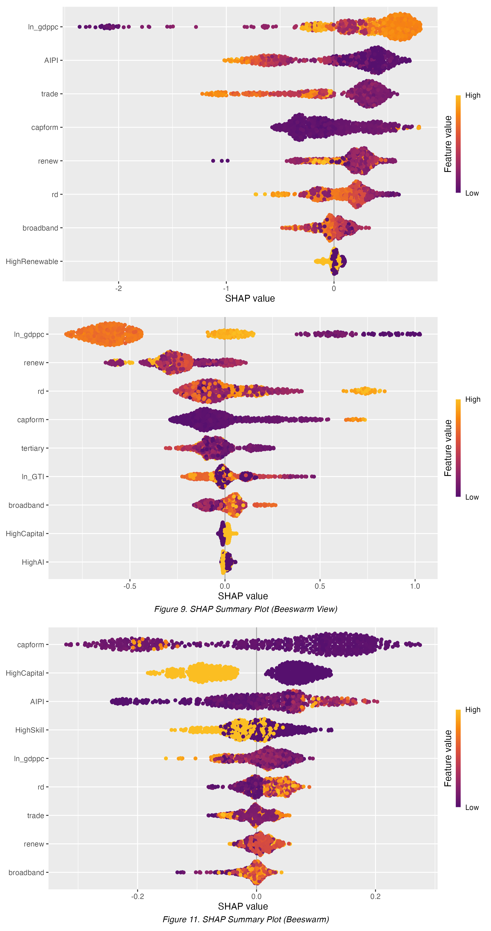
Figure A - 2. TreeSHAP Feature Importance, Beeswarm - OECD Panel (top to bottom: Part A, Part B, Part C)
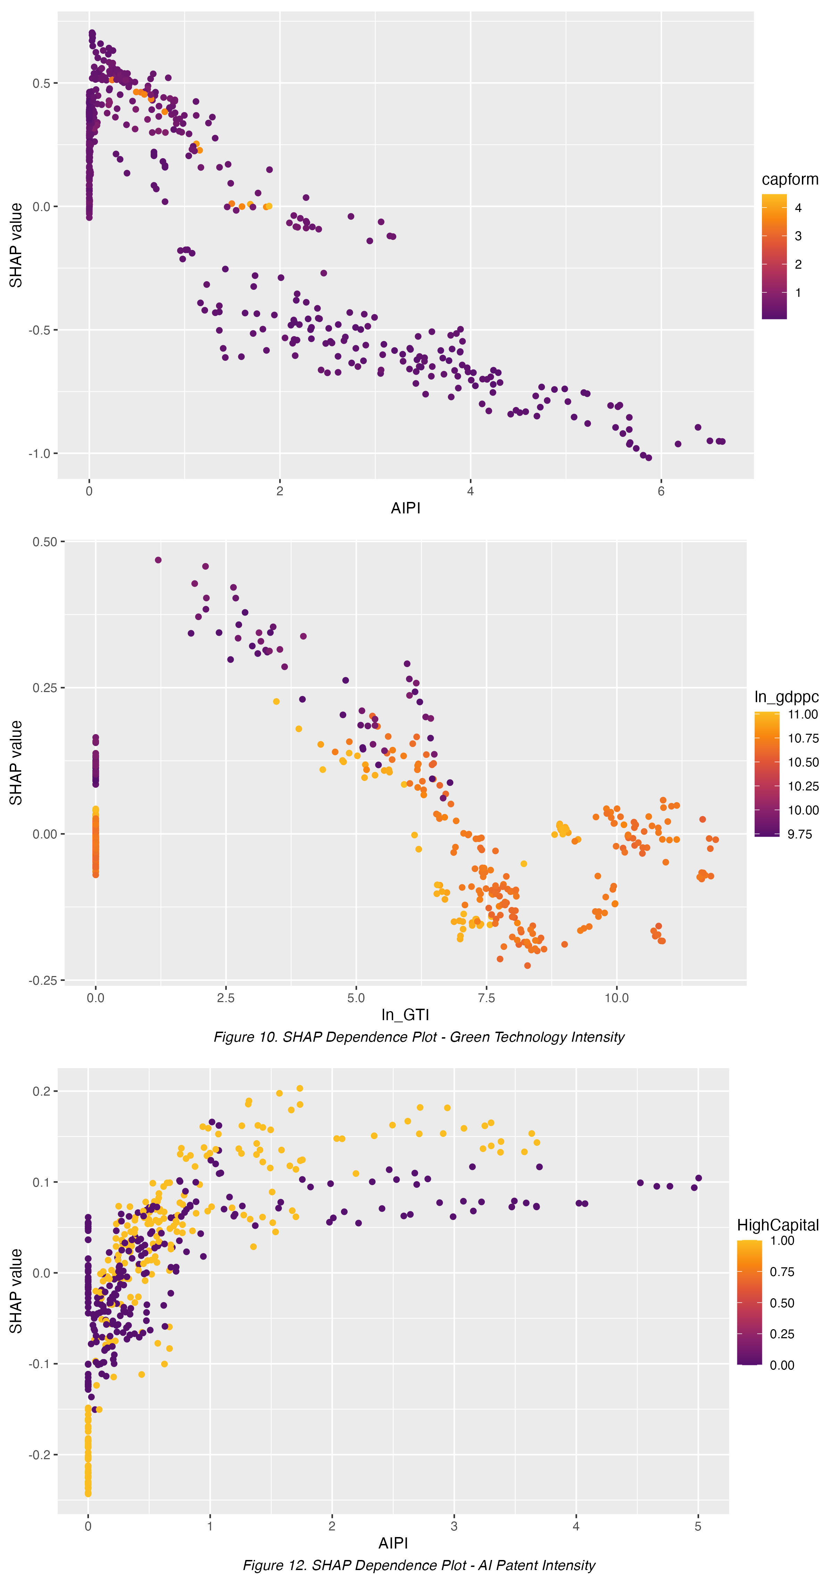
Figure A - 3. TreeSHAP Dependence, Main Regressor - OECD Panel (top to bottom: Part A, Part B, Part C)
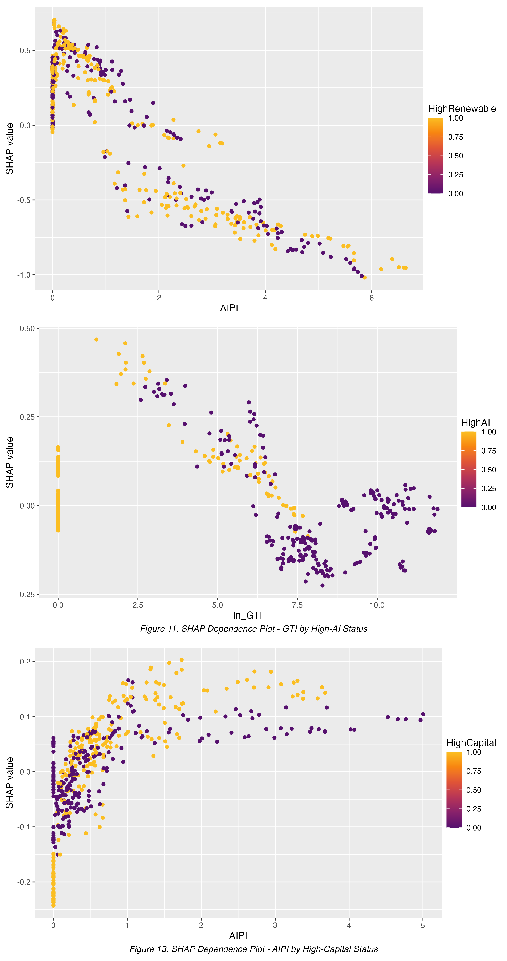
Figure A - 4. TreeSHAP Dependence, Moderator Variable - OECD Panel (top to bottom: Part A, Part B, Part C)
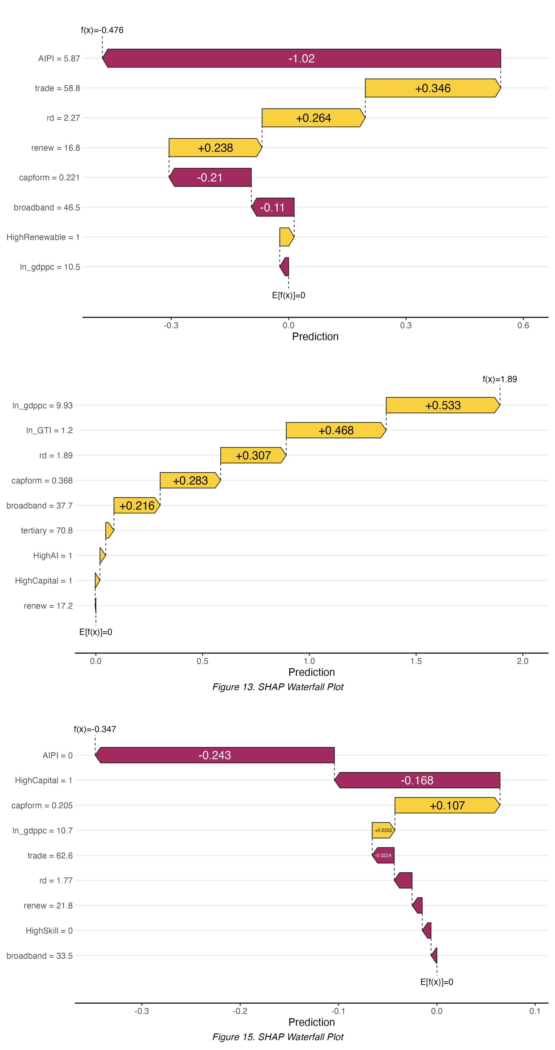
Figure A - 5. TreeSHAP Waterfall Example - OECD Panel (top to bottom: Part A, Part B, Part C)
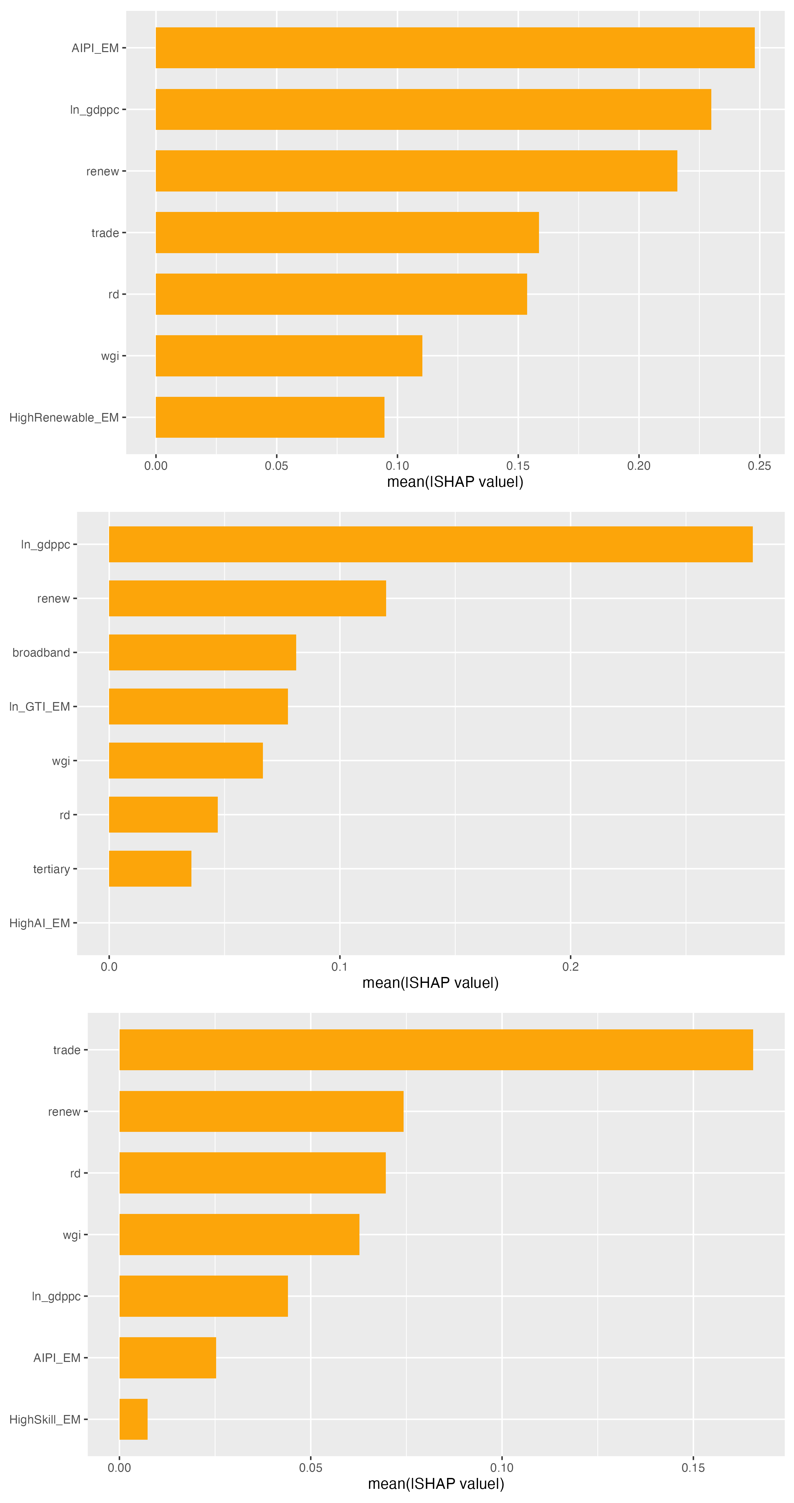
Figure A - 6. TreeSHAP Feature Importance, Bar Chart - Emerging-Market Panel (top to bottom: Part A, Part B, Part C)
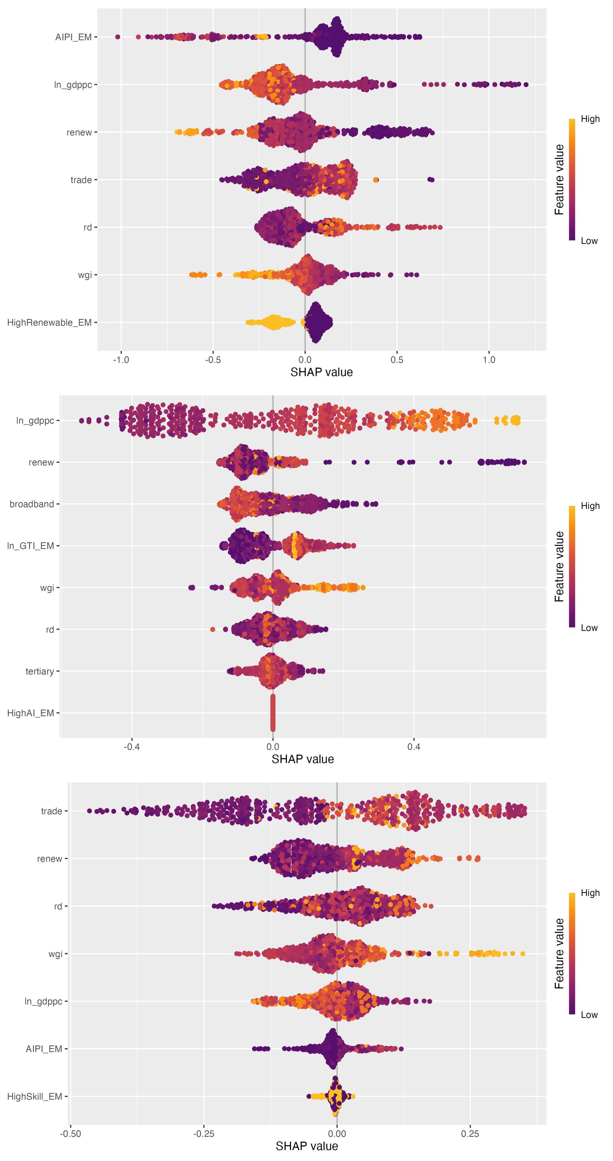
Figure A - 7. TreeSHAP Feature Importance, Beeswarm - Emerging-Market Panel (top to bottom: Part A, Part B, Part C)
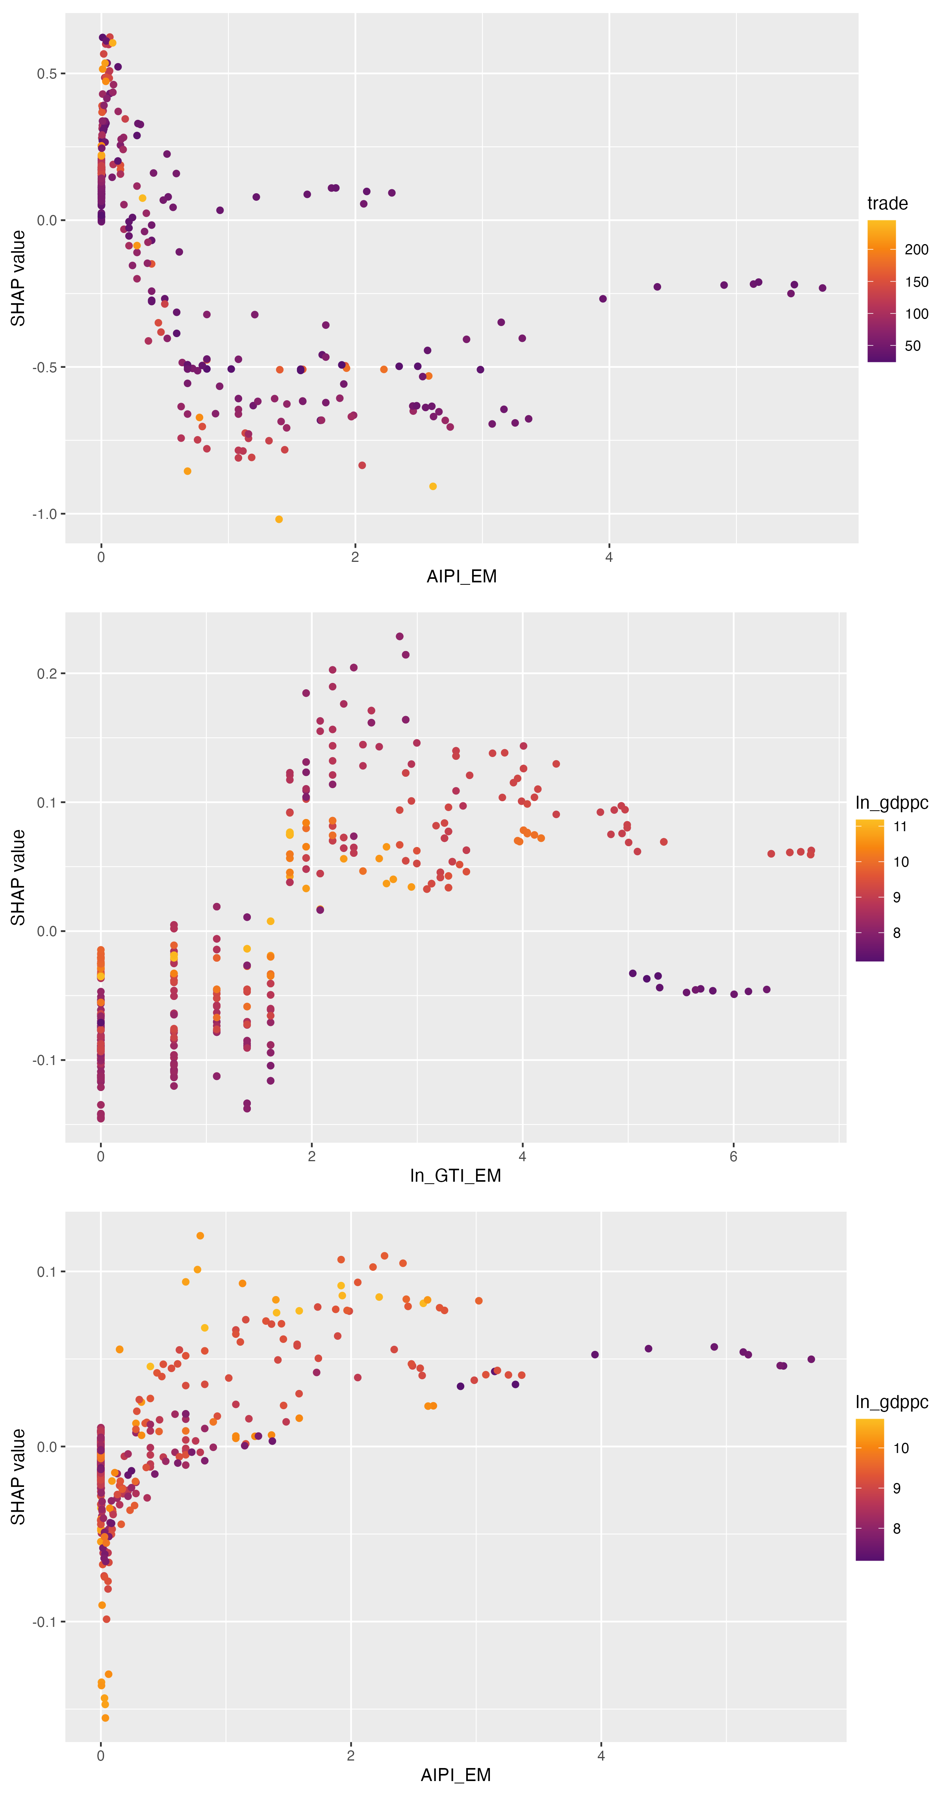
Figure A - 8. TreeSHAP Dependence, Main Regressor - Emerging-Market Panel (top to bottom: Part A, Part B, Part C)
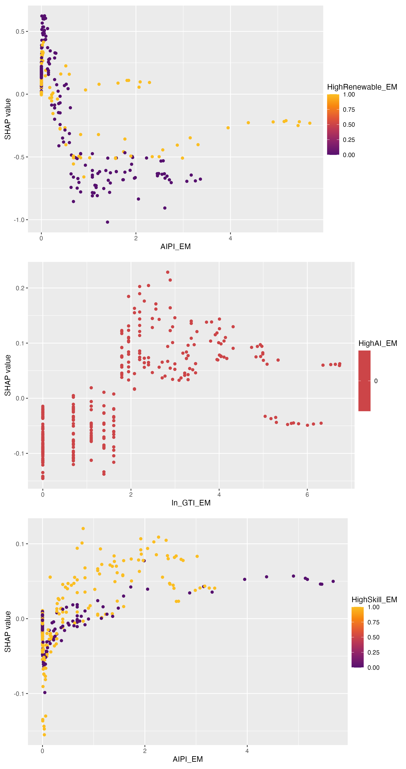
Figure A - 9. TreeSHAP Dependence, Moderator Variable - Emerging-Market Panel (top to bottom: Part A, Part B, Part C)
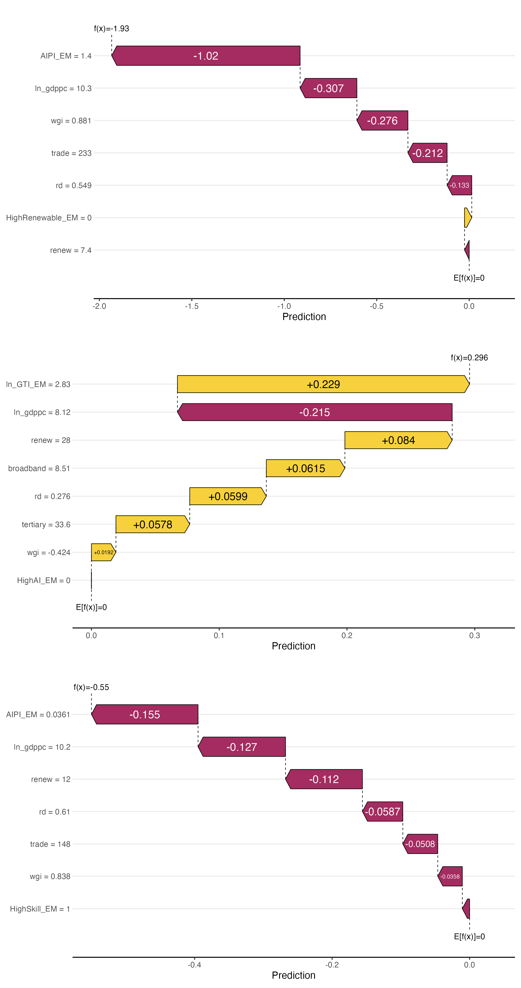
Figure A - 10. TreeSHAP Waterfall Example - Emerging-Market Panel (top to bottom: Part A, Part B, Part C)

A.2 Part A robustness (AI patent intensity and carbon emission intensity)
Table A1 reports five robustness checks on the OECD Part A result: separate FE-IV estimates for high-renewable and low-renewable subsamples (R1), an alternative equal-weighting scheme across industries in place of the ALP crosswalk weights (R2), a placebo exercise with randomly shuffled industry weights (R4), and re-estimation on the exact C+D_E+H industry sample used throughout the main analysis (R5). The AI Patent Intensity coefficient stays negative and of similar magnitude across R1, R2 and R5, while the R4 placebo coefficient is positive and of a different order of magnitude from the main estimate, consistent with the placebo weighting having removed the genuine identifying variation. Table A2 reports the underlying first-stage regression in full: the excluded instrument ${AIPI}_{bartik}$ loads onto AIPI with a coefficient of 0.867 and a first-stage F statistic that clears the conventional relevance threshold of 10 by a wide margin (detailed in Section 6.2). Table A3 reports the source-robustness exercise that substitutes WIPO AI-publication counts for the main EPO AI-patent counts and, in doing so, brings Myanmar and Viet Nam into the estimation sample; the WIPO-based point estimates are less precisely estimated (reflecting the WIPO series' shorter time coverage and higher measurement noise) but are not statistically distinguishable from the EPO-based estimates, and the Viet Nam-inclusive ASEAN interaction (column 4) shows the same sign pattern as the main EM specification in Table 9.

Table A - 1. Robustness Checks, Part A: AI Patent Intensity and Carbon Emission Intensity (OECD Panel)
 | (R1a) High-renew | (R1b) Low-renew | (R2) Alt. weighting | (R4) Placebo | (R5) C+D_E+H only
AI Patent Intensity (ln, IV) | -0.078  (0.050) | -0.114**  (0.053) |  |  | -0.096***  (0.033)
AI Patent Intensity (ln, IV, equal weights) |  |  | -0.075*  (0.041)
AI Patent Intensity (ln, IV, placebo weights) |  |  |  | 0.121***  (0.036)
GDP per capita (ln) | -0.406  (0.399) | -0.407  (0.376) | -0.261  (0.305) | -0.243  (0.340) | -0.259  (0.275)
Renewable energy (%) | -0.017*  (0.009) | -0.038**  (0.016) | -0.020**  (0.008) | -0.020***  (0.007) | -0.020**  (0.009)
Capital formation / Value added | 0.419*  (0.240) | 0.430  (0.308) | 0.373**  (0.182) | 0.319*  (0.184) | 0.403**  (0.179)
Num.Obs. | 456 | 480 | 936 | 936 | 936
R2 Within | 0.190 | 0.201 | 0.133 | 0.190 | 0.168
FE: pair_id / year | Yes | Yes | Yes | Yes | Yes
R1: FE-IV on high-renewable vs low-renewable subsamples (split at OECD median). R2: equal 1/3 industry weights instead of ALP crosswalk weights.
R3 (SGMM alt. lags 3:5) reported in text only, not compatible with this table format. R4: placebo with industry weights shuffled across C/D_E/H, expect beta approximately 0.
R5: C+D_E+H only = main estimation sample (G/J/K/M_N excluded at STEP 5 owing to EDGAR CO2 coverage limits); confirms the zero-CO2-outside-sample assumption.
SE clustered at pair level. * p<0.10, ** p<0.05, *** p<0.01. Alpha = 0.10.

Table A - 2. First-Stage Regression: Instrument Validity, Part A (OECD Panel)
 | First stage: AIPI ~ AIPI_bartik
AIPI_bartik [instrument] | 0.867***  (0.053)
GDP per capita (ln) | -0.043  (0.375)
Renewable energy (%) | 0.001  (0.012)
Capital formation / VA | 0.439***  (0.165)
R&D (% GDP) | 0.149*  (0.080)
Trade openness (%) | -0.001  (0.003)
Broadband subscriptions (per 100) | -0.022  (0.018)
Num.Obs. | 936
R2 Within | 0.522
FE: pair_id / year | Yes
Dependent variable: AIPI = ln(industry-weighted AI patent count + 1). Instrument: ${AIPI}_{bartik}$ = ln(leave-one-out industry-weighted AI patent count + 1),
computed from the other 24 OECD countries in the same year (Bartik shift-share). Two-way FE (pair_id + year). SE clustered at pair level.
First-stage F on the excluded instrument exceeds the conventional relevance threshold of 10 (see Section 6.2). * p<0.10, ** p<0.05, *** p<0.01. Alpha = 0.10.

Table A - 3. Source Robustness: EPO vs WIPO AI Patents, and Viet Nam In-Sample, Part A (EM Panel)
 | FE-IV, EPO | FE-IV, WIPO | FE, WIPO | FE + ASEAN int., WIPO
AI Patent Intensity (ln, IV) [EPO] | 0.801  (0.695)
AI Patent Intensity (ln, IV) [WIPO] |  | -0.353  (0.959)
AI Patent Intensity (ln) [WIPO] |  |  | 0.025  (0.030) | 0.033  (0.034)
AI Patent Intensity [WIPO] x ASEAN |  |  |  | -0.060  (0.055)
GDP per capita (ln) | -0.567  (0.671) | -0.804*  (0.417) | -0.753*  (0.391) | -0.749*  (0.392)
Renewable energy (%) | -0.024  (0.018) | -0.028**  (0.013) | -0.026**  (0.011) | -0.026**  (0.011)
Num.Obs. | 591 | 677 | 677 | 677
R2 Within | 0.041 | 0.035 | 0.035 | 0.036
FE: pair_id_em / year | Yes | Yes | Yes | Yes
Cols (2)-(4): ${AIPI}_{alt}$ built from WIPO AI-related patent publications by origin (indicator 4c), same C/D_E industry weighting, log(x+1), leave-one-out Bartik IV.
WIPO-based sample adds ASEAN countries absent from the EPO source, including Myanmar and Viet Nam. Empty WIPO cells = zero publications (valid zeros).
SE clustered at pair level. * p<0.10, ** p<0.05, *** p<0.01. Alpha = 0.10.

A.3 Part B robustness (green technology intensity and labor productivity)
Table A4 reports the first-stage regression for the Part B shift-share instrument, ${GTI}_{bartik}$, which loads onto ln(GTI+1) with a coefficient of 0.111 and a first-stage F well above 10 (full diagnostic values in Section 6.2). Table A5 reports the bias-corrected LSDVC dynamic-panel estimator (Kiviet 1995; Bruno 2005) as an additional robustness check against the static two-way FE and FE-IV specifications reported in the main text: the corrected coefficient on ln(GTI+1) is negative and similar in magnitude to the raw LSDV estimate, and both are consistent in sign with the main-text FE-IV coefficient once the different estimation samples (balanced dynamic panel vs. full panel) are taken into account. Table A6 reports the sensitivity of the High-AI moderator's median-split definition to an alternative top-tercile cutoff and to a leave-one-industry-out reclassification exercise; the interaction sign is stable under both alternatives, with at most one industry's classification flipping under leave-one-out perturbation.

Table A - 4. First-Stage Regression: ${GTI}_{bartik}$ as Instrument, Part B (OECD Panel)
 | First stage: GTI_bartik -> ln(GTI+1)
Instrument: ln(base_GTI+1) x ln(global_excl_patents+1) | 0.1111***  (0.0074)
Capital formation / Value added | 0.3493  (0.2662)
GDP per capita (ln) | -0.2714  (0.4781)
Renewable energy (%) | -0.0018  (0.0072)
Fixed broadband (per 100) | 0.0118  (0.0082)
Tertiary enrollment (%) | 0.0050  (0.0032)
R&D expenditure (% GDP) | -0.0654  (0.0559)
Num.Obs. | 1847
R2 Within | 0.585
FE: pair_id / year | Yes
Dependent variable: ln(GTI+1). ${GTI}_{bartik}$ = ln(base_GTI_ic+1) x ln(global_excl_patents_it+1), the Goldsmith-Pinkham et al. (2020) shift-share construction.
Two-way FE (pair + year). SE clustered at pair level. * p<0.10, ** p<0.05, *** p<0.01. Alpha = 0.10.

Table A - 5. Dynamic Panel LSDV and Bias-Corrected LSDVC, Part B (OECD Panel)
Term | Raw LSDV | LSDVC (Kiviet/Bruno)
Lagged ln(labor productivity) | 0.8155  boot. SE 0.0287 | 1.0779  boot. SE 0.0461
ln(GTI+1) | -0.0219  boot. SE 0.0065 | -0.0209  boot. SE 0.0052
Capital formation / VA | -0.2856  boot. SE 0.1081 | -0.2744  boot. SE 0.0911
GDP per capita (ln) | 0.2316  boot. SE 0.0694 | 0.0540  boot. SE 0.0585
Observations / Pairs | 2015 / 168 | 2015 / 168
Bootstrap replications | - | 500 / 500 successful
Initial consistent estimator (phi seed) | - | Diff.GMM: 0.8188
Cross-check: LSDVC phi (Everaert-Pozzi 2007) | - | 0.9294
Bias-corrected LSDVC point estimate on ln(GTI+1) is consistent in sign and magnitude with the main FE-IV result reported in Table 9.
Direction check against the Difference GMM seed shows the corrected estimator moves away from the GMM value, a known finite-sample feature of LSDVC bias correction rather than a specification failure.
Table A - 6. Moderator (High-AI) Threshold Sensitivity, Part B (OECD Panel)
Check | Result | Note
Primary split (median AIIE) | High-AI beta1 = 0.0161; Low-AI beta1 = 0.0205 | High-AI = 1 if AIIE >= OECD-industry median (7 industries).
Alternative split (top-tercile AIIE) | High-AI beta1 = 0.014; Low-AI beta1 = 0.0266 | High-AI_tercile = 1 if AIIE >= top-tercile cutoff (quantile 2/3).
Sign agreement, tercile vs median | Yes, both same sign as primary median split | Tests whether the subsample conclusion is an artifact of the median cutoff.
Leave-one-industry-out classification stability | Max flips = 1 of 6 industries | Tests fragility of the median threshold to dropping any single industry from the ranking.
Full leave-one-industry-out detail in HighAI_leave_one_industry_out_OECD.csv (project data folder).

A.4 Part C robustness (AI patent intensity and labor income share)
Table A7 reports the Gollin (2002) self-employment adjustment to the labor-share measure, comparing the naive labor share (compensation of employees divided by value added, which excludes self-employment income) against a Gollin-adjusted labor share that inflates the naive measure by the country-year self-employment share from WDI. The AI Patent Intensity coefficient is essentially unchanged in sign and magnitude between the naive and Gollin-adjusted columns, for both the FE and FE-IV specifications, indicating that the near-zero aggregate labor-share result reported in Table 6 is not an artifact of the self-employment measurement issue. Table A8 reports the same bias-corrected LSDVC dynamic-panel check applied to Part C: the corrected coefficient on AI Patent Intensity remains negative and small, consistent with the near-zero main-text result. Table A9 reports the WIPO-based source-robustness and Viet Nam in-sample exercise for Part C, mirroring Table A3 for Part A; the ASEAN interaction term in column 4 is positive and statistically significant at the 5 percent level, indicating that within ASEAN specifically (which now includes Viet Nam under the WIPO source), higher AI patent intensity is associated with a relatively larger labor income share than in the rest of the emerging-market panel, a pattern discussed further in Section 7.3.

Table A - 7. Robustness: Gollin (2002) Self-Employment Adjustment, Part C (OECD Panel)
 | FE, naive | FE, Gollin-adj | FE-IV, naive | FE-IV, Gollin-adj
AI Patent Intensity (ln) | -0.0163  (0.0160) | -0.0154  (0.0159)
AI Patent Intensity (ln, IV) |  |  | 0.0114  (0.0255) | 0.0111  (0.0250)
GDP per capita (ln) | -0.2455*  (0.1333) | -0.2765**  (0.1327) | -0.2376*  (0.1353) | -0.2689**  (0.1347)
Capital formation / Value added | 0.6631***  (0.1388) | 0.6669***  (0.1392) | 0.6555***  (0.1395) | 0.6595***  (0.1399)
R&D expenditure (% of GDP) | 0.0450**  (0.0220) | 0.0405*  (0.0216) | 0.0397*  (0.0229) | 0.0354  (0.0224)
Num.Obs. | 3120 | 3120 | 3120 | 3120
R2 Within | 0.153 | 0.157 | 0.152 | 0.156
FE: pair_id / year | Yes | Yes | Yes | Yes
Naive labor share = LABR/VALU (compensation of employees / value added); excludes self-employment income.
Gollin-adjusted labor share = labshare / (1 - self_emp_share), where self_emp_share is the WDI modeled ILO self-employment share applied uniformly across industries within a country-year (STAN A*10 does not separate paid employees from total employment by industry).
Adjustment follows Gollin's 'average wage' assumption (self-employed earn the same as employees); reported as a robustness check alongside the naive main specification (Table 6), not a replacement.
SE clustered at pair level. * p<0.10, ** p<0.05, *** p<0.01. Alpha = 0.10.

Table A - 8. Dynamic Panel LSDV and Bias-Corrected LSDVC, Part C (OECD Panel)
Term | Raw LSDV | LSDVC (Kiviet/Bruno)
Lagged ln(labor income share) | 0.6658  boot. SE 0.0268 | 0.8424  boot. SE 0.0731
AI Patent Intensity | -0.0090  boot. SE 0.0061 | -0.0082  boot. SE 0.0055
GDP per capita (ln) | -0.0834  boot. SE 0.0463 | -0.0527  boot. SE 0.0379
Capital formation / VA | 0.5489  boot. SE 0.0960 | 0.5101  boot. SE 0.0929
Observations / Pairs | 2880 / 240 | 2880 / 240
Bootstrap replications | - | 500 / 500 successful
Initial consistent estimator (phi seed) | - | Diff.GMM: 0.6509
Cross-check: LSDVC phi (Everaert-Pozzi 2007) | - | 0.7591
Bias-corrected LSDVC point estimate on AI Patent Intensity is consistent in sign and magnitude with the main FE result reported in Table 6.

Table A - 9. Source Robustness: EPO vs WIPO AI Patents, and Viet Nam In-Sample, Part C (EM Panel)
 | FE-IV, EPO | FE-IV, WIPO | FE, WIPO | FE + ASEAN int., WIPO
AI Patent Intensity (ln, IV) [EPO] | 0.455  (0.339)
AI Patent Intensity (ln, IV) [WIPO] |  | -0.474  (0.880)
AI Patent Intensity (ln) [WIPO] |  |  | 0.009  (0.018) | 0.001  (0.019)
AI Patent Intensity [WIPO] x ASEAN |  |  |  | 0.056**  (0.027)
GDP per capita (ln) | 0.041  (0.393) | -0.111  (0.355) | -0.030  (0.298) | -0.034  (0.300)
Trade openness (% GDP) | -0.006**  (0.002) | -0.003  (0.004) | -0.005***  (0.002) | -0.005***  (0.002)
Num.Obs. | 530 | 616 | 616 | 616
R2 Within | 0.113 | 0.081 | 0.079 | 0.081
FE: pair_id_em / year | Yes | Yes | Yes | Yes
Cols (2)-(4): ${AIPI}_{alt}$ built from WIPO AI-related patent publications by origin (indicator 4c), same industry weighting and log(x+1) transform as the EPO baseline; IV = leave-one-out Bartik within the EM sample.
WIPO-based sample includes ASEAN countries absent from the EPO source, including Myanmar and Viet Nam. Empty WIPO cells = zero publications (valid zeros).
SE clustered at pair level. * p<0.10, ** p<0.05, *** p<0.01. Alpha = 0.10.

A.5 Instrument-weight diagnostics across all three parts
Table A10 reports the Goldsmith-Pinkham, Sorkin and Swift (2020) Rotemberg-weight decomposition for the shift-share instruments used in Parts A and C, alongside the corresponding per-industry first-stage diagnostic used for Part B (whose instrument construction does not decompose into Rotemberg weights in the same way). Both Part A and Part C concentrate the large majority of their identifying weight in the Manufacturing industry, reflecting that Manufacturing is simultaneously the largest industry by value added and the largest source of AI patenting activity in the OECD panel; this concentration is disclosed here as an honest limitation of the shift-share design rather than obscured, and is a standard feature noted in the shift-share instrumental-variables literature itself. For Part B, the per-industry first-stage check flags the Utilities/water industry as carrying a weak first-stage relationship (F = 0.63), meaning the green-technology instrument's identifying power for Part B is effectively concentrated in Manufacturing, Transport/storage and Information/communication rather than spread evenly across all four industries in the panel.

Table A - 10. Goldsmith-Pinkham-Sorkin-Swift (2020) Rotemberg-Weight Decomposition and Per-Industry First-Stage Checks
Part / industry | Rotemberg weight | Industry-specific beta | First-stage F  (Part B only)
Part A (dashes = not applicable) | - | - | -
C - Manufacturing | 0.970 | 0.024
D_E - Utilities/water | 0.029 | -0.154
H - Transport/storage | 0.0001 | -1.052
Part B (dashes = not applicable) | - | - | -
C - Manufacturing |  | 0.013 | 303.3
D_E - Utilities/water |  | -1.618 | 0.63 (weak)
H - Transport/storage |  | -0.002 | 138.9
J - Information/comm. |  | 0.003 | 573.2
Part C (dashes = not applicable) | - | - | -
C - Manufacturing | 0.778 | -0.014
J - Information/comm. | 0.095 | -0.039
OTU - Other utilities/services | 0.039 | -0.001
B - Mining/quarrying | 0.019 | 0.057
LTN - Real estate/professional | 0.021 | 0.047
D_E - Utilities/water | 0.024 | -0.012
GTN - Wholesale/retail/transport | 0.016 | -0.039
K - Financial/insurance | 0.008 | 0.004
A / F (agriculture, construction) | 0.000 | n/a (no variation)
Rotemberg weights (Goldsmith-Pinkham, Sorkin and Swift, 2020) decompose the shift-share FE-IV estimate into a weighted average of just-identified industry-specific betas; weights sum to 1 within each part.
Part A and Part C both concentrate identifying weight in Manufacturing (industry C), reflecting that manufacturing is both the largest industry by value added and the largest source of AI patenting in the OECD sample; this is disclosed as a concentration caveat rather than a violation of exogeneity, consistent with the shift-share literature's own diagnostic practice.
Part B reports a different (first-stage) per-industry diagnostic rather than Rotemberg weights: the Utilities/water industry (D_E) shows a weak first-stage F (0.63), meaning identification for Part B's green-technology instrument is effectively carried by Manufacturing, Transport and Information/communication, not by Utilities.
Full per-industry decomposition files: GP_Rotemberg_decomposition.csv (Part A), GP_perindustry_decomposition_OECD.csv (Part B), GP_Rotemberg_decomposition_OECD.csv (Part C), in the project data folder.

