PRAKASH. K

REG.NO.1234/4556
TELUGU CINE & TV SPECIAL EFFECTS MASTERS & TECHNICIANS UNION
NO. 32/17,INDIRANAGAR , JAWAHAR NAGAR ,BAJARAHILLS,
HYDERABAD – 500045PH.NO.6302890852,8885663939
MEMBERSHIP N0: 1
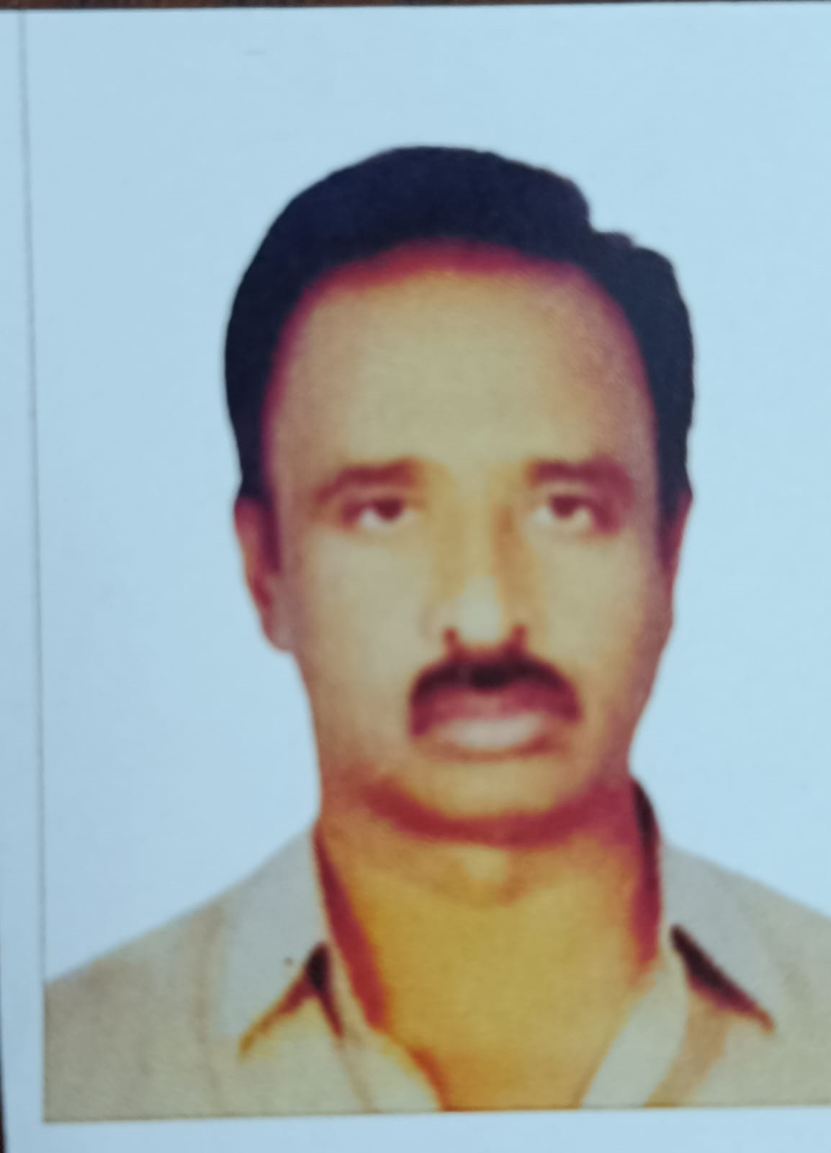
MEMBER NAME : PRAKASH .K
FATHER NAME : FATHER
DATE OF BIRTH : 01.01.2025
ADRESS : HAFEEZPET
DESIGNATION : SPL.EFX. MASTER
BLOOD GROUP : A POSITIVE
AADHAR NO : 1278945631
MOBILE NO : 7894561231


REFERENCE SIGNATURE MEMBER SIGNATURE

