Part Five Screenshots
Thomas Urbain
- Proof of Execution
  - Local
    - 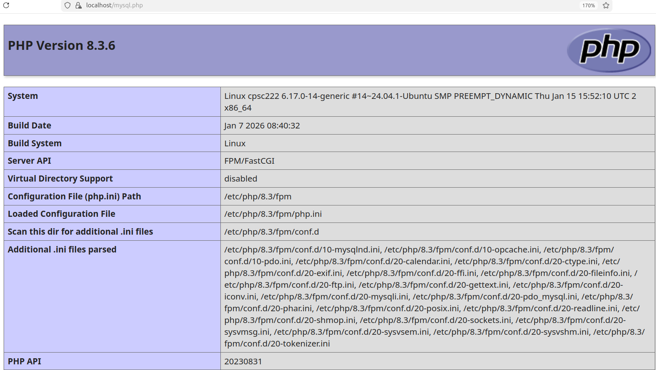
    - 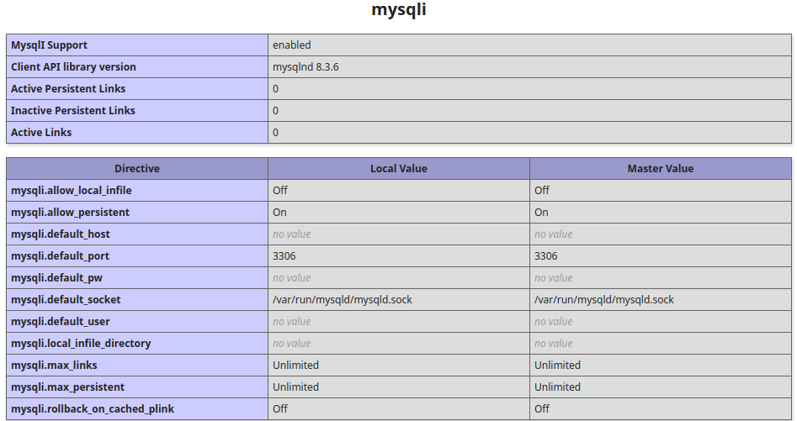
  - Remote

    - 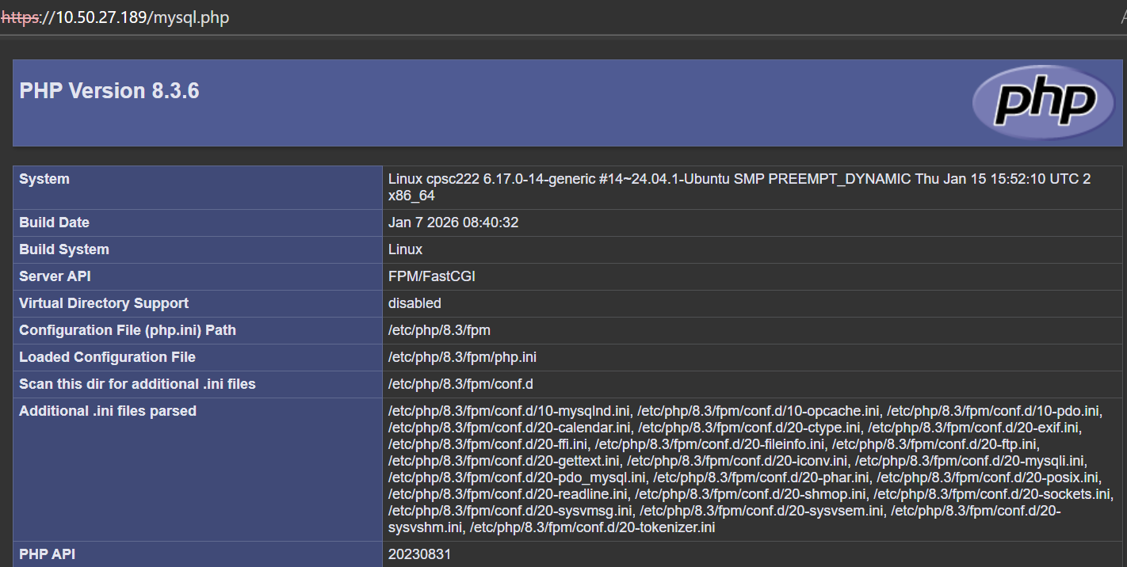
    - 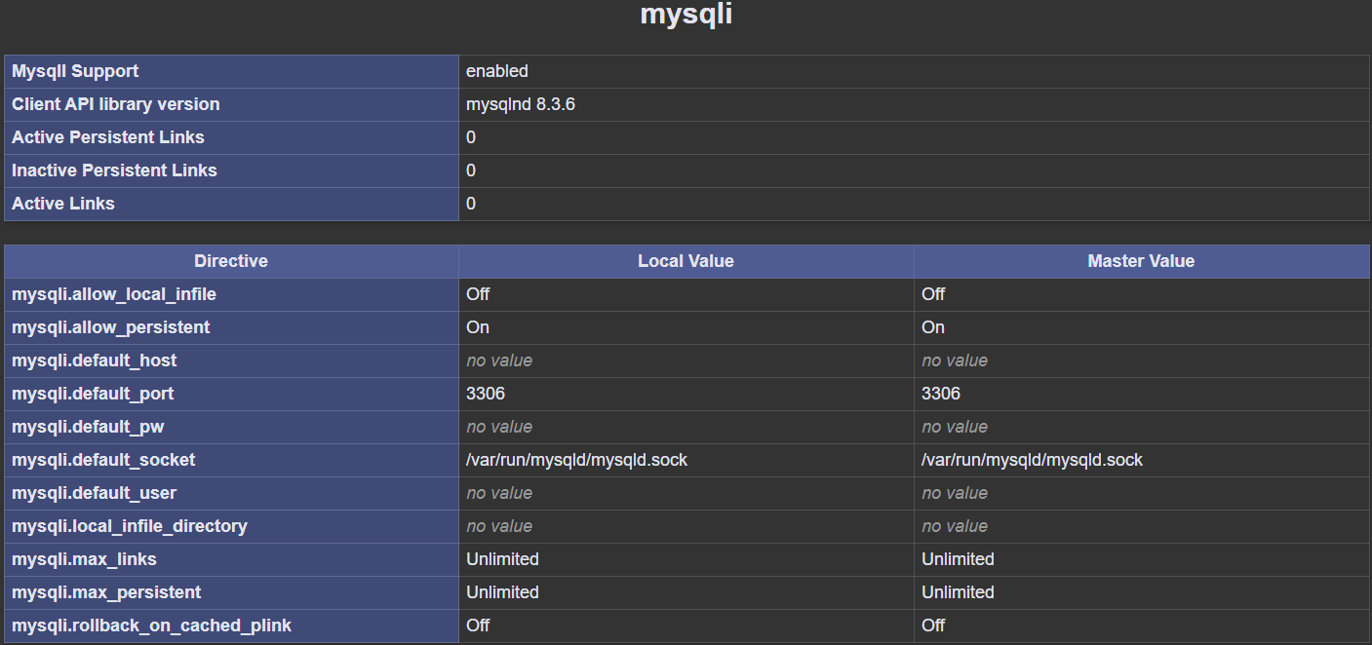
- Screenshot of git config --list
  - 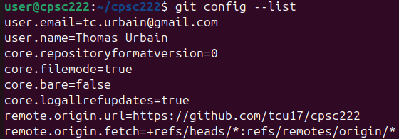
- Screenshot of pwd and ls -la
  - 