Part Four Screenshots
Thomas Urbain
- Proof of successful execution
  - Local
    - 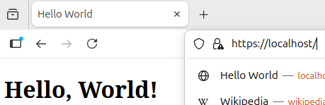
    - 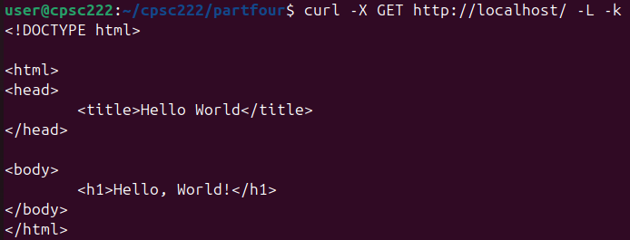
  - Remote
    - 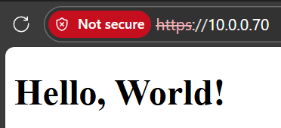
- Screenshot of git config --list
  - 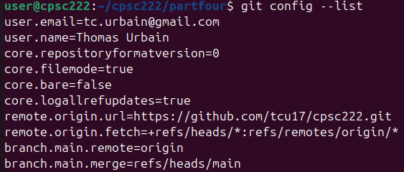
- Screenshot of pwd and ls -la
  - 