Part Three Screenshots
Thomas Urbain
- Proof of successful execution
  - Local Machine
    - Users
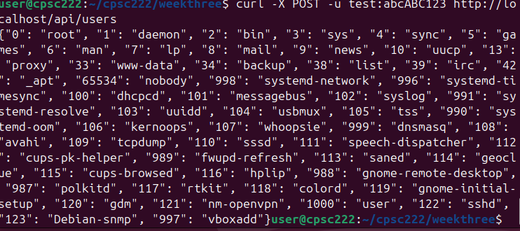
    - Groups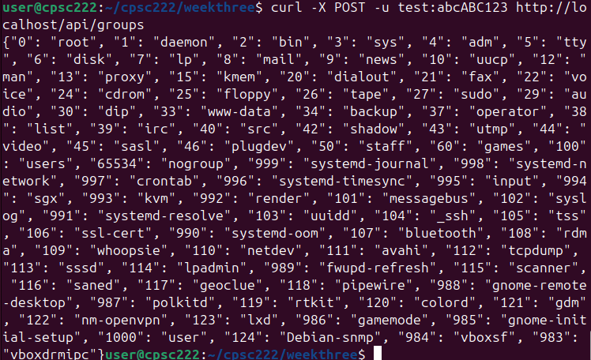
  - Remote Machine
    - Users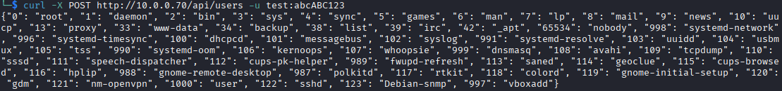
    - Groups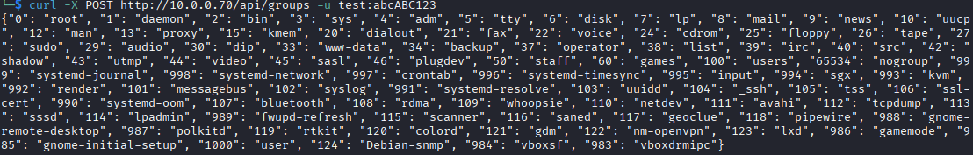
- Screenshot of git config –list
  - 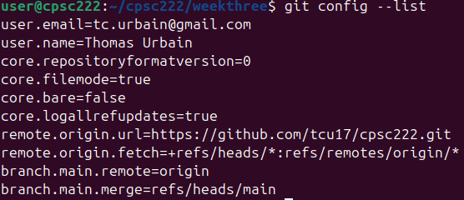
- Screenshot of pwd and ls -la
  - 