Week Two Screenshots
Thomas Urbain
- Screenshot of snmpwalk working
  - Local Machine
  - Remote Machine
- Screenshot of git config --list
  - 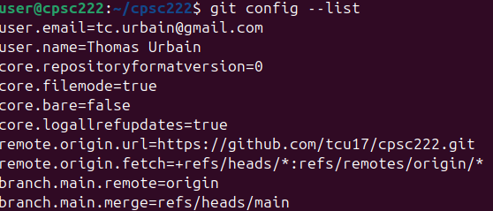
- Screenshot of pwd and ls -la
  - Inside weektwo Directory