CSI AI Visibility Baseline Comparison
27 August 2026 baseline compared with 15 September 2026 follow up
This report compares 400 AI observations from each run across Gemini, Perplexity, Claude, and OpenAI. It assesses changes in mentions, citations, recommendation strength, platform visibility, and independently corroborated authority. The September run completed with 100 successful observations on every platform.
Main conclusion
CSI’s overall Visibility Index increased from 33.5 to 36.3. Citation share rose eight percentage points, but Perplexity produced nearly all of the platform-level gain. Gemini improved only slightly, Claude declined, and OpenAI remained essentially flat. Independent authority qualified in 33 of 400 observations, showing that CSI is more visible than it is independently corroborated.

Executive scorecard
Metric | 27 Aug | 15 Sep | Change
Overall Visibility Index | 33.5 | 36.3 | +2.8
Mention share | 40.8% | 42.5% | +1.8 pp
Citation share | 51.3% | 59.3% | +8.0 pp
Recommendation share | 19.3% | 20.8% | +1.5 pp
CSI source frequency | 50.5% | 58.5% | +8.0 pp
Independent authority | Not populated | 8.3% | 33 of 400

The broad citation gain is real, but CSI-controlled source frequency also increased from 202 to 234 observations. The next phase should convert owned-source visibility into decision-level recommendations and claim-matched third-party evidence.

Platform performance
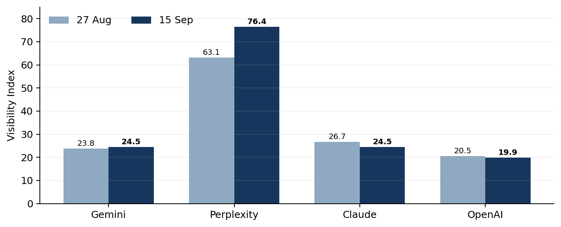
Platform | Index 27 Aug | Index 15 Sep | Delta | Mention Δ | Citation Δ | Rec. Δ
Gemini | 23.8 | 24.5 | +0.7 | +2 pp | +1 pp | −1 pp
Perplexity | 63.1 | 76.4 | +13.3 | +16 pp | +19 pp | +9 pp
Claude | 26.7 | 24.5 | −2.2 | −11 pp | +11 pp | 0 pp
OpenAI | 20.5 | 19.9 | −0.6 | 0 pp | +1 pp | −2 pp

What changed
Perplexity drove the improvement. Its mention share reached 92%, citation share 99%, and recommendation share 55%. The Visibility Index increased 13.3 points to 76.4, making Perplexity the clear source of growth.
Gemini remained citation-heavy and recommendation-light. CSI appeared in 61% of citations but earned only four recommendations. Its citation-to-recommendation conversion was 6.6%, and the Visibility Index rose only 0.7 points.
Claude’s citation presence improved while entity visibility weakened. Citation share rose from 46% to 57%, but mention share fell from 38% to 27%. The platform increasingly reaches relevant sources without consistently naming CSI in its answer.
OpenAI remained the weakest discovery channel. Mention share stayed at 24%, citation share rose one point to 20%, and recommendation share fell to 17%. CSI appeared as a source in 17 observations, one fewer than the baseline.

Category movement
Platform | Baseline weakest | Current weakest | Current strongest
Gemini | Business Case 0.0 | Standards 0.0 | Integration 40.0
Perplexity | Strategy 30.3 | Architecture 30.0 | EPC 85.9
Claude | Integration 0.0 | Architecture 0.0 | Training 55.0
OpenAI | Standards 0.0 | Procurement 0.0 | Integration 80.0

Independent authority
The September run added a claim-matched authority test for every observation that mentioned CSI. An observation qualified only when an independent Tier A or Tier B source substantively supported the specific proposition made about CSI. CSI-controlled sources could not establish independent authority by themselves.
Platform | Qualifying observations | Share of all observations | Average qualifying score | Provider-selection authority
Gemini | 6 | 6% | 2.00 | 6 of 29 20.7%
Perplexity | 14 | 14% | 2.21 | 6 of 29 20.7%
Claude | 6 | 6% | 2.50 | 6 of 29 20.7%
OpenAI | 7 | 7% | 2.29 | 7 of 29 24.1%
Total | 33 | 8.3% | 2.24 | 25 of 116 21.6%

Authority gap
CSI was mentioned in 170 observations, but only 33 observations contained qualifying independent corroboration. That equals 19.4% of CSI-mentioned observations. Visibility is expanding faster than third-party validation.

Implications
Owned content is improving discoverability. The rise in CSI source frequency indicates that the website and related CSI-controlled properties are being retrieved more often. This supports the content-cluster strategy, particularly on Perplexity.
Independent evidence remains the limiting signal. The strongest path to durable recommendation visibility is external validation tied to specific claims: documented project roles, partner confirmation, conference proceedings, customer-approved case material, and recognized industry publications.
Provider-selection prompts show more commercial promise. Independent authority qualified in 21.6% of provider-selection observations, materially above the 8.3% rate across the full benchmark. Decision-stage content should therefore be paired with credible external evidence.

Competitive context
Yokogawa and Wood remained the most frequently named competitors across the four platforms. Wood increased from 125 to 131 top-list appearances, while Yokogawa moved from 141 to 136. CSI’s opportunity is to own narrower decision claims where large vendors have broad recognition but less specific evidence around vendor-neutral OPA execution, EPC estimating, migration planning, and business-case development.

Recommended action plan
Priority | Action | Decision signal to improve | Evidence required
1 | Publish an OPA business-case and EPC execution hub with decision pages for estimating, scope definition, migration planning, and implementation risk. | Gemini and OpenAI recommendations; weak business-case and procurement categories. | Named methodology, worked examples, assumptions, deliverables, and verifiable project evidence.
2 | Secure claim-matched third-party corroboration for CSI’s strongest propositions. | Independent authority and recommendation confidence. | Partner or client confirmation, conference proceedings, formal case material, trade publication coverage, or industry-body references.
3 | Clarify CSI entity naming and claims on pages Claude already retrieves. | Claude mentions and entity association. | Consistent CSI naming, concise claim statements, expert bios, explicit service-to-evidence links, and stable page metadata.
4 | Create provider-selection comparison pages built around buyer decisions. | Commercial recommendation share. | Transparent selection criteria, role clarity, proof points, limitations, and links to independent evidence.
5 | Track citation quality separately from citation volume. | Owned-source dependence and platform resilience. | Monthly counts for owned, mixed, and independent support, plus claim-level authority gaps.

Measurement recommendation
Use the September 15 run as the post-intervention reference. Hold prompts, models, scoring rules, and platform weighting constant for the next comparison. Run the next benchmark after a defined evidence cycle rather than after routine copy edits. A practical trigger is four to six weeks after publishing the business-case and EPC cluster and securing at least two new independent, claim-matched sources.

Methodology and limitations
Each run contains 100 prompts across four platforms, producing 400 successful logical observations. Overall Visibility Index is the average of the four platform indices. Mention, citation, and recommendation shares use all 400 successful observations. Recommendation requires a visibility score of at least 4. The September Independent Authority measure used a conservative claim-matching classifier and qualified scores of 2 or 3 only.
AI responses vary over time even when prompts and models are held constant. The comparison shows directional platform behavior rather than a deterministic causal effect from any single website change. The August summary did not contain populated Independent Authority fields, so authority is reported for September without a baseline delta.
Source: CSI AI Visibility Google Sheet, Summary rows 2–5 and 10–13. Benchmark keys 2026-08-27-full100-v1 and 2026-09-15-full100-v1. Report prepared 16 September 2026.

