EMI PIC module

Authors :  Date :  Reference :  Title :  File : | Marino Frana MFR  28/04/09  EMI PIC MODULE MANUAL

 | Name | Date | VISA
Written by | Marino Frana | 28/04/09

DIFFUSION LIST

DIFFUSION OF THE DOCUMENT
Addresses Company | Copies
ECSAT | 1

VERSIONS

Version | Date
1 | 28/04/09 | Creation

TABLE OF CONTENTS
1. Introduction 4
2. short description of LAN_ACOM module services 5
2.1. Service ETAT 5
2.2. Service ARRET 5
3. message STRUCTURES 7
3.1. Service ETAT message structure 7
3.2. Service ETAT messages 9
3.2.1. Request of start service ETAT 9
3.2.2. Request of stop service ETAT 9
3.2.3. Request of statuses 9
3.2.4. Status message 9
3.2.5. Acknowledge of start module ETAT 9
3.2.6. Non acknowledge of start module ETAT 9
3.2.7. Acknowledge of stop module ETAT 9
3.2.8. Non acknowledge of stop module ETAT 10
3.2.9. Acknowledge of request statuses 10
3.2.10. Non acknowledge of request statuses 10
3.3. Service ARRET messages 10
4. message flow between module and application 11
4.1. Service ETAT message flow 11
4.2. Service ARRET message flow 12
4.3. Service PAYMENT message flow 12
5. registry 13

Introduction
Purpose of this module is to manage storage and transfer of files (mostly pictures) over network.

There are 2 versions of module, with same core functionality (version 1.0.0 and 1.0.1). This document describes both of them.

Version 1.0.0 works as following :
- Module is checking for existence of files in directory configured in “LocalDirectory” registry key, attempts to transfer files over network to directory configured in “ServerDirecory” registry key
- In case of successful transfer, files are moved to backup directory
- Module deletes files from backup directory once per day at time configured in “PurgeTime” registry key if they are older than value configured in “PurgePeriodDays” registry key (value is in days)
Version 1.0.1 extends the functionality in the following way
- Module is checking directory configured in “ImportFromDir” registry key and moves files from there to directory configured in “LocalDirectory” and creating subfolders tree for storage
- Module can be configured to filter files by extension and send files that match different filters to different destinations (up to 10 destinations, each destination can have it’s own set of filters (number of filters is not limited) )
- Allows more flexible file name format with more data (file name is source of data for creating subdirectory trees)

short description of LAN_ACOM module services

// structure for messages for communication with user
typedef struct
{
struct_srv_entete entete;
union
{
struct_emi_pic_restit srv_restit;
struct_emi_pic_trf srv_trf;
struct_emi_pic_emi srv_emi;
struct_srv_etat srv_etat;
}u;
} struct_emi_pic_message;

Service ETAT
Service ETAT manages status of network connection. It send message SRV_TYP_NOUVEL_ETAT on every change of status and on request from service user.

Service ARRET
Service ARRET manage shutdown of module.

message STRUCTURES

Service ETAT message structure
Structure of ETAT message:
typedef struct
{
unsigned int errorLink : 1;
unsigned int reserved : 15;

}struct_emi_pic_etat, *LP_EMI_PIC_ETAT;

SERVICE | TYPE OF SERVICE | DATA | APPLI -> EMI PIC | EMI PIC -> APPLI
All services
(Except M_SRV_ARRET) | SRV_DEBUT_ACQ |  |  | X
(Except M_SRV_ARRET) | SRV _DEBUT_NACQ |  |  | X
(Except M_SRV_ARRET) | SRV _FIN_ACQ |  |  | X
(Except M_SRV_ARRET) | SRV _FIN_NACQ |  |  | X
 | SRV _SERVICE_INVONNU_NACQ |  |  | X
 | SRV _TYPE_INCONNU_NACQ |  |  | X
 | SRV _TYPE_SERVICE_INCONNU_NACQ |  |  | X
 | SRV _MODULE_ARRETE_NACQ |  |  | X
 | SRV _DEBUT |  | X
 | SRV _FIN |  | X
M_SRV_ARRET | p_message->entete.type
 | SRV_ARRET_ACQ |  |  | X
 | SRV_ARRET_NACQ |  |  | X
M_SRV_ETAT | p_message->entete.type
 | SRV_DEMANDE_ACQ |  |  | X
 | SRV_DEMANDE_NACQ |  |  | X
 | SRV_ETAT | p_message.srv.msg_etat |  | X
 | SRV_DEMANDE |  | X

Service ETAT messages
From user of service to service:

Request of start service ETAT
Identifier of message |  | M_SRV_ETAT
Data of the message | type of message | SRV_DEBUT
 | Data | empty

Request of stop service ETAT
Identifier of message |  | M_SRV_ETAT
Data of the message | type of message | SRV_FIN
 | data | empty

Request of statuses
Identifier of message |  | M_SRV_ETAT
Data of the message | type of message | SRV _DEMANDE
 | data | empty

From service to user of service:

Status message
Identifier of message |  | M_ SRV _ETAT
Data of the message | type of message | SRV _ETAT
 | data | PYL_msg_etat etat  statuses of all devices

Acknowledge of start module ETAT
Identifier of message |  | M_ SRV _ETAT
Data of the message | type of message | SRV _DEBUT_ACQ
 | Data | empty

Non acknowledge of start module ETAT
Identifier of message |  | M_ SRV _ ETAT
Data of the message | type of message | SRV _DEBUT_NACQ
 | Data | empty

Acknowledge of stop module ETAT
Identifier of message |  | M_ SRV _ ETAT
Data of the message | type of message | SRV _FIN_ACQ
 | Data | empty

Non acknowledge of stop module ETAT
Identifier of message |  | M_ SRV _ ETAT
Data of the message | type of message | SRV _FIN_NACQ
 | Data | empty

Acknowledge of request statuses
Identifier of message |  | M_ SRV _ ETAT
Data of the message | type of message | SRV _DEBUT_ACQ
 | Data | Empty

Non acknowledge of request statuses
Identifier of message |  | M_ SRV _ ETAT
Data of the message | type of message | SRV _DEBUT_NACQ
 | Data | empty

Service ARRET messages

message flow between module and application

Service ETAT message flow
ETAT service stopped: Request start of the service 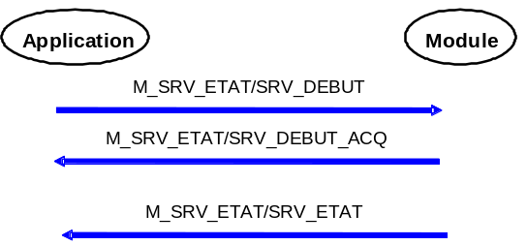
ETAT service running: One or more PYL statuses are changed
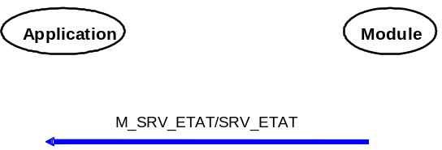
ETAT service stopped: One or more PYL statuses are changed
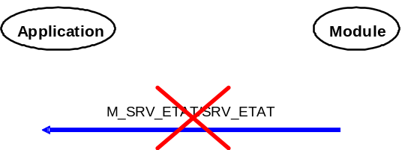
ETAT service running: Request for start service
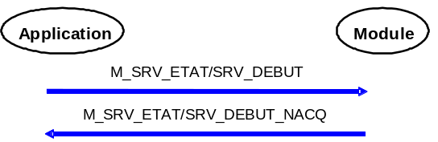
ETAT service running: Request for stop service
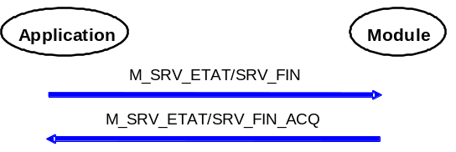

ETAT service stopped: Request for stop service
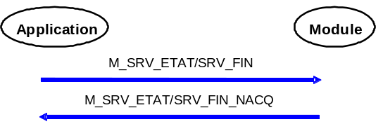

registry
Common registry keys
HKEY_LOCAL_MACHINE/SOFTWARE/CSROUTE/LaneControler/Config/Modules/EMI_PIC/BL_EMI_PIC
_Id | STRING | Module id
PriorityInit | DWORD | Threads priority on start
PriorityMax | DWORD | Threads priority after start
Pool | STRING | Reserved
BackupDirectory | STRING | Directory path for backup of files
EmissionPeriodMS | DWORD | Delay between transferring files to server, in milliseconds
LastPurgeDateTime | STRING | Date/time of the last purge, set by module
LocalDirectory | STRING | Directory path for file storage while waiting transfer
PurgePeriodDays | DWORD | Time (in days) how long the files should be kept in backup
PurgeTime | STRING | Time (in format hh:mm) when the purge should be performed
ReemissionPeriodMS | DWORD | Delay before reemission attempt

Version 1.0.0 specific registry
HKEY_LOCAL_MACHINE/SOFTWARE/CSROUTE/LaneControler/Config/Modules/EMI_PIC/BL_EMI_PIC
DayIsSubDir | DWORD | 1 on, 0 off – day information is used to create subfolder
MonthIsSubDir | DWORD | 1 on, 0 off – month information is used to create subfolder
YearIsSubDir | DWORD | 1 on, 0 off – year information is used to create subfolder
DispatchByLaneNumber | DWORD | 1 on, 0 off – Use the lane number to construct server directory or subdirectory where pictures will be copied
DispatchByDay | DWORD | 1 on, 0 off – Use the day to construct server directory or subdirectory where pictures will be copied
DispatchByMonth | DWORD | 1 on, 0 off – Use the month to construct server directory or subdirectory where pictures will be copied
DispatchByYear | DWORD | 1 on, 0 off – Use the year to construct server directory or subdirectory where pictures will be copied
ImageNameForamt | STRING | Expected format of the image file name where:  P – plaza number  L – lane number  Y – year  M – month  D – day  H – hour
ServerDirectory | STRING | Directory path for image destination on server

Version 2.0.2 specific registry

HKEY_LOCAL_MACHINE/SOFTWARE/CSROUTE/LaneControler/Config/Modules/EMI_PIC/BL_EMI_PIC
FileNameFormat | STRING | Expected format of the image file name where:  - "PLAZA" plaza, default length 3  - "LANE" lane, default length 2  - "YEAR" year, default length 4  - "MONTH" month, default length 2  - "DAY" day, default length 2  - "HOUR" hour, default length 2  - "MINUTE" minute, default length 2  - "SECOND" second, default length 2  - "MILLISECOND" millisecond, default length 3  - "ID" record id, default length 6  - "TRANSACTION" transaction, default length 6  - "GENERIC1" generic 1, default length 10  - "GENERIC2" generic 2, default length 10  Values in these elements is later used for creation of paths.  Number after “:” defines the length of data, in chars. For example, default default length of lane parameter is 3, so it can be defined as ;LANE; or ;LANE:3;, but if we want to use different data length, fore example 5, we can define it as ;LANE:5;  Example of the file name format:  P;PLAZA:4;_L;LANE:4;_;YEAR:4;;MONTH:2;;DAY:2;;HOUR:2;;MINUTE:2;;SECOND:2;;MILLISECOND:3;_R;ID:6;  Example of the file name that matches this format:  P1001_L0010_20091001120010123123456  Where plaza = 1001, lane = 0010, date is 01.10.2009., time is 12:00:10 and 123 milliseconds, ID is 123456  Same data elements are used as elements for creation of directories  Places for the data are defined between 2 semicolons (;), what is outside of that is treated as regular text.
ImportDirFormat | STRING | Format for creation of subdirectories in LocalDirectory when moving files from ImportDirectory  Example: ;YEAR:4;\\;MONTH:2;\\;DAY:2;\\;HOUR:2;  For the file from example in FileNameFormat key, the directory tree would be created as :  ‘local directory path’\2009\10\01\12\
ImportPeriodMS | DWORD | Delay between checking for new files in “ImportFromDir” directory (set to 0 to turn off)
UseTransmissionCounter | DWORD | Switch (1 = ON, 0 = OFF). If ON, files will internally be stored with transmission counters in file name (three digit number is added between file name and extension, eg. xxxx.001.jpg). Number represents count of successful transfers of file to configured destinations. Counter includes reemission of files.
ImportFromDir | STRING | Directory path to check for new files to transfer
HKEY_LOCAL_MACHINE\SOFTWARE\CsRoute\LaneController\Config\Modules\EMI_PIC\BL_EMI_PIC\ConfigDestinations
This key holds definitions for destinations for files (registry keys). There can be up to 10 defined destinations (registry keys), there is no strict rule for their names. Each of the subkeys must contain following keys and values
DestinationDir | STRING | Directory path to transfer files to
ExtensionDuringCopy | STRING | Temporary extension for files during copy. File will be renamed to original extension after it has been fully transferred (to avoid conflicts over files from different processes, if another process tries to access file before it has been fully transferred). Can be left blank if not used
PathFormat | STRING | Format for subdirectories to store files. If left blank, all files will be copied directly to directory defined in DestinationDir key
HKEY_LOCAL_MACHINE\SOFTWARE\CsRoute\LaneController\Config\Modules\EMI_PIC\BL_EMI_PIC\ConfigDestinations\*destination ame*\Filters
This key holds definition(s) for the filters for file extensions. Names of the filters are not strictly defined and there is no limit on number of filters. If filter value is defines as “*”, any file extension will match the filter
*filter name* | STRING | Extension of each file found in “LocalDirectory” key will be tested against all filters in all configured destinations. Only (and only if) filter and extension match, the file will be copied to directory defined in “DestinationDir” in subdirectories created by format in “PathFormat” key (if any) with values taken from file name.

