

GRID

Geotechnical Resilience through Intelligent Design

Deliverable 2.1
Report on statistical models with guideline for uncertainty quantification and risk management strategies

Tuesday, 19 May 2026

Deliverable administrative information
Deliverable number | 2.1
Deliverable title | Report on statistical models with guideline for uncertainty quantification and risk management strategies
Dissemination level
Submission deadline | 30.06.2026
Version number | 0.2
Authors | Tiancheng Wang (TUM)
Internal reviewers | -
Document approval

Legal disclaimer
GRID is funded by the European Union under the MSCA Staff Exchanges project 101182689 Geotechnical Resilience through Intelligent Design GRID. Views and opinions expressed are however those of the author(s) only and do not necessarily reflect those of the European Union or European Research Executive Agency (REA). Neither the European Union nor the granting authority can be held responsible for them.
Copyright © GRID Consortium, 2026

 | https://zenodo.org/communities/grid
 | https://cordis.europa.eu/project/id/101182689
 | https://www.youtube.com/@GRID-Proj
 | https://github.com/GRID-Proj
For further information please visit https://grid.boku.ac.at

Executive summary
This report presents statistical models for representing variability and uncertainty in geotechnical engineering, together with a practical guideline for uncertainty quantification and risk-oriented interpretation. The report retains probabilistic subsoil modeling as its main methodological basis and extends the discussion to two complementary sources of geotechnical uncertainty: structured inhomogeneity of material state variables and uncertainty in data-driven predictive models under sparse experimental data. The report outlines how uncertainty can be quantified and visualized at model level, and how the resulting uncertainty information can support risk-informed interpretation, targeted review, model validation, and model updating in engineering practice. In this way, Deliverable D2.1 provides the conceptual and methodological foundation for uncertainty quantification and risk management strategies, while Deliverable D2.2 will further translate this foundation into a reproducible implementation and repository-based user guidance.

Table of contents
Deliverable administrative information 2
Legal disclaimer 3
Executive summary 5
Table of contents 6
List of figures 8
1 Introduction 10
2 Subsoil Modeling Methodology 12
2.1 Overview of subsoil modeling strategies 12
2.2 Geostatistical Approach 14
2.2.1 Variography 14
2.2.2 Kriging 17
2.2.3 Geostatistical Simulation 19
2.2.3.1 Sequential Gaussian Simulation 21
2.2.3.2 Sequential Indicator Simulation 21
2.3 Structured material inhomogeneity 22
2.4 Data-driven predictive models under sparse data conditions 23
3 Uncertainty Quantification Guideline and Practical Interpretation 26
3.1 Statistical Aggregation of Realizations 27
3.2 Measures for Uncertainty 27
3.2.1 Information Entropy 28
3.2.2 Variability 28
3.3 Practical Interpretation of Uncertainty 30
3.4 Risk-Oriented Interpretation 31
4 Conclusions 33
5 Limitations and Recommendations 34
References 36

List of figures
Figure 1: Subsoil modeling decision (modified after [13]) 12
Figure 2: Overview of geostatistical modeling methods (taken from [7]); green: method adopted in this report. 13
Figure 3: Semivariogram search mask and parameters (a) and example application (b) (adopted from [5]) 15
Figure 4: Semivariogram models illustrating exponential and Gaussian structures with identical range $a$, including the nugget effect and sill. Semivariance $γ$ is plotted as a function of lag distance $h$. 16
Figure 5: a) Kriging estimation at $x0$ from three known data points, $x1$, $x2$, and $x3$, and b) derivation of covariance values using the semivariogram (taken from [16]) 17
Figure 6: Geostatistical simulation steps: (A) setup of a grid, (B) simulation, (C) generation of realizations, and (D) summary, taken from [5] 20
Figure 7: Comparison between conditional structured representation (a,b) and weakly conditional unstructured representation (c,d) of void-ratio variability, adapted from [19] 22
Figure 8: Multi-fidelity data strategy for data-driven constitutive modeling under limited experimental data, adapted from [20] 24
Figure 9: Variability and Entropy as measures for uncertainty [24] 29
Figure 10: Voxel-wise entropy visualization of a 3D probabilistic subsoil model. High entropy values (red) indicate spatial zones of elevated uncertainty, whereas low entropy values (blue) correspond to areas of comparatively high model confidence. 30

List of tables
Table 1: Practical interpretation of uncertainty indicators for risk-informed decision support 31

Introduction
Reliable subsoil characterization is a fundamental requirement for the planning and delivery of infrastructure projects [1], [2]. Ground conditions directly influence design choices, construction methods, project costs and safety [3]. In practice, unforeseen subsurface conditions remain one of the major causes of delays, budget overruns, and technical complications, particularly in projects involving foundations, excavations, tunnels, and other underground works. For this reason, subsoil modeling plays a central role in reducing geological uncertainty and supporting sound engineering decisions.
Conventional subsoil models are often developed using deterministic approaches. These methods typically provide a single interpreted representation of the subsurface based on available site investigation data [4]. While such models are useful for general visualization and design reference, they do not explicitly describe the uncertainty associated with sparse data, spatial variability, or interpretative assumptions [5]. As a result, deterministic models may create an impression of certainty that is not fully supported by the underlying information.
Probabilistic approaches provide a more suitable framework for representing subsurface uncertainty [6]. In contrast to deterministic methods that deliver a single interpreted outcome, probabilistic methods explicitly describe the degree of confidence associated with subsurface predictions. Depending on the modeling approach, this uncertainty may be represented either through multiple equally plausible realizations of the subsurface or through direct estimates of probabilities, class memberships, or other uncertainty-related metrics [7], [8], [9].
Within probabilistic subsoil modeling, geostatistical simulation provides a particularly suitable framework for representing spatial uncertainty [5], [7]. In contrast to methods that only deliver local probability estimates, geostatistical simulation aims to reproduce the spatial continuity and heterogeneity of the subsurface while remaining conditioned to the available site investigation data [10]. By generating multiple conditional realizations that honour both observations and the inferred spatial correlation structure, this approach allows uncertainty to be assessed not only locally, but also in terms of the overall geological architecture and its spatial variability [11].
This report adopts a geostatistical simulation workflow based on the combined application of Sequential Indicator Simulation (SISIM) and Sequential Gaussian Simulation (SGSIM) for probabilistic subsoil modeling. Rather than addressing uncertainty through generic probabilistic descriptions, the present approach derives uncertainty explicitly from conditional stochastic realizations. SISIM is used for categorical geological variables, such as lithological facies or stratigraphic classes, while SGSIM is applied to continuous geometric variables, such as the elevation of relevant subsurface boundaries. The two simulation methods are combined within a hierarchical workflow in order to reproduce the principal geological architecture of the subsurface and to generate multiple equally plausible model realizations conditioned to the available investigation data.
The resulting realizations are subsequently evaluated to quantify spatial uncertainty in terms of occurrence probability, local variability, and entropy. The aim is to provide a reproducible methodological basis for uncertainty quantification that is consistent with the adopted geostatistical modeling strategy and suitable for practical geotechnical interpretation.
Furthermore, the report does not restrict uncertainty to the final 3D subsoil model alone. Instead, it considers uncertainty at three complementary levels. The first level is the spatial uncertainty of the site-scale subsoil model, addressed through geostatistical simulation and voxel-wise uncertainty indicators. The second level is the structured inhomogeneity of geotechnical state variables, such as void ratio, which can influence strain localization and the interpretation of laboratory tests. The third level is the uncertainty associated with data-driven predictive models developed from limited experimental data. This structure allows the report to connect probabilistic subsoil modeling with material-scale variability and model validation, while still keeping the main focus on statistical models and practical uncertainty quantification.

Subsoil Modeling Methodology

Overview of subsoil modeling strategies
Subsoil models can generally be developed using either deterministic or probabilistic approaches [12]. Deterministic methods aim to produce a single interpreted representation of the subsurface, whereas probabilistic methods seek to describe the uncertainty associated with that interpretation. In practical engineering applications, deterministic approaches remain widely used because they are comparatively simple to implement and provide a direct basis for visualization and design.
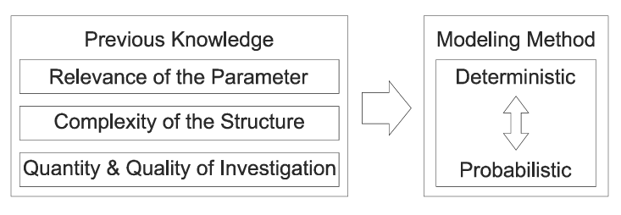
Figure 1: Subsoil modeling decision (modified after [13])
Among deterministic approaches, implicit modeling based on interpolation is particularly common. In this context, geological boundaries or subsurface properties are estimated at unsampled locations from available site investigation data. Typical interpolation methods include inverse distance weighting, radial basis functions, and geostatistical interpolation techniques such as kriging. Linear or triangulation-based interpolation methods are computationally efficient, but they often provide only a geometric connection between boreholes and may not adequately represent the natural variability of geologically formed ground. Radial basis function methods allow smoother surface reconstruction, especially for irregularly spaced data, but their performance depends strongly on the selected basis function and they do not explicitly account for spatial correlation structures.
Geostatistical interpolation methods such as kriging provide a more rigorous basis for prediction because they incorporate spatial correlation through variogram modeling [14]. However, despite their statistical foundation, interpolation-based approaches still typically result in a single deterministic estimate. In areas with sparse data, this may lead to overly smoothed model results and does not sufficiently reflect the uncertainty associated with geological heterogeneity, limited observations, and interpretative assumptions [15].
For this reason, probabilistic geostatistical modeling methods are of particular relevance for subsoil modeling. In contrast to deterministic interpolation, these methods generate multiple conditional realizations that honor both the available data and the inferred spatial continuity of the subsurface. This enables uncertainty to be represented explicitly and assessed not only locally, but also with respect to the overall geological architecture.
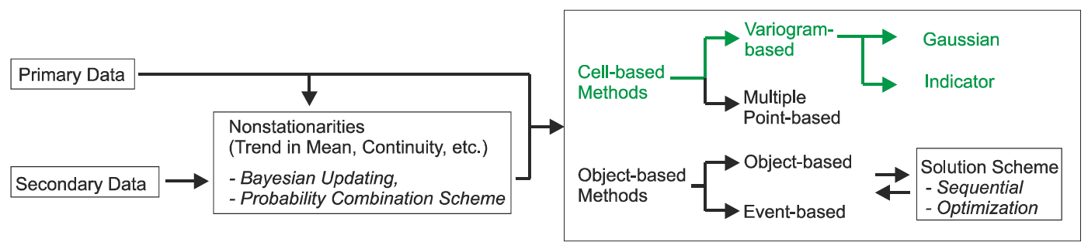
Figure 2: Overview of geostatistical modeling methods (taken from [7]); green: method adopted in this report.
Within this framework, different simulation methods are required depending on the type of variable to be modeled. Sequential Gaussian Simulation (SGSIM) is used for continuous variables, such as subsurface boundary elevations, whereas Sequential Indicator Simulation (SISIM) is applied to categorical variables, such as lithological or stratigraphic units [7], [11]. In the present report, these two methods are combined within a hierarchical geostatistical workflow in order to represent both continuous and categorical aspects of the subsurface and to derive uncertainty measures from multiple conditional realizations.

Geostatistical Approach
Geostatistical methods provide a suitable framework for probabilistic subsoil modeling because they explicitly account for spatial continuity and allow uncertainty to be represented through conditional simulation. In this way, they can generate multiple plausible realizations of the subsurface while remaining consistent with the available site investigation data.
The following section outlines the Kriging interpolation method, which is a fundamental geostatistical estimation method that uses the variogram model to predict unknown values from surrounding observations [13]. Its objective is to provide an optimal linear estimate while accounting for spatial correlation [7], [11].

Variography
This spatial correlation information, captured by the variogram, forms the basis for kriging estimation, where it is used to derive the covariance structure and subsequently determine the weights assigned to neighbouring observations. The semivariogram is the key tool in kriging, describing how the variance of differences between data points varies with their separation distance [16]. It forms the basis of geostatistical modeling by describing the spatial correlation structure of the available data. In practical terms, it is used to quantify how strongly values at nearby locations resemble each other and how this similarity decreases with increasing spatial separation. This information is required to parameterize both kriging and sequential simulation methods.
The first step of variography analysis is the calculation of an experimental semivariogram from the available data. The semivariogram expresses the average squared difference between values separated by a given lag distance and direction. It can be written as:
$$γ\left(h\right)=\frac{1}{2}*\frac{\sum_{i=1}^{\left.n(h\right)}{\left(z\left(x\right)-z(x+h))²\right.}}{\left.n(h\right)}$$
where $Z\left(x\right)$ denotes the variable of interest at location $x$, and $h$ is the separation vector. Prior to variogram analysis, the data should be examined for outliers and trends and adjusted if necessary. When the distribution is highly skewed, a transformation can be applied to approximate normality. Variogram calculation is typically performed using a binning approach that groups data pairs according to their separation distance (see Figure 3).
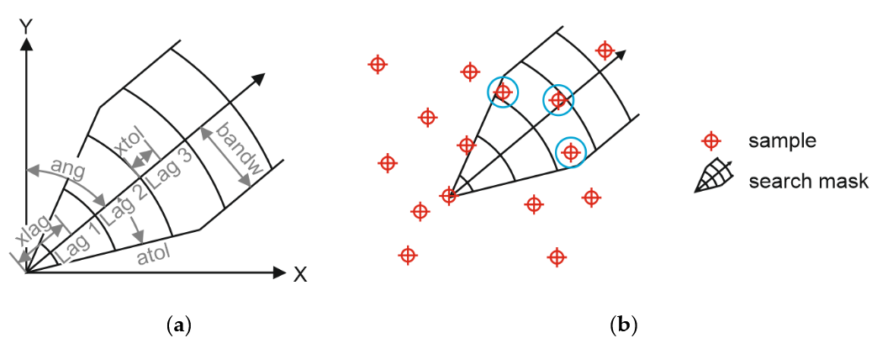
Figure 3: Semivariogram search mask and parameters (a) and example application (b) (adopted from [5])
To account for anisotropy, semivariograms are computed in multiple spatial directions. The experimental semivariogram obtained is subsequently approximated by a theoretical model, such as an exponential function, or a Gaussian function:
$$Exponential: γ\left(h\right)=c_{0}+C\left(1-\exp\left(-\frac{3h}{a}\right)\right)$$
$$Gaussian: γ\left(h\right)=c_{0}+C\left(1-\exp\left(-{\left(\frac{3h}{a}\right)}^{2}\right)\right)$$
where $a$ is the range, $C$ is the maximum value of the semivariance [16]. The range describes the distance over which spatial correlation remains relevant, the sill represents the overall variance level, A non-zero semivariance at very short separation distances is commonly interpreted as measurement uncertainty or microscale variability and is referred to as the nugget effect $c_{0}$, it accounts for short-scale variability and measurement uncertainty.
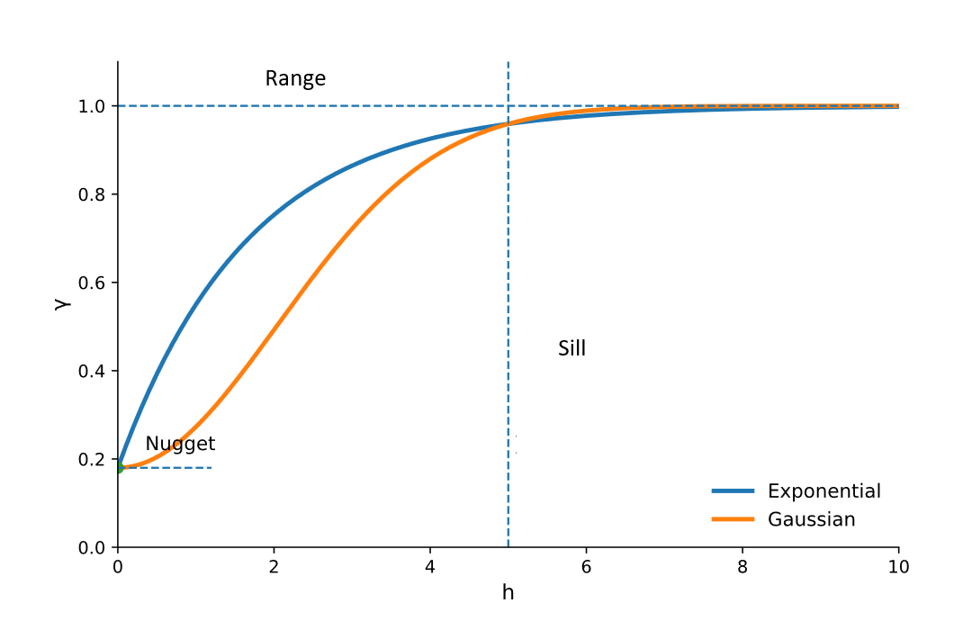
Figure 4: Semivariogram models illustrating exponential and Gaussian structures with identical range $a$, including the nugget effect and sill. Semivariance $γ$ is plotted as a function of lag distance $h$.
Variogram modeling should not be understood as a purely automatic fitting exercise. It requires both statistical analysis and geological judgement. Before variographic analysis, the dataset should therefore be checked for inconsistencies, trends, and implausible outliers. For skewed continuous variables, transformation to a normal-score domain may also be necessary, depending on the subsequent simulation method.
An important aspect of geostatistical estimation is anisotropy. In many geological settings, spatial continuity is direction-dependent, meaning that similarity does not decrease equally in all directions. This behaviour is represented by directional variograms and incorporated into kriging through anisotropic covariance modelling. In practical terms, the ranges along the principal directions may be represented by an ellipse in two dimensions or an ellipsoid in three dimensions, allowing the covariance model to reflect geological continuity more realistically in the dominant directions of sedimentation, erosion, or stratigraphic extension.

Kriging
Based on the variogram model, the spatial correlation structure can be expressed in terms of covariance, which forms the basis for determining the kriging weights. The covariance between locations is obtained from the semivariogram by subtracting the semivariance from the sill.
The kriging weights are determined by solving a system of linear equations that ensures an optimal and unbiased estimate. This system can be written as [7], [16]:
$$\sum_{β=1}^{n}{λ_{β}C\left(x_{β}-x_{α}\right)}=C\left(x_{u}-x_{α}\right), α=1,…,n$$
where $C(x_{β}-x_{α})$ represents the covariance between observed data points and $C(x_{u}-x_{α})$ denotes the covariance between the unknown location and the observations.
Schematically, Figure 5a illustrates a configuration of known data points used to estimate the value at an unsampled location:
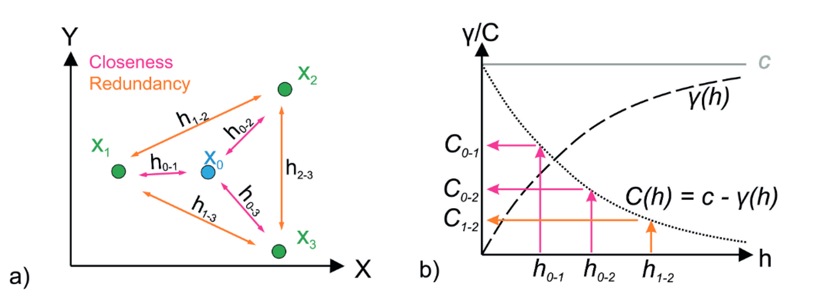
Figure 5: a) Kriging estimation at $x_{0}$ from three known data points, $x_{1}$, $x_{2}$, and $x_{3}$, and b) derivation of covariance values using the semivariogram (taken from [16])
The distances between these points are used to derive covariance values from the semivariogram Figure 5b. Based on this configuration, the kriging system can be expressed in matrix form, which allows the weights to be obtained by solving a system of linear equations, typically using Lagrange multipliers as a standard optimization method [11], [16]:
$$\left[\begin{matrix} 0 & C_{1-2} & C_{1-3} \\ C_{2-1} & 0 & C_{2-3} \\ C_{3-1} & C_{3-2} & 0\end{matrix}\right]\left[\begin{matrix}λ_{1} \\ λ_{2} \\ λ_{3}\end{matrix}\right]=\left[\begin{matrix}C_{0-1} \\ C_{0-2} \\ C_{0-3}\end{matrix}\right]$$
This system balances two competing effects: observations that are closer and more strongly correlated with the target location receive higher weights, while redundant information among neighbouring points is reduced. Solving this system yields the kriging weights, which are then used to compute the final estimate:
$$z^{*}\left(x_{u}\right)=m+\sum_{α=1}^{n}{λ_{α}\left(z\left(x_{α}\right)-m\right)}$$
where the kriging estimate at an unsampled location $x_{u}$ is expressed as a weighted linear combination of neighbouring observations. The weights $λ_{α}$ are determined based on the spatial correlation structure of the data and ensure an unbiased estimate. In contrast to purely distance-based interpolation methods, the kriging weights are not assigned solely according to geometric proximity. Instead, they are derived from the fitted spatial covariance structure of the variable. As a result, nearby observations with strong covariance to the target location generally receive higher weights, whereas clustered observations may receive reduced influence because their information is partly redundant. Therefore, Kriging delivers the best linear unbiased estimate while explicitly honouring the spatial structure captured by the variogram [11].
The kriging variance can be calculated at the interpolated locations with the following equation [11]:
$$σ^{2}\left(x_{u}\right)=C\left(0\right)-\sum_{α=1}^{n}{λ_{α}C\left(x_{u}-x_{α}\right)}≥0$$
It can be observed that the kriging variance primarily depends on the spatial configuration of the known data points and their distances to the estimation location, but not on the actual observed values. Consequently, it does not fully reflect geological variability. For instance, if two neighbouring boreholes indicate identical soil conditions, the uncertainty between them is expected to be lower than in cases where contrasting soil types are observed [5]. However, this distinction is not captured by the kriging variance [16].
Therefore, kriging variance alone is not sufficient for a comprehensive quantification of subsurface uncertainty. To address this limitation, the sequential simulation methods described in the following section are applied, allowing uncertainty to be evaluated based on multiple conditional realizations rather than a single estimation [7].

Geostatistical Simulation
Kriging remains an estimation method and therefore produces a single smoothed solution. Geostatistical simulation extends the kriging concept from estimation to stochastic realization [7], [11], [17]. Instead of computing a single best-estimate value, geostatistical simulation generates multiple equally plausible realizations of the subsurface, thereby enabling an explicit representation of spatial uncertainty.
In sequential simulation, values are drawn from a local conditional distribution defined by the available data and the spatial correlation model. This process is performed along a random path through the model grid. At each grid node, the conditional distribution is estimated based on nearby observations and previously simulated nodes, and a value is sampled from this distribution. Repeating this procedure for all grid nodes yields one realization of the subsurface. Multiple repetitions generate an ensemble of realizations, which collectively represent spatial uncertainty [7], [11], [18].
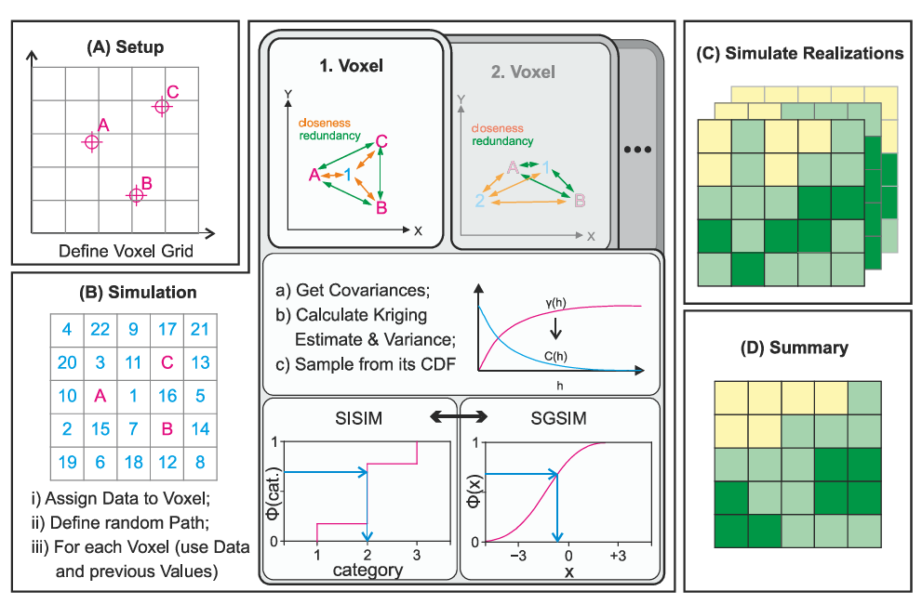
Figure 6: Geostatistical simulation steps: (A) setup of a grid, (B) simulation, (C) generation of realizations, and (D) summary, taken from [5]
The general sequential simulation workflow adopted for both Sequential Gaussian Simulation (SGSIM) and Sequential Indicator Simulation (SISIM) is illustrated in Figure 6. It consists of grid definition, node-by-node simulation along a random path, generation of multiple realizations, and statistical summarization of the results.
In Step A, a simulation grid and coordinate system are defined, typically in two or three dimensions. In Step B, the simulation is performed by first conditioning the model to available borehole data and then traversing the grid along a random path. At each node, nearby data and previously simulated values are identified, and the covariance structure derived from the variogram is used to estimate the local conditional distribution. Depending on the simulation method, this distribution is represented either as a Gaussian distribution (SGSIM) or as a discrete cumulative distribution function (SISIM). A value is then sampled from this distribution.
In Step C, the simulation is repeated multiple times to generate a set of realizations representing different possible subsurface configurations. In Step D, these realizations are statistically summarized, for example by calculating the mean, variance, or class probabilities at each voxel, providing insight into both the most likely structure and the associated uncertainty.
The following sections present the detailed methodologies of SGSIM and SISIM as applied in this study.

Sequential Gaussian Simulation
The SGSIM is performed in Gaussian space. Therefore, the input data are typically transformed to a standard normal distribution prior to simulation. At each simulation node, a local conditional Gaussian distribution is defined from the kriging mean and variance, and one value is randomly sampled from this distribution. After the simulation, the results are back-transformed to the original data space.
In subsoil modeling, SGSIM is particularly suitable for continuous geometric variables, such as the elevation of relevant subsurface boundaries or erosional surfaces. By generating multiple conditional realizations, SGSIM enables the uncertainty of these continuous model components to be quantified in terms of statistics such as mean, quantiles, and variance.

Sequential Indicator Simulation
SISIM is applied to categorical variables. In this approach, geological classes are transformed into indicator variables, and local conditional probabilities are estimated for each category. At each simulation node, the final class is sampled from the corresponding conditional distribution.
SISIM is particularly suitable for lithological units, facies, or stratigraphic classes, where the objective is to represent the spatial distribution of discrete geological categories. By generating multiple realizations, SISIM provides the basis for deriving class probabilities and other categorical uncertainty measures.

Structured material inhomogeneity
The geostatistical workflow described above addresses spatial uncertainty in the final subsoil model. However, geotechnical variability also occurs at the material and specimen scale. In this context, structured inhomogeneity refers to spatially organized variations of state variables, such as void ratio, fabric, density, stiffness, or strength, rather than purely uncorrelated randomness. Such inhomogeneity is relevant because laboratory specimens and ground volumes are rarely perfectly uniform, even when they are prepared from the same material or interpreted as a single geological unit [19].
A representative example is the statistical modeling of initial void ratio fields. In the related GRID publication on strain localization [19], void ratio is treated as a spatially variable state variable and represented using conditional random fields. The random field is generated with a prescribed spatial correlation structure and then transformed so that its marginal distribution follows a physically meaningful void-ratio distribution. In this way, the model represents both the global state of the specimen and the local spatial variability of the material [19].
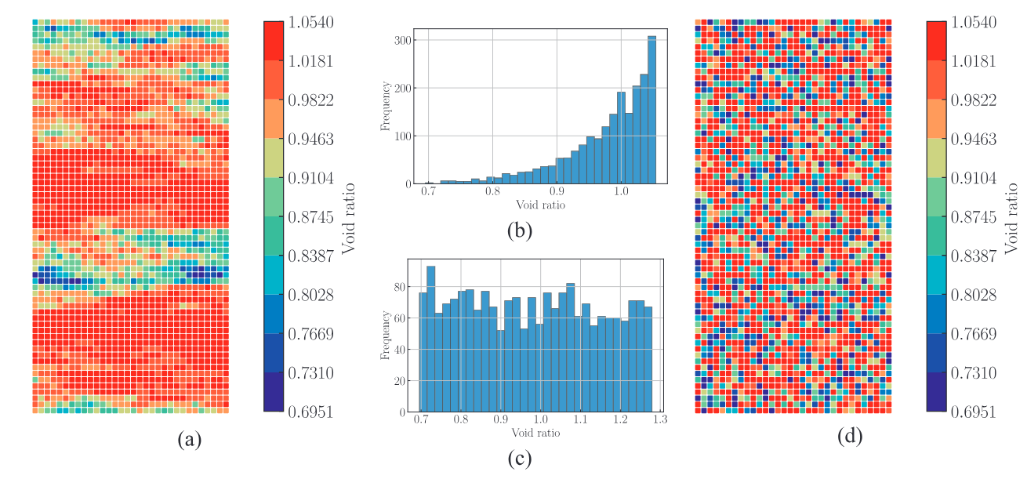
Figure 7: Comparison between conditional structured representation (a,b) and weakly conditional unstructured representation (c,d) of void-ratio variability, adapted from [19]
Figure 7 illustrates that statistical modeling of geotechnical uncertainty is not limited to site-scale geological boundaries or lithological classes, but can also be applied to state-variable inhomogeneity at the material scale.
This material-scale perspective is important for uncertainty quantification because different realizations of a structured state field may lead to different localization patterns, including diffuse deformation, single shear bands, or multiple shear bands. The analysis therefore shows that part of the observed macroscopic response may arise from structural inhomogeneity rather than from the intrinsic constitutive behavior alone. For geotechnical risk interpretation, this means that uncertainty is not only associated with unknown geological boundaries, but also with the spatial organization of material states that influence deformation mechanisms and failure modes.

Data-driven predictive models under sparse data conditions
A further source of uncertainty arises when predictive geotechnical models are developed from sparse, expensive, or noisy experimental data. This aspect is addressed by the related GRID publication on physics-encoded neural networks for constitutive modeling [20]. In that work, synthetic data generated from a reference constitutive model are used to pre-train a physics-encoded neural network, which is then fine-tuned using high-fidelity experimental records. This multi-fidelity strategy provides a practical way to combine the broad coverage of synthetic data with the realism of laboratory observations [20].
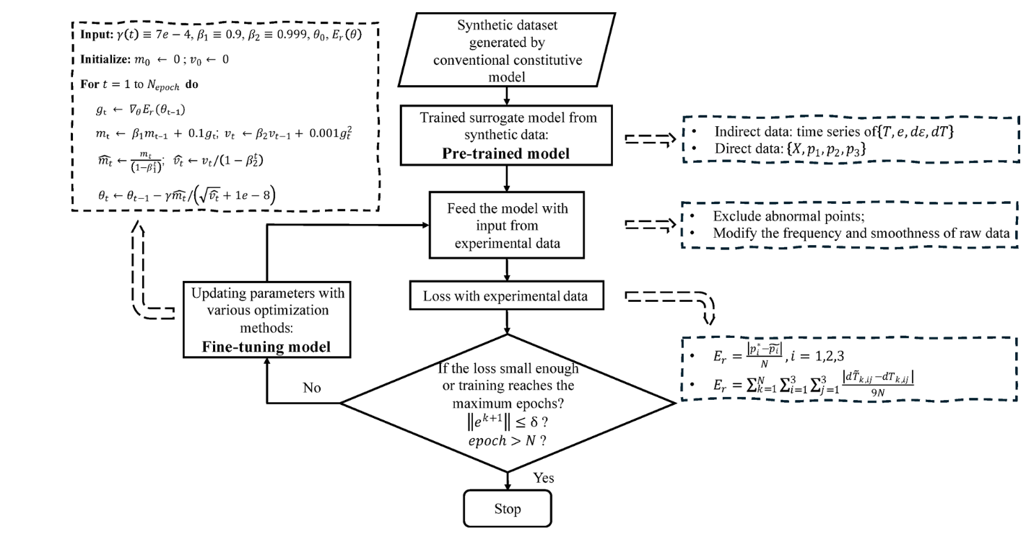
Figure 8: Multi-fidelity data strategy for data-driven constitutive modeling under limited experimental data, adapted from [20]
The relevance for this deliverable is not the detailed neural-network architecture, but the uncertainty-aware modeling logic. Limited experimental data create uncertainty in the calibrated model, while purely data-driven fitting may lead to models that reproduce training curves but fail in finite-element boundary value simulations. Therefore, the performance of predictive geotechnical models should be assessed not only by loss values or curve-fitting metrics, but also by their convergence behavior, compliance with known physical phenomena, and robustness under boundary conditions relevant to engineering applications [20].
Within the D2.1 framework, this provides a bridge between uncertainty quantification and risk management. A model that is statistically well fitted but physically unstable may introduce practical risk if it is used for design simulations. Consequently, validation at the intended application level, including finite-element simulations and checks of key geotechnical phenomena, should be considered part of the uncertainty-management strategy.
Together with the geostatistical and structured-inhomogeneity examples discussed above, this highlights that uncertainty quantification in geotechnical engineering should address not only spatial variability in the subsoil model, but also material-scale variability and predictive-model reliability. In the following chapter, the practical guideline focuses primarily on realization-based uncertainty quantification for the final voxel-wise subsoil model, because this represents the main probabilistic modeling output of the present deliverable. Material-scale variability and predictive-model reliability are considered as complementary aspects in the subsequent interpretation and risk-management discussion.

Uncertainty Quantification Guideline and Practical Interpretation
In infrastructure projects, the uncertainty related to geological and geotechnical conditions frequently represents the most considerable risk [2]. Unexpected geological or geotechnical conditions can lead to several risks, including ground settlement, tunnel blockages, excessive wear on excavation tools, significant groundwater inflows, and obstacles like boulders and geological lenses. These issues can cause slower tunneling progress, project delays, increased costs, damage to nearby infrastructure, or harm to construction equipment. Despite comprehensive site investigations and testing in underground construction and tunneling (UCT) projects, significant uncertainties in geological and geotechnical parameters continue to pose challenges [21].These uncertainties persist even though UCT projects typically involve more extensive investigative efforts compared to other geotechnical endeavors. This highlights the inherent complexity and variability of geological conditions, underscoring the need for ongoing research and adaptation in geotechnical engineering practices, primarily due to the inherent spatial variability of soil and rock characteristics, which cannot be fully captured by solely employing univariate and multivariate analyses of site investigation data [2], [22].
To capture the spatial uncertainties of geological and geotechnical parameters in geotechnical projects that cannot be gathered through field investigation alone, employing geostatistics to analyze soil spatial variability is a reasonable approach. The disciplines of geostatistics and random field theory facilitate the spatial analysis of data, encompassing geological and geotechnical conditions. The geostatistical workflow described in Chapter 3 generates multiple realizations of the final voxel-wise subsoil model. Uncertainty quantification is therefore performed directly on the ensemble of realizations rather than on the intermediate simulation variables separately. For each voxel, the simulated geological class is evaluated across all realizations in order to derive statistical measures that describe the local degree of uncertainty.
This ensemble-based approach allows the uncertainty of the final subsoil model to be quantified in a spatially explicit manner. The most important outputs are voxel-wise class probabilities, from which further indicators such as the most likely class, Shannon entropy, and variability can be derived. In this way, uncertainty is assessed directly at the scale of the final model representation used for interpretation and decision support.

Statistical Aggregation of Realizations
Each realization represents one plausible configuration of the subsoil model under the adopted geostatistical assumptions. By comparing all realizations voxel by voxel, the frequency of occurrence of each geological class can be calculated. These frequencies are interpreted as estimates of voxel-wise class probabilities.
For a voxel $x$, the probability of class $i$ is defined as:
$$p_{i}\left(x\right)=\frac{n_{i}\left(x\right)}{N}$$
where $n_{i}\left(x\right)$ is the number of realizations in which class $i$ occurs at voxel $x$, and $N$ is the total number of realizations. The most likely class at a given voxel is then the class with the highest probability.
This voxel-wise probability distribution forms the basis of all subsequent uncertainty measures. It allows the final probabilistic subsoil model to be represented not only by a most likely classification, but also by an explicit description of local prediction confidence.

Measures for Uncertainty
The primary uncertainty output is the voxel-wise class probability distribution. From this distribution, additional indicators can be derived in order to summarize local uncertainty in a compact and interpretable form.

Information Entropy
A widely used measure is Shannon entropy. For a voxel $x$, the definition of entropy is (SHANNON 1948):
$$H_{Norm}=\frac{\sum_{i}^{N}{\left(p_{i}\log\left(p_{i}\right)\right)}}{\log\left(1/N\right)}, with i = 1, ..., k$$
where $p_{i}(x)$ is the probability of class $i$, and $k$ is the number of possible classes. The normalization ensures that entropy values range from 0 to 1. Low entropy indicates that one class clearly dominates and the local prediction is therefore comparatively certain. High entropy indicates that several classes have similar probabilities, which implies a more ambiguous prediction.
Compared with visual representations of probabilistic estimations [23], information entropy provides a clear advantage by summarizing the probabilities of multiple soil layers into a single numerical indicator for each sub-region of the model.

Variability
A second indicator is variability, defined as:
$$V\left(x\right) = 1 - p_{max}\left(x\right)$$
where $p_{max}(x)$ is the probability of the most likely class at voxel $x$. Variability directly expresses how uncertain the dominant class prediction is [10], [23]. A low variability value indicates high local confidence, whereas a high variability value indicates that the predicted class is not strongly supported relative to the alternatives.
Both indicators provide useful but slightly different perspectives. Entropy reflects the overall spread of the full probability distribution and is sensitive to the relative contribution of all classes. Variability is more direct and easier to interpret in engineering practice, because it is immediately linked to the confidence in the most likely class. For this reason, variability is particularly suitable for communication and decision support, while entropy provides additional information on the internal structure of uncertainty.
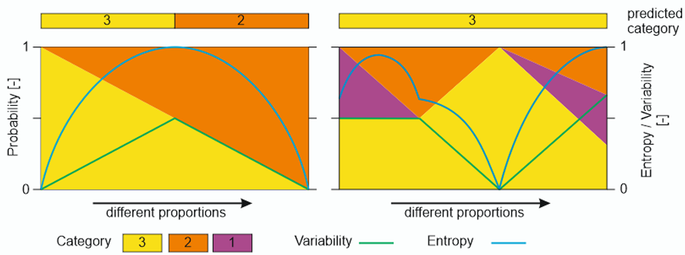
Figure 9: Variability and Entropy as measures for uncertainty [24]
Figure 9 illustrates the difference between both measures. In the two-class case, entropy is more sensitive at low uncertainty levels, whereas variability changes linearly with the probability of the dominant class. In the multi-class case, entropy is strongly influenced by the distribution of minority classes, while variability remains controlled only by the most probable class. As a result, entropy captures the overall structure of uncertainty in greater detail, whereas variability provides a more direct indication of local prediction confidence.
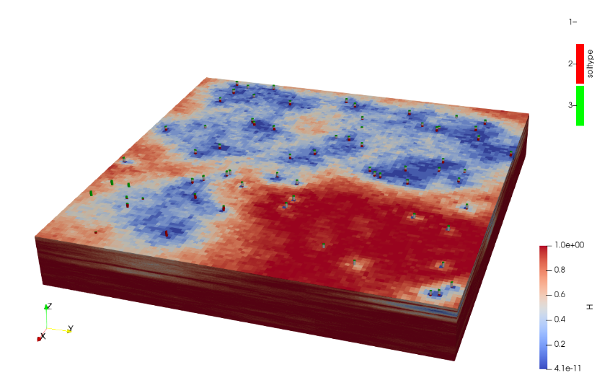
Figure 10: Voxel-wise entropy visualization of a 3D probabilistic subsoil model. High entropy values (red) indicate spatial zones of elevated uncertainty, whereas low entropy values (blue) correspond to areas of comparatively high model confidence.
An example of entropy-based uncertainty visualization in a 3D probabilistic subsoil model is shown in Figure 10. The voxel-wise entropy distribution makes it possible to identify spatial patterns of model uncertainty directly within the predicted subsurface volume. Zones with high entropy, shown in red, indicate areas where the predicted geological class distribution is more diffuse and the model outcome is therefore less certain. By contrast, zones with low entropy, shown in blue, represent areas of higher local confidence, where one class clearly dominates across the realizations. In this way, entropy provides an intuitive spatial overview of where the model is robust and where the geological interpretation remains uncertain.
However, entropy or variability-based indicators should not be interpreted as a complete measure of geological uncertainty. In areas with very limited or unevenly distributed conditioning data, the model may still assign a dominant class with high probability due to strong model assumptions. This can lead to apparently low entropy and therefore to an overconfident interpretation, although the actual data support is weak. For this reason, entropy should be interpreted together with additional information, such as distance to conditioning data, model assumptions, and engineering relevance.
In this way, entropy provides an intuitive spatial overview of where the model prediction is internally stable and where the geological interpretation remains uncertain.

Practical Interpretation of Uncertainty
The uncertainty indicators should not be interpreted in isolation, but in relation to the geological setting and the engineering relevance of the modeled zone. Areas with low entropy and low variability indicate robust model predictions and comparatively high local confidence. By contrast, high entropy or high variability highlight zones where the geological classification is ambiguous and where the model result should be treated with greater caution.
Such zones do not automatically imply model failure. In many cases, they reflect sparse data support, transitional geological conditions, or genuinely complex subsurface architecture. Nevertheless, their identification is highly valuable for engineering interpretation, because they indicate where additional investigation, refined modeling, or conservative design assumptions may be required.
Table 1 provides a practical interpretation framework for linking model uncertainty indicators to engineering relevance and possible project-level actions. It serves as a bridge between the interpretation of uncertainty indicators and the risk-oriented discussion in the following section.
Table 1: Practical interpretation of uncertainty indicators for risk-informed decision support
Uncertainty condition | Engineering relevance | Suggested interpretation | Possible action
Low entropy / low variability | Low | Robust model zone with limited engineering impact | Use as general reference information
Low entropy / low variability | High | Reliable model zone for engineering interpretation | Use for design interpretation, while documenting input data and modeling assumptions
High entropy / high variability | Low | Uncertain model zone with limited practical consequence | No immediate additional investigation required
High entropy / high variability | High | Critical uncertain zone with possible engineering impact | Review model assumptions, check data support, and consider additional investigation or conservative design assumptions
Local high uncertainty near geological interfaces | Medium to high | Possible transitional zone, boundary ambiguity, or insufficient borehole support | Check borehole evidence, stratigraphic consistency, and sensitivity to modeling assumptions
High uncertainty near safety-relevant structures or construction zones | High | Potential design or construction risk | Prioritize targeted review, update the model if new data are available, and consider risk-reducing measures

Risk-Oriented Interpretation
Quantified uncertainty should not be interpreted as risk itself. Risk depends on both the level of uncertainty and the engineering relevance of the affected zone or model component. Nevertheless, spatial uncertainty information provides an essential basis for risk-informed decision-making, because it identifies where the geological prediction is robust and where additional caution is required. In this sense, uncertainty indicators such as voxel-wise probabilities, entropy, and variability support the prioritization of review, investigation, and model updating.
Areas of elevated uncertainty should not automatically lead to additional investigation. Instead, supplementary investigations are most justified where high uncertainty coincides with high engineering relevance. This applies particularly to zones in which the geological model directly influences design assumptions, construction methods, or safety-related assessments.
The probabilistic subsoil model should therefore be understood as an updateable decision-support model rather than as a fixed final product. When new borehole data or revised geological interpretations become available, the model should be re-evaluated and, where necessary, updated accordingly. To maintain transparency and traceability, such updates should follow a consistent versioning principle, including documentation of the input data basis, major modeling assumptions, and the date of model revision.
The uncertainty indicators derived from the geostatistical realization ensemble should therefore be understood not as risk measures themselves, but as a basis for risk-informed interpretation. Their main practical value lies in identifying zones of reduced model robustness, supporting targeted review of engineering-critical areas, and guiding model updates when new investigation data become available.

Recommended workflow for uncertainty interpretation
Based on the methodological principles described above, uncertainty quantification should be carried out through a structured workflow that links data preparation, geostatistical modeling, realization-based uncertainty assessment, and engineering interpretation.
- Collect and organize the available geotechnical and geological data, including borehole logs, interpreted geological units, relevant boundary elevations, and other project-specific information.
- Check and clean the input data. This includes reviewing inconsistent borehole descriptions, implausible outliers, missing values, duplicated records, coordinate errors, and possible inconsistencies in lithological or stratigraphic classification.
- Define the modeling domain and grid resolution according to the engineering purpose, data density, and expected geological complexity. The grid should be fine enough to represent relevant structures, but not imply a level of precision that is unsupported by the available data.
- Separate the variables according to their data type. Continuous variables, such as boundary elevations or erosional surfaces, should be treated differently from categorical variables, such as lithological classes or stratigraphic units.
- Perform exploratory data analysis and variography. Spatial trends, anisotropy, directional continuity, nugget effects, sill, and range should be reviewed before selecting and fitting suitable variogram models.
- Select the appropriate geostatistical simulation method. Sequential Gaussian Simulation may be used for continuous variables after suitable transformation, whereas Sequential Indicator Simulation may be used for categorical geological classes.
- Generate multiple conditional realizations of the subsoil model. The realizations should honour the available data and reproduce the adopted spatial correlation structure as far as possible.
- Check the consistency and stability of the realizations. This includes reviewing whether the realizations are geologically plausible, whether conditioning data are honoured, and whether the number of realizations is sufficient for stable uncertainty indicators.
- Aggregate the realizations voxel-wise to derive class probabilities or other statistical summaries. For categorical models, the probability of each geological class can be calculated from the frequency of occurrence across all realizations.
- Derive uncertainty indicators such as the most likely class, entropy, and variability. These indicators provide compact and spatially explicit information on local model confidence.
- Compare zones of elevated uncertainty with engineering-relevant components, such as excavation areas, foundation levels, tunnel alignments, retaining structures, or groundwater-sensitive zones.
- Interpret uncertainty in a risk-oriented manner. High uncertainty does not automatically imply high risk; it becomes critical when it coincides with engineering relevance or safety-relevant model components.
- Document the input data basis, variogram assumptions, simulation settings, number of realizations, uncertainty indicators, and model version. This documentation is essential for transparency and later model updating.
- Update the model when new borehole data, revised geological interpretations, or project-specific requirements become available.

Conclusions
This report presented a statistical framework for geotechnical uncertainty quantification and risk-oriented interpretation. The main methodological basis remains the probabilistic subsoil modeling workflow based on variography, kriging-based local conditioning, and sequential simulation. By combining SGSIM for continuous boundary-related variables and SISIM for categorical geological classes, the workflow generates multiple conditional realizations of the subsurface and enables uncertainty to be assessed directly from the final ensemble of voxel-wise subsoil models.
The report further extends the interpretation of geotechnical variability beyond the site-scale subsoil model. Structured material inhomogeneity, such as spatially correlated void ratio fields, was identified as an additional form of analysed geotechnical data that can influence strain localization, macroscopic response, and the interpretation of laboratory tests. In addition, data-driven predictive models under sparse experimental data were discussed as a further source of uncertainty that requires validation at the intended application level, especially in finite-element simulations.
Within this framework, uncertainty is quantified through voxel-wise class probabilities and derived indicators such as Shannon entropy and variability. These measures provide complementary perspectives on local model confidence and support a more transparent interpretation of where the subsurface prediction is robust and where it remains ambiguous. The same principle applies more broadly to material-state fields and predictive models: uncertainty should be interpreted together with the assumptions, data basis, and engineering relevance of the model.
Accordingly, Deliverable D2.1 establishes the conceptual and methodological basis of the workflow, including statistical modeling, uncertainty quantification, and principles for risk-oriented interpretation. Deliverable D2.2 will build on this basis by implementing the workflow as a reproducible pipeline, supported by a repository structure, computational scripts, and user-oriented documentation.

Limitations and Recommendations
Despite its methodological advantages, the proposed framework does not capture all relevant sources of uncertainty in subsurface modeling. The present report focuses primarily on structural uncertainty in the final voxel-wise subsoil model, whereas other sources of uncertainty may also affect the results. These include, for example, conceptual geological uncertainty, classification inconsistency, interpretation bias in the input data, and uncertainties related to model boundaries or simplifying assumptions. The uncertainty measures presented here should therefore be understood as an important, but not exhaustive, characterization of model uncertainty.
Within the adopted geostatistical workflow, variogram modeling represents one particularly important source of uncertainty. The inferred spatial correlation structure depends on data density, directional coverage, and geological interpretability, and variogram fitting is often not unique. Different parameter choices may therefore lead to different simulation outcomes. Variogram uncertainty should therefore be recognized as an inherent limitation of geostatistical modeling rather than as a purely technical calibration issue.
The discretization of the model domain also influences the results. Grid resolution affects both the geometric representation of the subsurface and the interpretation of local uncertainty. A coarse grid may smooth relevant structures and reduce spatial detail, whereas a very fine grid may suggest a level of precision that is not justified by the underlying data and may substantially increase computational demand. Grid design should therefore be selected in a manner consistent with the data support, geological complexity, and engineering purpose of the model.
A further practical limitation is the trade-off between the number of realizations and computational cost. Increasing the number of realizations generally improves the stability of voxel-wise probabilities and derived uncertainty indicators, but it also increases runtime, storage requirements, and data handling effort. In large 3D models, this trade-off becomes particularly relevant. For this reason, the number of realizations should be chosen on the basis of stability checks and practical feasibility rather than by fixed convention alone.
Based on these limitations, several recommendations can be formulated. First, uncertainty results should always be interpreted together with geological judgement and engineering relevance rather than as purely automatic outputs. Second, sensitivity to key modeling assumptions, especially variogram parameters, grid resolution, and realization number, should be reviewed explicitly wherever possible. Third, uncertainty indicators should be communicated in a form that remains transparent and practically interpretable for project-specific decision-making.
With respect to the overall deliverable structure, the present report should be understood as the methodological foundation of the proposed workflow. Deliverable D2.1 defines the modeling concept, the uncertainty quantification logic, and the principles for practical use. Deliverable D2.2 should build on this basis by implementing the workflow as a reproducible pipeline, supported by a repository structure, computational scripts, and a user guide that enables consistent application, updating, and extension of the approach in future project contexts.

References
[1] O. Zinas, I. Papaioannou, R. Schneider, and P. Cuéllar, “Multivariate Gaussian Process Regression for 3D site characterization from CPT and categorical borehole data,” Engineering Geology, vol. 352, p. 108052, Jun. 2025, doi: 10.1016/j.enggeo.2025.108052.
[2] J. G. Grasmick, “Modeling spatial geotechnical parameter uncertainty and quantitative tunneling risks,” Colorado School of Mines ProQuest Dissertations & Theses, 2019.
[3] L. Zhu, C. Zhang, M. Li, X. Pan, and J. Sun, “Building 3D solid models of sedimentary stratigraphic systems from borehole data: An automatic method and case studies,” Engineering Geology, vol. 127, pp. 1–13, Feb. 2012, doi: 10.1016/j.enggeo.2011.12.001.
[4] G. Wei et al., “Research Progress of Three-Dimensional Engineering Geological Evaluation Modeling,” Sustainability, vol. 17, no. 8, p. 3739, Jan. 2025, doi: 10.3390/su17083739.
[5] A. Wiegel, A. A. Peña-Olarte, and R. Cudmani, “Perspectives of 3D Probabilistic Subsoil Modeling for BIM,” Geotechnics, vol. 3, no. 4, pp. 1069–1084, Dec. 2023, doi: 10.3390/geotechnics3040058.
[6] F. GUO et al., “A review of 3D geological modeling technology and methods,” Journal of Engineering Geology, vol. 32, no. 3, pp. 1143–1153, 2024.
[7] M. J. Pyrcz and C. V. Deutsch, Geostatistical Reservoir Modeling. OUP USA, 2014.
[8] S. Thiesen, D. M. Vieira, M. Mälicke, R. Loritz, J. F. Wellmann, and U. Ehret, “Histogram via entropy reduction (HER): an information-theoretic alternative for geostatistics,” Hydrology and Earth System Sciences, vol. 24, no. 9, pp. 4523–4540, Sep. 2020, doi: 10.5194/hess-24-4523-2020.
[9] C. Shi and Y. Wang, “Machine learning of three-dimensional subsurface geological model for a reclamation site in Hong Kong,” Bull Eng Geol Environ, vol. 81, no. 12, p. 504, Nov. 2022, doi: 10.1007/s10064-022-03009-y.
[10] O. T. Lindi, A. E. Aladejare, T. M. Ozoji, and J.-P. Ranta, “Uncertainty Quantification in Mineral Resource Estimation,” Nat Resour Res, vol. 33, no. 6, pp. 2503–2526, Dec. 2024, doi: 10.1007/s11053-024-10394-6.
[11] C. V. Deutsch and A. G. Journel, “GSLIB: Geostatistical Software Library and User’s Guide Second Edition”.
[12] Z. Hang et al., “A 3D Geological Modeling Method Using the Transformer Model: A Solution for Sparse Borehole Data,” Minerals, vol. 15, no. 3, p. 301, Mar. 2025, doi: 10.3390/min15030301.
[13] C. Gau, Geostatistik in der Baugrundmodellierung. Wiesbaden: Vieweg+Teubner, 2011. doi: 10.1007/978-3-8348-9774-9.
[14] “GIS-based analysis for soil moisture estimation via kriging with external drift,” in Agricultural Water Management, Academic Press, 2021, pp. 391–408. doi: 10.1016/B978-0-12-812362-1.00019-9.
[15] H. Wackernagel, Multivariate Geostatistics. Berlin, Heidelberg: Springer, 2003. doi: 10.1007/978-3-662-05294-5.
[16] A. Wiegel, A. Peña-Olarte, and R. Cudmani, “Quantification and validation of uncertainties in subsoil models,” geotechnik, vol. 47, no. 4, pp. 269–281, 2024, doi: 10.1002/gete.202400011.
[17] C. V. Deutsch and M. E. Rossi, “Mineral Resource Estimation”, doi: 10.1007/978-1-4020-5717-5.
[18] M. Abzalov, Applied mining geology, vol. 12. Springer, 2016.
[19] Z. Wang and R. Cudmani, “Revisiting strain localization from the view of structured inhomogeneity,” Computers and Geotechnics, vol. 190, p. 107694, Feb. 2026, doi: 10.1016/j.compgeo.2025.107694.
[20] Z. Wang and R. Cudmani, “Practical sparse data-driven constitutive modeling via transfer learning in physics-encoded neural networks,” Sci Rep, vol. 16, no. 1, p. 636, Jan. 2026, doi: 10.1038/s41598-025-34925-0.
[21] V. Guglielmetti, P. Grasso, A. Mahtab, and S. Xu, Mechanized tunnelling in urban areas: design methodology and construction control. CRC Press, 2008.
[22] G. A. Fenton and D. V. Griffiths, Risk assessment in geotechnical engineering, vol. 461. John Wiley & Sons New York, 2008.
[23] J. F. Wellmann and K. Regenauer-Lieb, “Uncertainties have a meaning: Information entropy as a quality measure for 3-D geological models,” Tectonophysics, vol. 526–529, pp. 207–216, Mar. 2012, doi: 10.1016/j.tecto.2011.05.001.
[24] A. Wiegel, “Probabilistic Subsoil Modeling for BIM,” Technical University of Munich, 2024.

