`

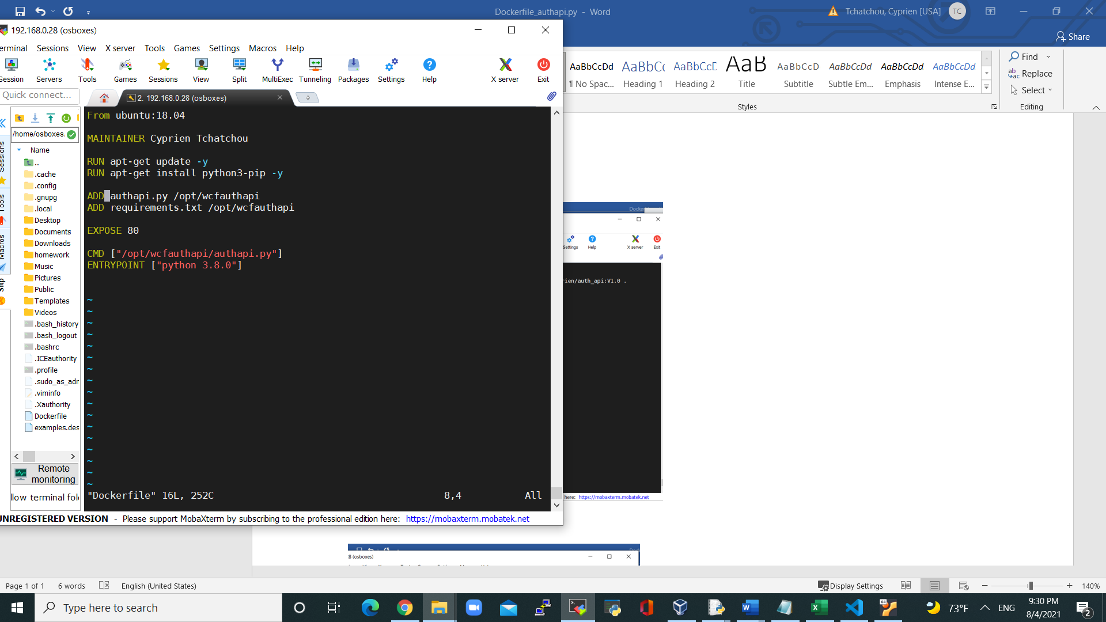

Figure : Dockerfile for authapi.py

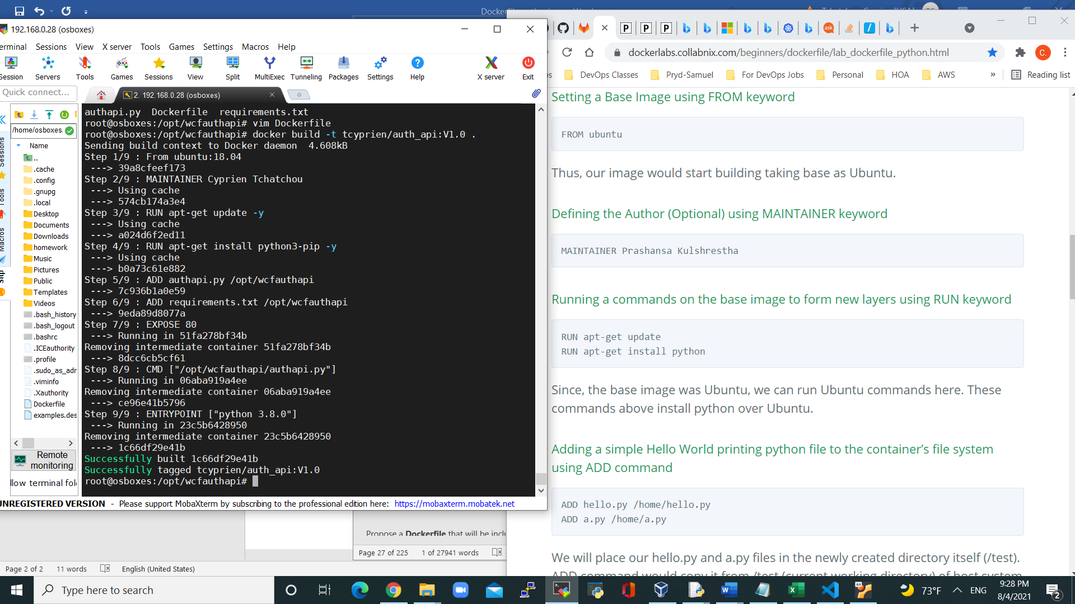

Figure : authapi container built

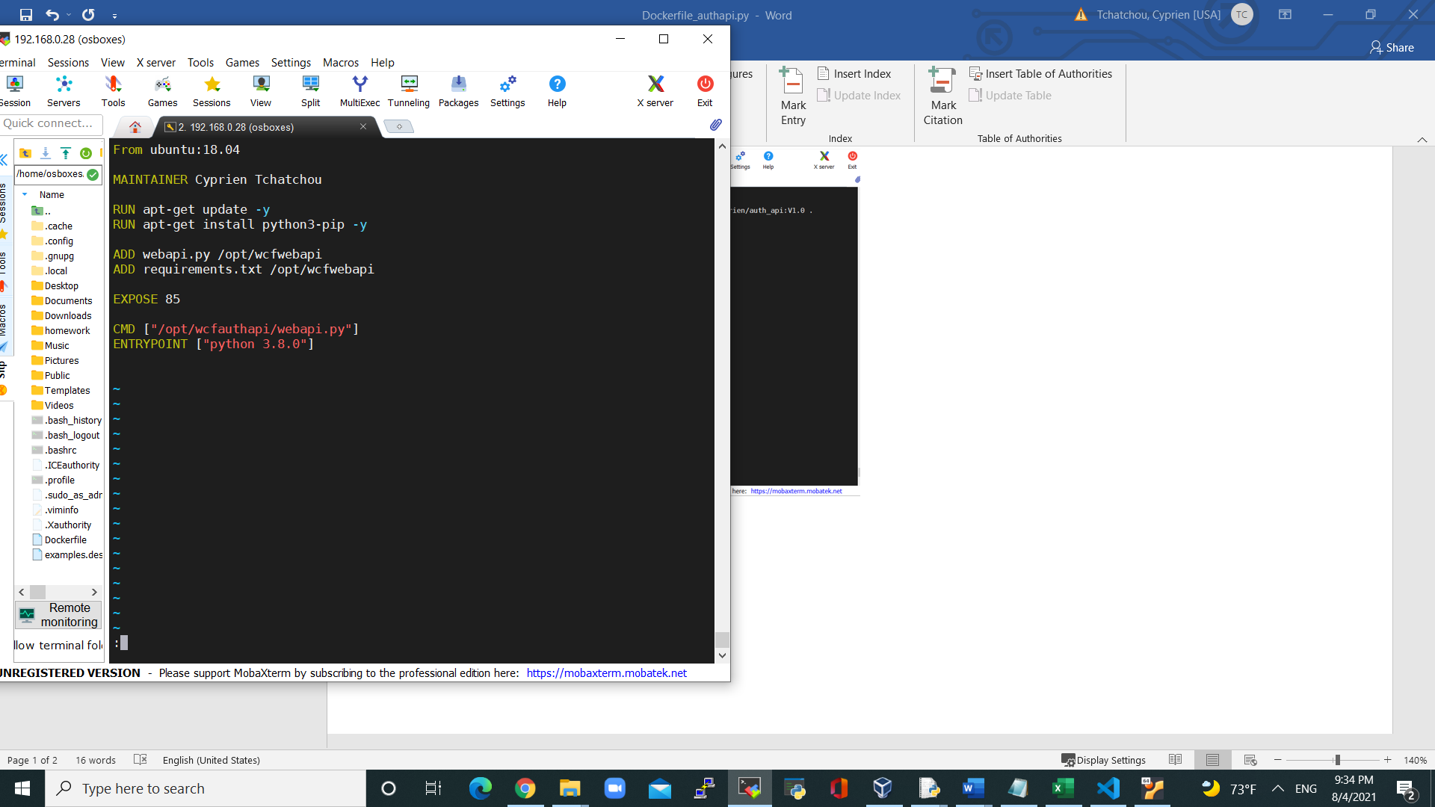

Figure : Dockerfile for Webapi

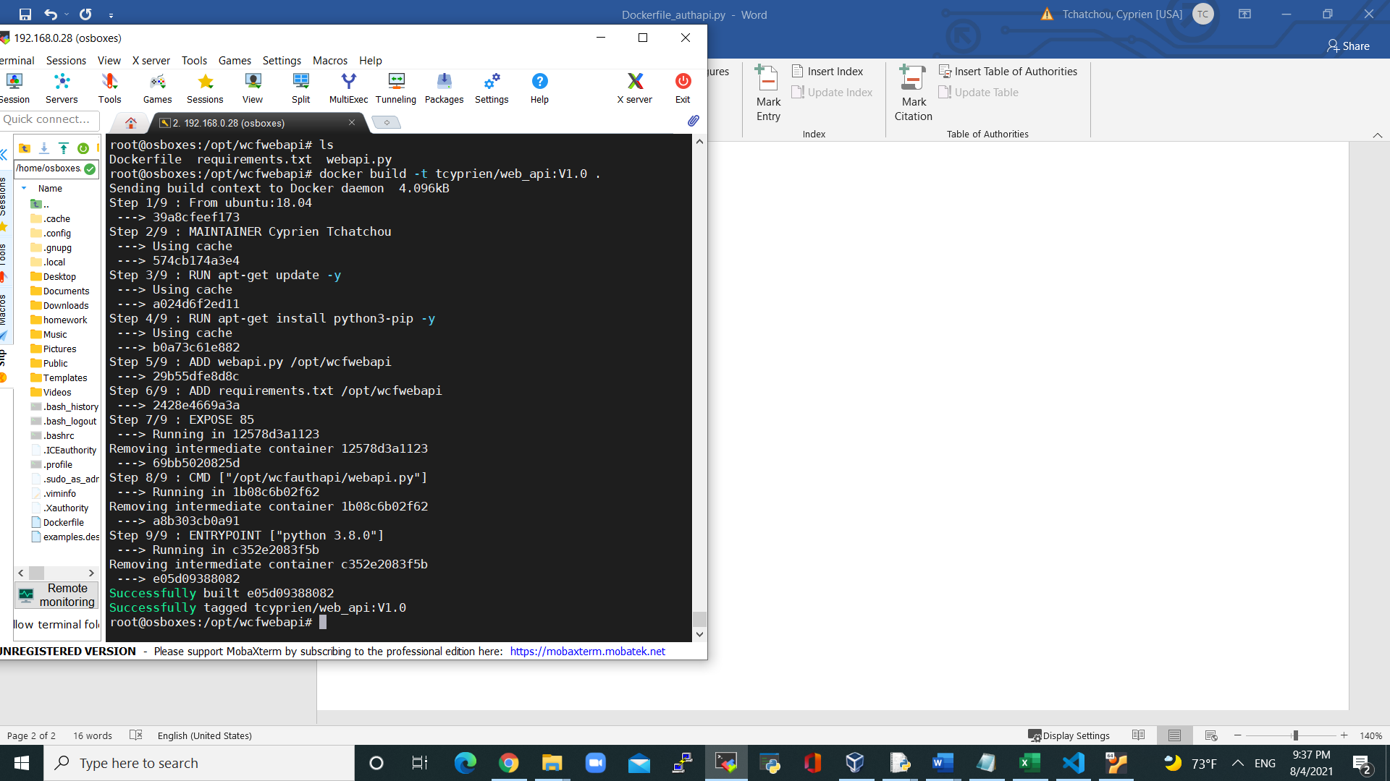Figure : web_api container built

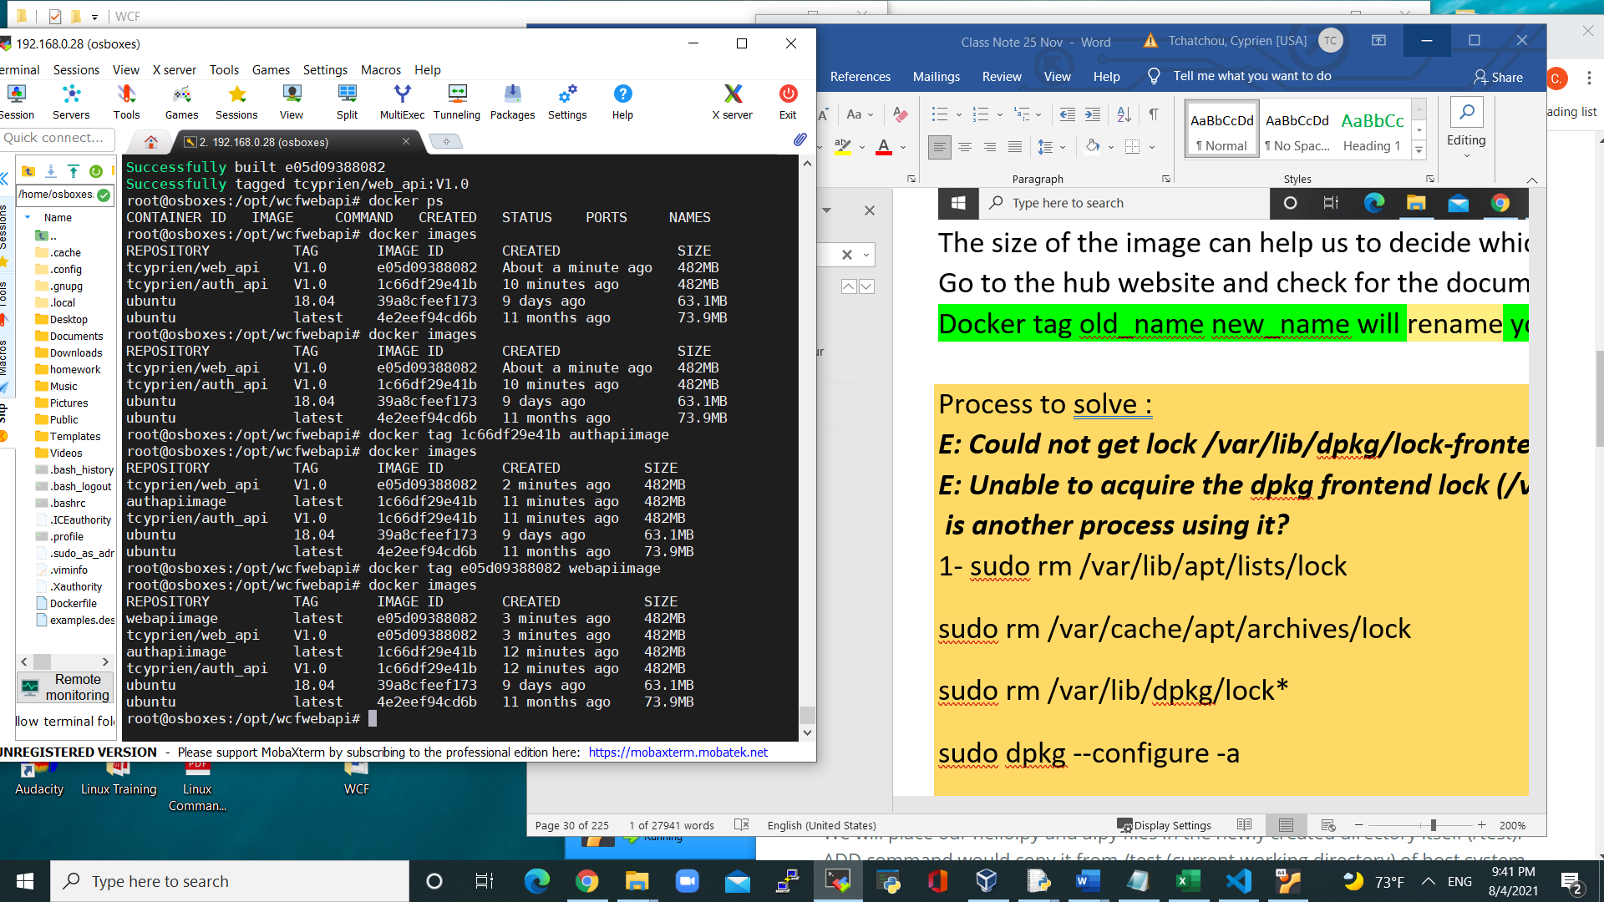

Figure : images renamed

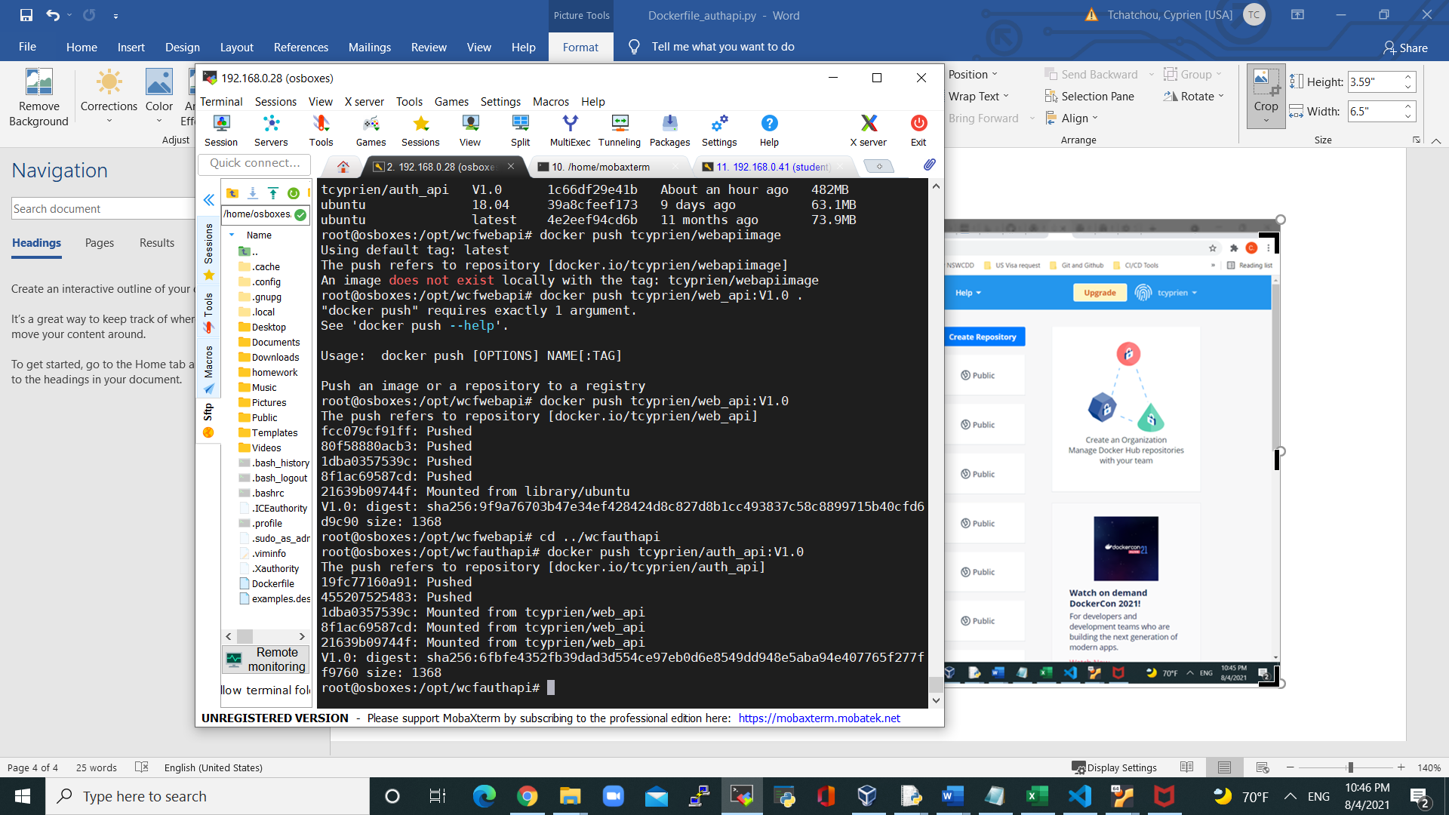

Figure : Image pushed to my Docker Repo

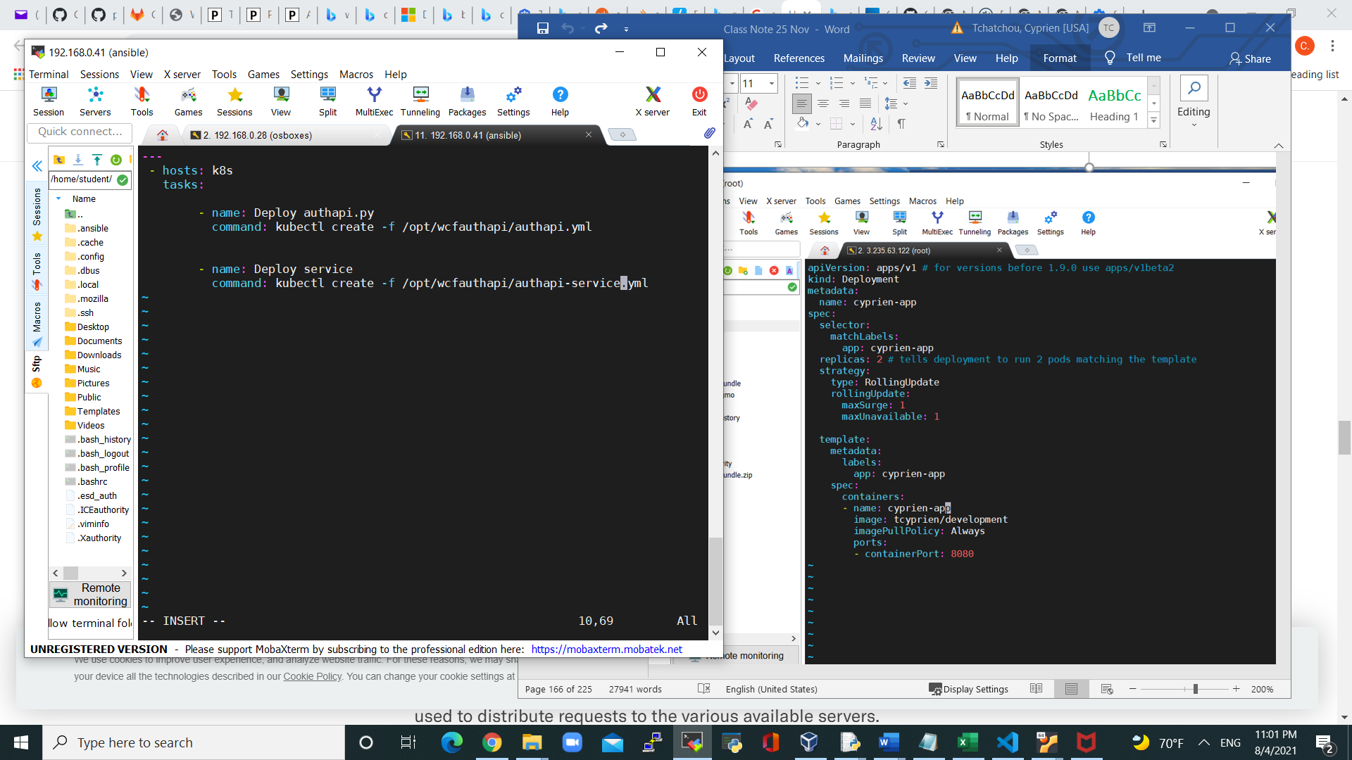

Figure :Ansible Yml file to deploy the Auth-Api to Kubernetes

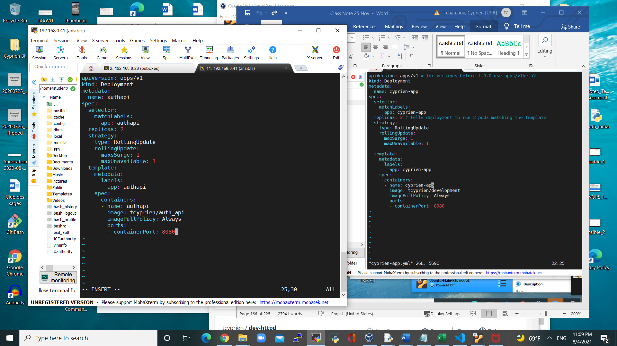

Figure : Deployment of Authapi on K8s Cluster

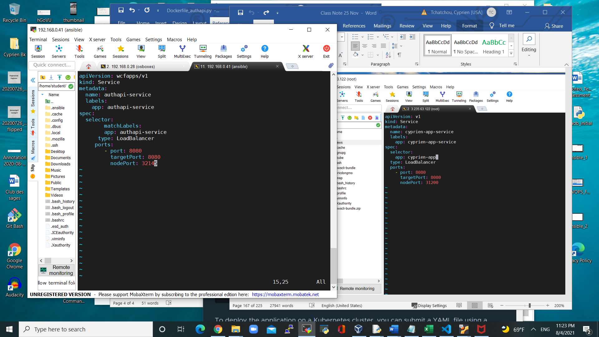

Figure : Service and load balancer deployment file