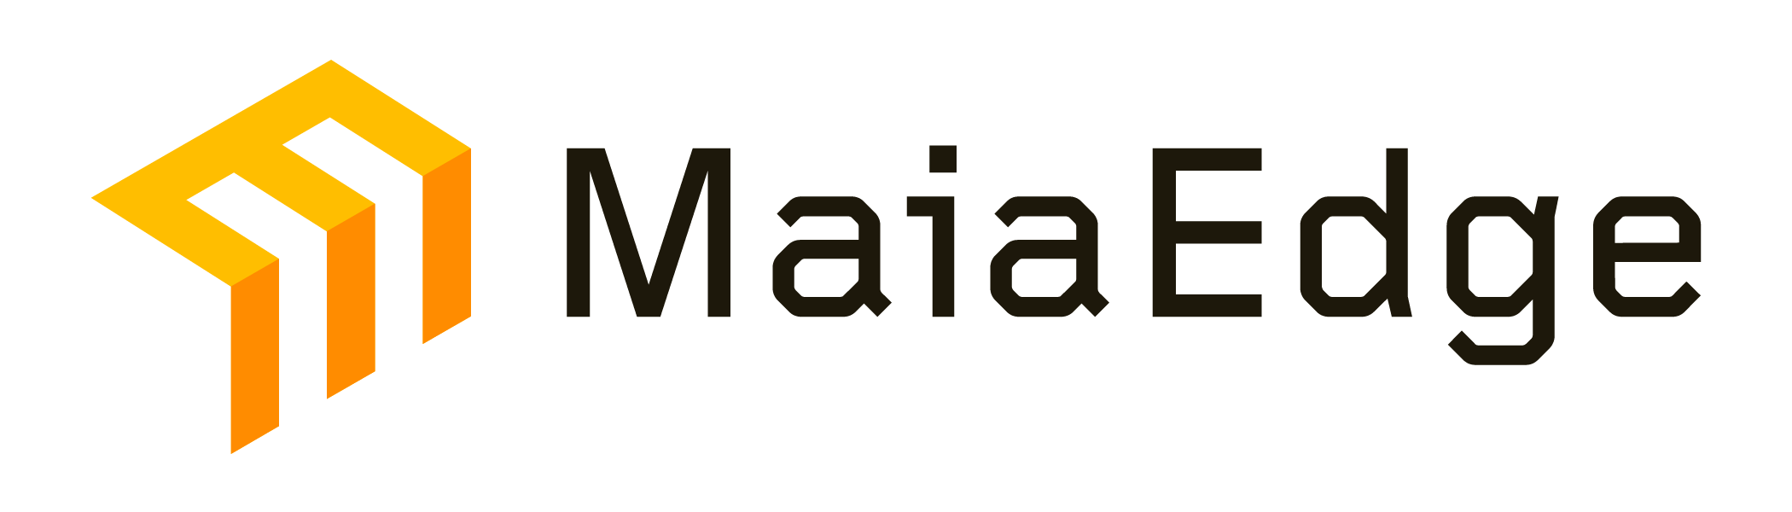 | Private Cloud Connectivity for Bare Metal AI Infrastructure  How MaiaEdge helps Cirrascale reduce customer egress costs and expand enterprise reach

Cirrascale's customers increasingly split AI workloads between hyperscalers and bare metal. The friction is the network: customers pay public internet egress rates, manage separate connectivity relationships, and have no unified view across environments. MaiaEdge removes that friction with a physical Path Border Controller (PBC) that stitches private paths between Cirrascale clusters and AWS or Azure via Direct Connect or ExpressRoute, and extends reach to enterprise customers over any available transport.

78%  Transfer cost reduction  Public internet → Direct Connect |  | 53%  TCO reduction via DIA  vs. dedicated L2 service (ACG Research) |  | 85%  Provisioning labor savings  Automated path setup vs. manual

USE CASE 1: HYBRID CLOUD BRIDGE (AWS + CIRRASCALE)
01 Move workloads from AWS to bare metal without cutting the cloud relationship
Problem: AI startups training models in AWS want to shift inference or fine-tuning to Cirrascale for cost and control, but cannot afford to sever their cloud dependency. Moving data over the public internet costs $0.09/GB in AWS egress. For a lab moving 50TB/month, that is $4,500 per month in transfer costs alone.
MaiaEdge: A MaiaEdge PBC at the Cirrascale cluster edge stitches a private path through AWS Direct Connect. Egress drops from $0.09 to $0.02/GB (78% reduction). The customer sees a single pane of glass across both environments. No VPN. No NAT hairpin. No VM-based router in the cloud.
- 50TB/month workload: saves ~$3,500/month ($42K/year) in AWS egress alone
- Cirrascale's no-ingress/egress policy compounds the savings versus staying on AWS
- Customer keeps existing AWS account and tooling; MaiaEdge handles the bridge transparently
- Demo-ready: live path from AWS S3 or EC2 into a Cirrascale VM, cost delta visible in real time

USE CASE 2: ENTERPRISE ACCESS VIA DIA
02 Connect enterprise customers before fiber arrives
Problem: Enterprise accounts are beginning to evaluate alternatives to hyperscalers, but they cannot wait 60 to 90 days for dedicated fiber provisioning to a Cirrascale data center. Legacy VPN options introduce latency and throughput limits that are incompatible with GPU inference workloads.
MaiaEdge: A small MaiaEdge PBC at the enterprise edge connects over any available DIA circuit, encrypted end-to-end with AES-256 GCM. ACG Research models a 53% TCO reduction versus dedicated L2 service delivery on comparable routes. Cirrascale can offer this as a connectivity SKU and charge a premium for the managed path.
- Supports 1-100G throughput over commodity DIA; no specialized circuit required
- Cirrascale advertises connectivity across all data center locations from a single entry point
- Gives enterprises a low-friction on-ramp before committing to dedicated infrastructure
- Builds Cirrascale's differentiation against hyperscalers: private, dedicated, and reachable

PRICING AND STRUCTURE
Structure | Detail
Hardware | Physical PBC placed at cluster edge (1RU)
License terms | 1, 3, or 5 year; monthly invoicing available
Pricing model | All-inclusive monthly; no per-feature charges
Cloud integrations | AWS Direct Connect, Azure ExpressRoute, Equinix

SUGGESTED NEXT STEP
Live demo: transfer a workload from AWS into a Cirrascale VM using a Direct Connect path provisioned by MaiaEdge. We show the full egress cost delta in real time and demonstrate the single-pane-of-glass view across both environments. Estimated time: 45 minutes. We can scope the demo to match the specific partner requirement Al referenced (AWS-to-Cirrascale data movement that surfaces through an AWS-native query interface).

