Abstract
Electroacoustic audiovisual composition often aspires to parity between sound and moving image, yet compositional workflows and perceptual salience frequently reintroduce hierarchy, positioning one medium as structural and the other as illustrative. Responding to calls to reconceptualise media relationships through intermediality, this article examines intermedial interference—constructive and destructive interactions between media features—as an evaluable property of generative audiovisual instruments. We study a Tonnetz cellular automata (CA) system in which sound and LED-panel activity are parallel projections of a single evolving state-space. Participants shaped the system by adjusting a compact parameter set governing population bounds, neighbourhood extent, neighbour-rule thresholds, update rate, activation lifetimes, recurrence (looping), and harmonic admissibility (scale). Using a within-subject design, each participant completed three short compositional tasks under controlled modality-access conditions (visual-only, audio-only, audiovisual). In all conditions, both audio and video were recorded and end-state parameter presets saved. Participants reported satisfaction, intention, steerability, intermedial coherence, balance, autonomy, and interference, followed by immediate replay-based reflection with both modalities present. We outline an analysis framework linking compositional experience to captured audiovisual artefacts and propose an interference taxonomy grounded in parameter regimes and observed strategies (e.g., density shaping, looping, and scale manipulation). A blinded external rating study of the resulting clips is underway to triangulate participant experience with artefact-level judgements. The study offers a practical evaluation method for practice-based intermedial research and a state-space projection framing of audiovisual composition as parallel media projections of a shared generative substrate.
Keywords: intermediality; audiovisual composition; electroacoustic music; generative systems; cellular automata; Tonnetz; media equality; intermedial interference; co-creative agency; practice-based
- Introduction Electroacoustic audiovisual composition is often discussed through models that implicitly privilege one medium over another: sound interpreted as primary structure with image as illustration, or image interpreted as primary narrative with sound as enhancement. Even where practitioners aim for parity, the practical realities of compositional workflow, interface design and perceptual salience tend to reintroduce hierarchy. This thematic issue calls for approaches that treat sound and moving image as co-equal media within an intermedial space, and for critical accounts of how meaning arises when the media are fused rather than juxtaposed. This article contributes; a practice-based, empirical study of intermedial composition using a Tonnetz cellular automata (CA) system in which sound and light are generated from a single evolving state-space. The work starts from a simple proposition: if sound and image are projections of the same latent “score”, then intermediality can be addressed not only as an aesthetic aspiration, but as a manipulable design problem. In such a system, relationships between media are not primarily established through post-hoc synchronisation or representational alignment, but through shared generative causality: changes to the underlying state propagate to both modalities. This framing has two implications for intermedial practice. First, it invites a conception of composition as shaping the dynamics of an underlying state-space rather than authoring separate sonic and visual layers. Second, it provides a concrete basis for analysing intermedial interference: constructive and destructive interactions can be observed when the two projections amplify, compete with, or contradict one another in perception. 1.1. Intermedial interference as a design and evaluation problem In the context of generative audiovisual instruments, intermedial interference can be understood as the perceptual and interpretive consequences of interactions between salient features of the two media: temporal alignment (or misalignment), structural correspondence (or divergence), salience dominance, and the distribution of perceived agency between human and system. In a state-space projection model, interference is not an incidental by-product; it is an emergent property of coupling choices, control affordances and constraint regimes. For example, increasing the update rate or density of events may raise perceived vitality while simultaneously producing attentional overload, shifting the balance of salience between modalities. Similarly, introducing recurrence (looping) may increase structural legibility while reducing the sense of liveness or co-authorship. These tensions are compositional in nature, but they are also evaluable: they manifest in what participants do, what they report experiencing, and what independent listeners/viewers perceive in the resulting artefacts. Despite the prevalence of generative systems in electroacoustic and audiovisual practices, evaluation is frequently limited to descriptive accounts or anecdotal responses, making it difficult to compare design choices or to articulate how a system supports co-equal media relationships. There remains a need for evaluation approaches that can (i) retain practice-based validity, (ii) produce analysable evidence within realistic artistic development timelines, and (iii) connect participant experience to perceivable properties of the resulting audiovisual artefacts. 1.2. System overview: Tonnetz cellular automata as an intermedial score The system studied here organises pitch classes on a Tonnetz-derived spatial lattice and drives their activation through asynchronous CA dynamics. The same evolving CA state is rendered simultaneously as (i) audio output and (ii) LED-panel activity, with fixed mappings between pitch-class admissibility and colour. Composition occurs through real-time adjustment of a small set of parameters controlling population bounds, neighbour-rule thresholds, temporal rate, activation lifetimes, neighbourhood extent (local versus extended), recurrence (looping), and harmonic admissibility (scale). Rather than treating sound and light as separate channels to be aligned, the instrument treats them as co-equal surfaces of a single evolving substrate: when the underlying state changes, both modalities change. This design intentionally blurs boundaries between instrument and environment. On one hand, it affords local interventions and steerability through parameter changes; on the other, it produces autonomous evolution that can surprise and resist direct control. The central evaluation question is therefore not whether the system is “usable” in a conventional sense, but how its coupling and constraints support (or undermine) intermedial equality, meaningful fusion, and negotiated authorship. 1.3. Research questions The study addresses the following questions: RQ1 (Intermedial equality): To what extent do participants experience sound and light as co-equal contributors to meaning when composing with the system?
RQ2 (Intermedial interference): What forms of constructive and destructive intermedial interference arise in practice, and how do they relate to modality access and parameter shaping?
RQ3 (Agency and causality): How do participants’ perceptions of authorship, predictability and steerability change when one modality is unavailable during composition?
RQ4 (Distributed authorship, exploratory): Can dyads with asymmetric modality access (one hearing, one seeing) negotiate a coherent intermedial outcome, and how is this outcome perceived by independent raters?
1.4. Methodological approach To operationalise “co-equal media” without reducing the work to preference testing, the study uses a within-subject design in which each participant completes three short compositional tasks under controlled modality-access conditions: visual-only, audio-only and audiovisual. In all cases, both audio and video are recorded, end-state parameter presets are saved for reproducibility, and participants complete brief post-block measures targeting coherence, novelty, agency, fusion/equality, and constructive versus destructive interference. Immediately after each block, participants replay the captured excerpt with both modalities enabled and provide a short reflection on expectation, fusion and competition. A baseline “system-alone” capture provides a control for the system’s intrinsic generativity. To relate felt experience to perceivable outcomes, the captured clips are subsequently rated by independent raters drawn from the author’s wider network using blind presentation and standardised scales (preference, coherence, novelty, fusion/equality, overload). Finally, an exploratory dyad variant tests distributed access: one participant composes with audio-only feedback while the other composes with visual-only feedback, negotiating parameter changes verbally to reach a joint outcome. 1.5. Contributions This article offers three contributions to intermedial electroacoustic audiovisual practice: A state-space projection framing of intermedial composition in which sound and light are treated as parallel projections of a single generative substrate (an ‘intermedial score’), supporting analysis without default media hierarchy.
An evaluative method suitable for practice-based research under time constraints, combining modality-access manipulation, replay-based reflection, baseline controls and independent rater assessment to connect compositional experience to perceivable artefacts.
An interference-focused analytic account (taxonomy and exemplars) describing how constructive and destructive intermedial interference manifests in this system, and how parameter regimes and modality access relate to perceived fusion, agency and overload.
1.6. Article structure Section 2 situates the work within intermedial audiovisual composition and generative electroacoustic practices, clarifying how interference and equality are understood in this study. Section 3 details the system and study method, including parameter set, capture protocol and rating procedures. Section 4 reports quantitative and qualitative findings, including within-subject condition effects, baseline comparisons and rater triangulation, alongside an interference taxonomy supported by audiovisual exemplars. Section 5 discusses implications for intermedial instrument design, including practical strategies for balancing autonomy, constraint and salience to support co-equal media relationships. The audiovisual instrument evaluated here is the TZ5 / Cellular Au-Tonnetz system, previously described in detail as a unified audio-visual MIDI generator that couples Tonnetz pitch-space mapping with cellular automata and a web-configured embedded control architecture. Springer Nature Link+1 That prior publication focuses on system design and demonstration rather than formal evaluation. The present paper therefore contributes an issue-driven evaluation aligned with Organised Sound’s call for intermediality: specifically, how “media equality” and intermedial interference manifest when participants compose under modality-restricted conditions (visual-only / audio-only / audiovisual) and when outputs are subsequently assessed by independent raters.
- Related work 2.1 Intermediality and “media equality” as a relational claim
Intermediality is often invoked to describe work that occurs “between” media, but its analytic value depends on specifying which intermedial relation is at stake. Rajewsky treats intermediality as a research lens and proposes a typology (medial transposition, media combination, intermedial reference) that helps avoid collapsing distinct practices into a single “multimedia” category (Rajewsky 2005). In this paper, the focus is media combination—sound and time-based light output co-present—and, more specifically, whether participants and observers experience the combined outcome as co-constitutive rather than one medium functioning as explanatory support for the other. The Organised Sound call sharpened this as a “media equality” problem: how meaning is produced when media are fused rather than merely juxtaposed (Organised Sound 2026).
Elleström’s modality model provides a useful scaffold for discussing equality without treating media as undifferentiated streams. By distinguishing material, sensorial, spatiotemporal, and semiotic modalities, the model makes it possible to describe where equality succeeds or fails: parity may hold in causal origin (both derive from the same substrate) but collapse in sensorial salience (one dominates attention) or semiotic authority (one is treated as the “real” carrier of form) (Elleström 2010). The present study adopts this precision: “equality” is treated as negotiated and contingent, not assumed.
2.2 Audiovisual relations: integration, framing, and interpretive hierarchy
Audiovisual theory in film and sound studies provides durable concepts for how sound and image are perceived as an integrated whole. Chion’s account of audio-vision emphasises that audiovisual perception is not additive; sound and image reciprocally frame one another’s meaning (Chion 1994). This is directly relevant to a modality-withholding design: composing with one modality absent and reinstating it at replay makes the construction of audio-vision observable, including how expectation, surprise, and retrospective binding contribute to perceived unity.
Intermedial frameworks also emphasise analysing relations between media—how they align, diverge, reinforce, or contradict—rather than presuming stable hierarchies such as accompaniment/illustration (Rajewsky 2005; Elleström 2010). These accounts legitimise treating audience interpretation as primary evidence for intermedial success, and they align with the paper’s focus on interference effects that emerge as relational phenomena rather than technical synchronisation achievements.
2.3 Intermedial interference as an evaluable property of coupled instruments
The Organised Sound call foregrounds “intermedial interference” as a prompt for reconceptualising media relationships, including constructive and destructive interactions between media features (Organised Sound 2026). Chiaramonte develops the term within electroacoustic audiovisual composition, treating the intermedial interaction itself as the compositional site and noting the difficulty of measurability when interference is phenomenological and context-dependent (Chiaramonte 2024).
The present study extends this line by focusing on a coupled generative instrument in which sound and light are parallel media projections of a single evolving state-space. This coupling makes interference design-sensitive: parameter regimes, constraint conditions, and control affordances can shift interference from productive fusion (reinforcement, heightened legibility, surprise-as-rebinding) to destructive conflict (contradictory cues, masking, reduced causal confidence). The within-subject modality-access manipulation is used to render these shifts tractable in practice-based evaluation.
2.4 Multisensory binding, crossmodal correspondences, and “cue” mechanisms
Work in multisensory perception suggests that binding depends on which cues are treated as reliable evidence for a shared causal story. Crossmodal correspondences offer a complementary design lens: Spence’s tutorial review synthesises evidence that people reliably associate features across modalities (e.g., pitch–brightness), making correspondences a resource for designing legible mappings rather than an anecdotal curiosity (Spence 2011). For the present instrument, correspondences help explain why some participants may use colour similarity as a proxy for harmonic planning, and why constraint conditions can reweight which cues dominate attention and inference.
2.5 Agency, co-creativity, and evaluation traditions in DMIs and generative systems
Generative and autonomous instruments often trade direct predictability for novelty and emergence, prompting an agency negotiation in which performers steer rather than command. Evaluation traditions in DMIs provide precedents for studying this without reducing outcomes to usability metrics. O’Modhrain proposes an evaluation framework for digital musical instruments that supports structured reflection on experience and capability while remaining sensitive to musical context (O’Modhrain 2011). Orio and Wanderley similarly discuss evaluation of input devices for musical expression, offering method rationales that bridge performer experience and system design iteration (Orio and Wanderley 2002).
This lineage motivates the paper’s mixed-method approach (self-report tied to captured artefacts) and supports Strategy A’s stance on external ratings: independent audience assessment is framed as a principled extension for triangulation, but not required for the core claims of the present results.
2.6 Tonnetz and cellular automata as compositional substrates
The Tonnetz has a substantial theoretical lineage within neo-Riemannian and transformational theory, providing a well-motivated harmonic space in which neighbourhood relations correspond to parsimonious voice-leading transformations. Cohn’s account of neo-Riemannian operations and Tonnetz representations provides a canonical grounding for treating Tonnetz geometry as more than a “clever layout” (Cohn 1997). Douthett and Steinbach’s work on parsimonious graphs further reinforces the status of these geometries as analytical and compositional structures rather than purely visualisations (Douthett and Steinbach 1998).
Cellular automata also have a long-standing lineage as musical generative formalisms, valued for producing emergent structure from simple local rules. Miranda’s chapter on cellular automata music provides a clear anchor for positioning CA as a legitimate compositional engine spanning sound generation and higher-level form (Miranda 2007). In the present system, the distinctive move is to treat CA state as an intermedial score: the same evolving substrate is rendered simultaneously as sound and as time-based light activity, enabling interference to be observed as an emergent property of coupled projections under constraint.
- Method (revised) 3.1 Participants and ethics
Recruitment and sampling. Participants were recruited via the author’s professional and personal networks using convenience sampling. Recruitment aimed to include a range of musical experience and varying familiarity with generative systems.
Solo sample. Nine participants completed the solo protocol (N = 9), each completing all three modality-access blocks (27/27 blocks total; 0% missing quantitative items). Participants self-reported age range, musical experience, music-theory familiarity, familiarity with generative systems, Tonnetz familiarity, and perceptual notes (colour-vision deficiency, sensitivity to flashing lights, optional comments). One participant reported red–green colour deficiency; one participant used speakers rather than headphones during the audio-only block.
Exploratory dyad. In addition to the solo protocol, one exploratory dyad trial was conducted in which the same pair completed two dyad sessions with role-swap (audio-role vs visual-role), yielding two dyad captures. Dyad data are treated as exploratory and are reported descriptively.
Consent and recording. All participants provided informed consent for audio/video capture and for anonymised excerpts to be used as research stimuli (including for an external rating task described below as ongoing).
3.2 System and apparatus 3.2.1 Instrument under study
The study evaluates the TZ5 / Cellular Au-Tonnetz audiovisual instrument, a coupled generative system in which sound and LED-panel activity are produced as parallel media projections of a single evolving Tonnetz-cellular automata (CA) state.
The instrument comprises four functional components:
Web control interface and configuration store. A browser-based UI provides sliders and toggles for the study parameter set. Parameter values are stored in an SQL-backed configuration store and served to the device as a JSON configuration payload over HTTP.
Embedded controller. An ESP32-S3 microcontroller retrieves the latest configuration, updates the CA state, and drives both the audio-control stream and LED output in real time.
Audio rendering chain. The embedded controller outputs musical events as MIDI (or equivalent event messages), rendered using a fixed synthesis configuration (e.g., Ableton Live or a hardware synth) held constant across sessions.
LED panel. A 91-pixel hexagonal LED array displays the evolving CA state using a fixed pitch-class–to-colour mapping.
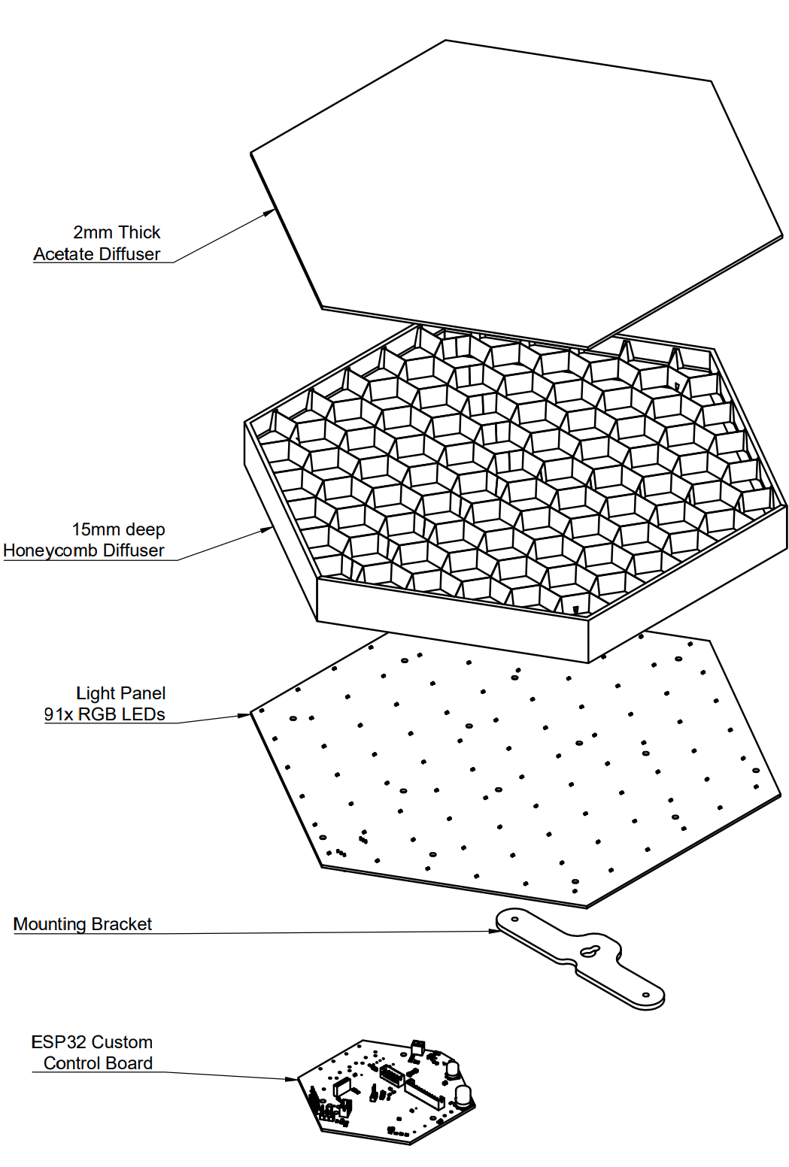
Figure X. Exploded view of TZ5 instrument.
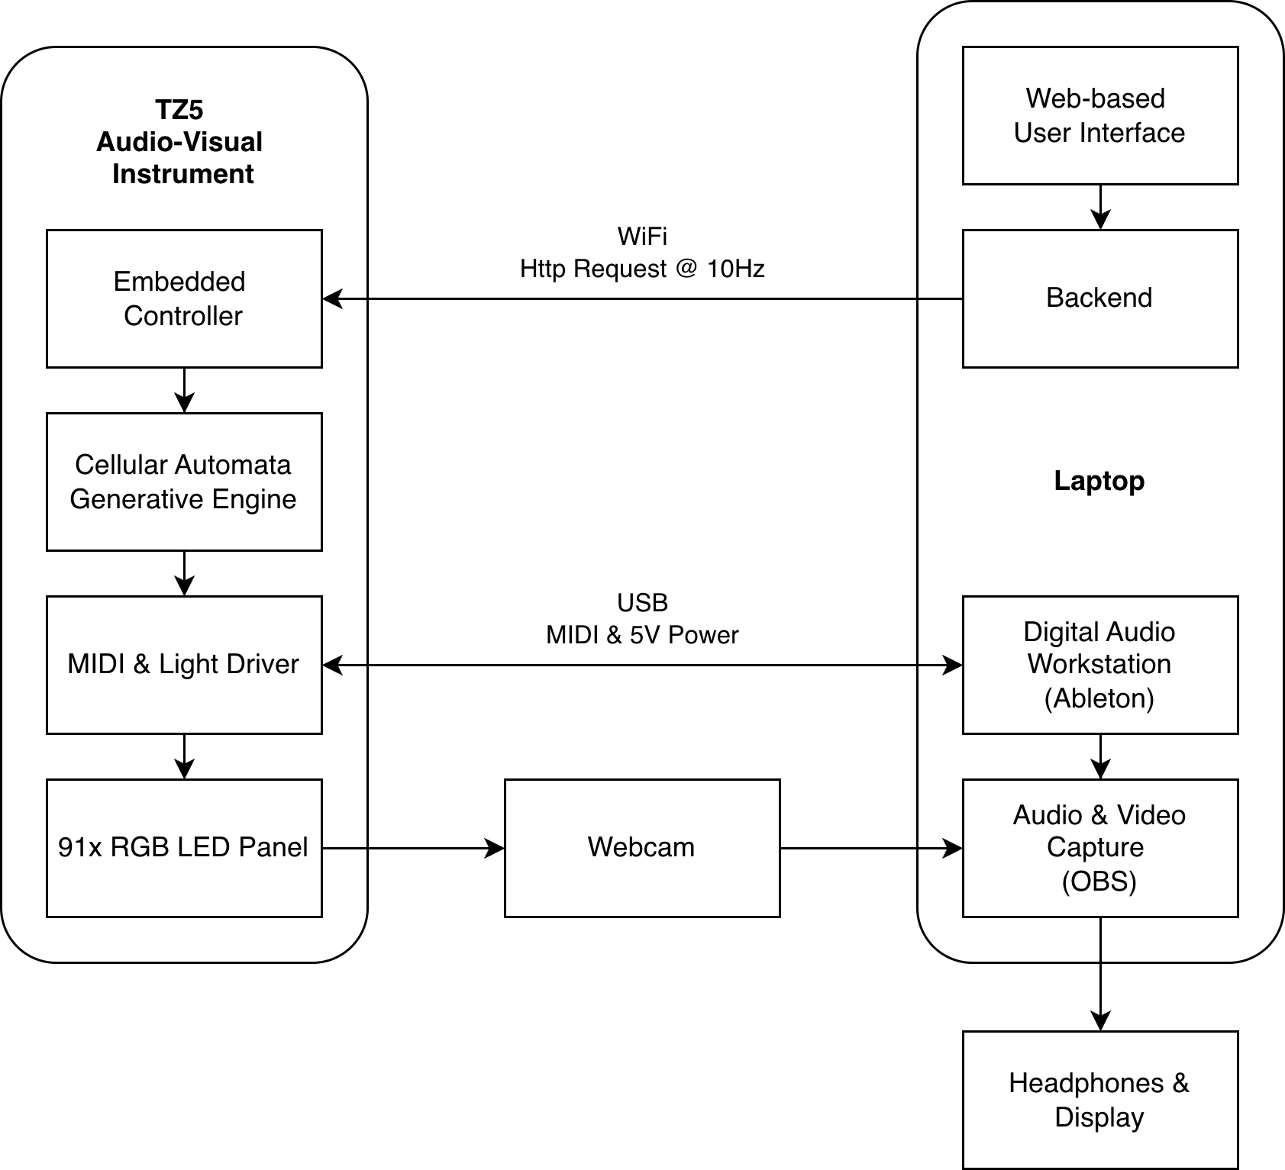
Figure X. System block diagram (UI → ESP32-S3 → LED panel + MIDI/audio chain).
3.2.2 Coupled generation and mappings
The system maintains a Tonnetz-mapped lattice of pitch classes. At each update, local CA rules and global population constraints determine which cells become active. When a cell activates, the system emits (i) a musical event (e.g., MIDI note) and (ii) a corresponding LED update. In this sense, sound and light are coupled by shared causal origin (state update), not by post-hoc synchronisation.
Note–colour mapping. Pitch classes are mapped to hue (HSV-based mapping), such that scale constraints simultaneously affect the admissible pitch set and the resulting colour palette. Colour mapping and synthesis settings were held constant across participants to keep perceptual comparisons focused on state dynamics and parameter steering rather than renderer variability.
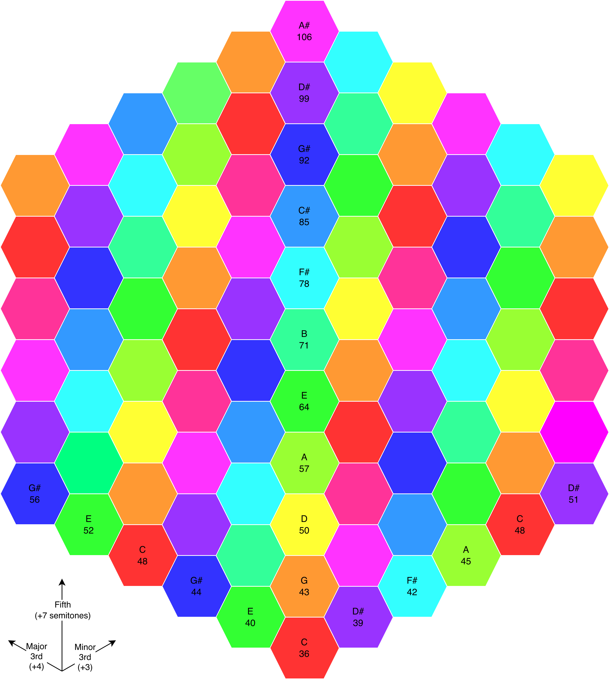
Figure X. Tonnetz pitch-class map used for hue mapping.
3.2.3 LED panel configuration (study setup)
The study used a 91-LED hex panel with fixed diffusion and fixed participant viewing geometry. Panel type and diffusion were held constant across all sessions:
Panel build: [custom PCB / mounted panel; dimensions].
Diffusion material: [paper / acrylic; thickness].
Viewing geometry: [distance/angle; seated/standing].
3.2.4 Participant-facing control parameters
Participants controlled the instrument exclusively via the web UI. The study parameter set targeted population/density, temporal dynamics, neighbourhood rule constraints, recurrence, and harmonic admissibility:
Population and density
Max Population (Max Notes): upper bound on concurrent active cells.
Min Population (Min Notes): lower bound; when activity drops below this threshold the system reseeds activity to maintain baseline density.
Temporal dynamics
Rate: CA update rate (ms or equivalent).
Life Length: activation lifetime parameter (firmware-defined units).
Neighbourhood and rule constraints
Neighbourhood extent: Local (6 neighbours) vs Extended (18 neighbours).
Min Neighbours / Max Neighbours: activation thresholds and crowding constraint.
Recurrence and memory
Loop On/Off: toggles between stochastic selection and replay of a stored coordinate-selection sequence.
Loop Length (Loop Steps): number of update steps stored and replayed; effective loop duration depends on Rate × Loop Length.
Harmonic admissibility
Scale: constrains which pitch classes can activate; because pitch classes map to hue, scale selection also shapes the visible palette.
Features disabled to reduce confounds
Automated chord progression / automatic scale sequencing features were disabled for this study, to attribute formal change primarily to participant steering and the coupled CA dynamics.
3.3 Study design 3.3.1 Overview (solo protocol)
The solo study used a within-subject design with three short composition blocks per participant, each manipulating modality access during composition:
A: Visual-only (panel visible; audio masked)
B: Audio-only (audio via headphones/speakers; panel occluded)
C: Audiovisual (both modalities available)
In all conditions, both audio and video were captured, and end-state parameter presets were saved to support traceability and repeatability.
3.3.2 Order control
Block order was counterbalanced across participants using a rotating schedule to reduce systematic order effects. Participant ID and block order were recorded in session metadata.
3.3.3 Baseline control (system-alone)
To characterise intrinsic generativity absent human steering, the system was also captured running from the common starting preset S0 with no parameter changes for the same duration as a participant block. This produced a baseline audiovisual artefact for qualitative comparison and for optional inclusion in the external rating stimulus set.
3.3.4 Exploratory dyad protocol (asymmetric modality access)
A single pair completed two dyad sessions with role-swap. In each dyad session, one participant had auditory access while the other had visual access, and the pair negotiated parameter changes verbally:
Audio-role: auditory access (headphones); no view of the panel.
Visual-role: panel view; no access to audio.
The dyad produced a final captured excerpt from S0 after collaborative steering. Dyad findings are treated as exploratory and used as a “teaser” for future systematic study.
3.4 Procedure 3.4.1 Orientation and familiarisation
Participants received a short briefing describing the instrument as a coupled audiovisual generator and outlining the three blocks. A familiarisation period (~10–15 minutes) with full audiovisual access introduced the core parameters (density bounds, rate, neighbourhood extent, looping, and scale constraints).
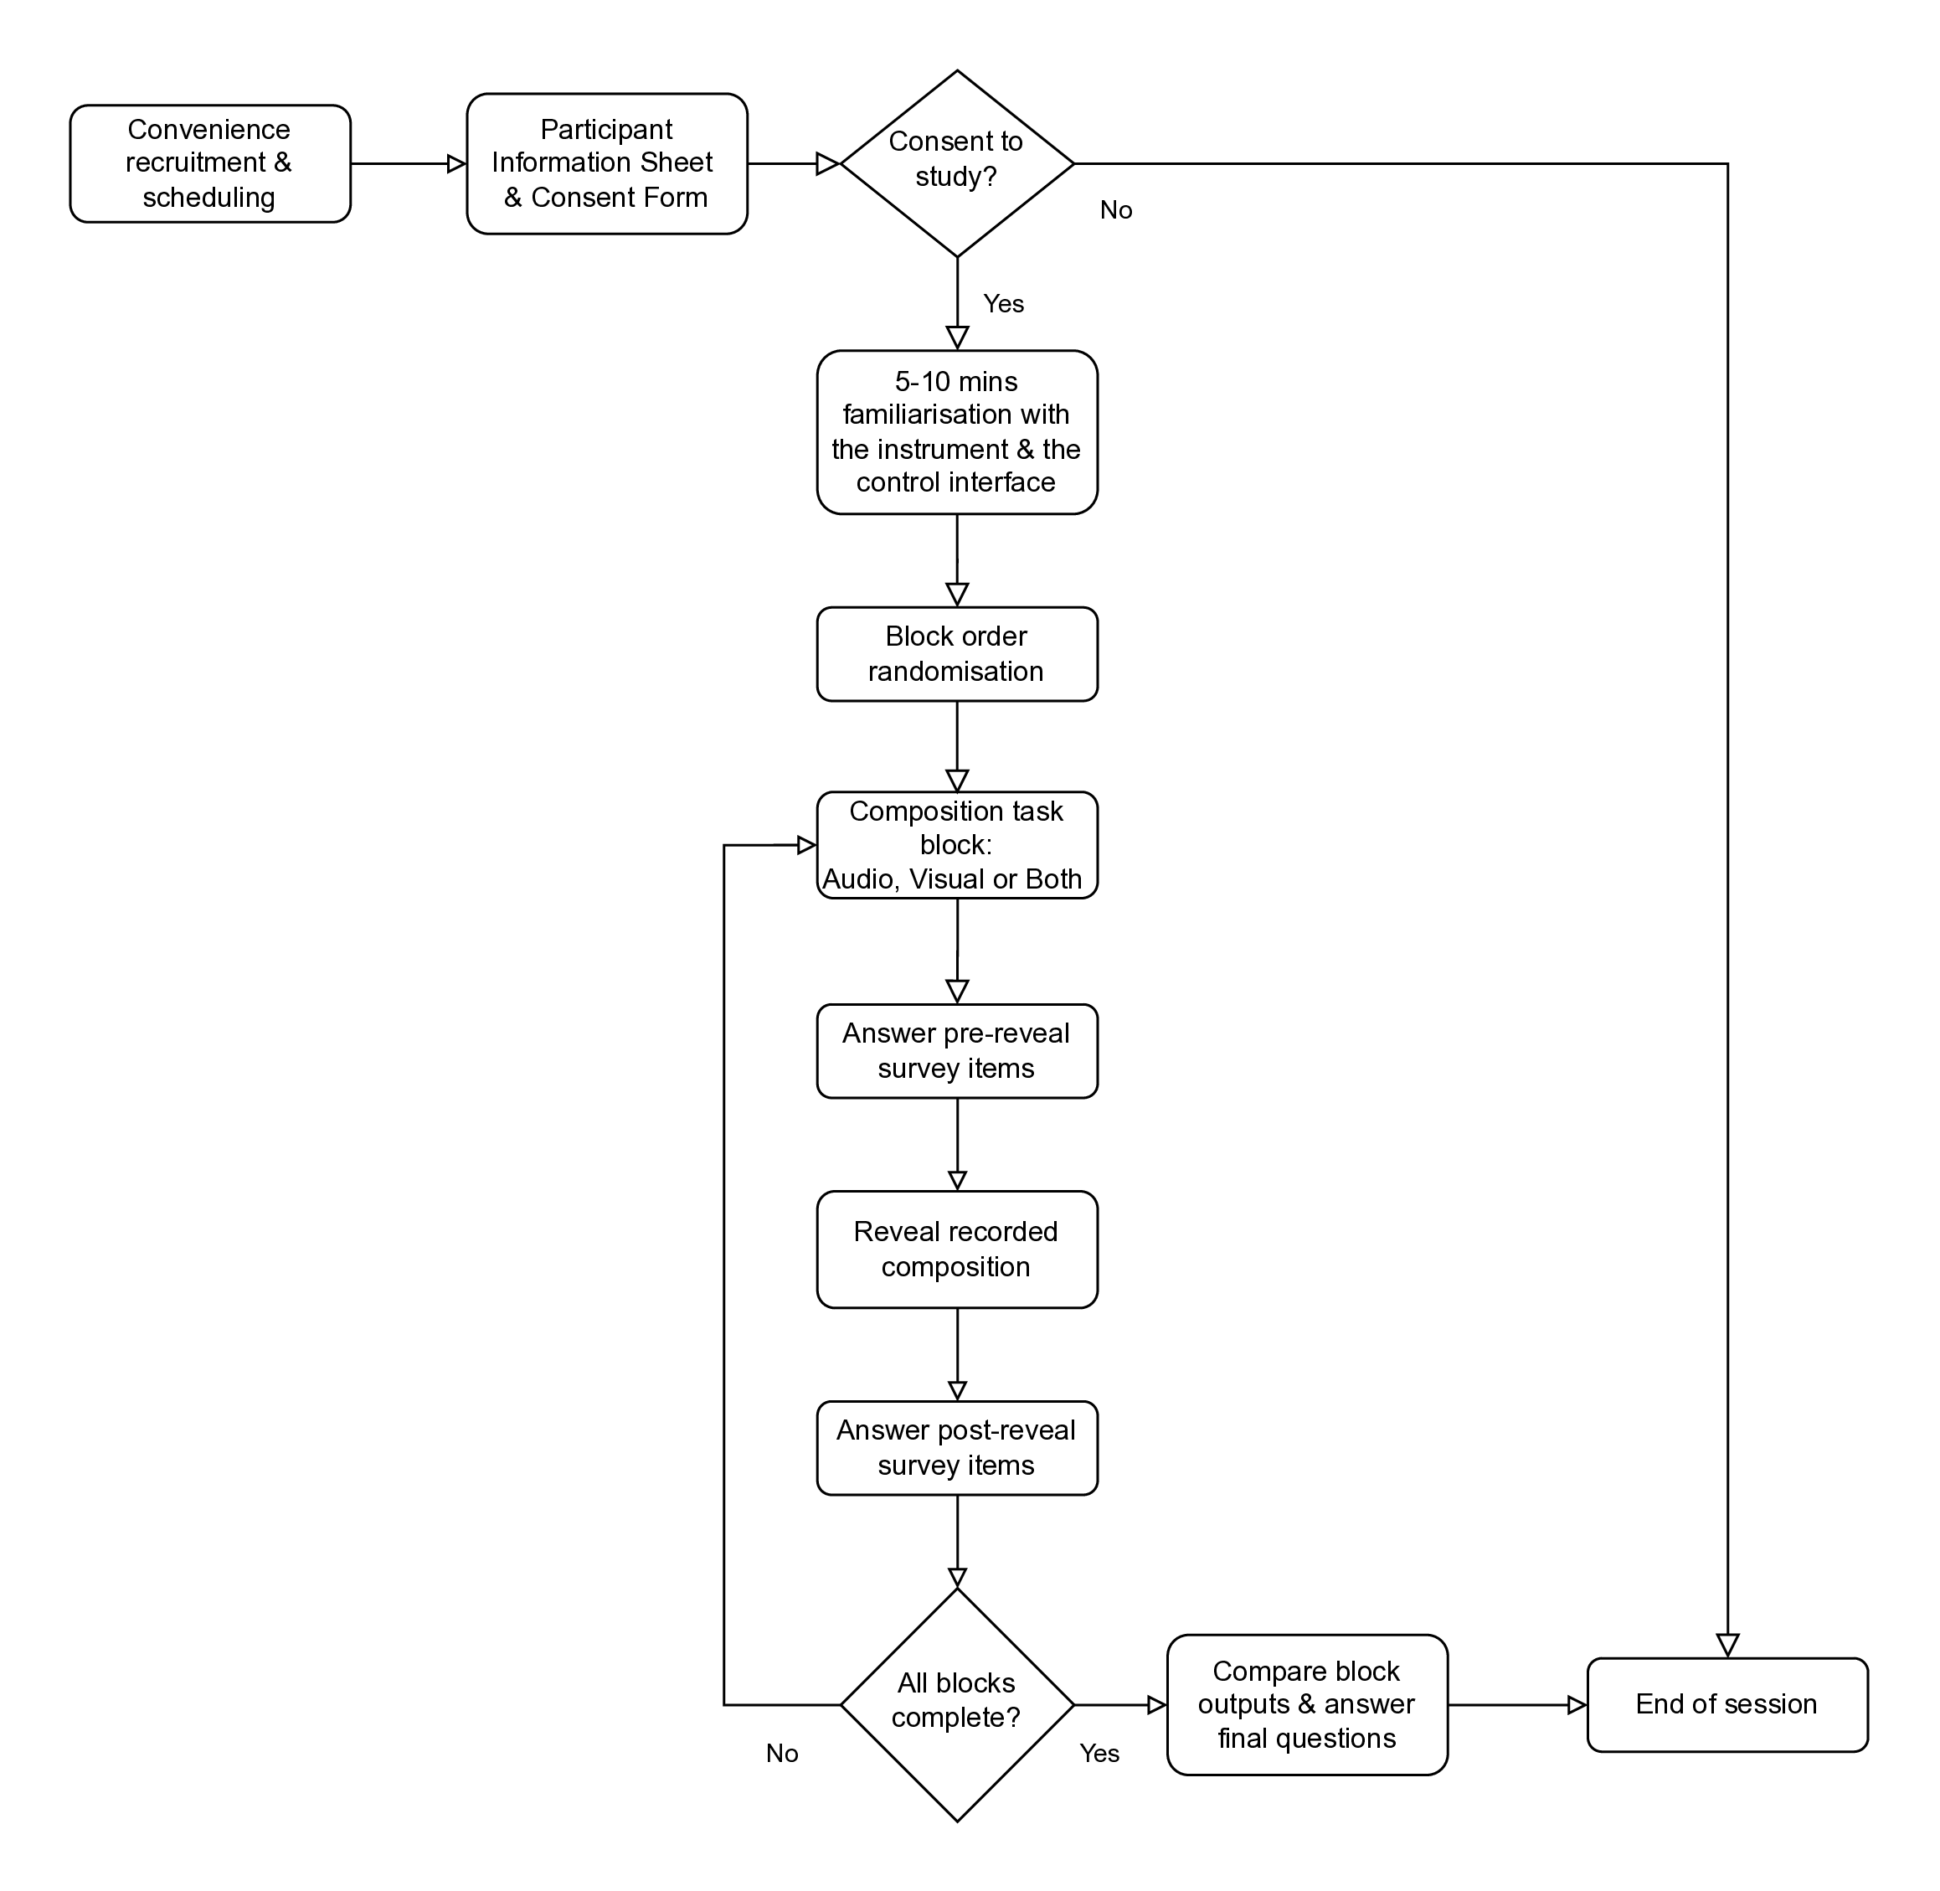
Figure X. Study procedure flow diagram.
3.4.2 Common starting point and captures
Each block began from a standardised preset S0 to support within-subject comparison. Participants explored the system under the assigned modality constraint for ~5–10 minutes, then recorded a final excerpt of [60–120] seconds. Parameter changes were permitted during recording. The end-state preset for each block was saved.
Block prompts were:
A (Visual-only): “Create an interesting pattern/motion on the LED panel.”
B (Audio-only): “Create an interesting melody/sonic texture.”
C (Audiovisual): “Create an interesting combined audiovisual experience.”
3.4.3 Reveal and per-block questionnaires
Immediately after each capture, the excerpt was replayed with both modalities enabled (the “reveal”). Participants completed:
Part A (pre-reveal): ratings and brief notes about the composition experience under constraint.
Part B (post-reveal): ratings and reflections about the fused audiovisual result after replay.
This structure was designed to separate (i) compositional experience under constraint from (ii) retrospective binding and reinterpretation when both modalities are present.
3.4.4 Dyad trial procedure
For each dyad session: confirm asymmetric access, explore from S0 (~5–10 minutes), record a final excerpt ([60–120] seconds) with parameter changes permitted, save the end-state preset, and complete the dyad questionnaire independently.
3.5 Measures 3.5.1 Per-block questionnaires (solo)
Each block used a two-part questionnaire with 7-point Likert ratings (1 = strongly disagree, 7 = strongly agree), plus short free-text prompts.
Part A (pre-reveal) captured:
satisfaction with outcome (A1),
intention clarity (A2),
steerability toward intention (A3),
interface understandability (A4),
useful surprise (A5),
frustrating unpredictability (A6),
confidence others would find the result interesting (A7), plus brief strategy notes.
Part B (post-reveal) captured:
same-process judgement (B1),
modality balance (B2),
coherence/legibility (B3),
constructive reinforcement (B4),
destructive contradiction (B5),
overload (B6),
expectation match (B7),
interpretation change (B8),
causal story plausibility (B9),
perceived system autonomy (B10),
reliance on visual cues (B11),
reliance on Tonnetz/music-theory cues (B12), plus free-text reflections on mismatch, fusion, and interference moments.
Participants also nominated up to three “most influential” parameters used in that block.
3.5.2 End-of-session comparison (solo)
At session end, participants:
ranked their three outputs,
selected which block felt “most intermedial,”
selected which block had the “biggest mismatch,”
provided one change request to improve media equality / intermedial legibility.
3.5.3 Dyad questionnaire (exploratory)
Dyad participants completed a short questionnaire independently, rating coordination, communication, shared reference points, perceived audiovisual coherence/balance, and joint ownership, alongside brief notes on negotiation and disagreements.
3.5.4 External ratings (planned triangulation; ongoing)
A separate pool of independent raters was recruited to evaluate anonymised audiovisual clips in a blinded, randomised web presentation. The intent of this rating task is to triangulate performer self-report with observer judgements of the captured artefacts. At the time of writing, this rating process is ongoing; therefore, the present paper reports no inferential claims from rater data. Rating progress (number of raters and clip completions) is documented in an appendix.
3.6 Data handling and analysis plan
Captured artefacts per solo block
end-state parameter preset (machine-readable export),
audio file and video file for the captured excerpt,
Part A and Part B questionnaire responses,
end-of-session ranking and reflections.
Primary comparisons
within-subject contrasts across A (visual-only), B (audio-only), and C (audiovisual),
descriptive comparison with system-alone baseline captures,
exploratory description of dyad behaviour and experience.
Qualitative analysis focus
compositional strategies under constraint,
reveal-driven reinterpretation and mismatch valence,
interference mechanisms (e.g., temporal/density cue conflicts, masking),
participant-led design requirements.
Quantitative analysis focus
condition-level summaries of key Likert items,
paired within-subject visualisation of focal measures (e.g., steerability, same-process judgement, overload),
descriptive distributions of end-of-session choices (preference, “most intermedial,” “biggest mismatch”),
descriptive distributions of parameter nominations by condition.
- Results: composing and interpreting intermedial relations under modality constraint
This section reports within-subject outcomes from the three composition conditions—A (visual-only), B (audio-only), and C (audiovisual)—combining descriptive summaries of the Likert items (see Table 2; Figs 1–4), parameter-choice counts (see Fig 6), and thematic synthesis of free-text reflections. Given the small sample (N=9), quantitative results are reported descriptively as medians [interquartile range] and paired plots are used to highlight within-participant patterns.
4.1 Participants and data completeness (Table 1)
Nine participants completed all three blocks (N=9; 27/27 blocks; 0% missing quantitative items). All sessions were solo and block order was counterbalanced. Musical experience ranged from none to advanced/professional; theory familiarity ranged from none to high. One participant reported red–green colour deficiency, and one used speakers rather than headphones. Participant background metadata are summarised in Table 1.
4.2 Condition preference, perceived intermediality, and mismatch (Fig 1)
End-of-session rankings show a strong preference for the audiovisual condition (C): 8/9 participants ranked C as their top condition (with 1/9 preferring B; 0/9 preferring A). Participants also most frequently selected C as “most intermedial” (7 selected C; 1 selected B; 1 response did not provide a single-condition selection and was coded as unsure/blank). In contrast, participants most often identified the audio-only condition (B) as producing the “biggest mismatch” (6/9), compared with A (2/9) and C (1/9). These distributions are shown in Fig 1. A montage of visual outcomes across participants and conditions is provided in Figure X.
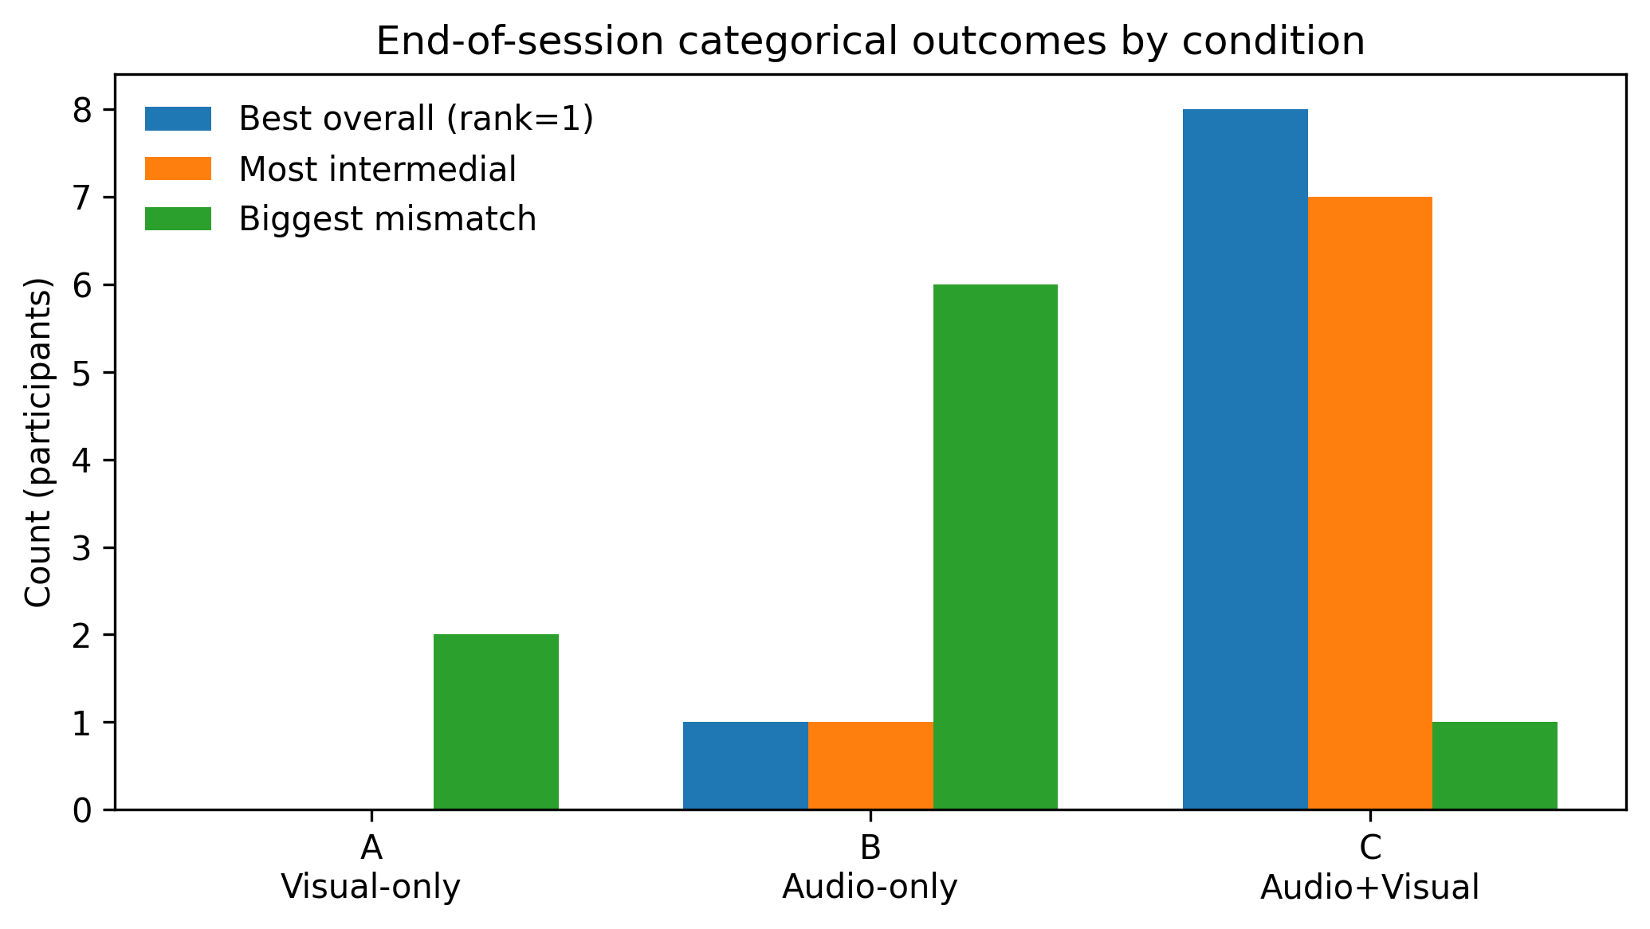
Figure 1. End-of-session counts for preference, most intermedial, and biggest mismatch.
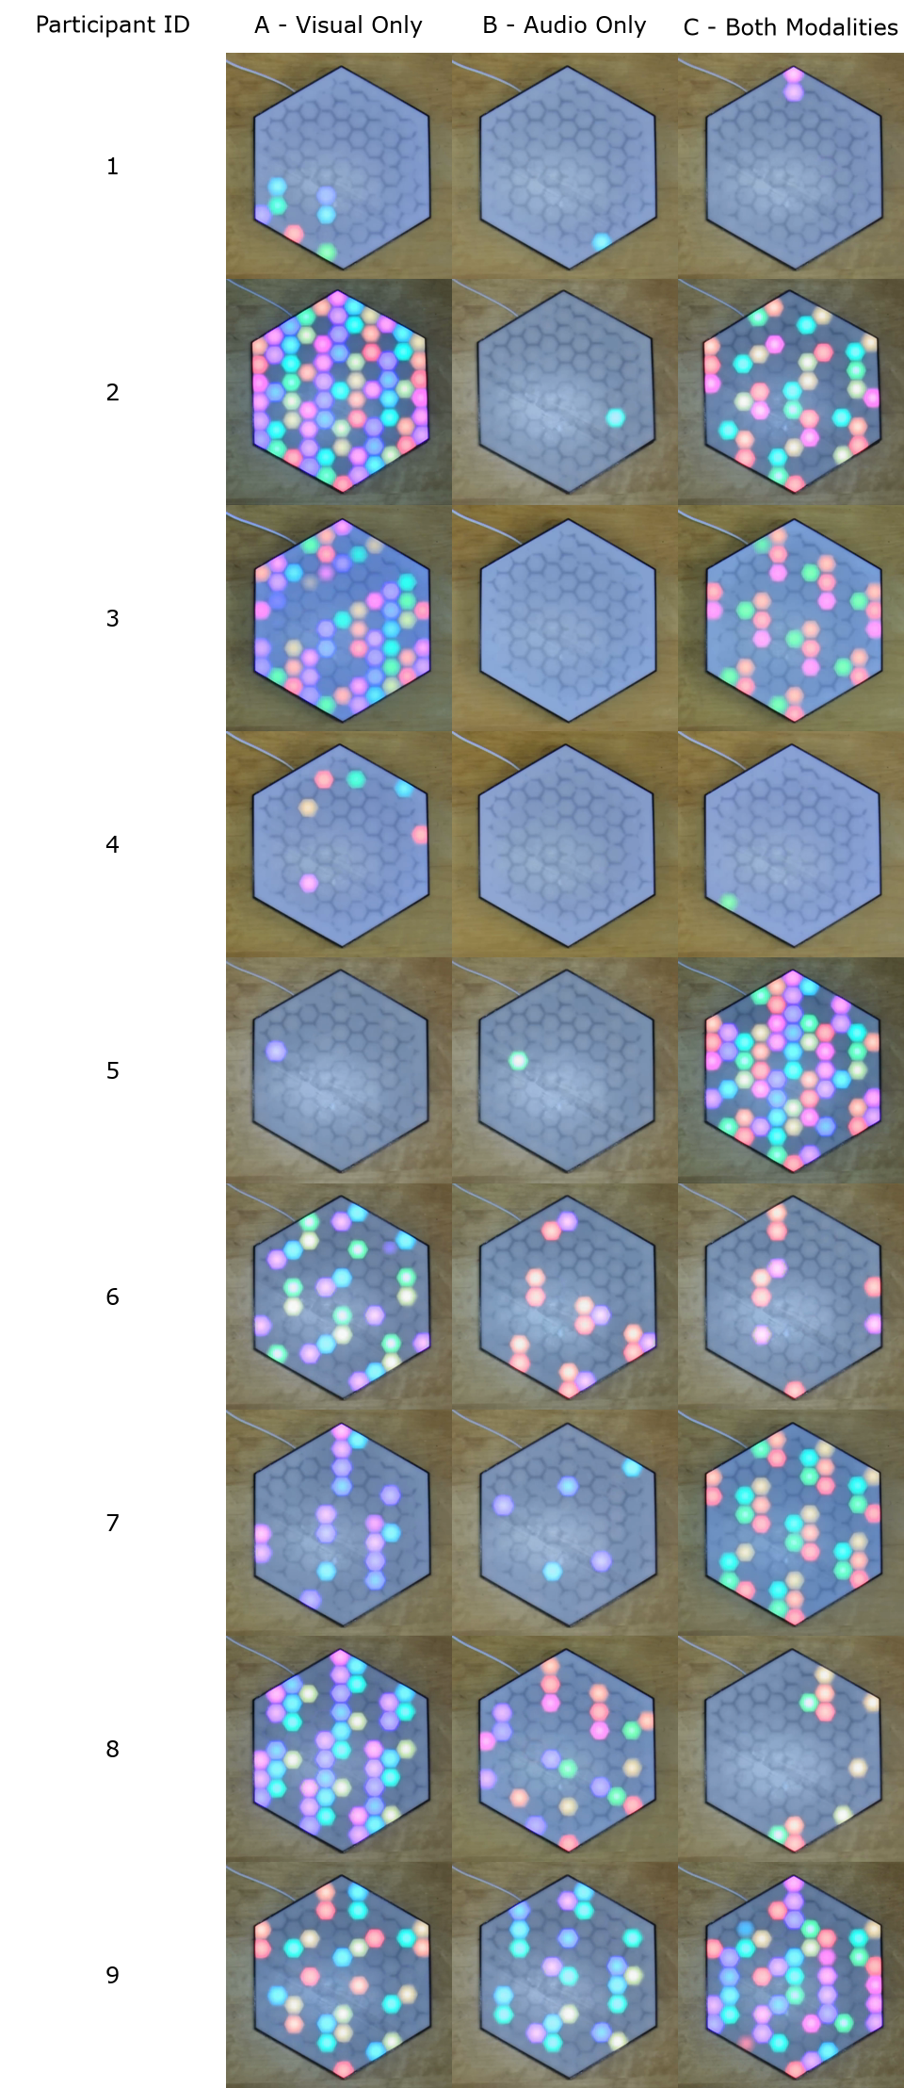
Figure X. Montage of participant outputs across conditions (A/B/C).
Taken together with the free-text accounts, these outcomes suggest that “intermediality” is not treated by participants as a narrow judgement of mapping correctness. Instead, it functions as an experiential judgement about whether the coupled system supports (i) intention formation, (ii) monitoring and causal inference during interaction, and (iii) retrospective sense-making during replay.
4.3 Compositional strategies under constraint: density, arcs, loops, and exploratory testing
Across conditions, participants described compositional approaches that clustered into five recurring strategy families: (i) density shaping (e.g., filling the grid and thinning it), (ii) arc/narrative forms (build-up toward chaos followed by release), (iii) loop-based structuring to establish predictability, (iv) harmony/scale manipulation (sometimes using colour similarity as a proxy), and (v) rapid A/B testing of parameters to learn local cause–effect relations. However, the emphasis of these strategies tended to shift with modality constraint.
In visual-only (A), participants commonly treated the panel as a dynamic visual field and composed by covering the grid, sculpting density, and exploring emergent pattern families. Consistent with these accounts, perceived steerability (A3) was highest in A (6.00 [4.00, 6.00]; Table 2; Fig 2), suggesting that visual feedback supported a confident action–evaluation loop even when audio was unavailable.
In audio-only (B), strategies were more often framed in texture, pacing, repetition, and risk management. Looping was described as a stabilising container to prevent drift into uncontrolled noise. Quantitatively, steerability dropped in B (4.00 [3.00, 5.00]; Table 2; Fig 2), aligning with descriptions of reduced state visibility and uncertainty about what the system was doing.
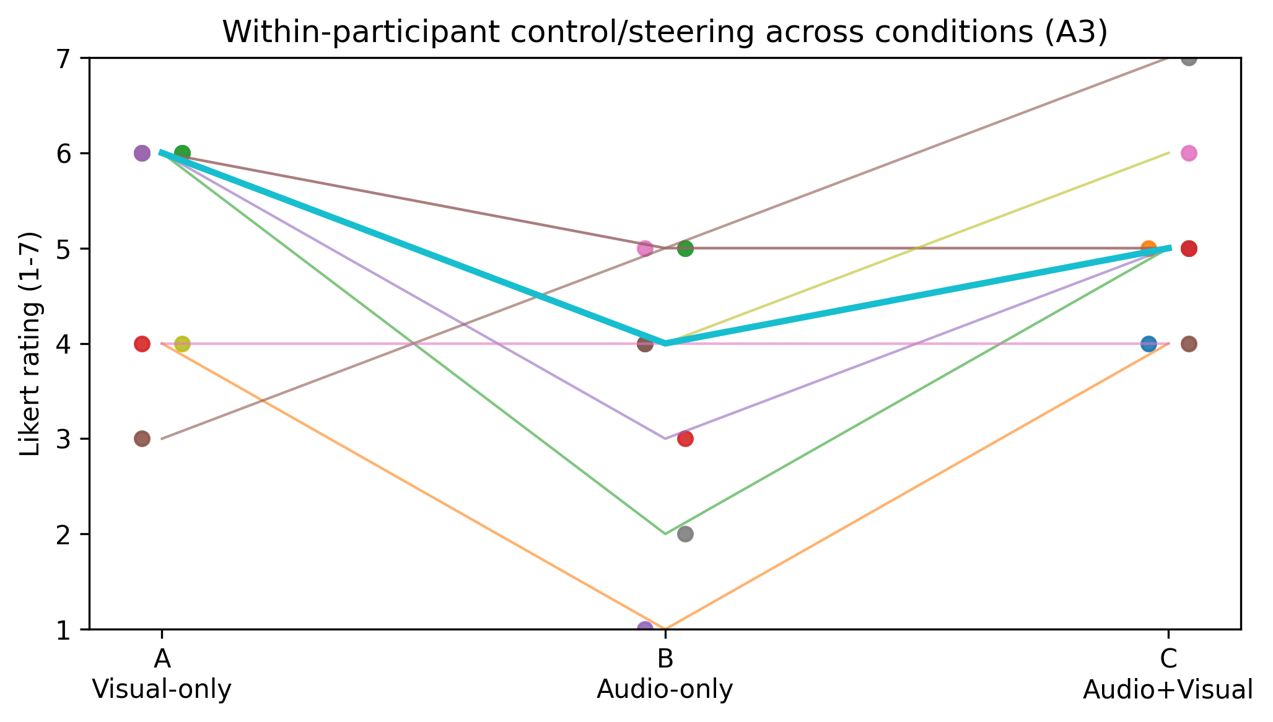
Figure 2. Paired steerability (A3) by condition.
In audiovisual (C), participants frequently described combining what they had learned in the earlier blocks and alternating more deliberately between density control, harmonic selection, and temporal shaping. Satisfaction (A1) was highest in C (6.00 [5.00, 6.00]; Table 2) and useful surprise (A5) also increased (6.00 [5.00, 6.00]), supporting accounts of C as enabling both intention and productive emergence. At the same time, some participants noted the workload of attempting to optimise sound and light simultaneously; frustrating unpredictability (A6) was slightly higher in C (4.00 [3.00, 4.00]) than in A (3.00 [2.00, 4.00]) or B (3.00 [2.00, 5.00]) (Table 2).
4.4 The reveal as a site of intermedial rebinding and reinterpretation (Fig 3; Table 2)
A recurring phenomenon was the reveal (immediate replay with both modalities enabled after composing under constraint) acting as a moment of retrospective binding and reinterpretation. Participants frequently described surprise, delight, or a re-evaluation of what they believed they had controlled; several accounts described replay as disclosing latent structure in the shared generative substrate.
This is supported by item B1 (“two views of the same underlying process”), which was higher after audio-only and audiovisual composition than after visual-only composition (A: 4.00 [3.00, 6.00]; B: 6.00 [6.00, 7.00]; C: 6.00 [6.00, 6.00]; Table 2), summarised in Fig 3. In other words, participants were most likely to judge the coupled replay as “the same process” when sound had been salient during composition (B) or when both modalities were available (C), whereas composing visually produced weaker same-process judgements for some participants.
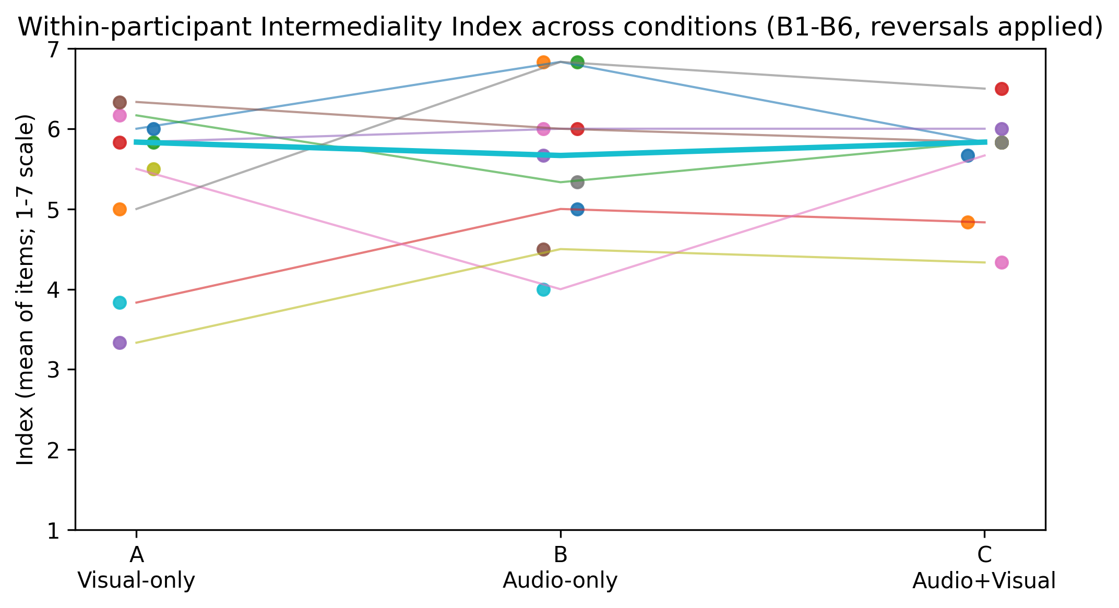
Figure 3. Paired intermediality index by condition.
These results also clarify why B was often selected as the “biggest mismatch” (Fig 1) without necessarily being experienced negatively: in multiple accounts, mismatch operated as a productive discontinuity, where replay exceeded expectations and functioned as a calibration signal that extended the participant’s causal model of the system.
4.5 Attentional hierarchy and “media equality” as a negotiated achievement (Table 2)
Participants repeatedly articulated an attentional hierarchy between modalities. Some reported that sound dominated experience and that audio needed to be removed before they could prioritise visual composition; others described the inverse, noting the difficulty of controlling audio-only states despite later recognising more structure on replay.
Quantitatively, “balanced modalities” (B2) showed similar medians across conditions (A: 6.00 [2.00, 6.00]; B: 6.00 [3.00, 6.00]; C: 6.00 [3.00, 6.00]; Table 2), but with wider dispersion in A. This supports a core qualitative theme: “media equality” is not an intrinsic property of the instrument; it is negotiated through attentional dominance, familiarity, and the availability of stabilising cues (notably repetition and looping).
Perceptual overload (B6) remained low across conditions (A: 2.00 [1.00, 2.00]; B: 2.00 [2.00, 3.00]; C: 2.00 [2.00, 2.00]; Table 2; optional Fig 4). Although participants sometimes used terms such as “chaos” or “busy,” overload did not emerge as the dominant failure mode at group level; mismatch and interpretability were more diagnostic, particularly in the audio-only condition.
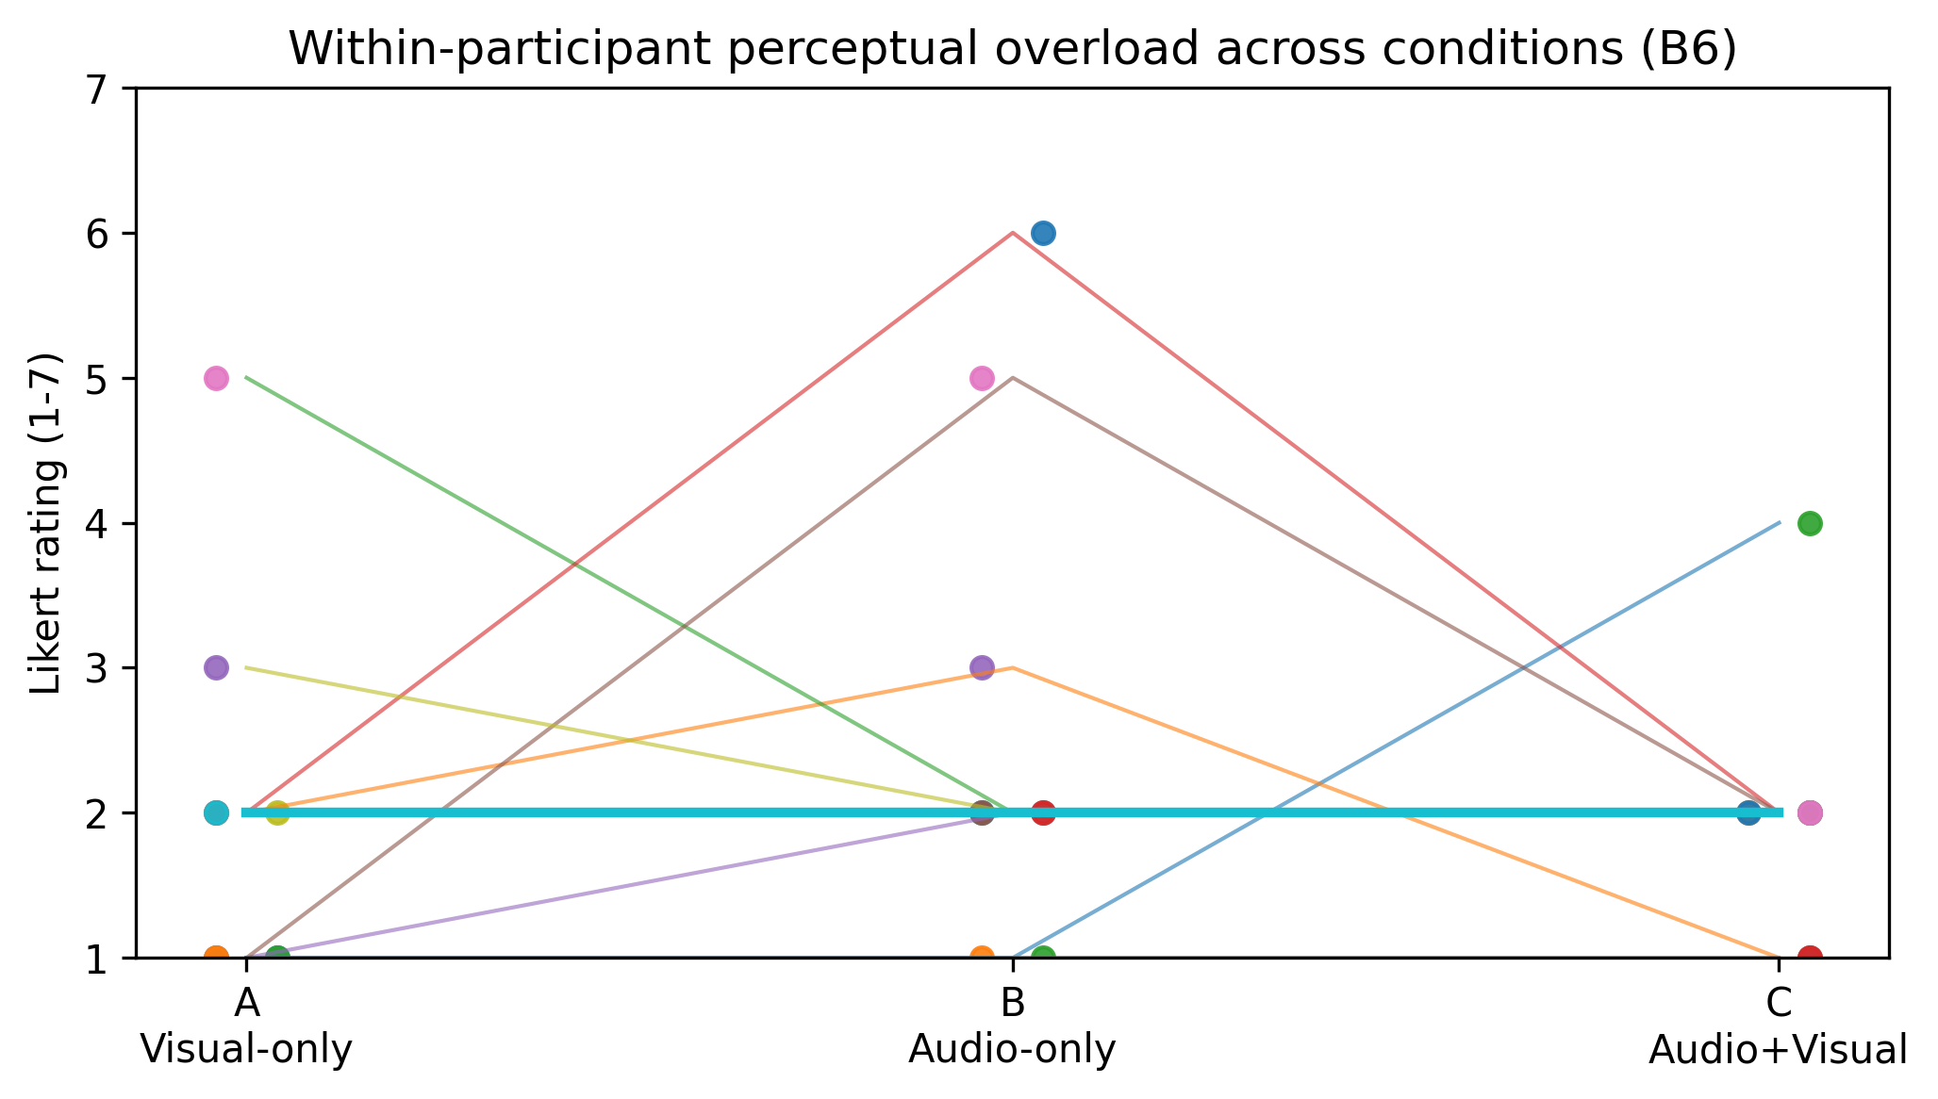
Figure 4. Paired perceptual overload (B6) by condition.
4.6 Intermedial interference as cue conflict: temporal mismatch, density mismatch, and perceptual masking
When interference was described as disruptive, it was typically framed as cue conflict, where one modality implied temporal or causal relations that the other did not support.
The most concrete conflict concerned duration cues: participants noted that light persistence could be misleading relative to note length, weakening temporal correspondence and cross-modal prediction. A second conflict concerned density cues: sparse visuals were sometimes perceived as sonically busy, while visually dense states could be perceived as less complex than expected. A third issue was perceptual masking introduced by timbre and octave stacking, described as collapsing multiple events into a single percept and reducing the auditability of harmonic relationships. Collectively, these reports align with the concentration of “biggest mismatch” selections in B (Fig 1) and lower steerability in B (Fig 2): when cues are withheld or unreliable, participants’ internal causal model becomes less stable during action.
4.7 Agency, autonomy, and co-creative negotiation with an autonomous substrate (Table 2)
Across conditions, participants framed interaction less as direct control and more as negotiated agency, emphasising the value of steerability coexisting with surprise. One participant explicitly questioned authorship (“whether I performed or the Tonnetz performed”), capturing a recurring ambiguity in how creative credit is distributed between human and system.
This theme is consistent with autonomy ratings (B10), which were moderate in A and B (both 4.00 [3.00, 5.00]) and slightly higher in C (5.00 [2.00, 5.00]; Table 2). Qualitatively, audiovisual composition often supported a shift toward a co-creative stance—acceptance and collaboration with the instrument—particularly after participants had experienced both constrained conditions and developed a more stable causal model.
4.8 Parameter strategy and interpretability: what participants used to steer (Fig 6)
Self-reported “most influential parameters” show both a stable core and a modality-dependent shift (Fig 6). Rate was the dominant control across all conditions (A: 8 selections; B: 7; C: 6), consistent with participants using global dynamism to structure arcs and transitions. Scale exhibited the clearest modality dependence: it was cited far more often when sound was available during composition (B: 7; C: 8) than in visual-only composition (A: 3), suggesting that harmonic admissibility becomes a primary steering dimension when participants can audition outcomes in real time. Other parameters (Life Length; neighbour and population thresholds; loop length/on-off) were cited at moderate frequency across conditions, supporting qualitative descriptions of “constraint tuning” to locate stable regimes and explore local variation.
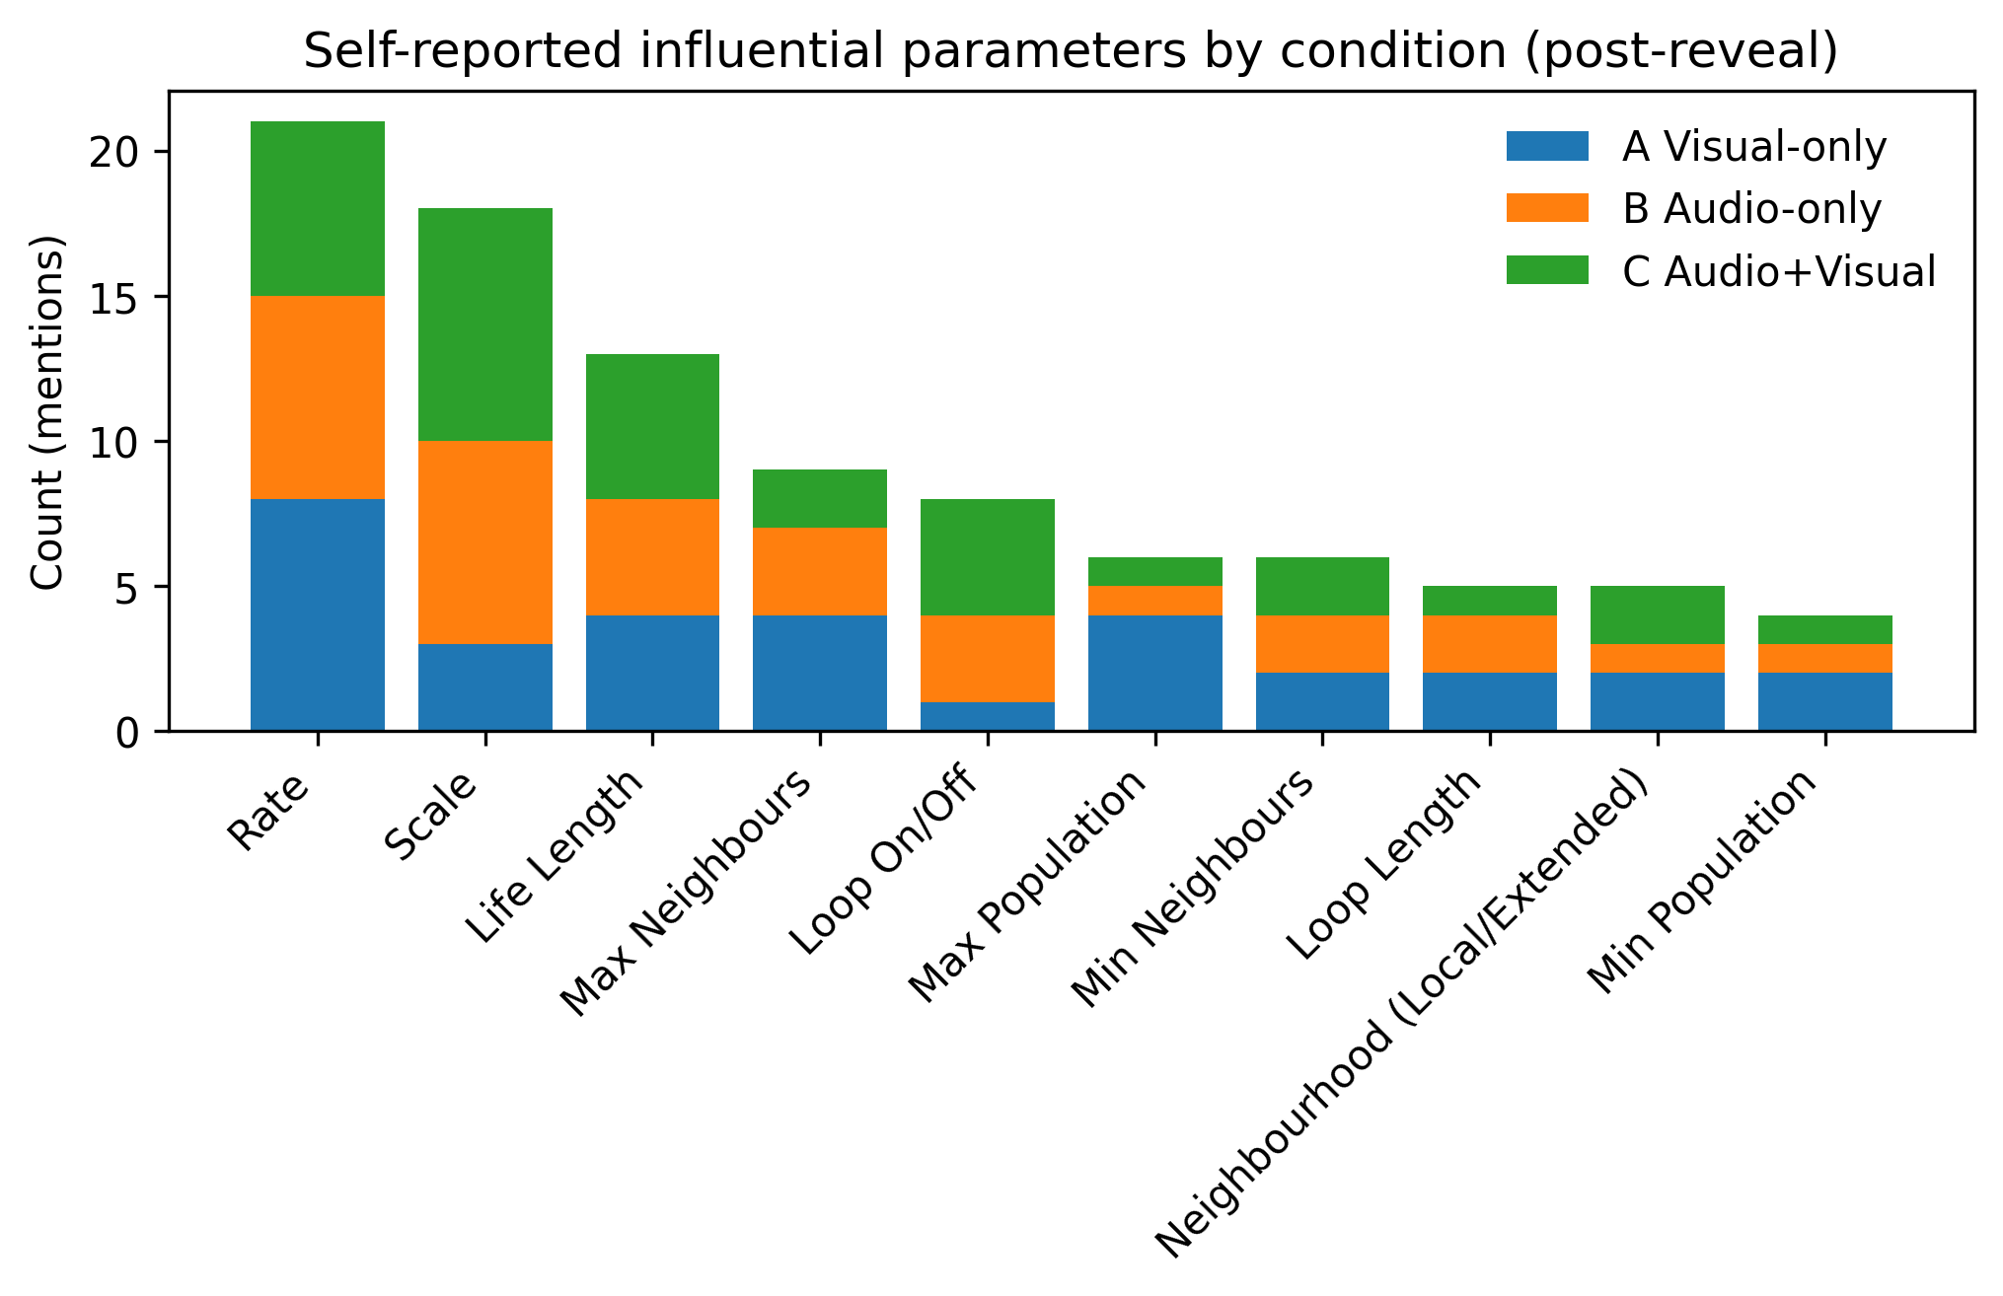
Figure 6. Parameter influence counts by condition.
4.9 Participant-led design requirements: improving legibility, prediction, and expressive articulation
Participants produced convergent, instrument-actionable requirements that map directly onto the mechanisms above: clearer loop and reset affordances; improved parameter semantics and scaling (including counter-intuitive rate behaviour); reduced interface fragmentation; improved colour fidelity and discriminability; better temporal correspondence between note duration and light persistence (or an intentional decay model communicating release); and richer articulation/timbre to reduce perceptual masking and improve event discriminability. These requirements connect to the results in a direct way: where cue reliability and parameter semantics were weak, participants reported mismatch and reduced controllability; where stable cues were available (especially repetition/looping), participants reported safety, predictability, and more intentional structuring.
Summary. Across conditions, intermedial relations in this instrument were experienced as a negotiation between cue reliability, attentional dominance, and an evolving causal model of a shared generative substrate. Constraint conditions did not simply degrade experience; they reconfigured how participants formed intention, monitored outcomes, and attributed agency—sometimes producing negative mismatch (loss of legibility) and sometimes producing positive mismatch (reveal-driven rebinding and delight).
- Discussion
Exploratory dyad trials (teaser for future study). Two dyad-only pilot trials tested asymmetric modality access: one participant monitored audio via headphones while the other monitored the LED panel, with both negotiating parameter changes in real time. Although the sample is too small for inference, dyad questionnaire ratings were generally high (predominantly 5–6/7 across items), and communication notes describe an emergent division of labour in which one participant tended to “drive” the interface while the other provided evaluative feedback (“try this / try that”) and high-level direction based on the withheld modality. Participants explicitly noted the need to alternate between affective descriptions (“feel”) and parameter-level talk, and to manage turn-taking (when to be quiet versus when to intervene), consistent with the challenge of coordinating from complementary partial information. Across both dyad trials, participants reported moments where improvements in one modality coincided with improvements in the other (e.g., when the sound “worked,” the visual also appeared to cohere), suggesting that the shared state-space can function as a common reference even under split access. In line with solo participants’ reflections that dyad success would likely depend on the relationship and communicative fluency of the pair (rather than on a single “best” modality assignment), a larger counterbalanced dyad study is a promising next step for testing whether distributed access can reliably produce coherent intermedial outcomes and how communication strategy mediates that success.
- Conclusion
- Acknowledgements

References
Besada, J. L., Bisesi, E., Guichaoua, C. and Andreatta, M. 2024. The Tonnetz at First Sight: Cognitive Issues of Human–Computer Interaction with Pitch Spaces. Music & Science 7: 20592043241246515. https://doi.org/10.1177/20592043241246515.
Bolter, J. D. and Grusin, R. 1999. Remediation: Understanding New Media. Cambridge, MA: MIT Press.
Chiaramonte, A. 2024. Intermedial Interference in Electroacoustic Audiovisual Composition: An Investigation into Combining, Integrating, and Fusing Sound and the Moving Image. A Portfolio of Audiovisual Compositions. PhD thesis. Bournemouth University.
Chion, M. 1994. Audio-Vision: Sound on Screen. New York: Columbia University Press.
Cohn, R. 1997. Neo-Riemannian Operations, Parsimonious Trichords, and Their “Tonnetz” Representations. Journal of Music Theory 41(1): 1–66.
Cook, N. 1998. Analysing Musical Multimedia. Oxford: Clarendon Press.
Didiot-Cook, T. 2025. Cellular Au-Tonnetz: A Unified Audio-Visual MIDI Generator Using Tonnetz, Cellular Automata, and IoT. In P. Machado, C. Johnson and I. Santos (eds.) Artificial Intelligence in Music, Sound, Art and Design. EvoMUSART 2025. Lecture Notes in Computer Science, 15611. Cham: Springer, 51–65. https://doi.org/10.1007/978-3-031-90167-6_4.
Douthett, J. and Steinbach, P. 1998. Parsimonious Graphs: A Study in Parsimony, Contextual Transformations, and Modes of Limited Transposition. Journal of Music Theory 42(2): 241–63.
Elleström, L. 2010. The Modalities of Media: A Model for Understanding Intermedial Relations. In L. Elleström (ed.) Media Borders, Multimodality and Intermediality. London: Palgrave Macmillan, 11–48. https://doi.org/10.1057/9780230275201_2.
Miranda, E. R. 2007. Cellular Automata Music: From Sound Synthesis to Musical Forms. In E. R. Miranda (ed.) Evolutionary Computer Music. London: Springer, 170–93. https://doi.org/10.1007/978-1-84628-600-1_8.
O’Modhrain, S. 2011. A framework for the evaluation of digital musical instruments. Computer Music Journal 35(4): 28–42. https://doi.org/10.1162/COMJ_a_00038.
Organised Sound. 2026. Call: Electroacoustic Audiovisual Composition and Intermediality: Reconceptualising media relationships. 15 January. www.cambridge.org/core/journals/organised-sound/announcements/call-for-papers/call-electroacoustic-audiovisual-composition-and-intermediality-reconceptualising-media-relationships (accessed 31 December 2025).
Orio, N. and Wanderley, M. M. 2002. Evaluation of input devices for musical expression: Borrowing tools from HCI. Computer Music Journal 26(3): 62–76. https://doi.org/10.1162/014892602320582981.
Rajewsky, I. O. 2005. Intermédialité, intertextualité et remédiation: une perspective littéraire sur l’intermédialité. Intermédialités 6: 43–64. https://doi.org/10.7202/1005505ar.
Spence, C. 2011. Crossmodal correspondences: A tutorial review. Attention, Perception, & Psychophysics 73: 971–95. https://doi.org/10.3758/s13414-010-0073-7.

