Temuujin Dorjbat

Foodmart

Introduction:

In this day and age, companies look towards sales and data in order to make accurate decisions that will serve a purpose for them moving into the future. This is otherwise known as data-driven decision-making. Data-driven decision-making (DDDM) is defined as using facts, metrics, and data to guide strategic business decisions that align with your goals, objectives, and initiatives. An example of this that we may see today is Apple testing a beta version of their IOS system that has yet to be released to the public. By doing so, they are allowed to test out and revise any imperfections that the customers uncover and fix them before the program is released to the public.

Problem:

At times companies can grow at a rapid pace but unfortunately that traction can end in a steep decline. In this case, Foodmart has multiple franchise locations however some are seemingly doing better than others in overall daily sales. This may be due to location, items sold, etc. Overall the company would like to close certain stores that are not meeting certain revenue minimums. As a result of the closers, Foodmart is divereting those operating funds into funding more profitable locations. In other words they will be using the save operating cost to further develop data that can be used to make their already existing profitable stores more profitable. By doing so they will knock out two birds with one stone inevitably generating more profit and a happy and frequent clientele.

Approach:

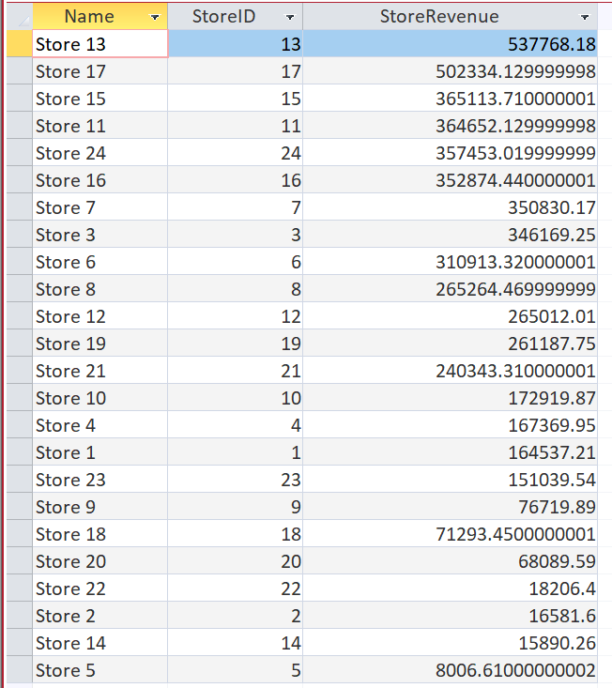

We used Microsoft Access in order to figure out which stores are underperforming. As we can see that Stores 5, 14, 2 and 22 are the least profitable stores in the franchise. On the other hand, Stores 13 and 17 are performing quite well compared to the rest.

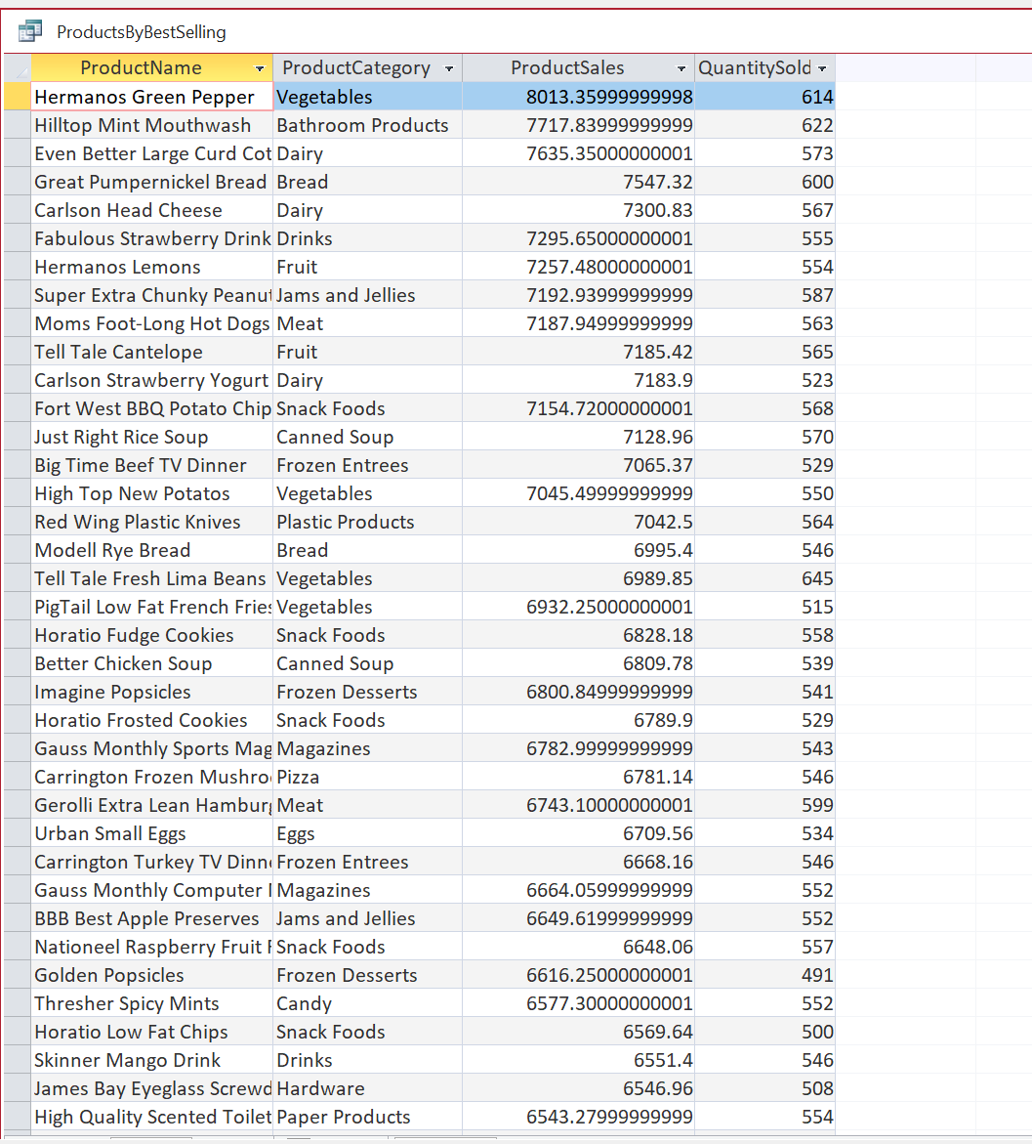

Here we also used Microsoft Access to see the best selling products and the quantity sold. As we can see, Hermanos Green Pepper, Hilltop Mint Mouthwash, and Even Better Large Curd Cottage Cheese are some of the best selling products in the franchise.

Results

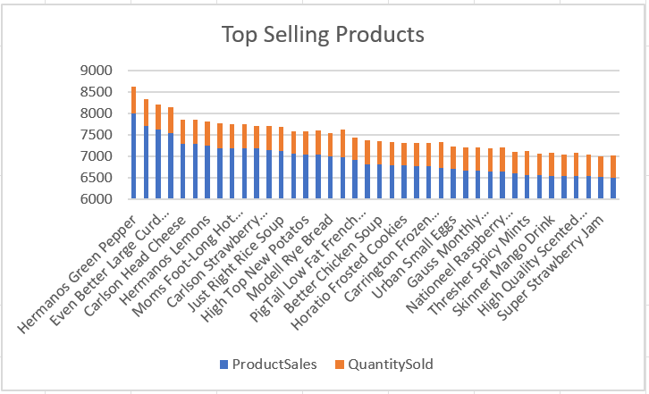

Here are the best selling products that are sorted by total amount of ProductSales and QuantitySold. This graph tells us that “Hermanos Green Pepper” is the number 1 top selling product with the most amount of Revenue and one of the top quantity sold items in the franchise.

Conclusion:

* We can conclude that “Store 5” is the least performing store in the franchise with only $8007 in revenue a day, therefore it should be selected as the store to be discontinued from the franchise.
* Furthermore we also found that the following products: Hermanos Green Pepper, Even Better Large Curd Cottage Cheese, Carlson Head Cheese and Hermanos Lemons are top 4 most exceptional products in terms of revenue and units sold. With these being the top products, now we may ask the franchise the following questions:

- Can we find a cheaper supplier?

- Can we negotiate a better price for these products?

- Is one particular employee raising the number of these products, and if so find out how that employee is presenting the products to the customers and how it differs from other employees that are selling the same product.

- Are the most valuable customers(customers with a membership) aware of these products? If not, we can give them free samples of the top selling products to further boost sales of the top products.

- Lastly, how can we market the top products better so it reaches their target audience more effortlessly and effectively.

Appendix:

Raw code for SQL in Microsoft Access to see all stores with their revenue, so we can find the least performing store in the franchise.

[SELECT Stores.Name, Facts.StoreID, SUM(Facts.Revenue \* Facts.UnitsSold) AS StoreRevenue

FROM Stores

INNER JOIN Facts

ON Stores.StoreID = Facts.StoreID

GROUP BY Facts.StoreID, Stores.Name

ORDER BY SUM(Facts.Revenue \* Facts.UnitsSold) DESC;]

Raw code for SQL in Microsoft Access to see the best selling products and the quantity sold.

[SELECT ProductName, ProductCategory, SUM(Facts.Revenue \* Facts.UnitsSold) AS ProductSales, SUM(UnitsSold) AS QuantitySold

FROM Products INNER JOIN Facts ON Products.ProductID = Facts.ProductID

GROUP BY ProductName, ProductCategory

ORDER BY SUM(Facts.Revenue \* Facts.UnitsSold) DESC;]

DATA: Foodmart.mdb