Project 2
<Hangman Game>

CIS-5
Tatiana DeJaco
02/11/15

Introduction

Title: Hangman Game

Hangman is a two player game where player one chooses a word at random and player two guesses its letters. Each time player two guesses incorrectly, player one draws a part of a stick figure. If player two guesses correctly, player one writes the letter where it is located in the word. The game continues until player two is able to reveal the word. However, if player one completes the drawing of a stick figure, then player two has lost the game.

I have altered the game so that instead of it being a two player game, it is now the computer versus a player. The computer chooses a word at random and the player guesses its letters. Also, I have given the user an option to ask for a hint. However, they can only have one hint. If they do ask for a hint, their score decreases by 3 points.

Summary

Project Size: 500+ lines
The number of variables: around 19
The number of method(s): 19

In the previous project I used concepts such as: if statements, if-else statements, switch statements, arrays, for-loops, while-loops, and enumeration types, and overloaded functions. I updated my project by adding concepts like 2-dimensional arrays, vectors, structures, formatted outputs and defaulted parameters.

The computer reads a word from a file containing a list of around 300 random words. At the end of the game, a file containing the chosen word and the user's results: whether they won or lost, the number of strikes, and their score.

The project itself took about a week.

I used the libraries: iostream, iomanip, string, fstream, and vector.

Sample Input and Output

Your guess? a <---- input

guess was incorrect so the hangman is drawn

Your guess? e <---- input

guess was correct so the blanks are filled

Pseudo Code

initialize hangman drawing

display fill in the blanks

while (the player has not yet found the word)

read player's guess

if (guess == '?')
then give them a hint about the word
else if (guess == '/')
then exit the game
else
then search for letter in word

if (player's found word == selected word)
then player won the game
else
if (incorrect guesses == 6 times)
then exit the game the player has lost

display the fill in the blanks after every turn

display their results

continue the game until player no longer wants to play

Flowchart for main(int argc, char** argv)
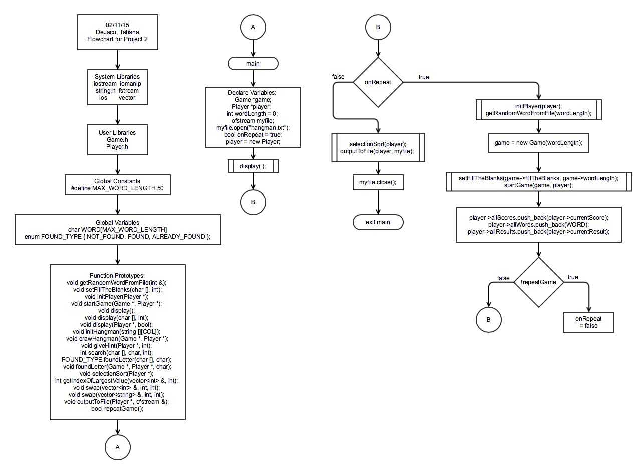
Flowchart for void getRandomWordFromFile(int &);
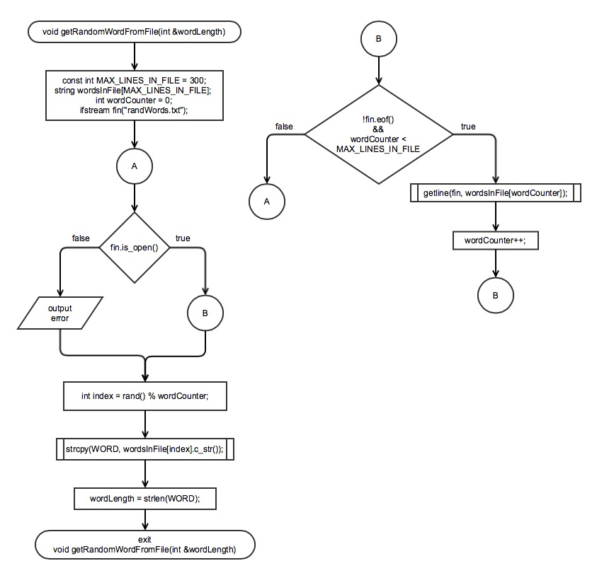

Flowchart for void setFillTheBlanks(char [], int);
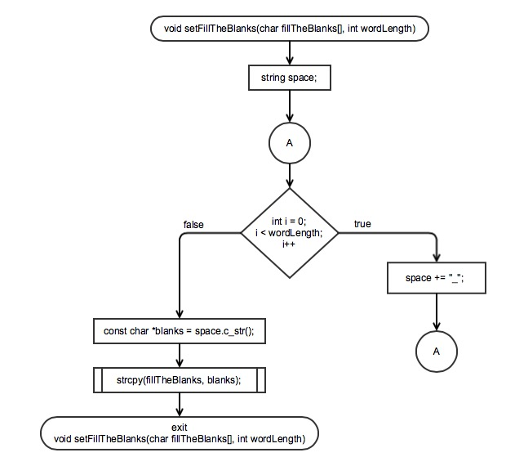

Flowchart for void initPlayer(Player *);
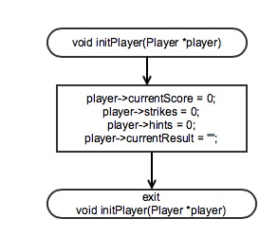
Flowchart for void startGame(Game *, Player *);
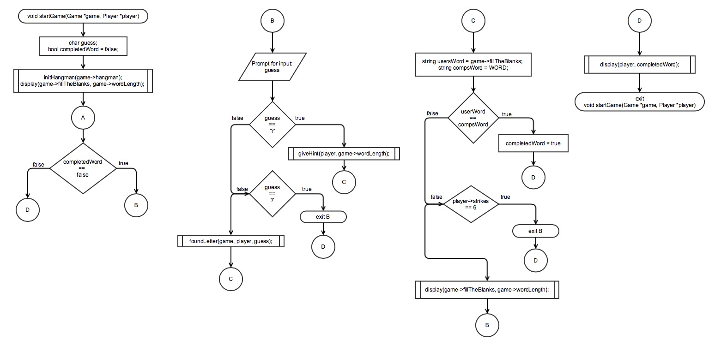
Flowchart for void display(), void display(char [], int), void display(Player *, bool);
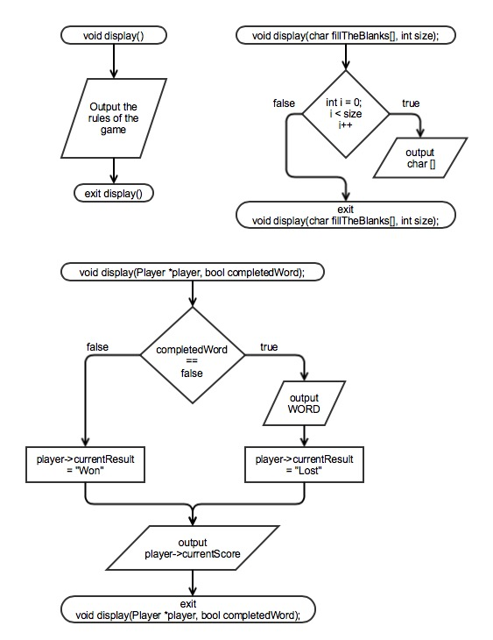
Flowchart for void initHangman(string [][COL]);
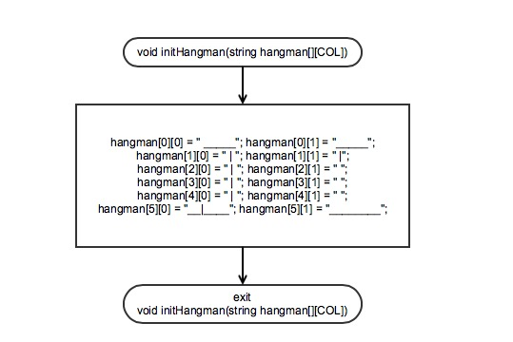
Flowchart for void drawHangman(Game *, Player *);
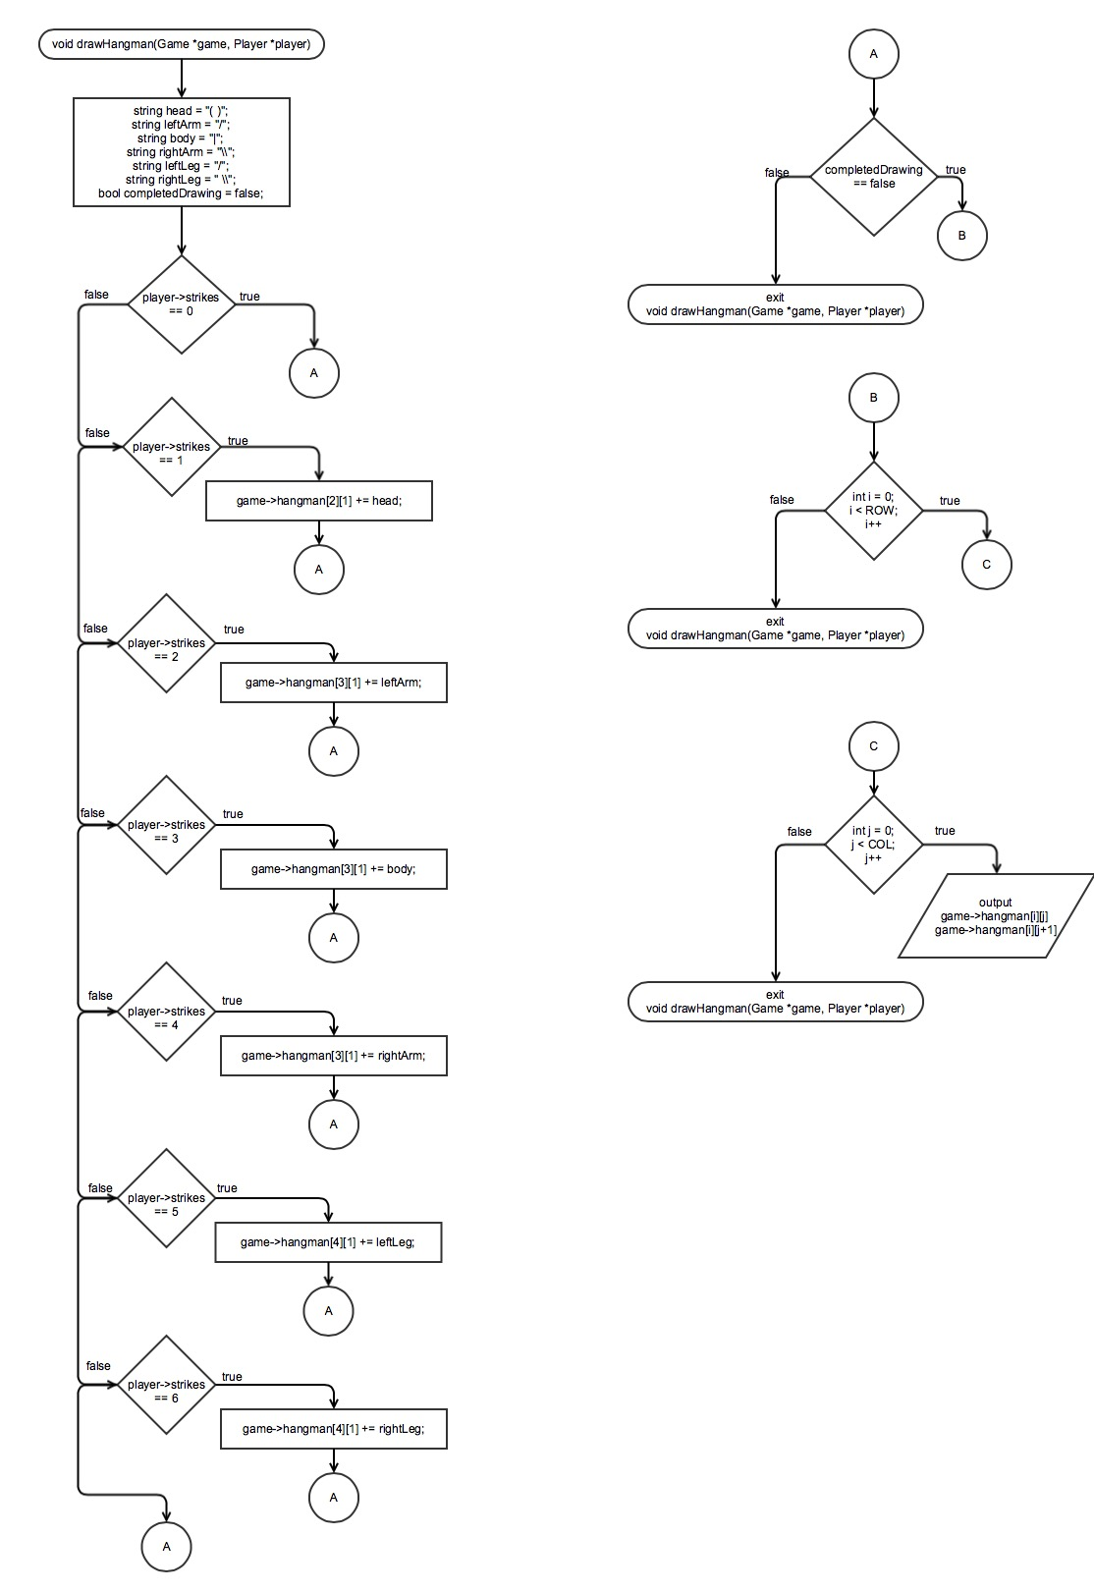
Flowchart for void giveHint(Player *, int);
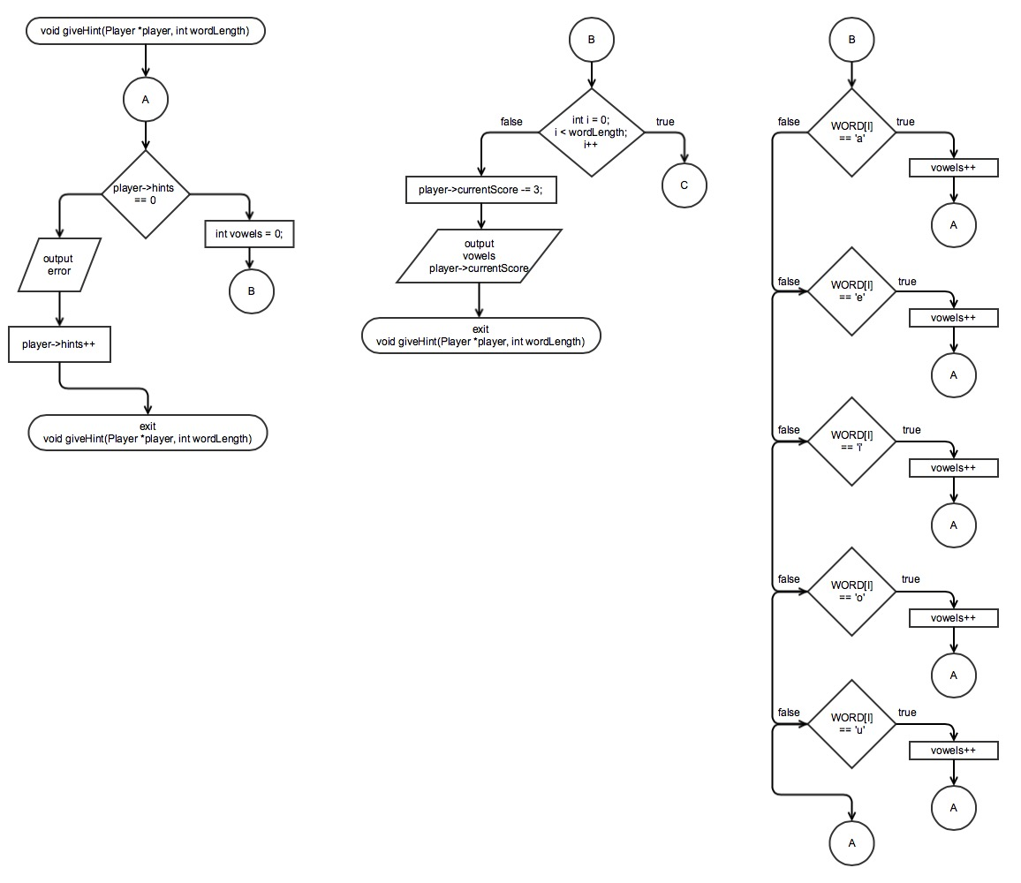
Flowchart for int search(char [], char, int);
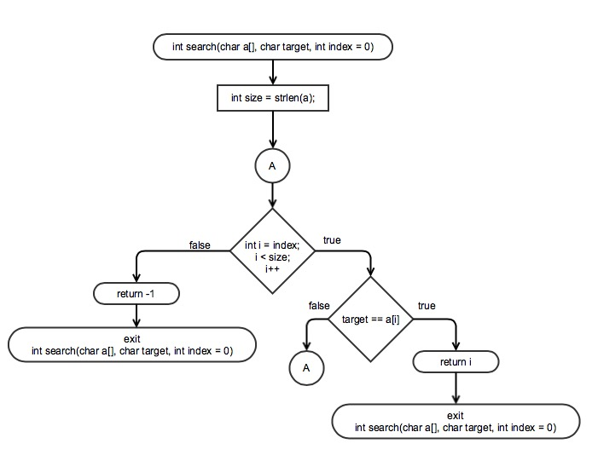
Flowchart for FOUND_TYPE foundLetter(char [], char);
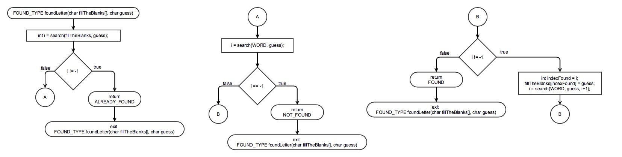
Flowchart for void foundLetter(Game *, Player *, char);
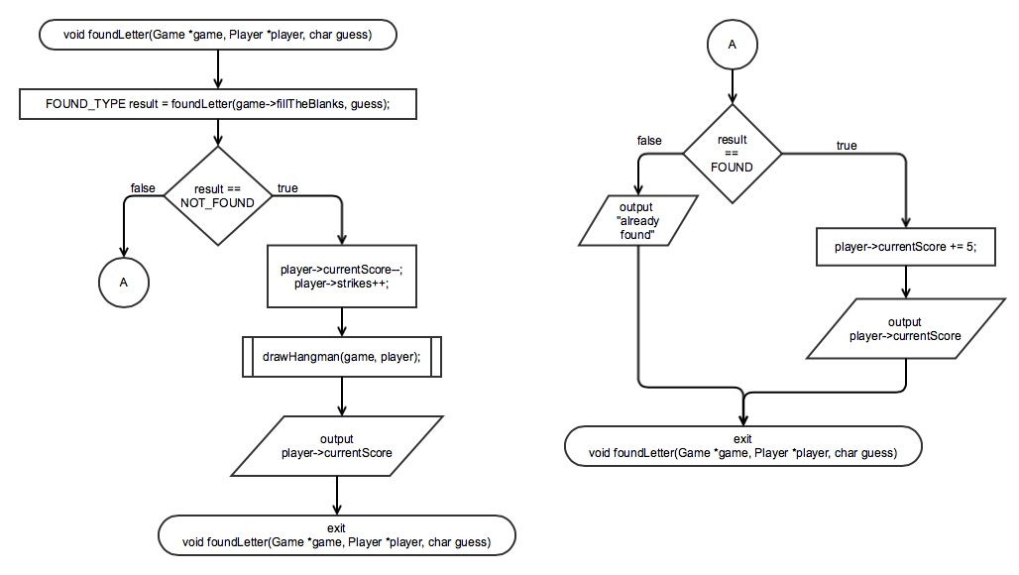

Flowchart for void selectionSort(Player *);
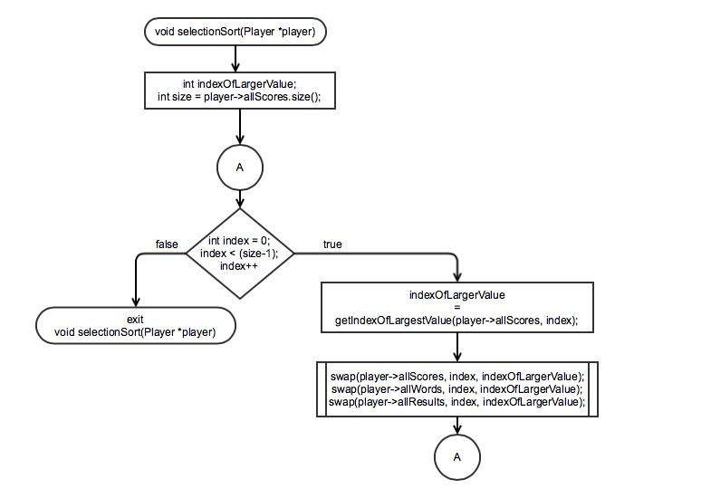
Flowchart for int getIndexOfLargestValue(vector<int> &, int);
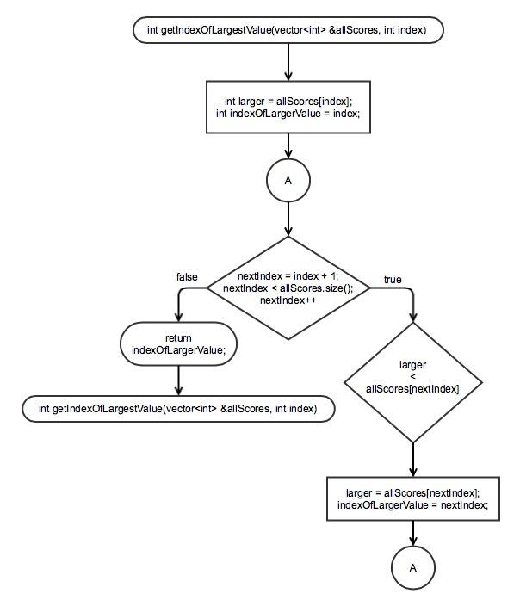
Flowchart for void swap(vector<int> &, int, int);
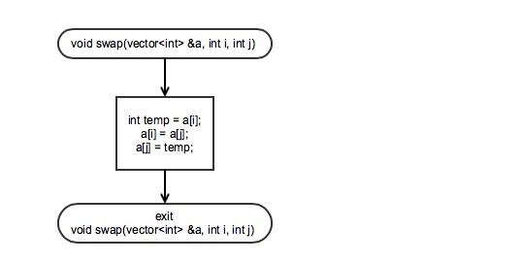
Flowchart for void swap(vector<string> &, int, int);
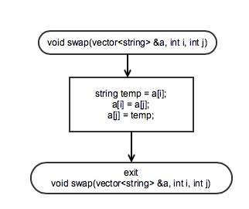
Flowchart for void outputToFile(Player *, ofstream &);
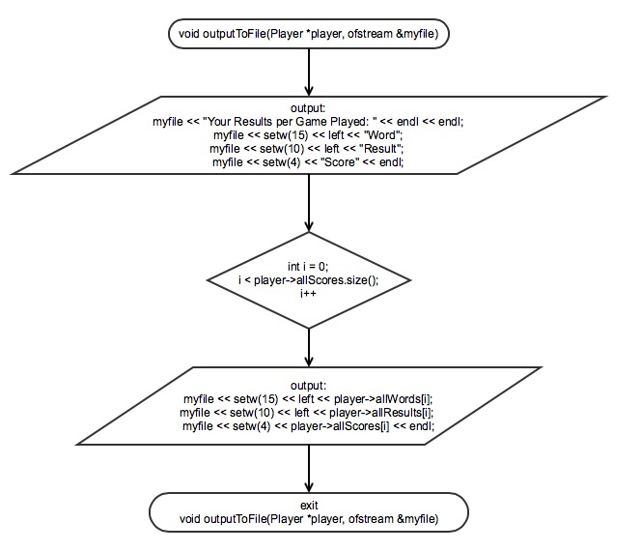
Flowchart for bool repeatGame();
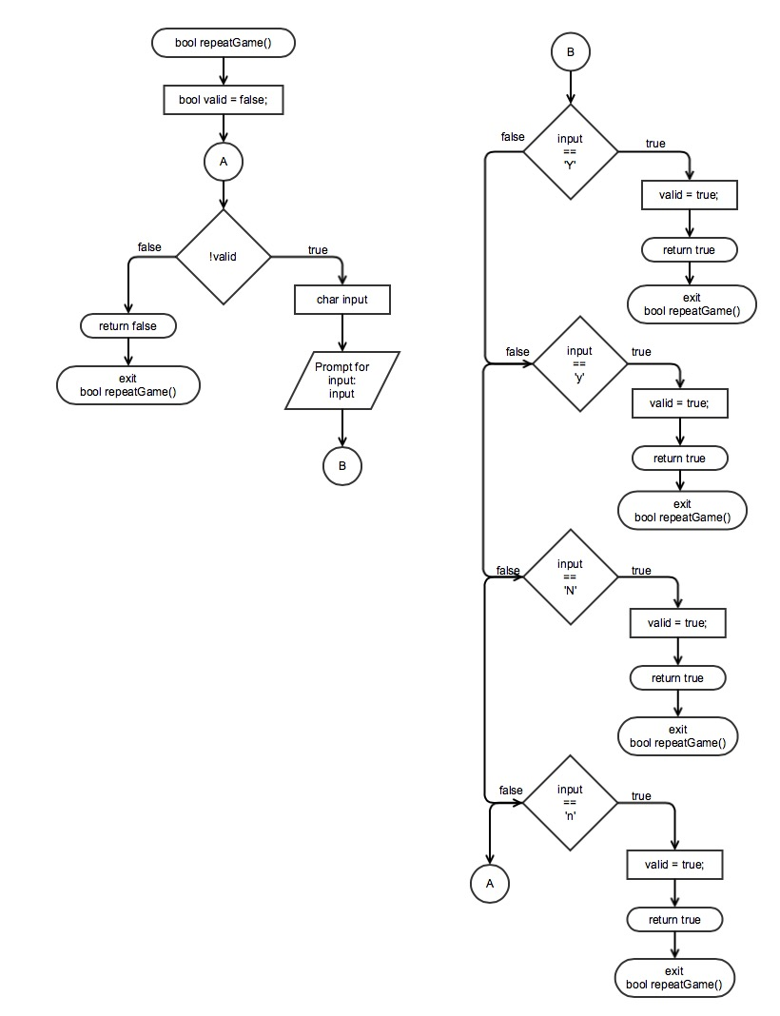
Major Variables
Type | Variable Name | Description | Location
Char [] | WORD | Contains a random word read in from a file. | Main.cpp (Global Variable)
Game | game | A structure containing commonly used variables needed for the game. | Main.cpp
Player | player | A structure used like a database for player. | Main.cpp
int | wordLength | The length of the random word read in from a file. | Main.cpp

C++ Constructs
Chapter | New Syntax and Keywords | Location
2 | cout | startGame(Game *, Player *);
 | cin | startGame(Game *, Player *);
 | output formatting | outputToFile(Player *, ofstream &);
 | int | main(int argc, char** argv)
 | char | main(int argc, char** argv)
 | bool | startGame(Game *, Player *);
 | string | drawHangman(Game *, Player *)
 | assignment operator (+=) | drawHangman(Game *, Player *)
 | arithmetic operator (+,-,*, /) | foundLetter(Game *, Player *, char)
 | increment operator (++) | foundLetter(Game *, Player *, char)
 | decrement operator (--) | foundLetter(Game *, Player *, char)
3 | enumeration type | main.cpp (Global Variable)
 | if-else statements | foundLetter(Game *, Player *, char)
 | switch statements | giveHint(Player *, int)
 | break | giveHint(Player *, int)
 | while loops | foundLetter(char [], char )
 | do while loops | startGame(Game *, Player *)
 | for loops | search(char [], char, int )
4 | functions | main.cpp
 | pass by value | display(char [], int);
 | global variable | main.cpp
 | overloaded functions | - foundLetter(char [], char)  - foundLetter(Game *, Player *, char)
5 | void functions | main.cpp
 | returning primitive data type | foundLetter(char [], char)
 | procedural abstraction | startGame(Game *, Player *)
6 | ifstream | outputToFile(Player *, ofstream &)
 | ofstream | outputToFile(Player *, ofstream &)
 | defaulted arguments | search(char [], char, int)
7 | arrays | struct Game.h
 | passing arrays between functions | search(char [], char, int)
 | multi-dimensional array | struct Game.h
 | searching an array | search(char [], char, int);
 | sorting an array | selectionSort(Player *);
8 | string array[] | struct Game.h
 | vectors | struct Player.h
10 | structures | struct Game.h, struct Player.h

Reference
- http://www.stackoverflow.com
- http://www.cplusplus.com
- textbook

Program
/*
* File: main.cpp
* Author: Tati
* Created on February 8, 2015, 1:24 PM
* Hangman Game
*/

// System Libraries
#include <iostream> // Reads Inputs
#include <iomanip> // Formatting Output
#include <string.h>
#include <fstream>
#include <ios> // Reads & Writes Files
#include <vector>
using namespace std;

//User Libraries
#include "Game.h"
#include "Player.h"

#define MAX_WORD_LENGTH 50

// Global Constants
char WORD[MAX_WORD_LENGTH];
enum FOUND_TYPE { NOT_FOUND, FOUND, ALREADY_FOUND }; // Used for comparing results

// Function Prototypes
void getRandomWordFromFile(int &); // Gets a random word from a file
void setFillTheBlanks(char [], int); // Sets how many blanks the user has to fill
void initPlayer(Player *); // Initialize player without initializing allScores and allWords
void startGame(Game *, Player *); // Play the game
void display(); // Display game rules to player
void display(char [], int); // Display's an array
void display(Player *, bool); // Output if the user won or lost
void initHangman(string [][COL]); // initialize hangman drawing
void drawHangman(Game *, Player *); // Draws Hangman
void giveHint(Player *, int); // Give the user a hint when wanted
int search(char [], char, int); // Linear Search through array for target
FOUND_TYPE foundLetter(char [], char); // Searches for the letter given by user
void foundLetter(Game *, Player *, char); // Searches for the letter given by user
void selectionSort(Player *); // Sorts player's results
int getIndexOfLargestValue(vector<int> &, int); // Used in and for selection sorting
void swap(vector<int> &, int, int); // Swaps the values: for scores
void swap(vector<string> &, int, int); // Swaps the values: for words
void outputToFile(Player *, ofstream &); // Output the word, # of strikes, and score to a file
bool repeatGame(); // Returns whether or not they want to play again

// Execution Here
int main(int argc, char** argv)
{
// initialize random seed
srand (time(NULL));

// Declare Variables
Game *game;
Player *player; // Create player database
int wordLength = 0; // the length of the word selected

// Open/Create a new file
ofstream myfile; // Output file for the hangman results
myfile.open("hangman.txt");

display(); // Display game rules

bool onRepeat = true; // assume player want to continue playing
player = new Player; // initialize database
while (onRepeat)
{
initPlayer(player);
getRandomWordFromFile(wordLength);
game = new Game(wordLength); // Initialize game
setFillTheBlanks(game->fillTheBlanks, game->wordLength);
startGame(game, player);

// Place score in vector
player->allScores.push_back(player->currentScore);
player->allWords.push_back(WORD);
player->allResults.push_back(player->currentResult);

if ( !repeatGame() )
onRepeat = false;
else
cout << endl;
}
cout << endl;
cout << "Your results were outputted to file: hangman.txt" << endl;

selectionSort(player); // Sort player's scores
outputToFile(player, myfile); // output results

// Close the hangman file
myfile.close();
}

/******************************************************
* Gets a random word from a file
* @param wordLength - the length of the random word
******************************************************/
void getRandomWordFromFile(int &wordLength)
{
const int MAX_LINES_IN_FILE = 300;
string wordsInFile[MAX_LINES_IN_FILE]; // array of words from file
int wordCounter = 0; // the number of words in file

// Computer will choose one word from the file of random words
ifstream fin("randWords.txt"); // opening an input stream for file

// Checking whether file could be opened or not. If file does not exist
// or don't have read permissions, file stream could not be opened.
if(fin.is_open())
{
// this loop run until end of file (eof) does not occur
while(!fin.eof() && wordCounter < MAX_LINES_IN_FILE)
{
// Read a complete line into the array. Each line
// contains one word.
getline(fin, wordsInFile[wordCounter]);
wordCounter++;
}
}
else // file could not be opened
cout << "File could not be opened." << endl;

// Pick a string from the list
int index = rand() % wordCounter;
strcpy(WORD, wordsInFile[index].c_str()); // Set the rand string to be the word
wordLength = strlen(WORD); // the length of the chosen word
}

/*********************************************************
* Create the fill in the blanks that user will fill
* throughout the game
* @param fillTheBlanks - character array to initialize
* @param wordLength - the length of the selected word
*********************************************************/
void setFillTheBlanks(char fillTheBlanks[], int wordLength)
{
// Create empty string that will be filled as the user guesses correctly
string space;
for (int i = 0; i < wordLength; i++)
space += "_";

const char *blanks = space.c_str(); // Create the empty string
strcpy(fillTheBlanks, blanks);
}

/***********************************************************************
* Initializes all variables in struct Player
* @param player - player to be initialized
***********************************************************************/
void initPlayer(Player *player)
{
player->currentScore = 0;
player->strikes = 0;
player->hints = 0;
player->currentResult = "";
}

/***********************************************************************
* Begin the game
* @param game - game variables
* @param player - player variables
***********************************************************************/
void startGame(Game *game, Player *player)
{
// Declare Variables
char guess; // User's guess

initHangman(game->hangman); // Initialize Hangman
//cout << "WORD was " << WORD << endl; // Debugging purposes
display(game->fillTheBlanks, game->wordLength); // display fill the blanks

bool completedWord = false; // true if user completely filled the blanks
do
{
// Prompt user for input
cout << "Your guess? ";
cin >> guess;

// If user asks for a hint, give them one at random
if (guess == '?')
giveHint(player, game->wordLength);
else if (guess == '/') // exit game when player types in '/'
break;
else
foundLetter(game, player, guess);

// Check if the blanks are filled and matches the computer's word
string usersWord = game->fillTheBlanks; // User's word
string compsWord = WORD; // Comp's word

if (usersWord == compsWord) // if blanks match the comp's word
completedWord = true;
else // blanks were not filled
{
if (player->strikes == 6) // Check if the user used up their strikes
break;
}
display(game->fillTheBlanks, game->wordLength); // display blanks
}
while (completedWord == false);

display(player, completedWord); // Display results to user
}

/****************************************************************************
* Display the rules of the game
****************************************************************************/
void display()
{
cout << "Hangman Game! Guess the letters of a Secret Word!" << endl;
cout << "Here are the Rules: " << endl;
cout << "1) When the hangman drawing is completed, you lose." << endl;
cout << "2) For every correct answer, you will receive 5 pts." << endl;
cout << "3) For every incorrect answer, you will be deducted" << endl;
cout << " a pt." << endl;
cout << "4) If your input is a '?' I will give you a hint but" << endl;
cout << " you are only allowed 1 hint and you will lose " << endl;
cout << " 3 pts." << endl;
cout << "To end the game, type '/'." << endl;
cout << endl;
}

/****************************************************************************
* Displays the fill in the blanks
* @param fillTheBlanks - character array to display
* @param wordLength - the length of the word
****************************************************************************/
void display(char fillTheBlanks[], int wordLength)
{
// Display the blanks
cout << endl;
for (int i = 0; i < wordLength; i++)
cout << " " << fillTheBlanks[i];
cout << endl;
}

/****************************************************************************
* Displays the user's results when game is over
* @param player - player variables
* @param completedWord - True if user completed the word else false
****************************************************************************/
void display(Player *player, bool completedWord)
{
cout << endl;
// Set Score and Output results
if (completedWord == false) // Word wasn't completed
{
cout << "You Lose! The word was " << WORD;
player->currentResult = "Lost";
}
else // Word was completed
{
cout << "You have completed the game! Congratulations!";
player->currentResult = "Won";
}
cout << endl;
cout << "Score: " << player->currentScore;
}

/****************************************************************************
* Initialize the hangman drawing
* @param hangman - 2D array used to draw the hangman
****************************************************************************/
void initHangman(string hangman[][COL])
{
hangman[0][0] = " _____"; hangman[0][1] = "_____";
hangman[1][0] = " | "; hangman[1][1] = " |";
hangman[2][0] = " | "; hangman[2][1] = " ";
hangman[3][0] = " | "; hangman[3][1] = " ";
hangman[4][0] = " | "; hangman[4][1] = " ";
hangman[5][0] = "__|____"; hangman[5][1] = "________";
}

/****************************************************************************
* Draw parts of the hangman as the user guesses wrong
* @param game - game variables
* @param player - player variables
****************************************************************************/
void drawHangman(Game *game, Player *player)
{
string head = "( )";
string leftArm = "/";
string body = "|";
string rightArm = "\\";
string leftLeg = "/";
string rightLeg = " \\";

bool completedDrawing = false;
if (player->strikes == 0); // do nothing
else if (player->strikes == 1)
game->hangman[2][1] += head; // draw head

else if (player->strikes == 2)
game->hangman[3][1] += leftArm; // draw left arm

else if (player->strikes == 3)
game->hangman[3][1] += body; // draw body

else if (player->strikes == 4)
game->hangman[3][1] += rightArm; // draw right arm

else if (player->strikes == 5)
game->hangman[4][1] += leftLeg; // draw left leg

else if (player->strikes == 6)
game->hangman[4][1] += rightLeg; // draw right leg
else
completedDrawing = true;

// Display Drawing if not complete
if (completedDrawing == false)
{
for (int i = 0; i < ROW; i++)
{
for (int j = 0; j < COL - 1; j++)
cout << game->hangman[i][j]
<< game->hangman[i][j+1] << endl;
}
}
}

/****************************************************************************
* Gives a hint to the user when wanted
* @param player - player variables
* @param wordLength - the length of the selected word
****************************************************************************/
void giveHint(Player *player, int wordLength)
{
// If user asks for a hint, give them one at random
if (player->hints == 0)
{
int vowels = 0; // # of vowels in the word

// Go through the WORD and count how many vowels are in there
for (int i = 0; i < wordLength; i++)
{
switch(WORD[i])
{
case 'a': { vowels++; break; }
case 'i': { vowels++; break; }
case 'u': { vowels++; break; }
case 'e': { vowels++; break; }
case 'o': { vowels++; break; }
default: break;
};
}
player->currentScore -= 3;
cout << "The word has: " << vowels << " vowel(s)." << endl;
cout << "Score: " << player->currentScore;
}
else
cout << "No more hints are available." << endl;
player->hints++;
}

/****************************************************************************
* A Linear Search for target in a character array
* @param a - character array to search through
* @param target - character to search for
* @param index - where to begin the search
* @return -1 if the character was not found
****************************************************************************/
int search(char a[], char target, int index = 0)
{
int size = strlen(a);
for (int i = index; i < size; i++)
{
if (target == a[i])
return i;
}
return -1;
}

/****************************************************************************
* Searches for guess and returns if found, already found, or not found
* @param fillTheBlanks - character array to search through
* to check if character was already found
* @param guess - search target
* @return FOUND_TYPE
****************************************************************************/
FOUND_TYPE foundLetter(char fillTheBlanks[], char guess)
{
// Check first if letter was already found
int i = search(fillTheBlanks, guess);
if (i != -1) // if not NULL
return ALREADY_FOUND;

// Check if letter was not found in fills
i = search(WORD, guess);
if (i == -1) // if null
return NOT_FOUND;

// Check if letter was found in the WORD
while (i != -1)
{
int indexFound = i;
fillTheBlanks[indexFound] = guess; // fill in the blanks
i = search(WORD, guess, i+1);
}
return FOUND;
}

/****************************************************************************
* Increments/Decrements score or strikes depending on search results
* @param game - game variables
* @param player - player variables
* @param guess - user's guess
****************************************************************************/
void foundLetter(Game *game, Player *player, char guess)
{
// Find the letter guessed by user in the word
FOUND_TYPE result = foundLetter(game->fillTheBlanks, guess);
if (result == NOT_FOUND)
{
player->currentScore--;
player->strikes++;
// Draw hangman when user guess wrong
drawHangman(game, player);
cout << "\nIncorrect! ";
cout << "Score: " << player->currentScore << endl;
}
else
{
if (result == FOUND)
{
player->currentScore += 5;
cout << "Correct! ";
cout << "Score: " << player->currentScore << endl;
}
else
cout << "Letter was already found." << endl;
}
}

/****************************************************************************
* Selection Sorts player: scores, words, results
* @param player - player variables
****************************************************************************/
void selectionSort(Player *player)
{
int indexOfLargerValue;
int size = player->allScores.size();

for (int index = 0; index < (size-1); index++)
{
indexOfLargerValue = getIndexOfLargestValue(player->allScores, index);
swap(player->allScores, index, indexOfLargerValue);
swap(player->allWords, index, indexOfLargerValue);
swap(player->allResults, index, indexOfLargerValue);
}
}

/****************************************************************************
* Grabs the index of the largest value in vector
* @param allScores - the vector to sort
* @param index - index of current larger value
* @return the index of the larger value
****************************************************************************/
int getIndexOfLargestValue(vector<int> &allScores, int index)
{
int larger = allScores[index];
int indexOfLargerValue = index;

// Go through the array and compare the next values in the array
// to the current smaller value.
for (int nextIndex = index + 1; nextIndex < allScores.size(); nextIndex++)
{
// If the value of smaller is greater than that of a[nextIndex]
// assign smaller to the next index's value and
// assign the index of the smaller value to be the next index.
if (larger < allScores[nextIndex])
{
larger = allScores[nextIndex];
indexOfLargerValue = nextIndex;
}
}
return indexOfLargerValue;
}

/****************************************************************************
* Swaps values in a vector
* @param a - vector to sort
* @param i - index to sort
* @param j - next index to sort
****************************************************************************/
void swap(vector<int> &a, int i, int j)
{
// swaps values.
int temp = a[i];
a[i] = a[j];
a[j] = temp;
}

/****************************************************************************
* Swaps values in a vector
* @param a - vector to sort
* @param i - index to sort
* @param j - next index to sort
****************************************************************************/
void swap(vector<string> &a, int i, int j)
{
// swaps values.
string temp = a[i];
a[i] = a[j];
a[j] = temp;
}

/****************************************************************************
* Output the user's results to a file
* @param player - player variables
* @param myfile - the file to output into
****************************************************************************/
void outputToFile(Player *player, ofstream &myfile)
{
// Output a file when game is complete
myfile << "Your Results per Game Played: " << endl << endl;
myfile << setw(15) << left << "Word";
myfile << setw(10) << left << "Result";
myfile << setw(4) << "Score" << endl;

for (int i = 0; i < player->allScores.size(); i++)
{
myfile << setw(15) << left << player->allWords[i];
myfile << setw(10) << left << player->allResults[i];
myfile << setw(4) << player->allScores[i] << endl;
}
myfile << endl;
}

/****************************************************************************
* Asks user if they would like to play again
* @return true if user wants to repeat game else false
****************************************************************************/
bool repeatGame()
{
cout << endl << endl;
bool valid = false;
while ( !valid )
{
char input;
cout << "Play Again(y/n)? ";
cin >> input;

switch(input)
{
case 'Y':
case 'y': { valid = true; return true; break; }
case 'N':
case 'n': { valid = true; return false; break; }
default: { break; }
};
}
return false;
}

/*
* File: Game.h
* Author: Tati
* Created on February 11, 2015, 12:38 PM
*/

#ifndef GAME_H
#define GAME_H

#define ROW 6
#define COL 2

struct Game
{
int wordLength;
char *fillTheBlanks;
std::string hangman[ROW][COL];

// Initializes variables
Game(int w)
{
wordLength = w;
fillTheBlanks = new char[w];
for (int i = 0; i < ROW; i++) // Initialize the hangman string to empty
for (int j = 0; j < COL; j++)
hangman[i][j] = "";
}
};

#endif /* GAME_H */

/*
* File: Player.h
* Author: Tati
* Created on February 9, 2015, 10:36 PM
* Database for player
*/

#ifndef PLAYER_H
#define PLAYER_H

#include <vector>
#include <string>
#include <string.h>

struct Player
{
// Initializes variables
Player(): currentScore(0), strikes(0), hints(0), currentResult("") {}
// Current Game Variables
int currentScore; // User's score
int strikes; // User's strikes
int hints; // User's number of hints used
std::string currentResult; // User's result
// All Game Variables
std::vector<int> allScores;
std::vector<string> allWords;
std::vector<string> allResults;
};

#endif /* PLAYER_H */

