Project 1
<Hangman Game>

CIS-5
Tatiana DeJaco
02/02/15

Introduction

Title: Hangman Game

Hangman is a two player game where player one chooses a word at random and player two guesses its letters. Each time player two guesses incorrectly, player one draws a part of a stick figure. If player two guesses correctly, player one writes the letter where it is located in the word. The game continues until player two is able to reveal the word. However, if player one completes the drawing of a stick figure, then player two has lost the game.

I have altered the game so that instead of it being a two player game, it is now the computer versus a player. The computer chooses a word at random and the player guesses its letters. Also, I have given the user an option to ask for a hint. However, they can only have one hint. If they do ask for a hint, their score decreases by five points. Lastly, I've also changed how the player loses. The player loses by guessing incorrectly a total seven times. I chose to give them a strike limit of seven because in a stick figure there are a maximum of seven parts.

Summary

Project Size: 200+ lines
The number of variables: around 19
The number of method(s): 7

I tried to use all the concepts that were covered in the course but, in the end, I used: if statements, if-else statements, switch statements, arrays, for-loops, while-loops, and enumeration types, and overloaded functions.

The computer reads a word from a file containing a list of around 300 random words. At the end of the game, a file containing the chosen word and the user's results: whether they won or lost, the number of strikes, and their score.

The project itself took about 5 days. I wanted to add an option for the user to switch the role of the computer. In other words, the option to chose the word and have the computer guess it's letters. Sadly, I ran out of time and was unable to implement it.

I used the libraries: iostream, string, and fstream.

Pseudo Code

Initialize

read a file
choose a word from file

create the fill in the blanks

display the rules of the game
display the fill in the blanks

while the user has yet to completely fill in the blanks
read: the user's guess
if input is a ?
if the number of hints used is equal to zero
output: the number of vowels there are in the letter
decrement their score by 5
else
output: no more hints
increment the number of hints used
else
if the letter was not found
output: incorrect! -1pt
decrement their score
increment their strike count
else
if the letter was found
output: correct! +5 pts.
Increment score by 5
else
output: letter was already found

display the fill in the blanks
if the word filled out is equal to the word chosen by the computer
end the game user won
else
if strike count is equal to 7
end the game user lost
display the game results

FlowChart For Class Proj1 main(int argc, char** argv)
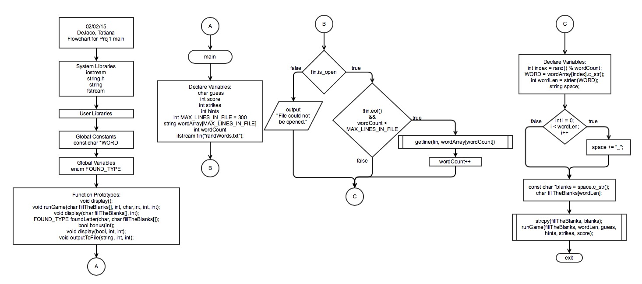
FlowChart For Class Proj1 void display(), void display(char fillTheBlanks[], int), void display(bool, int, int)
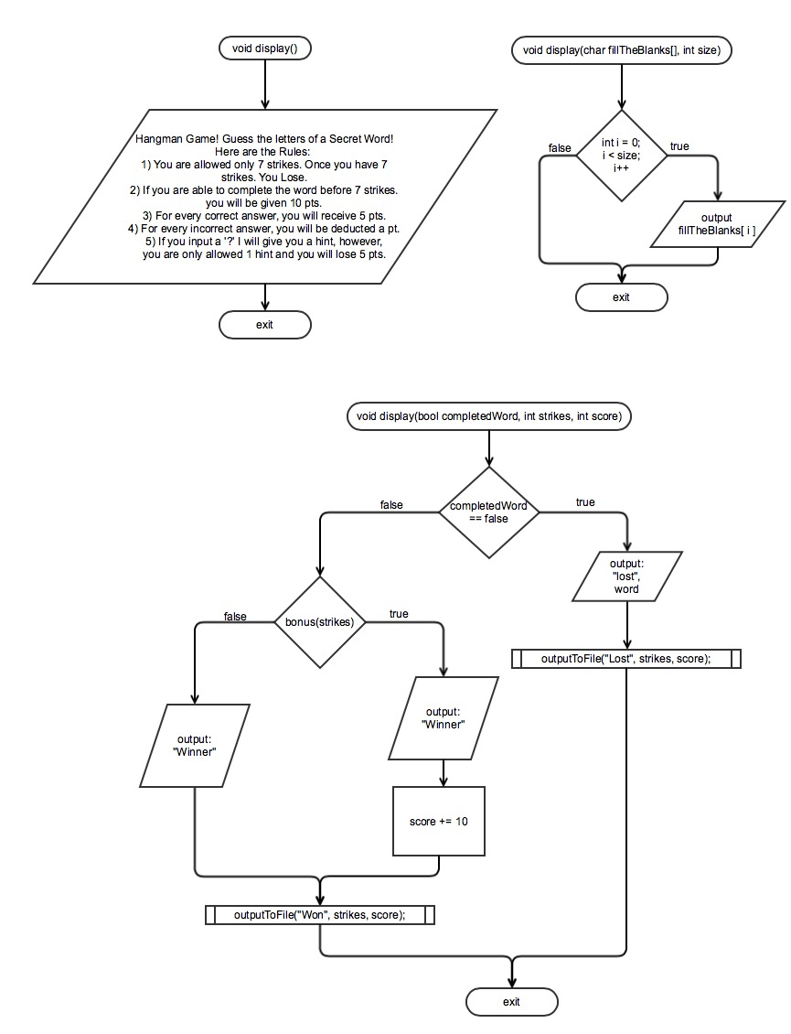
FlowChart For void runGame(char fillTheBlanks[], int, char,int, int, int)
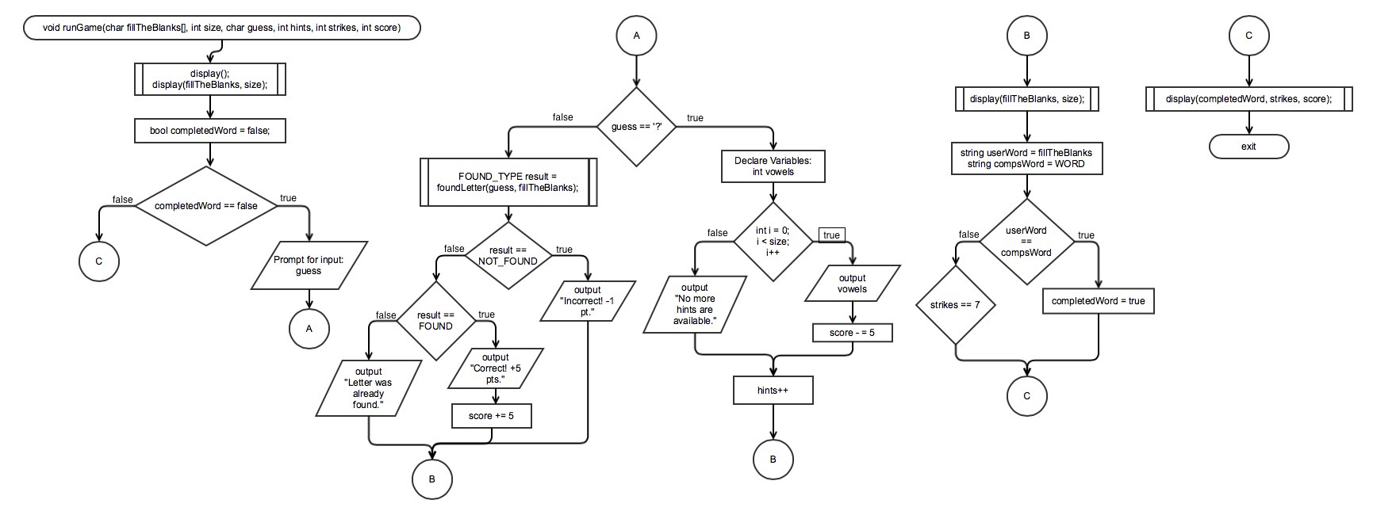
FlowChart For FOUND_TYPE foundLetter(char, char fillTheBlanks[])
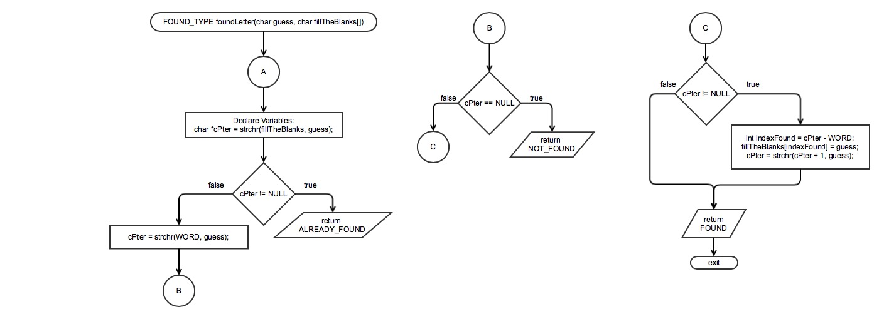
FlowChart For bool bonus(int)
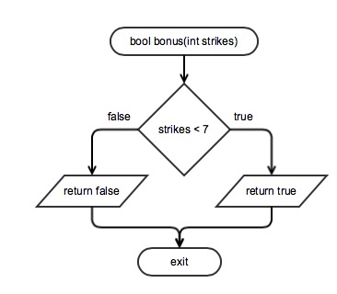

FlowChart For outputToFile(string, int, int)
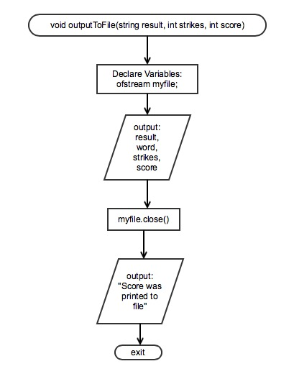

Major Variables

Type | Variable Name | Description | Location
const char | WORD | The string that the computer chose at random | Class Proj1
char | guess | The user's input | main(int argc, char** argv)
int | score | The user's current score | main(int argc, char** argv)
 | strike | How many times the user guessed incorrectly | main(int argc, char** argv)
 | hints | How many times the user asked for a hint | main(int argc, char** argv)
 | wordLen | The length of the word chosen by the computer | main(int argc, char** argv)
const char[] | fillTheBlanks | The user fills in the blanks as they guess correctly | main(int argc, char** argv)

C++ Constructs

Chapter | New syntax and Keywords | Location
2 | cout | runGame(char, int, char, int, int, int);
 | cin | runGame(char, int, char, int, int, int);
 | int | main(int argc, char** argv)
 | char | main(int argc, char** argv)
 | bool | runGame(char, int, char, int, int, int);
 | string | main(int argc, char** argv)
 | assignment operator (+=) | runGame(char, int, char, int, int, int);
 | arithmetic operator (+,-,*, /) | runGame(char, int, char, int, int, int);
 | increment operator (++) | runGame(char, int, char, int, int, int);
 | decrement operator (--) | runGame(char, int, char, int, int, int);
3 | enumeration type | Class Proj1
 | if-else statements | bonus(int)
 | switch statements | runGame(char, int, char, int, int, int);
 | break | runGame(char, int, char, int, int, int);
 | while loops | runGame(char, int, char, int, int, int);
 | for loops | runGame(char, int, char, int, int, int);
4 | functions | Class Proj1
 | global constant | Class Proj1
 | global variable | Class Proj1
 | overloaded functions | runGame(char, int, char, int, int, int);
5 | void functions | Class Proj1
 | return | bonus(int)
 | procedural abstraction | runGame(char, int, char, int, int, int);
6 | ifstream | outputToFile(string, int, int)
 | ofstream | outputToFile(string, int, int)
7 | arrays | main(int argc, char** argv)

Reference
- http://www.stackoverflow.com
- http://www.cplusplus.com
- textbook

Program

/*
* File: main.cpp
* Author: Tati
* Created on January 28, 2015, 10:12 PM
* Hangman Game
*/

#include <iostream>
#include <string.h>
#include <string>
#include <fstream>
using namespace std;

const char *WORD; // The string the computer has chosen
// Used for comparing results
enum FOUND_TYPE { NOT_FOUND, FOUND, ALREADY_FOUND };

// Displays the rules of the game
void display();
// Run the game
// Pass in the blanks to be filled, it's size, guess, hints, strikes, & score
void runGame(char fillTheBlanks[], int, char,int, int, int);
// Display the fill in the blanks
void display(char fillTheBlanks[], int);
// Look for the letter given by user
// Pass in guess, the blanks to be filled
FOUND_TYPE foundLetter(char, char fillTheBlanks[]);
// See if user completed word in less than 7 strikes
bool bonus(int); // Pass in their number of strikes
// Output if the user won or lost
// Pass in if word was completed, # of strikes, & score
void display(bool, int, int);
// Output the word, # of strikes, and score to a file
// Pass in their result, their # of strikes, and ttl score
void outputToFile(string, int, int);

int main(int argc, char** argv)
{
// initialize random seed
srand (time(NULL));

// Declare Variables
char guess; // the user's guess
int score = 0; // the user's score
int strikes = 0; // how many times they guessed wrong
int hints = 0; // how many hints the user used up

const int MAX_LINES_IN_FILE = 300;
string wordArray[MAX_LINES_IN_FILE]; // allocating an array of 1kb
int wordCount = 0; // counts the number of word in file
// Computer will choose one word from the file of random words
ifstream fin("randWords.txt"); // opening an input stream for file
// Checking whether file could be opened or not. If file does not exist
// or don't have read permissions, file stream could not be opened.
if(fin.is_open())
{
// this loop run until end of file (eof) does not occur
while(!fin.eof() && wordCount < MAX_LINES_IN_FILE)
{
// Read a complete line into the array. Each line
// contains one word.
getline(fin, wordArray[wordCount]);
wordCount++;
}
}
else //file could not be opened
cout << "File could not be opened." << endl;

// Display a random word from file
// Pick a string from the list
int index = rand() % wordCount;
WORD = wordArray[index].c_str(); // Set the rand string to be the word
int wordLen = strlen(WORD); // the length of the chosen string

// Create empty string that will be filled as the user guesses correctly
string space;
for (int i = 0; i < wordLen; i++)
space += "_";
const char *blanks = space.c_str(); // Create the empty string
char fillTheBlanks[wordLen]; // The user will fill as they guess correctly
strcpy(fillTheBlanks, blanks);

runGame(fillTheBlanks, wordLen, guess, hints, strikes, score);
return 0;
}

// Displays the rules of the game
void display()
{
cout << "Hangman Game! Guess the letters of a Secret Word!" << endl;
cout << "Here are the Rules: " << endl;
cout << "1) You are allowed only 7 strikes. Once you have 7" << endl;
cout << " strikes. You Lose." << endl;
cout << "2) If you are able to complete the word before 7 strikes." << endl;
cout << " you will be given 10 pts." << endl;
cout << "3) For every correct answer, you will receive 5 pts." << endl;
cout << "4) For every incorrect answer, you will be deducted a " << endl;
cout << " pt." << endl;
cout << "5) If you input a '?' I will give you a hint, however," << endl;
cout << " you are only allowed 1 hint and you will lose 5 pts." << endl;
cout << endl;
}

// Run the game
void runGame(char fillTheBlanks[], int size, char guess, int hints, int strikes, int score)
{
// Display the rules of the game
display();
// Display how many letters are in the word
display(fillTheBlanks, size);

bool completedWord = false; // true if user completely filled the blanks
while (completedWord == false)
{
// Prompt user for input
cout << "Your guess? ";
cin >> guess;

// If user asks for a hint, give them one at random
if (guess == '?')
{
if (hints == 0)
{
// Tell them how many vowels are in the word
int vowels;
// Go through the WORD and count how many vowels are in there
for (int i = 0; i < size; i++)
{
switch(WORD[i])
{
case 'a': { vowels++; break; }
case 'i': { vowels++; break; }
case 'u': { vowels++; break; }
case 'e': { vowels++; break; }
case 'o': { vowels++; break; }
default: break;
};
}
cout << vowels << " vowel(s) is in this word." << endl;
cout << "-5 pts" << endl;
score -=5;
}
else
cout << "No more hints are available." << endl;

hints++;
}
else // if user didn't ask for a hint
{
// Find the letter guessed by user in the word
FOUND_TYPE result = foundLetter(guess, fillTheBlanks);
if (result == NOT_FOUND)
{
cout << "Incorrect! -1 pt.";
score--;
strikes++;
}
else
{
if (result == FOUND)
{
cout << "Correct! +5 pts.";
score += 5;
}
else
cout << "Letter was already found.";
}
cout << endl << endl;

// Show user where their guess was filled in
display(fillTheBlanks, size);

// Check if the blanks are filled and matches the computer's word
string usersWord = fillTheBlanks; // User's word
string compsWord = WORD; // Comp's word
if (usersWord == compsWord) // if blanks match the comp's word
completedWord = true;
else // blanks were not filled
{
if (strikes == 7) // Check if the user used up their strikes
break;
}
}
}
// Display results to user
display(completedWord, strikes, score);
}

// Display fill in the blanks
void display(char fillTheBlanks[], int size)
{
// Display the blanks
for (int i = 0; i < size; i++)
cout << " " << fillTheBlanks[i];
cout << endl;
}

// Look for the letter given by user
FOUND_TYPE foundLetter(char guess, char fillTheBlanks[])
{
// If the guess letter is in the string fillTheBlanks
// then the user already guessed that character.
char *cPter = strchr(fillTheBlanks, guess); // char pointer
if (cPter != NULL)
return ALREADY_FOUND;

// If it is NOT in the fillTheBlanks,
// then check if character is in the word
cPter = strchr(WORD, guess);
if (cPter == NULL)
return NOT_FOUND;

// If character WAS not in the fillTheBlanks
// and character WAS found, then it is in the word.
// So...get it's location in the word.
while (cPter != NULL)
{
// FIll in the blank with the guess
int indexFound = cPter - WORD;
fillTheBlanks[indexFound] = guess;
// Advance to the next location of guess WORD
cPter = strchr(cPter + 1, guess);
}
return FOUND;
}

// See if user completed word in less than 7 strikes
bool bonus(int strikes)
{
if (strikes < 7)
return true;
else
return false;
}

// Display results of game and output results to a file
void display(bool completedWord, int strikes, int score)
{
cout << endl;
// Set Score and Output results
if (completedWord == false) // Word wasn't completed
{
cout << "You Lose!";
cout << " The word was " << WORD;
outputToFile("Lost", strikes, score);
}
else // Word was completed
{
if (bonus(strikes)) // user finished before 7 strikes
{
cout << "Amazing! You completed the word before 7 strikes! ";
cout << "+10 pts!";
score += 10;
}
else
cout << "You have completed the game! Congratulations!";
outputToFile("Won", strikes, score);
}
}

// Output the word, # of strikes, and score to a file
void outputToFile(string result, int strikes, int score)
{
// Output a file when game is complete
ofstream myfile;
myfile.open("hangman.docx");
myfile << "You " << result << " the game!" << endl;
myfile << "The word was: " << WORD << endl;
myfile << "You used up " << strikes << " strikes" << endl;
myfile << "Your score = " << score << endl;
myfile.close();
// Tell User their result was outputted to a file
cout << endl;
cout << "Your score was printed to a file";
cout << "...Go check out your score!" << endl;
}

