Tim Clark

## Systems Operations Manager / Devops Engineer

email: [Jobs@incomprehensible.co.uk](mailto:Jobs@incomprehensible.co.uk)  
address: 41 Goldsmith Road, Worthing, BN14 8ES   
phone: 01903 2395239

## RECENT PROJECTS

* Introduced containerization to production - utilizing a host of open source technologies (including Jenkins, Docker Swarm, Traefik, Jaeger, Java SpringBoot, Prometheus) – the first applications has now been in production for 3 years and some take millions of hits a day.
* Migrated 100’s of legacy services (mostly Java) to a new fully virtualized environment – while cleaning up some technical debt and saving compute resources along the way.
* I was one of the architects of an Ansible based server provisioning system (which we used to automatically build out infrastructure at scale on a VMware platform)
* Migrated legacy applications to new supportable base on AWS and on-prem – using containerization where possible - and virtualizing the whole infrastructure away from ‘bare metal’.
* Implemented a new automated deployment framework with input from Devs and QA teams.
* I was the UK lead of the team that moved 1000’s of VM’s between datacentres as part of a datacentre migration
* Training and transition new employees throughout my time at Highwire - building a strong team of DevOps/sysadmins and training them in new technologies and methodologies

## WORK EXPERIENCE

#### Highwire Press - Systems Operations Manager

June 2018 – Present

Continuing the great Devops work but with additional responsibility for building a team of Systems/Devops staff across Highwire's UK operation. Moved legacy applications onto Docker with a mixture of Jenkins, Swarm and Ansible - and introducing concepts like centralised logging, OpenTracing and ephemeral lifecycles. Working with AWS and in-house hosting facilities (mainly VMware). In 2020, I was part of a team that moved thousands of VM’s from a datacentre at Stanford University.

#### Highwire Press – DevOps Engineer

Jan 2017 – June 2018

I technically joined Semantico Ltd just as they were purchased by Highwire Press. I now work with a fantastic and varied set of publishing platforms and helping lead on all things DevOps. Due to staff changes following the acquisition I was 'stepping up' to help fill the role of IT Operations Manager, EMEA until a replacement could be found – honing my skills with managing teams and tech projects.

#### Precedent Communications - various roles – including Director of Technical Services

May 2003 – January 2017

“Meaningful ideas, intelligently delivered” - Precedent specialised in strategy, web, brand and mobile, with offices in London, Cardiff, Edinburgh, southern hemisphere offices in Perth, Melbourne and Hong Kong - and most importantly of all, Worthing, West Sussex.  
  
Building on the work we'd started with Pinnacle Internet - we grew the Hosting offering into multi-datacentre, geographically disparate service highly valued by customers and profitable to the business as a whole - punching way “above our weight”. Our customers included British Medical Association, Parkinsons UK, Wildlife Trust, British Heart Foundation and Anthony Nolan – and we worked with a variety of platforms and CMS’s.   
  
I managed a global team who supported Precedent systems internationally - while helping to architect HA and load balanced solutions for customers. I oversaw the hosting platform and architecture, incident management and budget along with managing the OPS team spread around the UK and Australia.

**Pinnacle Internet – Senior Systems Administrator**

May 2000 – May 2003

I installed Pinnacle's first datacentre based server in 2000 - and quickly became the Senior Systems Administrator. Pinnacle were bought out by Precedent Communications in 2003.

## EDUCATION

#### University of Kent

1997 - 2000

Computer Science Degree (Hons)

(+10 GCSEs, 3 A Levels)

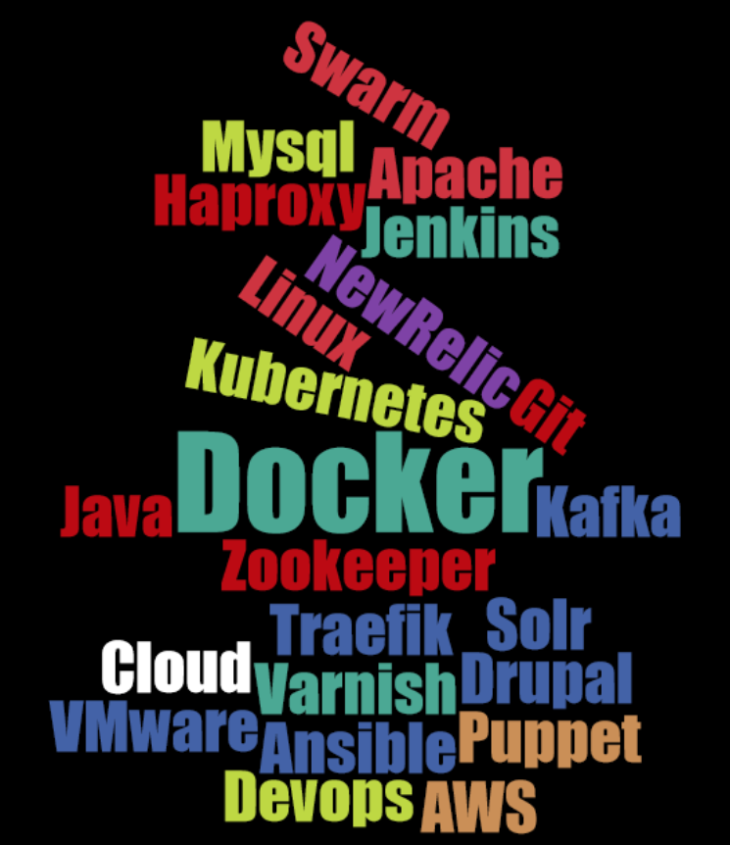

### HOBBIES

**Computers and Gaming**  
**Watching Football** (Tottenham – never a dull moment)  
**Maybridge Community Church** (where I am part of a team which plans services)  
**Family life** (I have 2 kids and a long-suffering Brownie leader wife)

## My Current Favourite Podcasts

Kermode and Mayo’s Film Review  
Kubernetes from Google  
TED Daily  
Freakanomics  
FLOSS  
Mid-Faith Crisis  
Electronic Wireless Show  
Doctor Who: Verity  
BBC Friday Night Comedy

## SKILLS Swarm Mysql Apache Haproxy Jenkins NewRelic Git Kubernetes Java Docker Kafka Zookeeper Traefik Solr Cloud Varnish Drupal VMware Ansible Puppet Devops AWS Prometheus

## RECOMMENDATIONS

*“I had the extraordinary pleasure to work directly with and manage Tim Clark at HighWire Press. Tim was a Team Leader in our Operations group and a mentor to the other Operations staff. Time directly managed our UK Operations and was responsible for day to day problem solving, infrastructure and technology upgrades, task assignments, and special major projects. Tim was also a partner for our Account Management team and was client-facing when the clients had particularly thorny issues to solve in the Operational arena. I found Tim to be exceptionally effective and valued by the entire organization for his even temperament, professional acumen, and insightful approach to problem solving. Tim is creative, curious and fearless when it comes to tackling new technology and he is always looking for opportunities to make improvements. Tim challenged our organization to move forward, to adopt emerging technologies and to continuously improve. At the same time Tim was able to align Company directives and reconcile Operations initiatives with overall Company goals for everyone's benefit. Tim’s real strength is his drive to continuously improve systems and he will be an asset with any team he is a member of. I would be pleased to have the opportunity to work with Tim again in the future”* – **Todd McGee - Vice President of Engineering at Highwire** (Todd managed me directly)

*“I worked for Tim for 4 years. During that time I went from Junior Systems Administrator to experienced Linux System Administrator and prepared to start my transitioning to DevOps. In full honesty I could not have done it with out Tim and his leadership. Tim is a hard working leader and people always look up to him for answers and his technical expertise. He treats his employees like family and works with them inside and outside of work. One of the best managers, great role model and I would gladly work with him again.”* - **Edgars Budniks - Systems Administrator at HighWire** (Edgars reported directly to me directly)

*“Tim is an excellent innovator, applying his ever growing knowledge in the Systems Admin and DevOps domain. A fearless experimenter and problem solver and always exploring new ways to use technology more effectively to deliver reliable and performant solutions. He is also an absolute pleasure to work with and is a great asset to any team and organisation”* – **Oliver White – Director of Engineering at Highwire** (Oliver was senior to me – but not my direct line manager)